Undergraduate Dissertation coversheet & feedback form

PLEASE COMPLETE THE TOP SECTION OF THIS FORM AND SUBMIT ONE COPY WITH YOUR DISSERTATION
For completion by student:
Student Name: Bethan Catherine Watts

Student University Email: 1700966@student.uwtsd.ac.uk
Module code: HPHI6017 | Student ID number:  1700966 |  |  |  | Educational support needs:  Yes/No
Dissertation title: “To what extent was marriage integral to the consolidation of Tudor power, 1485 – 1603?”
Supervisor: Dr Harriett Webster |  |  | Word count: 10,023
I confirm that this is my original work and that I have adhered to the University policy on plagiarism.
Signed …Bethan Watts…………………………………………………………
For completion by the first marker:
Comments:

First Marker’s Mark:  Signature: |  |  |  | Date:
For completion by the second marker (if appropriate):

Comments:

Second Marker’s Mark:  Signature: |  | Date:
NB. All marks are provisional until confirmed by the final examination board.

How agreed mark was decided upon—comments for External Examiner:

Proposed Mark:

Signature of External Examiner:

Final Agreed Mark:

“To what extent was marriage integral to the consolidation of Tudor power,
1485 – 1603?”

Bethan Catherine Watts

Dissertation submitted in partial fulfilment of a B.A. (Hons.) in Medieval Studies
University of Wales Trinity Saint David

May 2020

Acknowledgements

I would like to thank Dr Harriett Webster for her help and assistance in the writing of this dissertation.

I also wish to acknowledge two anthologies of contemporary Tudor sources which greatly assisted in the research process of this dissertation. The Chronicles of the Tudor Queens by David Loades was vital in my analysis of Queens Elizabeth and Mary, and Tudor England, 1485 – 1603 by Dan O’Sullivan was perhaps my greatest resource of contemporary materials for this dissertation.

Abstract

In this dissertation, I will propose that matrimony played a vital role in how the Tudor monarchs exercised and maintained their power from 1485 to 1603. I aim to arrive at the conclusion that marriage was the greatest motivating factor behind how the Tudors addressed their domestic and foreign policies, and how they controlled their image through art and propaganda. I shall approach this dissertation through a revisionist lens, primarily focusing on the social and political history of time.

I will focus on the entire timeline of the Tudor Age, from 1485 to 1603, paying close attention to the marriages, betrothals and divorces of each of the five Tudor monarchs. In addition to this, I will also consider the impact the marriages of the daughters of Henry VII had on England and the monarchy at the time, as well as how their offspring came to dominate the political landscape in the late sixteenth century.

The sources utilised in this dissertation vary greatly. I have used contemporary correspondence, poetry, privy accounts and eye-witness testimonies as the foundation of much of my primary evidence. The birth of printed literature, as well as a drastic increase in portraiture production during the the Cult of Gloriana, led to many surviving textual and material sources available for my research. As well as primary evidence, a plethora of secondary materials were utilised in this dissertation, with arguments that both support and negate my theories. Due to the saturation of historiography surrounding this period of history, secondary materials written from varying perspectives were easily accessible and adaptable to my own arguments. I have also utilised material sources in the third chapter of this dissertation which is entirely dedicated to the analysis of Tudor portraiture and its relationship with marriage.

Table of Contents

Introduction…………………………………………………………………………....7
Chapter 1 – Marriage and Domestic Policy……………………………………….10
Chapter 2 – Marriage and Foreign Policy…………………………………………19
Chapter 3 – Marriage in Portraiture and Art………………………………………30
Conclusion……………………………………………………………………………39
Bibliography…………………………………………………………………………..41
Appendix……………………………………………………………………………...46
List of Illustrations……………………………………………………………………47

Introduction

England from 1485 to 1603 was a country whose identity was punctuated by the marital lives of its rulers – the Tudors. When the Ladies Dictionary of 1694 outlined the fundamentals of matrimony, which included a “suitable agreement in ages, humours, breeding, religion, families, and fortune” between couples, it had clearly overlooked the eclectic marriages of its monarchs that had occurred in the decades prior. The Tudors’ widely varying attitudes to marriage shaped the country that they ruled, and all with varying degrees of success. Henry Tudor’s decision to marry Elizabeth of York in 1486 united the houses of Lancaster and York, and it was arguably Henry’s greatest achievement that he became the patriarch of the “rosebushes of England” who would themselves come to shape the country.
The six marriages of Henry VIII have each left their imprint on English history in a variety of ways, including being the impetus behind the English Reformation, and the stimulus for the drastically changing domestic and foreign policies of the time. The matrimonial attitudes of Henry’s daughters, who would both rule in their own right, equally shaped the course of English history. In an age where marriage was considered to be “the major defining moment of [a woman’s] life”, the Tudor queens certainly both challenged and supported this ideology. For Elizabeth, her refusal to marry became her glory – for Mary, it was her downfall.
This dissertation will be split into three chapters, and will cover three themes: domestic policy, foreign policy and contemporary art, and the extent that these were influenced by the marriages of the Tudor monarchs. In the Tudor Age, an effective government relied on successful domestic policy, and so, in this first chapter, I will discuss why I believe that the marriages of each Tudor monarch was the lead influence in their governance of domestic policy. I will discuss the lengths that Henry VII went to establish his new-found dynasty in the hostile Yorkist-sphere that existed in England at the time of his accession. Further, I will discuss how the betrothals Henry made for his children were of crucial importance to England’s domestic policy, and how, in particular, it was the marriages of his daughters, Margaret and Mary, that had the longest lasting impact on solidifying the Tudor dynasty in English history. Finally, in this chapter, I shall investigate the extent that Henry VIII changed the dynamic of the social classes in England during his reign by rewarding his love interests and elevating them and their families to power, displaying how the social class boundaries of the time could easily be manipulated through marriage.
In the second chapter, I will evaluate the importance of the marital unions of the Tudors in relation to the foreign policies that they exercised during their reigns. For all of the Tudor monarchs, a potential successful foreign marriage brought about protection in war, improved relations with European countries, and often an increase in wealth. I will analyse how Henry VIII’s divorce to Katherine of Aragon became the precursor for an anti-Spanish sentiment in England that would in time influence opinions of Mary I, and why, it was Mary’s marriage to a Spanish prince that reverberated negative sentiments for a previously well-loved figure. I will challenge the traditional view that it was Mary’s severe methods of fostering Catholicism in England that caused downfall, and that instead, it was a ubiquitous negative reaction to her marriage that immortalised her as an ineffective monarch. Finally, I will focus on whether European attitudes to the marital affairs of Elizabeth I had changed in the years following Mary’s disastrous reign, and how countries such as France and Spain reacted to her refusal to marry with disdain. I will compare these sentiments to how the English viewed their monarch, and how they believed that a Virgin Queen was the greatest asset to their foreign policy.
The final chapter, different from the rest due to its reliance on surviving contemporary portraiture, focuses on how marriage was represented through art. In this chapter I will argue that marriage was woven into almost every aspect of art at the time, and I have chosen eight instances where this is demonstrated, with artworks from the reigns of Henry VII, Henry VIII and Elizabeth I the most notable. I will argue that art had become much more influential than it had been in the Middle Ages, and that for the first time the English monarchs could control how their images were perceived not only in their own kingdom, but also the wider world in which they lived. Therefore, I will argue that the Tudors used portraiture as a form of propaganda, and that aspects of marriage was woven into almost every piece of art produced at their courts during this time.
I believe that my research proposal is relatively new and refreshing against the saturated backdrop of existing studies in Tudor history. Although the marriages of the Tudors are mentioned in almost every secondary scholarship, I believe that the majority of historians overlook the vital role that marriage played in the control of Tudor power, and that they instead attribute this power to other factors such as military expertise or religious propaganda. John Guy, for example, fails to mention the six marriages of Henry VIII in the entirety of his study of the Tudor Age, instead attributing the changing policies of the time to other aspects, including pressure from councillors and the Tudor populace. Guy’s opinions therefore are greatly challenged in this dissertation. On the other hand, revisionist historian Tracy Borman’s opinion that almost every aspect of Elizabeth I’s life was influenced by marriage is an idea that I aim to adapt in this dissertation. Although Borman arguably writes panegyrically of Elizabeth I, her opinions of the marital affairs of the Tudor queen are thought-provoking, and I will expand upon these in this dissertation.

Wordcount: 977

Chapter 1 – Marriage and Domestic Policy

In this chapter, I will discuss how the marriages of the Tudor monarchs had long-lasting influence over the domestic policy of the period, and how it would come to leave a perpetual imprint on English political history. Arguably, the Tudor dynasty would have failed to have thrived had it not been for Henry Tudor’s marriage to Elizabeth of York in 1486, which united the warring houses of York and Lancaster in the aftermath of the Wars of the Roses. Additionally, this union would consolidate Henry’s claim to the throne and would legitimise the heirs of his dynasty. In short, it was Henry’s marriage to Elizabeth that would become the grassroots of the Tudor dynasty.
Before considering the impact this marriage had on England at the time, I believe it is vital to look at the context in which it occurred. Henry Tudor’s consolidation of his power in England following his victory at Bosworth in 1485 was swift and calculated. The move from the deeply entrenched Yorkist attitudes in England to the adoption of Tudor ones was the first sign that showed that Henry was distancing himself from “the disaster-orientated framework of the Middle Ages”, and particularly of the reign of Richard III. Whilst some historians, such as MacCulloch, argue that Henry did little to change the dynamic of the domestic policy in England after his victory at Bosworth, and that “Tudor government often imitated patterns laid down by the Yorkist monarchs”, I believe that actually it was the opposite, that Henry Tudor had already greatly impacted England through his marriage, which proved a turning point in English history.
The marriage of Henry Tudor and Elizabeth of York came to be known as the ‘Unification of England’ and was arguably ubiquitously accepted by the English at the time following the convoluted failure of Richard III’s reign, which had been reinforced by the mysterious circumstances of the princes in the Tower. Arguably, Henry capitalized on this anti-Ricardian sentiment that existed at the time, and galvanized the English populace into supporting the new Tudor regime. Henry did this through numerous means, namely offering peace to the residual defeated Yorkists, and eradicating any threat to the throne. Through his marriage, Henry was able to offer of “the essential palliative to those Yorkist defectors” who had joined his cause against Richard III, indicating that Henry utilized incentives and was willing to forgive Yorkist-sympathizers to effectively indoctrinate them to the Tudor regime. Guy supports this, arguing that the touchstone of Henry’s reign was his policy of “the enforcement of political and financial obligation to the Crown, as much as of law and order”.
But as well as this, Henry also knew that to further consolidate his power, the birth of heirs was to be vital to protecting his dynasty. In time, four living heirs would be born, achieving the ‘Union of the Two Noble and Illustrious Families of Lancaster and York’”. To further this, the marriages that Henry’s offspring would eventually come to make would prove crucial to the Tudor dynasty. In his will, Henry VII outlined that, in order for “th’advancement of the profperitie, vtilitie and comoditie of our Subgiects”, it was vital for his children to marry well, clearly showing how their marriages would be at the benefit of all those who lived in England. Indeed, the strengthening of foreign ties through the means of his children’s marriages was arguably one of the most crucial aspects to the early Henrician Tudor regime. This came to a head when, in 1489, the Treaty of Medina del Campo was signed, designed to forge a marital alliance

“between Ferdinand and Isabella [of Spain], their heirs and subjects, on the one part, and Henry, his heirs and subjects, on the other part”.

The treaty was effectively enforced, and arguably was one of Henry’s greatest political achievements. It is interesting therefore, that of the most impactful of the events that occurred during the early reign of Henry VII, at least two of them involved the issue of marriage.
Another factor essential to the domestic policy of England under Henry VII, was how the king exercised his power. As well as the successful matrimonial proposals that Henry established for his children, he also excelled in establishing a sophisticated financial administration that broke away from medieval precedents and only existed at “the hands of himself and the selected few”. This financial administration, and the fact that Henry made it accessible only to his most trusted courtiers, was vital to the fabric of the early Henrician regime. Over the next few decades, this would dramatically shift under the control of Henry VIII where, for the first time, his ministers and officials were allowed “freedom of action only within accepted limits”. Whereas Henry VII had successfully managed to operate his control with only the advice of his most trusted courtiers, the Tudor court under Henry VIII’s leadership would see the alienation of established nobility as well as a considerable swell in political splinter-groups. In this next section of the chapter, I will argue why this alienation occurred during the reign of Henry VIII, and why I believe that it was entirely motivated by marriage.
Arguably, existence in the later Henrician court depended wholly on the worth of each courtier to King Henry VIII. Pair this with the fact that marriage was perhaps the most essential aspect for economic comfort – especially in the case of women – and it is clear to see how the Tudor court under Henry VIII appeared to constantly be changing. Erickson argues that, “at all social levels, marriage was by far the most convenient way to make a fortune”. This appeared certainly true for numerous courtiers during the reign of Henry VIII, where loyalty to the regime and to the monarch, “irrespective of a man’s social origins and background” could be the grounds of “appointments, promotions, favours and rewards”. This certainly went against the regime of Henry VII, whose strict observation of the social class structures was never compromised, unlike under the reign of his son where the social hierarchy was constantly evolving depending on whatever wife he was married to at the time.
For some, attracting the monarch’s attention became the key to their existence at court. As well as patronage, the monarch could reward his most loyal courtiers with financial gain, and, in the case of a select number of distinguished nobility, could be elevated into new-found positions of power through the monarch’s marriage. In the words of the contemporary poet, Thomas Whythorne, there was a difference between “wiving” and “wooing”, and that it appeared that Henry VIII often tread the fine line between this, rewarding his mistresses and elevating them to the position of queen. The best example of this occurred in the decade between 1523 and 1533, where Henry VIII had courted Anne Boleyn.
In the 1520s, George Cavendish, the biographer of Cardinal Wolsey, wrote negatively of Anne Boleyn, stating,

“that she, being in such favour, might work masteries with the king, and obtain any suit of him for her friend”.

It was common knowledge even during this time that the only way to advance at court was through the King, a fact that many exploited. Cavendish, continuing his snub on Anne Boleyn, wrote that Anne had “began to look very hault and stout, having all manner of jewels, or rich apparel” due to “the great love that he bare her”. Arguably, Henry’s reliance on sending physical gifts to attract his mistresses was central to his personal governance, and thus by extension, how his domestic policy was maintained. In 1527, Anne Boleyn wrote to Henry VIII,

“I pray you to consider that it cannot be sufficient to your generosity: for if you recompense so slight a conversation by gifts so great, what will you be able to do for those who are ready to consecrate their entire obedience to your desires? […] it induces me to think that your majesty has some regard for me”.

The fact that Anne explicitly mentions that Henry did not reward those who “consecrate their entire obedience” to him, yet rewarded Anne, of whom he was courting at the time, proves that Henry VIII only rewarded those of whom he considered most valuable to his person – and not those who were loyal to the regime. In turn, it was Anne Boleyn – and subsequently Jane Seymour – who would come to exercise a degree of power over the Henrician court, gaining their families prestige through means of their relationship with the king.
Both the Boleyn and the Seymour family would come to power through this way. This shift in power came to a visible head particularly during the Reformation, where the family of Anne Boleyn set the precedent for influencing the king’s domestic and religious policies. As well as this, it was during Henry’s marriage to Anne that the conception of numerous political and religious factions would occur. The reformist faction against Katherine of Aragon, headed by Thomas Cromwell and Thomas Howard in the 1530s exploited the familial connections to the new Queen. This shift in influence became so apparent when even the most established and trusted of Henry’s councilors - such as Thomas More – were ignored.
MacCulloch offers a different argument, that the greatest “Tudor families stand out because of their ethos of Crown service”, explicitly naming the Howard and Boleyn family. He goes on to suggest that Henry, during his marriage to Anne Boleyn, had a “purge” in courtiers, and that he maintained a limited government with only the families of his current wife as influencing advisors. I greatly disagree with this. For one thing, as I have previously suggested, I believe that it was not a unwavering ethos to the Crown that allowed these families to have power, but simply their connections that were established through the marriage between the king and their kinswoman. Additionally, I believe that instead of ‘purging’ courtiers, Henry’s reign actually saw the biggest increase in ‘new’ aristocracy of all five of the Tudor monarchs. A prime example of this is when, in 1532, Henry established the entirely new title of Marquess of Pembroke for Anne Boleyn to legitimize their relationship. Unlike “Henry VII and Elizabeth I [who] in particular were reluctant to create new peers to replenish noble stock”, there is evidence to suggest that under Henry VIII’s reign, the nobility had grown to unprecedented size, and all down to his rewarding of the families of his current wife.
On the 9th December, 1529, Anne Boleyn held a feast in celebration of her father’s elevation to the Earldom of Wiltshire. It was recorded that Anne “took precedence not only over the two Duchesses of Norfolk, the leading noblewomen of the land, but also over the Duchess of Suffolk, who as Dowager [Queen] of France, had the right to be served as Queen”. The Duchess of Suffolk, as Henry’s sister, should have been the highest ranking noblewoman at court, and the fact that Anne had taken such precedence highlights the extent of her influence. As stated previously, the social class boundaries during the reign of Henry VIII were highly unstable, and often easily manipulated. But Henry was certainly not the only Tudor to exercise control over his choice in spouse, and not alone in permeating the social hierarchy. His sisters, Margaret Queen of Scotland, and Mary Queen of France and Duchess of Suffolk, did the same, as will be discussed in this next section of this chapter.
In 1502, Henry VII forged a successful treaty known as the ‘Perpetual Peace with Scotland’ on the grounds that his eldest daughter Margaret marry the king of Scots, James IV. The treaty was well-received and shows the extent that Henry Tudor had already begun to integrate his newly established dynasty with other influential, and often ancient, European dynasties of the time. Indeed, it was due to the betrothals of his children that Henry VII maintained that England was always to be “within the mainstream of European affairs”.
By 1516, Queen Margaret had been widowed, and on the 2 May she travelled to London to meet with her brother Henry, who was now King of England. Her reasoning for this journey is the subject of much historical discourse. Some historians believe she wanted to enjoy the May Day festivities in London, whilst others, like Loades, argues that it was the intensifying political situation that was occurring in Scotland at the time that encouraged Margaret to leave. However, in my opinion, Margaret was motivated by marriage. Cardinal Wolsey, who spoke to Margaret on that day, hinted that she had come to England in search of a third husband. Wolsey wrote that it appeared that Margaret was seeking,

“the possibility of a match with the Emperor Maximilian, who conveniently happened to be a widower”.
From this, it is explicitly clear that Margaret’s actions were motivated by the search to find a new spouse, and that her journey to London was vital in the betterment of her marital ambitions.
Margaret’s younger sister Mary was also motivated by the same reasons as she had been and had equally taken her marital ambitions into her own hands. In 1515, after just a year of marriage, Mary’s first husband, the aged Louis XII of France died, leaving her a widow. Mary, aware of her husband’s advanced age, had written to her brother Henry to remind him of his promise that following Louis’ death, Mary was free to marry a man of her choosing. In January 1515, Mary wrote,

“Sir, I beseech your grace that you will keep all the promises that you promised me when I took my leave of you […] you knoweth well that I did marry for your pleasure at this time, and now I trust that you will suffer me to [marry] as me for liketh to do”.

From this, it is blatantly clear that both sisters of Henry VIII intended to marry as they saw fit, disregarding any unions suggested by their brother for the advancement of his kingdom. Whilst this may have initially been considered at the detriment of both the domestic and foreign policies of England at the time, arguably, it would only improve it. In 1516, Mary married Charles Brandon, the Duke of Suffolk. Her marriage would prove to be successful with the English, and would come to dominate the political spheres of England in the coming decades.
Mary’s marriage to Charles Brandon would come to define the domestic policy of Tudor England. Instead of naming his elder sister Margaret’s children (who had Scottish lineage through their father James IV of Scotland) as his heirs, Henry VIII named the children of his younger sister Mary. ‘The Act of Succession’, established in 1536 outlined that both daughters of Henry VIII – Mary and Elizabeth – were illegitimate, and that instead the true heir to the throne was his niece, Frances Brandon. Loades argues that “Frances Grey [Brandon] was preferred to Mary Stuart” by Henry’s council, who maintained that the line of succession was not determined “by legitimacy, nor by hereditary right”, but as the monarch saw fit. Ergo, it is clear that the marriages of Henry VIII’s sisters were intrinsic to both the line of succession and to English domestic policy, and that the unproblematic, staunchly-English line of Mary Tudor-Brandon was much preferred over the Scottish children produced from Margaret Tudor’s marriage. In Chapter Two, I will discuss further why the children of Anglo-foreign marriages were to become enormously disliked in Tudor England, and why Margaret Tudor’s marriage was to be the precedent for the xenophobia of the later Tudor reigns.
In conclusion, the marriages of the daughters of Henry VII had the longest lasting impacts on the English monarchy. When Elizabeth I died in 1603, so did the Tudor dynasty. However, it was through Margaret Tudor’s line that the first Stuart king of England, James I, would be crowned, an ancestor of every subsequent English monarch to follow, and whose line still sit upon the English throne today.

Wordcount: 2668

Chapter 2 – The Tudors and Foreign Policy

When Jane Seymour, third wife of Henry VIII died in 1537, the King’s desperation to find a replacement “dominated his foreign policy for the next two and a half years”. It appeared that every other foreign issue had been pushed aside in the quest for a suitable wife, with Henry’s councillors advocating one of foreign heritage. Henry’s last two wives – Jane Seymour and Anne Boleyn came from English backgrounds, and their historic lineages were both safe and secure. However, a foreign union would bring additional benefits, including protection in war, financial gain and political stability, that was, in the words of John Guy, of “paramount importance” to the Tudors and their foreign policies.
John Guy’s argument, that Henry VIII did not want a repeat of the “international humiliation” that he had endured throughout his divorce to Katherine of Aragon, correlates to the typical orthodox views adopted by historians of a similar calibre to Guy. To further this, Guy’s suggestion that twenty seven years before his marriage to Anne of Cleves, Henry VIII had received pressure from his councillors to marry Katherine of Aragon, is typically accepted. However, in my opinion, Henry’s marriage to Katherine was not only one of genuine affection, but one in which he saw himself as her ‘saviour’. Through this marriage, Henry had elevated Katherine, who had been left in England without a dowry, to the position of his queen, fitting the romantic, chivalric ideals of the time. Thomas Shipman, a poet writing in the years following the death of Elizabeth I, likened “courtship to martial combat”, whereas the 1615 Discourse of Marriage and Wiving, written by Alexander Niccholes, compared it to a “stratagem of war”. It is not difficult to imagine that these chivalric ideals of marriage existed during the time of Henry VIII, who, as a monarch who styled himself as the epitome of Arthurian culture, “had indulged his fitful impulses towards chivalric fame […] but without involving the kingdom in life and death struggle”. This quote, from the revisionist historian MacCaffrey, emphasises my theory that Henry saw himself as a model of chivalry and considered marriage a personal conquest.
However, as his reign progressed, Henry’s attitudes towards his marriages greatly influenced his attitudes to war, and that his lust for chivalric recognition became the dominating factor to his martial policies. The birth of Edward in 1537 arguably instilled a sense of security within Henry, and it was only after the succession had been solidified that Henry focused his attentions on the conflicts that were becoming increasingly more frequent in Europe at the time. But as well as the security that a male heir bought him, Henry’s lust for war was also arguably motivated by his marital history of his later reign. The discovery of Catherine Howard’s affair with Thomas Culpeper in 1542 saw a marked difference in the king’s persona at the time. When Anne Boleyn had been executed just seven years prior, Henry reacted by entering into a new marriage with Jane Seymour, and appearing as a stable, modern-Renaissance leader who still adhered to chivalric ideals. However, Henry’s reaction to Catherine’s infidelities in the early 1540s arguably show how the king had shifted to focusing on the country’s military efforts, encouraged by “resurrected youthful dreams of French conquests”. Arguably, it was the humiliation of Catherine’s affair that spurred Henry to re-establish the trust of his people through means of a successful foreign policy and numerous military campaigns. However, this humiliation instead arguably bolstered negative opinion of the king and how he handled his marital affairs, in England, leading to a distrust of Henry’s unstable attitudes toward marriage. The root of this had arguably emerged during the King’s proceedings to divorce Katherine of Aragon and marry the greatly disliked Anne Boleyn. At the time of this divorce in 1534, the Holy Roman Emperor, Charles V, had written to the Imperial Ambassador at Henry’s court, Eustace Chapuys. In the letter, Charles, who was Katherine’s nephew, wrote expressing his concern for his aunt and cousin Mary, indicating that sympathies for the humiliated queen and her bastardised daughter, was rampant around Europe:

“the thing concerned the lives and interests of the Queen [Katherine] and Princess [Mary]…out of pity for all this people, who regard with you as much affection as if they were your own subjects”.

Charles’ sentiment, that the people of his domain regarded Katherine and Mary with “as much affection as if they were your own subjects”, explicitly emphasize that at the time of his writing, Europe was united in its sympathies for Katherine. Whilst it is important to note the provenance of this letter – written by Katherine’s own nephew, and sent to Chapuys, who was notorious in his distrust of Anne Boleyn and the King at the time, it is important to remember that at this time, almost all of Europe was under Spanish influence through the children of Katherine’s sister, Joana, who had integrated themselves into the family trees of Europe. Therefore, it was not a stretch to believe that at the time, Henry’s (often convoluted) attitudes to marriage were treated with disdain by the majority of Europe at the time.
How could it be that just decades later, this pro-Spanish sentiment would disappear altogether in England, and that Princess Mary, who had always been treated with sympathy, would be ostracized for her marriage to a man whose family were, until recently, heralded in Europe?
*
Mary I was coronated in 1553 amidst much rejoicing. Robert Parkyn, who witnessed Mary’s coronation procession, wrote;

“whereat the whole commonalty in all places in the North parts greatly rejoiced, making great fires, drinking wine and ale, praising God…but all such as were of heretical opinions, with bishops and priests having wives, did nothing rejoice, but began to be ashamed of themselves”.

From this contemporary account, it was clear that at least in London, there existed some sense of support for Mary. Parkyn, who was a Catholic, may have simply been writing with sycophantism for a monarch who finally aimed to restore Catholicism to the country, yet other contemporary accounts from the time indicate that support for Mary was initially relatively ubiquitous, not only in England, but also in Europe, which was still largely Catholic at the time of her ascension. Perhaps this newfound support had derived from the disillusionment that had occurred during the reign of Edward VI, where a change in the liturgical year was reported to have been “resented by many”, even by the staunchest of Protestants. However, when, in 1554, Mary was pushed by councilors to choose a husband, this support, which had previously appeared ubiquitous across England – and especially in the pockets of Catholicism - began to fizzle out.
In 1553, Simon Renard, a diplomat from the court of Charles V wrote that Mary’s councilors believed it to be for the,

“good of the kingdom that the Queen should enter into an alliance and marry; and the sooner the better, because of the state of her affairs and her years […] [she replied] that she would accept a marriage for the good of her people, and in the hope of begetting heirs”.

It appeared from this dispatch that Mary was willing to make a marriage with the best interests of her people at heart, indicating that she genuinely cared the opinions of her people, and had taken into account any effects that her marriage would have had on the relationship between people and monarchy. Renard argued that,

“a husband should be proposed to her suitable in these respects with whom she could live in happiness and content, and who would remain at her side”

appearing to hint toward the genuine affection felt by the people for Mary. In the following quote, Mary appears to exude a sense of motherhood over her people, indicating that at the time, the relationship between monarch and people was a good one,

“Certainly if a prince and governor may as naturally and earnestly love her subjects as the mother doth love the child, then assure yourselves that I, being your lady and mistress, do as earnestly and tenderly love and favour you”.

It certainly goes against Fletcher’s argument that Mary’s “distrust of her people was well known”, and that she was often suspicious of the intentions of those of whom she ruled. Mary’s own opinion of her marital affairs were recorded, offering a glimpse into her attitudes towards matrimony, including her reaction to a petition created in November 1553, which encouraged the Queen to marry a man of her council’s choosing. Mary stated that,

“she found it very strange [that the council forced] her to take a husband who would not be to her liking would be to cause her death”.

Mary’s belief that a poorly made marriage would be the ‘cause of her death’ is telling of how she considered marriage to be central to her rule, and how vital it was to make a decision that would be accepted by her people. However, despite her intentions, evidence of the conception of Mary’s downfall occurred as early as 1553, where she publicly flaunted her Spanish ancestry, and capitalised upon her heritage to find a groom of similar ancestral blood.
According to Girolamo Soranzo, who was writing in the nineteenth-century, Mary’s scorn of her people was justified – she disliked them because they refused to accept her “boast of her Spanish blood”. This came to a head when Mary’s councillors suggested potential bridegrooms, and she responded by adopting Spanish customs. According to MacCaffrey, Mary’s “precipitate embrace of the House of Austria carried policy to the opposite extreme” suggesting that even before she was legally married to Philip of Spain, she had already began to integrate herself within his culture. It appeared that Mary had began to distance herself from England, and that this distancing alienated her from her people as she no longer appeared as an icon of her country, but rather instead of a foreign one.
By the time Mary ascended the throne, there existed a deep-rooted xenophobia of the Spanish, encouraged by years of tension between England and Spain during the reign of her father. MacCaffrey argues that it was this anti-Spanish sentiment that increased public unrest, for the English “could not abide an alien ruler on the English throne”. In September 1553, Simon Renard, the French Ambassador, wrote that “the English did not at all want his Majesty or his Highness [Philip of Spain], but would prefer the King of the Romans or the Archduke, partly because they dreaded the rule of the Spaniards”. There existed a fear that because Mary, as a female, was considered “easily influenced, inexpert in worldy maters and a novice all round”, that she would be swayed by the Spanish into potentially forming what the English feared would become a catastrophic marriage. Interestingly, Renard finishes his account by stating that, “if God does not preserve her she will be deceived and lost either by the machinations of the French, the conspiracies of the English, by poison or otherwise”, relating back to the fear that Mary held in which she believed a poor marriage could potentially cost her her life.
Indeed, public reaction against Philip’s arrival in England in 1554 clearly shows why Mary had cause for concern. When Philip arrived in Westminster in 1554,

“the people, nothing rejoysing, helde downe their heddes sorowfully. The day befor his coming in, as his retynew and harbengers came ryding thorugh London, the boyes pelted at theym with snowballes; so hatfull was the sight of ther coming in to theym”.

It is clear that, even before Philip had assumed position as ruler, he was rebuked by the English. The national effort in the early 1550s appeared greatly anti-Spanish, and therefore, by extension, anti-Marian. It would not be a stretch to argue that at this point in her reign, Mary was perhaps the most-despised of the Tudor monarchs and for reasons simply due to her marriage. The extent of this dissent came to a head when, in 1554, Thomas Wyatt made a desperate statement about the Queen’s marriage, appealing to like-minded Englishmen,

“of the Queen’s determinate pleasure to marry with a stranger…we seek no harm to the Queen…for herein lies the health and wealth of us all”.

The fact that Wyatt had explicitly stated that Mary’s marriage would affect the “health and wealth” of the English highlights how crucial the monarch’s marriage was to every aspect of life in the Tudor Age, and that even the lowest echelons of society would be greatly affected. However, perhaps this extreme reaction from the people was simply due to Mary’s gender, and that had she been a man, perhaps less dissent would have occurred in England.
This fear would only increase with the prospect of an heir, and that Philip would tighten his grip on England should this occur. Public unrest became such a detriment to Mary’s reign, with Wyatt’s Rebellion being the catalyst for numerous skirmishes against her marriage across England, that her Privy Council signed a treaty on 12 January 1554, that stated that should Mary die in childbed, or childless, then “Philip’s rights in England would die with her”. This appeared to somewhat alleviate the extent of public unrest, and for a while there appeared a harmonious relationship between monarch and people, with the treaty acting as successful repatriation. However, one turning point of Mary’s reign occurred in 1555, when news of the birth of an heir was proclaimed in Westminster. When it later appeared that Mary had suffered a false pregnancy, it arguably lost Mary the credibility of her reign, with believing that the pregnancy had been fictionalised and spread by her council,

“at thys time many talked diversly: some sayd thys rumour of the Queenes conception was spread for a policie”.

It appeared that Mary, simply a woman of her time, had been villainized by her people for reasons all stemming entirely back to her negatively-received marriage. David Loades suggests that this event had become, “a personal and political tragedy for her”, and that it had wholly “deprived her regime of momentum and credibility”. Loades’ comment succinctly describes my overarching argument, that Mary’s villianisation was caused entirely for matrimonial reasons, and that every other aspect of her reign that has been negatively depicted throughout history – including her persecution of the Protestants – had been motivated to a large degree by pressure from her husband. O’ Sullivan argues that it was popular reaction against Mary’s religious policies, “as well as against her marriage, [that] was skillfully exploited by Protestant exiles, especially the matyrologist John Foxe”. It is clear therefore, that every aspect of Mary’s reign – from its conception until its end – was entirely influenced by one thing – her marriage.
When Elizabeth ascended the throne in 1559, the people of England did not want a repeat of Mary’s disastrous reign. Almost immediately after Elizabeth’s coronation, her councilors had gathered to discuss her potential marriage, clearly emphasising how vital the monarch’s marriage was to their reign. In the 1560s, Sir Cuthbert Sharp had written that Elizabeth’s councilors had come to the conclusion that if Elizabeth should marry, they, “wished her bestowed on a sound Catholic”. It appears from this that not only did the council take the imminent role in deciding a suitor for Elizabeth, but also that Elizabeth would have less freedom than Mary had during reign, motivated by the fear of a negative public reaction should Elizabeth make a bad marriage. If Elizabeth had married, like Mary had, then it was likely to cause her downfall. Bernardino de Mendoza, an envoy from the Spanish court, had written in 1582 that, “if either your Majesty or Alencon and the French, get possession of the country, neither one nor the other could be trusted”, appearing to deter Philip, Mary’s widow, from marrying Elizabeth to regain control of England.
However, it appeared that Elizabeth, aware of the negative reception Mary had received during her reign, was committed to never making the same mistakes. Robert Naunton, writing in 1633 of his experience in the Elizabethan court, recalled that the Queen had explicitly stated, “I will have here but one mistress and no master”. It appears from this quote that Elizabeth was prepared to be the absolute master of her affairs, and that she was willing to forgo marriage in her regime. Naunton continued by stating that,

“the principal note of her reign will be, that she ruled much by faction and parties, which herself both made, upheld and weakened, as her own great judgement advised”,

indicating that Elizabeth had always intended to rule alone.
However, despite Elizabeth’s intentions, her refusal to marry was equally matched with backlash, not only in England, but across Europe. In France, skepticism arose with the belief that Elizabeth was afraid to “take any real risks” by refusing to marry, and that it was at the detriment to her regime that she was a female ruling alone. MacCaffrey argues that Elizabeth’s matrimonial ambitions revealed a “middle-aged spinster snatching at her last opportunity for marriage”, and that her refusal to marry was made “at the cost of rupturing the amity which bound together the inner world of the Elizabethan Court”, and potentially damaging the stability of England’s policies. From this, MacCaffrey appears to adopt the stance that Elizabeth’s refusal to marry did more harm than good, and that her radical attitudes to marriage “endangering the whole fabric of English political life”.
Guy is another historian who criticised Elizabeth’s refusal to marry, and believed that it was due to this that “stability had begun to breed instability through structural decay”. It appears that historians such as Guy and MacCaffrey, orthodox and traditional in their opinions, believed that the perpetual virginity of Elizabeth was at the detriment to her dynasty, and had undone the work of her predecessors. However, in my opinion, Elizabeth’s virginity was the key to her political success, particularly in regard to her foreign policy, and that, as Yates succinctly puts it, it had been “used as a powerful political weapon”. In my opinion, Elizabeth, unlike her sister, whose marriage had been wholly unsuccessful, had been victorious in her refusal to marry, and that through it, she had controlled her own policies and had found success in doing so. Additionally, I believe that Elizabeth had encouraged a new, modern way of thinking, where women could establish themselves without relying on a husband. This idea was echoed by influential contemporaries of the time, showing the extent of the positive public reaction to the Queen’s virginity. Edmund Spenser in his Mother Hubberd’s Tales and William Shakespeare, who modelled the character of Portia in Julius Caesar on the Queen, arguably assisted in the establishment of the Cult of Gloriana, where Elizabeth’s matrimonial ambitions were heralded, and her successful foreign policy celebrated.

Wordcount: 3133

Chapter 3 – Marriage in Tudor Portraiture

For the Tudors, art was central to their propaganda and was vital in how they controlled their image. But as well as this, as I will argue in this chapter, the Tudors also utilised art for matrimonial reasons, most principally in marriage negotiations. According to MacLeod, “the exchange of portraits beforehand was an essential part of the decision-making process” of betrothals, and was arguably the foundation upon which many Tudor marriages were built. In this final chapter of the dissertation, I will argue why I believe that contemporary Tudor artwork was central to the marital lives of the Tudor monarchs. For example, when Henry VIII was seeking a fourth wife after the death of Jane Seymour in 1537, it was the portrait of Anne of Cleves, painted by Hans Holbein the Younger in 1539, that swayed the king into making his decision. To what extent, therefore, were contemporary artists the engineers of the marital lives of the Tudors, and to what extent did their artwork affect attitudes of marriage at the time?
In 1509, following the death of Elizabeth of York in 1503, Henry VII commissioned a portrait of himself to send to Margaret of Austria, a potential bride. This portrait was “produced as an aid to the marriage negotiations” between Henry and Margaret and was one of the earliest instances of the Tudors utilizing art for the benefit of their marriages. But as well as being used for marriage negotiations, portraits could also legitimize a marriage, or celebrate a union. Cooper supports this argument, stating that “portraits were also produced to record particular rites of passage, such as marriage [...], death, [...] or appointments to a new political post”, and that they were vital in recording significant events of one’s life.
The portrait of Henry VII was not the only piece of art that the king commissioned that revolved around the subject of marriage. In 1503, the year his wife Elizabeth died, Henry VII commissioned a manuscript illumination called the Vaux Passional [Figure 1]. The fact that it was commissioned for Henry’s personal prayer book, and thus making it portable, suggests to me that Henry had intended it to be a private piece for remembrance, and that it was never intended to be made public. Despite this, Henry clearly wished to be depicted as a powerful monarch – he sits upon a throne, central to the image, while his surviving children, Henry, Margaret and Mary sit in an adjoining chamber mourning the death of their mother. The fact that he is seated upon the throne and divides the split between his family and his court is indicative of his power. Additionally, the red roses that adorn the border of the illumination are undoubtedly in reference to the red roses of Lancaster, a subtle reference to the Lancastrian defeat of the Yorkists at Bosworth in 1485, which was the catalyst for the birth of the Tudor dynasty.
The Vaux Passional can be interpreted in many ways. The medieval-esque illumination arguably highlights, the shift from the Middle Ages to the Renaissance. Indeed, after Henry’s reign, art would evolve from the almost-primitive form of medieval manuscript illuminations, to more sophisticated and detailed portraiture. Additionally, Henry was depicted as a successful king in this illumination, as is made clear by his throne, his courtiers, his garb and the setting in which it takes place, and ergo he is depicted as the powerful patriarch of his new dynasty. But as well as this, the fact that it clearly shows an integration of family and court suggests that Henry wished his children to be central to the image in order to consolidate the fact that his marriage to Elizabeth had been fruitful, and therefore successful.
This sense of family would be echoed in later Tudor art, as I will discuss further in this chapter. Arguably, the Vaux Passional was the foundation for later artworks such as the Whitehall Mural, and the precedent of the portrayal of Tudor nuclear families, indicating how integral the role of marriage and offspring were to contemporary art. The Vaux Passional was presumably commissioned to reference the successful marriage of Henry and Elizabeth, and how it ended the Wars of the Roses. The illumination also depicts thistles, which I believe is in reference to the marriage of Margaret Tudor to James of Scotland in 1503, the year this illumination was produced. This suggests that Henry wished for Margaret’s union to be referenced, furthering the belief that matrimony was central to the consolidation of Tudor power, and that the marital unions of Henry’s offspring were influential in establishing this.
As the Vaux Passional shows, the depiction of family in contemporary Tudor art was integral to the consolidation of a dynasty. The portrait of Sir Thomas More’s family is another prime example in which the importance of the marriages of offspring is portrayed. In this portrait, Thomas More is depicted with three generations of his family, offering valuable insight into the attitudes of marriage and family at the time. Similarly, the Family of Henry VII with George and the Dragon, painted c. 1503, presents similar attitudes [Figure 2]. Again, the fact that this artwork was produced in 1503 for Henry VII, where only himself, his son Henry and daughters Margaret and Mary would still be living, suggests that this was a work of art in remembrance of his deceased wife and children, and intended as an allusion to his successful dynasty. The fact that every individual is crowned establishes the Tudors as an undisputed dynasty, which is further emphasised by the Tudor roses that adorn the tents behind the figures, a symbol of the united houses of York and Lancaster. Arguably, I believe that it was intentional that Henry was depicted facing his wife as equals, suggesting that he wished to acknowledge her Yorkist lineage and capitalise upon it in order to make his children’s claim to the throne undisputable.
To further this, the Beaufort portcullis that adorn the pavilions are in reference to Henry’s Lancastrian lineage, and thus in extension his relation to Edward III, an ancestor he shared with the Yorkist kings. Additionally, George and the Dragon are depicted in the image, consolidating both the English and Welsh heritage of the Tudors, whilst also arguably suggesting that this new king and his dynasty were emulating the reigns of legendary figures such as King Arthur. To support this idea, the Tudors are depicted standing before what historians believe to be is Camelot, which is both a reference to the legendary king that Henry sought to emulate, as well as potentially a suggestion of what Henry hoped his progeny would achieve. Clearly, as this painting demonstrates, marriage was central to Henry VII’s policies of propaganda, and were vital to the consolidation of his rule and regime.
Henry’s children would come to mirror their father’s attitudes to marriage in the art that they commissioned. The Portrait of Mary Tudor and Charles Brandon, painted c. 1516, depicts Henry’s daughter Mary with her second husband Charles, Duke of Suffolk in their wedding portrait [Figure 3]. Tudor wedding portraits were uncommon in the early period of Tudor Age, and therefore this portrait is a prime example of marriage in early-Tudor art. Hoi believes that the portrait was commissioned by Charles and that it was intended as a way to consolidate his marriage to Mary, who was of considerably higher-standing than he was, therefore utilising the portrait as a device in which to legitimise their marriage and subsequent offspring. Whilst Charles is depicted in traditional Henrician court dress, Mary’s garb resembles her tenure as Queen of France. The French hood that she wears supports this, as does the fact that she holds an artichoke, which were commonly grown in France, in her hand. Fisher argues that this artichoke, which takes central focal point in the painting, was reminiscent of a royal orb, further consolidating Mary’s position as queen. Charles Brandon penned a poem to accompany the portrait that emphasised the imbalance in their social standing,

“Cloth of gold, do not despise,
Tho thou art matched to cloth of frize.
Cloth of frize, be not too bold,
Tho thou art matched to cloth of gold”.

The portrait therefore not only acts as a device in which legitimises their marriage, but also shows a divide in social standing, and arguably reflects the evolving attitudes to marriage at the time.
Mary’s brother Henry would also depict his marriages in art, perhaps most frequently of any of the Tudor monarchs. The Family of Henry VIII depicts the king and his legitimate children, as well as Jane Seymour, the mother of Edward, at Hampton Court Palace [Figure 4]. Henry, Jane and Edward are central to the painting, and represent the ideal Tudor royal family. The fact that the painting was produced in 1545, almost ten years after Jane’s death, suggests that she was immortalised for her success of producing Henry’s sole male heir. However, Henry’s daughters - Mary and Elizabeth - are also depicted in the painting, after almost a decade of omission from the line of succession, indicating that Henry had repaired his relationships with his daughters, possibly due to having a male heir in which the monarchy could now rely. Indeed, Edward emulates his father in both pose and garb, whilst Mary and Elizabeth are indistinguishable in their dark outfits, suggesting that compared to Edward, they were considered insignificant to the family dynamic. However, in my opinion, this portrait was the turning point in Mary and Elizabeth’s lives, where they were finally recognised as legitimate heirs to the throne. The fact that Elizabeth is depicted wearing an ‘A’ pendant necklace, an item so synonymous with her mother Anne Boleyn, could explain why the daughters of Henry VIII were included at in this portrait. It is my belief therefore, that the portrait may have been painted by a Boleyn-sympathiser.
The Family of Henry VIII was life-sized and presumably would have taken a predominant place upon a wall, emphasising that Henry’s progeny was undisputed and that his reign had been fruitful. The size of contemporary portraits are important to take into consideration - the Whitehall Mural, for example, due to its enormity, ensured that not only could more detail be presented, but that it would held an almost physical presence in the room [Figure 5]. Indeed, the Whitehall Mural, similar to the Family of Henry VIII depicts Henry and Jane, as well as King Henry VII and Elizabeth of York standing beside a Latin inscription celebrating the birth of Prince Edward in 1537, and thus in extension was a painting that highlighted the achievements of the Tudor dynasty. Interestingly, the Whitehall Mural portrayed Henry VIII in such a domineering and powerful way, that the king adopted the same pose for every subsequent portrait, indicating that the Mural was the precedent in which most later-Henrician propaganda was modelled.
However, legacy portraits such as the Whitehall Mural seemed to grow unpopular after the reigns of Henry VII and VIII, and that instead, during the reign of Mary I, wedding portraits became popularised. The Portrait of Mary I and Philip of Spain was produced in 1558 by a Marian sympathiser, and depicts the queen and her husband Philip amongst a London backdrop [Figure 6]. This date is very important in the interpretation of this portrait. Mary I had died in 1558, so it is possible that this portrait was produced in celebration of her life – or at the very least, in celebration of her marriage to Philip. However, by the end of her life, Mary had become villainised by her people, and therefore the production of this portrait was probably intended to gloss over the negative reaction to Mary’s reign, and present it as though it had been successful. This is supported by the fact that the monarchs are depicted in London, the seat of power, where in reality anti-Spanish sentiment and xenophobia was ubiquitous and deep-rooted, indicating that Mary had been disillusioned in how successful her reign appeared to be. Additionally, by 1558, Mary’s marriage to Philip was effectively over, with Philip spending years abroad in Spain without even corresponding with his wife. To me, therefore, it appears that Mary was also disillusioned in her marriage to Philip, but chose to present it in a successful way.
The fact that the principal colours of this portrait – red and gold, the colours of Spain – further indicates how Mary had alienated her country. Instead of adopting the Tudor colours of white and green, Mary adopted the colours of her husband’s house, indicating that her marriage was central to every aspect of her life. The fact that Philip is depicted standing, whereas Mary is depicted sitting, also emphasises that Mary embraced being a wife over being a queen, and that the true ruler of England at the time was not Mary, but Philip.
Mary I’s attitudes to marriage and propaganda would differ greatly from her sister Elizabeth I. Despite never marrying, Elizabeth’s propaganda is littered with allusions to marriage and virginity. The Armada portrait, painted in the aftermath of Elizabeth’s victory over the Spanish Armada, represents an almost deity-like figure, and certainly does not mirror the unbalanced shift in power that was central to the portrait of Mary and Philip [Figure 7]. In the Armada portrait, Elizabeth is depicted victorious – both the background of the English fleet, as well as her pose and her garb – which features much imagery relating to marriage - emphasises this. The ships symbolize victory as well as military strength, presenting England as a major political and military powerhouse. Elizabeth takes central position in the portrait, and her extravagant outfit acts as its focal point. The portrait, almost life-sized, exudes influence and power, and was arguably intended to present the queen as an intimidating and successful monarch. In the portrait, Elizabeth is depicted with her hand upon a globe, potentially in reference to how across Europe at the time, reactions to Elizabeth’s reign were ubiquitously positive. Arguably, it also could reference the global dominance that England had at the time in regard to such things as the the discovery of the Americas, and the control that England exercised over Spain following the defeat of the Armada.
Indeed, Elizabeth I used art to her advantage, and heavily relied upon portraiture in her propaganda. According to Cooper, “many compare her [Elizabeth] with the biblical heroines and classical goddesses, and present her as eternally youthful, almost untouched by ordinary mortality”, and I believe the Armada portrait is a prime example of this. This apparent agelessness became increasingly important politically to Elizabeth as the end of her life approached. With the succession in doubt, artworks such as the Armada portrait continued to establish that the queen was youthful and still in control of her dynasty. Elizabeth would have been 55 in the Armada portrait, yet her youthful face, as well as the abundant pearls representing virginity that decorate her gown, would arguably have kept suitors interested. The predominant colours of the Armada portrait – whites, blacks and golds, also represent virginity, and emphasise that Elizabeth would utilised allusions to marriage in her portraiture.
An example of Elizabeth’s propaganda influencing male suitors can be seen in the Portrait of Sir Henry Lee, painted in 1568 [Figure 8]. Lee, a trusted courtier at Elizabeth’s court, a close companion to the queen, wears lovers-knots on his sleeves. I believe that Lee commissioned this portrait for Queen Elizabeth and wished to appeal to her as a suitor. The lovers-knot can be interpreted as ‘lovers not’, and further supports the theory that Lee was appealing to the queen in order to win her favour. Additionally on Lee’s sleeves are “armillary spheres […] associated with Elizabeth I, and black and white were her personal colours”. The armillary spheres, however, in my opinion could also represent the globe in which Elizabeth holds in the Armada portrait, and is a reference to her power as monarch. Finally, the black and white colours – synonymous with virginity and the personal colours of Elizabeth I, further indicates that Lee was aiming to appeal to the queen, and that therefore marriage – or lack of – was central to much of the art, portraiture and propaganda at the time.
In conclusion, art was without a doubt, central to the Tudor regime, and played a significant role in the control of the image of the Tudor dynasty. As this chapter has demonstrated, the marriage and progeny of the Tudor monarchs, as well as allusions to such things as virginity were central to the artwork at the time, and were significant factors in how each individual Tudor monarch utilised art to their advantage.

Wordcount: 2777

Conclusion

It is inherently clear that marriage played a pivotal role to the operation of Tudor control and power, as outlined in this dissertation. For all of the Tudor monarchs, marriage often meant the difference between success and failure. Henry VII’s tight grip on England in the aftermath of the Wars of the Roses, and the establishment of his triumphant dynasty was all entirely due to his marriage to Elizabeth of York. However, on the other end of the spectrum, Mary I’s poorly-conceived marriage negotiations to Philip of Spain alienated even the most eulogistic of her advisors and lost her the trust of her people, immortalising her reign as potentially one of the most ubiquitously-disliked in English history.
For Henry VIII, his successes relied greatly upon which wife he was married to at the time – when married to Katherine of Aragon, for example, he was the epitome of chivalry and Arthurian romance, and the ideal king, his reign reminiscent of that of Henry V of whom he initially appeared to successfully emulate during his early reign. Married to Anne Boleyn, however, Henry came to resemble the grotesque figure of which he is often remembered. It was only Elizabeth, who, as this dissertation demonstrates, had learned that marriage could often make or break a monarch. Regardless of whether her refusal to marry was a ‘mistake’ or not, it was undoubtedly one of the biggest factors that dominated her reign. In the words of Fletcher, “foreign policy, marriage and religion were all to be important causes of conflict between Elizabeth and her parliaments; they were also the issues which caused the crisis of the reign of Mary”. In short, the marriages of the Tudors had widespread affects not only on their reign, but on their subjects as a whole, as well as greatly impacting the religious, domestic, social, economic and foreign policies of the time. Marriage was, clearly, intrinsic to how the Tudor world revolved.
In hindsight, the topic of the marriages of each Tudor monarch was far larger than I had originally anticipated, and thus if I could write this dissertation again, I would not have attempted to condense so much information in a dissertation of this size. The chapter on domestic policy, for example, which realistically could have taken up the entire dissertation, felt too rushed in my opinion. Additionally, I felt as though I could not explain in as great detail as I had wanted Elizabeth I’s reaction to foreign policy, and how the daughters of Henry VII impacted English history. Therefore, in retrospect, the topic was too large to be condensed into three chapters, and perhaps should have been considered in regards to marriage and domestic policy only, or the entire dissertation written upon marriage and art, in order to give a more detailed and closely-analysed thesis.

Wordcount: 468

Bibliography

Primary Sources

Anne Boleyn, Letter to Henry VIII, 1527, ed. S. Smith. (London: Scepter Publishers, 2017).
Arundell Esdaile, The Age of Elizabeth 1547 – 1603, ed. J. Frances. 2nd edn. (G. Bell and Sons, Ltd, 1915).
Bernardino de Mendoza, Despatch to Phillip II of Spain, 25 April 1582, ed. D. O’Sullivan. (Essex: Longman, 1993).
Cuthbert Sharp, Memorials of the Rebellion of 1569, ed. D. O’Sullivan. (Essex: Longman, 1993).
Edward Herbert, The Life of Edward Herbert of Cherbury, written by himself, ed. D. O’Sullivan. (Essex: Longman, 1993).
Edmund Spenser, Mother Hubberd’s Tale, c. 1579, ed. D. O’Sullivan. (Essex: Longman, 1993).
Elizabeth of York, Privy Purse Expenses of Elizabeth of York, [and] Wardrobe accounts of Edward the Fourth: with a memoir of Elizabeth of York and notes, ed. Sir N. Harris. (London: Frederick Muller, 1972).
Foxe, Actes and Monuments, London, 1583, ed. D. Loades. (London, Sutton Publishing, 2002).
Francis Bacon, The Letters and Life of Francis Bacon, ed. D. O’Sullivan. (Essex: Longman, 1993).
G. A. Bergenroth, Calendar of Letters, Dispatches, and State Papers relating to the Negotiations between England and Spain, ed. D. O’Sullivan. (Essex: Longman, 1993).
George Cavendish, The Life of Cardinal Wolsey, c. 1520, ed. D. O’Sullivan. (Essex: Longman, 1993).
Harris Nicholas, The Life and Times of Sir Christopher Hatton, ed. D. O’Sullivan. (Essex: Longman, 1993).
Henry VII, The Will of Henry VII, ed. S. Bryson. (Gloucestershire: Amberley Publishing, 2018), pp. 38 – 40.
Holinshed, Chronicles of England, Scotland and Ireland, 1577, ed. D. O’Sullivan. (Essex, Longman, 1993).
James Gardiner, Letters and Papers, Foreign and Domestic, of the Reign of Henry VIII, ed. D. O’Sullivan. (Essex: Longman, 1993).
John Gough Nichols, The Chronicle of Queen Jane, and of Two Years of Queen Mary, and Especially of the Rebellion of Sir Thomas Wyatt, ed. D. Loades. (London: Sutton Publishing, 2002).
John Hayward, The Life and Raigne of King Edward the Sixth, ed. B. L. Beer. (Ohio: Kent State University Press, 1993).
John Hussee, The Lisle Letters, 1537, ed. D. O’Sullivan. (Essex: Longman, 1993).
John Proctor, The Historie of Wyattes Rebellion 1554, ed. D. O’Sullivan. (Essex: Longman, 1993).
Mary Tudor Brandon, The Letters of Mary, Queen of France, ed. S. Bryson. (Gloucestershire: Amberley Publishing, 2018).
Robert Naunton, Fragmenta Regalia, 1633, ed. D. O’Sullivan. (Essex: Longman, 1993).
Robert Parkyn, Rejoicing at Mary’s accession, 1553, ed. A. G. Dickens. (London: English Historical Review: 1947).
Simon Renard, Letter to Antoine de Perronet, 9 September 1553, ed. D. Loades. (London: Sutton Publishing, 2002).
Simon Renard, Further Despatch to Antoine de Perronet, 5 October 1553, ed. D. Loades. (London: Sutton Publishing, 2002).
Thomas Cromwell, Cromwell’s Letters 1523 – 1540, ed. R. B. Merriman. (Oxford: Oxford University Press, 1902).
Thomas Smith, De Republica Anglorum 1583, ed. D. O’Sullivan. (Essex: Longman, 1993).
Thomas Wolsey, Letters and Papers, II, ed. D. Loades. (Gloucestershire: Amberley Publishing, 2012).
William Camden, The History of the Renowned and Victorious Princess Elizabeth, Late Queen of England 1558 - 1588, ed. W. T. MacCaffrey. (University of Chicago Press, 1970).
William Harrington, Comendacions of Matrymony, 1528, ed. D. O’Sullivan. (Essex: Longman, 1993).
William Shakespeare, Julius Caesar, Act II, Scene I, c. 1599, ed. D. O’Sullivan. (Essex: Longman, 1993).

Secondary Sources

Borman, T., Elizabeth’s Women, The Hidden Story of the Virgin Queen. (London: Vintage, 2010).
Borman, T., Henry VIII and the Men Who Made Him. (London: Hodder & Stoughton, 2018).
Cooper, T., Tudor and Jacobean Portraits. (London: National Portrait Gallery Publications, 2008).
Crawford, A., The Yorkists: The History of a Dynasty. (London: A&C Black, 2008).
Cressy, D., Birth, Marriage, and Death: Ritual, Religion, and the Life-Cycle in Tudor and Stuart England. (Oxford: Oxford University Press, 1997).
Crowson, P. S., Tudor Foreign Policy. (London: Adam & Charles Black, 1973).
Fisher, C., The Queen and the artichoke: A study of the portraits of Mary Tudor and Charles Brandon, The British Art Journal, Vol. III, No. 2. Available online at: https://www.jstor.org/stable/41614374?seq=1#metadata_info_tab_contents. [Accessed 1 May 2020].
Fletcher, A., Tudor Rebellions. 3rd ed. (London: Longman, 1983).
Goldberg, P.J.P., Medieval England: A Social History, 1250 – 1550. 2nd ed. (London: Bloomsbury, 2011).
Gunn, S. J., Early Tudor Government, 1485 – 1558. (London: Palgrave Macmillan, 1995).
Gunn, S., Charles Brandon, Henry VIII’s Closest Friend. (Gloucestershire: Amberley Publishing, 2010).
Guy, J., Elizabeth: The Forgotten Years. (New York: Penguin Random House LLC, 2016).
Guy, J., The Oxford History of Britain: The Tudors and Stuarts. Vol. III. (Oxford: Oxford University Press, 1984).
Hoi, R., New Impressions on the Brandon Wedding Portrait, Tudor Faces. Available online at: https://tudorfaces.blogspot.com/2013/07/the-brandon-wedding-portrait-some-new.html. [Accessed 20 April 2020].
Jordan, W. K., Edward VI: The Threshold of Power: The Dominance of the Duke of Northumberland (London: George Allen & Unwin Ltd, 1970).
Kelly, H. A., The Matrimonial Trials of Henry VIII (London: Stanford University Press, 1976).
Koenigsberger, H.G., Medieval Europe, 400 – 1500. 6th ed. (London: Longman, 1993).
Leyser, H., Medieval Women: A Social History of Women in England, 450 – 1500. 4th ed. (Sheffield: Phoenix Press, 2002).
Loades, D., Jane Seymour, Henry VIII’s Favourite Wife. (Gloucestershire: Amberley Publishing, 2013).
Loades, D., Mary Rose: Tudor Princess, Queen of France, the life of Henry VIII’s sister. (Gloucestershire: Amberley Publishing, 2012).
Loades, D., Mary Tudor. (Gloucestershire: Amberley Publishing, 2012).
Loades, D., The Chronicles of the Tudor Queens. (London: Sutton Publishing, 2002).
Luminarium, Portraits of Henry VIII: The Whitehall Mural. Available online at: http://www.luminarium.org/renlit/henry8face2.htm. [Accessed 1 May 2020].
MacCaffrey, W. T., Queen Elizabeth and the Making of Policy, 1572 – 1588. (New Jersey: Princetown University Press, 1981).
MacCulloch, D., and Erickson, A. L., and Guy, J., and Adams, S., The Oxford Illustrated History of Tudor and Stuart Britain, ed. J. Morill. (Oxford: Oxford University Press, 1996).
MacLeod, C., Tudor Portraits. (London: National Portrait Gallery Publications, 1996).
Matusiak, J., Henry VIII: The Life and Rule of England’s Nero. 2nd ed. (Cheltenham: The History Press, 2015).
Moorhouse, G., Great Harry’s Navy: How Henry VIII Gave England Seapower. 2nd ed. (London: Phoenix, 2006).
National Library of Wales, The Vaux Passional: Peniarth MS 482D. Available online at: https://www.library.wales/index.php?id=1 [accessed 20 April 2020].
National Portrait Gallery, Sir Thomas More, his father, his household and his descendants. Available online at: https://www.npg.org.uk/ [accessed 20 April 2020].
Norton, E., The Lives of Tudor Women. (London: Head of Zeus Ltd., 2016).
O’Sullivan, D., Tudor England, 1485 – 1603. (Essex: Longman, 1993).
Perry, M., The Sisters of Henry VIII: The Tumultuous Lives of Margaret of Scotland and Mary of France. (New York: St Martin’s Press, 1999).
Pickering, A., Lancastrians to Tudors: England, 1450 – 1509 (London: Cambridge University Press, 2000).
Plowden, A., Tudor Women: Queens and Commoners. 2nd ed. (London: Weidenfeld & Nicholson, 2002).
Ridley, J., A Brief History of the Tudor Age. (London: Robinson, 1998).
Smith, A. G. R., Tudor Government. (London: The Historical Association, 1990).
Smith, D., For All Seasons: Selected Letters of Thomas More. (London: Scepter Publishers, 2017).
Starkey, D., Elizabeth. (London: Vintage, 2000).
Starkey, D., Six Wives: The Queens of Henry VIII. (London: Vintage, 2004).
Tremlett, G., Catherine of Aragon: Henry’s Spanish Queen. (London: Faber and Faber Limited, 2010).
Watkins, S., The Tudor Brandons: Mary and Charles – Henry VIII’s Nearest and Dearest. (Winchester: Chronos Books, 2016).
Weir, A., Elizabeth the Queen. (London: Pimlico, 1998).
Weir, A., The Lady in the Tower: The Fall of Anne Boleyn. (London: Vintage, 2010).
Weir, A., The Six Wives of Henry VIII. (London: Vintage, 2007).
Wilkinson, J., Katherine Howard: The Tragic Story of Henry VIII’s Fifth Queen. (Stirling: John Murray Publishers, 2016).
Williams, P., The Tudor Regime. (London: Oxford University Press, 1979).
Yates, F., The Cult of Elizabeth: Elizabethan Portraiture and Pageantry. (London: Strong Publishing, 1977).

Appendix

List of Illustrations

[Figure 1] The Vaux Passional. Unknown artist, Vaux Passional Henry VII [Illumination on parchment] (c. 1503) https://www.llyfrgell.cymru/index.php?id=5926 (Accessed 10 January 2020).

[Figure 2] The Family of Henry VII with Saint George and the Dragon. Flemish School, The Family of Henry VII with St George and the Dragon [Oil on panel] (c.1503-1509) https://www.rct.uk/collection/401228/the-family-of-henry-vii-with-st-george-and-the-dragon (Accessed 10 October 2019).

[Figure 3] The Marriage Portrait of Mary Tudor and Charles Brandon. Jan Mabuse, Portrait of Mary Tudor and Charles Brandon [Oil on canvas] (c.1516) https://upload.wikimedia.org/wikipedia/commons/d/d0/Mary_Tudor_and_Charles_Brandon_original.jpg (Accessed 10 October 2019).

[Figure 4] The Family of Henry VIII. Unknown artist, possibly Hans Holbein the Younger, The Family of Henry VIII [Oil on canvas] (c. 1545) https://www.rct.uk/collection/405796/the-family-of-henry-viii (Accessed 10 October 2019).

[Figure 5] The Whitehall Mural. George Vertue, after Hans Holbein the Younger, The Whitehall Mural [Watercolour] (c. 1737) https://www.rct.uk/collection/themes/trails/the-art-of-monarchy/the-whitehall-mural (Accessed 10 October 2019).

[Figure 6] Mary I of England, 1516-58 and Philip II of Spain, 1527-98. Lucas de Heere, Copy of Mary I of England, 1516-58 and Philip II of Spain, 1527-98 [Oil and canvas] (c. 1558) https://collections.rmg.co.uk/collections/objects/14425.html (Accessed 10 October 2019).

[Figure 7] Elizabeth I Armada Portrait. Unknown English artist, Elizabeth I Armada Portrait [Oil on panel] (c. 1588) https://collectionimages.npg.org.uk/large/mw02077/Queen-Elizabeth-I.jpg (Accessed 10 October 2019).

[Figure 8] Portrait of Sir Henry Lee. Antonio Moro, Sir Henry Lee [Oil on panel] 1568 https://www.npg.org.uk/collections/search/portrait/mw03838/Sir-Henry-Lee (Accessed 17 January 2020).

Illustrations

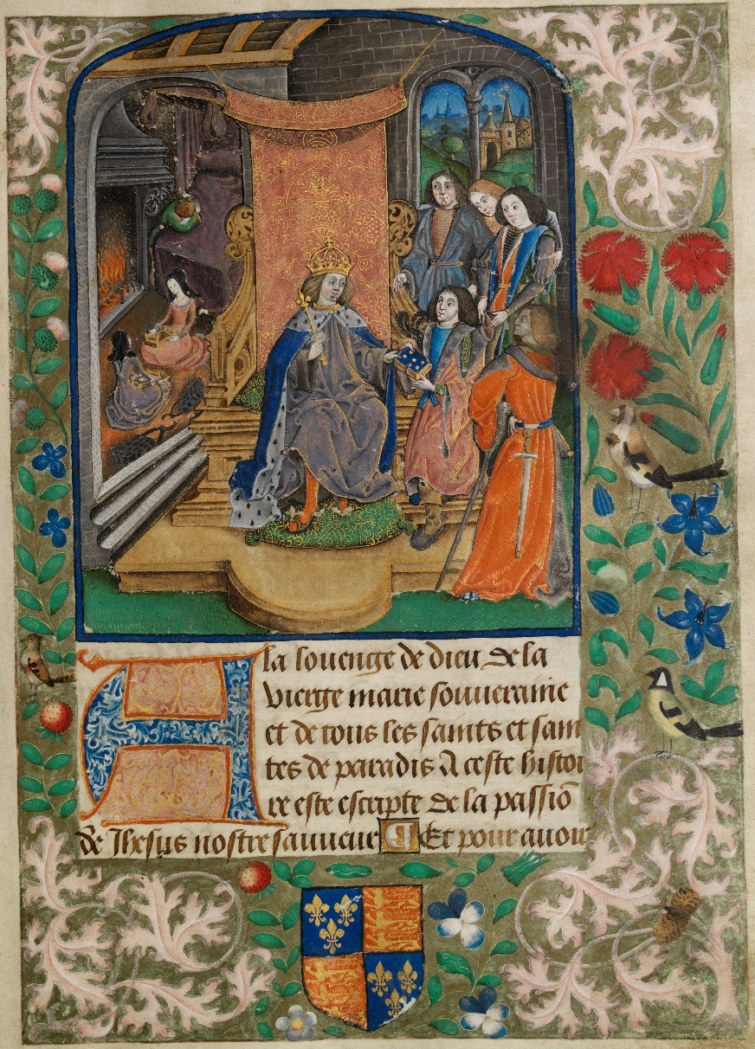

[Figure 1] The Vaux Passional Henry VII (c. 1503).
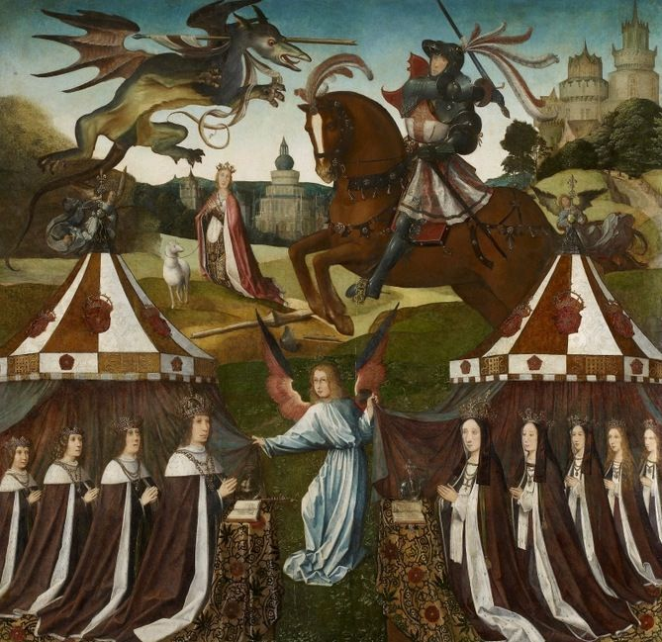

[Figure 2] The Family of Henry VII with Saint George and the Dragon (c. 1503 – 1509).

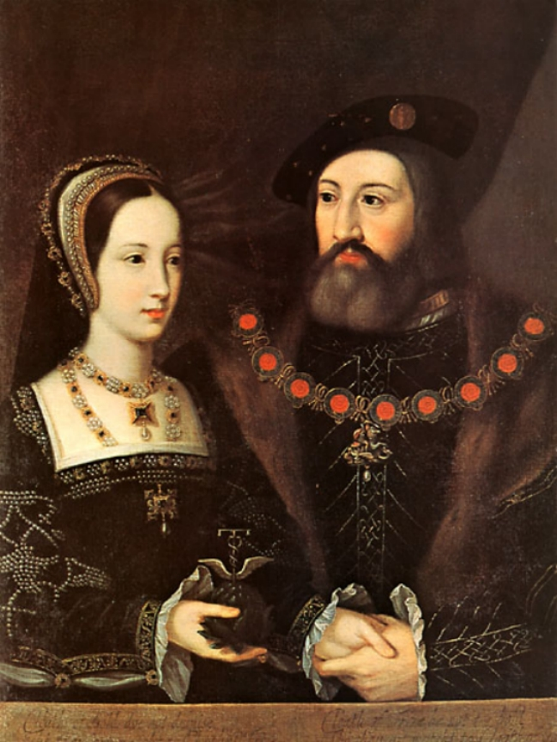
[Figure 3] The Portrait of Mary Tudor and Charles Brandon (c. 1516).

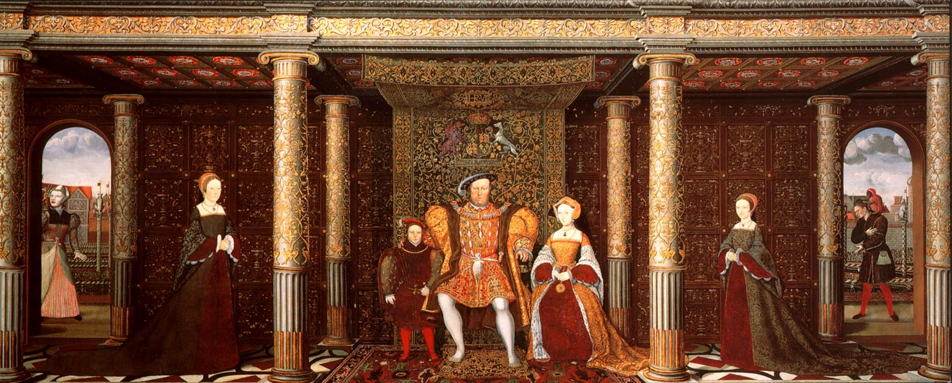

[Figure 4] The Family of Henry VIII (c. 1545).

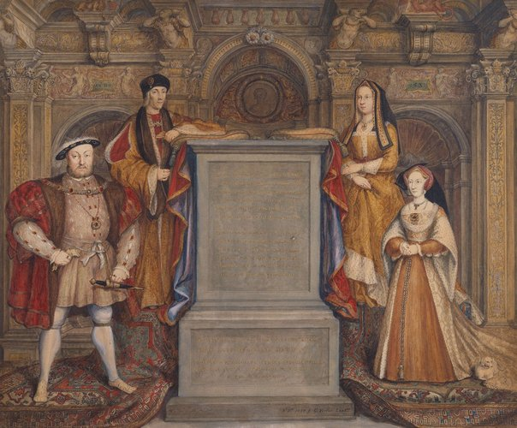

[Figure 5] The Whitehall Mural (c. 1737).

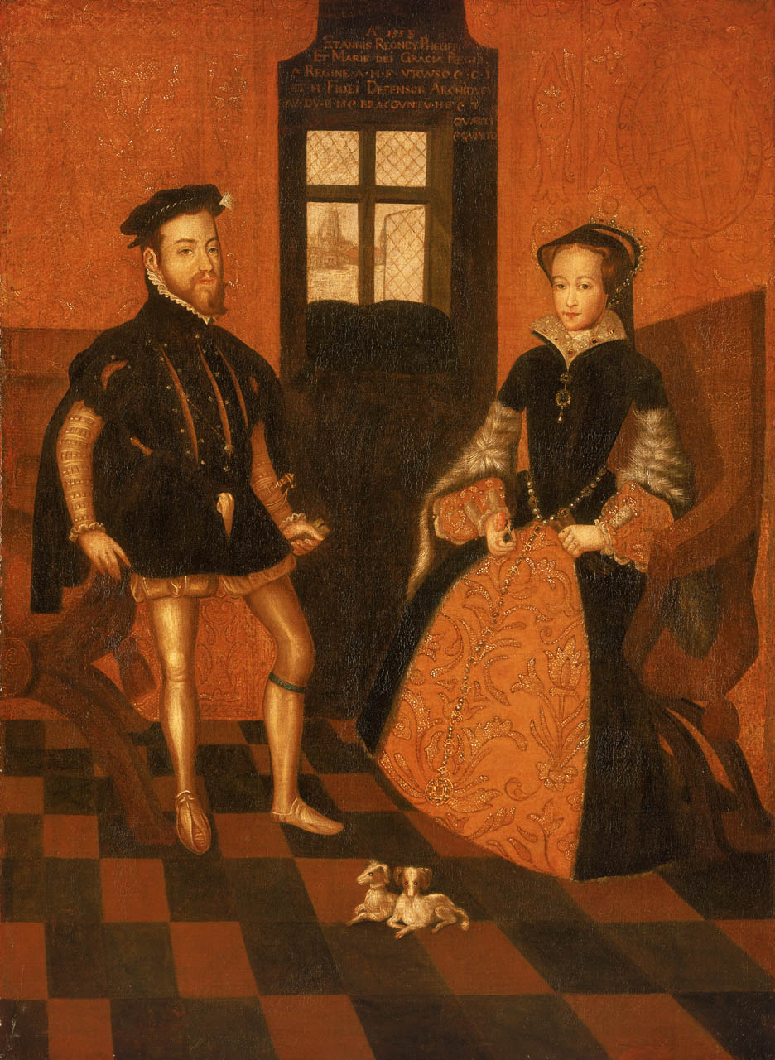
[Figure 6] Mary I of England, 1516-58 and Philip II of Spain, 1527-98 (c. 1558).

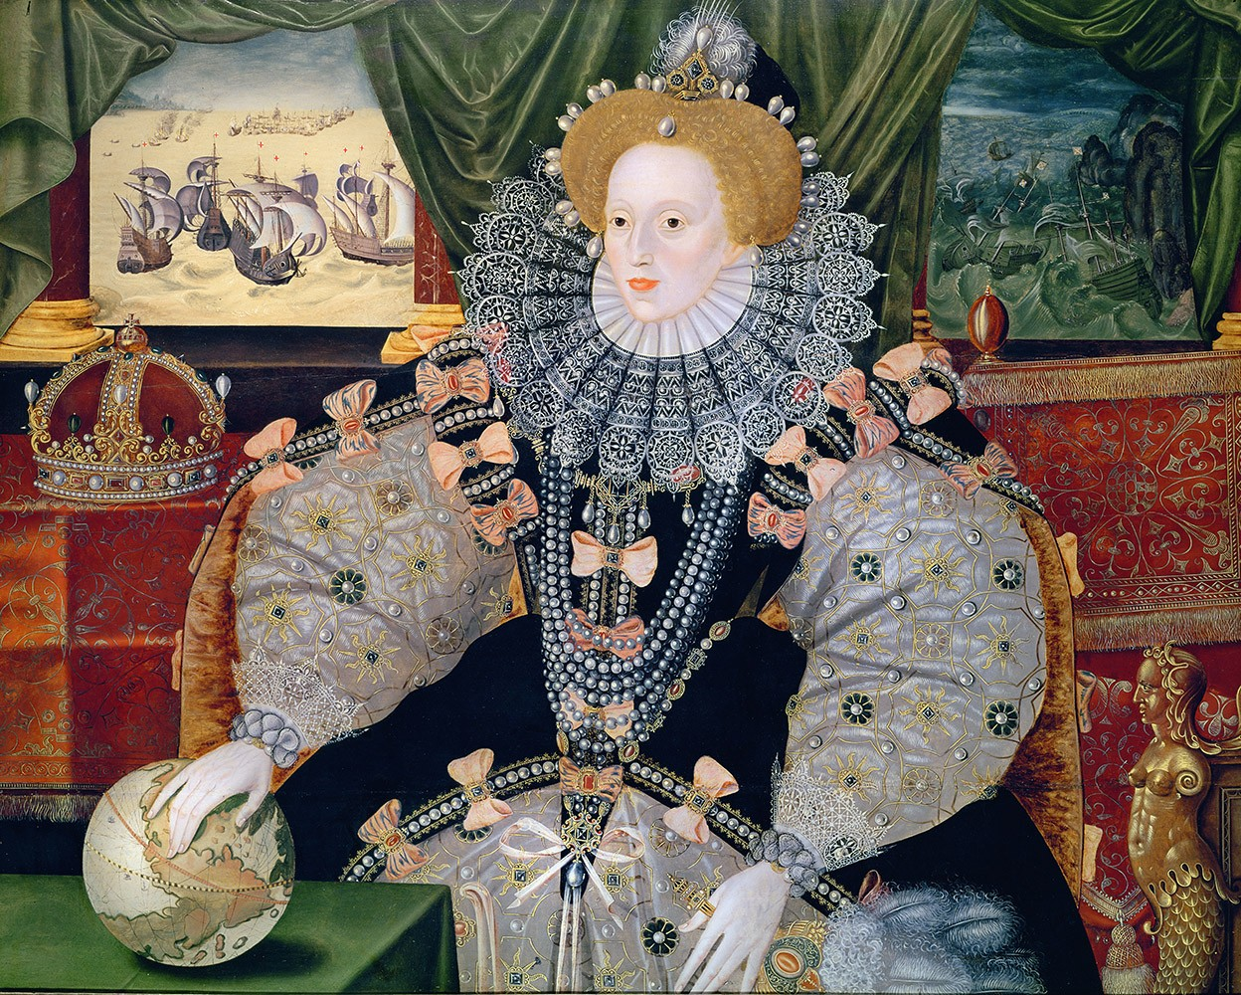

[Figure 7] The Armada Portrait (c. 1588).

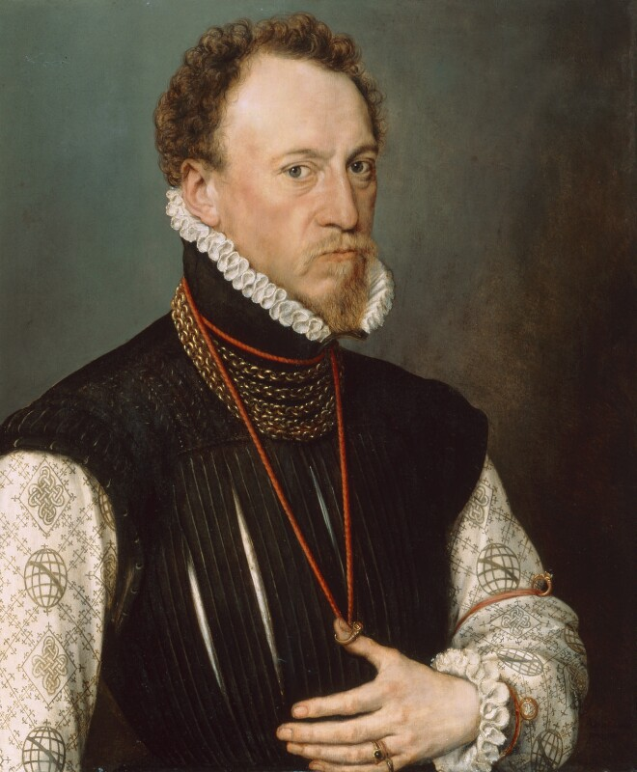
[Figure 8] Portrait of Sir Henry Lee (1568).

D. Cressy, Birth, Marriage, and Death: Ritual, Religion, and the Life-Cycle in Tudor and Stuart England. (Oxford: Oxford University Press, 1997), p. 235.
A. Plowden, Tudor Women: Queens and Commoners. 2nd ed. (London: Weidenfeld & Nicholson, 2002), p. 23.
D. Cressy, Birth, Marriage, and Death: Ritual, Religion, and the Life-Cycle in Tudor and Stuart England, p. 287.
J. Guy, The Oxford History of Britain: The Tudors and Stuarts. Vol. III. (Oxford: Oxford University Press, 1984).
T. Borman, Elizabeth’s Women, The Hidden Story of the Virgin Queen. (London: Vintage, 2010).
J. Guy, The Oxford History of Britain: The Tudors and Stuarts. Vol. III. (Oxford: Oxford University Press, 1984), p. 9.
D. MacCulloch, The Oxford Illustrated History of Tudor and Stuart Britain, ed. J. Morill. (Oxford: Oxford University Press, 1996), p. 38.
J. Guy, The Oxford History of Britain: The Tudors and Stuarts. Vol. III., p. 2.
Ibid., p. 10.
Ibid., p. 12.
J. Guy, The Oxford History of Britain: The Tudors and Stuarts. Vol. III., p. 10.
Henry VII, The Will of Henry VII, ed. S. Bryson. (Gloucestershire: Amberley Publishing, 2018), pp. 38 – 40.
G. A. Bergenroth, Calendar of Letters, Dispatches, and State Papers relating to the Negotiations between England and Spain, ed. D. O’Sullivan. (Essex: Longman, 1993).
J. Guy, The Oxford History of Britain: The Tudors and Stuarts. Vol. III., p. 13.
Ibid., p. 19.
A. L. Erickson, The Oxford Illustrated History of Tudor and Stuart Britain, ed. J. Morill. (Oxford: Oxford University Press, 1996), p. 98.
J. Guy, The Oxford History of Britain: The Tudors and Stuarts. Vol. III. (Oxford: Oxford University Press, 1984), p. 12.
D. Cressy, Birth, Marriage, and Death: Ritual, Religion, and the Life-Cycle in Tudor and Stuart England. (Oxford: Oxford University Press, 1997), p. 237.
George Cavendish, The Life of Cardinal Wolsey, c. 1520, ed. D. O’Sullivan. (Essex: Longman, 1993).
George Cavendish, The Life of Cardinal Wolsey, c. 1520, ed. D. O’Sullivan. (Essex: Longman, 1993).
Anne Boleyn, Letter to Henry VIII, 1527, ed. S. Smith. (London: Scepter Publishers, 2017).
D. MacCulloch, The Oxford Illustrated History of Tudor and Stuart Britain, ed. J. Morill. (Oxford: Oxford University Press, 1996), pp. 38 – 40.
Ibid., p. 41.
A. L. Erickson, The Oxford Illustrated History of Tudor and Stuart Britain, ed. J. Morill. p. 41.
M. Perry, The Sisters of Henry VIII: The Tumultuous Lives of Margaret of Scotland and Mary of France. (New York: St Martin’s Press, 1999), p. 196.
J. Guy, The Oxford History of Britain: The Tudors and Stuarts. Vol. III. (Oxford: Oxford University Press, 1984), p. 15.
M. Perry, The Sisters of Henry VIII: The Tumultuous Lives of Margaret of Scotland and Mary of France., p. 202 – 205.
D. Loades, Mary Rose: Tudor Princess, Queen of France, the life of Henry VIII’s sister. (Gloucestershire: Amberley Publishing, 2012), p. 52.
Thomas Wolsey, Letters and Papers, II, ed. D. Loades. (Gloucestershire: Amberley Publishing, 2012), p. 158.
It is worth noting that Margaret never set foot again in England after this point, and that the last time she had been in England was 1503. It is without a doubt that marriage was the main motivating factor behind this journey.
Mary Tudor Brandon, The Letters of Mary, Queen of France, ed. S. Bryson. (Gloucestershire: Amberley Publishing, 2018).
Margaret’s granddaughter was Mary Stuart, Queen of Scots through her son James V. Mary’s granddaughter was Lady Jane Grey through her daughter Frances Brandon-Grey.
D. Loades, Mary Tudor. (Gloucestershire: Amberley Publishing, 2012), p. 72.
J. Ridley, A Brief History of the Tudor Age. (London: Robinson, 1998), p. 53.
D. Loades, Jane Seymour, Henry VIII’s Favourite Wife. (Gloucestershire: Amberley Publishing, 2013), p. 8.
J. Guy, The Oxford History of Britain: The Tudors and Stuarts. Vol. III. (Oxford: Oxford University Press, 1984), p. 10.
J. Guy, The Oxford History of Britain: The Tudors and Stuarts, p. 24.
D. Cressy, Birth, Marriage, and Death: Ritual, Religion, and the Life-Cycle in Tudor and Stuart England. (Oxford: Oxford University Press, 1997), p. 235.
W. T. MacCaffrey, Queen Elizabeth and the Making of Policy, 1572 – 1588. (New Jersey: Princetown University Press, 1981), p. 157.
J. Guy, The Oxford History of Britain: The Tudors and Stuarts, p. 32.
James Gardiner, 30th September 1534, Letters and Papers, Foreign and Domestic, of the Reign of Henry VIII, ed. D. O’Sullivan. (Essex: Longman, 1993).
Robert Parkyn, 27th September 1553, Rejoicing at Mary’s accession, 1553, ed. A. G. Dickens. (London: English Historical Review: 1947).
D. O’Sullivan, Tudor England, 1485 – 1603. (Essex: Longman, 1993), p. 1.
Simon Renard, Further Despatch to Antoine de Perronet, 5 October 1553, ed. D. Loades. (London: Sutton Publishing, 2002).
Simon Renard, Further Despatch to Antoine de Perronet, 5 October 1553, ed. D. Loades. (London: Sutton Publishing, 2002).
A. Fletcher, Tudor Rebellions. 3rd ed. (London: Longman, 1983), p. 74.
Ibid., p. 77.
A. Fletcher, Tudor Rebellions. 3rd ed. (Longman, 1983), p. 76.
Ibid., p. 77.
W. T. MacCaffrey, Queen Elizabeth and the Making of Policy, 1572 – 1588. (New Jersey: Princetown University Press, 1981), p. 158.
Ibid., p. 505.
Simon Renard, Letter to Antoine de Perronet, 9 September 1553, ed. D. Loades. (London: Sutton Publishing, 2002).
Ibid.
Ibid.
John Gough Nichols, The Chronicle of Queen Jane, and of Two Years of Queen Mary, and Especially of the Rebellion of Sir Thomas Wyatt, ed. D. Loades. (London: Sutton Publishing, 2002).
John Proctor, The Historie of Wyattes Rebellion 1554, ed. D. O’Sullivan. (Essex: Longman, 1993).
A. Fletcher, Tudor Rebellions. 3rd ed., p. 77.
Foxe, Actes and Monuments, London, 1583, ed. D. Loades. (London, Sutton Publishing, 2002).
D. Loades, The Chronicles of the Tudor Queens. (London: Sutton Publishing, 2002), p. 62.
D. O’Sullivan, Tudor England, 1485 – 1603., p. 2.
Cuthbert Sharp, Memorials of the Rebellion of 1569, ed. D. O’Sullivan. (Essex: Longman, 1993).
Bernardino de Mendoza, Despatch to Phillip II of Spain, 25 April 1582, ed. D. O’Sullivan. (Essex: Longman, 1993).
Robert Naunton, Fragmenta Regalia, 1633, ed. D. O’Sullivan. (Essex: Longman, 1993).
Ibid.
W. T. MacCaffrey, Queen Elizabeth and the Making of Policy, 1572 – 1588., p. 507.
Ibid., p. 505.
Ibid., p. 507.
J. Guy, The Oxford History of Britain: The Tudors and Stuarts, p. 70.
F. Yates, The Cult of Elizabeth: Elizabethan Portraiture and Pageantry. (London: Strong Publishing, 1977), p. 35.
William Shakespeare, Julius Caesar, Act II, Scene I, c. 1599, ed. D. O’Sullivan. (Essex: Longman, 1993). In this play, Portia appears as a character who challenges stereotypical Tudor views of marriage and the role of wives, appearing to model Portia on Queen Elizabeth.
C. MacLeod, Tudor Portraits. (London: National Portrait Gallery Publications, 1996), pp. 3 – 4.
Ibid., pp. 2 – 4.
T. Cooper, Tudor and Jacobean Portraits. (London: National Portrait Gallery Publications, 2008), p. 9
The Vaux Passional. Unknown artist, Vaux Passional Henry VII [Illumination on parchment] (c. 1503) https://www.llyfrgell.cymru/index.php?id=5926 (Accessed 10 January 2020).
National Library of Wales, The Vaux Passional: Peniarth MS 482D. Available online at: https://www.library.wales/index.php?id=1 [accessed 20 April 2020].
National Portrait Gallery, Sir Thomas More, his father, his household and his descendants. Available online at: https://www.npg.org.uk/ [accessed 20 April 2020].
The Family of Henry VII with Saint George and the Dragon. Flemish School, The Family of Henry VII with St George and the Dragon [Oil on panel] (c.1503-1509) https://www.rct.uk/collection/401228/the-family-of-henry-vii-with-st-george-and-the-dragon (Accessed 10 October 2019).
A. Crawford, The Yorkists: The History of a Dynasty (London: A&C Black, 2008), p. 151.
Royal Collections Trust, The Family of Henry VII with Saint George and the Dragon. Available online at: https://www.rct.uk/collection/401228/the-family-of-henry-vii-with-st-george-and-the-dragon [Accessed 20 April 2020].
The Marriage Portrait of Mary Tudor and Charles Brandon. Jan Mabuse, Portrait of Mary Tudor and Charles Brandon [Oil on canvas] (c.1516) https://upload.wikimedia.org/wikipedia/commons/d/d0/Mary_Tudor_and_Charles_Brandon_original.jpg (Accessed 10 October 2019).
R. Hoi, New Impressions on the Brandon Wedding Portrait, Tudor Faces. Available online at: https://tudorfaces.blogspot.com/2013/07/the-brandon-wedding-portrait-some-new.html. [Accessed 20 April 2020].
Mary’s first marriage was to Louis XII of France.
C. Fisher, The Queen and the artichoke: A study of the portraits of Mary Tudor and Charles Brandon, The British Art Journal, Vol. III, No. 2. Available online at: https://www.jstor.org/stable/41614374?seq=1#metadata_info_tab_contents. [Accessed 1 May 2020].
The Marriage Portrait of Mary Tudor and Charles Brandon. Jan Mabuse, Portrait of Mary Tudor and Charles Brandon [Oil on canvas] (c.1516) https://upload.wikimedia.org/wikipedia/commons/d/d0/Mary_Tudor_and_Charles_Brandon_original.jpg (Accessed 10 October 2019). The Cloth of Gold represents Mary, the Cloth of Frieze represents Charles.
The Family of Henry VIII. Unknown artist, possibly Hans Holbein the Younger, The Family of Henry VIII [Oil on canvas] (c. 1545) https://www.rct.uk/collection/405796/the-family-of-henry-viii (Accessed 10 October 2019).
The Whitehall Mural. George Vertue, after Hans Holbein the Younger, The Whitehall Mural [Watercolour] (c. 1737) https://www.rct.uk/collection/themes/trails/the-art-of-monarchy/the-whitehall-mural (Accessed 10 October 2019).
Luminarium. Portraits of Henry VIII: The Whitehall Mural. Available online at: http://www.luminarium.org/renlit/henry8face2.htm. [Accessed 1 May 2020].
Mary I of England, 1516-58 and Philip II of Spain, 1527-98. Lucas de Heere, Copy of Mary I of England, 1516-58 and Philip II of Spain, 1527-98 [Oil and canvas] (c. 1558) https://collections.rmg.co.uk/collections/objects/14425.html (Accessed 10 October 2019).
Elizabeth I Armada Portrait. Unknown English artist, Elizabeth I Armada Portrait [Oil on panel] (c. 1588) https://collectionimages.npg.org.uk/large/mw02077/Queen-Elizabeth-I.jpg (Accessed 10 October 2019).
T. Cooper, Tudor and Jacobean Portraits. (London: National Portrait Gallery Publications, 2008), p. 7.
Portrait of Sir Henry Lee. Antonio Moro, Sir Henry Lee [Oil on panel] 1568 https://www.npg.org.uk/collections/search/portrait/mw03838/Sir-Henry-Lee (Accessed 17 January 2020).
C. MacLeod, Tudor Portraits. (London: National Portrait Gallery Publications, 1996), p. 24.
A. Fletcher, Tudor Rebellions. 3rd ed. (London: Longman, 1983), p. 81.

