Financial Management
Comparison of Mandarin Oriental Hotel Group and Premier Inn Report
BMIH5007
Kobirul Islam
2130690
Tristan Hawkins
2,044

Table of Contents
Introduction 1
Appraises of Mandarin Oriental Hotel Group and Premier Inn in financial management practices and strategies 1
Total revenue comparison 1
Factors that drive revenue growth or decline 3
Market position comparison 4
Market share 4
Customer demographics 4
Brand perception 5
Growth potentials 6
Expansion strategies 6
Market opportunities 6
Potential barriers to growth 7
Financial commitment to CSR 7
Recommendations 8
Conclusion 9
References 10

Introduction
The report will present information comparing two different large hotel companies which are Premier Inn Hotel and Mandarin Oriental Hotel Group. The report will compare these two companies based on various factors which will help companies to understand areas where the companies can make improvements. The report will first present a comparison of the total revenue of the two companies and the market position of the two companies. It will later present information about the growth potential of the two companies and it will also present a comparison of the CSR practices of the two companies. Finally, the report will illustrate information about the various types of recommendations for both companies to gain success.

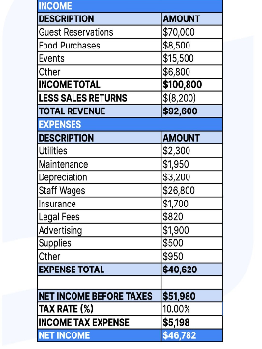
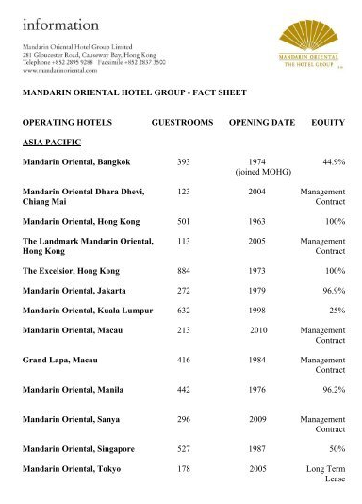
Appraises of Mandarin Oriental Hotel Group and Premier Inn in financial management practices and strategies
Figure 01: Comparison of the income statement of Premier Inn Hotel and Mandarin Oriental Hotel Group.
Source: (Williamson, 2020).

Total revenue comparison
Sources of revenue: Both Mandarin Oriental Hotel Group and Premier Inn provide hotel room services to the customers and it is the main source of revenue for both companies. Mandarin Oriental Hotel Group has many hotels all around the world and they provide hotel room service in different price ranges which helps the company to generate revenue and the same goes for Premier Inn hotels (Tosun, 2021). The current amount of Mandarin Oriental Hotel Group is approximately £130 Million and the amount of revenue of Premier Inn is £2.62 billion. Therefore, Premier Inn has a large amount of revenue compared to Mandarin Oriental Hotel Group.
Revenue trends: The revenue sources of Premier Inn hotels are:
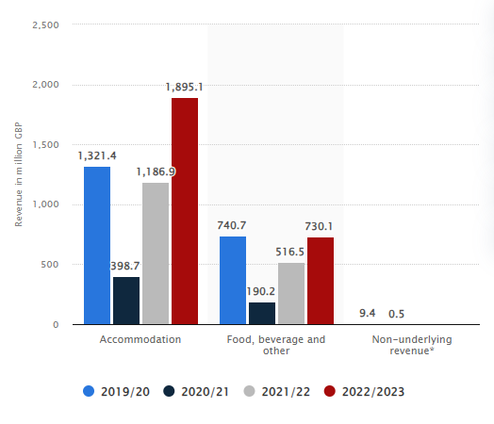
Figure 02: Revenue Trends of Premier Inn.
Source: (Simon, 2022).
Premier Inn has faced difficulties in generating revenue due to the negative impact of the COVID-19 pandemic. The revenue generation of Premier Inn hotel was high in 2019 but it declined in 2020. But as the world overcome the negative impact of COVID-19 through vaccination and medical advancement, Premier Inn Hotel has gained increased sale and generated more revenue (Rosen, 2021).
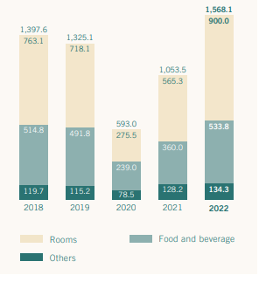
Figure 03: Revenue trends of Mandarin Oriental Hotel Group.
Source: (Nelson, 2023).
The revenue trends of Mandarin Oriental Hotel Group also show that the company used to have a high level of sales in 2018 and 2019 which increased the level of revenue. However, the revenue generated has decreased due to the impact of the COVID-19 pandemic which also decreased the sales of Mandarin Oriental Hotel Group which impacted negatively (Nelson, 2022). But as the situation got better, Mandarin Oriental Hotel Group was able to generate more revenue by providing services to the customers which the company did in the previous times.

Factors that drive revenue growth or decline
Factors behind revenue growth: The increasing demand for tourism has increased the growth of Mandarin Oriental Hotel Group as well as Marriot Hotel. Due to globalization and enhanced relationships between countries, business tides have gotten strong which has increased the demand for hotel business. Also, visiting countries to enjoy vacations has become a trend which has increased the demand and business of the tourism industry impacting positively on Mandarin Oriental Hotel Group as well as on Premier Inn (Hertog, 2021).
Factors behind revenue decline: The impact of COVID-19 is the main reason for falling business in the tourism industry and it has declined the revenue of all hotel businesses. As mentioned above, due to the impact of COVID-19, Mandarin Oriental Hotel Group as well as Premier Inn has faced a decline in revenue because countries provided obligations in leaving countries and socialization.

Market position comparison
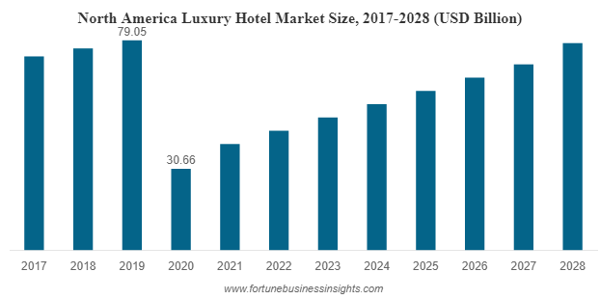
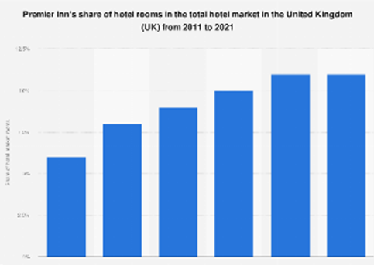
Both Premier Inn Hotel and Mandarin Oriental Hotel Group have different types of strategies to target customers and collect further market share. Some of the approaches for market position comparison are presented below:
Figure 04: Market share of Premier Inn (1st) and Mandarin Oriental Hotel Group (2nd).
Source: (Frey and George, 2020).

Market share
The market share of Premier Inn Hotel Limited has increased with time due to the company’s new policy of customer attraction. The company has offered various types of services and offers to attract customers (Darby and Karni, 2019). After the pandemic, the company has decided to provide free WIFI services, welcome drinks, compensatory snacks and so on which has increased customer attraction and helped the company to obtain more market share. The company had an 18% market share in the global tourism business which has increased by 20%.
On the other hand, Mandarin Oriental Hotel Group has faced a decline in market share due to its high price range. During the COVID-19 pandemic, hotel companies offered lower prices but Mandarin Oriental Hotel Group did not provide any type of offers which has decreased the market share from 12% to 7% (Becker, 2023). But the company has taken approaches to offer great deals which is helping the company to increase the market share.

Customer demographics
Mandarin Oriental Hotel Group: Mandarin Oriental Hotel Group uses demographic segmentation as well as behavioural segmentation to segment and target the customers. The company targets tourist from the age of 21 to 60 and the company targets customer who has a moderate and high level of income (Balassa, 2020). As the company offers luxurious hotel services, the company targets customers who can afford their services.
Premier Inn: To segment and target customers, Premier Inn hotel uses demographic segmentation as well as Psychographic segmentation. The company targets customers who want to take business tours as well as vacation tours and the company has established their hotels all around the world to obtain the customers. Customers who want to enjoy a good hotel service at an affordable price are targeted by Premier Inn.

Brand perception
For the brand perception of Premier Inn Hotel and Mandarin Oriental Hotel Group, a perception mapping tool is used below:
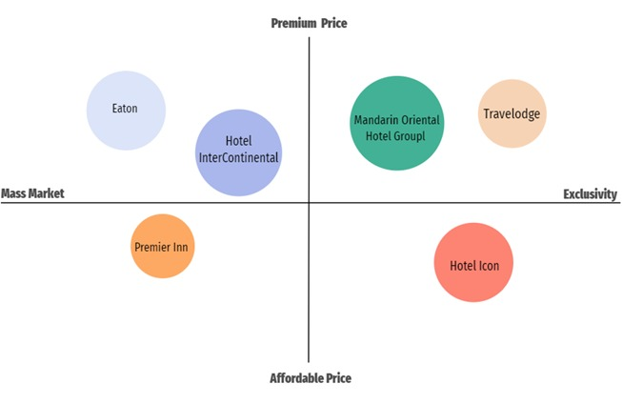
Figure 05: Market perception map of the hotel industry.
Source: (Ashley and Roe, 2022).
Based on the market perception map, Premier Inn offers its service to the customers at an affordable price and the company also focuses on the mass market. It means that Premier Inn Hotel tries its best to obtain as much as market share possible to obtain market dominance. Therefore, Premier Inn Hotel applied this cost-saving approach which has helped the company to gain more market share. On the other hand, Mandarin Oriental Hotel Group operates business at a premium price and the company offers exclusive services to the customers (Archer, 2022). To offer exclusive service to the customers, Mandarin Oriental Hotel Group needs to purchase resource and material which are high in quality and increases the operating cost of the company. Therefore, the company has a high price range compared to other companies.

Growth potentials
The following information is given to examine the topic growth potentials of both companies. Premier Inn as well as Mandarin Oriental Hotel Group operate within distinct sectors of the hospitality business, each possessing intriguing prospects for expansion.

Expansion strategies
Premier Inn hotel
International expansion: One of the expansion strategies that companies often consider is international expansion. Premier Inn has placed significant emphasis on its global expansion efforts, with particular attention directed towards regions such as the Middle East, Europe, as well as Southeast Asia (Alchian, 2022). The continuation of this strategy can be achieved through the identification of major markets that exhibit a burgeoning need for economical and high-quality accommodations.
Technology utilization: The utilization of technology to optimize customer experience as well as streamline operational processes is referred to as digital innovation. This includes the allocation of resources towards the development of mobile applications that prioritize user-friendliness, the implementation of digital check-in systems, and the provision of tailored services.
Mandarin Oriental Hotel Group
Dominance in the luxury segment: One potential expansion strategy involves the pursuit of dominance in the luxury segment. This entails leveraging the increasing demand for luxury travel by expanding operations in prominent premium destinations across the globe. (Frey and George, 2020)
Diversification: The practice of providing a range of offerings beyond traditional lodging, including distinctive experiences and services. This may entail establishing alliances with prestigious businesses or engaging in special event collaborations.

Market opportunities
Premier Inn hotel
Budget travel segment: One potential market opportunity is the budget travel segment. The persistent need for affordable lodging presents an opportunity for Premier Inn to strategically cater to budget-conscious individuals seeking cost-effective accommodations (Nelson, 2023).
Enhancing Business Travel Services: The implementation of additional amenities tailored to the needs of business travellers, such as the provision of conference facilities and the establishment of corporate partnerships, has the potential to access a highly profitable market segment.
Mandarin Oriental Hotel Group
Emerging Luxury Areas: The identification and entry into emerging areas are characterized by an increasing demand for luxury accommodations.
Integration of wellness: The integration of wellness amenities and experience travel packages to accommodate the changing expectations of affluent tourists (Rosen, 2021).

Potential barriers to growth
Premier Inn hotel
Competition: One potential barrier that may impede progress is competition. In the context of the budget hotel segment, the presence of fierce competition necessitates the implementation of strategic differentiation to establish a distinct and prominent position.
Obstacles in Regulatory Compliance: International expansion might provide obstacles due to the varying legislation across different countries (Simon, 2022).
Mandarin Oriental Hotel Group
Economic downturn: One potential barrier that could hinder progress is an economic downturn. The luxury hospitality sector is known to exhibit vulnerability during periods of economic depression, whereby a recessionary environment may exert an influence on the high-end travel industry.
High level of cost: The maintenance of the elevated standards typically associated with luxury hotels incurs significant operational costs, which might potentially affect the overall profitability of the establishment (Williamson, 2020).

Financial commitment to CSR
For the financial commitment to CSR or corporate social responsibilities, both companies apply the triple bottom line approach to meet the sustainability practice, ethical business practice as well and community engagement of CSR which is presented below:

Figure 06: Tripple bottom line of CSR approach.
Source: (Ashley and Roe, 2022).
People: For community engagement as well as to maintain business practice, both companies largely focus on their stakeholders. Both Premier Inn Hotel and Mandarin Oriental Hotel Group pay wages and salaries to their workers, pay dividends to their shareholders and take special care of their customers (Becker, 2023). Also, a small portion of the profit of both companies is given to poor people and hospitals which meet their CSR duties and enhance the brand image of both companies.
Profit: The main target of Premier Inn Hotel and Mandarin Oriental Hotel Group is gaining profit because both are profitable companies and they will be able to operate their CSR actions if they can obtain a good profit ratio. Premier Inn Hotel has a high profit ratio due to targeting all kinds of customers and Mandarin Oriental Hotel Group has a low ratio of profit due to targeting a small segment of customers. However, both companies generate enough profit that meet the CSR duties (Darby and Karni, 2019).
Planet: Premier Inn provides more care to the environment and the globe to increase its brand image and to fulfil CSR activities. The company offers charity to various organizations and the company also motivates the workers and the customers for recycling to help to keep the environment clean (Hertog, 2021). On the other hand, Mandarin Oriental Hotel Group only provides aid to various organizations and takes approaches for environmental response.

Recommendations
- To overcome the financial conditions, both Mandarin Oriental Hotel Group and Premier Inn should take financial leverage from the government as loans. It will help both companies to decrease the loss that the companies have made in the COVID-19 pandemic.
- Like Premier Inn Hotel, Mandarin Oriental Hotel Group should also target customers of every earning level. It will help the company to gain more customers and market share (Nelson, 2023).
- Using technologies and social media marketing can help both Mandarin Oriental Hotel Group and Premier Inn Hotels to gain success in the business.

Conclusion
Both organizations must possess the ability to adjust and respond to the ever-changing dynamics of the market and the evolving preferences of consumers. The growth narratives of these entities are expected to be significantly influenced by the implementation of effective marketing strategies, advancements in technology, and the formation of strategic alliances.

References
Alchian, A.A. (2022). Uncertainty, Evolution, and Economic Theory. Journal of Political Economy, 58(3), pp.211–221.
Archer, B. (2022). Importance of tourism for the economy of Bermuda. Annals of Tourism Research, 22(4), pp.918–930.
Ashley, C. and Roe, D. (2022). Making tourism work for the poor: Strategies and challenges. Development Southern Africa, 19(1), pp.61–82.
Balassa, B. (2020). The Purchasing-Power Parity Doctrine: A Reappraisal. Journal of Political Economy, 72(6), pp.584–596.
Becker, G.S. (2023). Crime and Punishment: An Economic Approach. Journal of Political Economy, 76(2), pp.169–217.
Darby, M.R. and Karni, E. (2019). Free Competition and the Optimal Amount of Fraud. The Journal of Law and Economics, 16(1), pp.67–88.
Frey, N. and George, R. (2020). Responsible tourism management: The missing link between business owners’ attitudes and behaviour in the tourism industry. Tourism Management, 31(5), pp.621–628.
Hertog, P. den (2021). Knowledge-Intensive Business Services as Co-Producers of Innovation. International Journal of Innovation Management, 4(4), pp.491–528.
Nelson, P. (2022). Information and Consumer Behavior. Journal of Political Economy, 78(2), pp.311–329.
Nelson, P. (2023). Advertising as Information. Journal of Political Economy, 82(4), pp.729–754.
Rosen, S. (2021). Hedonic Prices and Implicit Markets: Product Differentiation in Pure Competition. Journal of Political Economy, 82(1), pp.34–55.
Simon, H.A. (2022). Bounded Rationality and Organizational Learning. Organization Science, 2(1), pp.125–134.
Tosun, C. (2021). Roots of unsustainable tourism development at the local level. Tourism Management, 19(6), pp.595–610.
Williamson, O.E. (2020). Transaction-Cost Economics: The Governance of Contractual Relations. The Journal of Law and Economics, 22(2), pp.233–261.

