Class task: Questions to be added to excel.
Topic:
- Use of self-service ordering kiosks at McDonald’s.
Aim:
- To understand how customers feel about using the self-service kiosks to order and why they choose them instead of the counter.
Objectives:
- To find out to whet extent customers like the process
- To understand if customers prefer machines over ordering with staff.
Population:
- Those who have used the kiosk to order at a McDonalds site over a set period.
Sampling method:
- Probability sampling - Cluster Sampling → all or randomly selected individuals within a naturally present grouping ‘cluster’ e.g. geographical area that is assumed to be representative of the sampling population
Conceptual Framework:
- Based on the TAM model
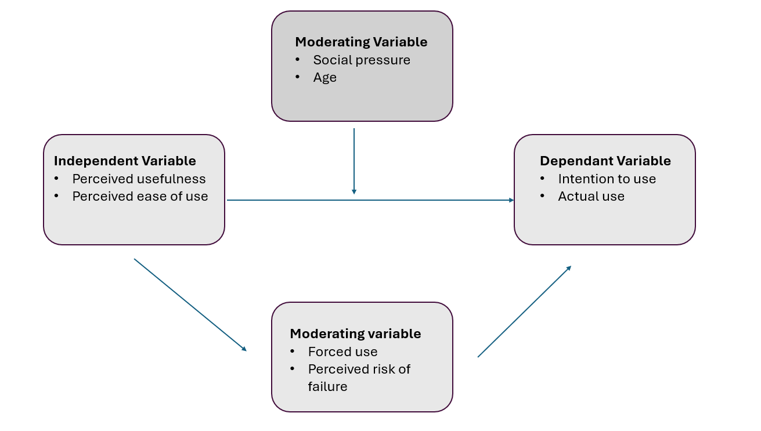
Questionnaire questions
Categorical questions:
- Age range – need to add ranges
- Gender – need to add options
- Do you use the self-service kiosk every visit – yes / no?
- Was there an alternative option for your visit today – yes / no / not sure?

Ordinal questions:
- How often do you visit McDonalds – need to add range options

Interval questions:
- How effortless was the kiosk to use? – Add response options x 5
- How satisfied were you with the experience using the kiosk today? – Add response options x 5

Ratio Questions:
- On a scale of 1 to 5 how would you rate your preference of using the kiosk over ordering with a member of staff? – Add Likert scale.
- On a scale of 1-5 how would you rate the overall ordering process? – Add Likert scale.
- How many times have you experienced an issue when using the kiosk to order? – add response range options x 5.

