

ACFA7004 Module Research Proposal

The optimization of metasurface structure based on deep learning

by
Li Zhu(2203862)

April 2023

1 INTRODUCTION
Metamaterials is an artificial composite material composed of sub-wavelength structural units. Usually, a group of small scatterers or aperturals are arranged in a regular array over the entire space region to obtain some special electromagnetic properties, such as super transmission, negative refractive index and perfect absorption properties. The surface structure of a metamaterial is named a metamaterial. As an important part of metamaterial nanocomponents, it can efficiently adjust the phase size, polarization Angle and propagation mode of electromagnetic wave in the transmission process and has been widely used in beam control, super resolution imaging, nonlinear optics and other fields. In addition, compared with traditional three-dimensional metamaterials, metasurface can save a lot of computing space and physical resources. Therefore, the design research of metasurface structure has very important practical significance and application value. In the aspect of designing metasurface structures, traditionally commonly used full-wave numerical simulation methods include Finite Element Method (FEM) and Finite difference time domain method (FDTD). However, a large number of modeling, parameter scanning and optimization processes are required in the design process, which requires relatively high human experience, time and computing resources. Especially in the design of complex structures
When, the process of modeling and parameter adjustment will be more complicated, usually occupy a lot of simulation time, and the final design result may be only a local optimal structure. Therefore, to quickly obtain the potential correlation between shape structure and spectral response information is the key to achieve efficient design of metasurface structures. In recent years, with the development of various Deep Learning (DL) models and technologies, many optimization methods or genetic algorithms have become popular in the structural design of various devices. For big data, the exhaustive method of deep learning is much more accurate and fast than the artificial tests one by one. Moreover, once the deep learning model is trained, it can usually give the results according to the expected design requirements soon, much faster than most traditional simulation design methods. All these factors can greatly accelerate the design process of device structure. Deep learning has been widely used in computer digital vision, image signal processing, multimedia and natural language processing. At present, the industry has built a variety of mature deep learning network models, among which the most commonly used model is convolutional neural network. Convolutional neural networks, proposed by Le Cun Y et al in 1998, are characterized by convolutional nuclei that demonstrate great capability in processing data with mesh topologies. The concept of Deep Neural Network (DNN) was first proposed in 2006
Its essence is a perceptron that analyzes the relationship between data features by constructing multiple hidden layers, referring to the operation mode of human brain neural network.

2 LITERATURE REVIEW

2.1 Metasurface

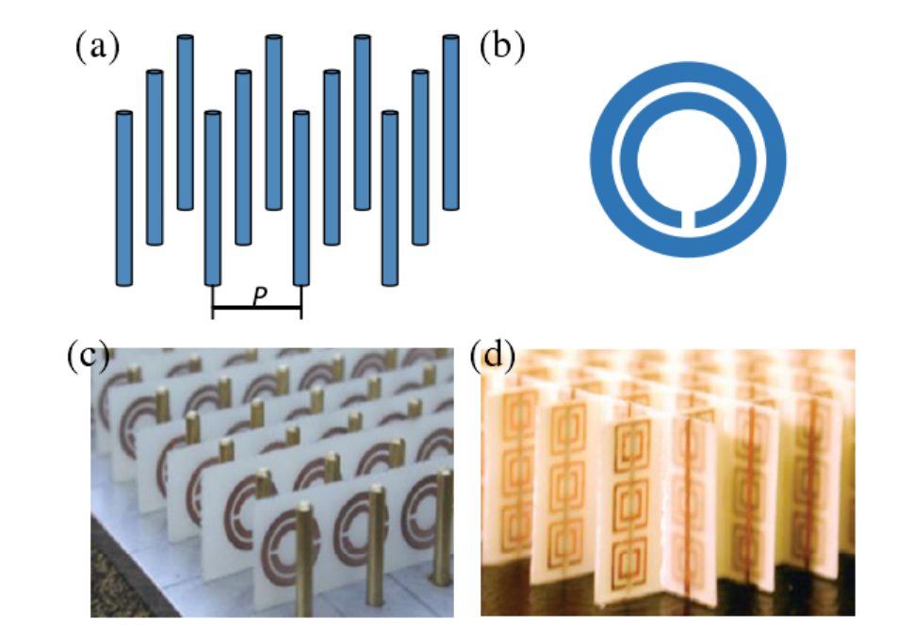
Figure 1
Research on metamaterials began in the 1960s, and there was no concept of metamaterials at first. Instead, they were referred to as negative index materials or left-handed materials. In 1968, Veselago, a theoretical physicist in the former Soviet Union, analyzed the propagation of electromagnetic waves in media with negative permittivity and permeability by equations, and elaborated the electromagnetic properties when propagating in such materials. He pointed out that the direction of the group velocity of electromagnetic wave is opposite to the direction of the phase velocity, and that the electric field E, wave vector k and magnetic field H satisfy the left-handed helix rule, which is contrary to the propagation characteristics in the traditional materials with positive dielectric constant and permeability. Therefore, he called this material left-handed, which breaks through people's cognition of traditional dielectric materials^{[1]}. However, this was only a theoretical hypothesis at the time, without any experimental test, and for a long time scientists were unable to find left-handed materials that fit the hypothesis. With the deepening of research and technological development, Professor Pendry from Imperial University London realized a material with negative dielectric constant by adjusting the electromagnetic response of the material with artificial structure in 1996 (Figure 1.2(a))^{[2]}. This discovery is groundbreaking and is the first time in human history that a material with a negative dielectric constant has been found. Then, in 1999, Professor Pendry again obtained artificial materials with negative permeability in a certain frequency band through periodic open resonant rings (Figure 1.2(b))^{[3]}. So far, materials with negative permittivity or negative permeability have been discovered. In 2000, inspired by Professor Pendry, Professor Smith from the University of California combined the above two materials and successfully obtained left-handed materials with negative permittivity and permeability (Figure 1.2(c)(d))^{[4,5]}. Since then, metamaterials have come to life and been developed by leaps and bounds. In 2002, Professor Itoh of the University of California in the United States formed LC through high-pass filter
The transmission line network implements left-handed materials ^{[6]}. In 2003, Luo et al from MIT and Professor Pendry theoretically proved that negative refraction and subwavelength imaging can be achieved through metal photonic crystals^{[7]}. In 2004, Sridhar et al. from Northeastern University proved the negative refraction characteristics of microwaves in metal photonic crystal prisms through experimental data^{[8]}. For the convenience of understanding, the development history of left-handed materials is summarized in chronological order in Table 1.1. It can be seen that the development of left-handed materials was slow at the beginning and began to develop rapidly after entering the 21st century. Later, with the continuous progress of theoretical research and machining technology, a large number of researchers found that more functions could be realized by combining metamaterials with Micro Electro Mechanical Systems (MEMS) through micro-nano machining technology. The research of metamaterials has also developed from microwave band to terahertz, infrared and visible wavelengths^{[9-13]}. The research focus of metamaterials has also changed from obtaining double-negative left-handed materials at the very beginning to studying various metamaterial-based applications, such as metamaterial modulator (FIG. 1.3(a)) ^{[14]}, metamaterial switch (FIG. 1.3(b))^{[15]}. , shadow-body cloak (FIG. 1.3(c))^{[16]}, biological supramolecular (FIG. 1.3(d))^{[17]}, and metamaterial sensor (FIG. 1.3(e) and (f))^{[18-23]} and so on. Among them, metamaterial sensor has the most research vitality due to its broad market and demand, which will be introduced in detail in this paper. The following will introduce the research progress of metamaterial sensor from three aspects: microwave metamaterial sensor, terahertz metamaterial sensor and infrared metamaterial sensor according to the working frequency of metamaterial.

2.2 Deep Learning
Deep Learning As an important new technology in the development of machine learning algorithmTechnique, which draws on the working mode of human brain neurons, through the construction of multiple hidden layers of the feature model, benefitA certain amount of training data and information is used to understand and learn the characteristic relationship contained in these training data.The main structure of deep learning is neural network, and the basic unit of neural network is neuron.figure2.As shown, the earliest prototype of neural network is the perceptron model(perceptron model), also known as a single layer Neural network(monolayer neural network), by computational scientists Rosenblatt in 1958 Put forward in the year, while this is the earliest origin of deep learning.
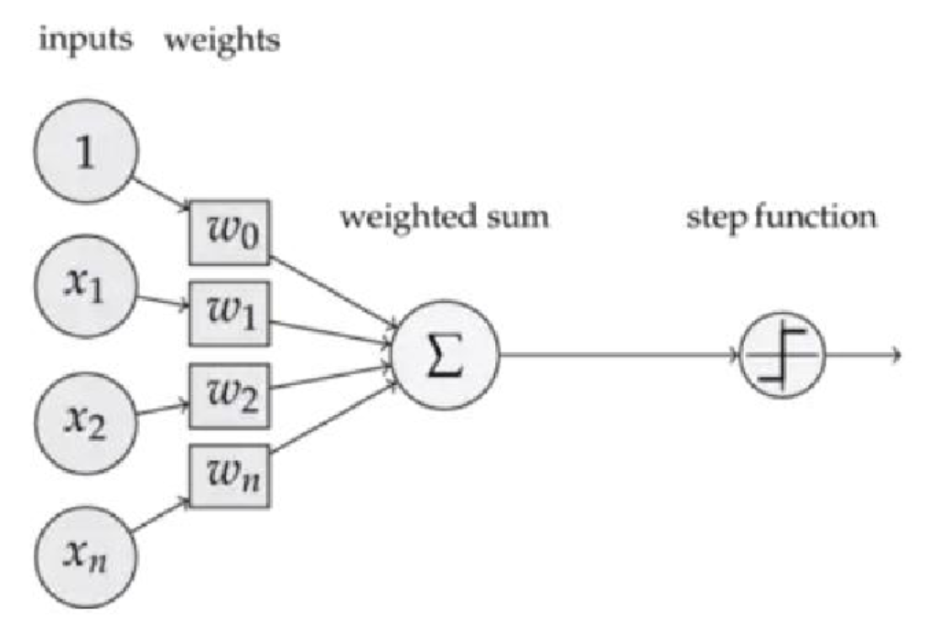
Figure 2

2.3 Deep learning applications to metasurface
The introduction of deep learning into the design process of terahertz metasurface is a relatively new research direction, and many researchers at home and abroad have made exploration in this field. Recently, Professor Liu Yongmin et al. proposed to learn to design chiral metamaterial structures by building a bidirectional neural network structure. As shown in Figure 3, the metamaterial designed by them has two arms with arm lengths L1 and L2, and two dielectric layers of different thicknesses are added to build a fully reflective metamaterial at the bottom of the metal substrate ^{[24]}. For this metamaterial, they constructed a bidirectional neural network structure whose input parameters are several parameters of the structure, such as arm length, cross Angle and medium thickness, while the reflection coefficient, representing the optical response, serves as the output. The forward network constructed by this method has the ability to predict the spectral response corresponding to different structural parameters, while the reverse network can design appropriate structural parameters according to the required spectral response.
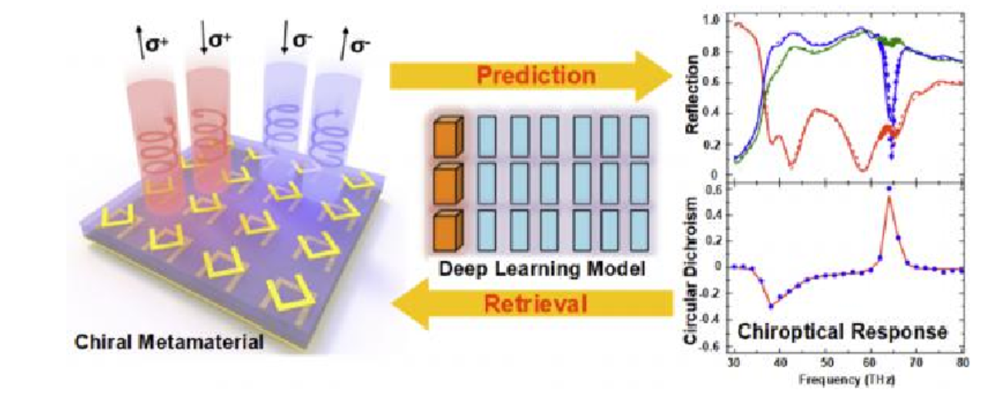
Figure 3

Christian C.Nadell et al. from Duke University accelerated the design of all-medium metasurface by constructing neural networks ^{[25]}. They designed a silicon cylinder, and found through pre-simulation that silicon cylinders with different radii and heights can produce different optical responses. To obtain the expected optical responses, a lot of structural design and simulation work needs to be repeated from conventional methods. Therefore, the researchers chose to construct a deep neural network to learn the relationship between the structure parameters of the silicon cylinder and its spectral response. They took the radius, height, radius period ratio and height period ratio of the silicon cylinder as the input, and the transmittance spectrum representing the spectral response as the output. Each set of data is composed of the structural parameters of four silicon cylinders within a period. The network firstly connects the input parameters to nine fully connected layers, and then directly outputs the corresponding prediction spectrum after passing through the deconvolution layer and the convolutional layer. The network they built can accurately predict the corresponding spectral characteristics through the input parameters, so as to quickly screen the predicted spectrum and get the desired optical response. In addition to the above research work, many other researchers have made exploration and research in this direction. These papers prove the great potential of deep learning application in the direction of terahertz metasurface design, and also provide many valuable references for the work of this paper.

2.4 Neural network type
2.5.1 Convolutional neural network (CNN)
Convolutional neural network (CNN As a common type of neural network, it is widely used in tasks Computing some matrix data or structured data is not only widely used in visual processing and image in recent years Graphics field, in the text data field and natural language field have shown a very significant role in solving the big The problem of quantity. CNN The processing of details in the image is very powerful, and can identify various kinds of images Identical shapes, such as circles, squares, or twisted lines^{[26]}And even for face recognition Relatively high accuracy, this advantage makes it occupy an important role in the field of artificial intelligence The status of. And, compared to the visual patterns of previous computers,CNN Trained network model Each feature in the image can be extracted smoothly, and the input image does not need any preprocessing or other Operation.As a common feedforward neural network,CNN It usually consists of multiple convolution layers to extract together Characteristic information. Generally, the more layers, the higher the degree of refinement of processing images, usually using a few simple The convolutional layer can recognize some simple image tasks, such as recognizing traditional handwritten digits, while the multi-layer volumeProduct structure can process and recognize some complex objects^{[27]}. Convolution layer as CNN The first layer is also Is the most important layer, can add pooling layer and other convolution layer to increase the network model image Data processing ability, for the input image feature information extraction will be more comprehensive and accurate, but at the same time The complexity of the whole structure increases, and training becomes slower and more demanding. One of the first simple convolutional neural networks for example Le Net-5 It is made up of Yann Le Cun in 1998 It was put forward in 2000^{[28]}.Le Net As a common convolutional neural network, it can write characters by handWhat is the text more accurately identified, and the various shapes of the writing font with low pixels extracted in the convolution layer Collect information, and then transmit the information to the next layer. But Le Net-5 The number of network layers is relatively simple,As a result, it lacks the ability to recognize some letter shapes, which can lead to some mistakes, especially for people When there's a lot of information about faces. Today, the more complex the network is for processing diverse images Better results, and some convolutional neural networks already have 30 Above the floor, and there are others Mixed layer, but the basic building blocks of the convolution kernel remain the same.Le Net-5 The specific architecture is shown below 2-9As shown:Convolution layer as CNN The characteristic part and the important part, is the first level to extract the graphic feature, the whole This is where the network structure uses the most computing time. As for the feature detection part of the convolution layer, in The whole network structure has a huge role, you can check in the receptive field, search for some features Reliability and existence of information. Convolution layer division
3 Part, including data image input, filter And the extracted feature map.Pooling layer is also known as downsampling, which can reduce the dimension of extracted feature data and reduce the overall output The amount of data. Unlike the convolution layer, the pooling layer uses only one filter This filter does not have any weight. Pooling mode is mainly divided into the following two types:
- Maximum pooling: The filter selects the largest pixel value in the input data to transmit to the next group Close. In general, this method is used more frequently than the average pooling below.
- Averaging pooling: Averaging pooling involves calculating the average of each patch of the feature map, which may result Some feature data is lost, but it also reduces complexity, speeds up feature extraction, and reduces overfitting.In the same case.Full connection layer: After receiving the extracted feature information, the full connection layer will undergo a dimension reduction processing before Transfer to the output layer. So in a fully connected network all the nodes are connected to the upper and lower nodes, the lower nodes The point will summarize the features printed earlier. Typically in a network model, the nodes of the fully connected layer.There are more dots than any other layer.

2.5.2 Generate adversarial network
Generate adversarial network (GAN) is another popular neural network model, which can be seen in the picture Learn its features and patterns, and then generate new images with the same features as the original, such as by training handwriting Font to generate new handwriting, or train face image to generate a new face.GAN The population is divided into two Network model structures, one is a generator, the other is a discriminator, and they are trained to compete with each other High training effect. Once the generator part produces a new image, but it can be easily recognized by the discriminator If it turns out to be a false image, that means the generator and discriminator have not been trained to achieve a good equilibrium. Usually As the number of iterations increases, the generator will produce more realistic results.Each training iteration is performed by placing a set of feature vectors
Passed as input to the generator. Random noise is passed through the generator to generate fake samples, and then the generator's input The fake sample is transferred to the discriminator network as input, and the real sample is input to the discriminator network.The discriminator classifies the examples as "true" or "false."Generator network is a feedforward neural network, the input is random noise or sample data, and then Learning over time to produce plausible fake data, it uses feedback from the discriminator to gradually change Good output, when the two reach a more balanced state, the discriminator will be difficult to distinguish between true and false. Passmeter Calculate the generator's loss function, and you can use the generator's loss function to represent the generator in fraud identification The ability of the machine^{[29]}The input to the discriminator may come from two sources: training sets (such as real photos of faces or real recordings Sound), generators (such as generated synthetic faces or forged recordings). When training a discriminator, it is usually not trained Instead of practicing the generator, keep the weight of the generator the same and use it to generate negative samples for the discriminator. Use combinationAppropriate functions (such as cross entropy losses) calculate discriminator losses, and can also update discriminators by back propagation Weight of ^{[30]}.In essence, this process is the same as training any other type of binary classifier, with That was mentioned before CNN Something similar. Due to the application requirements of various aspects,GAN The algorithm has been derived from a variety of structure types, commonly used Deep convolution generative adversarial network (Deep Convolutional Generative Adversarial Networks,DCGAN)^{[31]}, conditional generation adversarial network (Conditional Generative Adversarial Networks,CGAN)^{[32]}, loop generation adversarial network (Cycle Generative Adversarial Networks Cycle GAN)^{[33]},Self-attention generation adversarial network (Self-Attention Generative Adversarial Networks,SAGAN)^{[34]}Etc.
2.5.3 SAGAN
Ordinary GAN Although the network can generate similar images, but the details of the image generation is difficult Therefore, deep convolutional networks are introduced to increase the attention to details in some generated images. So It makes the picture a little bit more detailed, but because of the convolutional network it's very easy to get into a local maximum because of the receptive field In addition, the expansion of receptive field requires the use of a large amount of data computing power to compensate, so when it comes to generating areas When it comes to large images, there are all kinds of deficiencies^{[35]}. For example, for cat and dog images, we need to pay attention toThere's a lot of detail, the legs or the eyes of cats and dogs and so on, and if there's a little bit of distortion, it's obvious The feeling is that the image generation is not very good, at a glance can tell the truth. So the key question is ordinary The size of the convolution kernel of phi will be limited to a small local region feature when the convolution is computed for the upper part .Hou, will ignore some influencing factors in the following part, so the final generated image for some details .I didn't handle it very well.When the number of parameters is too large and the amount of computation is too large, some traditional processing methods include using deeper convolutional networks.Or directly use the full connection layer to obtain global information. Then a new one was proposed GAN Network, i.e. SAGAN
. It adds, in the process of generating the image Attention Mechanism to enlarge the sense of convolution layer[36].The wild, ultimately solved before some view of the limitations of the above mentioned problems.

2.5.4 CGAN
CGAN described as a deep learning method with some conditional parameters. A surname^{[37-40]}.As you can see,Network structure by putting tag informationy Unified input into generator network and discriminator network to produce corresponding.The result. In the generative network, the input is noise data x and label data y. It was in the authentication network is the image (where x Usually represents a real image)X and tag y.CGAN to introduce the corresponding label Information can enable GAN the convergence rate of, and eventually the performance of the generated adversarial network will become better^{[41]}. In network training, add a label information as a guide to the images expected to be generated in the generator, which can be in the network the collation specifies the approximate range of the generator to generate, which will eventually generate the image guided by the desired target.

2.5.5 DCGAN
Be in GAN further introduction CNN.CNN it has excellent features for the image take the ability to blend in GAN better quality pictures will be output later^{[42]}. Major improvements in the structure of the network model Part of it was introduced in the authentication network CNN^{[43]} .Convolutional layer to process the picture; In generative networks, all are used deconvolution process to produce the picture, so the number of nodes increases as the number of layers increases, in the case of the picture from one dimension the data is deconvolved to 3 dimensional data.
DCGAN Is equivalent to a convolutional neural network, but the output of the model discriminator can only is 0 or 1, is similar to a binary model, unlike a true convolutional neural network can output it other types. Usually choose .Softmax as the final activation function, where the identification result is 1 The representative image is True, the identification came back 0 That means the image is false^{[44]}.

3 METHOD：Prediction based on Convolutional Neural Network
In our research, we study optical structures (either made of basic metal rods or open rings, or some other fancy shape). Compared to the former, the latter structure is often more difficult to parameterize. The structure of the former can be expressed only by setting a few geometric parameters. So, being able to convert our object into a two-dimensional image is a great solution.
The traditional scheme is actually based on algorithms to optimize the parameters of optical structure, but some software companies integrate these algorithms into the software. People need to set their own parameters according to the physical principle, and then find the optimal parameters. But the advantage of deep learning is that you can get the optimal structure through network training.
The original scheme here is the model based on the fully connected neural network, but for the dimension of image analysis performance, the convolutional neural network is better than the fully connected neural network training results. Of course, this conclusion is a large number of scholars and experts in the process of scientific research activities to come out. So, I'm going to train my metasurface with a model of convolutional neural networks.
Before the training, the first step is to collect a large number of data sets, and in the course of my research, my data sets come from two sources, one is the two-dimensional image of the metasurface, and the other is the optical response of these structures obtained from simulation software. The structure image of the metasurface and its corresponding optical response results are used to train the model to find the relationship between the two.
After the training is completed, we test the corresponding relationship results obtained, and then take the image of the metasurface structure as the input of the test data set. After the input, the neural network can predict its corresponding optical response. Finally, by comparing the predicted value with the actual value, we can evaluate the performance of the neural network model. Our ultimate goal is to obtain a neural network model that can accurately predict the optical response of metasurface structures, so as to replace the optimization method of simulation software and improve work efficiency.
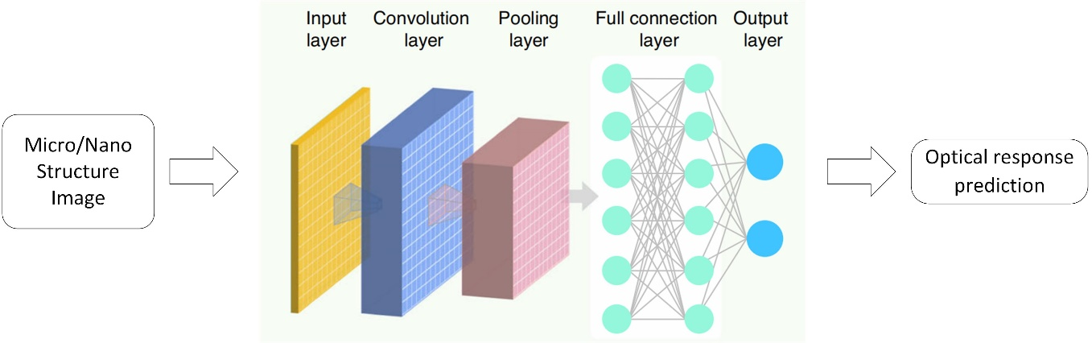
Figure 4
4 RESULTS
Use the two-dimensional image of the metasurface and its corresponding optical response as the dataset. The resolution of the image is 32 * 32, and the structural image of the dataset is in free format. To complete the production of graphics, commercial mathematical software MATLAB can be used, which can randomly generate several rectangles of any shape on the canvas. Then use the optical module of Comsol simulation software to simulate the structural diagram and obtain its response results. Preliminary production of 12000 sets of structural images and corresponding optical response data, 10000 sets of data for model training, and 2000 sets of data for model testing.
We try to visualize the entire training process of the monitoring model as much as possible, and test, analyze, compare, and verify the test results.
Overall, throughout the entire training process, we need to ensure that the loss values of the predicted results converge, that is, when using the training dataset to train our designed model, we need to ensure that the loss values of the convolutional neural network model can converge. This is one of the keys to proving that the training effect reaches a stable state. Of course, we also need to pay attention to other factors, such as the number of neurons, network layers, size of convolutional kernels, learning rate, etc. Finally, when the model parameters are determined, we use the mathematical software MATLAB again to draw the curve of the value of the neural network loss function changing with the number of training iterations. Generally speaking, the value of the loss function will gradually decrease to a very small value.
Finally, in order to ensure the accuracy of the experimental results, it is necessary to randomly select several metasurface structure samples from the test dataset used for optical response prediction after the model training is completed, and compare them with the actual values. A table is drawn to demonstrate the effectiveness of the model prediction.

5 EVALUATION
The picture below is the Project Planning Gantt chart, which can be used as a schedule to plan and monitor the progress of our work.
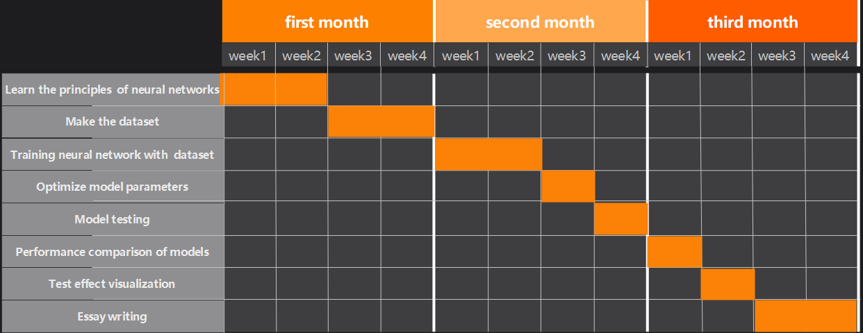
Figure 5
Although this paper has made some progress and achievements in the application of deep learning to design metasurface structures, there are still many problems to be solved due to limited personal skills:
(1) In terms of structural spectral response prediction, due to the influence of training data set, although the prediction accuracy is relatively high, it can only be predicted under the set simulation conditions of the data set. Subsequently, spectral responses under multiple simulation conditions can be integrated into deep learning training to achieve spectral prediction under different conditions.

(2) In the aspect of reverse structure design, the accuracy of generating network needs to be improved, and other network structures can be used to further structure design. For parameter extraction of image generation, we can try to extract the specification parameters of complex structure by other methods, or we can also use the way of programming metasurface to reconstruct the surface structure in simulation software as the practical application of design.

REFERENCE

[1] LIU Shenggang. New Development of Terahertz Science and Technology [J]. China Basic Science,2006(01):7-12.
[2] Liu Shenggang, Zhong Renbin. New development of Terahertz Technology and Its Application [J]. Journal of University of Electronic Science and Technology of China,2009,38(5):481-486
[3] JIN B, ZHANG C, WU P, et al. Recent progress of terahertz spectroscopy on medicine andbiology in China[J]. Terahertz Science and Technology, 2010, 3(4) : 192-200.
[4] Wu Fei, Liao Binbing, Han Yahong. Interpretability of deep learningAeronautical Weaponry, 2019, 26(1):39-46.
[5] ZHANG Wenyu. Research Progress and Application of Metamaterials [J]. Equipment Machinery,2018, (2):67-71.
[6] Cui Tiejun, Wu Haotian, Liu Shuo. Advances in information metamaterials[J]. Acta Physica Sinica,20,69(15):181-193.
[7] Aosong Feng, Zejie Yu, and Xiankai Sun, Ultranarrow-band metagrating absorbers for sensingand modulation[J]. Opt. Express 26, 28197-28205 (2018)
[8] Wei M, Feng C, Yongmin L. Deep-Learning Enabled On-Demand Design of ChiralMetamaterials[J]. ACS Nano, 201812, 6: 6326-6334
[9] Chen, Yingshi, Zhu, Jinfeng, Xie, Yinong, Feng, Naixing, and Liu, Qing Huo. "Smart InverseDesign of Graphene-based Photonic Metamaterials by an Adaptive Artificial Neural Network[J]." Nanoscale, 2019, 11(19): 9749-755. Web.
[10] Deng, Zi-Lan, Deng, Junhong, Zhuang, Xin, Wang, Shuai, Shi, Tan, Wang, Guo Ping, Wang,Yao, Xu, Jian, Cao, Yaoyu, Wang, Xiaolei, Cheng, Xing, Li, Guixin, and Li, Xiangping. Facile Metagrating Holograms with Broadband and Extreme Angle Tolerance[J]. Light, Science &Applications, 2018, 8: 78. Web.
[11] Wei Ma, Feng Cheng, Yihao Xu, Qinlong Wen, Yongmin Liu. Probabilistic Representation and Inverse Design of Metamaterials Based on a Deep Generative Model with Semi-Supervised Learning Strategy[J]. Advanced Materials, 2019, 31(35): 10819.
[12] 梁东. THz 波段微结构金属光栅传输特性的理论与实验研究[D]. 天津: 天津大学, 2007.
[13] Zhao Q , Zhou J , Zhang F , et al. Mie resonance-based dielectric metamaterials[J]. Materials Today, 2009, 12(12):60-69.
[14] 孔伟金,王书浩,魏世杰,云茂金,张文飞,王心洁,张蒙蒙.基于严格耦合波理论的宽光谱金属介质膜光栅衍射特性分析[J].物理学报,2011,60(11):364-370.
[15] Qi A , Wang Y , Guo X , et al. A novel lateral cavity surface emitting laser with top sub-wavelength grating[J]. Journal of Semiconductors, 2015, 36(1):014012.
[16] 袁英豪. 太赫兹波在亚波长金属结构中的传输特性及其应用研究[D]. 武汉: 华中科大学,2011.

[17] Ma Decao, Xian Yong, Su Juan, Li Shaopeng, Li Bing. The visible light red of the antagonistic network is generated based on the improved conditions External image conversion algorithm [J/OL]. Acta Photonica Sinica
[18] Wang Jun, Gao Fang, Sheng Haixian, Zhang Yu. Image generation algorithm for generating adversarial networks based on Swin Transformer [J/OL]. Minicomputer system
[19] Deng Bo, He Chunlin, Xu Liming, Song Lanyu. A Review of Generating adversarial network Text Image Generation Algorithms [J]. Computing Mechanical Engineering and Applications,202,58(23):42-55. (in Chinese)
[20] Yu Jun, Wang Xiaofeng, Sun Zhiheng, Sun Jimeng, Qin Hao, Su Yingying. Based on the improved loop generation adversarial network Fog image generation algorithm [J]. Journal of Chongqing University of Science and Technology (Natural Science Edition),2022,24(04):68-74.
[21] PENG J J. Research and Application of text image generation Algorithm Based on Generative Adversarial Network [D]. Nanchang University Study,2022.
[22] Huang S Y. Research on Text description Image Generation Algorithm Based on Generative Adversarial Network [D]. Jiangnan University Study,2022.
[23] Yin Y K. Research on Text image Generation Algorithm Based on Generative Adversarial network [D]. Changchun University of Technology Science,2021.
[24] ZHANG Heshu. Research on Image Restoration Algorithm Based on Generative Adversarial Network [D]. Nanjing University of Information Engineering Science,2021.
[25] Lai Z C. Cyclic supervision image generation algorithm based on generative Adversarial network [D]. Sichuan University,2021.
[26] Wu Man. Research on Text-to-image generation Algorithm based on Generative Adversarial network [D]. University of Electronic Science and Technology Science,2021.
[27] ZHU Z. Research on deformation image generation algorithm based on generative Adversarial network [D]. Huazhong University of Science and Technology
Science,2020.
[28] Wang Yiqun. Research on Non-paired Heterogeneous Face Image Generation Algorithm Based on Generative Adversarial Network [D]. Nanjing University,2020.
[29] JIANG F. Research on progressive image generation Algorithm Based on generative Adversarial network [D]. Zhejiang University,2019.
[30]Carreon Anthony,Barwey Shivam,Raman Venkat. A generative adversarial network (GAN) approach to creating synthetic flame images from experimental data[J]. Energy and AI,2023,13.
[31]Kim Sunhye,Jang Hyejin,Yoon Byungun. Developing a data-driven technology roadmapping method using generative adversarial network (GAN)[J]. Computers in Industry, 2023145.
[32]Wang Zhixiang,Zhang Zhen,Feng Ying,Hendriks Lizza E. L.,Miclea Razvan L.,Gietema Hester,Schoenmaekers Janna,Dekker Andre,Wee Leonard,Traverso Alberto. Generation of synthetic ground glass nodules using generative adversarial networks (GANs)[J]. European Radiology Experimental Research,202,6(1)
[33] A. Sevik, P. Erdogmus and E. Yalein, "Font and Turkish Letter Recognition in Images with Deep Learning," 2018 International Congress on Big Data, Deep Learning and Fighting Cyber Terrorism (IBIGDELFT), 2018, pp. 61-64, doi:
10.1109/IBIGDELFT.2018.8625333.
[34] M. A. Abbas, "Improving deep learning performance using random forest HTM cortical learning algorithm," 2018 First International Workshop on Deep and Representation Learnin(IWDRL),2018,pp.13-18,doi: 10.1109/IWDRL.2018.8358209.
[35] K. Gangadharan and Q. Zhang, "Deep Learning of Biomechanical Dynamics With Spatial Variability for Lifestyle Management," 2022 IEEE 4th Global Conference on Life Sciences and Technologies (Life Tech), 2022, pp. 514-515, doi: 10.1109/Life Tech53646.2022.9754916.
[36] Hariprasath Manoharan; Ganesan Sivarajan; Subramanian Srikrishna, "Deep Learning Analysis of Location Sensor Data for Human‐Activity Recognition," in 71 Sensor Data Analysis and Management: The Role of Deep Learning , IEEE, 2021, pp.103-116, doi: 10.1002/9781119682806.ch6.
[37] E. Bayhan, Z. Ozkan, M. Namdar and A. Basgumus, "Deep Learning Based Object Detection and Recognition of Unmanned Aerial Vehicles," 2021 3rd International Congress on Human-Computer Interaction, Optimization and Robotic Applications (HORA), 2021, pp. 1-5, doi: 10.1109/HORA52670.2021.9461279.
[38] MIKOLOV T, SUTSKEVER I, CHEN K, et al. Distributed representations of words and phrases and their compositionality [J]. Advances in neural information
processing systems, 2013, 26.
[39] ROBLIN C, LAHEURTE J-M, D’ERRICO R, et al. Antenna design and channel
modeling in the BAN context—Part I: Antennas [J]. Annals of Telecommunications-annales des télécommunications, 2011, 66(3): 139-55.
[40] Z. Guoyun, L. Jun, H. Yang, L. Meifeng and S. Hongyang, "Fine-grained image classification method based on generating adversarial networks with SIFT texture input," 2021 International Conference on Computer Engineering and Artificial Intelligence (ICCEAI), 2021, pp. 104-107, doi: 10.1109/ICCEAI52939.2021.00020.
[41] R. Wang, R. Qin, J. Zou and L. Zhang, "AGR-FCN: Adversarial Generated Region based on Fully Convolutional Networks for Single- and Multiple-Instance Object Detection," 2019 IEEE International Conference on Imaging Systems and Techniques (IST), 2019, pp. 1-6, doi: 10.1109/IST48021.2019.9010104.
[42] A. Akandeh and F. M. Salem, "Slim LSTM NETWORKS: LSTM_6 and LSTM_C6," 2019 IEEE 62nd International Midwest Symposium on Circuits and Systems (MWSCAS), 2019, pp. 630-633, doi: 10.1109/MWSCAS.2019.8884912.
[43] W. He, Y. Wu and X. Li, "Attention Mechanism for Neural Machine Translation:
A survey," 2021 IEEE 5th Information Technology,Networking,Electronic and Automation Control Conference (ITNEC), 2021, pp. 1485-1489, doi:
10.1109/ITNEC52019.2021.9586824.
[44] G. Liu, S. Lan, T. Zhang, W. Huang and W. Wang, "SAGAN: Skip-Attention GAN For Anomaly Detection," 2021 IEEE International Conference on Image Processing (ICIP), 2021, pp. 2468-2472, doi: 10.1109/ICIP42928.2021.9506332.

