Academic skills:
Academic skills are fundamental skills and habits, with them being an important element of moving forward in education and employment in the future. Swansea University helps to support this by stating [1]“Good study habits foster independence and critical thinking, essential for academic success and future careers.” Some of the essential skills required for academia include:
- Academic honesty – siting sources
- Research skills – via books, internet and potentially A.I
- Writing – being able to summarize, paraphrase and meet word counts
- Mathematical skills – helpful within tech-based learning/coding
- Time management – balancing assignments to meet deadlines
- Soft skills - personal attributes for employability
- Reading – proof reading research information and work documents
- Communication skills – group work with peers

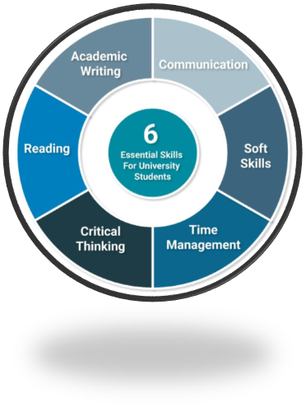
[2]

Employment skills:
Employment skills are built from the backbone of academic skills with the core difference being that they are used within a different environmental setting which can change depending on the type of work environment. Some of the core employment skills include:

- Communication skills – includes being able to listen and being vocal when able to ask appropriate questions.
- Decision making – being able to analyse tasks and identify problems
- Self-management- having efficient work-based habits
- Teamwork – being able to work amongst groups of varying sizes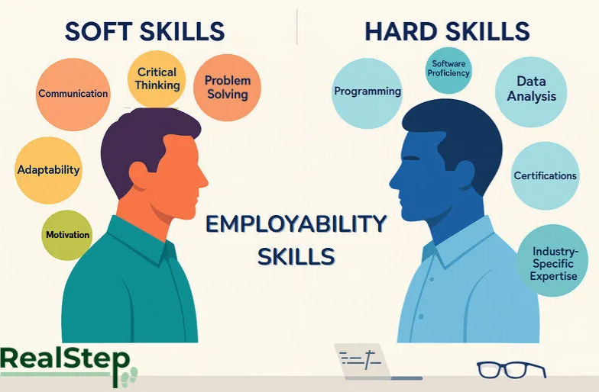

Hard skills are employment specific traits in which are required to be able to perform optimally within different work environments. Hard skills also include specific skills required for certain fields of employment with programming being the easiest example as within most programming jobs it is required to have a minimal understanding of different programming languages such as c++ or python. Meanwhile soft skills are a fundamental requirement that pair with hard skills. Unlike hard skills, soft skills are more personal skills which fall in line in regard to both employment and academic skills, this includes time management, communication, teamwork and critical thinking skills.

- Chat GPT – best for general usage overall due to it being able to solve a combination of complex problems and basic prompts by utilizing the web to find the correct response.
- Google Gemini – best used within the search engine it’s designed around to help with research-based tasks as well as being able to help utilise/search for specific applications and websites (example YouTube, google docs.)
- Claude – Claude is best used for more complex computer/tech related tasks with it being ablet to help break down code and understand it better as well as improve any code fed into it.
- Microsoft copilot – best use for Microsoft copilot is for organisation of document specifically ones which utilise different applications within the Microsoft office 365 package.
- Amazon Alexa – amazon Alexa is best used for setting reminders throughout the day or for quick bursts of information if performing research-based work.

Claude A.I:

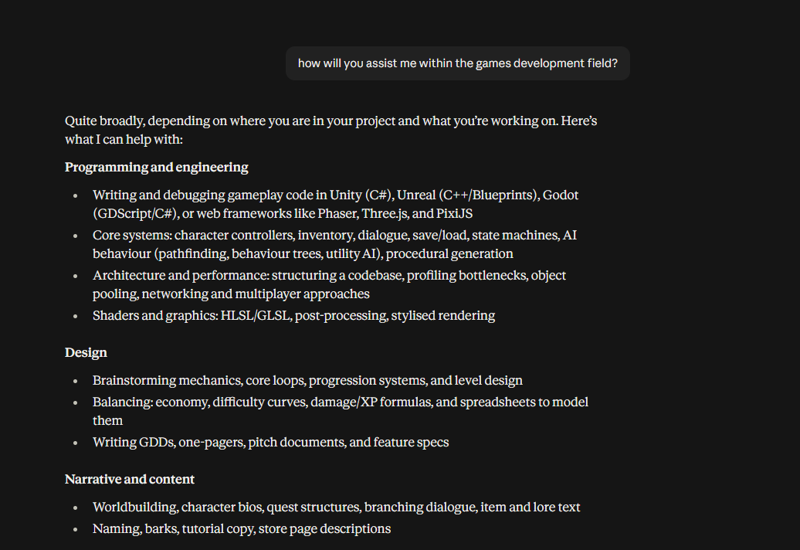
Claud can assist me within many aspects of games development including, programming, level & character design as well as world building.
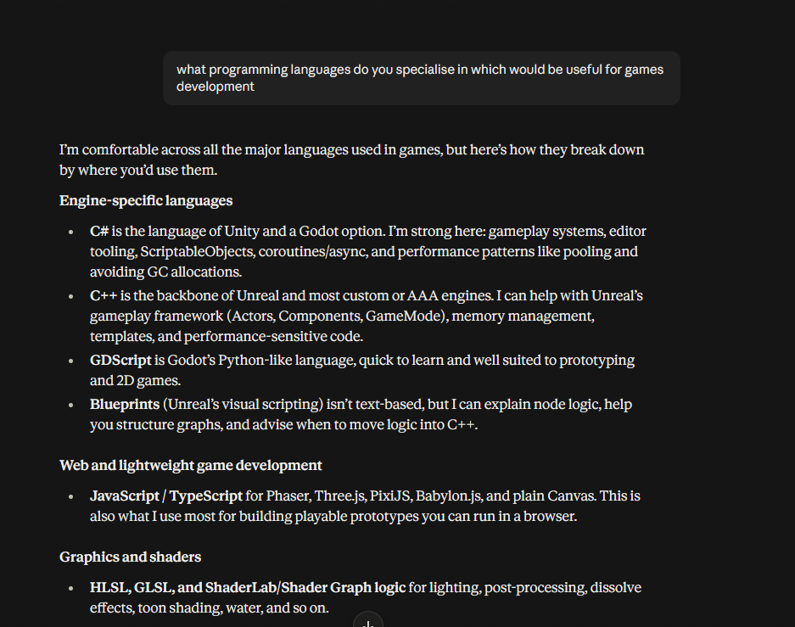
Claude specialises in many different languages allowing me to be more flexible and work with a specific language I prefer.
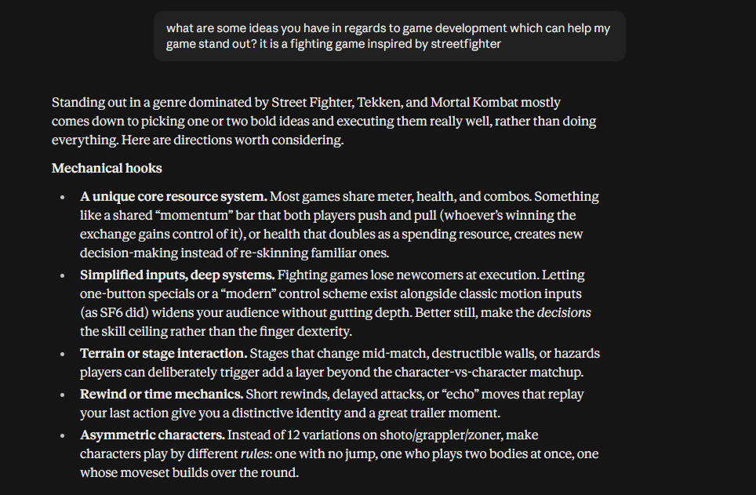
If I am struggling with ideas, Claude can help provide inspiration by helping me understand what makes other games stand out.
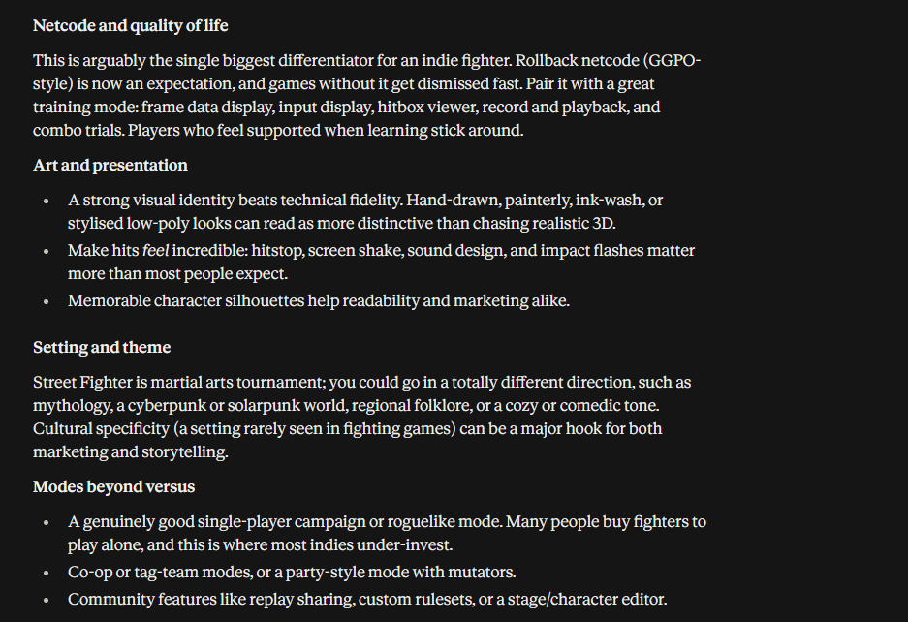
Additionally, Claude can help make recommendations to help the game stand out amongst the competition regarding multiple different aspects.

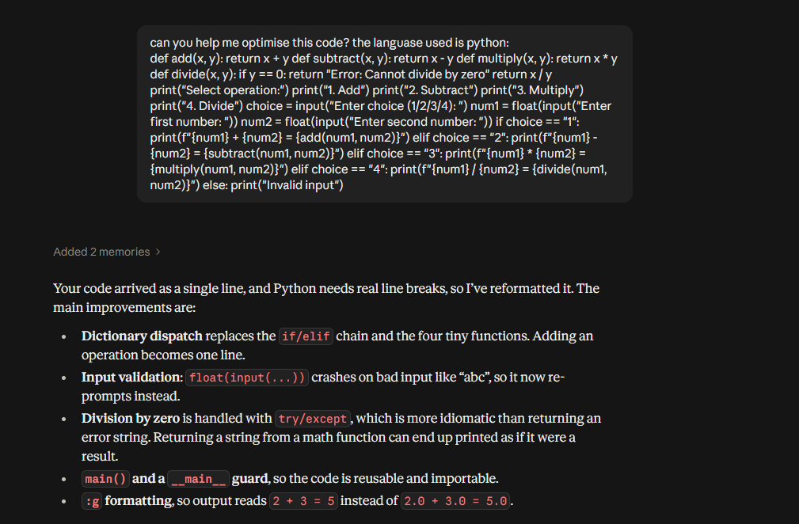
Finally, I can utilise Claude to help me optimise my code, with it highlighting my mistakes allowing me to know where I went wrong.
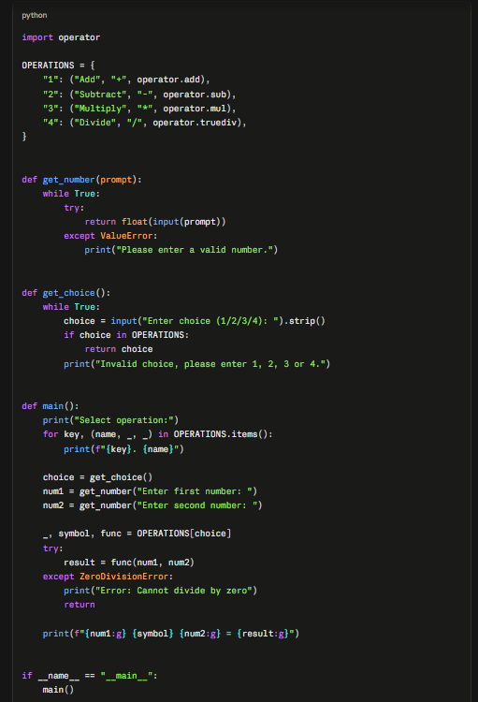
Furthermore, Claude provides a version of the code which corrects the mistakes I made within the one submitted. This optimised version of the code can be used to both help me learn from my mistakes as well as save time when programming allowing for me to focus on other areas of games development.

