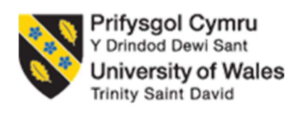

Student Name: Amishaben Bhikhabhai Panchal
Student ID: 2537875
Programme: Master of Business Administration
Module: Marketing Management
Module code: LCMB7024
Assignment Title: Portfolio:
•⁠ Presentation
•⁠ Report
•⁠ ⁠Reflection
Lecturer: Laila Maazouz, Taonga Kaonga Sobere Snithers

Table of Contents
1.0 Element 1: Sustainable Brand Extension Poster Presentation 3
2.0 Element 2: Develop a Segmentation, Targeting, Differentiation, and Positioning (STDP) 4
2.1 Key market segments relevant to the brand extension using geographic, demographic, psychographic, and behavioural variables 4
2.2 Detailed explanation of your chosen target audience 6
2.3 Way brand will differentiate itself from competitors in the market 7
2.4 Positioning of the brand extension 7
3.0 Element 3: Marketing Mix (4Ps or 7Ps) 8
3.1 Way each element of the marketing mix will be applied and how it aligns with and supports the overall brand extension strategy 8
4.0 Element 4: Reflection 13
4.1 Reflection on my experience developing the brand extension 13
4.2 Reflection on the experience preparing and delivering the poster presentation 13
4.3 Key skills, knowledge, and insights you have gained throughout this process 13
4.4 Way these have contributed to my personal and professional development 13
4.5 Way I could further enhance my approach and performance in similar projects in the future 14
References 15

1.0 Element 1: Sustainable Brand Extension Poster Presentation
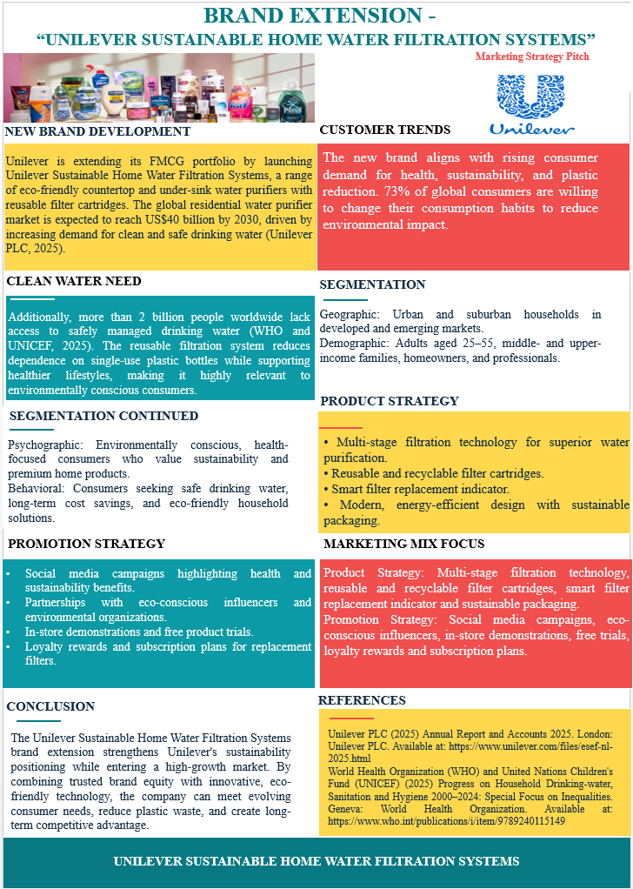

2.0 Element 2: Develop a Segmentation, Targeting, Differentiation, and Positioning (STDP)

2.1 Key market segments relevant to the brand extension using geographic, demographic, psychographic, and behavioural variables
Geographic Segmentation
The key markets for Unilever Sustainable Home Water Filtration Systems should be urban and suburban households in areas where drinking water quality and environmental sustainability are becoming a growing issue (Akter, 2025). Markets such as North America, Western Europe, India, China and Southeast Asia are poised to be high potential markets, as these regions experience rapid urbanisation and increased disposable incomes which in turn fuel demand for premium home purification products. 56% of the world's population (around 4.6 billion) lives in urban areas in 2024, and that will rise to 68% by 2050, leading to a greater demand for household water solutions (Deloitte, 2025). The global home water filtration market size is expected to reach US$50.9 billion by 2033, with favorable growth prospects in the rapidly urbanising regions of Asia-Pacific, North America and Europe (World Bank, 2025).
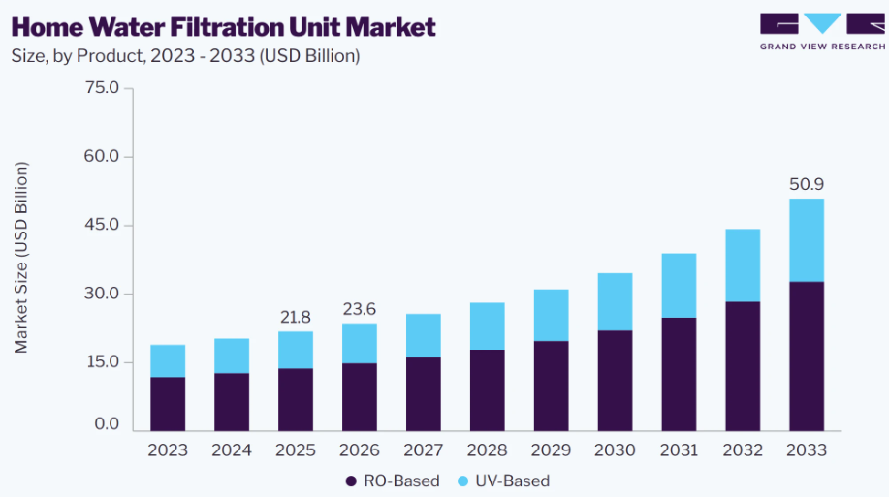
Fig 1: Home Water Filtration Market
Source: (Grand View Research, 2025)
Demographic Segmentation
The main demographic target includes adults (aged from 25 to 55), mainly middle and upper income with families, homeowners, professionals and parents who value the health and quality of products in their households (WHO, 2025a). These consumers have higher earning potential and much more inclined to buy sustainable long-term use appliances. In 2025, it was reported that there are more than 3.8 billion people in the global middle-income group, and it is estimated that more than 61% of consumers in the 30–54 age group are purchasing premium household appliances (Fortune Business Insights, 2026). Besides, the percentage of dual income households is growing worldwide, which puts even more pressure on the need for products that are convenient and enable technology to enhance daily life and lower long-term household expenses.
Psychographic Segmentation
The brand extension's psychographic appeal is to those who are environmentally concerned and health-minded, with an interest in sustainability, innovation, and responsible consumption (WHO, 2025b). These customers are very conscious about plastic waste and want products that help them to reduce the waste. 69% of consumers deliberately bought more environmentally-friendly products in the last 12 months and 64% would be willing to pay more for environmentally responsible brands (Grand View Research, 2025). The attitude of the consumer matches Unilever's sustainability agenda and arms the company with the ability to market its re-usables as a wellness and lifestyle choice.
Behavioural Segmentation
Behaviourally, the brand should aim at those who buy bottled water regularly, change their household filters, and are actively looking for reducing the total cost of using reusable alternatives over time (WHO and UNICEF 2025). These consumers rely on product reliability, convenience, product performance, and trusted brands to aid their buying decision. The bottled water market is expected to expand from USD 292.7 billion in 2025 to USD 432.6 billion by 2031 at 6.72% CAGR, showing that there is significant spending happening in the market that Unilever can leverage and migrate to home water filtration systems that offer convenience, subscriptions, and endless cost savings (Endika et al., 2025). As for the impact on repeat household purchases, 78% of consumers worldwide said they consider product quality and brand trust to have a significant effect on that (NielsenIQ, 2025). As Unilever replaces filters at a later stage, they can build up a customer's loyalty and dependence on the company, by offering filters for subscription and the opportunities to buy them again, as well as their use of smart indicators to tell the consumer when to replace it.
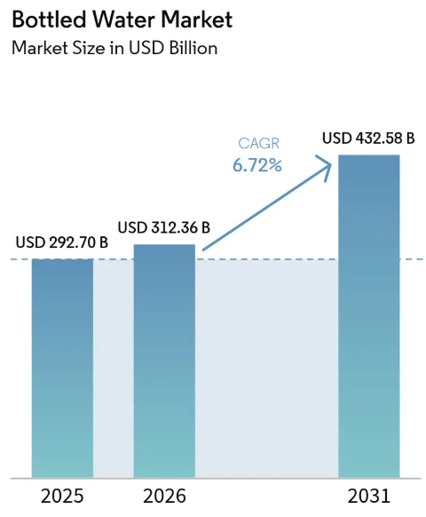
Fig 2: Bottled Water Market
Source: (Mordor Intelligence, 2026)

2.2 Detailed explanation of your chosen target audience
The main target customers of Unilever Sustainable Home Water Filtration Systems are urban adults ranging 25-55 years old, mainly from middle and upper class, homeowners, and working professionals who are health, convenience, and sustainability conscious. This segment has good purchasing power and is very interested in the quality of the house and purchases premium products offering good value for long duration (Hartono, 2025). Approximately 73% of consumers worldwide would be willing to alter their purchasing habits to decrease environmental impact, and 67% would like to buy products containing sustainable packaging (OECD, 2025). Moreover, dual-earners households still exist and grow worldwide and require new, sustainable home solutions that can enhance the quality of life for the household and save the long-term cost of living.

2.3 Way brand will differentiate itself from competitors in the market
Unilever will have distinct offerings for Sustainable Home Water Filtration Systems, leveraging its brand reputation around the world and its innovative and eco-friendly designs and filter technology (Nchepkorir, 2025). The reusable and recyclable filters decrease plastic waste and decrease replacement expenses over time, compared to many competitors that rely on one-time use filter cartridges. Smart filter replacement indicators and sustainable packaging add to the convenience and environmental benefit. Somewhere around 64% of consumers are willing to pay more for sustainable products and 70% would prefer brands that are truly committed to sustainability (PwC, 2025). This is a combination of trusted quality, affordability, innovative technology, and environmental responsibility, which is a sustainable competitive advantage.

2.4 Positioning of the brand extension
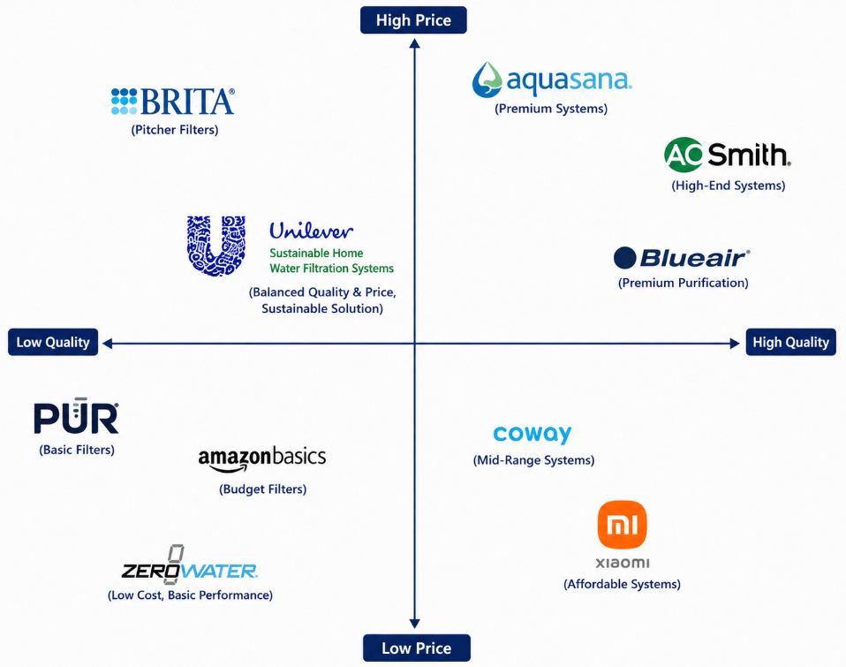
Fig 3: Positioning Map
Source: (Self-Created)

3.0 Element 3: Marketing Mix (4Ps or 7Ps)

3.1 Way each element of the marketing mix will be applied and how it aligns with and supports the overall brand extension strategy
Product
Unilever Sustainable Home Water Filtration Systems' product strategy is to provide safe drinking water while working towards the company's sustainability goals by designing products that are innovative and good for the environment. The brand extension will comprise of multi-stage RO and carbon filtration technology in counter top and under sink filtration systems, reusable and recyclable filter cartridges, smart filter replacement indicator and energy efficient functioning (Statista, 2025). Unlike traditional purifiers, which are made of disposable cartridges and generate a significant amount of plastic waste, the reusable filtration system developed by Unilever can help mitigate environmental impact and reduce the total cost of ownership. The products will also have a contemporary look and design that matches the modern lifestyle of urban homes. The product resonates with consumers' expectations for health, convenience and sustainability (Omoruyi et al., 2025). Over 2.2 billion people worldwide still do not have access to safely managed drinking water and there is significant demand for safe and sustainable home water purification systems. The sustainability capabilities of Unilever support the brand extension, with 29% virgin plastic reduction, 25% recycled plastic in packaging, 57% reusable, recyclable or compostable packaging, and collection/reprocessing of more than 100% of the packaging that Unilever sells by 2025 (UNICEF, 2025a).
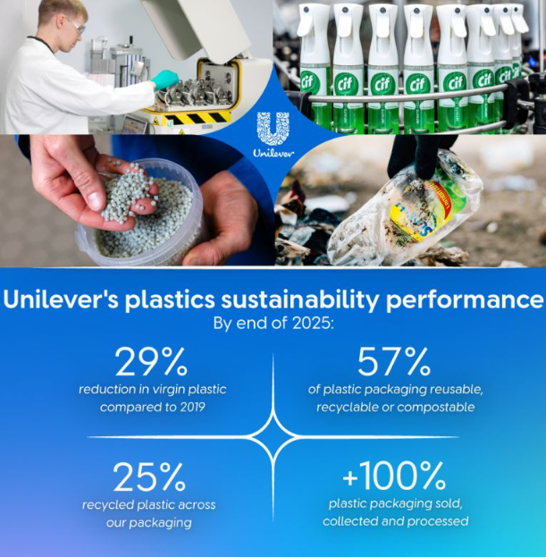
Fig 4: Plastic Sustainability Performance
Source: (Uijen, 2025)
Price
The pricing strategy will be value based pricing with the Unilever Sustainable Home Water Filters in the upper mid-market segment. The company will not only engage in a price war but focus on creating better products, building brand equity and brand trust, sustaining innovation and adding value in the long-term. The proposed retail pricing varies from $180 to $450, depending on the filtration capacity, smart technology integration and installation type, offering a more affordable alternative to ultra-premium products but still being premium compared to entry-level brands (UNICEF, 2026). Usually, consumers consider the total cost of ownership of products rather than the price of the product initially. Reusable filter cartridges can save the user a lot on filter replacement costs over many years as compared with the expenses for conventional disposable filters. Recurring revenues will be generated with subscription-based filter replacement services which will further enhance the convenience of the customer. This pricing policy is aligned with the increase in consumer willingness to pay more for sustainable products: around 64% of global consumers are willing to pay more for sustainable products and 70% prefer brands that have a strong sustainability commitment (Ruikar, 2025). The pricing structure also fits into the Unilever's bigger premiumisation plan. The company achieved a turnover of €50.5 billion in 2025, with 3.5% underlying sales growth, with 2.0% being driven by price growth, which proves that the company is capable of generating value through premium products and not just through volume growth (United Nations, 2025). The company's competitive pricing, profit margins and its global footprint and supply chain efficiencies are a result of its strong financial performance. In this context, value-based pricing will ensure both customer satisfaction and long-term profitability and help solidify the positioning of the new brand extension as premium.
Place
The place strategy will leverage Unilever’s global distribution network to ensure the product is available for multiple channels of retail and digital distribution. Distribution will be targeted at supermarkets, hypermarkets, home improvement retailers, electrical appliance stores, authorised distributors, and leading e-commerce platforms, allowing consumers to buy products with the ease they prefer to (Uwagaba, 2025). The products will also be sold direct to customers online, giving customers the opportunity to subscribe for replacement filters. The global infrastructure of Unilever is a strong competitive advantage. It has operations in 190 countries, with its top 24 markets representing approximately 85% of the company's turnover, allowing it to expand quickly internationally and ensure its supply chain is efficient (EPA, 2025). Consumer preference for online shopping and omnichannel retail is driving digital commerce to be one of Unilever's seven strategic growth priorities. Due to the higher population density, rising disposable income and enhanced water quality awareness, urban markets will be the main distribution channel. Collaborating with kitchen renovation firms, partnering with property developers, and establishing strategic links with plumbing companies can be additional strategies for penetrating the market by incorporating filtration systems into new residential developments (Unilever PLC, 2026).
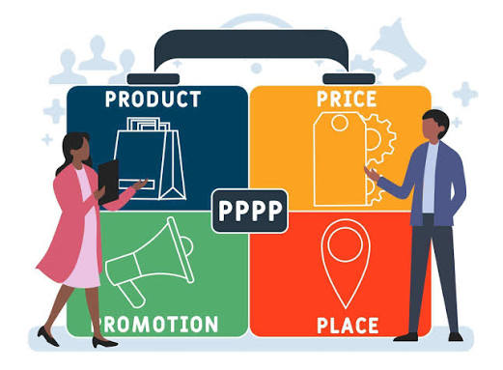
Fig 5: 4Ps of Marketing
Source: (SEOptimer, 2021)
Promotion
The promotional approach will convey the dual message, of “healthier drinking water” and “environmental sustainability”, as well as the trusted global brand image of Unilever. The use of digital advertising, social media marketing, influencer marketing, television ads, public relations, experiential marketing and water quality, plastic reduction, and sustainable living education will all be integrated into the marketing communications mix. Product innovation, the use of reusable filtration technology, cost savings over time and positive environmental impact will be highlighted in marketing messages (UN-Water, 2025). Digital marketing is going to be the main focus as consumers are more likely to look for household appliances online before buying them. Engaging videos, interactive product demonstrations, customer feedback and the telling of sustainability stories will enhance consumer engagement and reinforce purchase intent. Collaborations with environmental groups, healthcare experts, and sustainability advocates will further add to the brand's credibility. In-store demos and free samples will minimize perceived purchase risk and give consumers product experience prior to purchase. Unilever is well endowed with marketing expertise offering great support for this strategy. Today, the company is reaching out to around 3.7 billion consumers daily and, with the Power Brands, it accounts for 78% of total turnover, thus proving to be very effective in global marketing (UN-Water, 2026). In addition, digital commerce is one of the company's main strategic growth priorities, which is in line with the growing focus on customer engagement through technology. Repeat sales will be ensured and customers' lifetime value will be raised by loyalty programmes and subscribing services for replacement filters.

4.0 Element 4: Reflection

4.1 Reflection on my experience developing the brand extension
The development of the Unilever Sustainable Home Water Filtration Systems brand extension developed my skills of strategic marketing and innovation. I gained to the concept of bringing an existing brand into a new product category that reflects the same brand values and identity. Market research helped me understand customer needs and evaluate market opportunities and analyse my competitors. This process helped me to better understand how to link sustainability trends with customer expectations, and formulate a viable brand extension strategy substantiated with market evidence.

4.2 Reflection on the experience preparing and delivering the poster presentation
The poster presentation helped me to develop a greater skill in communicating concepts in a marketing presentation in a brief and engaging way. I discovered that it is crucial to choose the right information, communicate important facts and keep a proper sequence between the various marketing components. I also gained a lot of confidence in making presentation, giving decisions, and answering questions. Overall, the experience helped me improve my presentation skills, as well as my communication skills in general to different audiences, business ideas and concepts.

4.3 Key skills, knowledge, and insights you have gained throughout this process
It gave me great exposure into the valuable skills required to conduct market research and strategic planning, market segmentation, competitor analysis, and marketing mix development. I developed hands-on experience in using theoretical marketing approaches to a practical business situation and have provided recommendations using up-to-date industry information. Also, I was able to develop my critical thinking, problem solving, academic research and report writing skills. It also broadened my knowledge of sustainable marketing strategies and the need to meet consumer tastes and preferences while promoting the growth of the business.

4.4 Way these have contributed to my personal and professional development
The experience and information acquired during this project has helped increase my confidence in creating evidence based marketing strategies and making informed business decisions. I became more organized in managing research, analysing information, and presenting ideas logically, personally. The project taught me how to think strategically, communicate effectively and analyse problems. These skills are vital in the marketing, brand management and business consultancy fields. It also raised my consciousness of sustainable development and its integration in long-term business development and competitive advantage.

4.5 Way I could further enhance my approach and performance in similar projects in the future
In future projects, my performance would be enhanced by engaging in a wider primary research by carrying out consumer surveys and/or interviews to get a deeper understanding of the customer. I would also set aside more time for competitor benchmarking and financial feasibility studies to support strategic recommendations. I would like to have improved data visualisations and present delivery skills more often, as this would both enhance my work and boost my confidence. All of this would help me make more robust, data-informed and professional looking marketing projects in the future.

References
Akter, S., (2025). Cross-cultural management and its impact on international corporate success-a case study of Unilever Plc.
CHEPKORIR, T.C., (2025). STRATEGIC MANAGEMENT DRIVERS AND PERFORMANCE OF UNILEVER KENYA LIMITED IN NAIROBI CITY COUNTY KENYA.
Deloitte (2025) Sustainable Consumer Survey. Available at: https://www.deloitte.com/global/en/issues/climate/sustainable-consumer.html
Endika, Y., Sulistyowati, E. and Farkhan, F., (2025). ANALYSIS OF CONSUMER SATISFACTION AND LOYALTY BASED ON THE GREEN MARKETING CONCEPT OF PT UNILEVER INDONESIA TBK. Nusantara Hasana Journal, 5(1), pp.196-209.
Fortune Business Insights (2026) Water Purifier Market Size, Share & Industry Analysis. Available at: https://www.fortunebusinessinsights.com/water-purifier-market-103118
Grand View Research (2025) Home Water Filtration Unit Market Size, Share & Trends Analysis Report by Product (RO-Based, UV-Based), by Region, and Segment Forecasts, 2025–2033. Available at: https://www.grandviewresearch.com/industry-analysis/home-water-filtration-unit-market
Grand View Research (2025) Water Purifier Market Size & Trends. Available at: https://www.grandviewresearch.com/industry-analysis/water-purifier-market
Hartono, D.K., (2025). The Analysis of Business Process Management Implementation: A Case Study in PT Unilever Indonesia Tbk. Global Journal of Economic and Finance Research.
Mordor Intelligence (2026) Bottled Water Market – Market Share Analysis, Industry Trends & Statistics, Growth Forecasts (2026–2031). Available at: https://www.mordorintelligence.com/industry-reports/bottled-water-market
NielsenIQ (2025) Sustainable Shoppers: Buy the Change They Wish to See. Available at: https://nielseniq.com/global/en/insights/
Omoruyi, U.S., Magbadelo, T.O., Adeshola, Q.I., Adewumi, J.O., Okpanachi, A. and Kachalla, I.S., (2025). Impact of Sales Promotion on Organisational Performance: A Case Study of Unilever Nigeria Plc. Path of science, 11(6), pp.1001-1008.
Organisation for Economic Co-operation and Development (OECD) (2025) Environment and Urban Development. Available at: https://www.oecd.org/environment/
PwC (2025) Voice of the Consumer Survey. Available at: https://www.pwc.com/gx/en/industries/consumer-markets/voice-of-the-consumer.html
Ruikar, D.S., (2025). The New Era of Marketing: A Case Study on Hindustan Unilever Limited (HUL) FMCG in India. Available at SSRN 6693079.
SEOptimer (2021) The 4 P’s of Marketing + Marketing Mix Examples. Available at: https://www.seoptimer.com/blog/4-ps-of-marketing/
Statista (2025) Bottled Water Market Worldwide. Available at: https://www.statista.com/outlook/cmo/non-alcoholic-drinks/bottled-water/worldwide
Uijen, W. (2025) Circular Economy, Sustainability and Uniquely Unilever [LinkedIn post], 11 December. Available at: https://www.linkedin.com/posts/willemuijen_circulareconomy-sustainability-uniquelyunilever-activity-7470843826589380608-JB4Q
UNICEF (2025a) Fast Facts: 1 in 4 People Globally Still Lack Access to Safe Drinking Water. Available at: https://www.unicef.org/press-releases/fast-facts-1-4-people-globally-still-lack-access-safe-drinking-water-who-unicef
UNICEF (2026) Global Annual Results Report 2025: Goal Area 4 – Every Child Lives in a Safe and Clean Environment. Available at: https://www.unicef.org/reports/global-annual-results-2025-goal-area-4
Unilever PLC (2026) Annual Report and Accounts 2025. Available at: https://www.unilever.com/files/esef-nl-2025.html
United Nations (2025) World Urbanization Prospects. Available at: https://population.un.org/wup/
United States Environmental Protection Agency (EPA) (2025) Home Drinking Water Filters. Available at: https://www.epa.gov/ground-water-and-drinking-water/home-drinking-water-filters
UN-Water (2025) Water Facts and SDG 6 Resources. Available at: https://www.unwater.org/water-facts
UN-Water (2026) UN-Water Annual Report 2025. Available at: https://www.unwater.org/publications/un-water-annual-report-2025
Uwagaba, J., (2025). Marketing and Communication Management Plan: A Guide for Ethical and Sustainable Strategies. Available at SSRN 5911962.
World Bank (2025) World Development Indicators. Available at: https://databank.worldbank.org/source/world-development-indicators
World Health Organization (WHO) (2025a) WHO Global Water, Sanitation and Hygiene Annual Report 2024. Available at: https://www.who.int/publications/i/item/9789240113978
World Health Organization (WHO) (2025b) Water, Sanitation and Hygiene (WASH). Available at: https://www.who.int/teams/environment-climate-change-and-health/water-sanitation-and-health
World Health Organization (WHO) and United Nations Children's Fund (UNICEF) (2025) Progress on Household Drinking-water, Sanitation and Hygiene 2000–2024: Special Focus on Inequalities. Geneva: World Health Organization. Available at: https://www.who.int/publications/i/item/9789240115149

