Milena Petrova Valeva
Student Number: 1817469
THE GLOBAL BUSINESS ENVIRONMENT
MODULE CODE / LCBB4005
Environmental Analysis of an industry - Assessment 1
Module Lecturer : Dr. Kenny Tang

CONTENT
1. INTRODUCTION
2. PART 1 – EXTERNAL FORCES
A. PESTLE
B. Porters five forces
C. Organizational changes
CONCLUSION
3. PART 2 – NEW OPPORTUNITIES
A. Porters generic value chain and conclusion
B. New business opportunities
C. Discontinued businesses
CONCLUSION
4. PART 3 – CONCLUSION
5. REFERENCES

INTRODUCTION
The EV industry has in recent years experienced strong growth boosted by several environmental factors such as government support and incentives, climate change concerns and governmental regulations. Between 2014 and 2018, the industry experienced 63% growth, from 300,000 units sold in 2014 to 2.1 million units in 2018 (McKinsey 2019). This report analyses the business environment of the EV industry, looking at the major opportunities and challenges faced by the industry.
PART 1 – External forces
Figure 1: Business environment
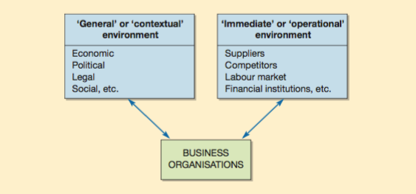

A. PESTLE analysis
Political environment
Government support
Although governments in major EV markets have primarily focused their policies on direct incentives to consumers in form of tax credits and subsidies, they have aided other parts of the EV value chain including research and development (R&D), manufacturing (battery and car production), and EV-related services (e.g., insurance, retail services, and mechanics). -Most of the major global economies including Japan, US, China and UK have aggressive plans to drive EV adoption by establishing specific targets for EV sales. France and UK have set up plans to hasten adoption of an all-electric fleet by 2040 (Biswas and Tortajada 2018). UK and France have plans to ban diesel and petrol cars by 2040, part of government efforts to hasten EV adoption.
Economic environment
Battery supply chain issues (High demand/ low supply)
As EV adoption continues to grow, manufacturers in North America and Europe are getting highly concerned about supply shortages of key materials needed for electric vehicle batteries (Stringer 2019). In fact, analysts believe demand for batteries will exceed supply in 2020 due to growing pressure on the supply chain of raw materials (Montgomery 2019).
In 2019, manufacturers in Europe were faced with delays in production due to poor battery supply chain. During the same period, South America, one of the major producers of lithium faced a shortage, failing to ramp up capacity. On the other hand, Chinese conversion capacity that was supporting prices is giving way as China becomes a net exporter of lithium chemicals (Montgomery 2019).
Though EV adoption is growing in several European countries, it is still limited to higher income consumers because of the rather premium costs in comparison to diesel cars.
Social environment
Socially, more consumers are increasingly noticing the impact of climate change, and continuously working to reduce their footprint. For this reason, some of them are willing to pay premium prices to replace ICEs and reduce their footprint (McKinsey &Company 2014).
Technological
Technological issues likely to impact EV adoption include battery range anxiety, long charging times, poor infrastructure as well as low awareness (McKinsey 2014; Deloitte 2019). Fast charging infrastructure is likely to be a key point of differentiation for OEMs.
Legal environment
The EV industry is highly reliant on policy support in form of waivers to access restriction, fuel economy standards, plans to ban diesel vehicles in major cities, mandates for automakers to sell a given number EVs as well as financial incentives to increase attractiveness of EVs (Albrahim et al 2019). These policies and regulations have created a favorable environment that is driving EV adoption across several regions. In Europe for instance, Paris has set up plans to ban all gasoline and diesel vehicles from the city centre by 2030 while Copenhagen plans to do the same starting from 2019 (Deloitte 2019). All these rules and regulations have been a major driver in the push to electrification.
Environmental issues
Perhaps the major driver of EV adoption is climate change as the world grows more aware of its impact. Several regions including EU countries, US and China have set up strict carbon dioxide emission targets and penalties on OEM excess emissions. In fact, some countries have also set up plans to ban diesel vehicles from major cities by 2025 (Albrahim et al 2019). In the UK, Central London has put in place ultra-low emission zones where by diesel car drivers are charged £12.50 for driving into Central London. In 2020, Birmingham is planning to introduce pollution charges of £6 -£10 on cars driving within the city’s ring road, Leeds plans to charge a fee of up to £50 on the most polluting vehicles while Bath will charge motorists £9 a day to drive into its Georgian streets (Collinson 2019).

B. Porters Five Forces analysis
Established by Porter, the Five Forces framework is meant to help assess the attractiveness and profitability of different industries as determined by the five forces of competitive pressure (Worthington and Britton 2014; Johnson et al 2017). For this reason, Five Forces is an important starting point for an organization’s strategic analysis. As shown below, five forces of competition are made up of three sources of horizontal competition (competition from substitutes, entrants and established rivals) as well as two sources of vertical competition (power of buyers and suppliers) of which each of these forces depends on a number of factors (Grant 2016).
Barriers to entry/ Threat of entry (high)
Barriers to entry can be defined as anything preventing entry of new firms in an industry (Worthington and Britton 2014). The automobile industry has always been protected by a number of barriers including economies of scale, capital requirements, absolute cost advantage which have through the years given OEMs a competitive advantage. However, with the drive to electrification, those barriers were eroded by government support as well as technology which has greatly reduced needed manufacturing components, opening the industry for inexperienced, but well-funded new entrants like Google and Tesla (Teece 2018).
Threat of substitutes
Substitutes have power to impact a market structure, in the absence of substitutes, there will be low competition, giving a given product high market power and profitability (Worthington and Britton 2014). Substitutes include bicycles, trains and ride hailing companies. among others. The closes substitutes are however the current car models which comply to emission standards. Considering the high cost of EVs, the threat of substitutes is high since they are all more affordable in comparison to the current premium prices of EVs.
Bargaining power of buyers
Due to the many available substitutes, the bargaining power of buyers is high. As noted by several analysts, this power is going to get high as the supply of EVs exceeds the demand, with lots of new entrants entering the market. With excess capacity, manufacturers will be forced to cut costs, this will result in low profitability and failure of some companies (Deloitte 2019).
Bargaining power of suppliers
Being a new product on the market, the EV industry is characterized by fewer suppliers, which is giving them an advantage against EV manufacturers. In fact, the EV battery is the most expensive component of the EV. Other than companies like Tesla which are able to manufacture their own batteries, most companies are highly dependent on outside suppliers, a fact that gives suppliers power to control the supply chain. This has resulted in production delays, disrupting the supply chain in Europe (Hertzike 2019). As noted by Grant 2016, suppliers can have too much power to the point of leaving an organization with less or no profits.
Competitive rivalry
The level of profitability in an industry depends on the competition among firms in the industry (Worthington and Britton 2014). In some industries, firms compete so aggressively to the point that prices are pushed below the level of costs which results in general losses (Grant 2016). Due to low entry barriers and high exit barriers, the EV industry is highly competitive and forecast to become worse. With growing acceptance, government support of EVs and declining costs, more and more companies are joining the industry, in fact, the demand is forecast to exceed demand by 2030 as new entrants command the biggest share (Deloitte 2019). This will force down the cost, resulting in losses and demise of some companies.
Conclusion
Supported by several environmental factors such as government support and incentives, climate change concerns and governmental regulations, the EV industry has continued to experience tremendous growth. However, with traditional entry barriers eroded by technology and government support, the industry has become vulnerable to new entrants, increasing competition. Lots of OEMs and new entrants have entered the market to enjoy the benefits and grow their market shares while incumbents have invested in order to stay in business. As per the five forces all the five forces are high, a sign of low profitability and unattractiveness.

C. Organizational changes/reasons
As noted by Huczynski and Buchanan (2013), technology has the most notable impact on an organization’s environment in that in can impact the general structure of an organization. Mullins (2016) has also noted that organizational change can be imposed by policy changes or can arise out external pressure and has potential to change all aspects of an organization’s functions and operations.
The automobile industry has in recent years’ experience technological disruption in form of EVs, disrupting the value chains, supply chains, and the whole industry structure at large. As electrification becomes priority, a number of changes in the automobile are happening very fast. These changes are not just limited to technological changes, as electric vehicles move to replace internal combustion engines, supply chains and value chains have been disrupted, impacting traditional OEMs. One of the major changes has been the supply chain due to the change of components responsible in manufacturing, this has greatly impacted traditional OEMs who have had to shift to the EV manufacture or be out of business. According to analysts, distributors and employees of traditional OEMs as well as suppliers of diesel engine components are likely to go out of business as several organizations go obsolete.
The growth of the EV market will largely impact the traditional supply chain which is currently internal combustion based. First, the technicalities at the manufacturing stage will represent a major shift from diesel engines to electric systems. The mechanical complexity of EVs is less, reducing manufacturing costs the number of workers required in the EV manufacturing process. This could mean a significant impact on jobs, requiring a shifting of skills from ICE to EV production and also reducing the number of manufacturing jobs. In addition, EVs requires less maintenance than ICE vehicles as fewer parts need to be replaced over vehicles’ lifetimes. This could have significant consequences for after sales service providers that generate large shares of their revenues from service and maintenance (McKinsey, 2014). A value shift in the automotive supply chain implies challenges for EU carmakers and traditional suppliers. For one, it could jeopardize huge sunk ICE-related investments. There is also a risk that traditional suppliers and carmakers only capture a small share of the value of EVs (Fredickson et al (2018).
In order to avoid these issues, OEMs have developed a number of strategies with the most notable one being partnerships between traditional OEMs and battery manufacturers. Volkswagen has partnered with Samsung SDI in order to solve its past supply chain issues (Shrub 2019). Other strategic partnerships have been between traditional OEMs and new entrants in order to share operation costs (McKinsey 2019).

Figure 2: Total number of OEM partnerships since 2014
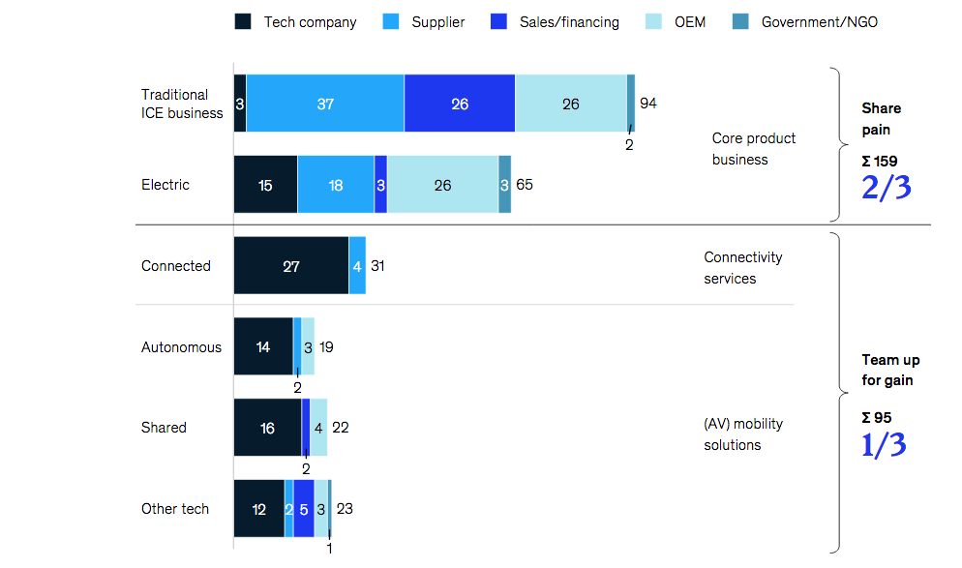
Conclusion
Boosted by several environmental factors such as government support and incentives, climate change concerns and governmental regulations, the EV industry has continued to experience tremendous growth. However, with traditional entry barriers eroded by technology and government support, the industry has become vulnerable to new entrants, increasing competition. Lots of OEMs and new entrants have entered the market to enjoy the benefits and grow their market shares while incumbents have invested in order to stay in business. As per the five forces all the five forces are high, a sign of low profitability and unattractiveness. In order to survive in the evolving industry, OEMs should forge partnerships with battery manufacturers and tech startups in order to cut costs, one of the major issue impacting adoption.

PART 2 – New opportunities
A. Porters generic value chain & conclusion (adapted to electric vehicles)
Porters generic value chain is a framework first developed by Michael Porter to illustrate how firms can perform certain sets of activities within their firm in order to deliver superior value and competitive advantage compared to competitors. Such value can be in form of low-cost advantages or differentiation. As a product passes through a chain of activities, it gains some value (Grant 2016). The electrification of the auto industry will change the entire industry value chain by eliminating lots of activities that have been core ICE car especially in production and marketing mas shown in the table below;

 | EV Industry Value Chain
SUPPORT ACTIVITIES | TECHNOLOGY DEVELOPMENT | EV technology development is taking two different technological pathways; the conversion route or the purpose-built route. Battery development is cornerstone of EV value chain and not the internal combustion engine but outsourcing may play a crucial role, which may change strategy focus of OEMs from production to design, sales and marketing as sources of competitive advantage.
SUPPORT ACTIVITIES | HRM | The electrification of ICEs is already creating challenges for human capital. There is a scarcity of chemical engineers already, crucial in working with battery technology. Other areas of HRM changes is increased importance of cyber security personnel and engineers with AI/robotics skills in the auto industry.
SUPPORT ACTIVITIES | PROCUREMENT | While EVs have fewer moving parts (around 20) compared to ICE cars (plus 2000), component suppliers will become more powerful partners with OEMs, due to supplying fewer but higher value components.
SUPPORT ACTIVITIES | FIRM INFRASTRUCTURE | Electrification will change firm infrastructure depending on whether OEM pursue conversion or purpose-built production strategy. Key challenge is quality control when IT and electrical components dominate EVs
SUPPORT ACTIVITIES | INBOUND LOGISTICS | OPERATIONS | OUTBOUND LOGISTICS | MARKETING & SALES | SERVICE
 | With less components in EV cars and high automation, traditional assembly processes will be reduced with fewer mechanical and logistical processes. | Depending on whether firms take conversion or purpose-built production, the auto assembly plant is predicted to become smaller. The typical EV factory will do away with many mechanical operations such as welding and gluing with IT/electronics dominating. | As car sales distribution shifts ever more towards ecommerce and online sales models, the focus of outbound logistics will shift to company owned warehousing distribution and retail store models and away from dealer networks | Marketing and sales channels will become integral to competitive advantage, so car sales may shift from auto dealer networks to OEM run EV retail shops e.g. Tesla case. | After-market auto-parts suppliers and fuel stations will lose out. New sources of value will arise e.g. charging stations.
PRIMARY ACTIVITIES

B. New business opportunities
McKinsey (2014) have estimated that it will require an estimated investment of at least US$6trillion in new EV infrastructure that is essential to the production and running of EVs globally. Such infrastructure will include new charging infrastructure, utility upgrades, new repair networks capable of servicing EVs, battery recycling facilities etc.
One of the first opportunities for exploitation is in utilities that supply electricity to the grid that EVs will be plugged in. According to Deloitte (2019), demand for electricity across major markets such as the US, Europe and China will increase as adoption of EVs continues with opportunities arising in form smart grid control technology, as well as partnering with utilities in terms of using grid energy storage facilities via off-peak charging as well as recycled batteries.
Secondly, new business opportunities for entrepreneurs and business executives to invest in charging infrastructure (both hardware and installation). While it’s the public sector that’s currently leading in terms of investment in this sector, demand for charging infrastructure currently exceeds supply, which will require private investment in the coming years if the EV sector is to reach commercial viability. In the US, private firms such as Charge Point are investing in business opportunities adjacent to charging e.g. billing and payments (McKinsey 2014). Business opportunities also lie in solar powered charging panels or stations.
Thirdly, business opportunities exist in battery management, especially in battery life cycle management. According to Simlett et al (2019) there will be an estimated global stockpile of 3.4million EV batteries by 2025, compared to 55,000 today. Given that EV batteries retain 50-70% of their energy performance, automakers and entrepreneurs will access new commercial opportunities arising from their use, reuse and recycling. This explains why some utility companies are already setting up and acquiring second-life battery businesses. Others are reconfiguring them for use in less energy consuming applications such as power backups for buildings and other applications (Simlett et al 2019).
Another business opportunity will be for those companies providing technology that supports an autonomous, connected, and shared EV transportation system including IT, software, electronics and e-motor component makers. This opportunity will extend to the semiconductor industry due to the fact that a typical EV needs to use three times the dollar value of semiconductor ingredients in comparison to a traditional combustion engine car. Garner research forecasts that between 2018 and 2023, growth in EV semiconductors will be more than 22%, with wide bandgap semiconductors (used in power transistors for EVs) already showing 55% growth in 2018, but the flexibility of the electric motor is pushing them into a range of new applications (Ray 2019).
C. Discontinued businesses
As countries such as the UK and France introduce plans to ban sales of petrol and diesel cars by 2040, the writing is on the wall for major oil multiples and the petroleum industry, who arguably stand to lose most from the rise of electric vehicles (Ward 2017). This is because as the world makes a transition to EVs, demand for oil is forecasted to decline as shown in figure below;

Figure 1: Global oil demand
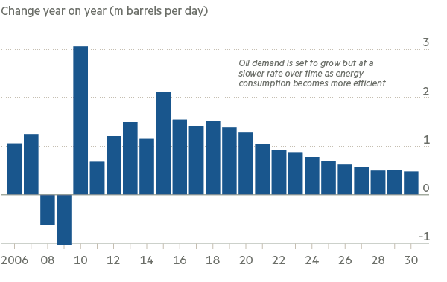Source: Ward 2017
Research already shows that the economics of renewable energy such as solar and wind generated electricity are already making it hard for oil to compete at current prices given the fact that renewable electricity alone has a zero marginal cost in the short-run on top of its other benefits over oil such as its environmentally cleaner, easier to transport and is projected to replace up to 40% of the global demand for oil (Scott 2019).
The fact that the economics of using oil to power petrol and diesel cars compared to the use of wind- and solar-powered EVs are in decline, the implications for oil majors as well as policy makers might be far reaching (Scott 2019). Nevertheless, while oil companies face the real possibility of decline in demand when it comes to use of fossil fuels in an era of EVs, there is disagreement as to when this will happen and the scale of impact. Companies such as Exxon Mobil and Shell believe oil demand will continue to grow into the 2040’s albeit at a slower pace with most of demand being driven by the developing world which will cannot simply make the switch from ICE vehicles due to lack of infrastructure (Ward 2017).
It is estimated that cars with traditional combustion engines require atleast 2,000 moving parts to power their powertrains compared to EV cars that require less than 20 moving parts for the electric powertrains (Deloitte 2019; Kahn 2019). A lot of suppliers in the supply chain whose business model has been built around supplying many of the components of the internal combustion engine, gearbox and transmission, will see some of their production businesses discontinued.
Other businesses that could face discontinuation as a result of the ascendance of EVs include the traditional automotive aftermarket that includes auto spare parts dealers who will face immediate decline in demand for certain auto-parts that power the ICE powertrain. This will especially impact the smaller and independent car repair shops who may have to revise existing strategies (Dombrowski and Engel 2014).
Conclusion
As the world prepares for the expected ascendance of EVs, debate continues on the impact of electrification on the existing value chain. The changes likely to occur and the impact will largely also depend on the strategy the majority of OEMS decide to pursue such as conversion or purpose built. Nevertheless, analysts still expect to see many players facing challenges including oil majors who might experience serious disruption to their business model as demand for oil slows. Outside of production, the EV market is going to present opportunities across investments in sectors such as charging stations, utilities, battery life cycle management services and recycling.

Part 3 – Conclusion
The electrification of the automobile industry has been on an upward growth trajectory this decade both in terms of units sold and produced. The growth of electric vehicles is a result of a number of both macro and micro factors with the three biggest macro drivers being government, consumer demand and technological breakthroughs especially in battery developments. As a result, EV sales are anticipated to begin accounting for a higher number of all vehicles sales by 2030 due to the ever-decreasing prices of batteries, which still account for upto 50% of the value of EVs.
Like most changes across industries, the drive towards electrification is bringing with it opportunities as well as threats for both incumbent OEMS as well other players. Opportunities for investment that are emerging include utilities, charging stations, battery life cycle management services and recycling. On the other hand, the anticipated decline in demand for oil in the long run has far reaching implications for oil majors as well as policy makers in terms of proper planning, to avoid unnecessary disruptions to economies and supply chains.

References
Albrahim, M., Zahrani, A.A., Arora, A. et al (2019) “An overview of key evolutions in the light-duty vehicle sector and their impact on oil demand” Energy Transit, 3: 81–103 doi:10.1007/s41825-019-00017-7
Biswas Asit and Tortajada Cecilia (2018) “Electric vehicles are changing the world. And they’re only just getting started” The Conversation [Online] at https://theconversation.com/electric-vehicles-are-changing-the-world-and-theyre-only-just-getting-started-90402
Collinson Patrick (2019) “Coming soon: the £24 charge for driving into central London” The Guardian [Online] at https://www.theguardian.com/politics/2019/jan/05/london-ultra-low-emission-zone
Deloitte (2019) “New market. New entrants. New challenges. Battery Electric Vehicles” [Online] at https://www2.deloitte.com/content/dam/Deloitte/uk/Documents/manufacturing/deloitte-uk-battery-electric-vehicles.pdf
Dombrowski, U., & Engel, C. (2014) “Impact of Electric Mobility on the after Sales Service in the Automotive Industry” Procedia CIRP, 16: 152-157
Fredriksson, G., Roth, A., Tagliapietra, S. and Veugelers, R. (2018) “Is the European automotive industry ready for the global electric vehicle revolution?” Policy Contribution [Online] at https://bruegel.org/wp-content/uploads/2018/12/PC-26_2018_1.pdf
Grant, M. Robert (2016) “Contemporary Strategy Analysis: Text and cases edition” 9th ed., John Wiley.
Hertzke P, Muller N, Schaufuss P, Schenk S and Wu T (2019) “Expanding electric-vehicle adoption despite early growing pains” McKinsey & Company [Online] at https://www.mckinsey.com/industries/automotive-and-assembly/our-insights/expanding-electric-vehicle-adoption-despite-early-growing-pains
Johnson, G., Scholes, K., Regner, P., Angwin, D., and Whittington, R. (2017) “Exploring strategy: Text and cases” 11th ed., Pearson Education
Kahn, Jeremy (2019) “Inside James Dyson’s Costly Decision to Kill His Electric Car” Fortune [Online] at https://fortune.com/longform/james-dyson-electric-car-appliances/
McKinsey (2014) “Electric vehicles in Europe: Gearing up for a new phase” [Online] at https://www.mckinsey.com/featured-insights/europe/electric-vehicles-in-europe-gearing-up-for-a-new-phase
Montgomery Gavin (2019) “Can Metals Supply Keep Up With Electric Vehicle Demand?” Forbes [Online] at https://www.forbes.com/sites/woodmackenzie/2019/07/24/can-metals-supply-keep-up-with-electric-vehicle-demand/#14e0a8eb6c9b
Mullins Laurie J (2016) “Management and Organizational Behavior” 11th Edition; Pearson Education.
Ray, Bill (2019) “Forget smartphones, electric cars will drive semiconductor growth” Gartner [Online] at https://blogs.gartner.com/bill-ray/2019/08/27/electric-cars-will-drive-semiconductor-growth/
Scott, Mike (2019) “Economics of Electric Vehicles Mean Oil's Days As A Transport Fuel Are Numbered” Forbes [Online] at https://www.forbes.com/sites/mikescott/2019/09/02/economics-of-electric-vehicles-mean-oils-days-as-a-transport-fuel-are-numbered/#fe334c451020
Simlett, J., Mortier, T., & Valsan, A. (2019) “Why the EV battery life cycle is more important than the battery life” Ernst & Young [Online] at https://www.ey.com/en_gl/automotive-transportation/why-the-ev-battery-life-cycle-is-more-important-than-the-battery-life
Stringer David (2019) “The U.S. and Europe Are Getting More Anxious About EV Battery Shortages” Bloomberg [Online] at https://www.bloomberg.com/news/articles/2019-07-08/u-s-europe-getting-more-anxious-about-ev-battery-supply-crunch
Teece David J (2018) “Tesla and the Reshaping of the Auto Industry” Management and Organization Review, Volume 14, Issue 3; pp. 501-512.
Ward, Andrew (2017) “Rise of electric cars challenges the world’s thirst for oil” Financial Times [Online] at https://www.ft.com/content/3946f7f2-782a-11e7-a3e8-60495fe6ca71
Worthington, I., and Britton, C. (2014) “The Business Environment” 7 th ed., Pearson Education.

