

Student name: Adriana Rodrigues Bissoli
Student ID: 2337158
Module name: Principles of Health and Social Care Practice.
Component: 1
Module code: BMHP5016
Lecturer name: Dr. Itse Olaoye
Date: 28 November 2025

Contents

1. Introduction 3
2. Task 1: The Reflection on the importance of Principles of Health and Social Care. 3
3. Task 2: Practical Example of Concepts in Practice. 5
4. Task 3: Self-Reflection as a Health and Social CareProfessional. 6
Description 6
Feelings 7
Evaluation 7
Analysis 7
Conclusion 7
Action Plan 8
Conclusion 9
References 10

1. Introduction
A person's values, interests, and experiences are given priority in person-centred care, which guarantees that treatment is tailored to promote autonomy, dignity, and overall welfare. It places a strong emphasis on meaningful communication and cooperative decision-making between healthcare providers and clients. The purpose of this reflective report is to critically analyse the use of person-centred concepts in a particular care interaction, considering both the positive and negative aspects. The study aims to improve professional understanding and support the creation of more compassionate and responsive practice by referencing pertinent theory and reflective frameworks.

2. Task 1: The Reflection on the importance of Principles of Health and Social Care.
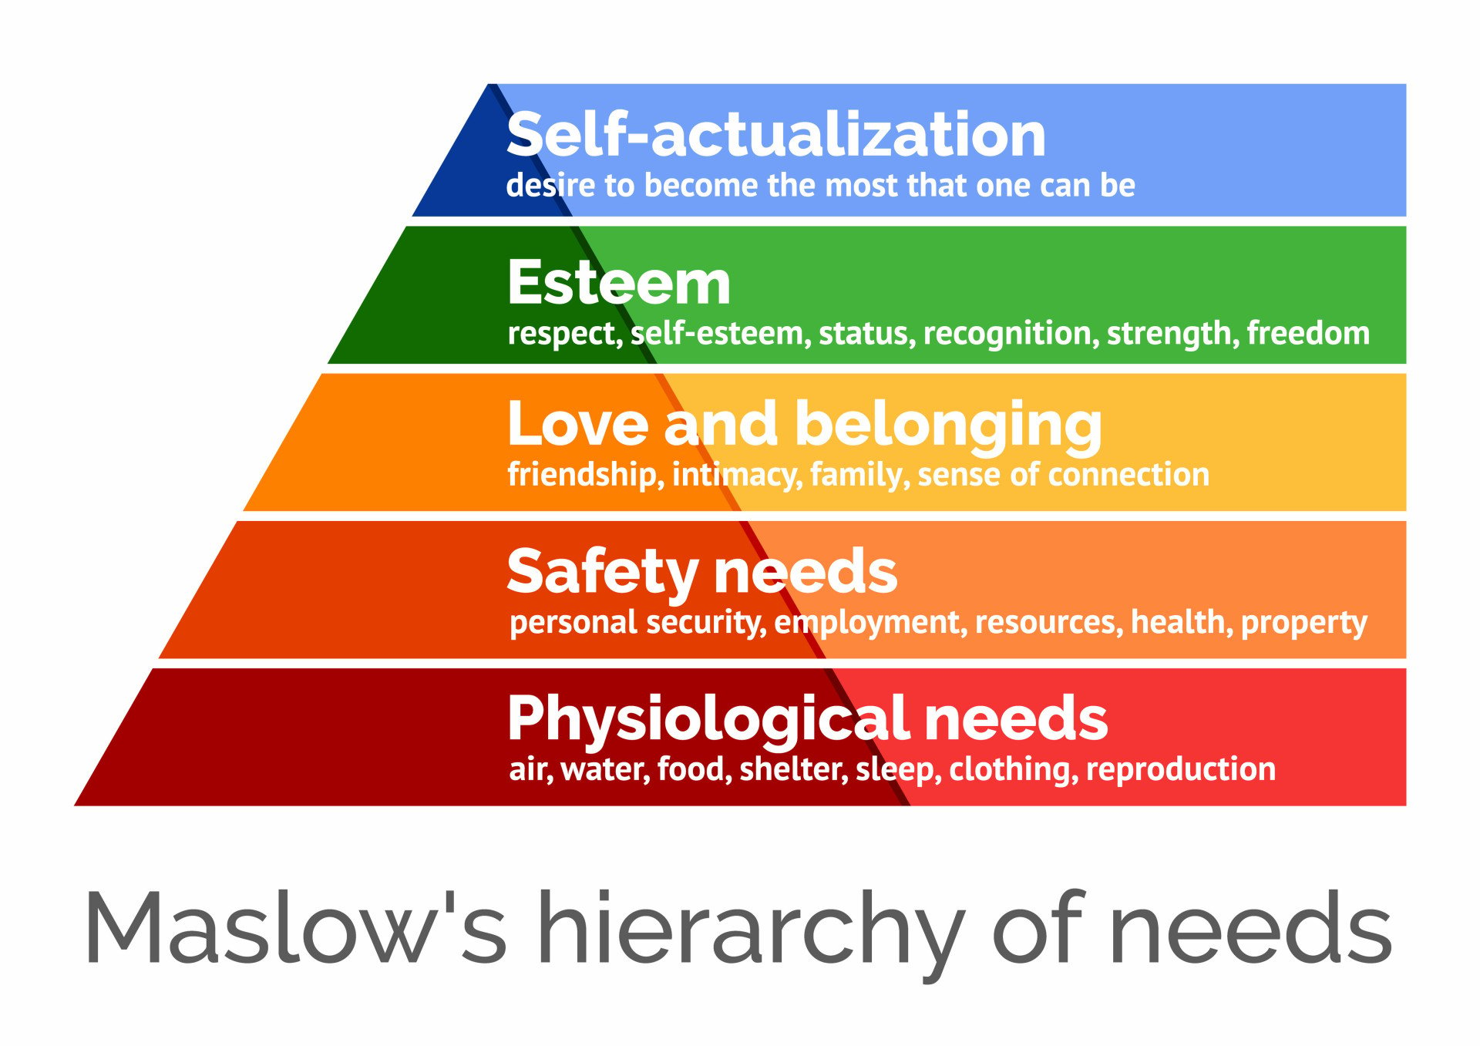 (McLeod, 2025).
Person-centred care is a philosophy that prioritises the individual’s unique needs, values, and life context in the planning and delivery of health and social care. Rather than viewing care as a set of standardised interventions, person-centred care involves collaborating with individuals and often their families to co-create care plans that reflect what matters most to them. According to Health Education England, it means ensuring that people’s preferences, needs, and values direct clinical decisions, and that care is respectful and responsive. The Local Government Association further explains that a truly person-centred service gives people dignity, personalised support, coordination across services, and helps them build on their own strengths. In UK practice, this approach improves outcomes, enhances satisfaction and supports autonomy, while aligning with regulatory standards such as those set by CQC and statutory requirements under the Care Act 2014. (Department of Health & Social Care, 2025).

Partnership working meanwhile refers to the deliberate cooperation between a wide range of stakeholders NHS bodies, local authorities, voluntary organisations, service users, and carers in designing, planning, and delivering care services. In England, the Integrated Care Systems (ICSs), formalise this collaboration, bringing together health and social care organisations in local areas to produce joint strategies and shared plans. NHS England describes partnerships as a golden thread through ICSs, partners must plan together, listen to communities, and deliver care as locally as possible. Such working is important because it reduces fragmentation, aligns resources, and ensures that services are better tailored to local populations’ needs meaning people receive more coherent and efficient care. (NICE, 2023)

Ethics is foundational to both person-centred care and partnership working. In UK health and social care, ethical principles are formalised in professional codes and regulatory frameworks. For example, the Health and Care Professions Council HCPC, sets out standards requiring professionals to treat service users with dignity, involve them in decisions, respect confidentiality, and work within their competency. The four key moral principles often guiding decisions are autonomy respecting people’s right to make informed choices, beneficence acting in the person’s best interest, non-maleficence avoiding harm, and justice fairness in treatment and resource allocation. These principles ensure that care is not only clinically effective but morally sound and respectful of individuals. (NHS Providers, 2022).
In the UK context, combining these three concepts person-centred care, partnership working, and ethics strengthens health and social care practice significantly. Person-centred care ensures that services align with what individuals truly value, partnership working brings different bodies together to deliver seamless, efficient care, and ethics underpins all decisions so that services are delivered fairly, transparently, and with respect for people’s rights. Together, they support a more integrated, compassionate, and just system that places people at the heart of care delivery.
Credible sources are reliable and trustworthy materials used to support learning, research, and decision-making in Health and Social Care. These include academic journals, government publications, and professional guidelines written by qualified experts. Using credible sources is important because it ensures that information is accurate, evidence-based, and up to date. This helps professionals provide safe and effective care, follow current policies, and make informed decisions that protect service users’ wellbeing. Evaluating credibility also prevents misinformation and promotes ethical, professional practice. (Tomaselli et al., 2020).

3. Task 2: Practical Example of Concepts in Practice.

In UK health and social care practice, embedding the principles of person‑centred care, partnership working and ethics leads to tangible improvements in outcomes. For example, in a community rehabilitation setting, can be observed, a patient recovering from a serious illness was supported by a multidisciplinary team. The team asked what mattered most to them returning to local walks, visiting family, and managing their own meals. The care plan was then adapted around those preferences. Therapists scheduled sessions to fit the patient’s home routine, social work arranged a minor home adaptation and nursing provided follow‑up visits timed around their personal commitments. As a result, the patient regained mobility faster, reported higher satisfaction, and avoided an unplanned readmission. This practical experience resonates with findings about person‑centred care in care homes for stroke survivors an ethnographic study in England found that when staff engaged fully with residents’ individual lives and goals, outcomes improved. (Teasell et al., 2020).
Partnership working comes into view when services join up across organisational boundaries. A published UK study of local collaboration between health care, social services and other sectors under recent system reforms shows that cross‑sector working helps reduce health inequalities and improve access for underserved populations. In one professional placement the social service recall when part of a discharge planning meeting to be involving the hospital team, the local authority, and a voluntary support organisation. Together we designed a transition home with coordinated input hospital physiotherapy, community nursing, social care visits and family training. The patient’s transition was smoother, fewer complications arose, and they reported feeling better supported. That collaboration meant fewer duplicated home visits, clearer communication, and a more person‑centred experience. (sutton.gov.uk, 2023)
Ethical practice threads through both. In the rehabilitation example, respecting the person’s autonomy by asking their goals and involving them in decisions-built trust and engagement. The multi‑agency transition project included ethics because the team ensured confidentiality, challenged assumptions about what the patient should want, and supported equality of access. UK ethics article Sharing whilst caring shows how data‑driven innovations raise questions of trust, dignity and human rights in care practice. Embedding ethical reflection in everyday care leads to safer, fairer support and better outcomes.
Published case studies reinforce this for instance, a 2024 multiple‑case study found that care homes implementing person‑centred approaches achieved better quality of life for residents, with staff adopting values of respect, empowerment and collaboration. In practice this means care is not just done to the person but with them, decisions are shared, and services join up rather than work in silos. The benefits include increased engagement, fewer hospital admissions, improved wellbeing and more efficient use of resources.
Ethics, person‑centred practice and partnership working thus operate as inter‑related pillars. When people feel heard and respected person‑centred, when organisations collaborate partnership, and when care is guided by fairness, autonomy and dignity ethics, then health and social care outcomes improve. The staff have worked with often comment that having meaningful conversations about what matters to the service user changes the dynamics motivation rises, adherence improves, and minor issues are addressed earlier, preventing escalation.
In a UK context facing stretched services and complex needs, these principles are more than ideals they are practical levers for improvement. Using case‑in‑point experiences and recent UK research shows that embedding these approaches reduces fragmentation, builds trust, and leads to measurable gains in wellbeing and independence. Kayes, N.M. and Papadimitriou, C. (2023).
Reflecting on challenges and opportunities for the practice of person-centred rehabilitation. (Kayes and Papadimitriou, 2023)

4. Task 3: Self-Reflection as a Health and Social CareProfessional.

Self-reflection is a critical component of professional development in health and social care, enabling practitioners to evaluate experiences, identify strengths, and address areas for improvement. Gibbs Reflective Cycle (1988) provides a structured framework through six stages description, feelings, evaluation, analysis, conclusion, and action plan encouraging systematic reflection. By applying Gibbs model, professionals can enhance clinical practice, foster empathy, and promote continuous learning, ultimately improving patient outcomes and personal growth.

Description
During my community rehabilitation placement, I supported an older adult recovering from a hip fracture. The goal was to help them regain independence safely at home. I worked with physiotherapists, occupational therapists, and social care staff to deliver a coordinated rehabilitation plan. The experience highlighted how central person-centred care, partnership working, and ethical practice are to my development as a practitioner.

Feelings
At first, I felt uncertain about contributing to a complex case, especially where multiple agencies were involved. I worried about saying the wrong thing or not understanding my role clearly. However, as I spent more time with the service user and the team, I became more confident. I also felt a strong sense of responsibility, knowing the individual relied on us to help them regain function and dignity.

Evaluation
The experience had several positive aspects. Working in a person-centred way meant tailoring exercises and daily living tasks to the individual’s goals rather than relying on standard templates. This improved their motivation and engagement. Partnership working also proved beneficial; communication between team members ensured that the plan was consistent and safe. However, I also recognised challenges. At times, information-sharing felt slow, and coordinating visits across different services required patience and flexibility.

Analysis
This experience reinforced the importance of person-centred care in rehabilitation. When the service user expressed that their main goal was being able to prepare meals independently, the team adjusted the programme to focus on kitchen-based tasks and safe movement. I realised that person-centred approaches not only respect autonomy but also significantly improve outcomes. Partnership working taught me how shared decision-making and consistent communication reduce risks and prevent duplicated or conflicting interventions. I learned the value of respecting professional boundaries while also recognising the overlap in roles within multidisciplinary teams. Ethical considerations were present throughout: gaining informed consent, protecting confidentiality during home visits, and ensuring fairness in resource allocation. These ethical foundations helped build trust and supported the service user to take an active role in their own recovery.

Conclusion
Overall, the experience strengthened my understanding of how these principles interact in real practice. I recognised that person-centred care cannot exist without ethical communication, and effective partnership working is essential for safe and meaningful rehabilitation. I also identified areas where I can grow, such as improving assertiveness during team discussions and developing clearer communication strategies with colleagues.

Action Plan
Going forward, I plan to enhance my knowledge of community rehabilitation pathways and attend multidisciplinary team meetings more proactively. I will continue practising reflective journaling to identify biases and areas for improvement. I also aim to develop stronger communication skills by observing experienced practitioners and seeking feedback. By focusing on these areas, I can strengthen my ability to deliver ethical, collaborative, and person-centred support in future practice.
Throughout my work in community rehabilitation, I have applied Maslow’s Hierarchy of Needs to understand service users’ physical, emotional, and social priorities during recovery. Meeting basic needs, such as safety and belonging, supports progress toward independence and self-actualisation. My reflections also align with the Care Act 2014 and Health and Care Act 2022, which promote person-centred, integrated, and ethical care. Adhering to professional codes of conduct ensures accountability, respect, and safeguarding. Together, these frameworks guide my decisions, enhance reflective practice, and ensure care that is lawful, compassionate, and focused on holistic wellbeing. (Health and Care Act, 2022).
In real UK healthcare settings, principles such as person-centred care, partnership working, and ethical practice are essential for delivering high-quality support. For example, professionals collaborate across services to design care plans that reflect individuals’ needs and choices. In my future career, I will apply these principles by actively involving service users in goal setting, communicating effectively with multidisciplinary teams, and upholding confidentiality and respect. By following national frameworks like the NHS Long Term Plan and Care Act 2014, I aim to promote independence, equality, and dignity in every aspect of my professional practice. (Legislation.gov.uk, 2022)

Conclusion

In conclusion, person-centred care is a cornerstone of effective practice within community rehabilitation and wider Health and Social Care. It ensures that care is guided by the unique needs, preferences, and goals of everyone rather than a one-size fits all approach. Throughout my reflections and experiences, listening to service users, valuing their choices, and involving them in decision-making promotes recovery, empowerment, and independence.
Person-centred care also strengthens relationships between professionals and service users by fostering trust, respect, and open communication. In a rehabilitation context, this means developing care plans that recognise not only physical recovery but also emotional, social, and psychological wellbeing.
When practitioners understand what truly matters to people such as returning
to daily routines or hobbies, they can design more meaningful interventions.
Collaboration and partnership working play a vital role in achieving this approach. Multidisciplinary teamwork allows for holistic support, as professionals from different backgrounds share knowledge and coordinate care effectively. Ethical practice, guided by frameworks such as the Care Act 2014 and Health and Care Professions Council (HCPC) Standards of Conduct (2023), ensures that person-centred care is delivered safely, fairly, and with respect for autonomy and dignity. (Carla Mendes Pereira et al., 2024).

References

Department of Health & Social Care (2025). Care and Support Statutory Guidance. [online] GOV.UK. Available at: https://www.gov.uk/government/publications/care-act-statutory-guidance/care-and-support-statutory-guidance. (Accessed 18th November 2025).
Guy, M. and Newcombe, L. (2025). NHS Patient Choice Policy in England: What Mapping the Private Healthcare Market for NHS Patients Can Tell Us. Liverpool Law Review. doi:https://doi.org/10.1007/s10991-025-09395-z. (Accessed 18th November 2025).
‌ Health and Care Act (2022). Health and Care Act 2022. [online] Legislation.gov.uk. Available at: https://www.legislation.gov.uk/ukpga/2022/31/contents. (Accessed 18th November 2025).
‌ www.england.nhs.uk. (n.d.). NHS England» Case studies. [online] Available at: https://www.england.nhs.uk/gp/case-studies/. ( Accessed 18th November 2025).
Kayes, N.M. and Papadimitriou, C. (2023). Reflecting on challenges and opportunities for the practice of person-centred rehabilitation. Clinical Rehabilitation, 37(8), p.026921552311529. doi:https://doi.org/10.1177/02692155231152970. (Accessed 19th November 2025).
Teasell, R., Salbach, N.M., Foley, N., Mountain, A., Cameron, J.I., Jong, A. de, Acerra, N.E., Bastasi, D., Carter, S.L., Fung, J., Halabi, M.-L., Iruthayarajah, J., Harris, J., Kim, E., Noland, A., Pooyania, S., Rochette, A., Stack, B.D., Symcox, E. and Timpson, D. (2020). Canadian stroke best practice recommendations: Rehabilitation, recovery, and community participation following stroke. part one: Rehabilitation and recovery following stroke; 6th edition update 2019. International Journal of Stroke, 15(7), p.174749301989784. doi:https://doi.org/10.1177/1747493019897843. (Accessed 20th November 2025).
NHS Providers (2022). A guide to the Health and Care Act 2022. [online] Nhsproviders.org. Available at: https://nhsproviders.org/resources/a-guide-to-the-health-and-care-act-2022. (Accessed 20th November 2025).
Carla Mendes Pereira, Matos, M., Carvalho, D., Macedo, P., Calheiros, J.M., Alves, J., Luís Paulino Ferreira, Dias, T.L., Rui Neves Madeira and Jones, F. (2024). Building Bridges between People with Stroke, Families, and Health Professionals: Development of a Blended Care Program for Self-Management. Journal of clinical medicine, 13(1), pp.300–300. doi:https://doi.org/10.3390/jcm13010300. (Accessed 20th November 2025).
sutton.gov.uk. (2023). Sutton Council’s adult social care services rated ‘good’ by CQC. [online] Available at: https://www.sutton.gov.uk/w/sutton-council-s-adult-social-care-services-rated-good-by-cqc. (Accessed 20th November 2025).
Mpft.nhs.uk. (2025). Community Stroke Rehabilitation :: Midlands Partnership University NHS Foundation Trust. [online] Available at: https://www.mpft.nhs.uk/services/community-stroke-rehabilitation-services/rehabilitation-community-stroke-team. (Accessed: 19th November 2025).
NICE (2023). Recommendations | Stroke Rehabilitation in Adults | Guidance | NICE. Available at: https://www.nice.org.uk/guidance/ng236/chapter/Recommendations. (Accessed: 20th November 2025).
McLeod, S. (2025). Maslow’s hierarchy of needs. [online] Simply Psychology. Available at: https://www.simplypsychology.org/maslow.html. (Accessed 27th November 2025).
Tomaselli, G., Buttigieg, S., Rosano, A., Cassar, M. and Grima, G. (2020). Person-Centered Care From a Relational Ethics Perspective for the Delivery of High Quality and Safe Healthcare: A Scoping Review. Frontiers in Public Health, [online] 8(44). doi:https://doi.org/10.3389/fpubh.2020.00044. (Accessed 27th November 2025).
York St John University (n.d.). Library and Learning Services Study Development. [online] Available at: https://www.yorksj.ac.uk/media/content-assets/document-directory/documents/Reflective-Writing-Gibbs-Model-of-Reflection-Factsheet.pdf. (Accessed 27th November 2025).
‌

‌

‌

‌

‌

‌

‌

‌

