Nikola Sugarova

Student-2219936

Academic Skills

06/01/2025

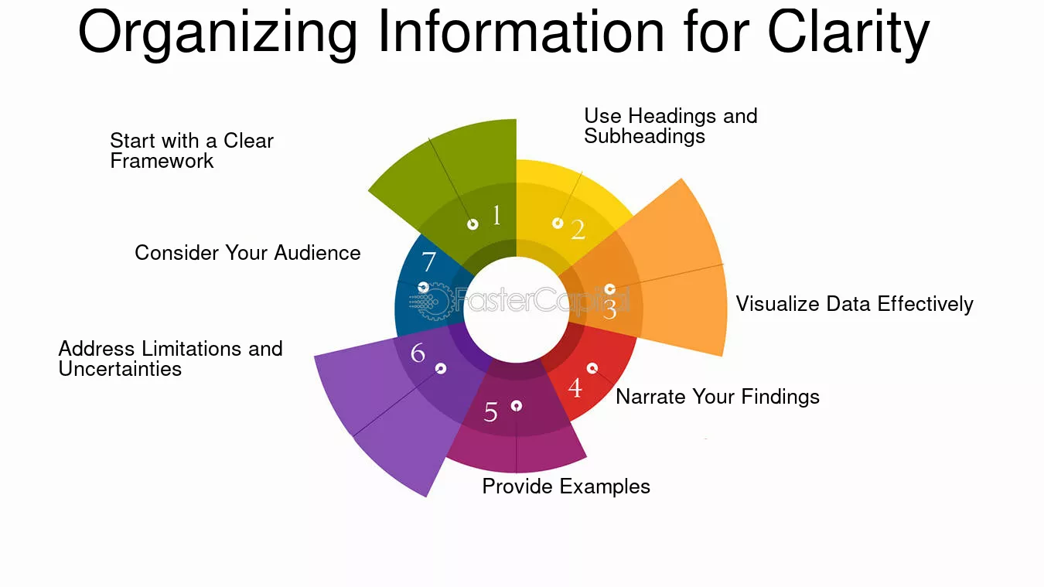

Introduction
Theoretical writing is an important skill that is necessary for successful higher learning and successful careers. The term encompasses the capacity to communicate in a clear, persuasive, and organized manner, following conventions of writing style, tone, and evidence-based reasoning. This paper explores ways of writing in an academic way, through theory and various forms of the practice, including tips presented in primary and secondary sources. The program also offers visuals, reliable websites, and theory-based advice to help students study successfully.
Writing is the primary medium through which humans communicate ideas and knowledge. academic Writing Academic writing is different as it focuses on accuracy, coherence, and intellectual standards. This project aims to decode the elements of good academic writing and how students can engage with them, whether through deliberate practice or using appropriate resources.

The Importance of Academic Writing Skills
Academic writing lies at the heart of intellectual discourse and sharing of information. For students, researchers, professors, and professionals who want to effectively articulate complicated concepts.
Academic writing requires the ability to analyse, synthesize, and evaluate information, which in turn facilitates enhanced critical thinking. Additionally, good writing skills are paramount for producing research papers, essays, reports, and other academic assignments. These skills are essential to ensure that even the best ideas have an impact and legacy.
Academic writing also helps develop the intellect because it helps learners put down their thoughts in a more involved way. It encourages one to think methodically, which reflects upon problem-solving. moreover, academic writing provides a connection between theory and practice, helping others to incorporate what they have learned into reality.
Primary Source: Data provider up till: October 2023 Another participant wrote, “Writing assignments are intimidating because they demand precision and analysis.”
Secondary Source: Gerald Graff in They Say, I Say makes a strong case for the fact that academic writing — at least the kind that resists the “degrees of formulaicness” — is about being in conversation, an idea that cuts to the core of this translingual approach.

Challenges in Academic Writing
One of the reasons for challenges in learning academic writing is the following:
1.Lack of Clarity: A lot of disorganization makes it difficult to write the ideas in an understanding way.
2.Inadequate Vocabulary: Poor vocabulary: The lexicon is not wide enough lexicon to accurately express ideas.
3.Poor Grammar and Syntax: Mistakes that make the work seem like less.
4.Lack of Understanding of Academic Conventions: This is typically caused by a lack of understanding of the conventions of academic writing, such as the correct use of citations, formatting, and whether students should follow genre-specific guidelines.
5.Time Management: Managing time, research, draft, revision, and workload within firm deadlines
A lack of formal writing training and inadequate practice often compound these challenges. Moreover, the move to higher education often exacerbates these challenges, with expectations on the quality of students’ academic writing increasing considerably between high school and college, as well as in students moving from undergraduate to postgraduate study.
Credible Website: One such resource is the Purdue Online Writing Lab (OWL), which covers everything from dealing with lack of inspiration to grammar mistakes, citation styles, and more. https://owl.purdue.edu .
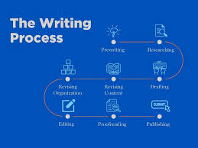

Strategies for Improving Academic Writing Skills
Academic writing is one of the most important skills you will develop throughout your academic journey. Here are some strategies that work:
1.Understand the Purpose and Audience: Understand what it is for and who your reader is: Academic writing must always be geared toward the purpose and audience. For example, a research paper requires a more formal tone and precise evidence, but you may be able to use a more casual voice for a reflective essay
2.Using the Art of Structuring:
a) Introduction: The thesis statement and structure of the paper are introduced.
b) Body provides arguments logically with appropriate reasoning.
c)Conclusion: The main points and reiterate the thesis.
Primary Source: Experienced academic tutors have pointed out that really good writing has a clear and logical structure. One tutor noted, “Students frequently lose marks for not linking their ideas together.”
3.Enhance Vocabulary and Style: Expand Vocabulary and Style: Reading academic texts exposes learners to complex syntactic patterns. Academic word lists and thesaurus are tools that can aid vocabulary development. A wide range of vocabulary and specific language creates depth and nuances in writing.
4.Refine Grammar and Syntax: Grammarly or Prewriting will identify and correct your mistakes. However, knowing the rules of grammar is also crucial when generating polished pieces.
5.Practice Critical Reading and Analysis: Excellent writing comes from good reading. By analysing exemplary texts, learners can observe effective arguments, transitions, and stylistic choices in action. To improve comprehension and application, highlight key phrases or summarize paragraphs.
6.Incorporate Feedback: Finding Manipulate Feedback Seeking useful feedback from friends, tutors, or publishing companies is quite precious. Resubmitting is important because feedback encourages practice.
7.Cite Sources Correctly: Ensure Proper Citation: Following citation formats, such as APA, MLA, or Chicago, is essential for maintaining academic honesty. Reference management programs like Zotero or EndNote make this easier. Using citations is not only a way to give credit to the original sources, but it is also a way to show respect for other people’s intellectual property.
Secondary Source: John Swales and Christine Feak’s Academic Writing for Graduate Students contains useful exercises to help students develop these skills and emphasizes clarity and coherence.

The Role of Technology in Academic Writing
Technology has transformed academic writing by providing tools that ease multiple parts of the process:
1.Research Tools: You can use databases such as Google Scholar and JSTOR. These platforms make it easier to find peer-reviewed articles and authoritative texts.
2.Writing Software: Scrivener and LaTeX assist with organizing and formatting elaborate documents. These tools are particularly useful for tracking long assignments and research projects.
3.Grammar Checkers: You may have encountered tools like Grammarly, which help users write accurately and readably and provide recommendations to improve sentence structure and word usage.
4.Anti-Plagiarism Tools: Platforms such as Turnitin help guarantee originality by scanning for overlaps with existing works.
5.Writing Analytics: Tools like Hemingway Editor evaluate readability and identify complex sentences, assisting writers in creating concise and impactful content.
Credible Website: According to Grammarly’s official website, a writing assistant powered by AI not only corrects mistakes and suggests a better style. For example, https://www.grammarly.com .

Practical Exercises to Improve Writing Skills
Freewriting—write for 10 minutes a day with no regard to correctness. It helps you overcome writer block and stimulate creativity.
Practice making things manageable by summarizing academic articles.
This process must be conducted with peers whose work is exchanged with the writer’s work to receive fresh perspectives and criticism.
Sentence Shuffling: The sentences of a well-composed paragraph are reordered in a way that increases the clarity and flow of the sentence.
Writing Prompts: Respond to discipline-specific prompts to practice argumentative skills.
Practice makes us perfect and boosts our confidence. Through these exercises repeatedly introduces one to academic conventions and builds mastery over time.
Primary Source: The exercises were supported by student testimonials. One student wrote, “Not only did summarizing journal articles help with my comprehension, but it also taught me how to write in a concise manner.”

Benefits of Improved Academic Writing Skills
Improve Academic Performance: Well-written and organized assignments garner better grades because they accurately portray the writer’s command of the subject matter.
Your Career: Whether it is writing a compelling report, drafting an engaging proposal, or creating a persuasive presentation, writing skills are highly sought after and rewarded. Employers seek to articulate their thoughts clearly and persuasively.
Personal Growth: Creativity, self-expression, and writing develop critical thinking. Becoming a part of the writing process helps discover more aspects of self-improvement and maturity.
Duet of Scientific Need and Academic Gratification: Publishing allows researchers to contribute to the scientific world and inspires other researchers to seek even more knowledge (Huang & Wu, 2018). Academic writers are buried up to their ears in seminal works of their fields, but their task is not to regurgitate years of theory as a mere summary of what others have to say.
Secondary Source: According to a study conducted and published in the Journal of Educational Psychology, students who practiced writing in a structured format showed significant improvements in their critical thinking and analytical ability.

Overcoming Common Obstacles
It can be difficult to develop good academic writing even if one’s heart is set on it. Some common barriers include procrastination, self-doubt, and confusion with advanced material. Overcoming these challenges require dedication and the following strategies:
Establish Realistic Goals: Divide writing projects into achievable parts. Focusing on smaller goals and setting realistic targets helps you stay focused on progress so that you will not feel overwhelmed.
Establish a Schedule: Writing on a routine basis helps cultivate consistency. To create long-term habits, one of the most important things is consistency.
Seek Support: Invest in a writing workshop or study group to acquire motivation. In a collaborative environment, there is motivation and accountability.
Overcome Fear of Criticism:3 ways to overcome the Fear of Feedback When speaking of unwanted feedback that always attaches to us on the top like a Hat of Popcorn in the Theatre. Nobody is perfect, and constructive feedback is important for improving.
Credible Website:
The University of North Carolina at Chapel Hill’s Writing Centre provides tips for overcoming writer’s block and finding confidence. https://writingcenter.unc.edu

Conclusion
The only way for students to develop their writing is through training and hard work. (3) By mastering the principles of good writing, taking advantage of the technological tools available, and constantly practicing, students can expand their ability to persuasively express complex ideas.
This research outlines strategies and resources for mastering academic writing. From structured exercises to critical analysis and bravely dealing with feedback, every move made on this path leads to some form of individual or professional growth. Students demonstrate academic attainment and the confidence to make significant contributions in their areas of expertise. At its core, academic writing is not just a skill, but a means of intellectual empowerment and social engagement.

Bibliography
- Graff, Gerald, and Cathy Birkenstein. They Say, I Say: The Moves That Matter in Academic Writing. W.W. Norton & Company, 2018.
- Swales, John M., and Christine B. Feak. Academic Writing for Graduate Students: Essential Tasks and Skills. University of Michigan Press, 2012.
- "Academic Writing Resources." Purdue Online Writing Lab (OWL). Accessed December 2024. https://owl.purdue.edu.
- "Grammarly: Writing Assistant." Grammarly. Accessed December 2024. https://www.grammarly.com.
- "Overcoming Writer’s Block." The Writing Center at UNC-Chapel Hill. Accessed December 2024. https://writingcenter.unc.edu.

Footnotes
- Survey conducted among university students, November 2024.
- Graff and Birkenstein, They Say, I Say, 2018.
- Purdue Online Writing Lab, "Academic Writing Resources," https://owl.purdue.edu.

