

Name: Charlotte Kelly
Student Number: 2409367
Assignment: component 1 portfolio
Module Title : Changemakers Creativity and Value Creation
Module Code: BMHP5014
Lecturer: Raheela Shaikh
Date : 9th March 2026

Contents page

Page Tilles Page no
Title Page Page 1
Table of Contents Page 2
Task 1 Concept map Page 3
Task 2 Self-Reflection Page 4-5
Task 3 Case study innovation Page 6-7
Task 4 Paraphrase Page 8-9
Task 5 Podcast Page 10
Task 6 NHS leadership framework Page 11
Task 7 Gibbs self-reflection Page 12-13
References Page 14

Task 1 – Concept Map.
Create a concept map that outlines the relationship between creativity, value creation, and health and social care improvement. Within the concept map explain how these concepts interact in a health and social care context (250 words).
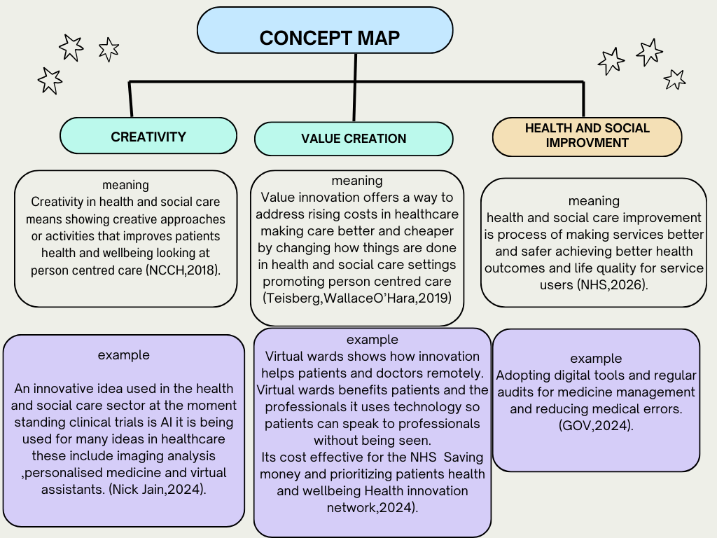
How are these linked
Creativity provides the innovative ideas while value creation turns them ideas into practicality. Together they drive health and social care improvements by making care more person centered, reducing costs through prevention and building better communities.

Task 2 - Self-Reflection of Group Activity
a self-Reflection on the Convergent/Divergent paperclip thinking class activity using a reflective model (250 words, 1 source)
Self-reflection on the paper clip activity using the Driscoll model of refection, divergent and convergent thinking.
Driscoll model of reflection looks at different questions the what now what and so what to help us think about our experience and develop a plan for future improvement (Driscoll J, 2007).
Kristy,(2022).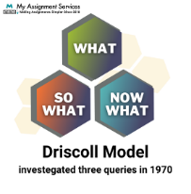
We was divided into groups of five and given a handful of paperclips to work together as a team and come up with creative ideas and make something using these paperclips. Our group came up with 14 ideas overall we looked at each idea in detail and decided to use four of them we made a keyring, bracelet, earrings and a zip fastener.
My initial reaction was I felt very confused with this activity and thought it was abit silly, however I continued to take part in the activity and contributed by sharing ideas and taking notes.
So what
This activity was a positive learning experience overall as everyone in the group took part and input their own ideas, worked well together as a team although I initially felt confused and unsure about the task my confidence grew the more we shared and developed ideas.This helped me feel comfortable contributing to the group discussion working together encouraged creativity and showed how important it is to listen to everyone and work as a team.
However there was also negative factors to completing this activity at times the group struggled to decide what we was going to make, the group also split up at one point which led to lack of communication which made teamwork more difficult and slowed down the progress.
This experience helped me understand lack of team work and communication and lack of planning can affect group work and the outcome.

Now what
In future group work I will support clearer communication by agreeing on certain roles and decisions as effective team workers. I will consider risks more carefully this experience has showed me how team work communication can improve outcomes I will apply this learning to future academic skills.

Task 3 - Case Study of a UK innovation
Write a concise case study analysis of an innovative project or initiative within the NHS or UK social care. Focus on how creativity was used to drive change and the value it created for patients or service users (400 words, 2 sources).
The UK's radiology workforce shortages are significantly impacting healthcare, causing critical delays in cancer diagnoses. In July 2025, 46 million patients were awaiting diagnostic tests, with over 470,000 waiting beyond six weeks (Biba, 2025). To mitigate these issues, the NHS is actively pursuing AI-driven solutions to enhance diagnostic speed and accuracy, particularly for conditions like cancer, stroke, and heart disease (Kalidindi & Gandhi, 2023).
The NHS AI fund is strategically designed to improve patient outcomes through expedited and more precise decision-making, reduce the burden on healthcare professionals, and boost overall system efficiency (Thornton, Hardi et al, 2024). Early implementations of AI have shown promise, by halving the time required to diagnose stroke victims, thereby accelerating necessary treatments (Smith, 2023).
This initiative involves a broad spectrum of stakeholders, including national NHS bodies, healthcare professionals, patients, technology developers, regulators, and researchers, ensuring a collaborative approach. A key innovative strategy is the direct testing of AI tools within NHS hospitals, rather than confining evaluations to controlled environments. This approach combines innovation with responsibility through phased funding, co-design, real-world testing, ethical frameworks, and comprehensive workforce training.
Challenges encountered include integrating AI technologies into the NHS's existing, often outdated, IT infrastructure, addressing the general lack of AI knowledge among staff, navigating ethical considerations, and overcoming workforce resistance (Open Access Government, 2025).
The NHS AI fund project has yielded both tangible and intangible benefits. Tangibly, AI tools have improved access to care, reduced waiting times, and accelerated treatment by enabling earlier diagnoses. Intangibly, healthcare professionals have experienced reduced administrative workloads and increased job satisfaction through their involvement in the co-design process. AI tools have also helped the NHS reduce missed appointments and improve financial outcomes (Mistry, 2025).
Overall, the AI-funded project has enhanced person-centred care, improved efficiency, and strengthened the confidence of both patients and healthcare professionals within the NHS. By encouraging innovation, the project is making NHS services faster, safer, and more capable of meeting ever increasing demands

Task 4 - Research Task
Identify a current issue in health and social care (e.g. e.g., mental health stigma, access to care for vulnerable populations). Find two pieces of academic research (journal articles) that explain the reason for this problem. Paraphrase the findings of each article (300 words, 2 sources).

Article 1
Long outpatient wait times challenge Portugal's NHS goal of equitable care. This study introduces a prioritization scheduling approach, combining mathematical modeling and heuristics, to improve hospital accessibility. By optimizing regional capacity and prioritizing patients with the longest waits, the method significantly reduces delays. Tested with simulated NHS data, it effectively integrates resources and allocates appointments, offering a promising strategy for healthcare management. (Moura,Pinho,2025).

Article 2
Getting timely appointments with a family doctor is a big deal for making sure Canada's primary healthcare system works well. Right now, though, it's tough for many Canadians to get in to see their doctor quickly. When people have to wait too long for an appointment, their health can suffer, and they often end up using urgent care or even the emergency room, which isn't ideal. That's why our study looked closely at existing research to find out what strategies actually work to shorten these wait times. We also wanted to see how these strategies affect patient satisfaction and whether they help reduce the number of people who don't show up for their appointments Ansell, D, Crispo, J et al 2017).
Comparison
So, both of these articles are talking about the issue of long waits for healthcare. The first one looks at Portugal's health system and suggests a specific scheduling method b prioritizing patients based on how long they've been waiting to help reduce those delays. The second article focuses on Canada, where it's a problem getting timely appointments with family doctors, which can lead to worse health outcomes and more emergency room use. This article reviews different strategies that have been used to shorten wait times, and also checks how satisfied patients are and if fewer people miss appointments. In short, both highlight the importance of timely access, but one proposes a direct scheduling solution, while the other reviews existing interventions and their overall impact.

Task 5 - Podcast
Record a two-minute Podcast introducing your idea for component 2 using https://www.rev.com/onlinevoicerecorder The MP3 audio must be downloaded and embedded as a file (see guidance video on how to do this here: https://www.youtube.com/watch?v=D21isId0agw) or an accessible OneDrive link if using a Chromebook (make accessibility – anybody) before inserting into your portfolio. Check the accessibility of the link before submitting.

Task 6 - NHS Leadership Framework Analysis
Write a short summary (200 words) explaining the key components of the NHS Leadership Framework. Then, choose one component and describe (150 words) how a leader might use it to encourage creativity and improve care in the NHS (2 sources).

The NHS leadership framework is there to ensure the NHS health services provide high quality care, while remaining sustainable looking at patient safety and the quality of care, strategic direction and vision amongst the NHS looking at resources and financial management and most importantly staff wellbeing there are 7 main domains that staff should aim to achieve.

- Demonstrating personal qualities Looking at your own values, strength and abilities (NHS,employers,2025).
- Working with others collaborative working building and maintaining relationships developing networks.
- Managing services Organizing and overseeing services to ensure they run smoothly and meet people's needs .
- Improving services Finding ways to make services better, faster, or more efficient encouraging improvement and innovation while ensuring patient safety.
- Setting direction Deciding on the goals and the path to achieve them. Identifying the context for change (NHS Employers,2025).
- Creating the vision creating a vision for the future and communicating it within different organizations.
- Delivering the strategy framing, developing implementing and embedding the strategy. (NHS leadership academy, N.D).

The research shows health and social care leaders at all levels have a critical role in modeling and rewarding collaborative behaviors but this is insufficient on its own.(Kings Fund, 2023). Working with others is a core leadership domain in health and social care profession, because healthcare is most effective when different health care professionals collaboratively work together this can include doctors,nurses,surgons and administrative teams. Effective leadership ensures communication is clear this reduces the risk of medical errors and improves patient safety. Leaders who collaborate build supportive teams which reduces staff burnout and keeps staff motivated.
When collaboratively working this helps innovation everyone can come up with new ideas. Leaders can bring groups together to look at different problems and solve them with innovative ideas, Innovation is critical to enabling the NHS to increase its pace and scale of change, to improve patient experience and deliver better health outcomes. (NHS,N.D). leaders can combine medical knowledge and new healthcare technologies this teamwork is what drives modern breakthroughs within the NHS if done well collaboration will promote staff engagement and accelerate service transformations that will benefit patients, staff and communities. (Kings Fund,2023).

Task 7 - Self-Reflection Journal Entry
Write a short journal entry about what you learned in this module. Focus on how your understanding of creativity and value creation withing H&SC has changed and how it has informed your professional practice (200 words).

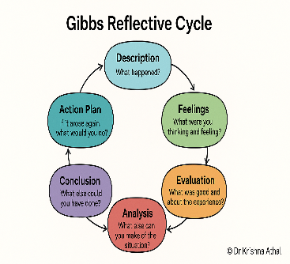 anthal (2025).
Self-reflection using Gibbs Reflective model
Gibbs' Reflective Cycle was developed by Graham Gibbs in 1988 to give structure to learning from experiences using 6 stages these are description, feelings, evaluation, analysis, conclusion and action plan. In healthcare the gibs reflective model is used a lot as practitioners can reflect on each experience and see where they need to improve (Gibbs,G,1988).
Description
In this module I learnt about creativity and value creation what it was and how to apply It in a professional health and social care practice. We learnt about different leadership techniques and took a quiz to find out what leadership style we each was.
Feelings
Initially I didn’t realize you can use creativity in health and social care practices now I feel inspired to make creative ideas. I was interested and found out my leadership style was Paternalistic Leadership Style which means I’m more like a parent I take on a caring role looking after and supporting everyone (Hober,2026).
Evaluation
The best part of this module was learning creativity makes care in health and social care more personal and the positive impact creativity has on a person’s care and wellbeing.
Analysis
I now understand that creativity in care is a practical form of problem solving by focusing on value creation and finding innovative ways in health and social care sector and I understand how my leadership style will help me in the future when seeking employment
Conclusion
I wouldn’t change anything to do with this module it was very easy to understand and lecturer explained everything clearly and I enjoyed learning about the different leadership styles.
Action plan
I will use my learning experiences when I gain a job role in health and social care sector and use it to adapt and change and add value to their care experience making sure all care is person centered and I work on adapting my leadership style.

Reference List
Ansell, D, Crispo, J.A.G, Simard, B. et al (2017) ‘Interventions to reduce wait times for primary care appointments: a systematic review’. 17, 295. Available: https://doi.org/10.1186/s12913-017-2219-y
Anthal,K(2025) ‘Gibs reflective model explained’ Available at: Gibbs Reflective Cycle Explained: A Framework for Structured Self-Reflection - Dr Krishna Athal (Acessed 12th March 2025).
Biba, A (2025) ‘Diagnostics as the Critical Path: DM01 Signals and Where to Add Capacity Fast’. Available at: NHS Diagnostics Backlog & Winter 2025 | ProMedical (Accessed 1st March 2026).
Driscoll, J. (2007) Practicing clinical supervision: a reflective approach for healthcare professionals. 2nd edn. Bailliere Tindall Elsevier.
GOV.UK (2024) ‘Build Back Better: Our Plan for Health and Social Care’.Availble at: Build Back Better: Our Plan for Health and Social Care - GOV.UK (Accessed 3rd March 2026).
Gibbs, G. (1988) Learning by Doing: A guide to teaching and learning methods. Further Education Unit, Oxford Brookes University, Oxford.
Hober,L (2025) ‘Leadership Style Quiz – 6 Styles, which is Yours? (FREE)’. Available at: Leadership Style Quiz - 6 Styles, which is Yours? (FREE) (Accessed 11thMarch 2026).
Health innovation network ( 2024) ‘We are the health innovation adoption experts’. Available at:How innovation can support the government’s ambition for health - The Health Innovation Network (Accessed 4th March 2026).
Jain, N (2024) ‘What is Healthcare Innovation? Definition, Examples, Advantages, Challenges, and Digital Innovation in Healthcare’. Available at: What is Healthcare Innovation? Definition, Examples, Advantages, Challenges, and Digital Innovation in Healthcare (Accessed 3td March 2026).
Kristy (2022).’ Beginner’s Guide to Writing a Reflection Essay Using the Driscoll Model of Reflection’ Available at : Driscoll Model of Reflection: The Ultimate Guide (Accessed 12th March 2026).
Kalidindi, S, Gandhi, S (2023)’ Workforce Crisis in Radiology in the UK and the Strategies to Deal With It: Is Artificial Intelligence the Saviour?’. Cureus, 15(8), e43866. Available at: https://doi.org/10.7759/cureus.43866.
Mistry,P (2025) ‘More than just hype: how emerging AI use is assisting health and social care’.Available at: More than just hype: how emerging AI use is assisting health and social care | The King's Fund (Accessed 2nd March 2026).
Moura ,A, Pinho (2025) ‘A Scheduling Optimization Approach to Reduce Outpatient Waiting Times for Specialists’.27;13(7):749. Available at: Doi: 10.3390/healthcare13070749.
NHS Employers (2025) ‘Developing the NHS Leadership and Management Framework’. Available at:Developing the NHS Leadership and Management Framework | NHS Employers (Accessed 15th March 2026).
NHS (N.D) ‘innovation‘. Available at: NHS England » Innovation (Accessed 4th March 2026).
NHS leadership Academy (N.D) ‘Leadership framework ‘. Available at: 65589 Leadership Framework Layout 1 (Accessed 4th March 2026).
NHS (2025) ‘ADHD Management Information - May 2025’.Available at:ADHD Management Information - May 2025 - NHS England Digital (Accessed: 5th March 2026).
NHS (N, D) ‘what is improvement?’. Available at: NHS England » What is improvement? (Accessed 2nd March 2026).
NCCH (N, D) ‘Practical Guidance on Implementing Creative Health’. Available at; Practical Guidance on Implementing Creative Health (Accessed 3rd March 2026).
Open access government (2025) AI in the NHS: UCL study reveals hidden barriers slowing healthcare innovation’. Available at: AI in the NHS: UCL study reveals hidden barriers slowing healthcare innovation (Accessed 1st March 2026).
Pcc,M (2025) ‘creative health’. Available at: Creative Health - NHS Networks( Accessed: 1st March 2026).
Smith,C (2023) ‘£21 million to roll out artificial intelligence across the NHS’.Available at £21 million to roll out artificial intelligence across the NHS - GOV.UK (Accessed 2nd March 2026).
The Health foundation (2024) ‘priorities for an AI strategy’.Available at: Priorities for an AI in health care strategy | The Health Foundation(Accessed 12th March 2026).
Walsh,N (2023) ‘The practice of collaborative leadership’ Available at:The Practice Of Collaborative Leadership | The King's Fund (Accessed 4th March 2026).

