

Bethan Davies-Jones
2414322

Application of Computer Aided Engineering Processes

University of Wales Trinity Saint David
Computer Aided Engineering
ACDB5007

May 2026

Abstract
This report covers the simulation of a ballistic impact in Ansys Workbench using the Explicit Dynamics analysis system. It describes the full methodology of the simulation and conducts a literature review to assess the accuracy of the acquired results. It then goes on to complete a critical analysis of the Ansys Workbench software, discussing the limitations that were directly applicable to the test case.

Keywords:
Ansys
Finite element analysis
Explicit dynamics
Ballistic impact
Von Mises
Discretisation (meshing)

Table of Contents
Abstract ii
List of Figures iv
List of Tables vi
List of Equations vii
List of Abbreviations viii
1 Introduction 9
1.1 Background Information 9
1.2 Ansys Workbench 10
1.3 The Underlying Principles 11
1.4 Test Case 13
2 Pre-Processing 14
2.1 Materials 14
2.2 Geometry 16
2.3 Mesh 18
2.4 Boundary Conditions 20
3 Results 21
3.1 Altering the Boundary Conditions 21
3.2 Altering the Mesh 21
3.3 Graduating the Mesh 26
4 Discussion 33
4.1 Validation 33
4.2 Structural Limitations of the Parts 35
4.3 Limitations of the Software 35
5 Conclusion 37
6 References 38
Appendix A – Additional Results of the First Simulation 42
Appendix B – Further Results of the Second Simulation 46

List of Figures
Figure 1 – Ansys Workbench project schematic showing the connection of multiple different simulations. 10
Figure 2 – Some of the different analysis systems available in Ansys Workbench. 10
Figure 3 – Project schematic for the explicit dynamics analysis system. 14
Figure 4 – Material properties of the structural steel. 14
Figure 5 – Material properties of steel 1006. 15
Figure 6 – Material properties of the copper. 16
Figure 7 – Target plate sketch in Fusion. 17
Figure 8 – The target plate as an extruded part in Fusion. 17
Figure 9 – 5.56mm bullet sketch in Fusion. 17
Figure 10 – 5.56mm bullet as a revolved part in Fusion. 17
Figure 11 – The global mesh applied to the bullet. 18
Figure 12 – Updated plate sketch in Fusion. 19
Figure 13 – Updated plate part in Fusion. 19
Figure 14 – The global mesh and sphere of influence applied to the target plate. 19
Figure 15 – “Energy error too large” system error message. 21
Figure 16 – “Time step too small” system error message. 22
Figure 17 – Second angle of the global mesh applied to the bullet. 22
Figure 18 – Third angle of the global mesh applied to the bullet. 23
Figure 19 – Finer mesh applied to the bullet tip. 24
Figure 20 – Front view of the results of the simulation. 24
Figure 21 – Isometric view of the results of the simulation. 24
Figure 22 – Values for the minimum, maximum and average equivalent stresses experienced throughout the various time steps of the simulation. 25
Figure 23 – Graph that shows the minimum, maximum and average equivalent stresses experienced throughout the simulation. 26
Figure 24 – First sphere of influence applied to the bullet. 28
Figure 25 – Values of the radius and element size for the first sphere of influence applied to the bullet. 28
Figure 26 – Second sphere of influence applied to the bullet. 28
Figure 27 – Values of the radius and element size for the second sphere of influence applied to the bullet. 28
Figure 28 – Third sphere of influence applied to the bullet. 28
Figure 29 – Values of the radius and element size for the third sphere of influence applied to the bullet. 28
Figure 30 – Graduating mesh applied to the bullet. 29
Figure 31 – Graduating mesh applied to the target plate. 30
Figure 32 – The front view of the result from the simulation with gradual discretisation. 30
Figure 33 – Values for the minimum, maximum and average equivalent stresses experienced throughout the various time steps of the simulation with the gradual discretisation on both components. 31
Figure 34 – Graph that shows the minimum, maximum and average equivalent stresses experienced throughout the simulation with the gradual discretisation on both components. 32
Figure 35 – Case study 1 for the Von Mises stress of a ballistic impact [33]. 33
Figure 36 – Case study 2 for the Von Mises stresses of a ballistic impact [12]. 34
Figure 37 – Case study 3 for the Von Mises stress of a ballistic impact [35]. 34

List of Equations
Equation 1 – The JC strength equation used in the Ansys simulation [17]. 10
Equation 2 – The JC failure equation used in the Ansys simulation [18]. 11
Equation 3 – The Mie-Gruneisen EOS used in the Ansys simulation [19]. 11

List of Abbreviations
CAD  CAE  CAM  CFD  EDA  FEA  FEM | Computer-Aided Design  Computer-Aided Engineering  Computer-Aided Manufacture  Computational Fluid Dynamics  Electronic Design Automation  Finite Element Analysis  Finite Element Method

Introduction

Background Information
Computer-aided engineering (CAE) is the use of computer simulation software to predict the performance of a product or to assist in the development or maintenance of a product [1]. CAE consists of several tools used at different stages in a product’s life cycle, such as computer-aided design (CAD), computer-aided manufacture (CAM) and electronic design automation (EDA) [2]. These various CAE tools are regarded as fundamentally crucial to the engineering industry in the modern day [3], and are key factors in the reduction of the cost and time of product development and the improvement of product quality [1]. However, when CAE is referenced, it usually refers to specific simulation software packages.
CAE, in terms of simulation, is broken down into three core phases:
- Pre-processing,
- Solving,
- And post-processing [4].
Pre-processing consists of model preparation, meshing, material selection, material properties and defining the constraints, loads and boundary conditions. Solving is the phase that requires the least work from the user and is simply the running of the simulation after the specific solver is selected. Post-processing is the analysis of the results produced in the solving phase, where they can then be visualised, verified and validated [5]. These three processes can be repeated several times with new iterations of the product until it reaches the simulated performance required.
There are many different software packages that can be used, some of the most popular being Abaqus, Ansys, Autodesk and Siemens [6]. Each of these have a variety of tools for several sub-domains of CAE, such as finite element analysis (FEA), computational fluid dynamics (CFD), multibody dynamics and systems simulations [7].

Ansys Workbench
This report focuses on the application of the Ansys software, specifically Ansys Workbench. Ansys Workbench is widely regarded as one of the superior Ansys simulation frameworks due to its ergonomic interface and integrated platform that ensures simple workflow management [8] [9]. The integration platform allows for different Ansys products to be linked through a drag-and-drop system, to then run multi-physics simulations from one software package.
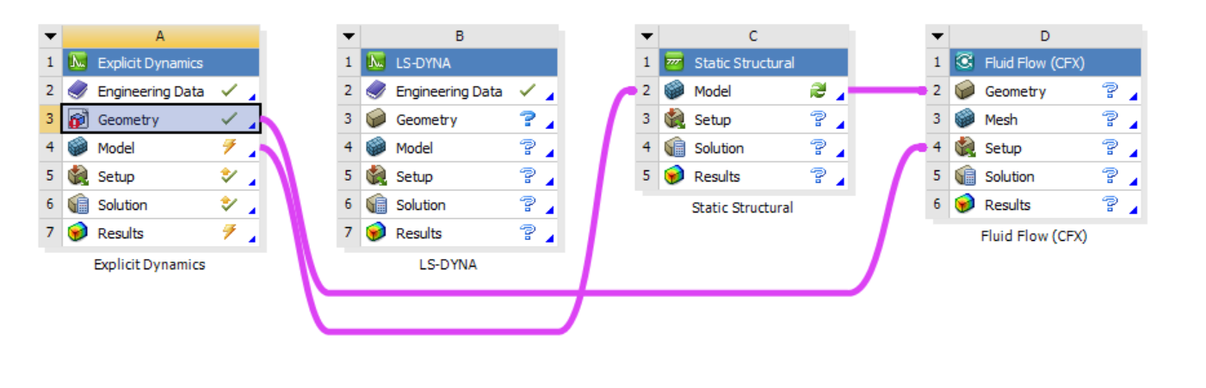
Figure 1 – Ansys Workbench project schematic showing the connection of multiple different simulations.
Within Workbench there are several different analysis systems available for use, such as FEA, CFD, thermal simulation and electromagnetic simulation.
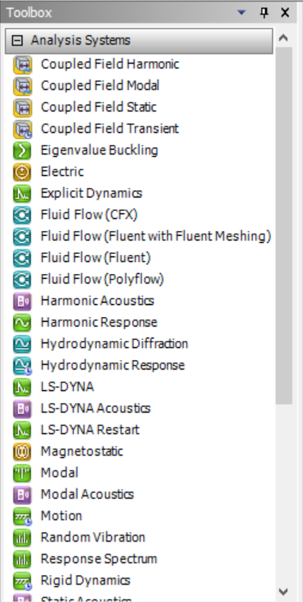
Figure 2 – Some of the different analysis systems available in Ansys Workbench.
The fabricated scenario for exploration in this report is the ballistic impact of a bullet into a target plate. Because of this, the analysis system chosen as the focal point for investigation in this report is the “Explicit Dynamics” system, due to its intended use in high-velocity, short-instance events and widespread use in modelling bullet impacts [10] [11] [12].

The Underlying Principles
The explicit dynamics analysis system uses explicit time integration as its foundation. This means that the simulation runs on a time-dependent basis, calculating the result of each time step from the previous [13]. This is coupled with a finite element method (FEM) of meshing, known as Lagrangian [14]. A Lagrangian FEM discretises the geometry into moving nodes, each associated with a material particle, meaning that the deformation of the simulation can be accurately evaluated [15]. This combination of approaches allows the simulation to operate efficiently for nonlinear simulations such as ballistic impacts.
Due to the nature of the element distortion within such a simulation, it is imperative that the relevant material property information is available to the solver [16]. This includes the applicable core mechanical properties that denote a material’s stress-strain relationship, such as Young’s modulus, Poisson’s ratio or the strain rate. This allows for the correct plastic and elastic deformation to be calculated as the waves propagate through the materials, ensuring the accurate depiction of the deformation.
As this specific test case is a ballistic impact model, it is also crucial to include the required damage parameters. This ensures that the simulation can precisely represent the energy dissipations undergone and predict results for outputs such as fragmentation, penetration and the extreme pressures experienced.
The particular parameters included are Johnson-Cook (JC) for both the steel and the copper, and the equation of state (EOS) for the steel.
Equation 1 – The JC strength equation used in the Ansys simulation [17].
$$Y=\left[A+Bε_{p}^{n}\right]\left[1+Clnε_{p}^{*}\right][1-T_{H}^{m}]$$
Where:
- Y is the yield stress,
- A, B, C, m and n are material constants,
- $ε_{p}$ is effective plastic strain,
- $ε_{p}^{*}$ is normalised effective plastic strain rate,
- $T_{H}$ is homologous temperature [17].

Equation 2 – The JC failure equation used in the Ansys simulation [18].
$$ε^{f}=\left[D_{1}+ D_{2}e^{D_{3}σ^{*}}\right]\left[1+D_{4}\ln\left|έ^{*}\right|\right]\left[1+D_{5}T^{*}\right]$$
Where:
- $ε^{f}$ is the equivalent plastic strain at failure,
- The D values are damage constants,
- $T^{*}$ is homologous temperature,
- $σ^{*}$ is the dimensionless pressure-pressure stress ratio [18].

Equation 3 – The Mie-Gruneisen EOS used in the Ansys simulation [19].
$$P=P_{H}+Γρ\left(E-E_{H}\right)$$
Where:
- Γ is Gruneisen’s constant,
- ρ is density,
- P is pressure,
- E is energy [19].
These equations (above) are used by the Ansys Workbench explicit dynamic solver to ensure that the simulated results portray the material behaviours more precisely to how they would deform in a real ballistic impact.

Test Case
The chosen test case was simple copper bullet fired into a steel target plate. This was chosen both due to its relevance to the munitions industry and the abundance of data present to perform a more comprehensive evaluation of the accuracy of the results produced by the Ansys software.

Pre-Processing
One of the key features of Ansys Workbench that particularly highlights its user-friendly approach is the project schematic window. It lays out the tasks required to run the simulation in a sequential order, while visually representing whether they have been completed to the correct standard.
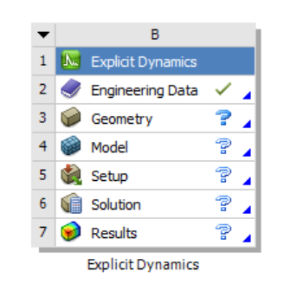
Figure 3 – Project schematic for the explicit dynamics analysis system.

Materials
The first task within the project schematic (Figure 3) is engineering data. This refers to the specific materials assigned to the simulation and their properties. Ansys automatically assigns a basic structural steel to every simulation, hence the green tick in Figure 3 to indicate that the field has been completed.
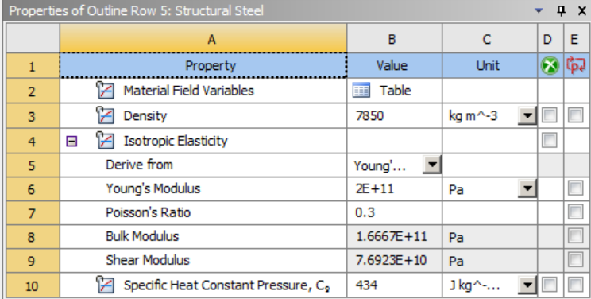
Figure 4 – Material properties of the structural steel.
The properties of the structural steel shown in Figure 4 do not contain any values of damage parameters, meaning it would not accurately represent the behaviour of the material. Instead, steel 1006 (Figure 5) was chosen from the Ansys library of materials for the target plate.
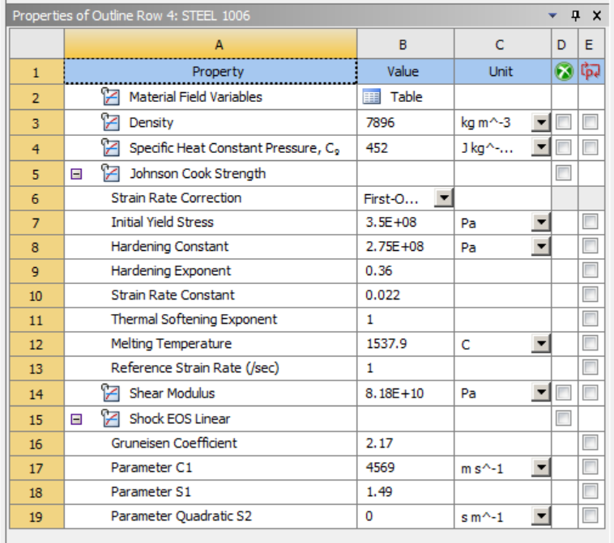
Figure 5 – Material properties of steel 1006.
5.56mm rounds can be made from several different materials, some with copper jackets, copper cores, and are usually all copper alloys rather than pure copper [13] [14] [15]. In this simulation the bullet was modelled as solid, pure copper for simplicity. The copper chosen was taken from the Ansys materials library and contained the JC parameters required.

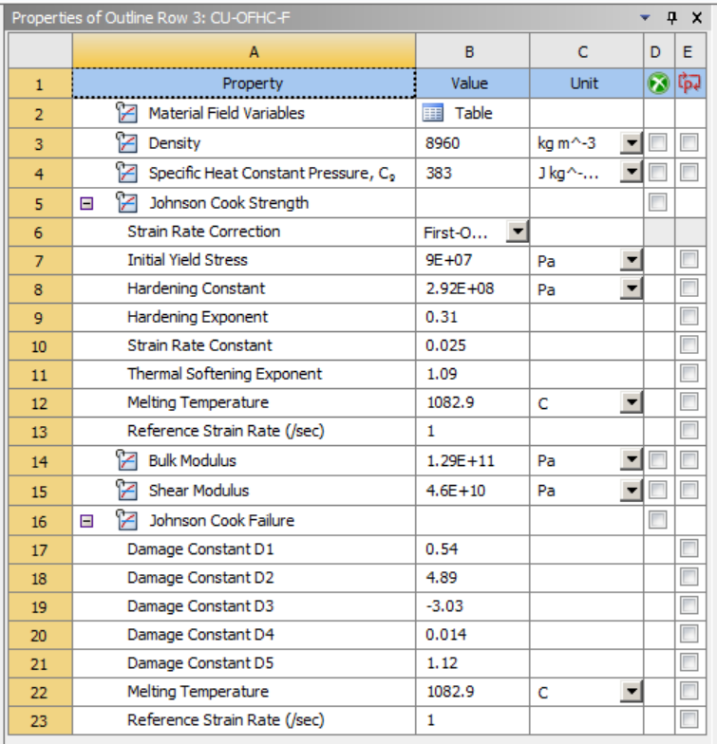
Figure 6 – Material properties of the copper.

Geometry
The parts were drawn and assembled in Autodesk Fusion – a CAD package entirely separate from Ansys.
The target plate was drawn as a simple 400$mm^{2}$ plate and extruded to a thickness of 10mm.
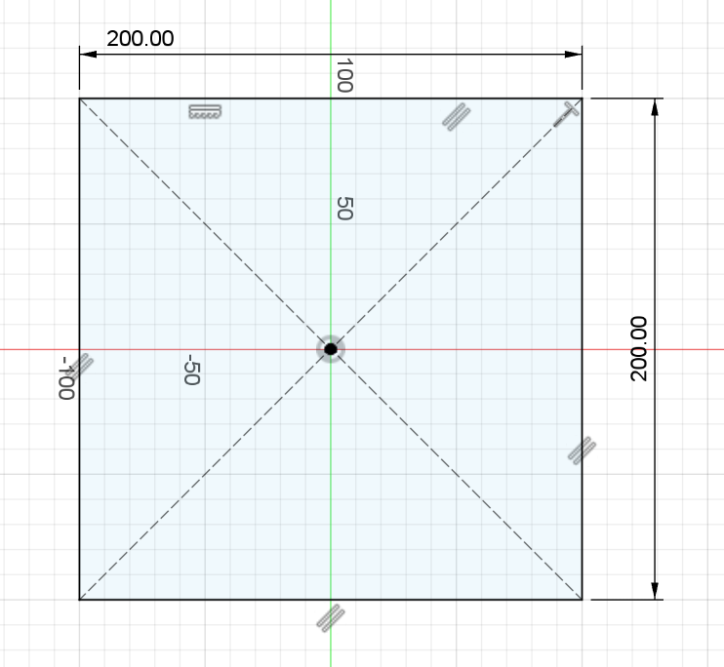  Figure 7 – Target plate sketch in Fusion. | 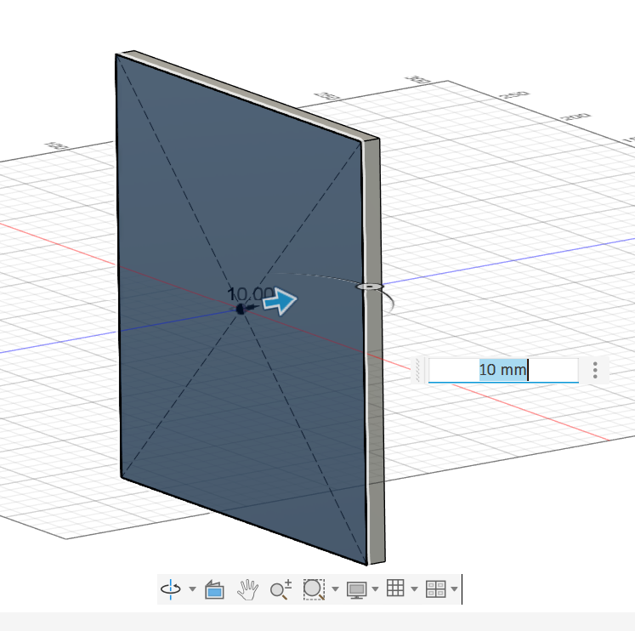  Figure 8 – The target plate as an extruded part in Fusion.
The bullet was modelled after a 5.56mm round with a chamfered base of 5.56mm diameter and a curved tip, revolved around the centreline.
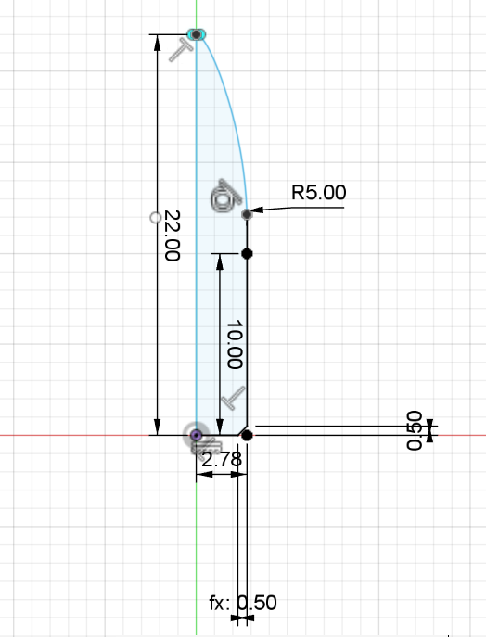  Figure 9 – 5.56mm bullet sketch in Fusion. | 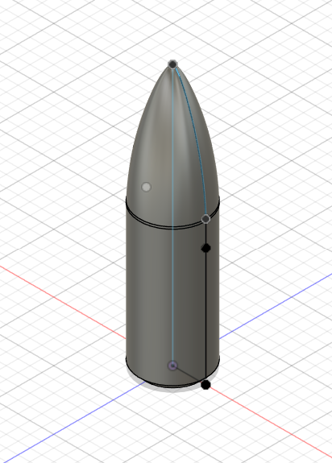  Figure 10 – 5.56mm bullet as a revolved part in Fusion.

Mesh
The global mesh was selected to have an element size of ${7x10}^{-3}m$ and visually appeared to be sized well in comparison to the bullet.
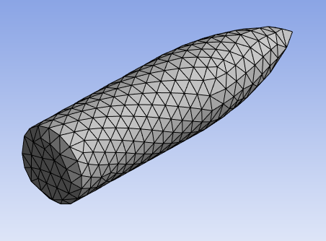
Figure 11 – The global mesh applied to the bullet.
When the global mesh was applied to the plate, however, it looked entirely disproportionate due to the difference in sizes between the bullet and the plate, and as a consequence of this large mesh, the elements would most likely not have distorted accurately. To combat this, it was attempted to add a sphere of influence to the plate, to generate a finer mesh within the region where the bullet would make contact. This action was unsuccessful, due to the fact that the plate was a perfectly uniform hexahedral structure, which is not compatible with the spherical space that the new mesh was to be applied to.
In order to rectify this, a structural change of the plate was made through the addition of filets to the edges. This made no impact on the integrity of the plate, but the introduction of curves to its geometry forced the auto-generated mesh to include tetrahedral elements as well, allowing for the sphere of influence to be added.
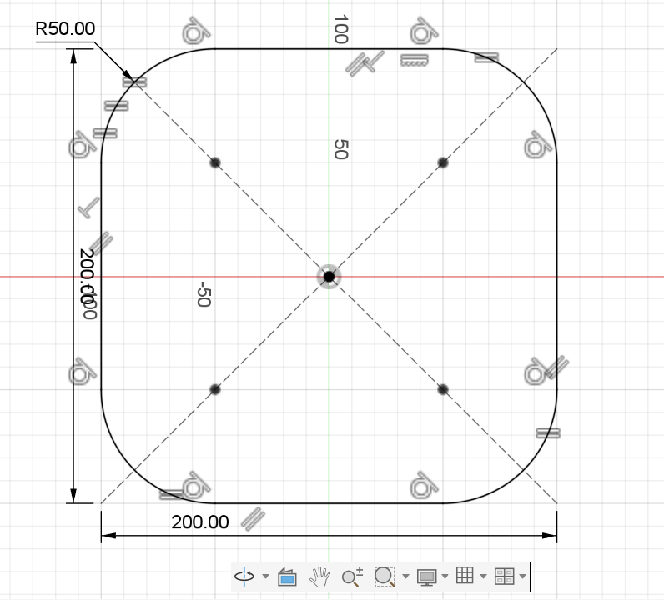  Figure 12 – Updated plate sketch in Fusion. | 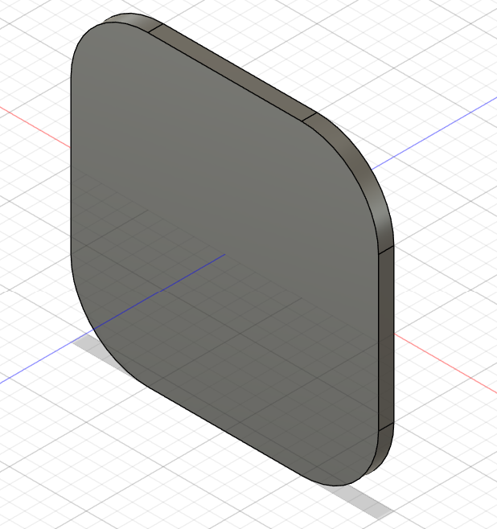  Figure 13 – Updated plate part in Fusion.
A single sphere of influence was added, centred at the global coordinates system, with a radius of ${3x10}^{-2}m$ and an element size of ${2x10}^{-3}m$.
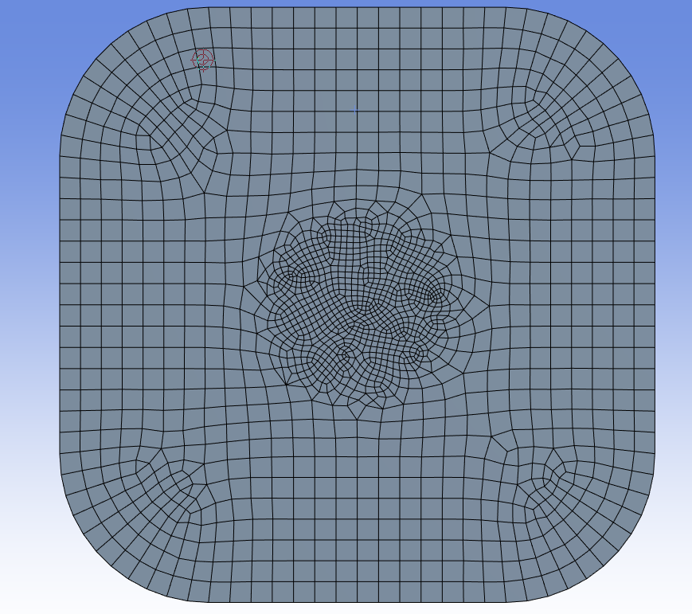
Figure 14 – The global mesh and sphere of influence applied to the target plate.

Boundary Conditions
The results of the simulation are furthermore dependent on the precise application of boundary conditions, without which can lead to incorrect representations of the test case [23]. The boundary conditions applied were to fix all side faces of the plate to make them infinitely rigid, and adding a velocity of ${500ms}^{-1}$ to the bullet. The velocity of a 5.56mm copper bullet can reach up to ${900ms}^{-1}$ when exiting the barrel [24], decreasing to approximately ${750ms}^{-1}$, ${675ms}^{-1}$, ${630ms}^{-1}$ and ${590ms}^{-1}$ after travelling 200m, 250m, 300m and 350m respectively [25]. The chosen value for this simulation of ${500ms}^{-1}$ was selected to eradicate the chance that the machine power would not be high enough to run the simulation, while attempting to keep it fairly accurate.
Without these boundary conditions, the simulation would not run correctly, resulting either in an unmoving bullet or the plate simply being pushed across the plane rather than withstanding the impact.

Results

Altering the Boundary Conditions
The initial simulation failed very quickly. The error message presented that the cause for the termination was that the “energy error [was] too large” (Figure 15).
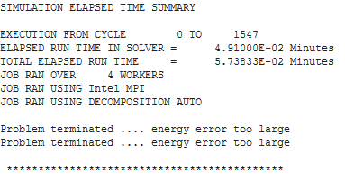
Figure 15 – “Energy error too large” system error message.
It was deduced that the origin of this message was due to the velocity applied to the bullet. In the pre-processing stage, a user error occurred in the fact that the velocity applied was fixed, rather than an initial condition. This meant that as the bullet was impacting the plate, the energy was not dissipating correctly, and the bullet was continuing to try and move at ${500ms}^{-1}$ through the material rather than losing speed on contact. This was quickly rectified, and the simulation was rerun.

Altering the Mesh
Again, the simulation terminated near-enough instantly. This time the system stated that the reason for failure was that the “time step [was] too small” (Figure 16).
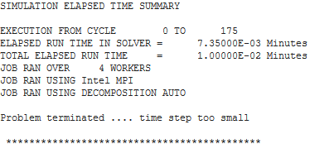
Figure 16 – “Time step too small” system error message.
With reference to the Ansys Innovation Space learning forum [26], it was concluded that this error was due to an extremely distorted element that was controlling the time step. Further investigation showed that it was the tip of the bullet that was distorting, due to the element size of the global mesh being too large and causing the bullet to form a sharp point (Figure 17 and Figure 18).
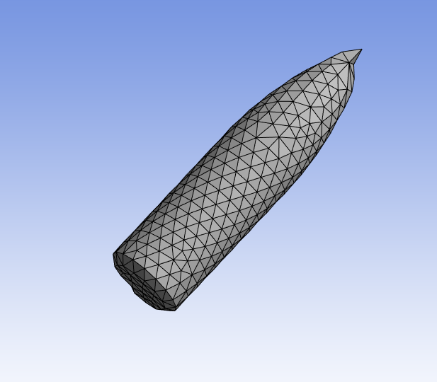
Figure 17 – Second angle of the global mesh applied to the bullet.
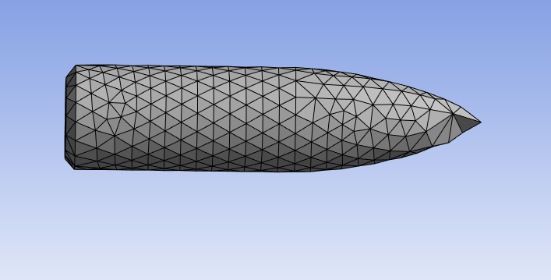
Figure 18 – Third angle of the global mesh applied to the bullet.
This point at the tip meant that as the bullet made contact with the plate, all of the energy from the collision was being forced through a singular node. To try and compute this excessive deformation, Ansys calculates the time step in smaller increments, but this is dictated by the mathematical model and when it reaches its minimum limit then the error appears.
In an attempt to combat this, the mesh was re-evaluated. There needed to be curvature at the tip of the bullet to prevent this error, so the mesh was refined until the sharp point was no longer apparent. With the geometry of the bullet, this required a much finer mesh, which therefore induced a very abrupt transition between the global mesh and the finer one (Figure 19).
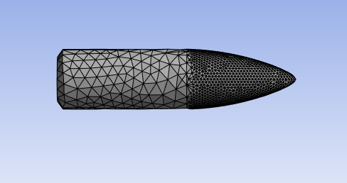
Figure 19 – Finer mesh applied to the bullet tip.
The simulation was run again, and this time was successful. It ran until completion and provided the requested results on the equivalent (Von Mises) stresses of the components.
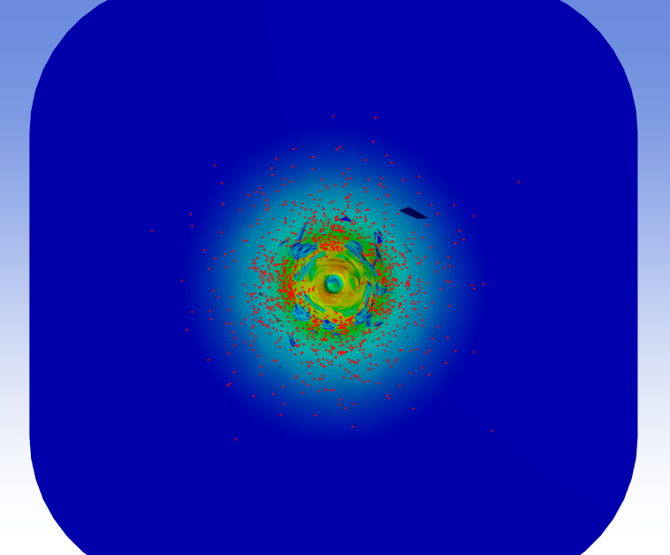  Figure 20 – Front view of the results of the simulation. | 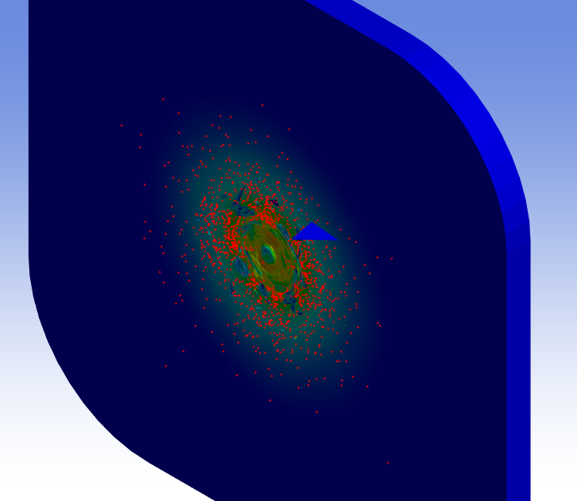  Figure 21 – Isometric view of the results of the simulation.
As can be seen in Figure 20 and Figure 21 (for further images of results see ‎Appendix A) the bullet completely deformed when it collided with the plate. This was due to the malleability of the copper and the strength of the steel, which was expected.
The red particles separating from the parts are representative of the eroded nodes, which can get destroyed when an element highly distorts or exceeds the maximum strain computable to the system [27] [28].
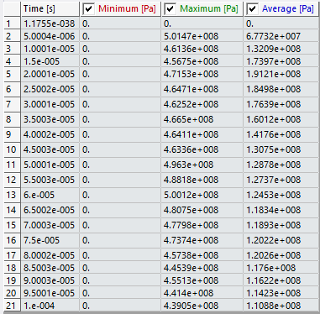
Figure 22 – Values for the minimum, maximum and average equivalent stresses experienced throughout the various time steps of the simulation.
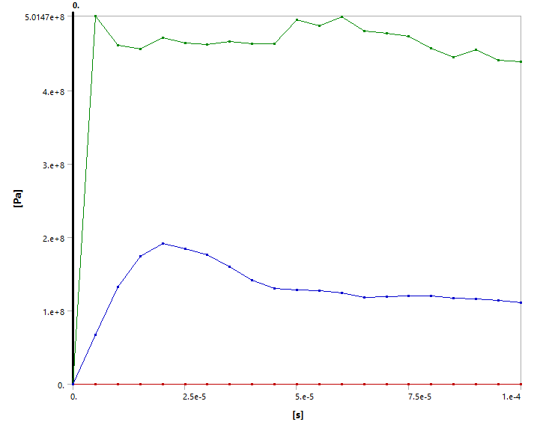
Figure 23 – Graph that shows the minimum, maximum and average equivalent stresses experienced throughout the simulation.
The maximum stress reached in the collision was just after the initial contact, with a value of ${5.0147x10}^{8}Pa$. This stress is not reached instantly on contact due to the brief moment it takes for the kinetic energy to transfer and for the wave to propagate [29]. However, this maximum only marginally higher than the stress experienced at ${6x10}^{-5}s$ which had a value of ${5.0012x10}^{8}Pa$. This secondary peak could have been caused by a reflected shock wave, or perhaps the steel reaching its structural limit, but it should not be almost equivalent to the stress experienced after the initial impact [30] [31].

Graduating the Mesh
While the previous simulation did run successfully, the results generated did not reach the required level of accuracy. This may have arisen from the discontinuity of the fine mesh; the tip of the bullet would have deformed as expected, but the back end may have exhibited unpredicted behaviours that do not reflect how the bullet would behave in the real world, hence the disproportionately high second peak in stress (Figure 22 and Figure 23).
The solution to this would be to use the fine mesh throughout the entirety of the bullet’s geometry but, given the low computational power of the device that was running the simulation, it was more realistic to introduce a graduating mesh, which would transition more smoothly from the fine mesh to the coarse one. This was achieved using several spheres of influence positioned at the centre of the global coordinate system, with different radii so that they overlapped different sections of the bullet geometry (Figure 24, Figure 25, Figure 26, Figure 27, Figure 28, Figure 29).
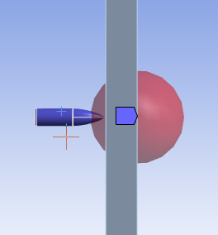  Figure 24 – First sphere of influence applied to the bullet. | 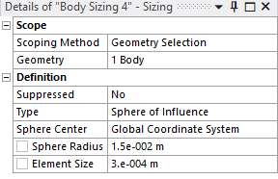  Figure 25 – Values of the radius and element size for the first sphere of influence applied to the bullet.
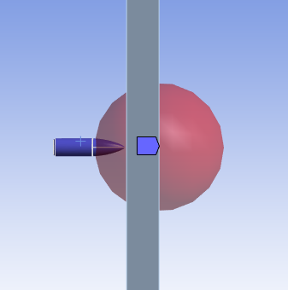  Figure 26 – Second sphere of influence applied to the bullet. | 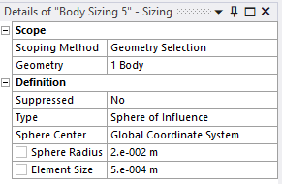  Figure 27 – Values of the radius and element size for the second sphere of influence applied to the bullet.
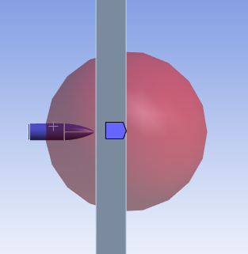  Figure 28 – Third sphere of influence applied to the bullet. | 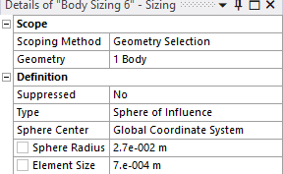  Figure 29 – Values of the radius and element size for the third sphere of influence applied to the bullet.
These spheres of influence did not create a perfect conversion between mesh sizes, but it was considerably less of a harsh boundary than in the previous discretisation.
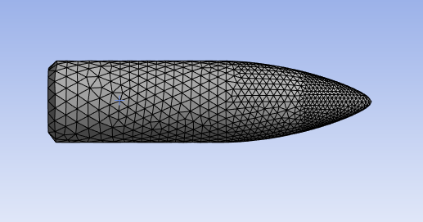
Figure 30 – Graduating mesh applied to the bullet.
After adding the graduating mesh to the bullet, the same was done to the target plate. As it already had a fine sphere of influence in the centre, it was only necessary to add a slightly larger one to bridge the change between the centre and the global mesh.
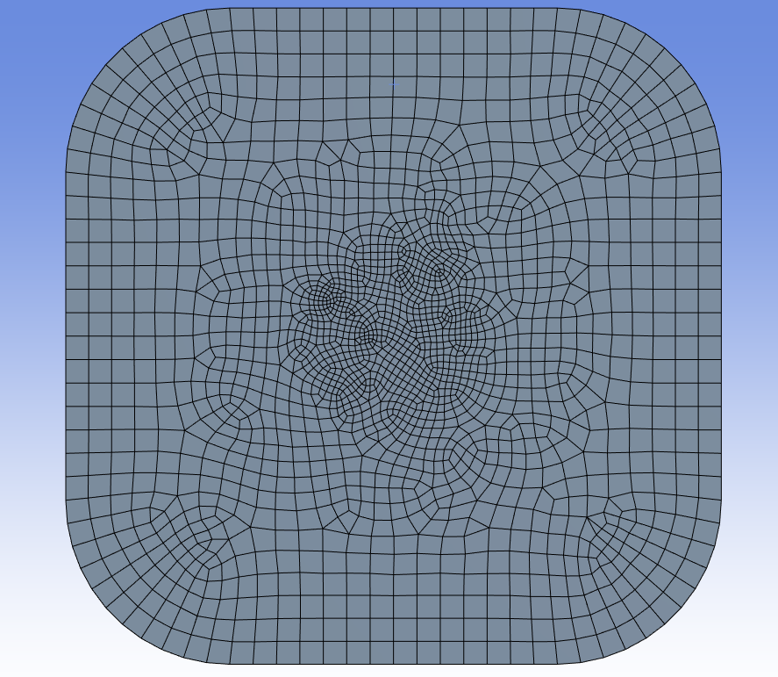
Figure 31 – Graduating mesh applied to the target plate.
Although the graduating mesh was slightly less smooth in the target plate, it was deemed inconsequential due to the small area of contact on the plate compared to the bullet.
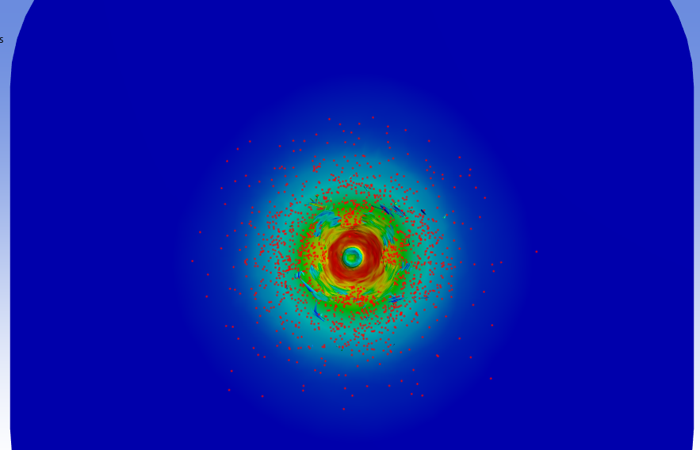
Figure 32 – The front view of the result from the simulation with gradual discretisation.
In Figure 32 (for further results see ‎Appendix B) it can be seen that again, the bullet completely deformed. However, a visual comparison to Figure 20 shows that there is a higher volume of eroding nodes when a gradual mesh is used, suggesting a more accurate representation of fragmentation.
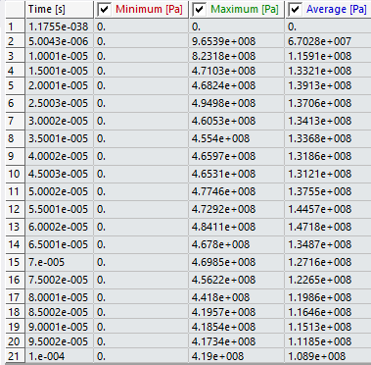
Figure 33 – Values for the minimum, maximum and average equivalent stresses experienced throughout the various time steps of the simulation with the gradual discretisation on both components.
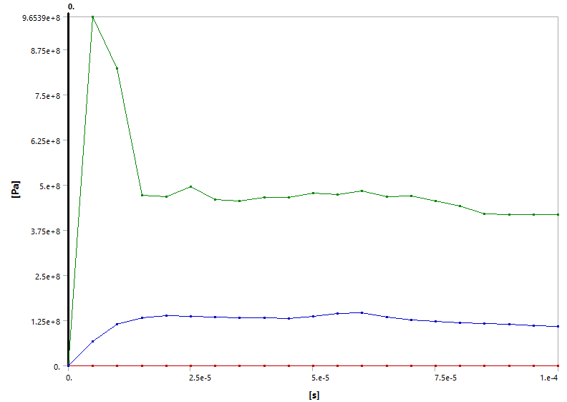
Figure 34 – Graph that shows the minimum, maximum and average equivalent stresses experienced throughout the simulation with the gradual discretisation on both components.
The use of a graduating mesh on the components significantly impacted the output of the simulation (Figure 33 and Figure 34). Most of the maximum stresses at each timestep stayed consistent to the previous simulation (Figure 23) at approximately ${4x10}^{8}{- 5x10}^{8}Pa$, however the maximum stress after the initial contact in the second simulation was nearly double the first. The highest stress value of the initial simulation was ${5.0147x10}^{8}Pa$, and the highest value in the second simulation was ${9.6539x10}^{8}Pa$. Additionally, in the second simulation the second peak is at a much lower value proportionally to the initial peak, further reinforcing the fact that the incorporation of a gradual mesh provided more accurate results for the test case.

Discussion

Validation
Von Mises stresses are mathematically constructed quantities and therefore are calculated, not directly measured [32]. This makes it difficult to gather data from real-world experiments, so to assess the accuracy of the results from the simulations, other results from various validated models will be used.
Three simulations of ballistic impacts were assessed, and while they all contained various values for velocities of the projectiles and material behaviours, when considered as a standard ballistic projectile scenario, they acted as rough approximations of the ideal results to be obtained.
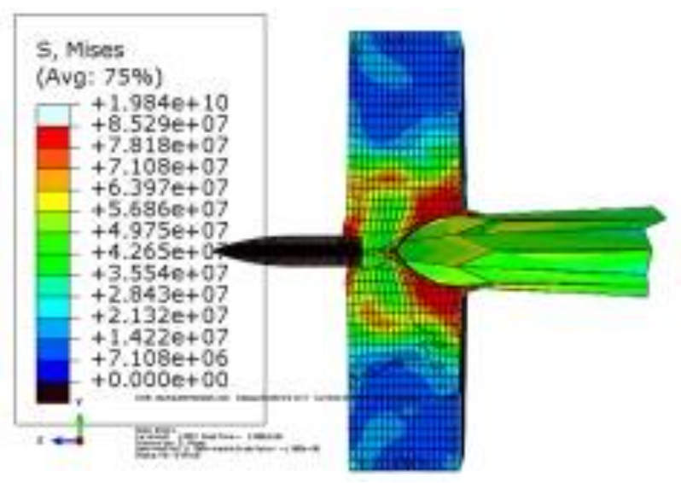
Figure 35 – Case study 1 for the Von Mises stress of a ballistic impact [33].
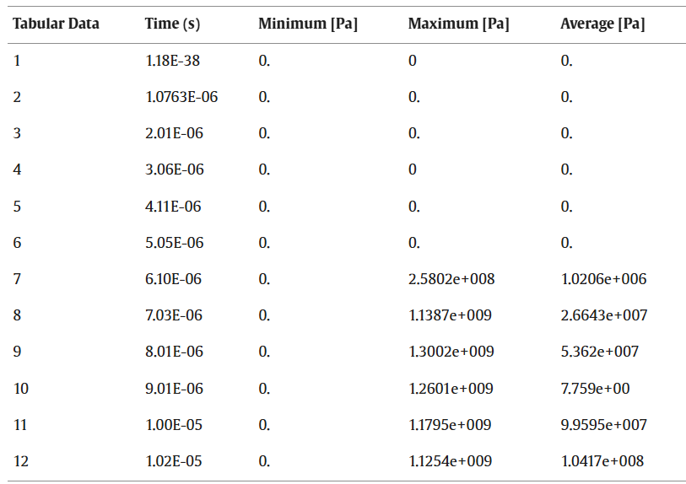
Figure 36 – Case study 2 for the Von Mises stresses of a ballistic impact [12].
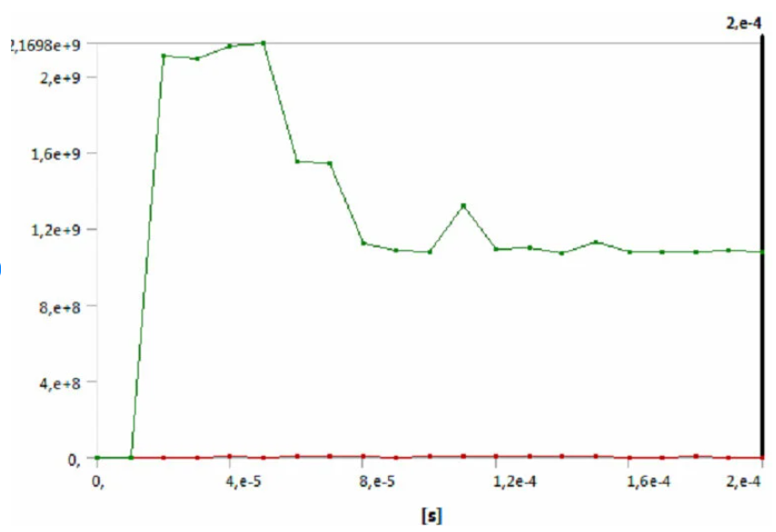
Figure 37 – Case study 3 for the Von Mises stress of a ballistic impact [35].
The results for the maximum stresses shown in Figure 35, Figure 36 and Figure 37 range from of ${1x10}^{9}Pa$ to ${2x10}^{10}Pa$. The result for the maximum stress obtained from the test case simulation falls just shy of this range at ${9x10}^{8}Pa$. Additionally, a comparison of the profile of the graphs (Figure 34 and Figure 37) shows that they share the same initial peak, followed by a proportionally smaller peak. This evidence suggests that the introduction of the graduating mesh to the test case simulation caused it to perform at the level required and that the results obtained hold a reasonable degree of accuracy.

Structural Limitations of the Parts
While the results of the simulation were deemed to be a fairly accurate representation of the test case, this accuracy could have been increased. The first point of improvement would be to negate the structural limitations of the parts. Due to the inability to access the engineering drawing for in-service military components, the geometry for the model of the 5.56mm bullet was not precise. The dimensions were far from true to size, and if this were to be rectified it would be likely that the results would steer closer to the real-life scenario it was modelling.
Furthermore, the material assigned to the bullet was pure copper. As discussed in section ‎2.1, the copper component of 5.56mm bullets are usually copper alloys and mostly only an external jacket. The alloyed jacket and increased density from a heavy-metal core would have likely portrayed the properties of the bullet more accurately. The material properties themselves were also a limiting factor, considering that they were taken from the Ansys database and may not have truly represented certain elements or contained specific information that may have produced inaccurate behaviours and could have altered the results.

Limitations of the Software
On top of the structural limitations, the software itself acted as a limiting factor. The computer used to run the simulation was not particularly high functioning, which costed in the computational power available for use. This meant that when meshing, decreasing the element size too far would cause the simulation to fail or take an unreasonable amount of time, and was not feasible, therefore limiting the potential to discretise the model to the required level – a factor that has been shown in this report to weigh heavily on the results of the simulation.
The computational power also impacts the range of mathematical ability that the software possesses, in the same sense as the mesh when considering realistic run times. Because of this, the JC damage model was used to represent the material behaviours. While it is perfectly appropriate in this scenario, the JC model fails to show certain outcomes, such as fractures or components experiencing thermal changes that lead to failure. This is not a fault of Ansys Workbench itself, but a limitation in the lack of specialised ballistic properties and outputs within the explicit dynamics analysis system.

Conclusion
In conclusion, Ansys Workbench provides a user-friendly interface that is easy to navigate and provides results to a reasonable degree of accuracy when parameters are correctly input by the user. The computational cost of the simulation is something to be greatly considered when attempting to run a model, and a computer with enough power for the specific test case should be used to ensure the best results. Boundary conditions must be properly considered, and if applied incorrectly will cause simulation failure.
Discretisation also plays an incredibly important role in the outcome of the simulation. The element size should be proportional to the size of the component, and small enough that the nodes are free to distort without reaching an excessive level. Regarding a curved geometry, the mesh should be small enough to ensure that there are no points or sharp corners, to avoid excessive distortion and simulation failure. The graduation of the mesh is vital, with a mesh that smoothly transitions between different element sizes greatly outperforming one that jumps abruptly in the accuracy of the results.

References

[1] | A. S. Bahman, “8 - Computer-aided engineering simulations,” in Wide Bandgap Power Semiconductor Packaging, Kidlington, UK, Woodhead Publishing, 2018, pp. 199-223.
[2] | K. Mitzner, “Chapter 1 - Introduction to PCB Design and CAD,” in Complete PCB Design Using OrCAD Capture and PCB Editor, Oxford, UK, Newnes, 2009, pp. 1-13.
[3] | J. R. Painter, “5 - Computer-integrated engineering systems,” in Mechanical Engineer's Reference Book (Twelfth Edition), Oxford, UK, Butterworth-Heinemann, 1994, pp. 5-44.
[4] | H.-J. Kwon, “Computer aided engineering (CAE) simulation for the design optimization of gate system on high pressure die casting (HPDC) process,” Robotics and Computer-Integrated Manufacturing, vol. 55, no. 1, pp. 147-153, 2019.
[5] | Z. Liu, “Design for intelligent interaction CAE software: a hybrid recommendation-based approach to improve simulation workflow efficiency,” Design and Artificial Intelligence, vol. 1, no. 3, 2025.
[6] | R. Salgarkar, “Top Companies in Computer Aided Engineering (CAE) Market,” MarketsandMarkets Inc, Delray Beach, 2025.
[7] | “Computer-aided engineering (CAE),” Siemens, 2026. [Online]. Available: https://www.siemens.com/en-gb/technology/computer-aided-engineering-cae/. [Accessed 21 April 2026].
[8] | K. K. Bose, “A review paper on Finite elements methods using ANSYS,” International Advanced Research Journal in Science, Engineering and Technology, vol. 8, no. 3, 2021.
[9] | O. Maxwell, “3D FE Modelling and Simulation of Reinforced Concrete Bridge Superstructure for Fatigue Analysis in ANSYS Workbench,” IRE Journals, vol. 7, no. 3, 2023.
[10] | T. J. Pooppally, “Analysis of bullet impact test on aluminum alloy plates at varying thickness and velocities,” Materials Today: Proceedings, vol. 95, no. 4, pp. 367-372, 2024.
[11] | A. Thorat, “Study and Analysis of a Bullet penetrating Armor material,” International Journal of Creative Research Thoughts, vol. 9, no. 4, pp. 4198-4203, 2021.
[12] | P. Rout, “Failure analysis of composite plate under ballistic impact,” Materials Today: Proceedings, vol. 74, no. 4, pp. 1008-1011, 2023.
[13] | Ansys, “What is Explicit Dynamics?,” Ansys, 11 May 2026. [Online]. Available: https://www.ansys.com/simulation-topics/what-is-explicit-dynamics. [Accessed 11 May 2026].
[14] | A. İ. Çelik, “Impact Analysis of Cylindrical Steel Water Storage Tanks Under the Seismic Action,” International Journal of Advances in Engineering and Pure Science, vol. 34, no. 1, pp. 1-13, 2021.
[15] | Z. Bi, “Chapter 11 - Applications—Multiphysics Systems,” in Finite Element Analysis Applications, London, UK, Academic Press, 2018, pp. 407-453.
[16] | J. C. Tan, “Mechanical properties of hybrid inorganic–organic framework materials: establishing fundamental structure–property relationships,” Chemical Society Reviews, vol. 40, no. 2, pp. 1059-1080, 2011.
[17] | Ansys, “11.7.5 Johnson-Cook Strength,” in Explicit Dynamics Analysis Guide Overview, Canonsburg, USA, Ansys, 2024.
[18] | Ansys, “11.11.7 Johnson-Cook Failure,” in Explicit Dynamics Analysis Guide Overview, Canonsburg, USA, Ansys, 2024.
[19] | Ansys, “11.9.6 Shock EOS Linear,” in Explicit Dynamics Analysis Guide Overview, Canonsburg, USA, Ansys, 2024.
[20] | E. Mariussen, “Toxic effects of gunshot fumes from different ammunitions for small arms on lung cells exposed at the air liquid interface,” Toxicology in Vitro, vol. 72, no. 1, 2021.
[21] | W. A. Martin, “Bullet on bullet fragmentation profile in soils,” Journal of Environmental Management, vol. 146, no. 1, pp. 369-372, 2014.
[22] | M. Sherrill, “Relative armor penetration of jacketed lead, solid copper, solid brass, and steel core bullets,” U.S. Air Force Academy, Colorado Springs, 2012.
[23] | R.-A. Moga, “The Importance of Boundary Conditions and Failure Criterion in Finite Element Analysis Accuracy—A Comparative Assessment of Periodontal Ligament Biomechanical Behavior,” Applied Sciences, vol. 14, no. 8, pp. 1-16, 2024.
[24] | S. I. Silton, “Aerodynamic and Flight Dynamic Characteristics of 5.56-mm Ammunition: M855,” Army Research Laboratory, Aberdeen Proving Ground, USA, 2010.
[25] | K. F. Akbas, “Effect of Bullet Velocity on Target Ballistics,” SELCUK UNIVERSITY JOURNAL OF ENGINEERING SCIENCES, vol. 23, no. 1, pp. 26-34, 2024.
[26] | C. Quan, “Ansys Innovation Space,” Ansys, 29 January 2024. [Online]. Available: https://innovationspace.ansys.com/forum/forums/topic/time-step-is-too-small/. [Accessed 12 May 2026].
[27] | Ansys, “6.4 Eroded Nodes in Explicit Dynamics Analyses,” in Explicit Dynamics Analysis Guide Overview, Canonsburg, USA, Ansys, 2024.
[28] | M. Ji, “Ansys Innovation Space Learning Forum,” Ansys, 17 September 2020. [Online]. Available: https://innovationspace.ansys.com/forum/forums/topic/material-exploding-into-red-bits/. [Accessed 13 May 2026].
[29] | N. K. Naik, “Ballistic impact behaviour of woven fabric composites: Parametric studies,” Materials Science and Engineering, vol. 412, no. 1, pp. 104-116, 2005.
[30] | P. Muller, “Contact time at impact of spheres on large thin plates,” Advanced Powder Technology, vol. 27, no. 4, pp. 1233-1243, 2016.
[31] | K. D. Bouzakis, “Fracture initiation mechanisms of thin hard coatings during the impact test,” Surface and Coatings Technology, vol. 185, no. 2, pp. 150-159, 2004.
[32] | S. Li, “Stress or Strain?,” in International Conference on Composite Materials, Nottingham, UK, 2024.
[33] | Y. Peimaei, “Elasto-plastic simulation of bullet penetration into Al7075-SiCp composites armor,” in Composites Characterization Fabrication and Application, Tehran, Iran, 2020.
[34] | C. Pirvu, “A model for evaluating the ballistic resistance of stratified packs,” IOP Conference Series: Materials Science and Engineering, vol. 147, no. 1, 2016.

– Additional Results of the First Simulation
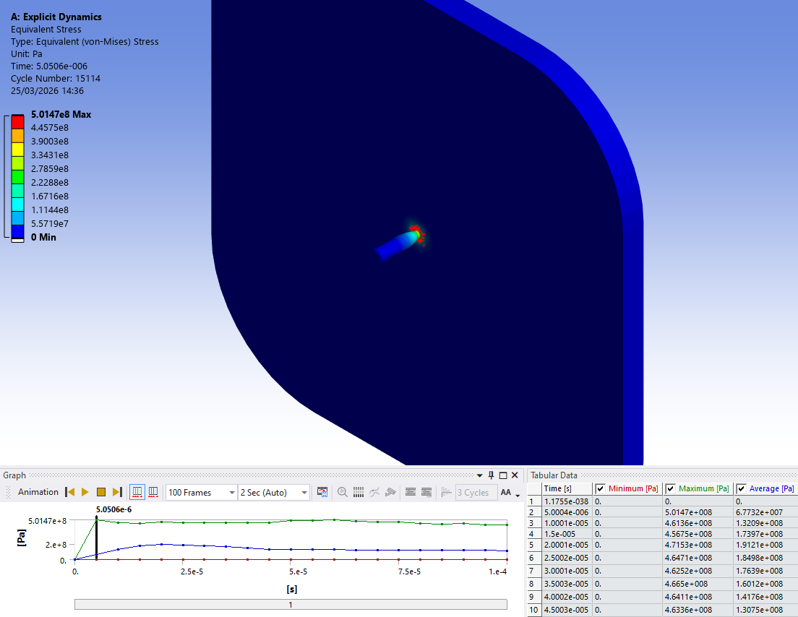
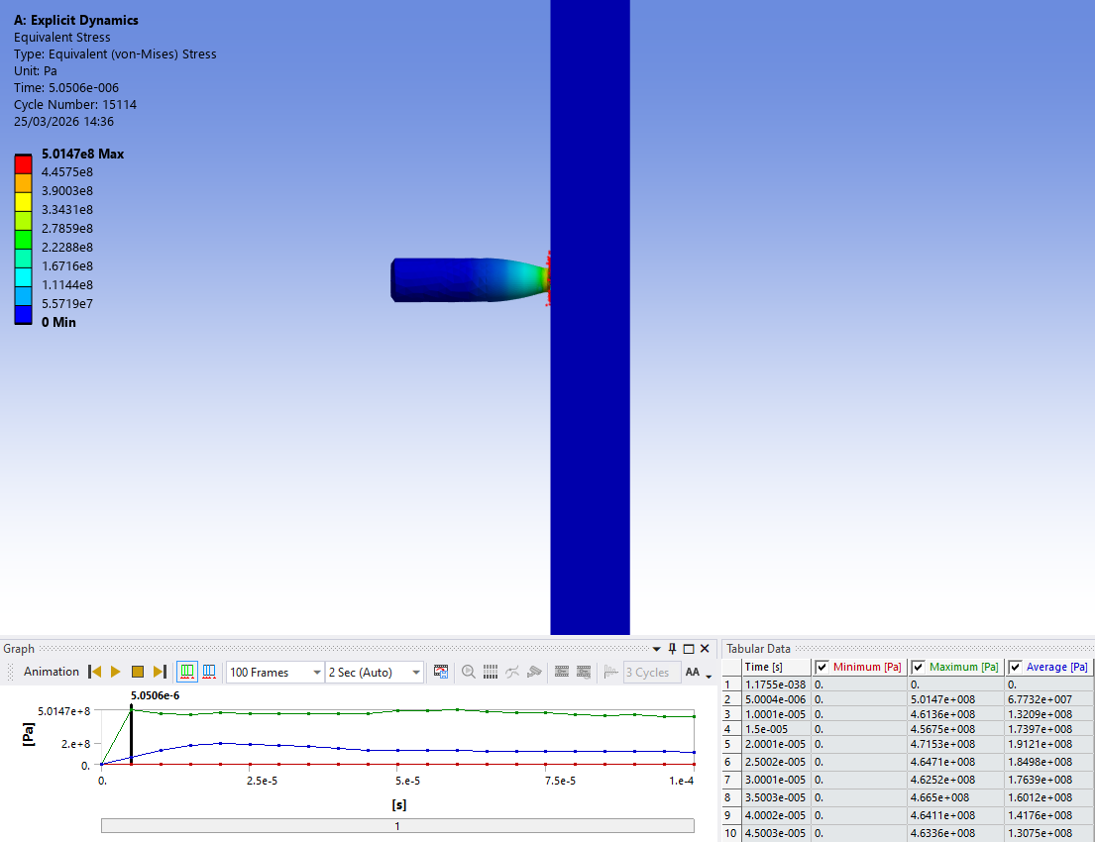
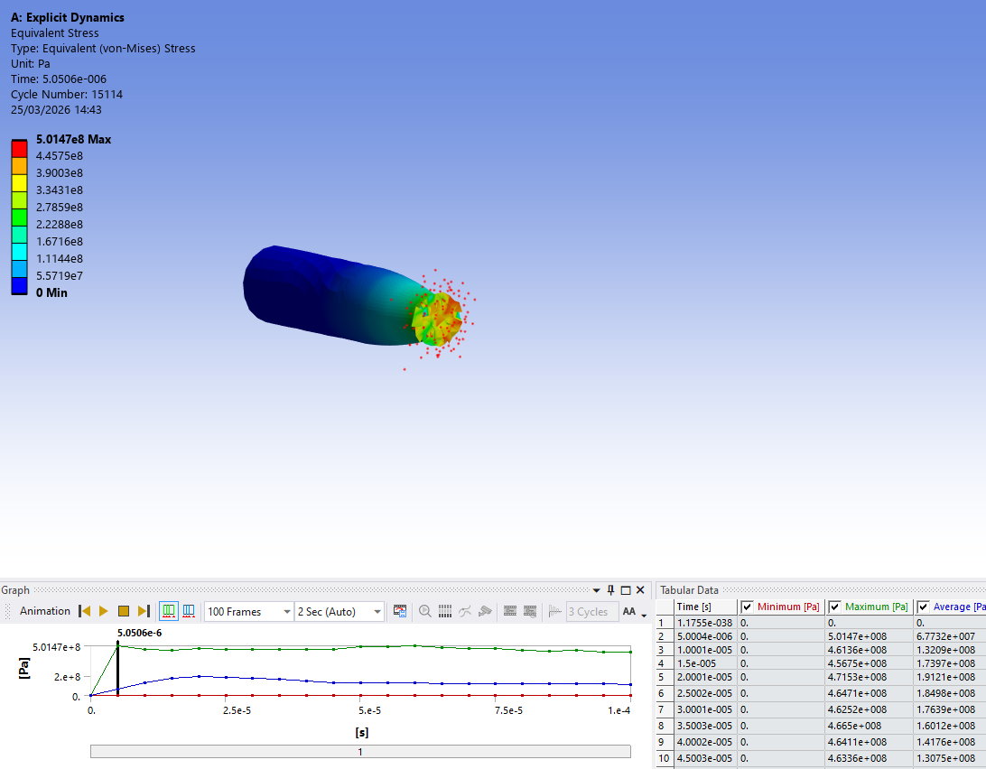
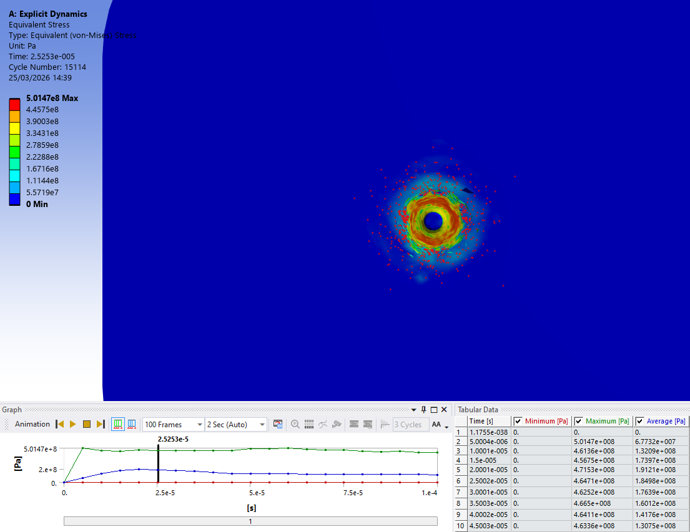
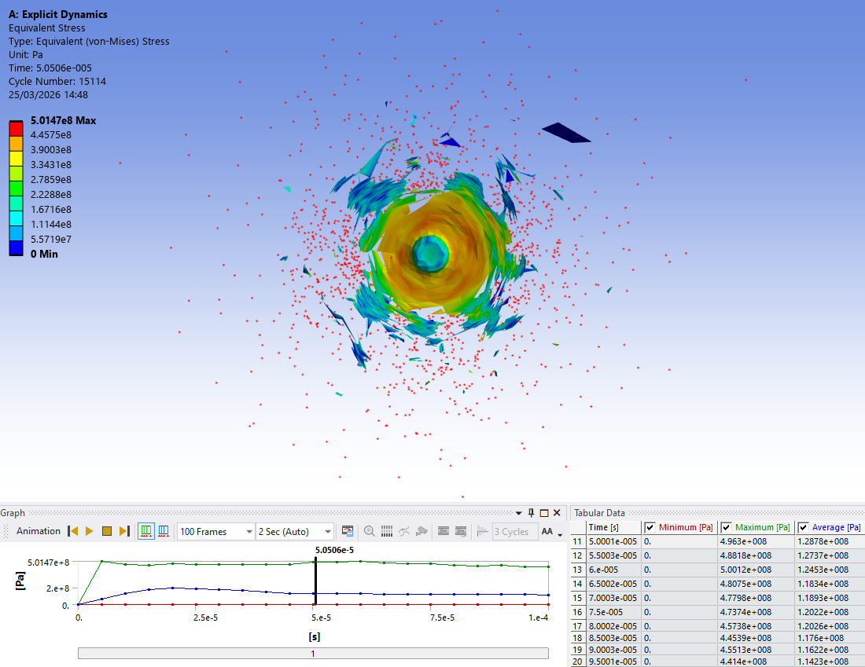
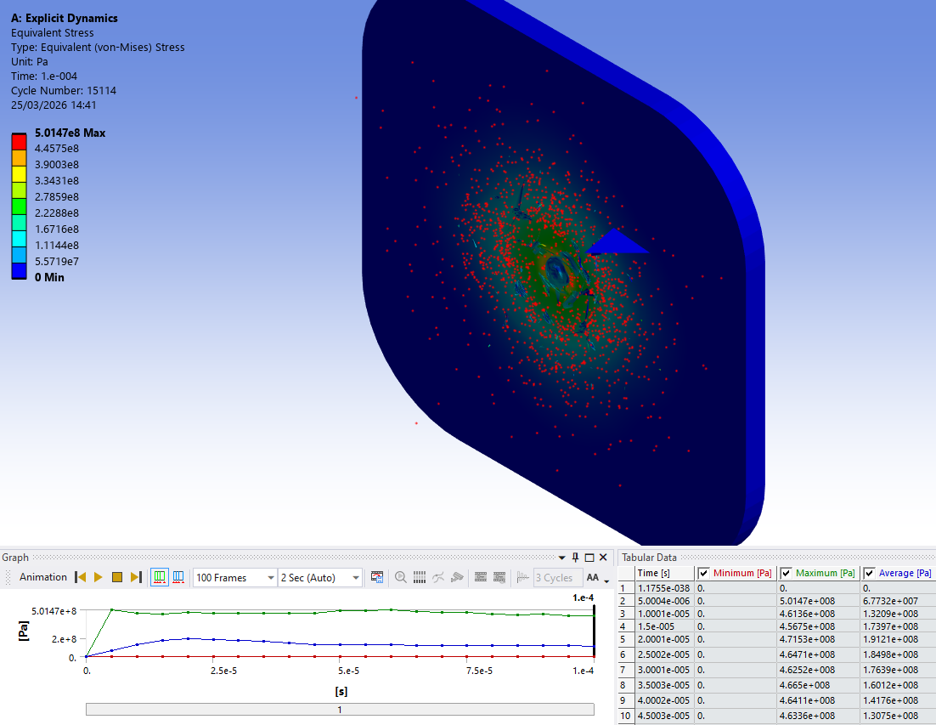
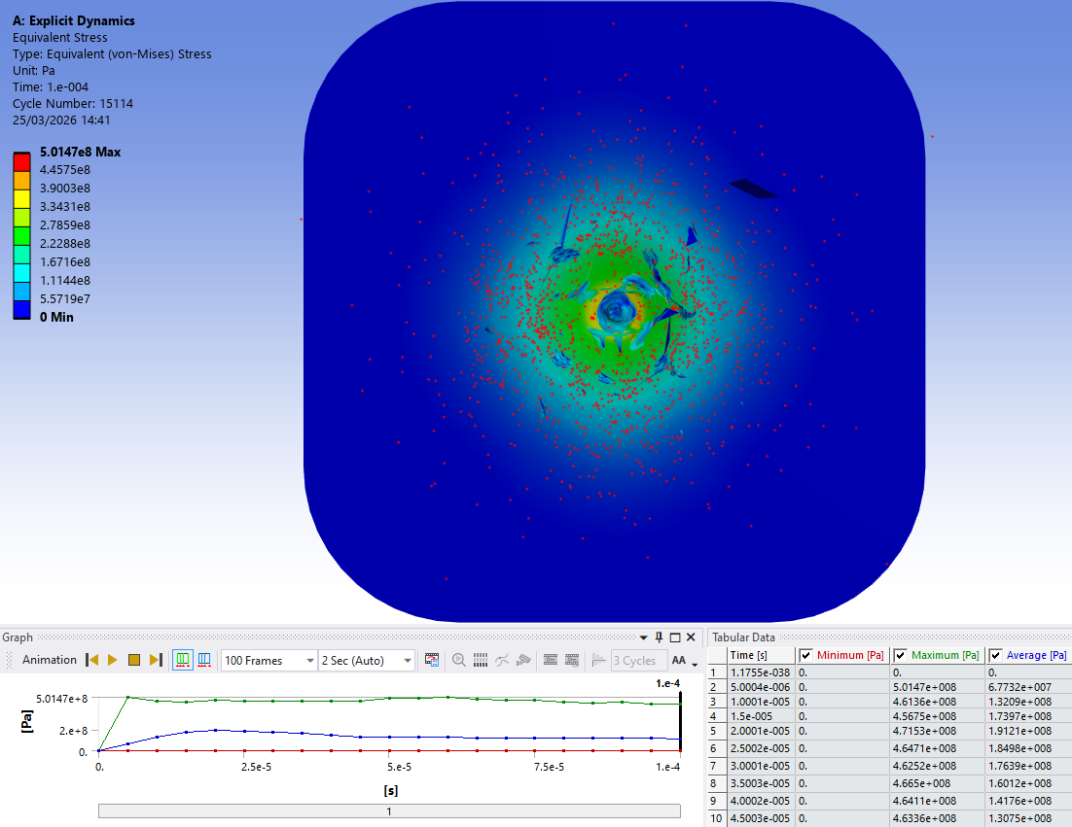
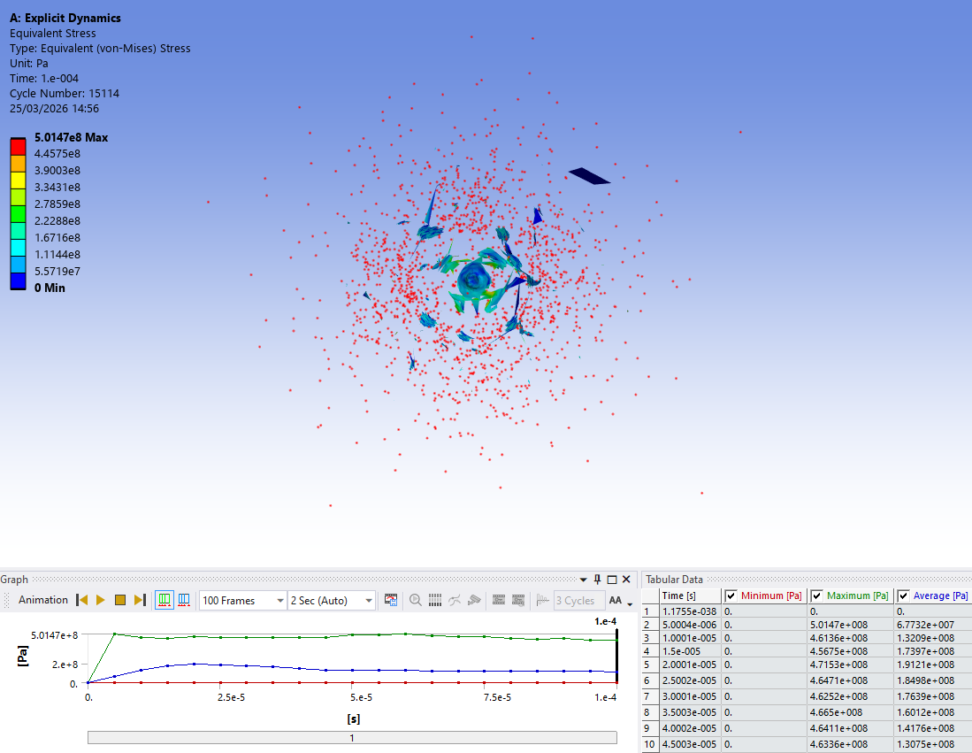

– Further Results of the Second Simulation


