Zanele Muholi is a renowned south African. Visual artist and photographer who creates powerful and thought-provoking work that has gained international attention.
Their work challenges societies norms and explores themes of gender, sexuality, race and representation. This essay will investigate Muholi’s art and their practices and focus on one piece of work. ‘’faces and phases’’ and will examine how critical theories help their approach when advocating for marginalised communities.

Unfortunately, south Africa can be a very dangerous place for lgbtq individuals, despite being one of the most progressive places in terms of lgbt rights, there are still high levels of violence, discrimination and hate crimes that target this community. Many individuals are pushed away and verbally and physically abused and even murdered just for their existence. This realty really highlights the importance of Muholi’s work in brining visibility and awareness to these massive issues.

A feminist theory provides a good understanding for muholis exploration of gender, race and sexuality. Their series ‘’faces and phases’’ contains of black lgbt individuals. It aims to capture their resilience and challenges of their identity. Muholi’s photographs celebrates the strength of these marginalised communities. Through their photography Muholi brings these individuals to the forefront and gives them the strength to show empowerment and to challenge the notions about gender and sexuality.
Furthermore, Muholi’s work critiques the way in which society often defines femininity and how a lot of society seem narrow minded. One of the many aims of muholis work is to celebrate the diverse range of femininity we have today and to highlight the importance of self-expressions and self-acceptance.
One specific image that highlights muholis feminist approach is ‘’Xana’’ from the ‘’faces and phases’’ series. This portrait, Xana poses confidently with her gaze directly at the camera. The choice to focus on Xanas face gives the opportunity for the viewer to fully connect with her experience. The lighting setup enhances the textures and depth of her skin. The image celebrates her race whilst also challenging the beauty standards society has put in place.
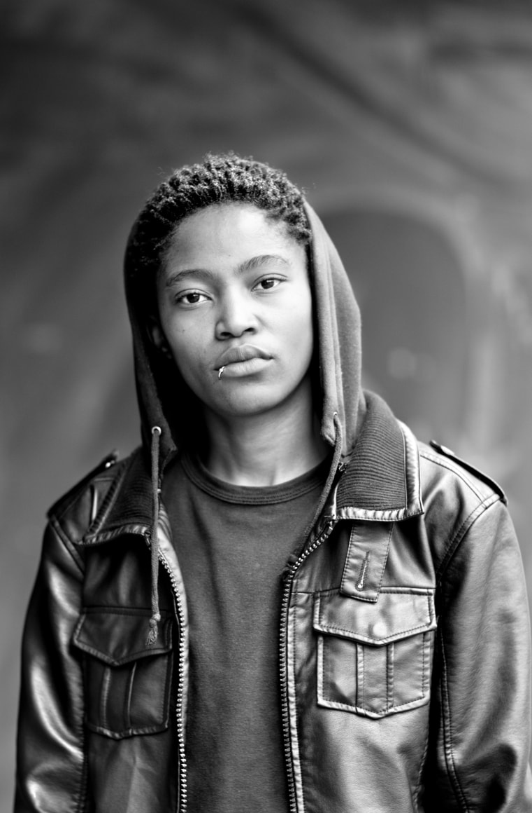
Xana Nyilenda, Newtown, Johannesburg, 2011
From the Series Faces and Phases.

The queer theory is particularly relevant in analysing Muholi’s work as with their project ‘’ faces and phases’’ she amplifies the lived experiences of queer individuals. They give a diverse representation of the love, desire and intimacy in the lgbtq community. The photographers’ challenges stereotypes and creates a sense of community and belonging in these marginalised areas. The work invites viewers to question what they may believe and the preconceptions they may have and give them a chance to expand their understanding of different queer identities there are today.

Postcolonial theory helps look at the impact of colonialism on racial and cultural identities within muholis work. The photographer was born and raised in South Africa. Their gives light to the complexities of black experiences and raises awareness for the dangers of being part of the lgbt community.

Muholis series called ‘’faces and phases’’ is about reclaiming identity and challenging representation
It consists of intimate portraits of black lgbt women in south Africa. The aim of this project is to provide visibility toa community that is marginalised and faces persecution. By using critical theories we can look into this photographers work on a deeper level.

Representation – Muholi’s work creates a space for individuals in south Africa that are part of the lgbt community to be represented in a safe space. The ai of their work is to give a voice to those individuals that have historically very under represented. The work this photographer produces also challenges the ideas and beliefs of the viewer and makes the think about their preconceptions of this community on a deeper level.

Visual activism – Muholi’s work is very aesthetically pleasing, but beyond this their work is a catalyst for change within society by capturing these stories and challenging the way society as a whole think. The act of visual activism gives the viewer a chance to challenge what they may think and create a dialogue that leads to better awareness and. Understanding of this community and the challenges they face.

Resistance and empowerment through imagery – Muholi’s practices have become an act of resistance and empowerment. They expose realities and the experiences of the lgbtq community. Symbolism, composition and lighting choices all contribute the message they re trying to convey and the way they challenge societies narratives that have bene created. Through their art Muholi invites viewers to examine their own misconceptions. Their work sparks conversation surrounding the ideas of acceptance, representation and equality, with the aim of societal transformation. By this photographer providing a space for visibility for these marginalised communities Muholi’s has helped individuals assert their identities and confidently reclaim their space in society.

In conclusion, Zanele Muholi’s photographic work demonstrates how critical theories can be applied to challenge and redefine societies norms. By examining their work through the feminist theory, we have seen empowerment of these marginalised individuals, we have also seen celebration of diverse representations of femininity. Similarly, queer theory shows Muholi’s commitment to exploring in depth the intricate details identity and not being defined by society’s understanding of gender and sexuality.

Through analysing their work, I have observed how Muholi’s art acts as a powerful tool for questioning these narratives and amplifying voices of these marginalised communities. There work is an important reminder on the significance of representation and encourages views to think on a deeper level with issues surrounding race, gender and sexuality. They dismantle oppressive ideas through their visual activism. Muholi continues to inspire and provoke necessary conversations surrounding the complexities of human existence.

