

Group Report (Component 2):
Students Names:
Andreea Tamba (2112920)
Viorica Birloiu (2227895)
Andreea Gabriela Caba (2122564)
Georgiana Madalina Usurelu (2226304)
Bianca Elena Visan (2108538)
Lecturer Name: Dr Ehsan Khajeh
LCBB4003_BIRM
Introducing the Modern Workplace

Abstract
This group report explores the management practices and employee well-being initiatives within McDonald's Corporation, focusing on the context of the modern workplace. The report begins with an introduction to the significance of effective management in the success of an organization and selects McDonald's as the subject for analysis. The company overview delves into McDonald's global presence, corporate structure, and commitment to corporate social responsibility.
The discussion on group effectiveness and employee well-being emphasizes the importance of cohesive teamwork, effective communication, and leadership in achieving organizational success. The report then delves into the management of groups, exploring Tuckman's Stages of Group Development, Leadership Theory, and Belbin's Team Role Theory in the context of McDonald's operations.
Empirical evidence is presented regarding McDonald's employee well-being initiatives, demonstrating positive outcomes in terms of enhanced skills, job satisfaction, and lower turnover rates. The report also explores various effective approaches and theories, including transformational leadership, servant leadership, team building, diversity and inclusion, employee assistance programs, health and wellness initiatives, and flexible work arrangements.
Finally, the report provides recommendations for better workplace management and employee well-being at McDonald's. The integration of leadership theories, such as transformational leadership and situational leadership, along with the implementation of Belbin's Team Role Theory, is suggested. The conclusion emphasizes the importance of understanding and enhancing employee behavior for organizational success, highlighting McDonald's commitment to key management tenets.
The report draws on a variety of reputable sources, including academic articles, management theories, and empirical evidence, to provide a comprehensive analysis of McDonald's management practices and initiatives for employee well-being in the modern workplace.

Table of Contents
Introduction 1
1. Company Overview 2
Figure 1: McDonald’s Logo 2
2. Group effectiveness and well-being of employees 3
3. Managing Groups 4
3.1 Tuckman's Stages of Group Development 4
Figure 2: Tuckman's Stages of Group Development 5
3.2 Leadership Theory 5
3.3 Belbin's Team Role Theory 6
Figure 3: Belbin's Team Role Theory 6
4. Empirical evidence about employee wellbeing 8
5. Effective various approaches or theories 9
6. Recommendation for better workplace management and employee wellbeing 11
Conclusion 12
Reference 13

Introduction
An essential function of management is running the day-to-day operations of the business. It plays an important role in the overall administration of a company and is an integral aspect of the production and finance strategies (Khatri et al., 2021). The capacity of a manager to properly manage an organization or company is crucial to the success of that entity. A manager is someone who makes significant, far-reaching choices that shape an organization's trajectory. Solutions may be thought of as a cycle consisting of education, the selection of a feasible course of action, and its subsequent implementation after the achievement of set objectives. The author has picked McDonald's, an early pioneer in the fast-food sector, for this analysis. First established in 1940 with a single eatery in San Bernardino, California, the chain has subsequently spread fast around the globe. McDonald's is now recognized by billions of people across the world due to the company's early start and the continuous high quality it has maintained since its inception. McDonald's has been around since the beginning of the fast-food franchise sector, giving it an advantage in recognizing and capitalizing on emerging markets and consumer preferences. This has allowed the corporation to continue to be successful and dominate the fast-food industry. This report will focus on the company's existing methods for managing group performance and employee well-being.

Company Overview
McDonald's Corporation operates in more than a hundred different nations throughout the globe, making it one of the most known and biggest fast food restaurant chains in the world (Rahman et al., 2019). Richard and Maurice McDonald opened the first McDonald's in San Bernardino, California, in 1940. In 1955, Ray Kroc began franchising the company, which was the beginning of its meteoric rise to become a worldwide fast-food behemoth. McDonald's has a strict chain of command that everyone must follow. Executives in charge of areas like marketing, finance, operations, and supply chain work closely with the chief executive officer to run the company. McDonald's is an international chain that may be found in many different nations. The organization includes divisions in several regions, each with its management team in charge of catering to local tastes while adhering to worldwide norms.
The firm is committed to enhancing its CSR (corporate social responsibility) activities and environmental standards. Sustainable sourcing, lessening their ecological footprint, and giving back to their communities are all part of this plan.

Group effectiveness and well-being of employees
Organizational success depends on the harmonious interplay of several factors, including management and the culture of the workplace. Establishing shared objectives and responsibilities is the first step. Cohesive teamwork toward common goals is more possible when individuals know what is expected of them and how they fit into the bigger picture (Rodrigues, 2021). Effective communication is similarly vital, ensuring that information flows openly within groups and beyond the business. The group's efficiency is enhanced by the free flow of ideas and discussion.
Trust and camaraderie between teammates may be greatly strengthened by participation in team-building exercises. Leaders play a crucial role in creating a culture where people feel safe taking initiative, owning their work, and making valuable contributions. Training and development initiatives that help workers advance professionally should be easily accessible (Fall et al., 2018). Supportive and healthy workplaces may be created via initiatives that promote work-life balance, diversity, and inclusion, as well as wellness programs and mental health services.
It is also crucial to cultivate a culture of flexibility, recognize and reward employees for their efforts, and find peaceful solutions to problems. Last but not least, giving workers a say in organizational matters and decision-making empowers them to feel like they belong there. By taking a holistic approach to these issues, businesses may improve group performance and employee satisfaction, leading to more productivity and satisfaction on the job.

Managing Groups
Managers use the term "group" to describe a grouping of employees assigned to work on the same goal or initiative (Belbin, 2023). These associations are created to accomplish a shared goal, address a common issue, reach a common conclusion, or perform a particular duty. Managing groups properly is a vital component of company management since it may greatly affect an organization's performance, productivity, and overall success. Several different approaches to managing teams and departments have been developed in the field of business administration.

Tuckman's Stages of Group Development
Companies like McDonald's are only one example of the many settings in which Tuckman's Stages of Group Development may be useful. Groups often go through these phases as they coalesce, function, and ultimately break apart.
In the forming stage, a group of persons joins together to work on a shared goal or job inside the McDonald's business. They are likely to be courteous, cautious, and slightly reserved as they get to know each other and comprehend the project's goals. A group could get together to, say, brainstorm ideas for a product's advertising strategy (Rodrigues, 2021). It's normal for arguments and differing viewpoints to surface during the storming phase. McDonald's employees may differ on how to allocate money or the overall strategy of a marketing campaign. The team must take a proactive approach to solving these problems and defining its objectives and duties. The McDonald's crew has entered the norming stage after effectively resolving issues and clarifying duties (Fall et al., 2018). The group as a whole begins to gel and work together more effectively. They agree upon a set of ground rules for their collaboration, which may include scheduling frequent meetings to review their progress and exchange ideas. The band is at its most efficient when they are playing. Everyone on the McDonald's team knows what they're working towards and what their specific tasks are. They're all on the same page when it comes to creating and implementing the marketing strategy, which helps them achieve their goals. After finishing their work together, the group breaks apart. McDonald's employees are free to pursue other opportunities or return to their previous responsibilities. It's a chance to think about past endeavours and how they may make them better in the future.
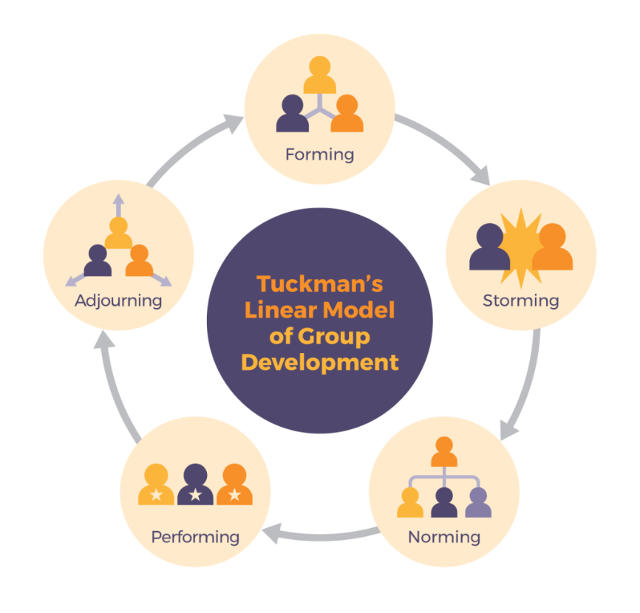

Figure 2: Tuckman's Stages of Group Development
Source: (Fall et al., 2018)
It's vital to keep in mind that organisations may return to previous phases if new obstacles or developments force them to do so (Bolden, 2022). All McDonald's teams, whether they're in marketing, operations, or somewhere else entirely, go through these phases whenever they complete a major project or assignment. Effective management and leadership play a critical role in helping teams traverse these phases to accomplish their objectives and retain productivity.

Leadership Theory
Leadership at McDonald's is a hybrid of transformational, servant, and situational styles, with a focus on setting a good example. Leaders are tasked with serving their teams and clients with enthusiasm and energy. They are flexible as leaders and inspire productive collaboration. Strategic leadership sets the course for the whole organisation, whereas ethical leadership is of the utmost importance at the board level. Franchise leadership guarantees the upkeep of the franchise's brand image, while flexible management helps the business adapt to its changing environment (Toor et al., 2018). McDonald's executives can't succeed in the fast food market without the tools that training and development provide.

Belbin's Team Role Theory
Belbin's Team Role Theory is an idea that classifies the typical functions performed by team members. The concepts it lays forth may apply to different parts of McDonald's or other major organisations, even if it's usually used for smaller teams and projects (Rodrigues, 2021). various workers may take on various responsibilities within the team setting that is McDonald's. McDonald's may benefit from the following Belbin team roles:
Someone who thinks outside the box and provides fresh ideas for food or advertising might be promoted to plant. The duties of a Resource Investigator might include the search for alternative local suppliers of ingredients or the establishment of new business alliances.
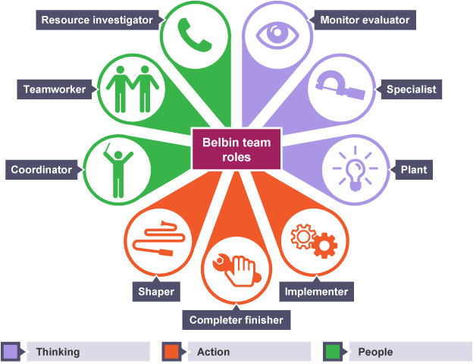

Figure 3: Belbin's Team Role Theory
Source: (Belbin, 2023)
McDonald's may employ coordinators who guarantee that different parts of a new restaurant opening or marketing campaign come together smoothly. A shaper is the kind of employee who steps up to the plate when the pressure is on and drives the team to success. A McDonald's restaurant's day-to-day operations rely heavily on the work of implementers, who are responsible for seeing that plans are carried out. Tasks for this position might include reviewing the efficiency of newly implemented procedures and performing quality assurance inspections (Belbin, 2023). In McDonald's high-pressure, customer-centric business, teamwork is essential to keeping a good mood and satisfying customers. There might be McDonald's employees on the team who are experts in areas like nutrition, food safety, or technology.
It's crucial to remember that although certain team jobs may come more readily to some individuals than to others, a well-rounded team usually has representatives from each capacity (Bolden, 2022). It's possible that McDonald's, like many other major companies, actively or passively encourages the creation of these positions in its many teams to improve problem-solving, decision-making, and overall team performance. McDonald's will be better prepared to face a wide range of difficulties and seize a wide range of possibilities if it acknowledges and makes use of these positions.

Empirical evidence about employee wellbeing
McDonald's has introduced a variety of group management and employee wellness initiatives to better serve its large and diverse workforce (Khatri et al., 2017). Staff members are encouraged to work together and develop professionally via a variety of training and development programmes. Research on the effects of such programmes has demonstrated favourable benefits in terms of enhanced employee abilities, work satisfaction, and lower turnover rates, albeit the particular empirical evidence may differ by place and time.
McDonald's also cares about its employees' well-being, which is why the company has such severe health and safety measures in place. A decrease in occupational accidents and injuries has been seen empirically, albeit the data may vary depending on the locale (Bolden, 2015). Increased employee happiness is a result of initiatives such as flexible scheduling and rewards programmes. Positive correlations between these programmes and worker contentment and loyalty have been shown, while regional variations exist. McDonald's dedication to diversity and inclusion initiatives is a key factor in fostering a feeling of community among workers. Programmes like this show that the firm cares about its employees and wants to make them happy, even if the data shows that various groups of people have had varied experiences. Overall, McDonald's exhibits a multifaceted strategy for managing groups and fostering employee well-being, with empirical data proving the beneficial effects of these activities.

Effective various approaches or theories
McDonald's, being a multinational organisation, may use a wide range of methods and ideas for managing teams and improving working conditions. Here are some potential outcomes for the business under several hypothetical strategies:
Transformational Leadership: Transformative leadership, which seeks to motivate workers by helping them see themselves as part of the company's larger mission, is one strategy that might boost morale and productivity. This strategy may boost morale and productivity by inspiring creativity and a shared feeling of mission among workers.
Servant Leadership: Servant Leadership has the potential to create a more compassionate and helpful atmosphere at McDonald's by putting the company's workers and customers first (Toor et al., 2018). There may be a favourable effect on customer service and staff retention if this strategy is used to boost employee morale, work satisfaction, and general well-being.
Team Building: Through the use of exercises and seminars, workers may learn to work together more effectively and develop a stronger sense of confidence in one another, which in turn may improve group dynamics and output. Increases in happiness and satisfaction at work may result from efforts to foster a cooperative atmosphere.
Diversity and Inclusion: Placing a premium on diversity and inclusion activities may help to make the workplace more welcoming and supportive of people from all walks of life. McDonald's might improve morale and well-being among workers by encouraging an environment where diversity is celebrated.
Employee Assistance Programs (EAP): Providing workers with access to effective EAPs may improve their well-being and engagement on the job by helping them cope with the stresses of their personal and professional lives (Kinman et al., 2020). Employees' work-life balance may be enhanced if they have access to counselling services and resources.
Health and Wellness Initiatives: Health and wellness programmes, such as those that encourage good eating and physical activity, may have a positive effect on the health and happiness of the workforce. Improved morale, vigour, and job satisfaction might result from such efforts, leading to a more efficient staff.
Flexible Work Arrangements: Introducing flexible work arrangements might satisfy the different demands of workers, such as students or parents, leading to enhanced job satisfaction and work-life balance. This method might lead to greater employee retention rates and general well-being, as workers feel supported in balancing their personal and professional duties.
McDonald's might boost workplace morale, employee well-being, and business results by adopting some of the management practices that have emerged from these distinct schools of thought. For these strategies to be effective and widely adopted by McDonald's, they must be adapted to the company's unique culture and personnel makeup.

Recommendation for better workplace management and employee wellbeing
Combining leadership theories and techniques might help McDonald's better manage groups and promote employee well-being. Transformational leadership, emphasising motivation and inspiration, might develop a feeling of purpose among workers, producing a healthy group dynamic (Robertson et al., 2019). To improve teamwork and morale, businesses may use Belbin's Team Role Theory to identify and capitalise on each member's unique skills. Furthermore, situational leadership would for flexible solutions to evolving requirements and novel obstacles within McDonald's inclusive setting. Ethical leadership is shown in the prioritisation of health and safety procedures, which benefits everyone at the company. Finally, consistent employee feedback and engagement surveys grounded on servant leadership principles might provide useful information for meeting the unique requirements of each workforce. By bringing together these many methods, McDonald's can develop a comprehensive and adaptable plan for group management and the improvement of staff well-being across all of their locations worldwide.

Conclusion
The key to a company's financial success lies in its management team's ability to comprehend and enhance employee behaviour. The key to a successful business is motivating employees to perform their best work and fostering an environment where everyone can trust and support one another. If the fundamental objective of McDonald's is to maximize organizational advantage via employee satisfaction, then they may be on the right road. McDonald's management success stems from the company's dedication to many key tenets, including clear lines of authority, extensive opportunities for professional growth, streamlined processes, constant innovation, a customer-first mentality, and environmental and social responsibility. McDonald's has maintained its status as a worldwide leader in the fast food business because of careful management of these factors.

Reference
Belbin, R.M. (2023) ‘Decision-making and the mature team’, Beyond the Team, pp. 68–73. doi:10.1016/b978-0-7506-4641-3.50014-x.
Bolden R. (2022) ‘The face of true leadership’, European Business Forum, (21), p. 54.
Fall, K.A. and Wejnert, T.J. (2018) ‘Co-leader stages of development: An application of Tuckman and Jensen (1977)’, The Journal for Specialists in Group Work, 30(4), pp. 309–327. doi:10.1080/01933920500186530.
Khatri, P. and Gupta, P. (2021) ‘Workplace spirituality: A predictor of employee wellbeing’, Asian Journal of Management, 8(2), p. 284. doi:10.5958/2321-5763.2017.00044.0.
Kinman, G. and Wray, S. (2020) ‘Well-being in academic employees – a benchmarking approach’, Handbook of Research on Stress and Well-Being in the Public Sector [Preprint]. doi:10.4337/9781788970358.00019.
Rahman, K.A., Areni, C.S. and McDonald, P. (2019) ‘Is the company the only meaningful brand for services?’, Journal of Brand Management, 17(3), pp. 197–206. doi:10.1057/bm.2009.6.
Robertson, J. and Mills, R.W. (2019) ‘Company failure or company health?—techniques for Measuring Company Health’, Risk Management, pp. 261–268. doi:10.4324/9780429282515-19.
Rodrigues, C.A. (2021) ‘Fayol’s 14 principles of management then and now: a framework for managing today’s organizations effectively’, Management Decision, 39(10), p. 880–889.
Toor S., & Ofori G. (2018). Leadership and Management in Engineering 8(2), p.64

Appendix
No | First Name | Last Name | Email | Tasks
1. | Andreea | Tamba | 2112920@student.uwtsd.ac.uk | Introduction and company overview
2. | Viorica | Birloiu | 2227895@student.uwtsd.ac.uk | Main body: group effectiveness and wellbeing of employee + empirical evidence about employee wellbeing + put together and final edits
3. | Andreea Gabriela | Caba | 2122564@student.uwtsd.ac.uk | Main body – Managing group: Tuckman’s Stages of group development + leadership theory
4. | Georgiana Madalina | Usurelu | 2226304@student.uwtsd.ac.uk | Main body – Managing Group: Belbin’s team role theory + Effective various approaches or theories
5. | Bianca Elena | Visan | 2108538@student.uwtsd.ac.uk | Main body: Recommendation for better workplace management and employee wellbeing + Conclusion

