DS 1 Template
Student ID: 2541234

My Screenshots/Photos
- Please add 4–6 screenshots or photos of your digital life.
- You can use your phone or laptop.
- For each screenshot, write one or two sentences explaining what it shows.

Screenshot/Photo 1
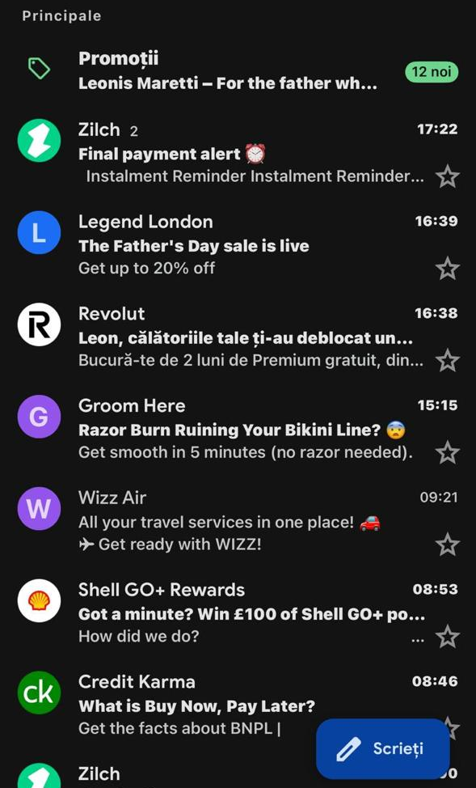
This screenshot shows my Gmail inbox, which I use every day to manage my personal emails. I also receive important messages from my university, clients, online services, and businesses. Gmail helps me stay organized, keeping all my communication in one place, and allowing me to respond quickly.

Screenshot/Photo 2
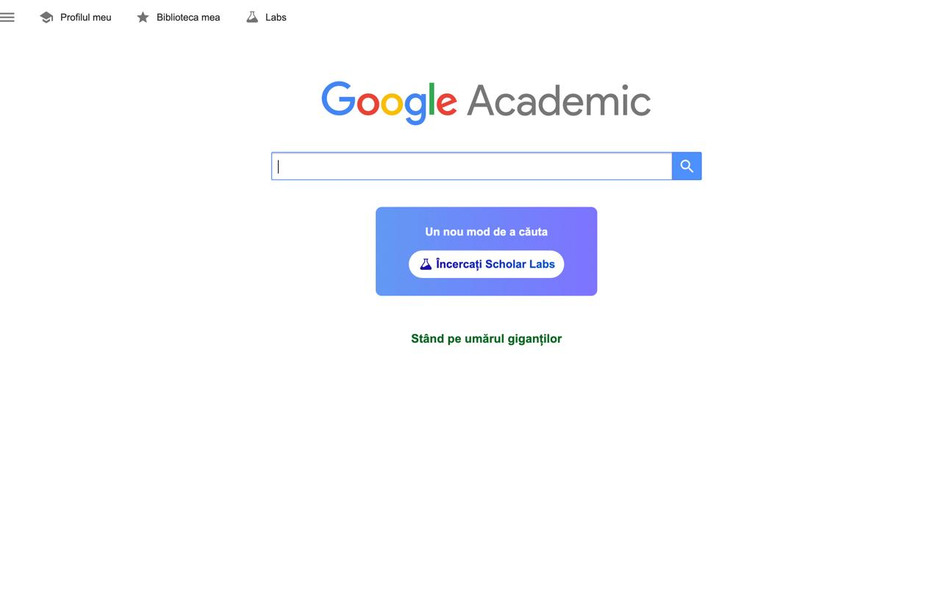
This screenshot shows Google Scholar, which I use to search for academic articles and research papers. It also helps me find reliable and trustworthy sources so that I can improve the quality of my academic work on my academic assignments and by using valuable information.

Screenshot/Photo 3
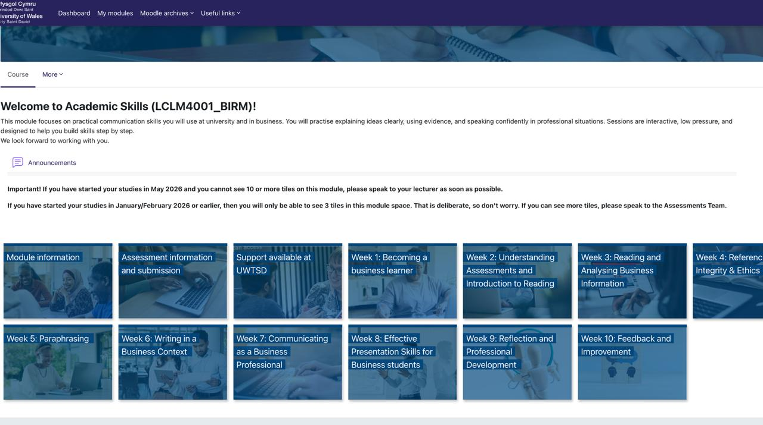
This screenshot shows my university's Moodle dashboard. I use this platform to access modules, download learning materials, complete weekly activities, and submit assignments. It is also one of the main digital tools I use during my studies.

Screenshot/Photo 4
[Insert Photo/Screenshot below]
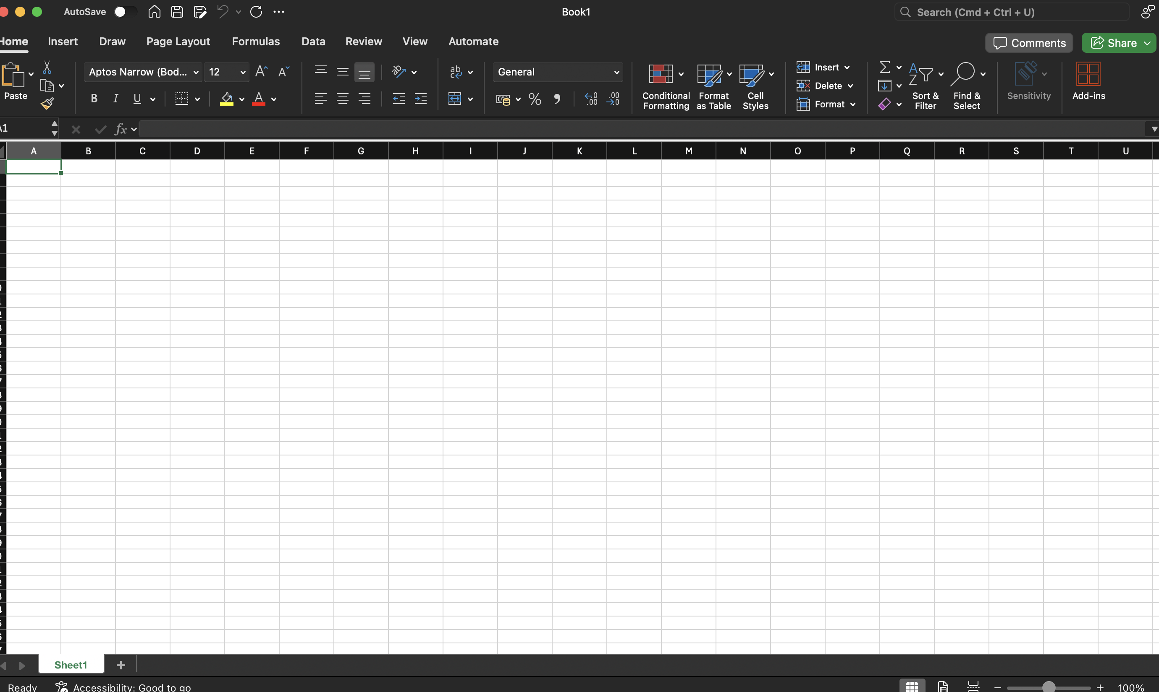
This screenshot shows Microsoft Excel, which I use to organize information and complete my university assignments. Excel helps me manage data, create tables, and improve my digital and analytical skills.

Screenshot/Photo 5
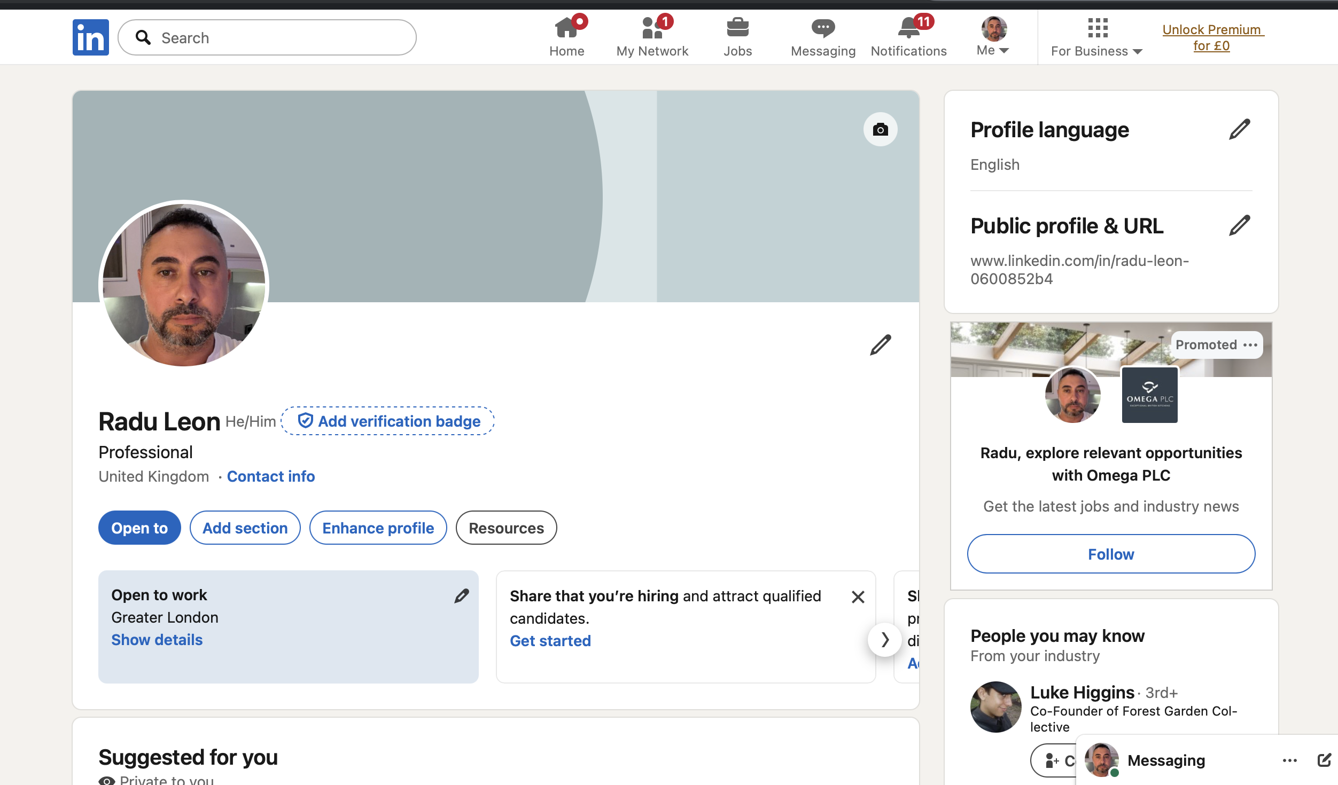
This screenshot shows my LinkedIn profile, which is still under development. I use this platform to build my professional network, search for job opportunities, and showcase my skills and experience to employers.

Screenshot/Photo 6
[Insert Photo/Screenshot below]
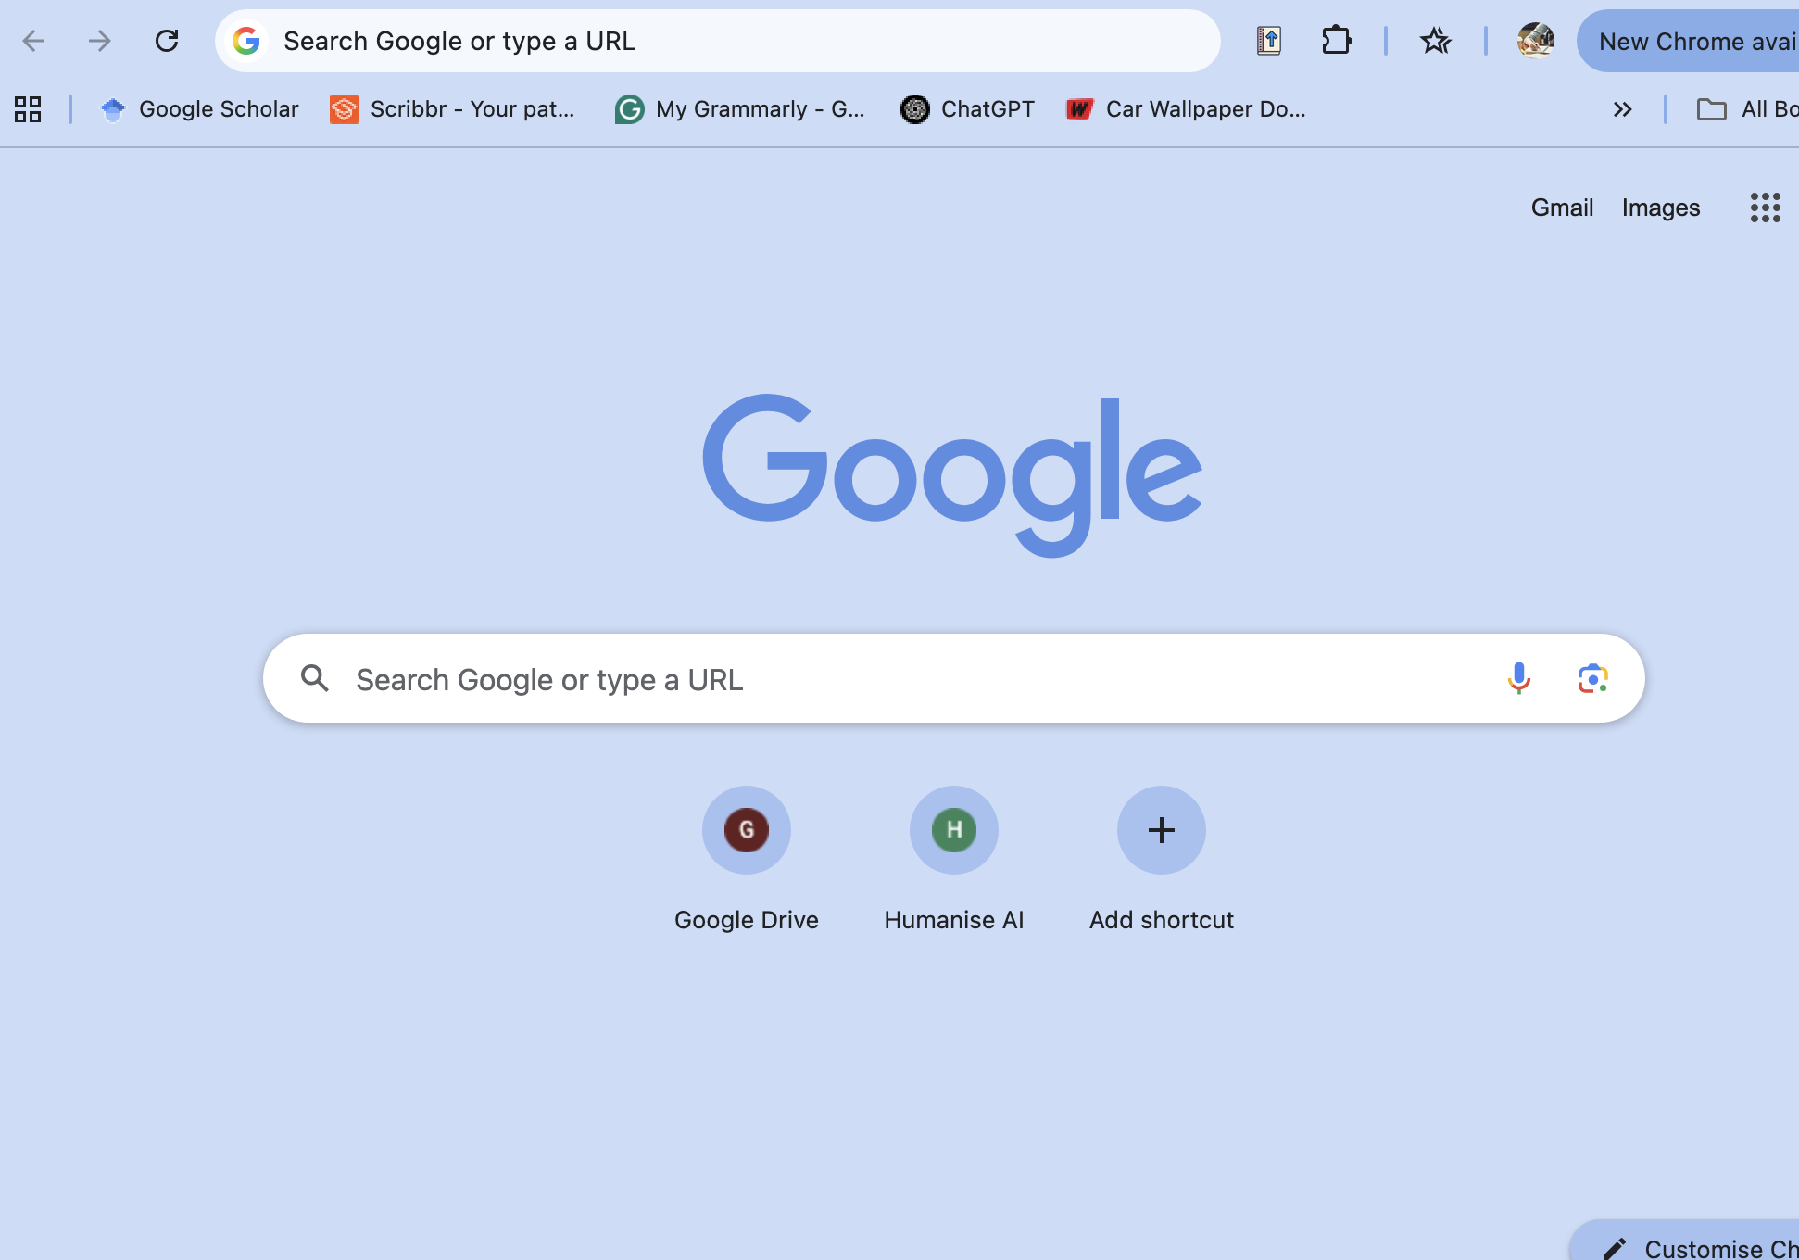
This screenshot shows Google Chrome, which I use every day to search for information, access academic resources, and complete online research. It is also one of the digital tools I use most frequently

My Short Reflection
- Write 5–8 simple sentences about your digital life.
- You can use the sentence starters below if helpful.
I use digital tools every day for my academic work but also for personal organization and communication. I feel very confident when using applications such as Microsoft Word, Excel, Chrome and LinkedIn. All these tools help me to complete assignments but also to search for information and to be able to develop my professional profile. I would like to improve my Excel skills and become more confident using digital functions. you have advanced. Sometimes I feel challenged when learning new software but I also like to improve my digital skills so that I can use them in my future career. Digital skills are also important because they help me study more effectively and prepare for employment.

Sentence starters
- I use digital tools to …
- I feel confident when I …
- I want to improve …
- I often use these tools: …
- I sometimes feel nervous about …
- I hope this module will help me …
- Digital skills are important for me because …
You can write more if you want.

Submission Checklist
Before you submit, please check:
​​​ ☒ I added 4–6 screenshots
☒ I wrote short sentences for each screenshot
☒ I wrote my short reflection
☒ My work is my own
☒ My file opens correctly
​​☒ My file opens correctly

