Chapter 4: Discussion
The primary objective of this study was to investigate if an individual's recall for feedback is impacted by variations between feedback that is oriented towards the past or future. This was explored using the Item Analysis of Subjects’ Free Recall Responses (Nash et al., 2018). Another aim of this study was to discover if individuals would recall more evaluative feedback comments compared to those who only viewed directive.
According to the study's findings overall, individuals did not favour recalling either evaluative or directive feedback. Contradicting with the hypothesis, neither feedback variation was shown to be more effective when it came to recalling this information. On further analysis of the data, it was found that there was a significant difference for the evaluative group when recalling the new feedback statements added in. There was no significant difference when conducting an independent samples t-test on the correct recall between old and new statements for the directive group.
The finding of this study opposes to the general belief that evaluative feedback is recalled better than directive (Nash et al., 2018), but supports the idea that feedback should be both critical and helpful. This relates to the effect it has on student’s self-efficacy beliefs as those who had a fixed mindset in previous studies admitted to acting defensively when receiving criticism compared to those with a malleable mindset (Forsythe & Johnson, 2016). When more directive comments are added into feedback to balance out the criticism it plays a crucial role in changing the student’s self-efficacy views which shapes the way they interact with feedback (Pajares & Valiante, 2006).

The significant difference found when looking at the evaluative group recalling more newer comments could be used to oppose the idea of an evaluative recall bias (Nash et al., 2018). When recalling information participants scored higher with the new comments that did not follow the same wording as the old feedback provided. This rejects the idea that individuals fail to search their memories for future-oriented information and links into schema-driven retrieval process which states that people tend to actively remember certain information regarding their prior performance. If feedback is frequently represented as evaluative in individual’s mental schemas, this might also explain why participants typically display an evaluative retrieval style when recalling feedback (Gregory et al., 2019). However, these findings reject this notion as it could be argued participants did the opposite by finding that the evaluative style of writing was the feedback they ignored.
This study does support the idea that individuals could have the tendency to appeal more towards feedback that is based on areas of development rather than criticism (Winstone, Nash, Rowntree, et al., 2016). This could be represented through participants making the newer feedback comments into more readily available memory representations to help them progress in the future (Goschke & Kühl, 1993) linking into the idea that this positive feedback aimed to focus on your strengths and uplift your spirit are more effective for a student’s progress (Hirsch, 2017).
When reflecting on the overall methodological approach, the study was effective as clear results were obtained easily and efficiently. This study was conducted in a lab which meant external factors were controlled and minimised, allowing the participant to focus. There were no issues with the SuperLab program, resulting in a smooth running of the study, keeping within the time specified.

In addition to these positive aspects, there were limitations to this study which involved the wording of instructions displayed before each task. Once the study had begun, the participant was left unsupervised inside the lab until they signalled to the researcher that they had finished. Upon collecting the piece of paper provided for the distraction task it was found that some participants had noted a few key words or some of the feedback comments. This then questions whether they would have remembered certain feedback comments more than others if they did not have these notes. If this study was to be replicated, future researchers should ensure clearer and more precise wording of instructions to clarify that the piece of paper is to only be used for the second task or when instructed to on screen.
The above limitation links in with another issue which was found with the keys used on the last task as participants had to press “A” or “L” or wait for the minute countdown for the screen to automatically move onto the next feedback comment. However, it was found that if the caps lock was on, then the screen would not change after a key was pressed, as it was only programmed to recognise lower case letters. This resulted in the participant staying longer than expected and they ended up writing their answers down on the paper as they thought the study was not recording their answer. If this study was to be replicated, then programming so both uppercase and lowercase letters are recognised would be very beneficial, so the study goes as planned and data is recorded easily.
Another potential drawback of this study might be the presence of external factors that could have affected the finding. Although this was conducted in a lab, meaning majority of factors were controlled, the environment was not always constant. Two examples would be the airflow as the temperature of the lab differed each day, and some participants came in with a strong smell of perfume which lingered. Due to this being a memory test, it is important for future research to consider these small factors that could affect an individual’s performance and minimise this risk by providing a fan to ensure a comfortable environment.
An evident constraint of the current study is its artificial nature. The mock assignment they read would have been familiar to them as it is the software that the university provides feedback on making it feel more natural to them. The participants were informed that this was not their work to minimise any potential discomfort they may feel. However, as the participants knew it was not their work it questions whether they reacted in the usual way they would as if they were receiving this criticism on their own work.
Future research should also aim to recruit more participants as only twenty-two were collected which meant approximately only ten participants per type of feedback. The twenty-two participants consisted of nineteen females and three males, resulting in the influence of gender-bias. By increasing the number of participants, it allows for more opportunities with the data such as generalisability or a more in-depth analysis looking if age, gender, or level of study effected an individual’s memory on the type of feedback they read. The participants were non-representative as the sample consisted of students studying psychology or a psychology related degree which could imply that some could have guessed the aim. They were all from the same university which may work under different proformas to other schools and the feedback provided as well as the way they interpret it will be a lot different to those in college or younger. As this was advertised on EMS, which is only available to students studying this course, it resulted in a self-selection bias as only these students could participate and may have resulted in those who are more confident in memory tests signing up rather than a variety making it hard to generalise to the public.
Along with its limitations, this study has also presented implications when applied to the education setting and the way in which feedback systems within schools can easily impact the way a student interprets different types of feedback. The findings implicate that the slightest variation in phrasing could alter its overall purpose to the individual receiving it, as those who received evaluative feedback comments were able to recognise the new feedback better. This suggests that students who are familiar to receiving more critical feedback (evaluative) can sense that change in wording when it comes to improving their work. This could be applied to the evaluative recall bias where individuals find it hard to recall this type of feedback meaning schools need to train teachers and implement more strategic methods when providing students with feedback by considering that there needs to be a balance between criticism and praise for a high degree of improvement.
By implementing more effective training to teachers it allows other implications such as the relationship and similar causation role emotions play into when there is not this standardised feedback provided. When a student becomes accustomed to receiving more of directive-based feedback it elicits a positive feeling as it focuses more on future improvements rather than point out the negatives in that piece of work. Applying the findings of this study could coincide with other findings that different types of feedback evoke different emotions causing this to effect what the individual remembers for next time (Lipnevich et al., 2021). As evaluative feedback is harsh criticism it could suggest why individuals were able to identify newer comments better, as the change in tone may have caused them to feel appraisal which is taken into consideration more due to its uplifting nature resulting in a more favourable perception of themselves (Winstone, Nash, Rowntree, et al., 2016b). From this, future research needs a better understanding of the role emotion plays when retrieving useful information for self-improvement. Future studies could explore this relationship by looking at emotions felt by participants pre and post study when reading evaluative and directive feedback on their own work versus another students. This could be compared to see why a sudden change in mood or self-efficacy beliefs decrease.
This study has also opened pathways for the education system to realise why they may not be seeing their expectations met when it comes to overall scores. Without new methods being implemented both students and teachers will struggle with communication and progress will not exceed expectations. Although students agree that written feedback is more beneficial than just a score, they are not actively engaging with it due to the wording or understanding. More longitudinal studies need to be conducted to test all these individual differences that could improve or decrease an individual’s motivation to keep in mind the feedback received.
In conclusion, this study has brought about valuable insights as to how education systems need new effective systems in place to ensure that individuals are receiving the correct help they need to progress their learning. This study has shown that new feedback systems need to account for individual differences to provide the best care to students as generalising results from previous studies that state one type of feedback is the most effective for everyone will not be beneficial or work. In many cases just providing one type of feedback will not result in a lot of progress as withdrawal from reading criticism may occur or constant praise telling the individuals not to set goals for themselves. Empirical evidence indicates it is essential for educators to promote and maintain their students' learning self-efficacy through instructional approaches include goal setting, performance feedback, and self-evaluations of progress can help achieve this for a higher chance at the student progressing (Schunk, 2003). With results showing that both evaluative and directive feedback being beneficial as each other, teachers need to ensure there is this balance, so the student understands the error, but then has the knowledge to use this as motivation to exceed their scores they achieved prior. Communication with the student about the feedback received will be vital to make sure that the tone of the statement is perceived correctly and so the student has a healthier experience when receiving criticism resulting in them taking the advice on board ready to implement into future work. To further our knowledge around this subject more data and variables need to be measured to increase ecological validity and the individual factors that can influence the recall of different emotion. Future research needs to conduct more longitudinal studies with a more diverse and larger sample to see whether the different type of feedback influences the student’s performance or their learning. It is applicable to education systems as it could help to explore the problem of students avoiding feedback and understanding the reasons behind it. More research needs to explore different learning models, and how effective they are when exploring the progress a student makes through using this technique, for example goal setting.

References
Black, P., Harrison, C., Lee, C., Marshall, B., & Wiliam, D. (2004). Working inside the Black Box: Assessment for Learning in the Classroom. Phi Delta Kappan, 86(1), 8–21. https://doi.org/10.1177/003172170408600105
Black, P., & Wiliam, D. (1998). Assessment and classroom learning. Assessment in Education: Principles, Policy & Practice, 5(1), 7–74. https://doi.org/10.1080/0969595980050102
Brown, E., & Glover, C. (2006). Evaluating written feedback. In Routledge eBooks (pp. 101–111). https://doi.org/10.4324/9780203969670-18
Burke, D. (2009). Strategies for using feedback students bring to higher education. Assessment & Evaluation in Higher Education, 34(1), 41–50. https://doi.org/10.1080/02602930801895711
Chan, J. C. K., & McDermott, K. B. (2006). Remembering pragmatic inferences. Applied Cognitive Psychology, 20(5), 633–639. https://doi.org/10.1002/acp.1215
Duijnhouwer, H., Prins, F. J., & Stokking, K. M. (2010a). Progress feedback effects on students’ writing mastery goal, self-efficacy beliefs, and performance. Educational Research and Evaluation, 16(1), 53–74. https://doi.org/10.1080/13803611003711393
Duijnhouwer, H., Prins, F. J., & Stokking, K. M. (2010b). Progress feedback effects on students’ writing mastery goal, self-efficacy beliefs, and performance. Educational Research and Evaluation, 16(1), 53–74. https://doi.org/10.1080/13803611003711393
Evans, C., & Waring, M. J. (2011). Student teacher assessment feedback preferences: The influence of cognitive styles and gender. Learning and Individual Differences, 21(3), 271–280. https://doi.org/10.1016/j.lindif.2010.11.011
Faigley, L., & Witte, S. P. (1981). Analyzing revision. College Composition and Communication, 32(4), 400. https://doi.org/10.2307/356602
Fani, T., & Ghaemi, F. (2011). Implications of Vygotsky’s Zone of Proximal Development (ZPD) in teacher education: ZPTD and self-scaffolding. Procedia - Social and Behavioral Sciences, 29, 1549–1554. https://doi.org/10.1016/j.sbspro.2011.11.396
Ferguson, P. (2011). Student perceptions of quality feedback in teacher education. Assessment & Evaluation in Higher Education, 36(1), 51–62. https://doi.org/10.1080/02602930903197883
Fleming, N. D. (1995). I’m different; not dumb. Modes of presentation (VARK) in the tertiary classroom. (Vol. 18).
Fong, C. J., & Schallert, D. L. (2023). “Feedback to the future”: Advancing motivational and emotional perspectives in feedback research. Educational Psychologist, 58(3), 146–161. https://doi.org/10.1080/00461520.2022.2134135
Fong, C. J., Warner, J. R., Williams, K. M., Schallert, D. L., Chen, L., Williamson, Z., & Lin, S. (2016). Deconstructing constructive criticism: The nature of academic emotions associated with constructive, positive, and negative feedback. Learning and Individual Differences, 49, 393–399. https://doi.org/10.1016/j.lindif.2016.05.019
Forsythe, A., & Johnson, S. (2016). Thanks, but no-thanks for the feedback. Assessment & Evaluation in Higher Education, 42(6), 850–859. https://doi.org/10.1080/02602938.2016.1202190
Gibbons, P. (2002). Scaffolding language, scaffolding learning. https://openlibrary.org/books/OL3939810M/Scaffolding_language_scaffolding_learning
Goschke, T., & Kühl, J. (1993). Representation of intentions: Persisting activation in memory. Journal of Experimental Psychology: Learning, Memory and Cognition, 19(5), 1211–1226. https://doi.org/10.1037/0278-7393.19.5.1211
Gregory, S., Winstone, N., Ridout, N., & Nash, R. A. (2019). Weak memory for future-oriented feedback: investigating the roles of attention and improvement focus. Memory, 28(2), 216–236. https://doi.org/10.1080/09658211.2019.1709507
Hirsch, J. (2017). Dump the Past, Embrace the Future, and Lead the Way to Change. The Feedback Fix.
Keh, C. (1990). Feedback in the writing process: a model and methods for implementation. ELT Journal, 44(4), 294–304. https://doi.org/10.1093/elt/44.4.294
Kolb, D. A. (1984). Experience as the source of learning and development,. The Experiential Learning Theory of Development.
Lipnevich, A. A., Murano, D., Krannich, M., & Goetz, T. (2021). Should I grade or should I comment: Links among feedback, emotions, and performance. Learning and Individual Differences, 89, 102020. https://doi.org/10.1016/j.lindif.2021.102020
Lipnevich, A. A., & Panadero, E. (2021). A review of feedback Models and Theories: Descriptions, definitions, and conclusions. Frontiers in Education, 6. https://doi.org/10.3389/feduc.2021.720195
Mars, R. B., Coles, M., Grol, M., Holroyd, C. B., Nieuwenhuis, S., Hulstijn, W., & Toni, I. (2005). Neural dynamics of error processing in medial frontal cortex. NeuroImage, 28(4), 1007–1013. https://doi.org/10.1016/j.neuroimage.2005.06.041
Nash, R. A., Winstone, N., & Gregory, S. (2021). Selective memory searching does not explain the poor recall of future-oriented feedback. Journal of Applied Research in Memory and Cognition, 10(3), 467–478. https://doi.org/10.1016/j.jarmac.2021.01.003
Nash, R. A., Winstone, N., Gregory, S., & Papps, E. (2018a). A memory advantage for past-oriented over future-oriented performance feedback. Journal of Experimental Psychology: Learning, Memory and Cognition, 44(12), 1864–1879. https://doi.org/10.1037/xlm0000549
Nash, R. A., Winstone, N., Gregory, S., & Papps, E. (2018b). A memory advantage for past-oriented over future-oriented performance feedback. Journal of Experimental Psychology: Learning, Memory and Cognition, 44(12), 1864–1879. https://doi.org/10.1037/xlm0000549
Newton, P. M., & Miah, M. (2017). Evidence-Based Higher Education – Is the learning styles ‘Myth’ important? Frontiers in Psychology, 8. https://doi.org/10.3389/fpsyg.2017.00444
Niemann, J., Wisse, B., Rus, D., Van Yperen, N. W., & Sassenberg, K. (2014). Anger and attitudinal reactions to negative feedback: The effects of emotional instability and power. Motivation and Emotion. https://doi.org/10.1007/s11031-014-9402-9
O’Donovan, B., Outer, B. D., Price, M., & Lloyd, A. G. (2019). What makes good feedback good? Studies in Higher Education, 46(2), 318–329. https://doi.org/10.1080/03075079.2019.1630812
Pajares, F., & Valiante, G. (2006). Self-Efficacy Beliefs and Motivation in Writing Development. In Handbook of Writing Research. https://psycnet.apa.org/record/2006-07885-011
Panadero, E., Andrade, H. L., & Brookhart, S. M. (2018). Fusing self-regulated learning and formative assessment: a roadmap of where we are, how we got here, and where we are going. The Australian Educational Researcher, 45(1), 13–31. https://doi.org/10.1007/s13384-018-0258-y
Pashler, H., McDaniel, M. A., Rohrer, D., & Bjork, R. A. (2008). Learning styles. Psychological Science in the Public Interest, 9(3), 105–119. https://doi.org/10.1111/j.1539-6053.2009.01038.x
Rohrer, D., & Pashler, H. (2012). Learning styles: where’s the evidence? Medical Education, 46(7), 634–635. https://doi.org/10.1111/j.1365-2923.2012.04273.x
Sadler, D. R. (1998). Formative Assessment: revisiting the territory (Vol. 5). https://doi.org/10.1080/0969595980050104
Schartel, S. A. (2012). Giving feedback – An integral part of education. Best Practice & Research Clinical Anaesthesiology, 26(1), 77–87. https://doi.org/10.1016/j.bpa.2012.02.003
Schunk, D. H. (2003). SELF-EFFICACY FOR READING AND WRITING: INFLUENCE OF MODELING, GOAL SETTING, AND SELF-EVALUATION. Reading & Writing Quarterly, 19(2), 159–172. https://doi.org/10.1080/10573560308219
Sutton, P. (2012). Conceptualizing feedback literacy: knowing, being, and acting. Innovations in Education and Teaching International, 49(1), 31–40. https://doi.org/10.1080/14703297.2012.647781
Sweller, J., Van Merriënboer, J. J. G., & Paas, F. (1998). Cognitive Architecture and Instructional Design. Educational Psychology Review. Educational Psychology Review, 10(3), 251–296. https://doi.org/10.1023/a:1022193728205
Winstone, N., & Nash, R. A. (2023). Toward a cohesive psychological science of effective feedback. Educational Psychologist, 58(3), 111–129. https://doi.org/10.1080/00461520.2023.2224444
Winstone, N., Nash, R. A., Parker, M., & Rowntree, J. (2016). Supporting learners’ agentic engagement with feedback: A Systematic review and a Taxonomy of Recipience Processes. Educational Psychologist, 52(1), 17–37. https://doi.org/10.1080/00461520.2016.1207538
Winstone, N., Nash, R. A., Rowntree, J., & Parker, M. (2016a). ‘It’d be useful, but I wouldn’t use it’: barriers to university students’ feedback seeking and recipience. Studies in Higher Education, 42(11), 2026–2041. https://doi.org/10.1080/03075079.2015.1130032
Winstone, N., Nash, R. A., Rowntree, J., & Parker, M. (2016b). ‘It’d be useful, but I wouldn’t use it’: barriers to university students’ feedback seeking and recipience. Studies in Higher Education, 42(11), 2026–2041. https://doi.org/10.1080/03075079.2015.1130032

Apendices
Appendix A

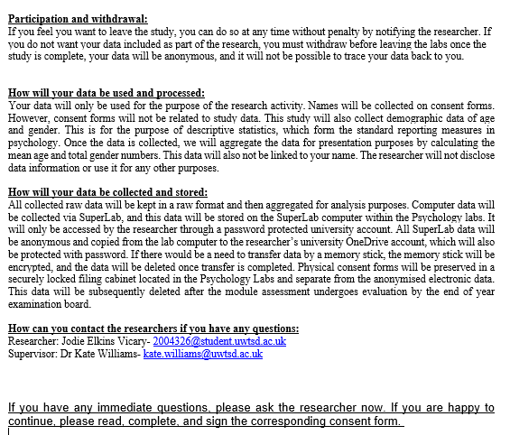

Appendix B
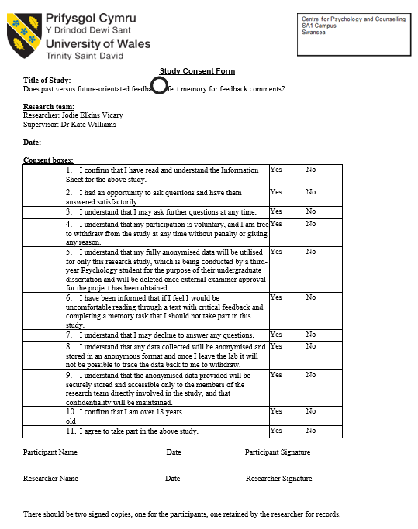

Appendix C
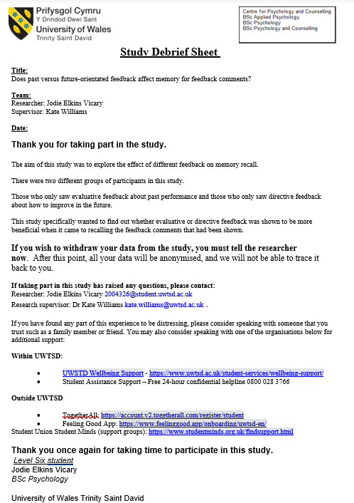
Appendix D


