Michael Oldham (2235684)
2235684@student.uwtsd.ac.uk
Configure & manage virtualised network
Network Operating Systems and Services

Contents
Task 1 – Installing and configuring different elements of the windows/linux servers and clients 2
Installing RRAS & Creating a Forest 2
Adding Windows Client to new Domain 3
Configuring rules in windows firewall too allow ICMP traffic 3
Create Users in my .acca domain 4
1.7 – Mount a second disk drive to D:\SwanseaFiles 5
Install DHCP Server and configure DHCP Services 6

Task 1 – Installing and configuring different elements of the windows/linux servers and clients

Installing RRAS & Creating a Forest
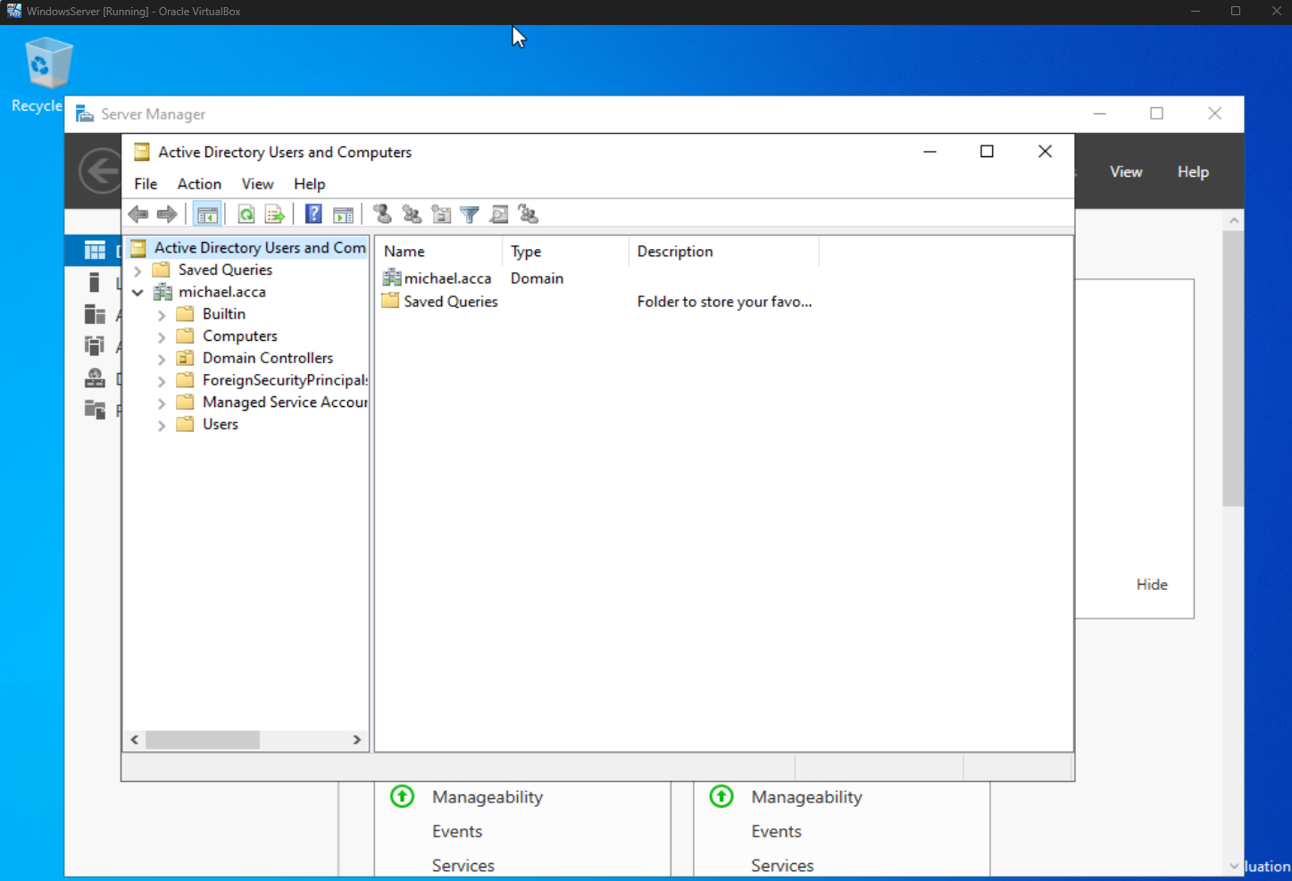

Adding Windows Client to new Domain
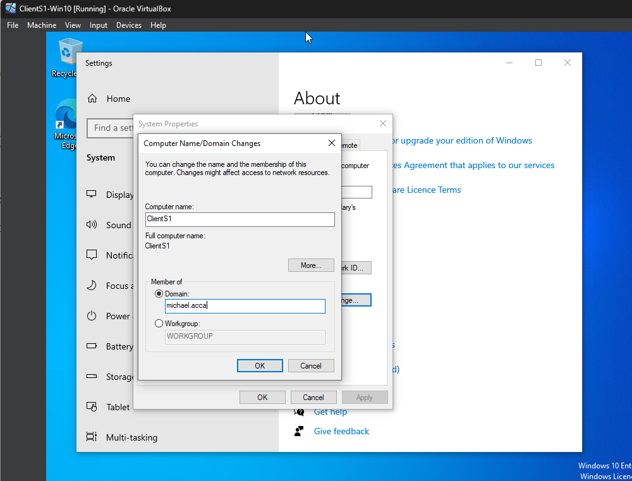

Configuring rules in windows firewall too allow ICMP traffic
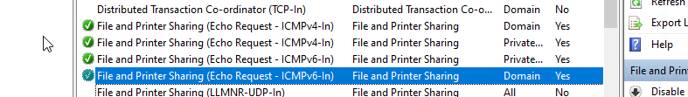

Create Users in my .acca domain
I used chat GPT to help me create the following script to use in windows powershell to import the users and their details.
Before I did this, I manipulated the data in the csv file to add my michael.acca domain and update the users email to match the domain and also to create the username for the SAM account name.
Import-Csv "C:\Users\Administrator\Desktop\users_list_updated.csv" | ForEach-Object {
$securePass = ConvertTo-SecureString "password1234" -AsPlainText -Force
$ou = "CN=Users,DC=michael,DC=acca"

New-ADUser `
-Name "$($_.first_name) $($_.last_name)" `
-GivenName $_.first_name `
-Surname $_.last_name `
-SamAccountName $_.username `
-UserPrincipalName $_.email `
-AccountPassword $securePass `
-Path $ou `
-Company $_.company `
-Title $_.job `
-City $_.city `
-Department $_.department `
-Enabled $true
}

1.7 – Mount a second disk drive to D:\SwanseaFiles
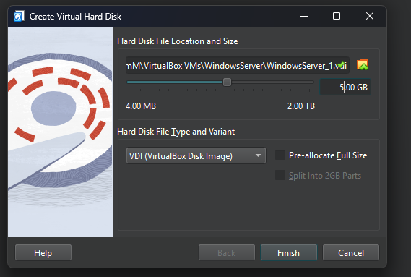
In the Virtualbox settings, I have created a new Hard Disk under the storage tab and for now allocated 5GB of storage ready to configure this drive on the server.

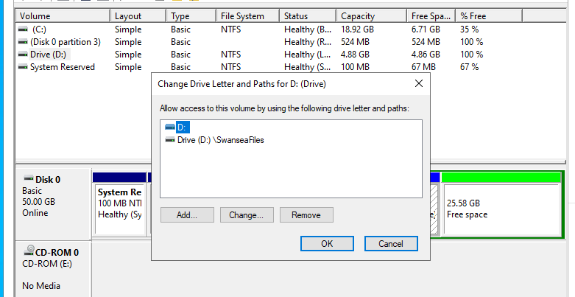
In disk management I then mounted the drive to D:\SwanseaFiles

Install DHCP Server and configure DHCP Services
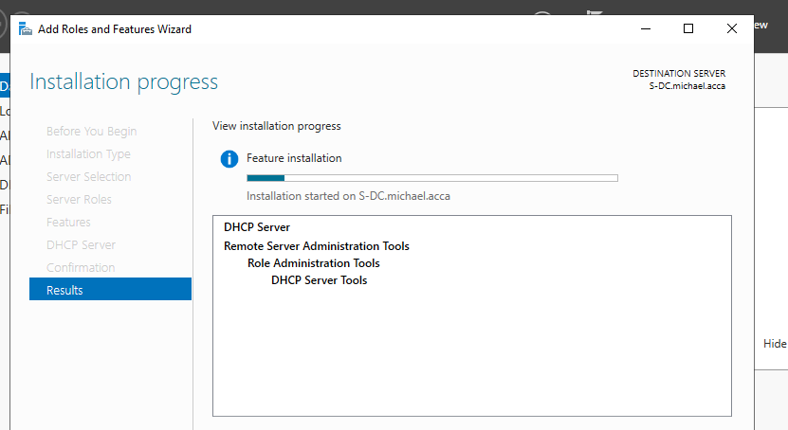

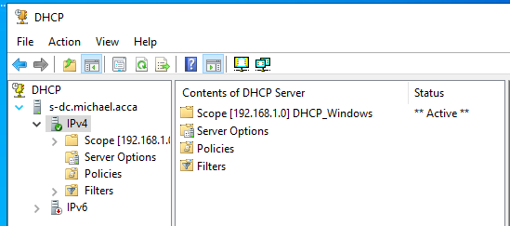
Here is after I had configured my IPv4 by adding a new scope to automatically assign IP address from 192.168.1.20 to 192.168.1.29 but also adding the exceptions for … 20 and … 21. This was just to show that they can be excluded if we know that we are using them for other devices or servers etc.

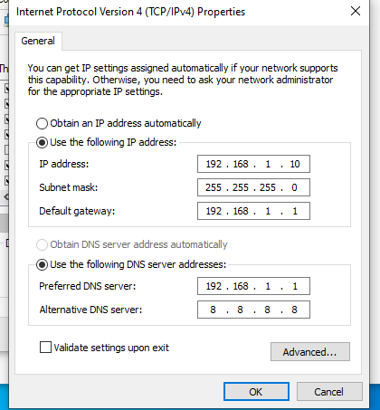
I then removed these IP addresses and DNS server addresses by choosing to obtain them automatically.
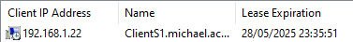
This shows that the ClientS1 windows machine has been allocated the IP address 192.168.1.22 (which was the first IP after the excluded 20 and 21).

