Group Based Project-

Deep Dive Recovery

ACDB 5021/5022

2307750

Daniel Cowen

12/12/2025

Contents
1 Contents 2
2 Table of figures 2
3 Section one – Introduction 4
3.1 The brief 4
4 Section Two – Design Project Management 4
4.1 Group roles 4
4.2 Assumptions 5
4.3 The approach 5
5 Section Three – Role Within the Team 5
5.1 Key considerations 5
5.2 Research into various methods 5
5.2.1 Robotic removal 5
5.2.2 Static detonation chambers 6
5.2.3 Blasting 6
5.2.4 Photolytic removal 6
5.2.5 Jet cutting 6
5.2.6 Freezing techniques 6
5.3 Pairwise comparison 6
6 Section Four – The Presentation 7
7 Section Five – Feedback and Potential Changes 7
7.1 Positive feedback 7
7.2 Negative feedback and potential improvements 8
7.3 Follow up questions 8
7.3.1 How the author arrived at the removal criteria 8
7.3.2 How the freezing technique helps 8
7.3.3 How did the group reorganise and manage the U turn 9
8 Section Six – Conclusion and Lessons Learnt 9
9 Annex 10
10 References 26

Table of figures
Figure 1- Work Based Group Project 10
Figure 2- Brief 10
Figure 3- Background information 10
Figure 4- Assumptions 11
Figure 5- Our approach 11
Figure 6- Design requirements 11
Figure 7- Requirements analysis 12
Figure 8- Candidate concept solutions and down selection 12
Figure 9- .......and the Winner is 12
Figure 10- Proposed process flow algorithm 13
Figure 11- Risk assessment on movement / recovery of munitions 13
Figure 12- HazID 13
Figure 13- Defining area of operation 14
Figure 14- Defining area of operation, Part 2 14
Figure 15- Determining Quantities 14
Figure 16- Catalogue munitions in water 15
Figure 17- Electronic cataloguing system 15
Figure 18- Assess integrity of each munition type 15
Figure 19- Overall structural integrity of the munitions 16
Figure 20- Overall structural integrity of the munitions, Part 2 16
Figure 21- Has the munitions casing been breached 16
Figure 22- Integrity of the explosive compositions in the munitions 17
Figure 23- Integrity of the explosive compositions in the munitions, Part 2 17
Figure 24- Assess levels of disruption to environment and ecology 17
Figure 25- Wildlife disruption on land 18
Figure 26- Wildlife disruption in water 18
Figure 27- Raise munitions from lakebed 18
Figure 28- Pairwise comparison 19
Figure 29- Robotic removal 19
Figure 30- Freezing techniques 19
Figure 31- Review munitions catalogued to compare correct holdings raised 20
Figure 32- Assess levels of disruption to environment and ecology after removal has started 20
Figure 33- Transport munitions 20
Figure 34- Storage for removed munitions 21
Figure 35- Disposal of munitions 21
Figure 36- High order bulk DEM 21
Figure 37- Bulk DEM: How it works... 22
Figure 38- Conclusions 22
Figure 39- Questions? 22
Figure 40- Pairwise comparison 23
Figure 41- Pairwise comparison results 23
Figure 42- Feedback page 24

Section one – Introduction
This report will take an in-depth look at the processes involved in creating and presenting the group-based project, the authors role within the group and the feedback and follow up questions identified after giving the presentation. The task given to the group was to extract dumped munitions from lakes in Switzerland, rendering the munitions safe and finding a safe way of disposing of the munitions whilst ensuring the task was done environmentally safe as well. The presentation was then delivered to the stakeholders with feedback given on what went well and any changes that could be made going forward.

The brief
The brief given to the team was to create a technical presentation and present to stakeholders for under 45 minutes on the following topic: for years the Swiss military have used the lakes as a dumping ground for old munitions believing they could be disposed of safely. The group was also told that the project was to investigate the munitions dumped within the deeper waters of the lakes. The information given to the group was:
- Lake Lucerne has an estimated 3,300 tonnes.
- Lake Neuchâtel has an estimated 4,500 tonnes.
- The Swiss Airforce used the lakes for bombing practice until 2021.
- Some munitions are at depths of 150 to 220 metres [1].

Section Two – Design Project Management
The author’s group was given the role of the deep dive team, researching into the various methods of retrieving the munitions within deeper waters. Due to the types of munitions being unknown the group was given munitions that have been studied on the level 4 OME HNC course, and the munitions were as follows:
- Hand grenades – Mills bombs that are TNT filled and boxed and unboxed.
- 8 cm Mortars – Mortars that are TNT filled, mainly boxed and fuze fitted.
- 105- and 155-mm shells- Shells that are fuzed, PRF, unpackaged and TNT or TNT/RDX filled.

Group roles
With this knowledge the group decided to give each individual member a role to research into:
Simon Shepherdson would oversee Safety/ Risk assessments, determining AO and Determining the quantities of each munition type.
Alex Clarke would oversee assessing the integrity of each munition type and rendering the munitions safe.
Stephen Deane would oversee cataloguing munitions and assessing levels of disruption to the environment and ecology.
Dan Cowen (the report writer) would oversee raising the munitions from the lakebed.
Daani Nayyar would oversee transporting, storing and disposing of the removed munitions.
Simon Shepherdson and Alex Clarke would be joint project managers.

Assumptions
the group decided to come up with a set of assumptions as seen in figure 4 which were:
- No restrictions on resources such as – Time, Funding, Manpower, Technologies available, Co-operations from local authorities and UK staff capability.
- Do rejected shells have PRFs attached
- Shell compositions - Pre 1950 (TNT only) and Post 1950 (TNT/RDX mix)
- Reject rates of batches dumped – Low rates for shells, medium rates for mortars and high rates for mills bombs.
- Suitable security/cordons in place for operations.

The approach
As stated on figure 5 the group initially took a scatter gun approach however this did not work as the team was not working together and there was no direction on the project. The group then decided to take a systems engineering based approach working together through the stages of the workbook. The various systems engineering methods used were Requirements gathering (figure 6), Requirements Analysis (Figure 7), candidate concept solutions (Figure 8 and Figure 9), pairwise comparisons, QFD 1 and 2, functional means analysis, use case, Pugh analysis and process flow analysis (Figure 10). By completing these it allowed of us to gain an understanding of each other’s roles and responsibilities and how they each linked within the group. On completion of the workbook, it was now down to each member of the group to research their roles further.

Section Three – Role Within the Team
As stated in section two the groups approach consisted of giving everyone within the group a required role for the task. The authors specific role for the task was to research into the various methods of retrieving the munitions from the lakebed. This was to allow for the next stages of transporting the munitions and the storage and disposal to be carried out.

Key considerations
There were three main considerations that needed to be monitored when completing this task. The first consideration was ensuring human exposure was kept to a minimum, this was vital to the operation to ensure that the teams working on the project are kept as safe as possible. The second consideration was to avoid an unplanned detonation which can cause harm to the environment and workers and can also lead to sympathetic detonations with surrounding munitions. The final area of consideration is that due to the munitions being older and more deteriorated as well as containing toxic and carcinogenic materials it is vital to ensure that the munition does not leak into the water damaging wildlife and causing further harm.

Research into various methods
After completing the initial research six possible methods were identified. These methods were robotic removal, static detonation chambers, blasting, photolytic removal, jet cutting and freezing techniques.

Robotic removal
This method is a tried and tested method used by the Germans in the north and Baltic seas to retrieve dumped WW2 munitions and uses robots that have various uses when searching and retrieving munitions from the seabed. The first type of robot swims along the service scanning the seabed for munitions allowing experts to identify and assess the munitions. Another type of robot crawls along the seabed with a claw that retrieves the munitions from sediment on the seabed whilst sorting them into a basket contained within the robot. The final robot also swims across the surface with claws that reach into the water and retrieve mines and other larger munitions. [2]

Static detonation chambers
Some land-based technologies used can also be used with sea dumped munitions. Static detonation chambers allow for safe destruction and cleaned off gas releases that can be mobile units that allow for a limit of 1-3kg of explosives. This method could also be used for any munitions not deemed safe enough for transportation or storage. [3]

Blasting
This method is done through attaching an explosive charge to the munition and causing a controlled explosion by either pulling the munition away from structures or other munitions and setting up safety zones for swimmers, divers and boats. [3]

Photolytic removal
Photolysis is a method used to remove the warfare-related organic substances from contaminated waters. This method allows for the explosives contained in old ammunition on the seafloor to be flushed out with hot water and to be collected in a reservoir on a barge. Almost all the main components contained in old munitions could be removed using UV lights. Custom UV facilities have a capacity of up to 100m3 per hour. [3]

Jet cutting
Water abrasive suspension jet cutting is a method used for apportioning large munitions or for deactivating fused munitions. The jet cutting can be used to cut a precise thin cut through rust, coral, concrete and steel in waters down to a 600m depth. These techniques can be used with robotic technology too. Using a jet cutter will not initiate an explosion. [3]

Freezing techniques
Due to older ammunition possibly leaking or becoming unstable it is highly likely that this will happen when retrieving from the lakebed, freezing techniques using liquid nitrogen or supercooling equipment may be used to encase the filling to provide high resistance and stability for transportation. This technique however due to the high energy demand may restrict the use within cold water environments. [3]

Pairwise comparison
Due to the vast number of options identified the next step was to complete a pairwise comparison which compares each option to the requirements mentioned as shown in figure 40. This produced the bar graph seen in figure 41 which shows that robotic removal, jet cutting and freezing techniques were the highest-ranking methods. This then allowed for the top-rated method to be chosen which is robotic removal combined with freezing techniques as it allows for human exposure to be eliminated as well as massively increasing the stability of the munitions when removing them from the lakebed. By using the two techniques combined the considerations stated at the start have all been covered and a successful solution was chosen.

Section Four – The Presentation
On completion of the individual research, it was then down to each member of the group to populate the slides with the information the individual believed to be the most valid. This then allowed for the group to come together as one and take a more in-depth look giving possible changes and improvements for certain slides and cutting back any excess information. Initially the groups slides were bulked out with large amounts of text and collectively it was decided that this would be changed to give an easier flow to the slides and an easier read for the stake holders. After completing the slides, the group had numerous run throughs initially using scripts but as the group continuously ran through the presentation the scripts were changed to que cards which would be used as pointers instead of a tool to read off. As a group it was also decided the two days before the presentation would be used to further refine the presentation through more run throughs to ensure the group was happy with the content that would be presented to the stakeholders.
The author feels the preparation and planning was shown in the presentation as the information was clear for the stakeholders and well presented by the group, the total run time of the presentation was 42 minutes and 7 seconds which was under the 45-minute time frame. The author also feels he presented his slides confidently with minimum reading from the slides or que cards. The author also believes there was a large technical aspect of the retrieval that was presented in a way that was easily understandable to those without previous technical knowledge. If presented again the author believes that with more time to prepare the presentation could be presented without the need for que cards and with a more interactive twist to keep engagement.

Section Five – Feedback and Potential Changes
On completion of the presentation everyone within the group was provided with a feedback sheet seen in figure 42. the first area covered in this section will be the positive aspects of the group and the author and the second part of this section will cover the areas for improvement within the group and individually.

Positive feedback
the first area highlighted as a positive within the group is that it was a well delivered presentation that demonstrated the derivation process and arrival at a viable design option, the author believes this shows how well the team worked together within the initial stages of completing the workbook and how the systems engineering route helped to give structure and direction towards the group. This is further backed up in the feedback which states that using the systems thinking and tools provided a record for the design process and a “why” for the direction of travel.
Another positive area of the group identified in the feedback was the high level of background research that was provided by the individuals within the group as well as the slides having a nice, consistent theme throughout. It also states how well the group referenced each other’s sections.
The final positive area for the group was the attention to health and safety and mitigation to the environmental and ecological damage with reference to the legislation. The author agrees with this feedback as the main priority for the group during the process was the health and safety aspect of the project.
A positive area for the author was a good volume and pace when presenting the information on the retrieval of the munitions from the lakebed.

Negative feedback and potential improvements
The first negative area of the group was that the presentation lacked the slick, suited and rehearsed appearance of the competition. The author believes this is a fair comment and feels the group could have paid more attention to the final details which is something that will not be overlooked if giving the presentation again to the stakeholders.
Another negative area of the group was that due to the images being smaller on some of the slides the information contained within them was hard to read at times, this was also the case for the slides that contained larger amounts of text which was hard to read at times. This is another area which can be changed for further presentations by handing out printed copies of each slide to the stakeholders attending the presentation.
A negative area is that the author was seen as reading from the slides for most of the presentation. The author has since asked for opinions from other stakeholders in attendance as well as the group and the other feedback has stated that the author did well at not overly reading off the slides and only using que cards when necessary. The author feels that if given more time to rehearse the need for que cards would have been eliminated and will be an area to work on in future presentations.
The final area of negative feedback was that the author had a limited response to questions. The author feels that a lot of the questions were directed to other areas within the group and if the author had received further questions about the specific subject of munition retrieval, would have answered any further questions.

Follow up questions
The final area of feedback is questions for consideration in the report. The author was provided with three questions that required further development, these questions were:
- How did the author arrive at the removal criteria?
- How does the freezing technique help? Does it encase the munition?
- How did the group reorganise and manage the U turn?
the next three subsections will take a deeper look at these questions and provide further answers.

How the author arrived at the removal criteria
The author decided to take the role of retrieving the munitions as it was an interesting role that allowed the author to gain further knowledge of various techniques used around the world for retrieving munitions in a safe way. After completing the systems engineering techniques it was evident that the group had prioritised safety of the teams involved and environmental safety, this is what lead to the three main considerations of keeping human exposure to a minimum, avoiding unplanned detonation and ensuring the munitions don’t leak carcinogenic and toxic material into the lake.

How the freezing technique helps
This method stops any leaking due to the ice encasing the munition and subsequently encasing the filling. This provides high resistance surrounding the filling, leading it to be contained and more stable while ensuring the filling does not escape the casing. This is important for the retrieval from the lakebed as it dramatically reduces the risk of unplanned detonation by de-accelerating the chemical reaction as well as removing the risk of toxic filling polluting the environment.

How did the group reorganise and manage the U turn
After realising the scatter gun approach didn’t work due to group all taking an individual path, it was decided that the group would work together to get an idea of the direction in which the group wanted to take the project. This allowed for a greater understanding of everyone’s individual roles and how they link with each other. The author believes the U-turn was easily managed as a group due to the project management and team working well together throughout the full process.

Section Six – Conclusion and Lessons Learnt
To conclude this report the author believes the group presented a well-made technical presentation that fit the brief, flowed well and was easily understood by the stakeholders. The author also believes the group worked well towards the end of the project after finding issues within the team towards the beginning. Having started off with a scattergun approach a key lesson learnt was that working with the group instead of individually massively helps with achieving an end goal efficiently whilst gaining the knowledge of everyone else’s roles and methods of working. As a group it was believed the presentation went well and the feedback given within the group was positive. If this task was done again the author would chose to work in collaboration with the other group as they feel there would have been less issues and more direction on the project.

Annex
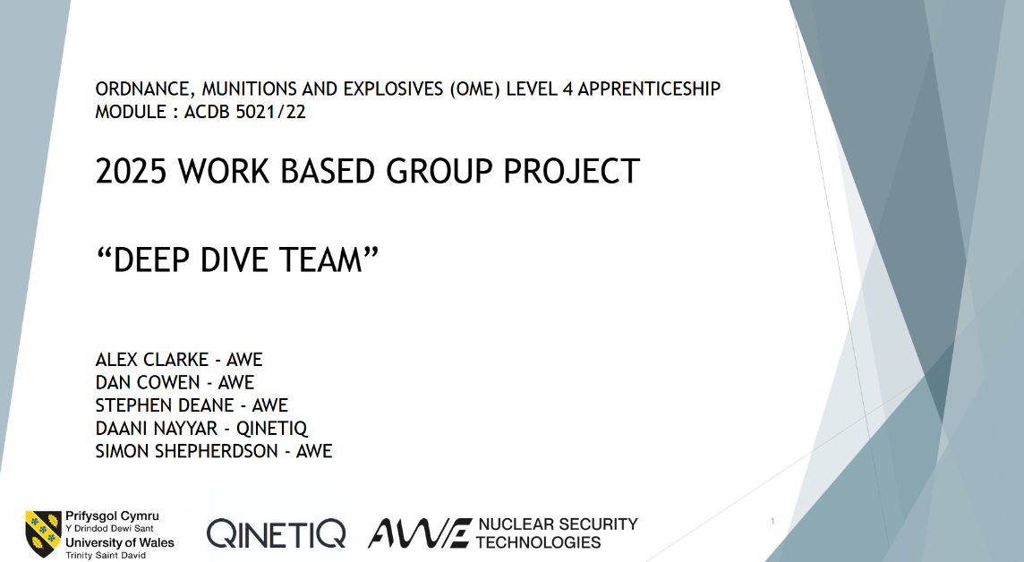

Figure 1- Work Based Group Project
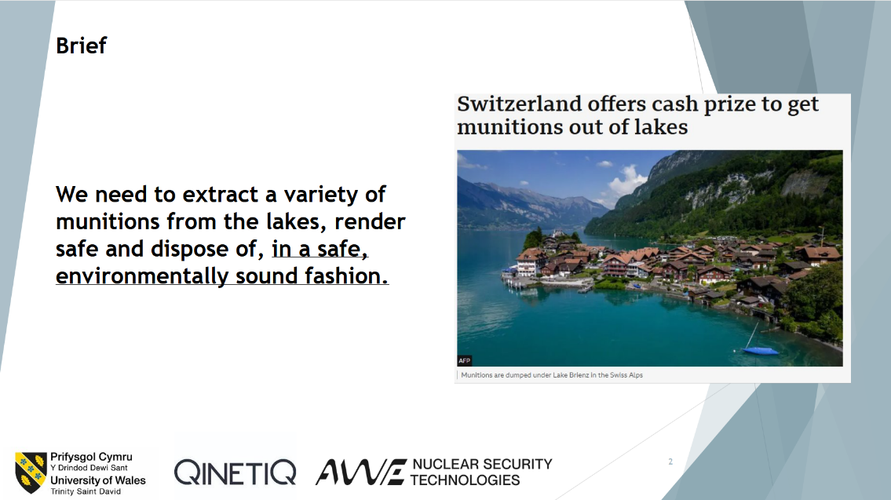

Figure 2- Brief
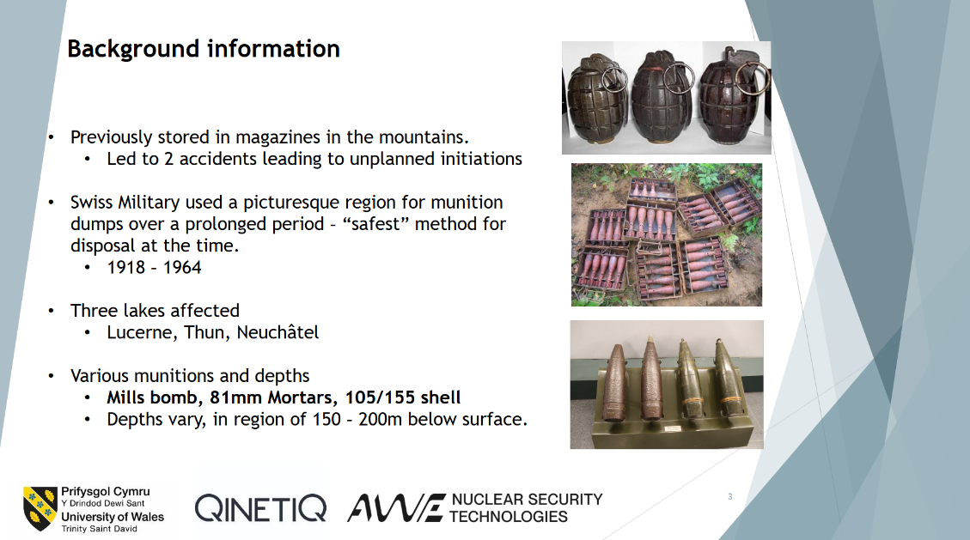
Figure 3- Background information

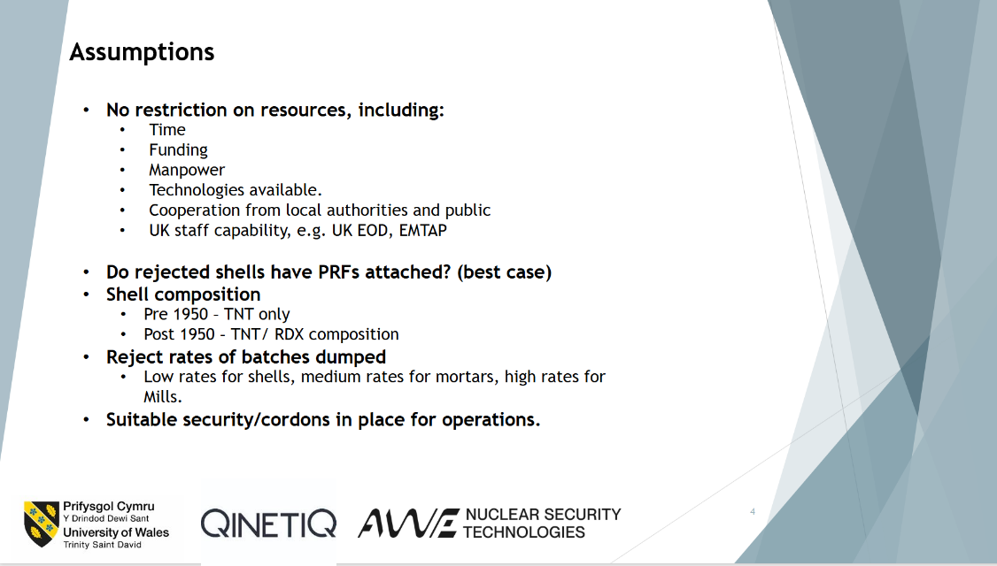

Figure 4- Assumptions
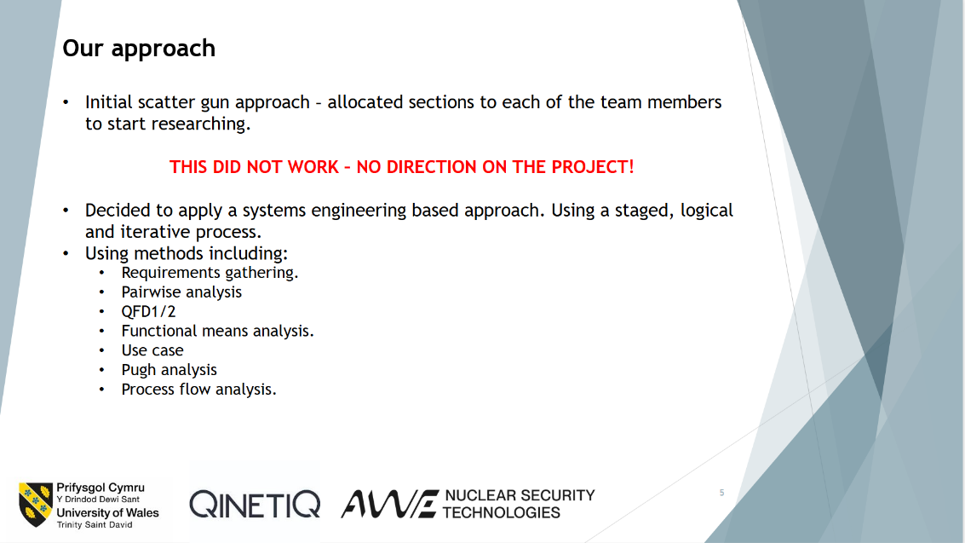

Figure 5- Our approach
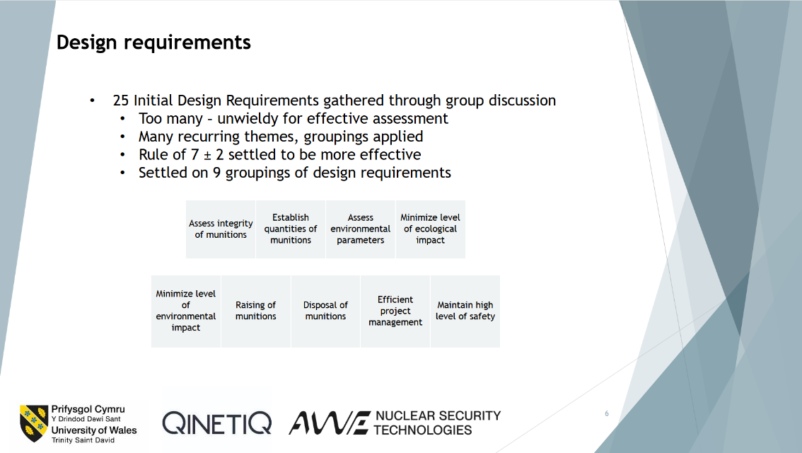

Figure 6- Design requirements

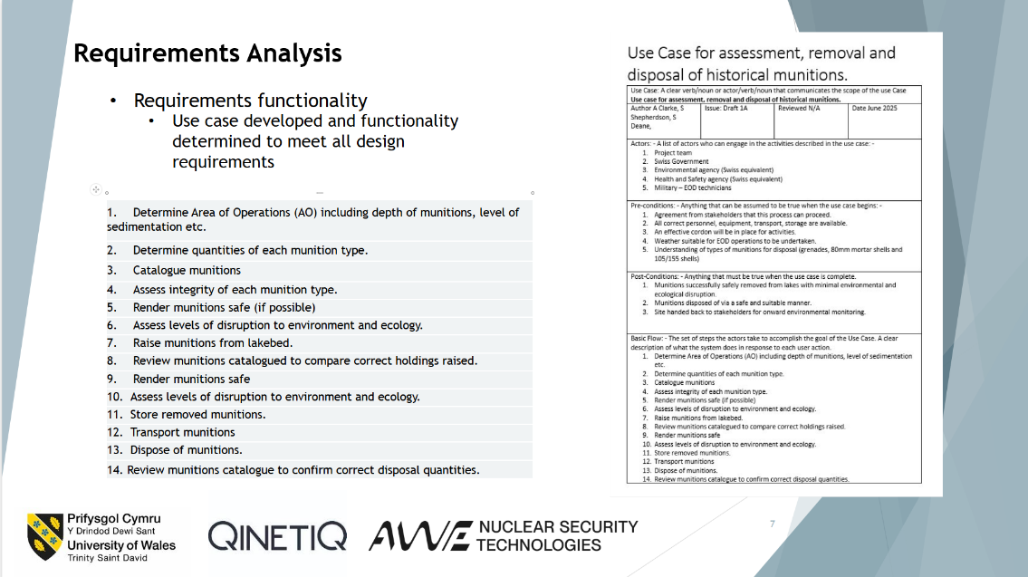

Figure 7- Requirements analysis
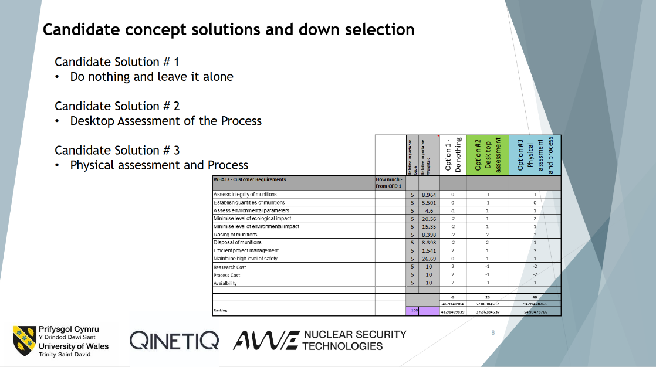

Figure 8- Candidate concept solutions and down selection
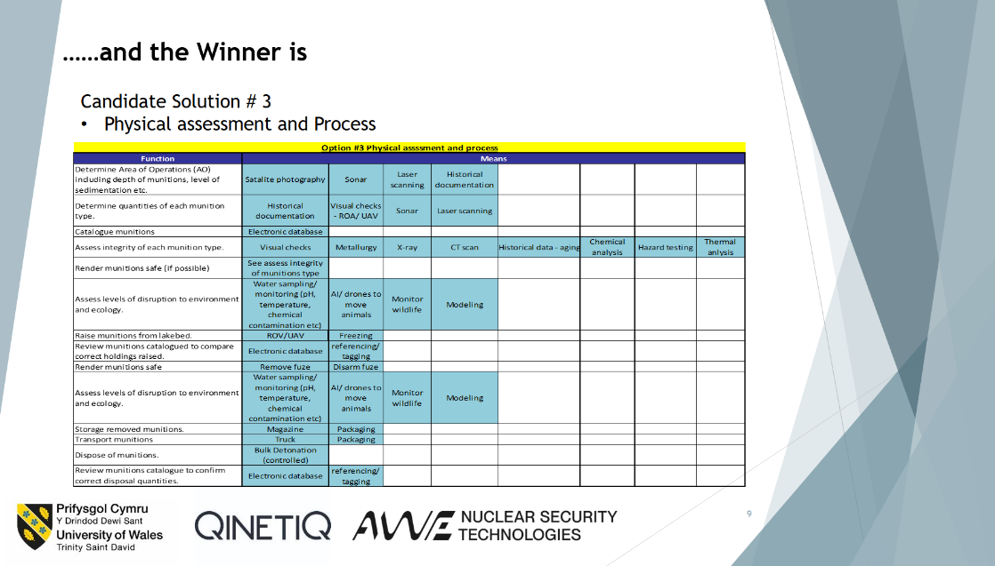
Figure 9- .......and the Winner is

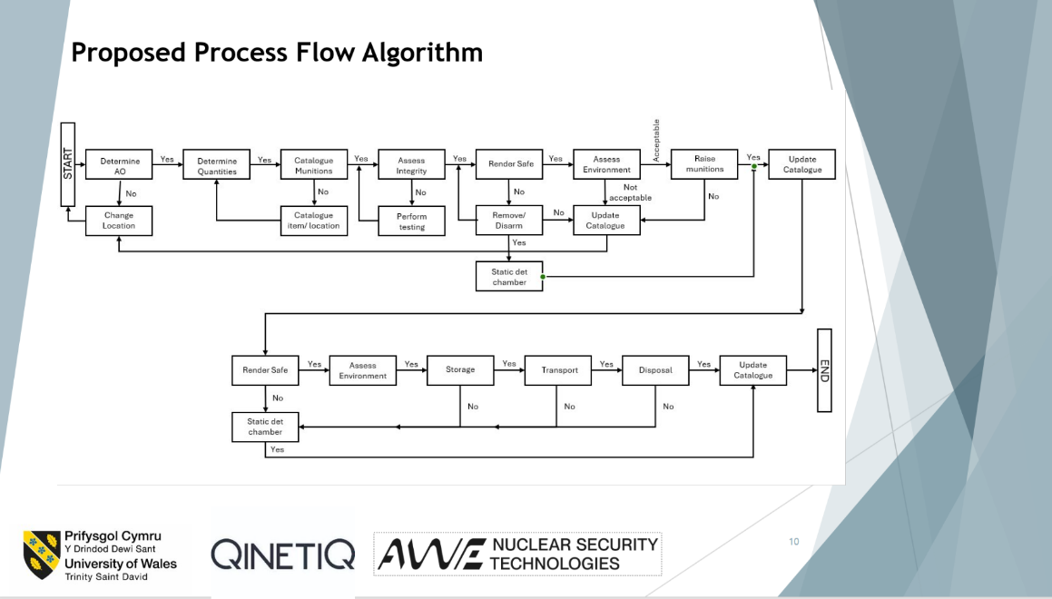

Figure 10- Proposed process flow algorithm
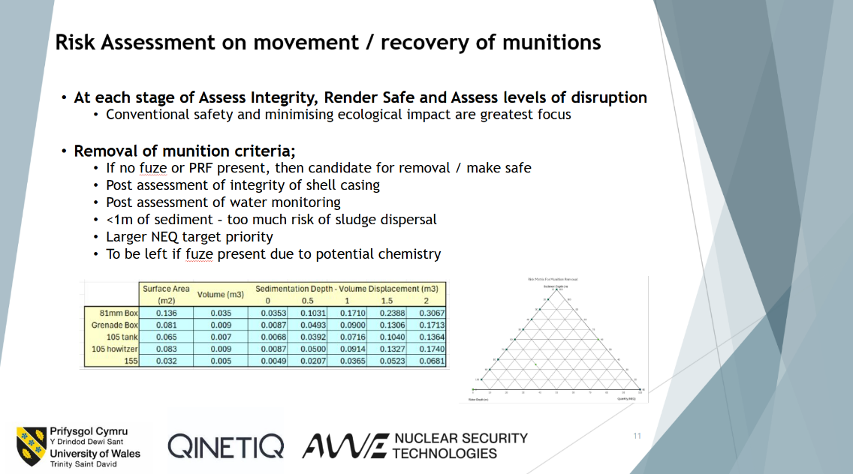

Figure 11- Risk assessment on movement / recovery of munitions
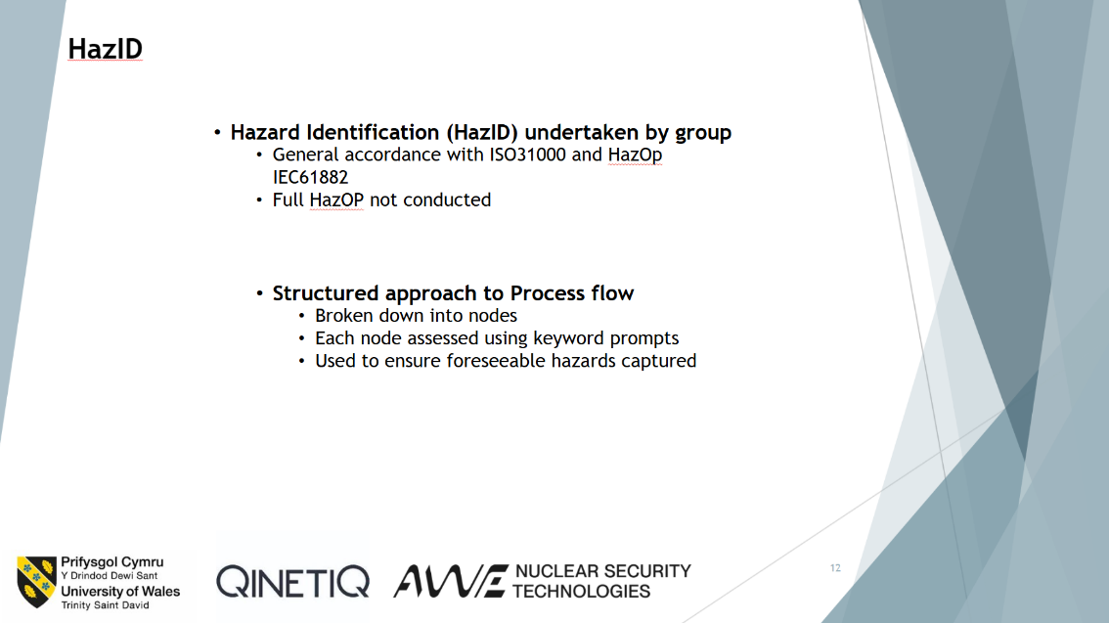
Figure 12- HazID

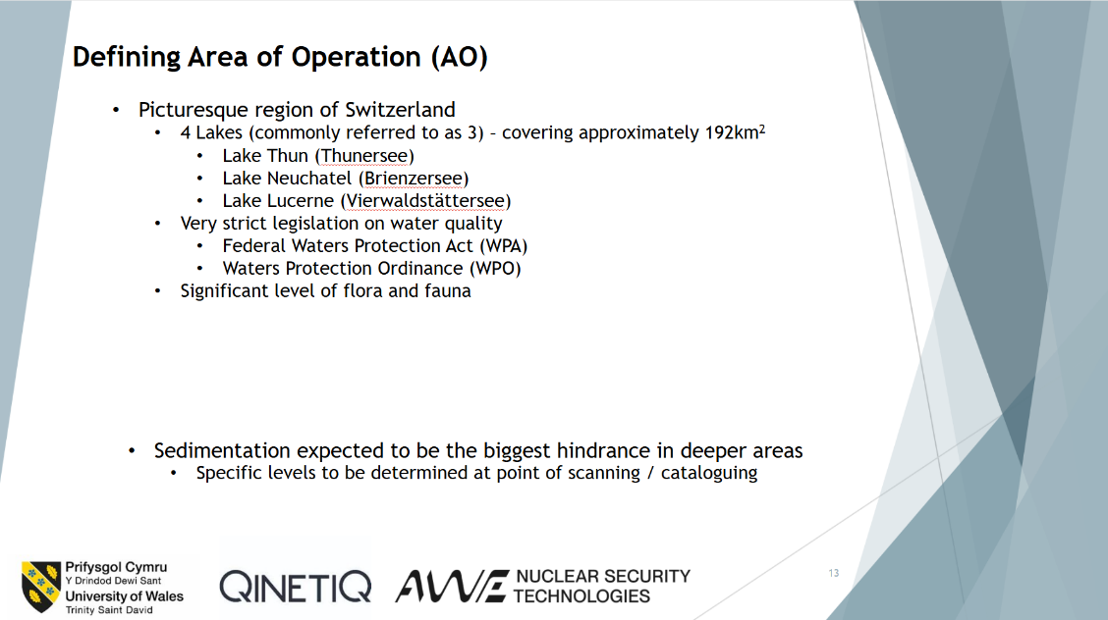

Figure 13- Defining area of operation

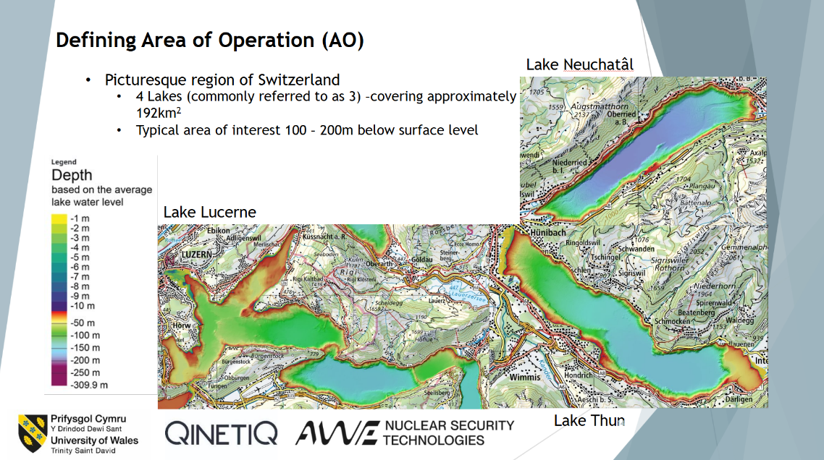
Figure 14- Defining area of operation, Part 2

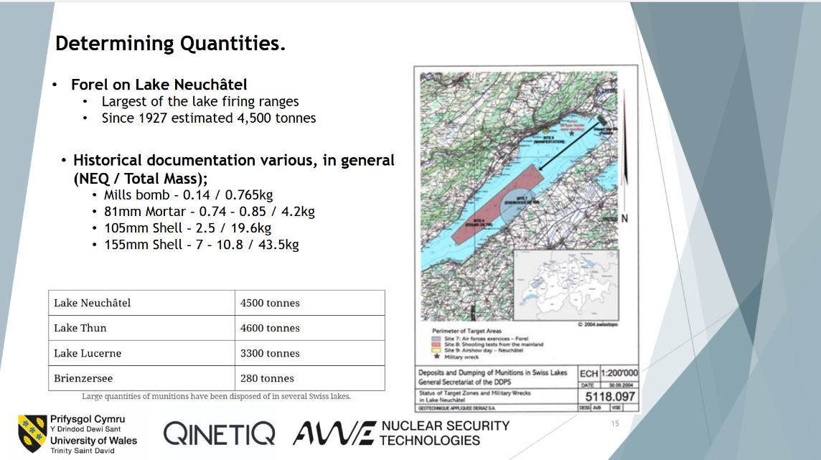
Figure 15- Determining Quantities

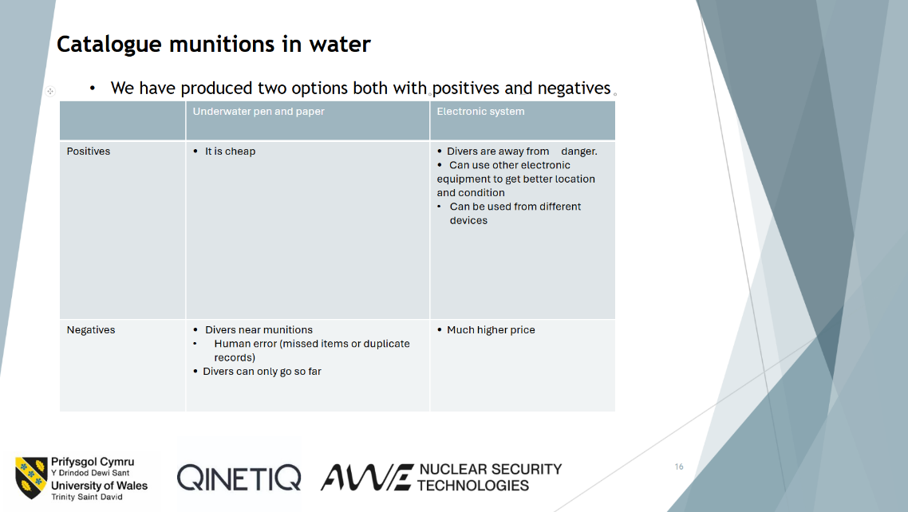

Figure 16- Catalogue munitions in water
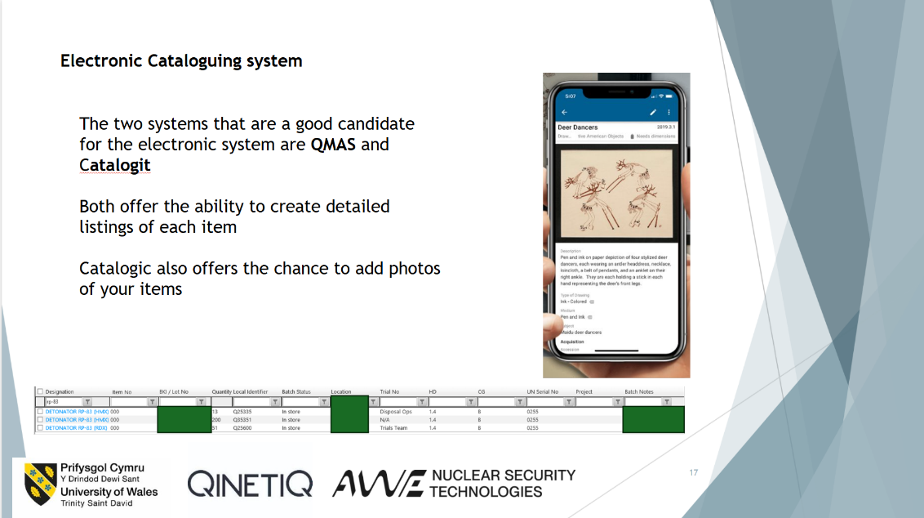

Figure 17- Electronic cataloguing system
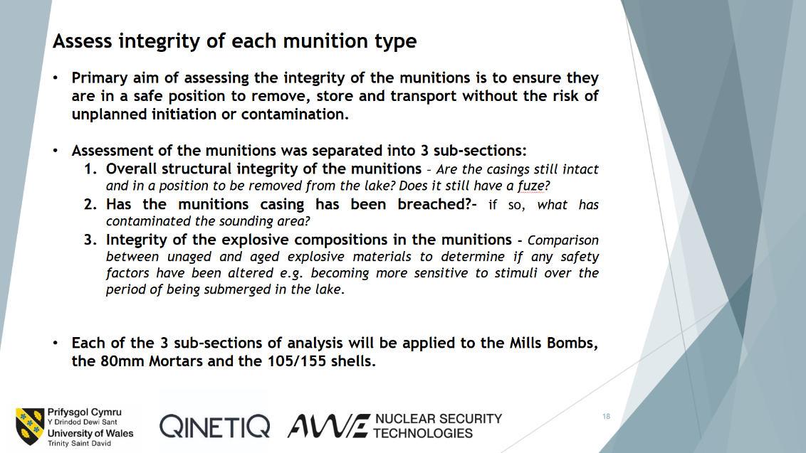
Figure 18- Assess integrity of each munition type

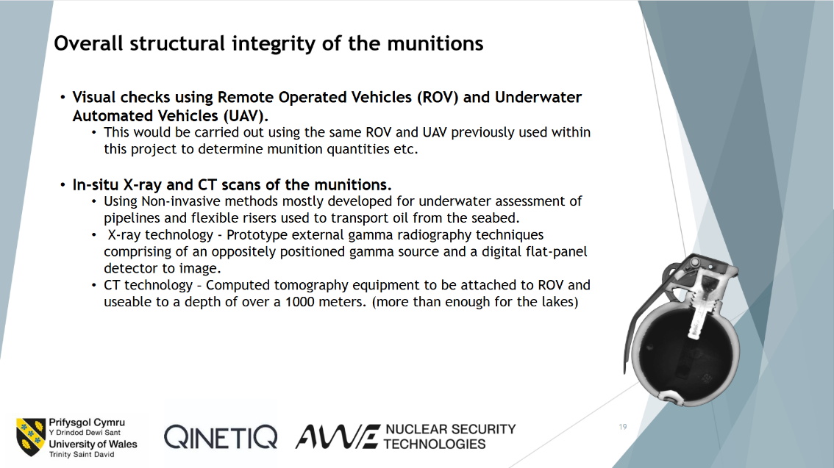

Figure 19- Overall structural integrity of the munitions
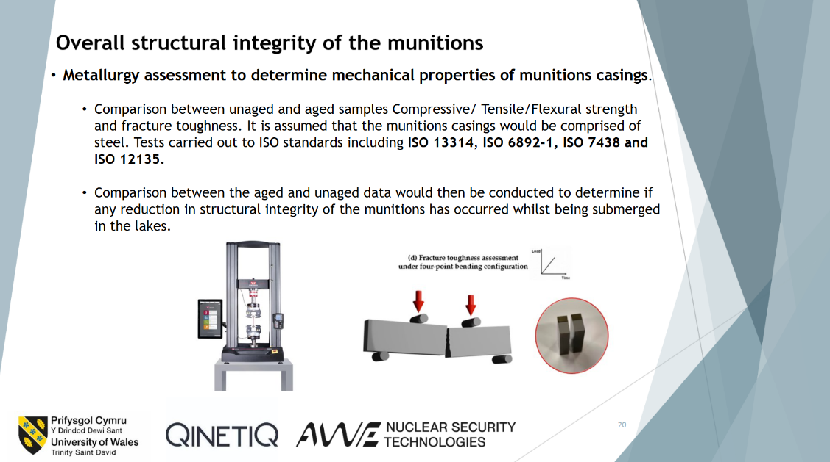
Figure 20- Overall structural integrity of the munitions, Part 2

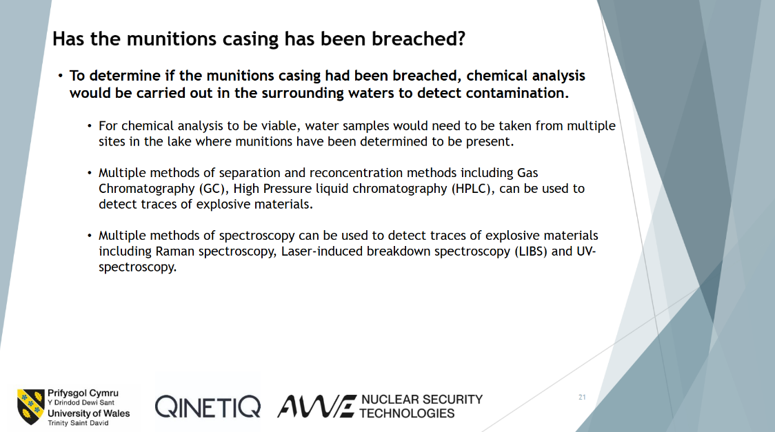
Figure 21- Has the munitions casing been breached

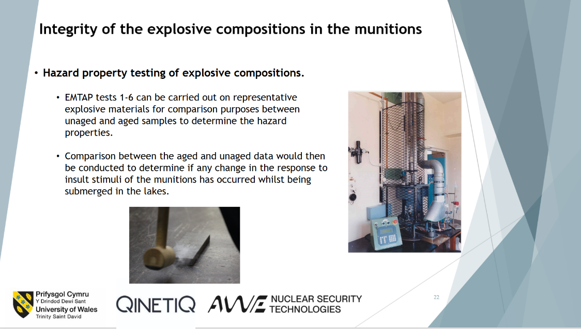

Figure 22- Integrity of the explosive compositions in the munitions
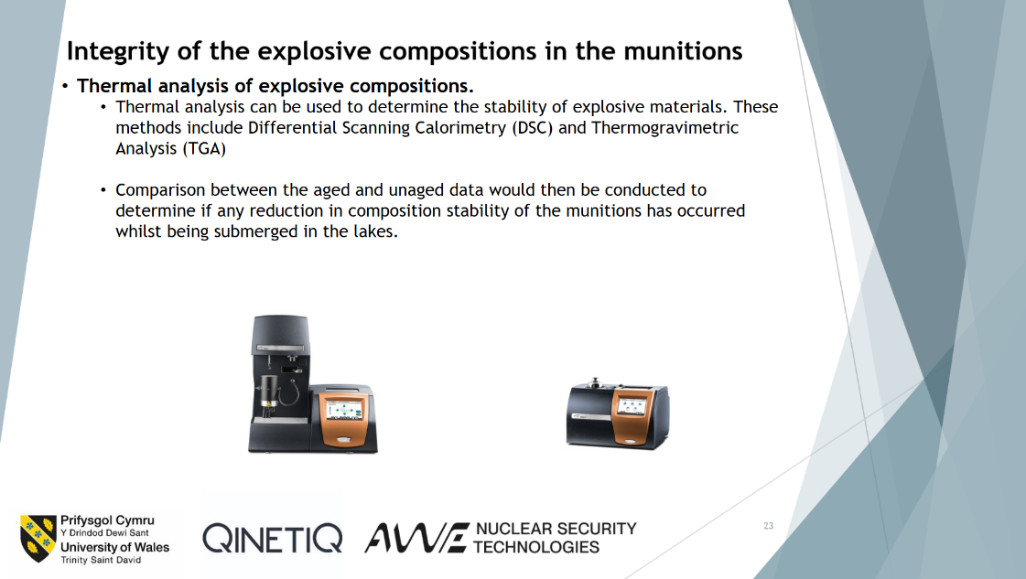

Figure 23- Integrity of the explosive compositions in the munitions, Part 2
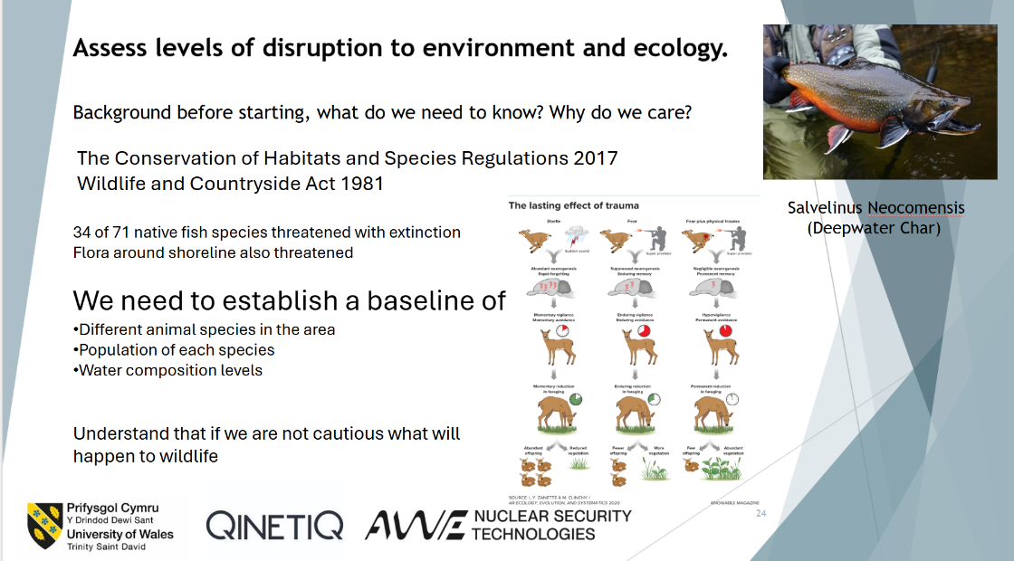
Figure 24- Assess levels of disruption to environment and ecology

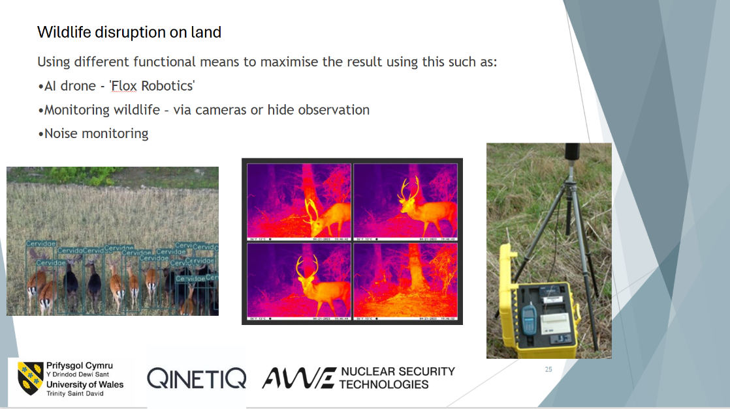
Figure 25- Wildlife disruption on land

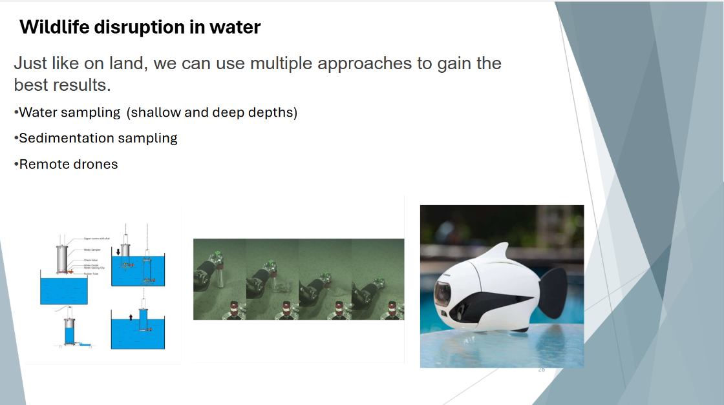

Figure 26- Wildlife disruption in water
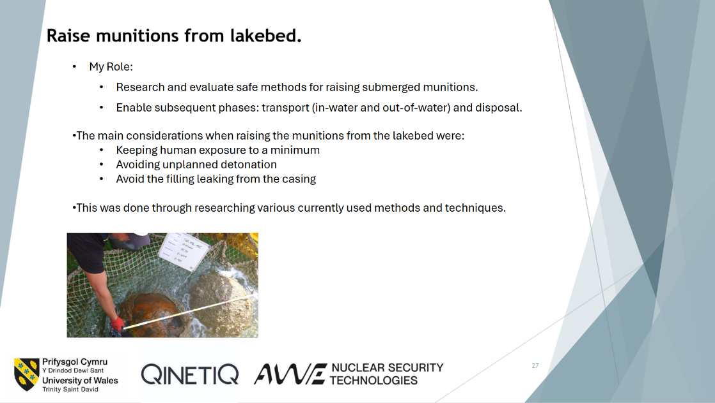
Figure 27- Raise munitions from lakebed

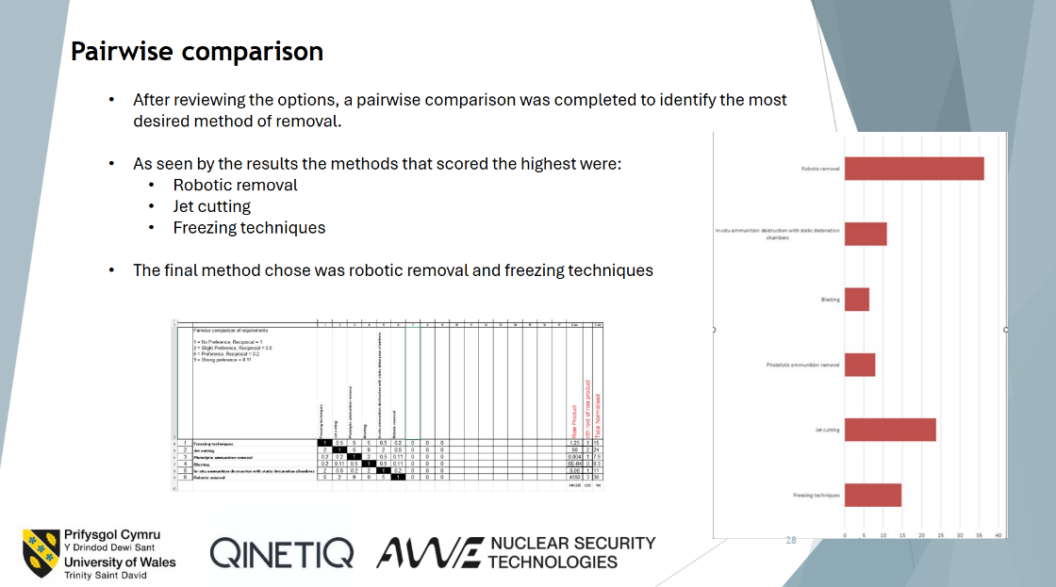

Figure 28- Pairwise comparison
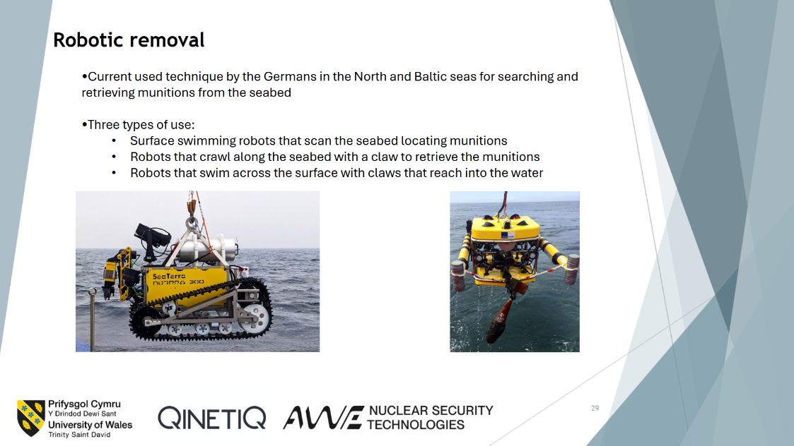

Figure 29- Robotic removal
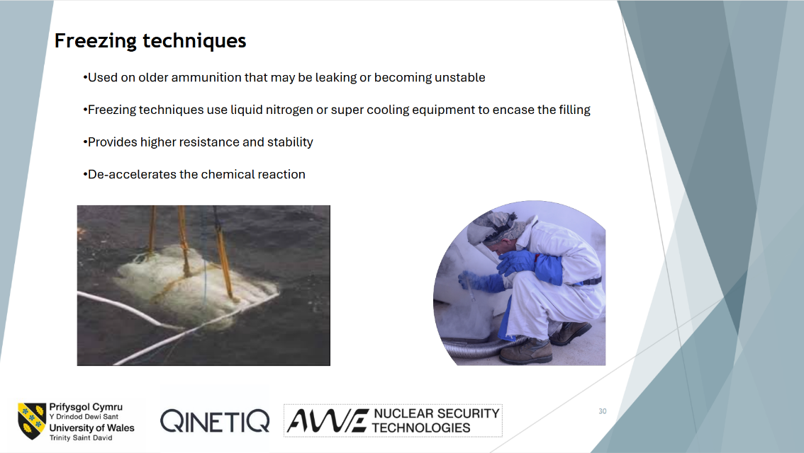
Figure 30- Freezing techniques

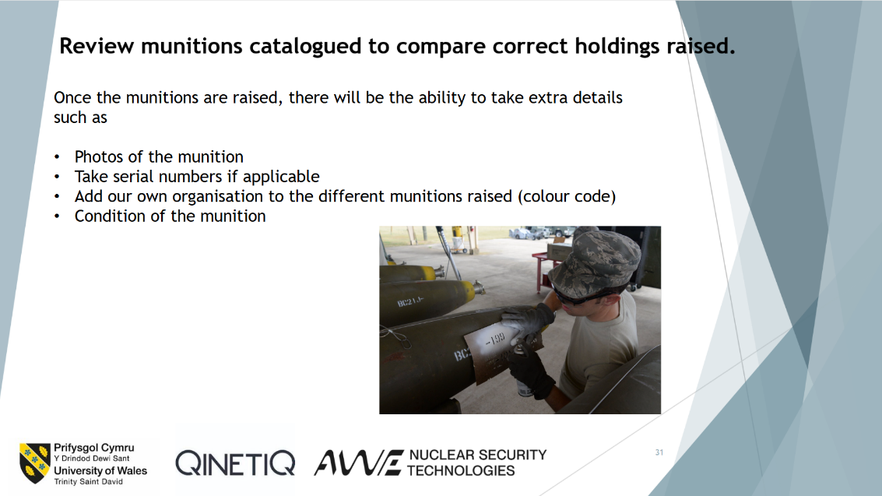
Figure 31- Review munitions catalogued to compare correct holdings raised

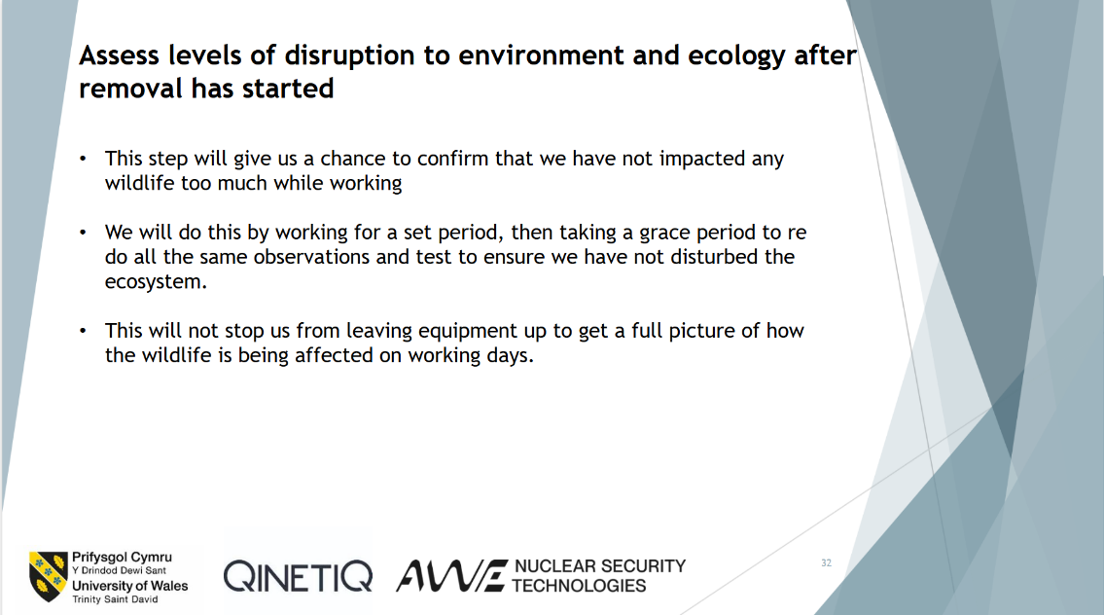
Figure 32- Assess levels of disruption to environment and ecology after removal has started

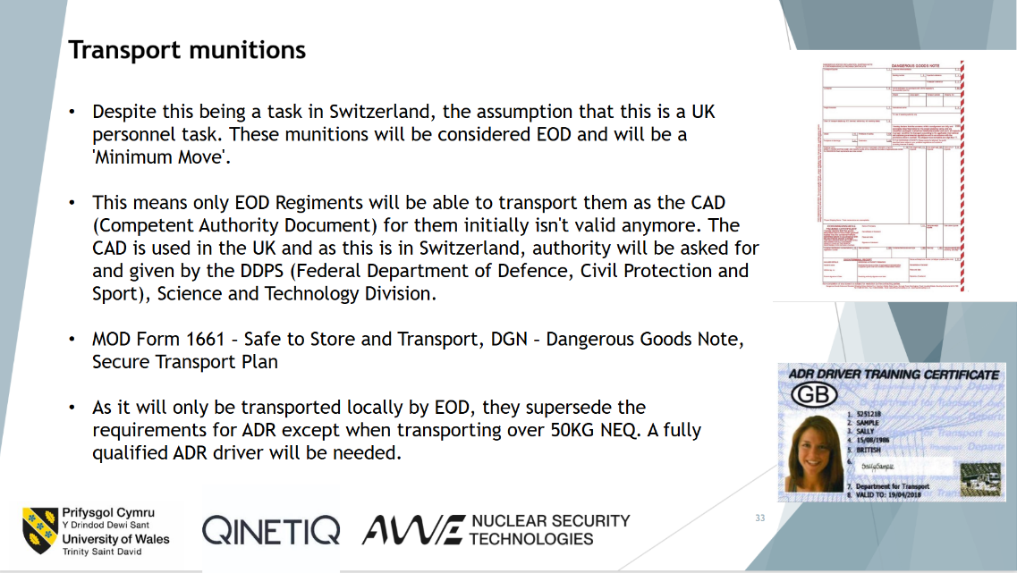
Figure 33- Transport munitions

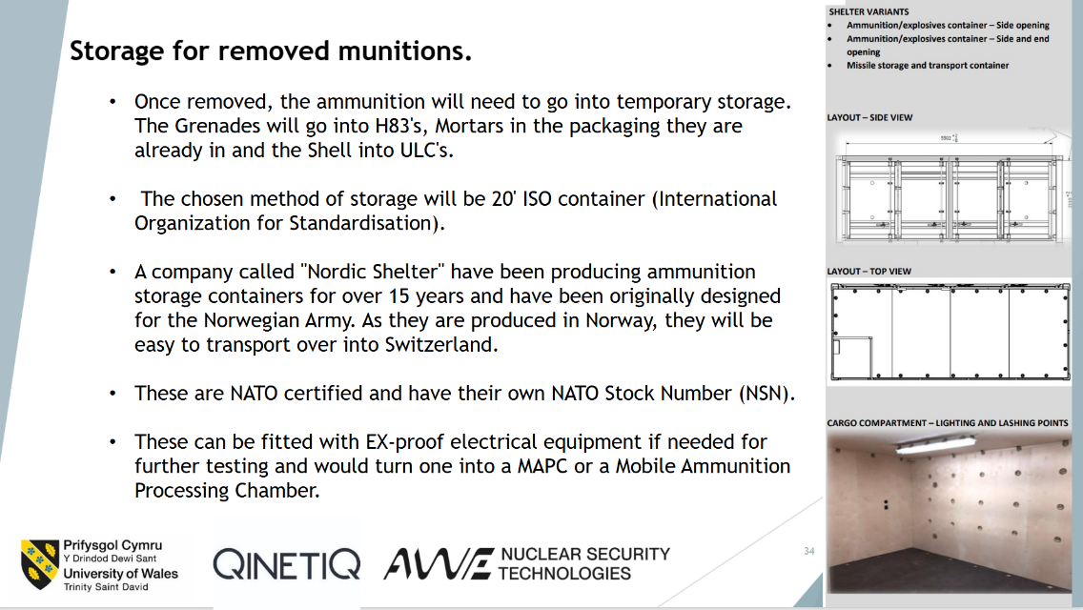

Figure 34- Storage for removed munitions
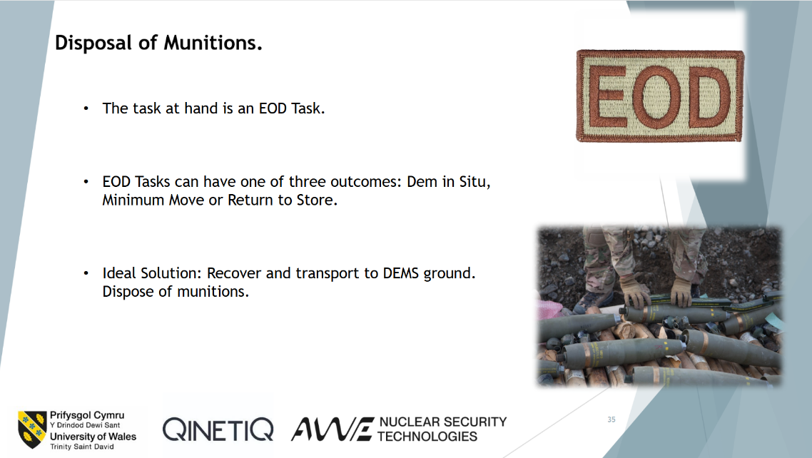

Figure 35- Disposal of munitions
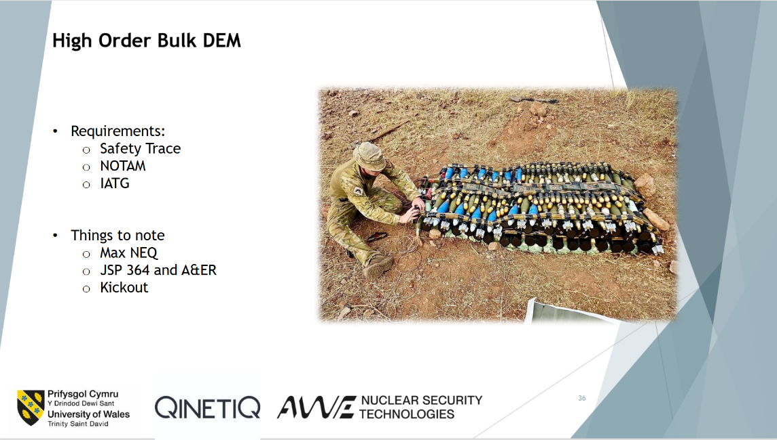
Figure 36- High order bulk DEM

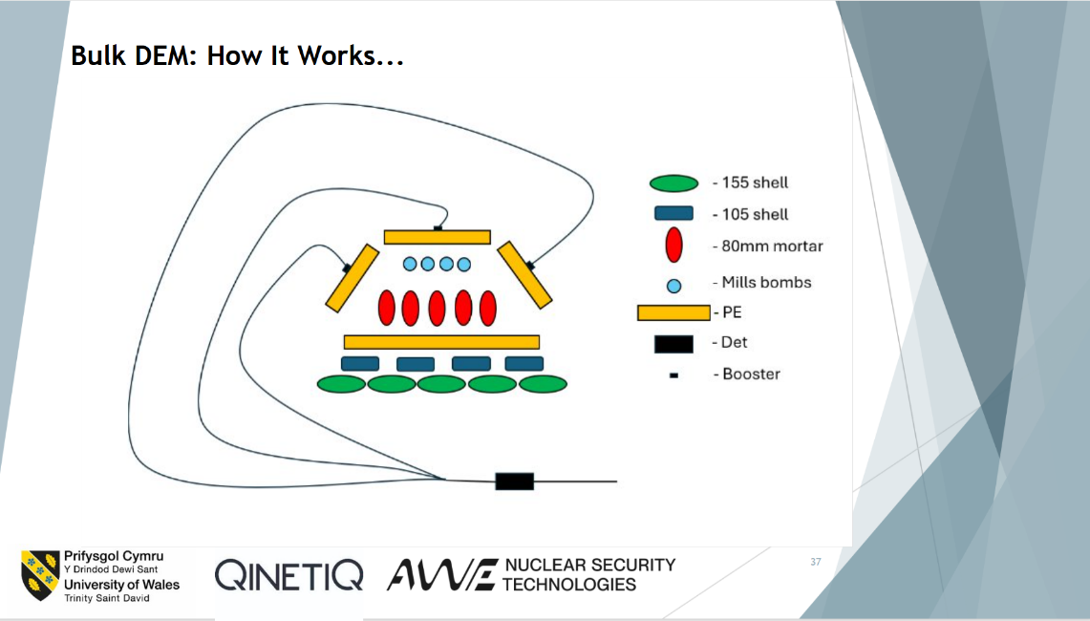
Figure 37- Bulk DEM: How it works...

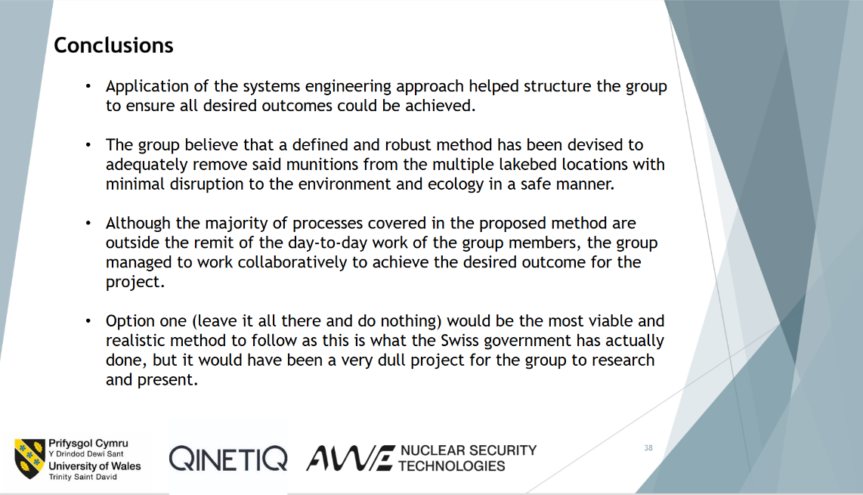

Figure 38- Conclusions
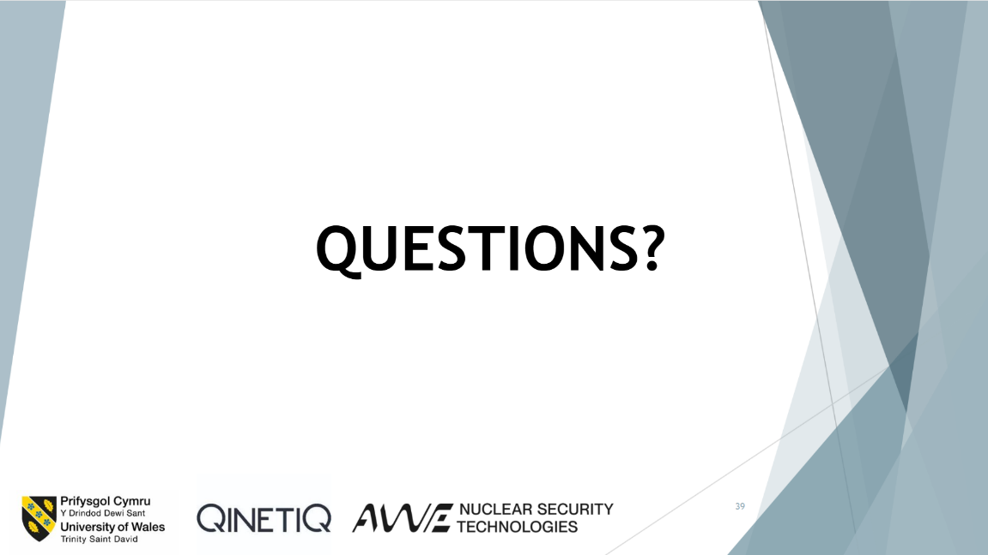

Figure 39- Questions?
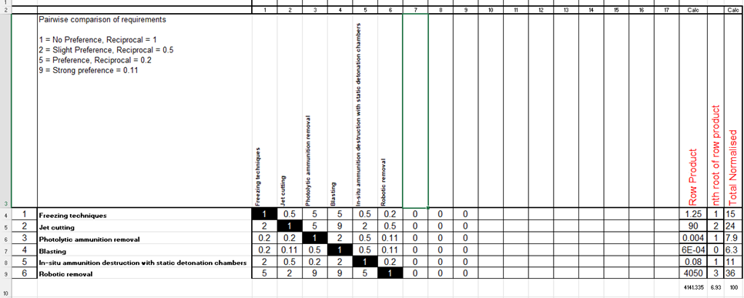
Figure 40- Pairwise comparison
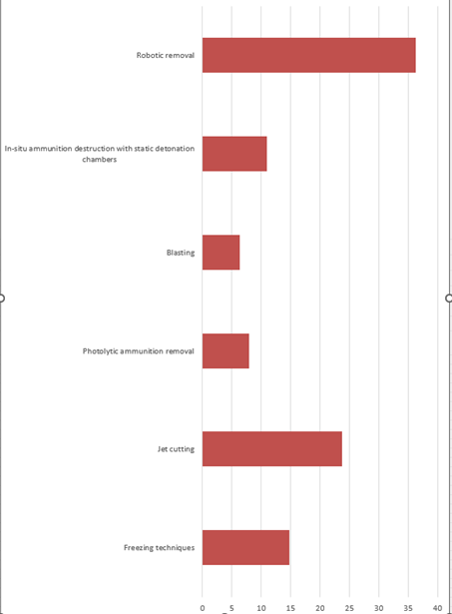
Figure 41- Pairwise comparison results

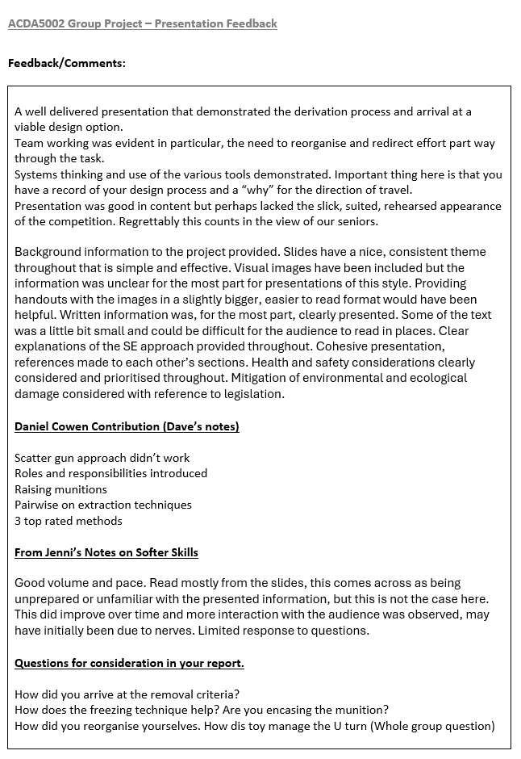
Figure 42- Feedback page

References
[1] I. Foulkes, “Switzerland offers prize money to get munition out of lakes,” BBC News, Aug. 17, 2024. Available: https://www.bbc.co.uk/news/articles/cdd7y3nm09lo (accessed Nov. 10, 2025)
[2] S. Hardach, “The German robots hunting the sea for WW2 bombs,” Bbc.co.uk, Jun. 25, 2024. https://www.bbc.co.uk/future/article/20240621-the-robots-hunting-ww2-bombs-in-the-sea (accessed Nov. 10, 2025).
‌ [3] Underwater Unexploded Ordnance - Methods for a Cetacean-friendly Removal of Explosives as Alternatives to Blasting,” 2015. Available: https://www.ascobans.org/sites/default/files/document/AC22_Inf_4.6.e_Ordnance_Removal.pdf (accessed Nov. 10, 2025)
‌

‌

