Warehouse policy HMS Heron

1 Design a warehouse network appropriate to the organisation's logistics policy.
Know the role of the warehouse in logistics strategy
Design a warehouse network appropriate to the organisation’s logistics policy

Warehouse network design is a fundamental part of the supply chain, organisations always have stock inwards and outwards, so they need somewhere to store it all. It must be easy to locate, and the following information will help satisfy that brief. I will talk about the key factors that will impact on the optimum facility network and the design of the warehouse to meet its needs.

Network planning is where the organisation requires however many warehouses, the service, efficiency and costs will be influenced by the location and its capacity. Customer service is crucial and getting the product to the customer within their expected time (Lead time) is essential. Receiving storage, despatch volumes and types of processes performed in the warehouse need to be built into the design layout of the building. The distribution strategy will have an impact on the network optimisation overall. The type equipment used in the warehouse will need determining. Will they be automated, or will the processes be mainly manual devices?

It’s important to think about goods inbound and who, where is the company located. It is very important to get reliable suppliers as any delay in supply will affect the Lead time to the customer equalling poor customer satisfaction. It’s key to locate the warehouse close enough to the customer to support the service offered without creating any supply problems. It’s important to realise what are the main activities taking place, this will reflect in the space allocated for each activity. What are the characteristics of the products to be stored in the warehouse:

- How easy are they to store?
- Are they hazardous, fragile or do they need special handling?
- What will they be stored on?
- Is there policy or regulations in place to regulate where the items are stored?
- Is temperature control required?

2 Identify trade-offs that will reduce cost or enhance service.
Understand warehouse strategy options
Identify trade-offs that will reduce cost or enhance service

There are always trade-offs in business, either keep larger inventories of products. This results in higher warehouse costs and more waste. There is also the option of keeping a small inventory to save money but risk having not enough stock to meet customers demand. It is possible to re-organize logistics to be able to improve inventory, infrastructure and transportation. Managing a chain of products throughout all the stages of achieving delivery to the customer is called Supply Chain Management (SCM). The benefits of effective and efficient SCM can provide:

Reduced costs
This will improve the bottom line and result in lower costs for the organisation and the customer

Better delivery
Better and faster delivery to the client

Enhanced product conformity / reliability
Improvements to the product due to research design will lead to better reliability and performance

Better service
Public perception will improve

Better technology
This can improve and aid the development of the product

3 Evaluate customer service requirements.
Understand the impact that a warehouse can have on customer service
Evaluate the customer service requirements

It’s not always possible to capture customer service analysis, but specific survey questionnaires could be raised in relation to warehouse service and design. Most customers will automatically blame the warehouse when their product hasn’t been delivered on time. A common problem can also be picking the wrong item which once realised can be easily amended but this creates a longer lead time. A series of customer requirements are needed to be met. These will comprise of providing a receipt and despatch details once the customer has made the purchase and the item is despatched. Tracking information needs to be current and updated regularly. Warehouse quality control checks need to be addressed. When an error is made the customer needs to be compensated.

Ask customers what they need and expect of an organisation. Are the customers’ needs being fulfilled by the organisation’s goals and objectives? Capture customer feedback and use that feedback to improve the service given to them. Provide the staff with more customer service related training and explain why this is a good thing that they need to buy into all the improvements. All this feedback is useful data and can be used to focus the organisation into a more successful company.
14 Develop a set of performance indicators

Understand the importance of setting standards and performance indicators
Develop a set of performance indicators

Key Performance Indicator (KPI), This system is good in measuring values and giving feedback to an organisation on how well it is operating. It can show what improvements could be made and the possible outcome. Firstly, define the key performance indicators then consult the stakeholders. Plan a dashboard design and select KPI dashboard software. Collect key data and commit to feedback sessions. Use the KPI dashboard.

Below shows, the standards which an organisation needs to adopt to apply to legislation and create a safe working environment.

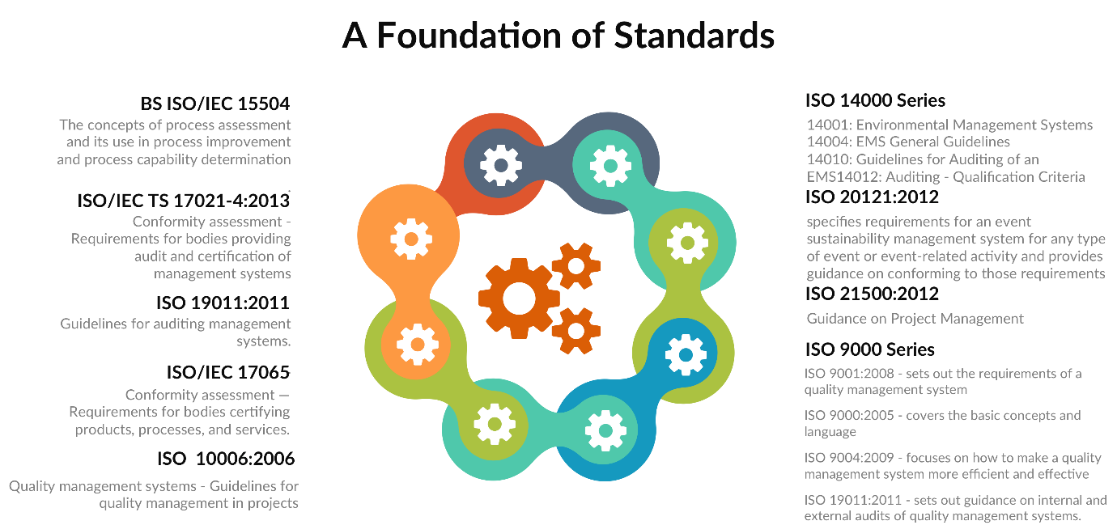

15 Use performance indicators and benchmarks to effect improvements in warehouse performance.
Know how to manage in a warehouse using standards and benchmarks. Use performance indicators and benchmarking to effect improvements in warehouse performance
Standards need to be applied to the workplace and the hierarchy need to check that they are being adhered to throughout the warehouse. Training, evaluation and coaching are all important parts of making sure the workforce has the required knowledge to meet these standards daily. It is important to use the information gained during any benchmarking studies to move the organisation forward, developing warehouse processes.
Data gained by employing performance indicators have immediately inform staff when standards or speed rates have fallen. This can then be used to amend this problem and get all the warehouse processes working to their best output. A benchmark study from other organisations can help flag up areas that can be made more streamlined and improve the organisation to either meet or surpass that benchmark.
Cost per order
This can be adapted and made lower depending on the bottom line or the quantity being demanded.
Order processing turnaround time
Aim for 100% within 24 hours
Initial customer order fill rate
Inventory controlled metric, % of customer order shipped within 24 hours
Order accuracy
Per hour benchmark
Quantity for every hour in the following areas: receiving units, picked units, orders packed, packages shipped, total orders processed and returns processed.
Inventory accuracy
Stock held.

