Submission date: 31 March 2023
NAME: GURLAL SINGH
Submission id: 2224201
File Name: Marketing Fundamental
Word count: 1513

INTRODUCTION
Reliance Jio Info com Limited, is known as Jio, is a Indian mobile network. The main headquarters of Jio located in Mumbai and the Chairman is Mukesh Ambani and he is second richest person in Asia and CEO are Parvir Kumar. The Jio provide only 4G service and they don’t deal with 2G or 3G. The launch of Jio make the revolution in the mobile operators of India.
Now Jio claim the World’s largest data consumption on mobile data.

BACKGROUND
In India there are about 4 to 5 mobile operator’s including the private and public sector which become the king of the market. A new telecom brand named Jio launch in February 2017, this idea came in the mind of honourable Mukesh Ambani when his daughter came back from London after completion of study and tell her father that Internet speed is very low. After launching of Jio other business operator like Vodafone and Idea combine to give competition to Jio. But one problem come in front of Chairman that he did not find the well deserving CEO for his empire, this problem solve by taking the interview of Pravir Kumar, he is best in all field firstly he reject the proporsal to become CEO but Mukesh Ambani asked one question “How is your Father”? that impressed to the Pravir Kumar.

JIO LOGO
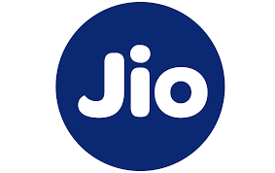
The logo of Jio has hidden symbol in it when you flip you read as oil. This symbol represent past and future of Reliance. The oil company become the biggest industry in 20th century and when flip Jio become the biggest industry in 21st century.

TECHNOLOGY
Jio provide 4th generation of mobile technology which provide high speed Internet service and provide LTE to voice service on Internet. The speed of Jio network is very fast as compare to other networks like BSNL and AIRTEL.

BETA LAUNCH
The 4G service was launch internally to Jio’s partner, its staff and their family on 27 December 2015. The brand ambasder of Jio is King Khan or Bollywood Actor Shah Rukh Khan. The Jio event took place in Reliance corporate park in New Mumbai along with many celebrities like A R Rahman, Actor Ranbir kapoor and Javed Jaffrey. This event witnessed by more than 35000 Reliance Employees.


PLANNING AND MARKETING STRATEGY
Reliance Jio Limited revolution in the telecom sector, The scenario of Indian telecom before Jio entered was
- There were more than 1 billion mobile user in India, out of which 34% connected to the internet
- Only 12% from these 1 billion use 3G data or above

The success of Jio can be mainly operational planning by following steps.
- Firstly they provide free data service upto 9 month.
- They increase speed of internet 5mb to 15 mb.
- They launch 4G mobile phone name “LYF” at cost of 2500 Indian Rupees with free 4G sim card for 6 months.

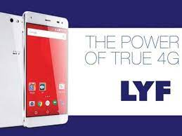
STAFF RECRUITMENT AND TRAINING
The selection procedure in Reliance Jio is Compeletly following three steps.
- Written Test it analyse the skills in topic simple logics comparison etc.
- Technical written test it analyse the knowledge of candidate in field of electronic and networking subjects.
- HR Interview this is a final test based on the merit and it analyse the personal ability of candidate.



STAFF TRAINING
The Reliance Industry provide the training on the basis of requirement of employees and organisational work schedule. Sometime this industry send employees to the different countries like Canada, UK, Australia. The Reliance think that they should increase the ability of employee. If the effieciency and effectiveness of staff increase the result of growth is positive towards the company.


STRENGTH OF RELIANCE JIO
Strength is define as resource or capacity the organisation can use effectively to achieve its objective.
The following are strength of Jio
- Strong customer base – Jio attract the 100 million subscribers in first six month of its launch which is record not other provider has able to do that.
- Technology – Jio currently use the latest 4G LTE technology which is the best technologies for the future and it may be launch 5G and 6G in the future.
- Brand Management – The reason for huge customer base of Reliance is brand Management strategies like brand ambasder Shah Rukh Khan and Amitabh Bachan have helped building connectivity with customers.
- Fast and Wide network – Reliance Jio has presence in all 22 telecom circle’s in India and network speed is very fast .
- Multiple offers in single name – Reliance Jio offers different kinds of services like movies, games, shopping, chats and messengers etc. giving the customer chose a lot of options from them.

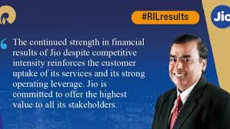

WEAKNESS OF RELIANCE JIO
- Late entry into Market – Reliance Jio made late entry into market which already captured by the other companies like BSNL and AIRTEL
- Activation issues – Reliance Jio face many issues because it contain huge volume of customer and take more time to activate sim card .
- Pricing controvercises – Reliance Jio was criticised for having lower prices than the market and company face many issues like corruption and money loadring.
- To many free bies – Reliance Jio offer many services at free of cost as result it increase the share value but it not provide free facilities for long time.
- Data connection poor – The speed of internet sometime lower in selected regions.

OPPORTUNITIES FOR RELIANCE JIO

- APPS : Reliance Jio has lot of scops in band width thus they can offer apps to customer at chargeable or free of cost.
- LOW PRICING STRATIGIES : Reliance Jio pride itself because they provide low cost internet services with use of this strategy they can grow with other markets.
- Expansion to other countries : Now a days Reliance Jio provide services in India however there is wide scope in foreign countries.

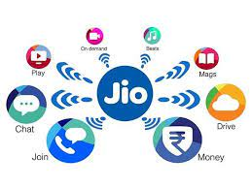
THREATS OF RELIANCE JIO
- Risk of Loss of Customer : Customer prefer Jio because of low prices if the prices increase it will reduce the customer.
- Removal of Free services : Jio provide a lot of free services if they removed free services it impact on the reduction of sale of company.
- Negative Image : From starting of Jio it face many criticism, thus have negative brand image for company.

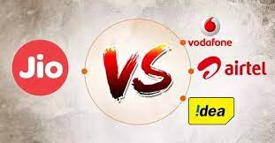
IMPACT OF JIO LAUNCH

As the Jio launch in 2017 it impact the Indian economy. The Reliance share become boost in just few days with starting of this the share price is around 600 but after the launch price hit the top round 900.
After the 7 to 8 months Reliance Jio started the charging price of it as result price war started between mobile operators for example jio charged 239 Indian Rupees for 1 month with seeing it airtel also reduce the price from 400 Indian Rupees to 239 Indian Rupees.

IMPACT ECONOMY AND TELECOM INDUSTRY
- Market share of other major operators such as Vodafone, Idea fall sharply down. They were forced to reduce their tarrif cost less than 15 GB from atleast 250 GB.
- Airtel, Vodafone, Idea requested to TRAI regarding the tariff set by Jio. TRAI reject the proporsal.
- The BSNL which is a Government telecom operator also cut down their prices of internet services per month.

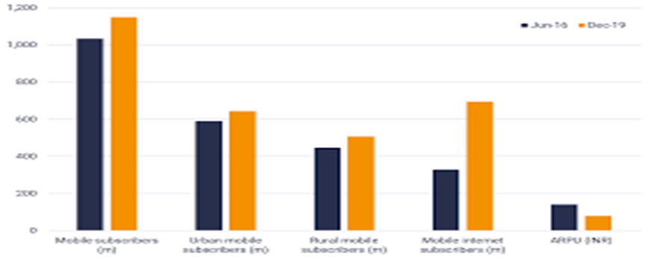
JIO APPS
A mobile app is computer program design to run on a mobile device such as phone, tablet. Apps were originally intended to productivity assistance such as email, calander, contact , database and they are generally download from operating system such as app store or google play store.
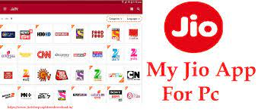

APPS OWNED BY JIO
- Jio chat – Instant messaging app
- Jio X press News – enews app
- Jiofi – App connecting to jio wifi
- Jio TV – Jio user watch 642 TV channels
- Jio Health Club – Free Tests, Doctors and reports
- Jio cinema – Free movies

OTHER SERVICES OWNED
BY JIO
LYF smartphones
In 2015, Jio entered in domestic hand set in text to supply 4G handset. On 25 January 2016 the company launch LYF smartphone cost around 2500 Indian Rupees.
Jio DTH
Reliance Jio Expected to launch their DTH service in 2024 which cost around 180 Indian Rupees give competition to other DTH operator like a tata sky, airtel and dish tv.
Jio 5G network
Reliance Jio already building a 5 G network for future as the news come that speed of 5G network around 35mb per second.
Jio Giga TV
Reliance Jio offer Giga TV with Jio suite when the broad band services are offered. This TV will provide 4K sport, video calling and added other services.

CONCLUSION

Reliance Jio Limited known as Jio is an Indian mobile network operator owened by Reliance Industries and Headquarters in Mumbai.
In this project, a complete analysis of upcoming of Jio and its sudden success story locked. The organised structure planning, staffing, training, impact and services owened by Jio discussed briefly. In this process effort were may to bring through various research and studies conducted in this fields. Jio is now becoming the fastest growing telecom company in the world. The marketing fundamentals also discussed in this project.

