

LEVEL 5 ASSESSMENT SPECIFICATION
Module: | Business Inquiry & Research
Name: | Cameron Grant
Module code: | BMSP5007 | Contribution to Overall Module Assessment (%): | 30%
Lecturer: | Dr Roisin Mullins | Internal Verifier: | Dr Alex Bell
Assignment Title: | Assessment 2: Quantitative Study | Word count (or equivalent): | 1500
Submission deadline: | April 23rd, 2021 | Return date of provisional marks & written feedback: | 21/05/2021
Submission method: | All written assessments, where practical and possible, must be submitted via Turnitin unless otherwise instructed by the Lecturer. (Please DO NOT put this assessment specification into Turnitin or it will match many similarities with other students’ submissions.)  Alternative submission method (if applicable): Late submission of the assessment will result in a late penalty mark. Penalties for late submission: Up to one week late, maximum mark of 40%. Over one week late, 0%. Only the Extenuating Circumstances Panel may approve a change to submission dates.
Academic honesty / referencing: | Academic honesty is required. In the main body of your submission you must give credit to authors on whose research and ideas your work is based. Append to your submission a reference list that indicates the books, articles, etc. that you have used, cited or quoted in order to complete this assessment.

This report presents the study of the sociological impacts of mental health and the changes in its perception during the pandemic. Many mental health charities have seen an increase in texts by 60% resulting in a total 81,256 between this January and February than the same time last year (Culbertson 2021). The reason behind choosing this is because I am a student on an outdoor course and since studying this course I have noticed mental health has been a re-occurring theme. One of the future generations act (2015) goals is a healthier wales which states:

“A society in which peoples physical and mental well-being is maximised and in which choices and behaviours that benefit future health are understood (Wellbeing and future generations act 2015.)”

For this study I chose to use a quantitative research study. Quantitative research explored the specific and clear defined questions that examines the relationship of two events, or occurrences, where the second event is the cause of the first event (Open University, 2021). The population I chose were students and family members. The reasoning behind this is students had a first hand experience in being in lockdown alone in accommodation furthermore, my family are frontline works so I can seen the perceptions from both ends. Positionality, The term positionality both describes an individual’s world view and the position they adopt about a research task and its social and political context (Foote & Bartell 2011). My positionality I believe the males to exercise more based on how big a problem men’s mental health was before lockdown, likewise I think more men will be exercising post lockdown due to the restrictions.

I chose to use a questionnaire, According to the Open University (2021 p. 16)“surveys and questionnaires use carefully constructed questions, often ranking or scoring options or using closed-ended questions” Furthermore the Open University (2021 p. 16)“states “Good quality design is particularly important for quantitative surveys and questionnaires”.

Ontology and epistemology are different ways of viewing research philosophy, Ontology can be defined as Blaikie, N. (2010) “the science or study of being”. For this research I am following the epistemology of positivism as a theoretical perspective, this is not about capturing emotions of feeling. This is because in quantitative research the study to use methods that are objective as possible. Saunders (2012) states “portrays the position that social entities exist in reality external to social actors concerned with their existence”.. According to Crawford (as cited in Singh 2006)

“research is simply a systematic and refined technique of thinking, employing specialised tools, instruments and procedure in order to obtain a more adequate solution of a problem”(Singh, 2006 p.2)

The methodology I am going to use is an online experimental survey through quantitative research. Quantitative research focuses on measurement and proof. This type of research adopts a scientific approach. This is based on the assumption that something is meaningful only if it can be observed and counted. Its vital characteristics are numerical data that allows a range of statistical analysis. There are multiple approaches to quantitative research which include experimental, descriptive, correlational and causal comparison. Inferential statistics are frequently used to generalise what is found about the study sample to the population as a whole (NHS Education for Scotland 2021).

The aims and objectives of my research is as follows:
- To explore mental health before lockdown.
- To describe the links between people doing exercise before and after the pandemic.
- To explore mental health after the lockdown.
- To study how many often people exercises and the benefits post and pre lockdown.
- Compare and contrast to see if there is a correlations or relatable patterns in the data that match with other academic research.

The paradigm I am choosing to proceed for this research is to create a statistical analyse on the data produced from a structured online survey that was distributed around to 30 respondents with 10 questions. The questions are as the following:
- What is your gender
- How old are you?
- How often did you hear about mental health and problems associated with it pre-pandemic?
- How often do you hear about mental health and the problems associated with it now?
- Has there been a notable change since the easing of the restrictions?
- Are you aware of steps you can take to improve your mental health?
- Are you aware of any mental health Apps?
- Which mental health helplines do you hear about the most?
- Are you aware of the benefits of exercise that correspond with mental health?
- How often do you exercise per week?
Once this was created using an online survey. I chose to advertise on social media by making posts, this was a simple method to distribute the questionnaire to people in the surrounding area. I aimed to have a large target audience in order to fit the criteria and to gather data. However, choosing only to use social media could impact the results by being biased to those who are able to use technology.
I decided to choose two data collection methods for my survey, these methods are cross tabulation and correlation. The definition of cross tabulation is:
“Cross tabulation is a statistical tool that is used to analyse categorical data. Categorical data is data or variables that are separated into different categories that are mutually exclusive from one another” Williams (2021 p.1).
This tool will be vital to show the if there is a difference between the mental health post and pre lockdown in women and men . Furthermore, I decided to use correlation to show the pattern in people exercising and its effectiveness in improving mental health. The definition of correlation according to Bock (2021 p.1) “Correlation is a term that is a measure of the strength of a linear relationship between two quantitative variable”. From the tables presented below you will find the results of the cross tabulation and correlation data collection methods in the online survey I undertook.

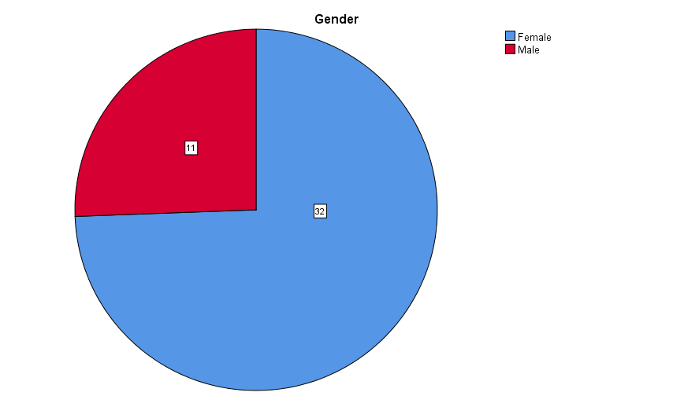

Age
 |  | Frequency | Percent | Valid Percent | Cumulative Percent
Valid | 18-24 | 11 | 25.6 | 25.6 | 25.6
Valid | 25-34 | 4 | 9.3 | 9.3 | 34.9
Valid | 35-44 | 10 | 23.3 | 23.3 | 58.1
Valid | 45-54 | 10 | 23.3 | 23.3 | 81.4
Valid | over 54 | 8 | 18.6 | 18.6 | 100.0
Valid | Total | 43 | 100.0 | 100.0

From these graphs I can differ that, most of the respondents form my results are female, and the minority is males. Of this group the mean age of these respondents are between 35-44 and 45-54. However from these graphs it is possible my results could be biased due to the fact that more of the respondents are female than male. Furthermore, the mode for the table above is 11 this is due to the fact that there is more people of this age in that category.

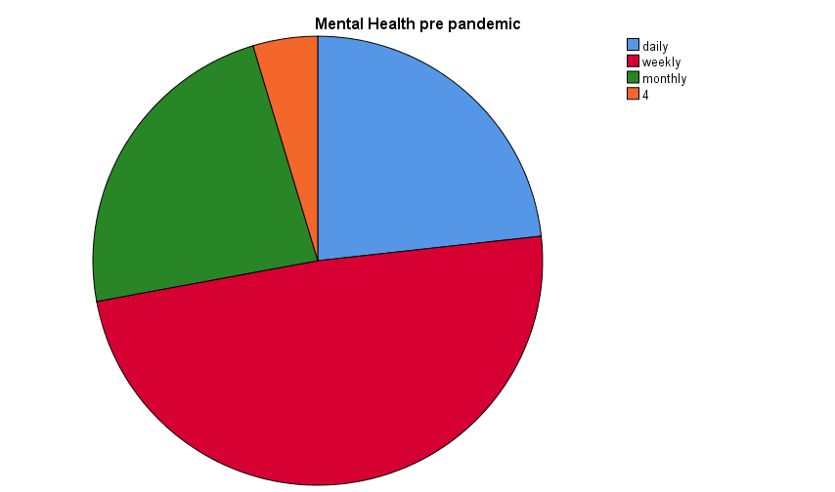

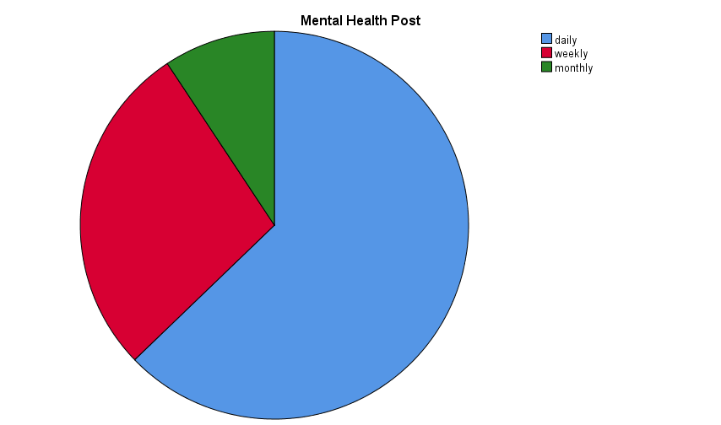

From the responses from the respondents it is clear that during the pandemic people where seeing mental health post on a weekly basis compared to after the pandemic where the respondents stated they saw more mental health posts on a daily basis. This is linked to the research that during the pandemic mental health became an increasing problem. According to the C.S. Mott Children’s Hospital National Poll on Children’s Health at Michigan Medicine, “a national poll shows that 46 percent of parents say their teen had shown signs of a new or worsening mental health condition since the beginning of the pandemic in March 2020”. Furthermore, “The poll looked at responses based on 977 parents of teenagers between 13 and 18 years old. The results showed that 1 in 3 and 1 in 5 boys have experienced new or worsening anxiety”.

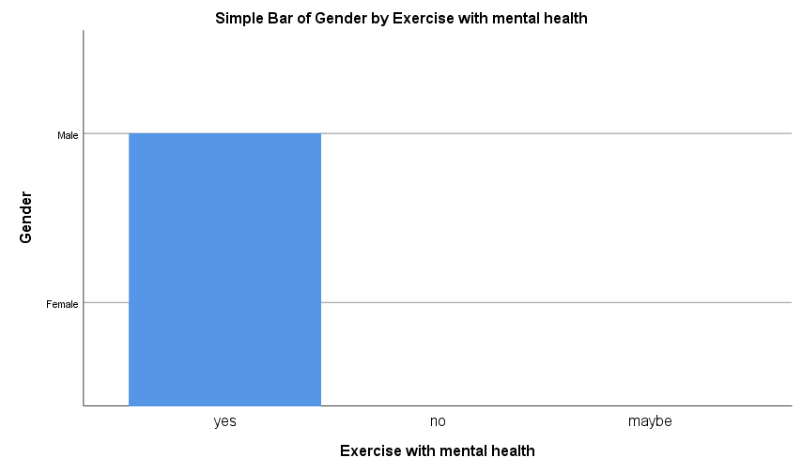

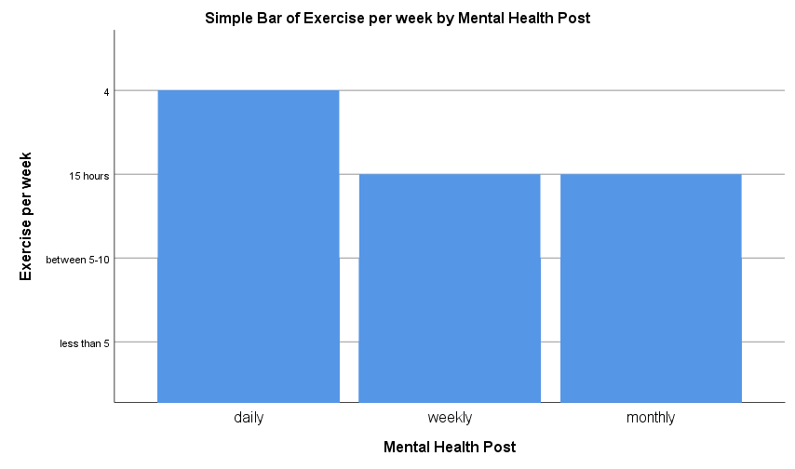

Gender * Mental Health Post Crosstabulation
Count
 |  | Mental Health Post |  |  | Total
 |  | daily | weekly | monthly | Total
Gender | Female | 24 | 6 | 2 | 32
Gender | Male | 3 | 6 | 2 | 11
Total |  | 27 | 12 | 4 | 43

All three graphs correspond to one another this is due to the fact that 100% of the respondents answered yes to knowing the corresponding to link to mental health and how exercising benefits peoples mental health. Furthermore in the second graph it shows that more respondents exercised daily and 24 of these respondents were female and three males exercise daily. The mean for these results were 6 females and males exercised on a weekly basis for 15 hours. This was different to the results I expected based on my positionality however, due to the respondents being majority female this test could be biased based on this assumption.

To conclude my overall question, Since the pandemic there has been a shift in people seeing more mental health posts and exercising because of the benefits exercise has on mental health.
From the analysis I discovered that more women are doing exercise on a daily basis then men this could be because of The poll looked at responses based on “977 parents of teenagers between 13 and 18 years old. The results showed that 1 in 3 and 1 in 5 boys have experienced new or worsening anxiety”. Furthermore, I found out that there was an increase in people seeing mental health posts after the pandemic because “a national poll shows that 46 percent of parents say their teen had shown signs of a new or worsening mental health condition since the beginning of the pandemic in March 2020”.

I found collecting my data during this research task became easier, once I had found the paradigm of which I would like to study, the questions were based on this topic. I found making the online survey and then I decided I would send it using social media platforms such as Facebook. This in turn, created some weaknesses such as by choosing to use social media this meant only people that were cable to use technology could answer furthermore, this could have resulted in my answers being biased as some of the respondents could have been in close-relation to me.
If I was to do this again I would change the overall research ontology so I could deepen my understand in another topic such as climate change. Furthermore, I would choose a different target audience and I would increase the number of respondents to gain more reliable and measurable answers.

References
Future Generations Commissioner for wales (2015) A healthier wales Available at: https://www.futuregenerations.wales/a-healthier-wales/ (Accessed 01/04/2021)
Bock, T. (2019) What is Correlation? Available at: https://www.displayr.com/what-is-correlation/(Accessed 01/04/2021)
Cross Tabulation: Definition & Examples. (2015). Retrieved from https://study.com/academy/lesson/cross-tabulation-definition-examples-quiz.html.
Culbertson, A. (2021). A shrinking world: How a yea of lockdown has hit young peoples mental health, Available at: https://news.sky.com/story/covid-19-how-a-year-in-lockdown-has-affected-young-peoples-mental-health-1225390 (Accessed 01/04/2021)
Dahlberg, L. and McCraig C. (2010) practical research and evaluation. A start to finish guid for practitioners. SAGE publications.
Drillinger, M. (2015) Impact of COVID-19 Lockdown on Teens’ Mental Health Available at: https://www.healthline.com/health-news/impact-of-covid-19-lockdown-on-teens-mental-health(Accessed 01/04/2021)
Experiences Impact Researcher Positionality. Educational Studies in Mathematics, vol. 78,pp. 45-68.
Foote, M, Q. and Barnell, T. G. (2011) Pathways to Equity in Mathematics Education: How Life
GOV, (2021) Guidance for the public on the mental health and well-being aspects of coronavirus (covid 19). Available at https://www.gov.uk/government/publications/covid-19-guidance-for-the-public-on-mental-health-and-wellbeing/guidance-for-the-public-on-the-mental-health-and-wellbeing-aspects-of-coronavirus-covid-19 (Accessed 01/04/2021)
Hesket, E. A. and Laidlaw J. M. (2018) Quantitative Research Designed and produced by the Education Development Unit NHS Education for Scotland. Available at: http://www.resources.nes.scot.nhs.uk/ti/QuantativeResearch.pdf(Accessed 01/04/2021)
NHS (2021) Mental wellbeing while staying at home, Available at: https://www.nhs.uk/oneyou/every-mind-matters/coronavirus-covid-19-staying-at-home-tips/ (Accessed 01/04/2021)
Open university (2021) 6 methods of data collection and analysis, Save the Children. Available at: file:///C:/Users/Cameron/Downloads/6%20methods%20of%20data%20collection.pdf (Accessed 01/04/2021)
Saunders, M., Lewis, P. & Thornhill, A. (2012) “Research Methods for Business Students” 6th edition, Pearson Education Limited
Thomas R. Gruber. A Translation Approach to Portable Ontology Specifications.Knowledge Acquisition, 5(2):199-220, 1993.

