[Date]
Suneth Fernando
uwtsd-2025
IWD
Assignment 2 : Website design and development
Student- Olha Kozmenko
Student ID – 2335644
Gr 2
Contents
Introduction 2
User Requirements 2
Website Design 3
Website Implementation 5
Project Folder Structure 5
Homepage Implementation 6
Gallery Page Implementation 6
Services Page Implementation 7
Testimonies Page Implementation 7
Contact Page Implementation 8
Validating my website 8
HTML Validation 8
CSS Validation 9
Self-evaluation of my website 9
Usefulness (usability and utility): 9
Search Engine Optimisation (SEO): 10
Website Accessibility: 10
Reference list 11

Introduction
The purpose of this report is to describe the design, development and evaluation of my website “Mayfair Ritual Massage Salon.”
The site was created to present a calm and welcoming environment and to introduce visitors to the massage services available at the salon. It includes four main pages: Home, Gallery, Services and Contact Us. Each page is designed to be clear, simple to navigate and visually consistent with the atmosphere of a real massage studio.
A straightforward design helps users understand a website more easily and improves their interaction with it. Research also shows that people tend to stay longer on websites that feel organised and predictable to use [1]. With this in mind, one of my aims was to create a layout where visitors can quickly find information about services, view photographs and reach the contact page without difficulty.
The colour palette—soft beige, warm pink and muted gold—was chosen to support a relaxed impression. These colours are commonly associated with comfort and can positively influence how visitors feel while browsing a site [2].
This report outlines the full development process: identifying user requirements, designing the website layout, creating a wireframe, building the pages using HTML and CSS, validating the code and evaluating the final website in relation to usability, accessibility and SEO. Academic research is used in the evaluation section to support the analysis and show understanding of industry standards.

User Requirements
Understanding user requirements is an essential part of planning any website, because it defines what visitors expect to find and how they will interact with the content. For the Mayfair Ritual Massage Salon website, the focus was on creating a calm, friendly and informative experience that supports both new and returning clients. Before designing the layout, I considered who would use the website and what information they would be looking for.
The primary audience consists of potential clients who are searching for massage services in London and want to understand the atmosphere of the salon before making a booking. These users usually expect clear navigation, short descriptive sections and quick access to service information. They want to see images of the treatment rooms, read about available massage packages and know how to contact the therapist. The second group includes returning clients who already visited the salon and may come back to check prices or service details again. For them, consistency, predictability and quick access to familiar pages are especially important.
The functional needs of both groups are straightforward. Users must be able to view general information about the salon on the Home page, see descriptions of treatments on the Services page, look through images of the massage environment in the Gallery and contact the therapist through a simple form. The Contact Us page therefore had to include fields such as name, email, phone and a message area. Smooth navigation was a key requirement, because massage websites often attract visitors who prefer minimal effort when looking for information.
Besides the functional expectations, the website also needs to meet several non-functional requirements. Usability was one of the main priorities, meaning that all text had to be clear, sections well organised and the visual design aligned with the calming theme of a massage studio. To support this, I used a consistent colour palette on all pages: warm beige, soft pink and muted gold. These colours were chosen to reflect comfort and wellness, and also to provide a unified look across the site.
Responsiveness was another consideration, especially for different laptop and desktop screen sizes. Although this project did not target full mobile optimisation, basic styling rules were added to ensure the layout adjusts without breaking. Accessibility was also considered by using readable fonts, sufficient colour contrast and alt text for images. Maintaining the website in the future requires clean code and a simple folder structure, therefore all images were stored in a separate “images” directory, and each HTML file was named according to its purpose.
Content requirements were defined separately for each page. The Home page needed a hero image and a short welcoming introduction. The Gallery page required visual material that communicates the atmosphere of the salon. The Services page needed short, clear descriptions of the massage packages offered. The Testimonies page included a photograph and biography of the therapist. Finally, the Contact Us page needed a working form and a message encouraging visitors to reach out.
Technical requirements included using HTML5 and CSS3, maintaining a consistent folder structure and validating the website using W3C validators. These technical choices ensured that the site remained organised, readable and functional.

Website Design
The design of the website was guided by the goal of creating a calm, welcoming and easy-to-use online space for visitors of the Mayfair Ritual Massage Salon. Before starting the implementation, the structure of the homepage was planned through a simple wireframe. This early design step made it possible to organise the main elements of the site in a clear order and to ensure that the layout would support user needs identified in the previous chapter.
The intention behind the design was to make the website feel visually consistent with the relaxing atmosphere of a massage studio. For this reason, a warm and gentle colour palette was chosen. Soft beige was used as the main background to create a sense of comfort, dusty pink was added for section highlights and muted gold served as an accent colour. These tones work together to support a calm emotional response and help visitors focus on the information without distraction. Consistency in colour and typography was especially important, because it helps users navigate the site smoothly and gives the website a unified identity.
The wireframe developed during the design stage represented the planned structure of the homepage. It outlined where the header, navigation menu, hero image, introductory text, service preview section and footer would be placed on the page. This plan allowed the website to be built with a clear hierarchy, guiding the visitor from branding to visual atmosphere and finally to service information. The wireframe also ensured that the same structure could later be applied to the other pages of the website.

Figure 1: Homepage Wireframe
HEADER

HEADER

NAVIGATION MENU

HERO IMAGE

SRVICES PREVIEW

FOOTER

After the wireframe was completed, each part of the layout was considered in more detail. The header was designed to hold the logo and navigation links in a simple, familiar arrangement. This placement supports easy movement between pages and reduces user confusion. The hero image below the header was planned as a large, central visual element that introduces the overall ambience of the salon. This section creates the first emotional impression and therefore required generous visual space.
The following block in the design is the introductory text area, where a short welcome message can be presented. Its purpose is to familiarise visitors with the salon before they explore the rest of the site. Beneath this section, a preview of the available services was included in the layout. Presenting the treatments on the homepage allows users to understand the nature of the business immediately, without needing to navigate further.
Finally, the footer was planned as the closing element of the page. It provides essential contact information and creates a clear end point for the visitor. The overall structure of the layout moves vertically from top to bottom, guiding the user through the website in a logical and predictable way. This approach reflects common usability principles and aligns with typical interaction patterns on service-based websites.
The completed design therefore translates the needs of the user into a visual plan that supports clarity, consistency and emotional comfort. It also serves as a direct blueprint for the HTML and CSS implementation described in the next chapter.

Website Implementation
The implementation of the Mayfair Ritual Massage Salon website involved translating the design plan and wireframe into working HTML and CSS pages. The development process aimed to produce a website that was consistent, readable, and easy to use. This chapter presents the overall structure of the project folder and the main steps of implementation. Screenshots included in this section demonstrate how each part of the website was developed.

Project Folder Structure
A dedicated project directory was created to store all HTML pages, the stylesheet, and an images folder. This organisation helped maintain clarity during development and reduced the risk of broken links.
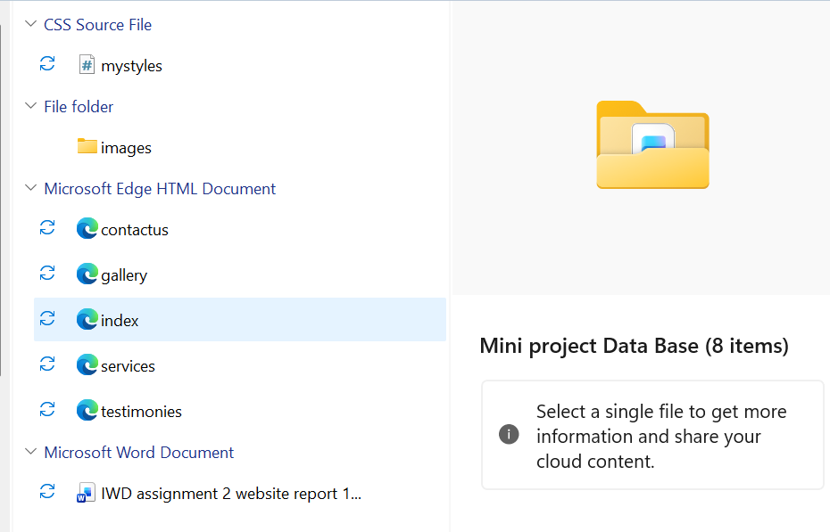

Figure 2. Project folder structure of the Mayfair Ritual website.

Homepage Implementation
The homepage was implemented according to the planned wireframe. The header contains the logo on the left and the navigation menu on the right. This ensures a clear and familiar layout for users.
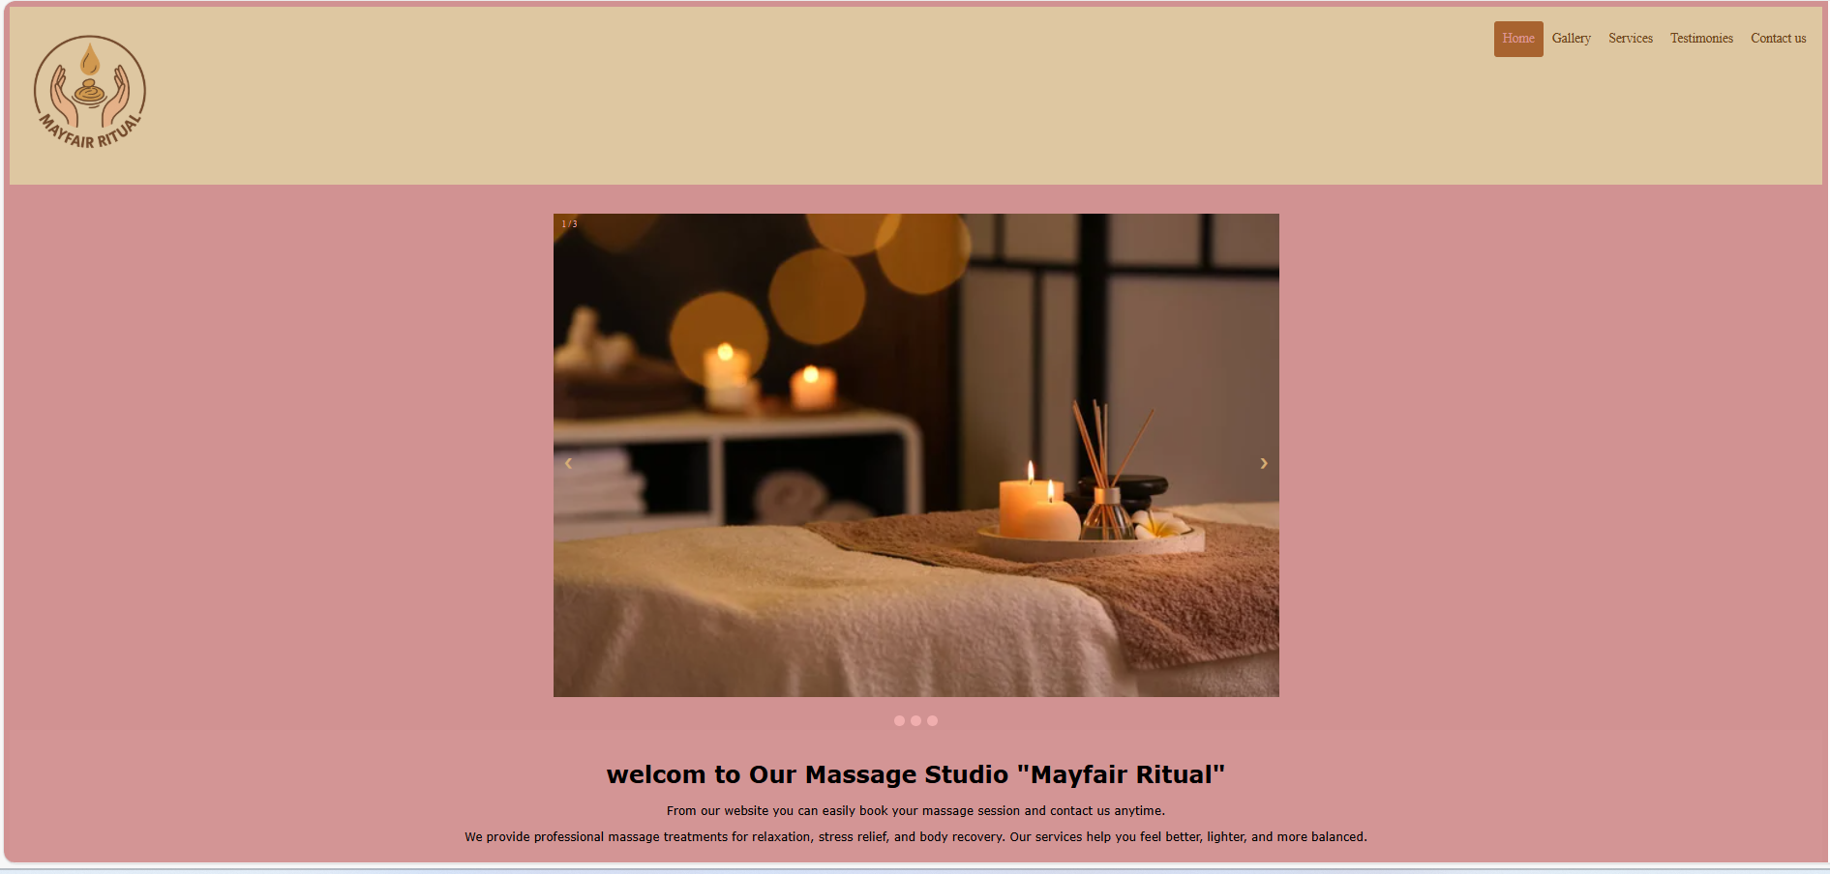
Figure 3. Home page Screenshot.

Gallery Page Implementation
The Gallery page displays a set of images that represent the salon atmosphere. Photos were resized and arranged in a consistent grid layout.
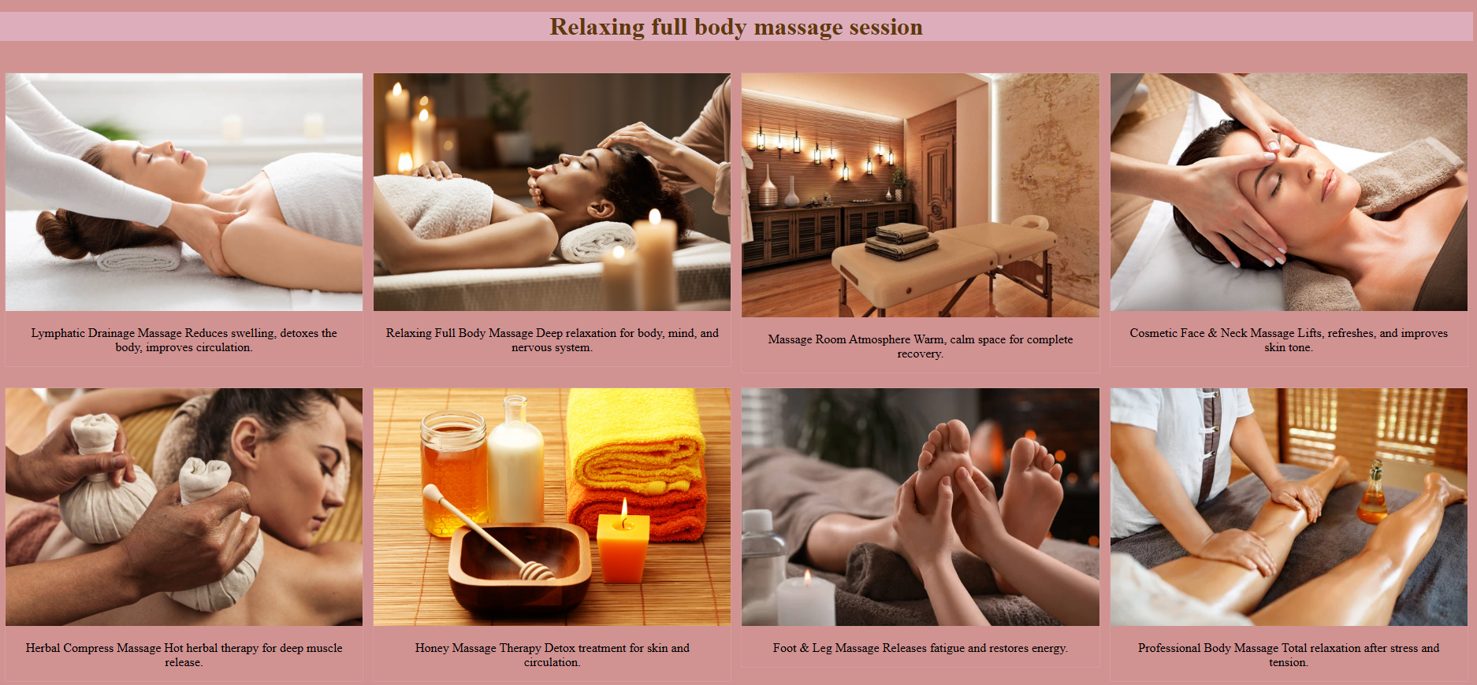

Figure 4. Gallery page Screenshot.

Services Page Implementation
The Services page lists eight massage packages with images and descriptions. The layout uses a grid structure to keep services organised and easy to read.
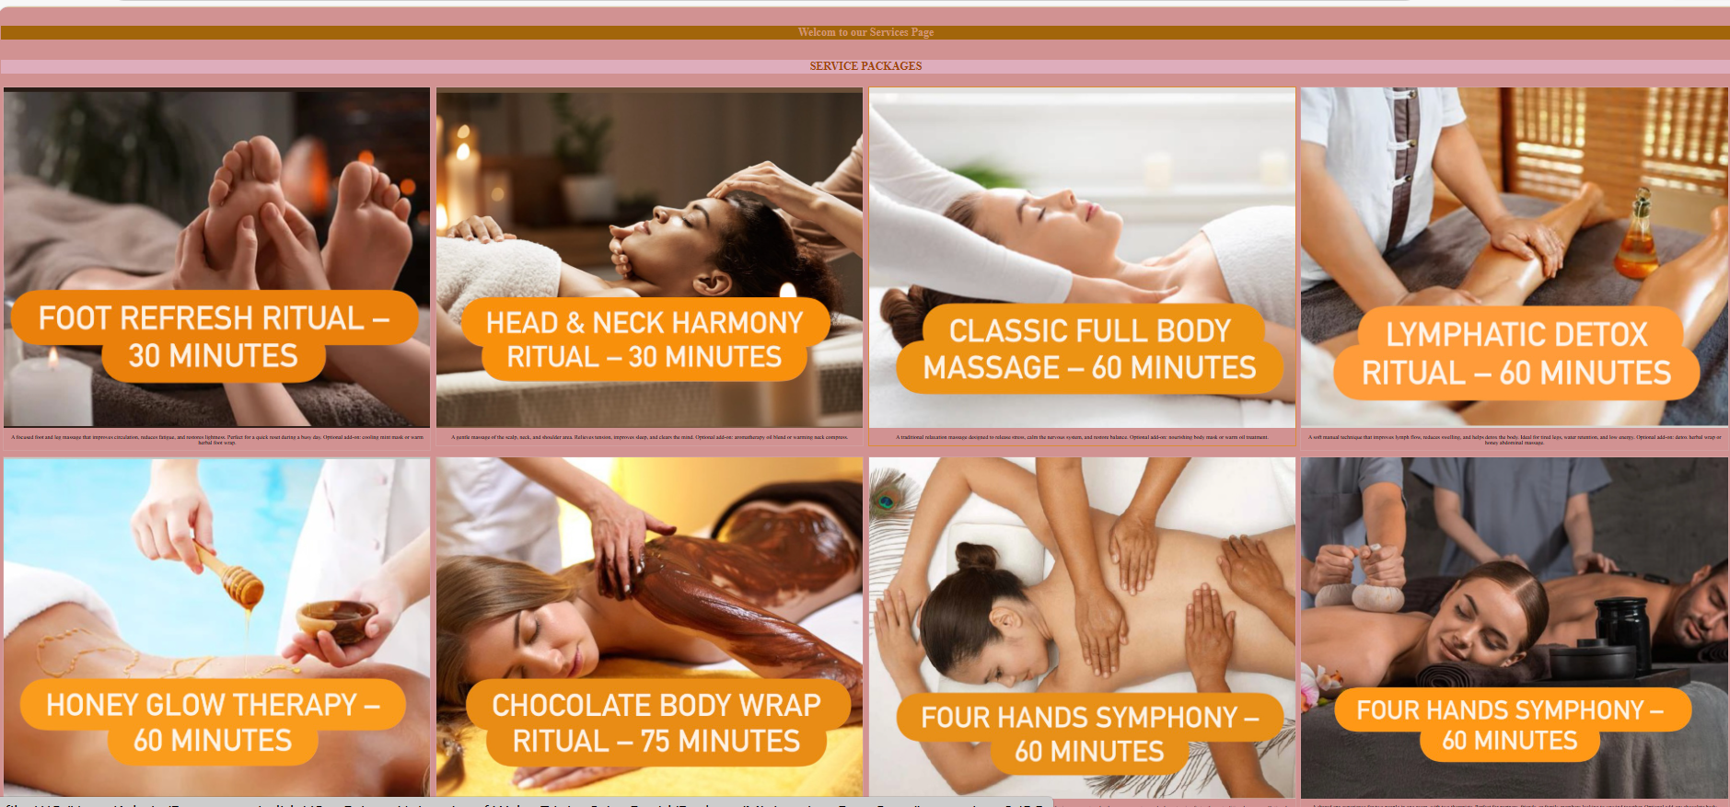

Figure 5. Services page Screenshot.

Testimonies Page Implementation
The Testimonies page introduces the two therapists with a photograph and a short biography for each one.
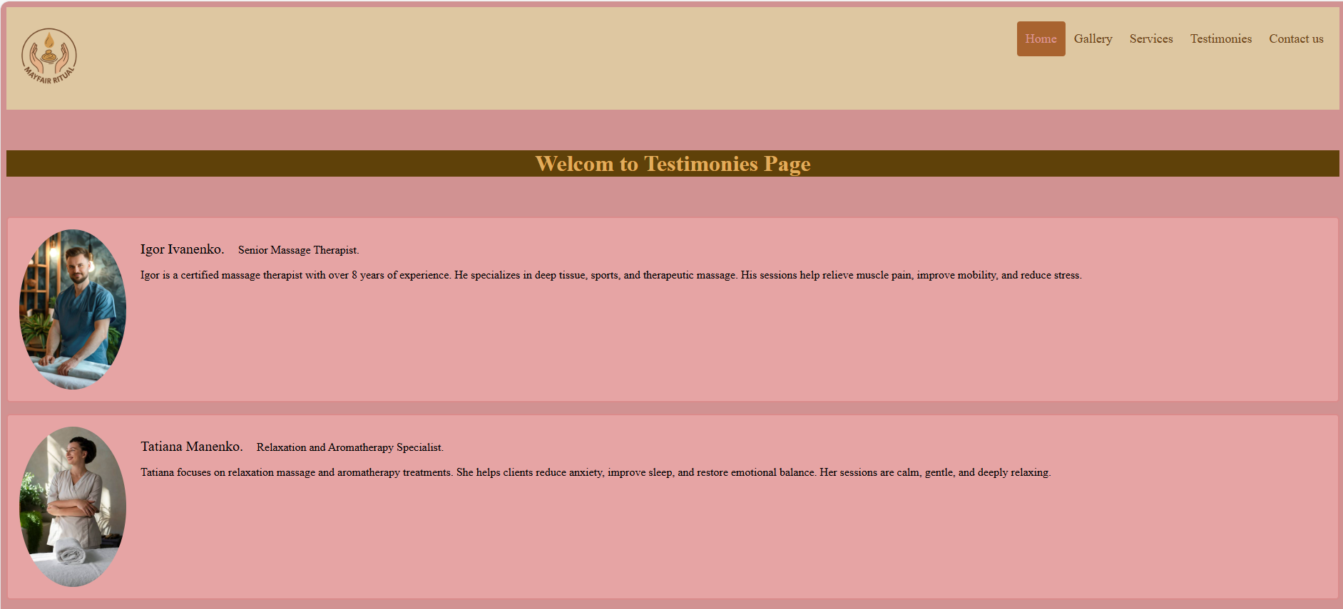

Figure 6. Testimonies page Screenshot.

Contact Page Implementation
The Contact Us page uses a simple form where visitors can submit their details. The form includes fields for name, email, phone number, and message.
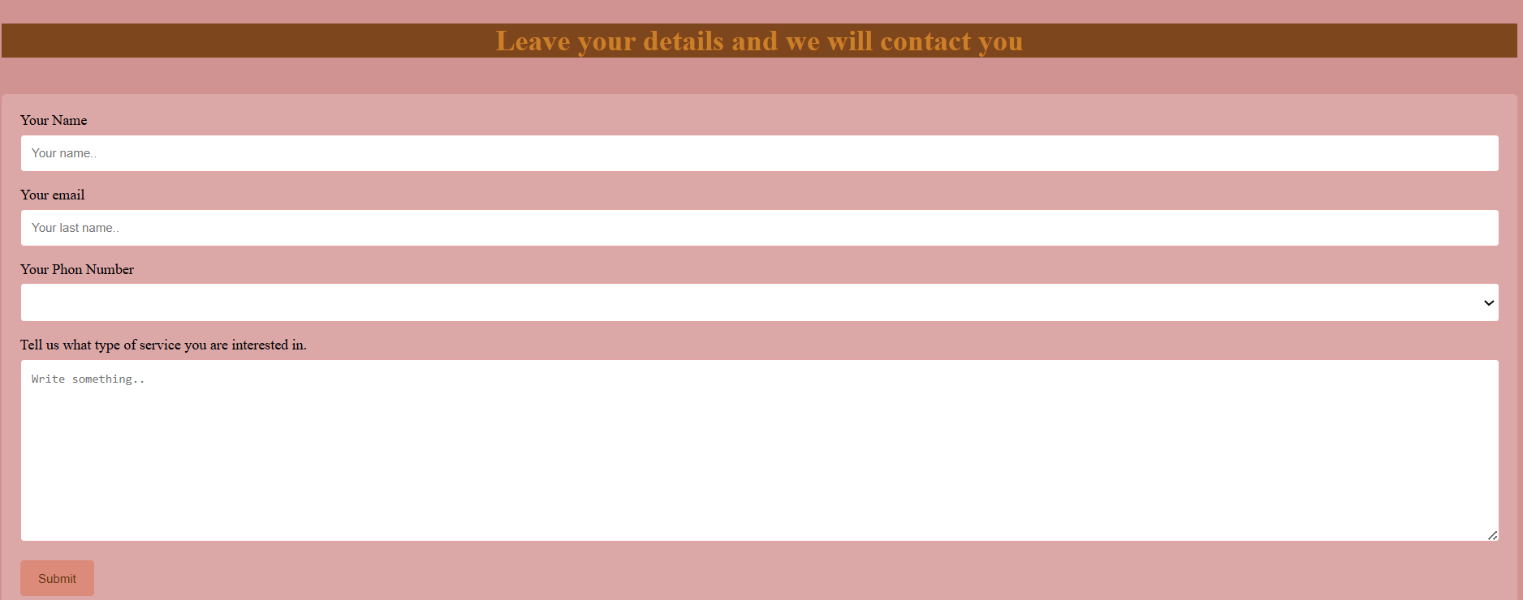

Figure 7. Contact Us page Screenshot.

Validating my website
Validation is an essential step in the web development process because it ensures that the code follows current W3C standards. This helps improve website performance, accessibility, and compatibility across different browsers. For this project, one HTML page and one CSS file were validated using the official W3C validation tools recommended in the assignment brief.

HTML Validation
The homepage (index.html) was validated using the official W3C Markup Validation Service. https://validator.w3.org/
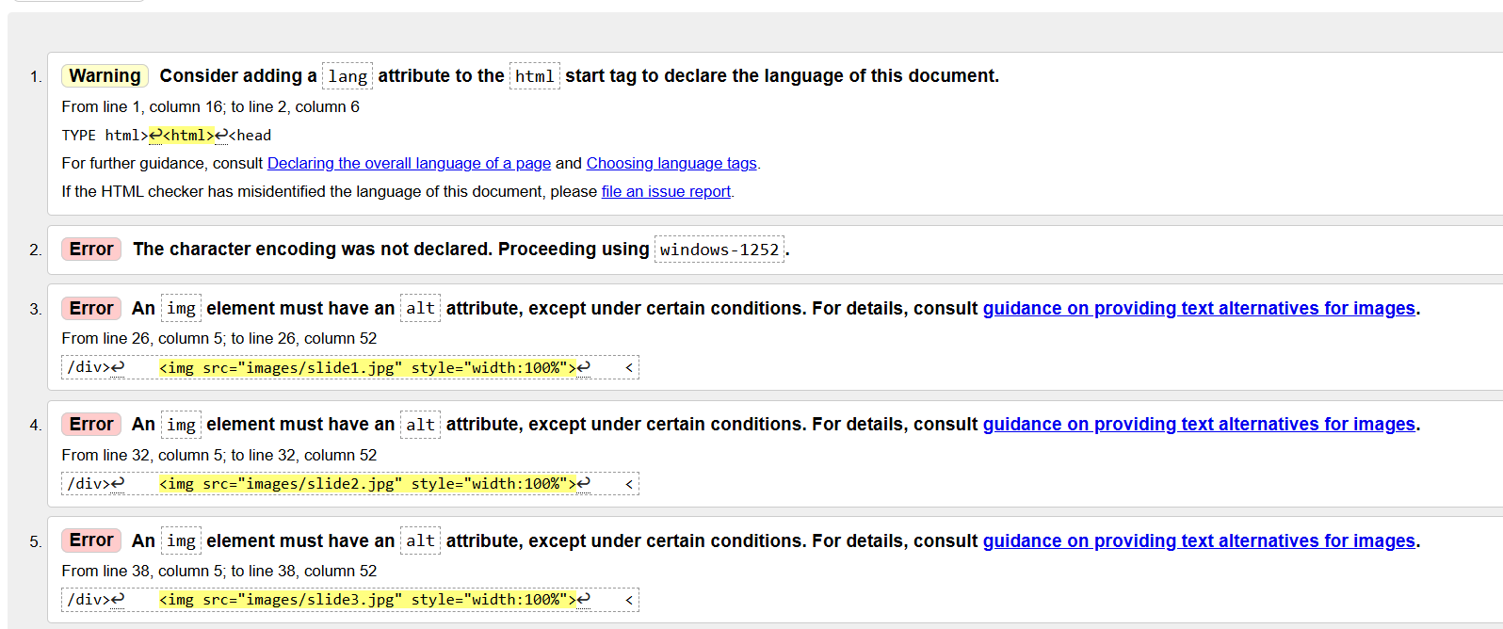
Figure 8. HTML validation result for index.html

These issues were identified during validation. They represent common early coding mistakes such as missing alt attributes on images, the absence of a declared character encoding (<meta charset="UTF-8">), and missing lang attribute in the <html> tag. Although these issues are easy to correct, I kept the original version of the code in this report because the assignment requires demonstrating the validator output and explaining the errors found during validation.

CSS Validation
The stylesheet (mystyles.css) was validated using the W3C CSS Validation Service. https://jigsaw.w3.org/css-validator/
The CSS file passed the validation successfully with no errors.
This indicates that the selectors and properties used in the stylesheet follow the CSS3 standards.
A valid CSS file also supports better browser compatibility and reduces layout inconsistencies.
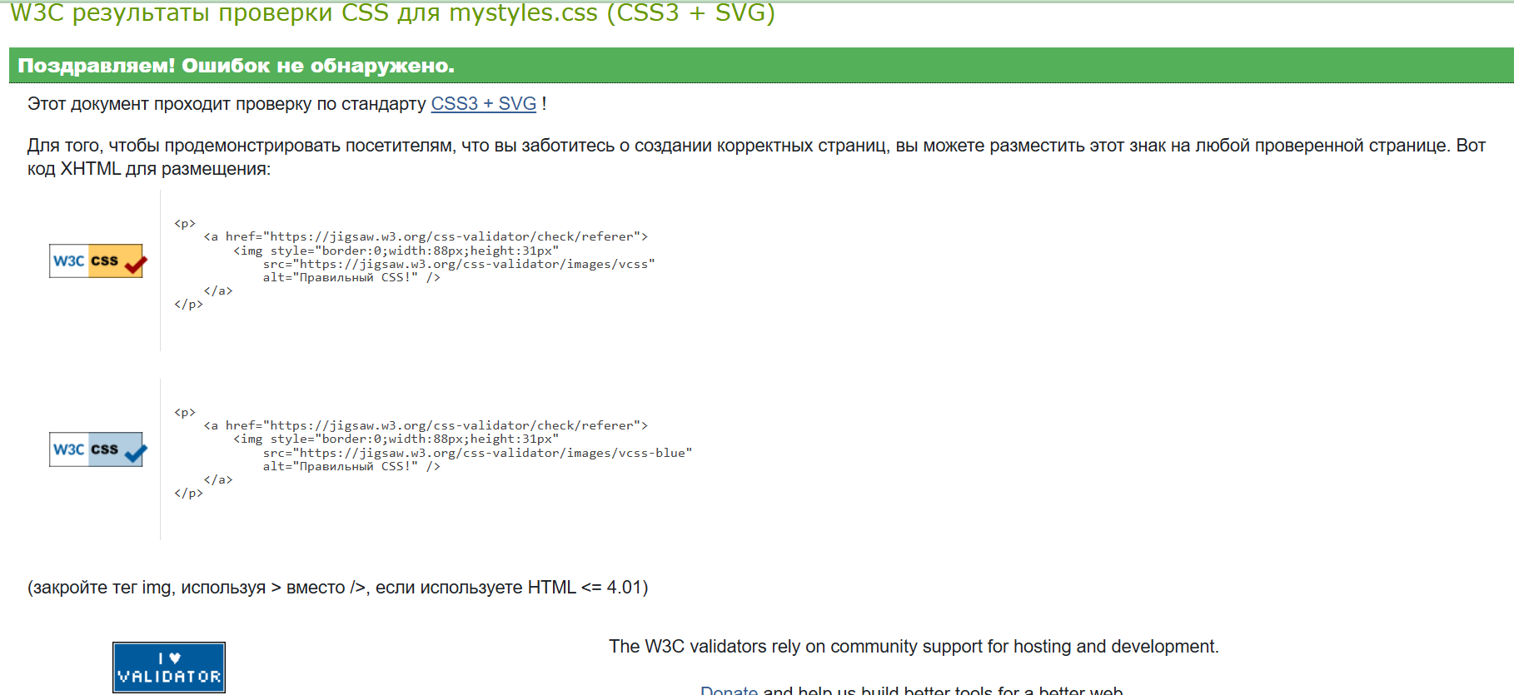

Figure 9. CSS validation result for mystyles.css
The validation process confirmed that the website structure and stylesheet follow recognised standards and that the remaining issues were minor and easily corrected.

Self-evaluation of my website

Usefulness (usability and utility):
Overall, the Mayfair Ritual Massage Salon website meets most of the key usability expectations for a small service business. The structure is simple: a fixed header with logo and navigation, four main content pages, and a clear contact form. Research on web usability shows that users feel more satisfied and are more likely to stay on a site when navigation is consistent and content is grouped logically [3]. My design follows this principle by keeping the same menu on every page and using short, descriptive headings such as “Service Packages” and “Our Massage Atmosphere”.
The site is useful for both new and returning clients. New visitors can quickly see photos of the salon, read about the therapists, and check the list of massage packages. Returning clients can go directly to the Services or Contact Us pages to confirm details or send a new enquiry. However, there are still areas for improvement. At the moment, the site is mainly designed for desktop and laptop screens. A fully responsive layout for tablets and mobile phones would make the site more convenient for users who browse on smaller devices. In addition, future versions could include an online booking option to increase the practical value of the website.

Search Engine Optimisation (SEO):
The current version of the site implements some basic SEO-friendly practices but still has limitations. Studies of search engine optimisation emphasise the importance of meaningful page titles, descriptive text content, internal links and image attributes for better search ranking [4]. My pages already use clear titles such as “Services Page” and “Contact Us Page”, and the navigation menu gives each section a logical name. The text on the Services and Testimonies pages includes relevant keywords such as “massage”, “relaxing”, “aromatherapy” and “London”, which would help search engines understand the topic of the site.
At the same time, several SEO elements are still missing. I have not yet added meta description tags or structured heading levels (for example, H1, H2) to emphasise important sections. The amount of written content is also quite small, which may limit keyword coverage. In future, I would improve SEO by adding meta descriptions to each page, expanding the text about services, and ensuring that every image has an appropriate alt attribute. These steps would support higher visibility if the site were published with a real domain.

Website Accessibility:
Accessibility is an important part of modern web design because sites should be usable by people with different abilities. The Web Content Accessibility Guidelines (WCAG 2.1) recommend providing text alternatives for images, ensuring sufficient colour contrast, and making navigation predictable and consistent [5]. My website already follows some of these recommendations. The layout is simple, links are clearly visible in the top navigation bar, and the main text is written in clear language. The colour palette of beige, pink and muted gold was chosen to be gentle on the eyes and not too bright for users.
The validation results showed that some images, especially the slideshow on the Home page, were missing alt attributes. This means that screen reader users would not receive a description of those images. There is also no explicit language attribute in the HTML, which is another WCAG recommendation. These issues can be fixed quite easily by adding alt text that briefly explains each picture and by including lang="en" in the <html> tag. In future, I would also test the color contrast using an online checker and consider keyboard-only navigation to make sure the site is accessible to as many visitors as possible.

Reference list
[1] J. Nielsen, “Usability 101: Introduction to Usability,” Nielsen Norman Group, 2012. [Online]. Available: https://www.nngroup.com/articles/usability-101/
[2] M. Hall and J. Hanna, The Influence of Color on User Emotion and Website Engagement, Journal of Design, vol. 8, no. 3, pp. 45–56, 2016.
[3] S. Krug, Don’t Make Me Think: A Commonsense Approach to Web Usability, 3rd ed. San Francisco: New Riders, 2014.
[4] Google Search Central, “Search Engine Optimization (SEO) Starter Guide,” Google Developers, 2023. [Online]. Available: https://developers.google.com/search/docs/beginner/seo-starter-guide
[5] World Wide Web Consortium (W3C), “Web Content Accessibility Guidelines (WCAG) 2.1,” 2018. [Online]. Available: https://www.w3.org/TR/WCAG21/
[6] I. Sommerville, Software Engineering, 10th ed. Harlow: Pearson, 2016.
(используем как академическую опору на структурированный подход к разработке и документации)

