Professional development plan

Besart Muslija

1912280

04/01/2021

Table of Contents
Introduction 3
Professional development plan 3
Career development plan 3
REFERENCES 14

TASK 2

Introduction
Career development plan is one of the most essential factors that a person has to focus upon while having an effective professional life. A person who is feeling that he or she is underperforming by seeing the feedback then it is important that he or she has to improve the skills and capabilities to be effective (Lejeune, Beausaert, and Raemdonck, 2018). Reflection is helpful for providing effective ways to manage own abilities and know what are the strengths and weaknesses of n individual. There is need to have a proper planning of career process as it will help in knowing different ways to manage and control the personal skills.

Professional development plan
The career development plan will be helpful for managing own activities in proper manner and attaining the goals in specified time frame. This will help to get effective ways to manage self-strengths and weakness and making a plan (Maguire, and Blaylock, 2017). This is a strong planning which will be developed in such a way that career goals and objectives are attained.
This is essential for me to have a proper career development planning so that goals and objectives are attained. These are managed properly and various skills are improved by using this plan. As the security management person, I have developed an effective career development plan which is mentioned below -
Short term goals
- Enhance leadership abilities
- Develop and build relationships across industry and organisation
- Enhance the experience as the security manager
Long term goals
- Security and inspection manager

Career development plan
On the basis of above goals and objectives, there is a career development plan prepared. This is useful for evaluating different scenarios which will help me to enhance my career.

Action | Objective | Measurement
Ability of leading and developing teams | Develop strong leadership skills for handling and managing different business activities. | Providing successful projects to clients. This can be evaluated by feedbacks from stakeholders.
Developing and implementing security protocols, policies and procedures | This includes enhancing the ability for policies, protocols and procedures for the organisation | Effective and strong policies are implemented within the company for smooth functioning.
Recruiting, training and supervising security officers and managers (Rubens, and et. al., 2018). | To have the most talented and skilled employees within the company | This can be evaluated by performance of company.

Personal development plan

Personal development plan is prepared in order to know what are the strengths that a person has. These are associated with the managing of different abilities of own which can be improved by various methods there are a lot of factors which are considered while managing the activities and tasks. There is need to manage the effectiveness of personal development of an individual. There are different scenarios on which the action plan is prepared and it consist of awareness, values, reflection, goal-setting and planning for personal development. It is very important for me to manage the working in effective manner and develop new skills needed for working in effective manner (Salter, and Rhodes, 2018). The personal development is based upon CV. It is essential for me to manage and develop new things which can help in improving the work conditions. It is also essential for me to enhance effectiveness of the individual. A lot of opportunities are present within market for me as the security manager. It is an effective manner for me to enhance my capabilities and put efforts in conducting the organisational activities. There are a lot of training and development sessions I have used for improving my work. This has helped me to manage the effectiveness of completing my work in time. After the evaluation of various feedbacks, I have analysed that there are some weaknesses which I have and these have to be enhanced for completing projects. The professional development plan of mine is listed below -

My personal development targets? | Short- or long-term target? | How will I achieve my targets? What activities do I need to undertake to achieve my objectives? What support do I need? | Date of review | Progress made towards target | Further action required | Actual date of achieving target
I have a personal goal for developing and building good team. | Short term target | This is concluded that there are various ways which I can use to develop leadership skills and abilities. This is very essential for me to manage the working of me as the security manager effectively. There is need to develop and enhance the team management skills as these will be providing me ability to give effective guidance to my subordinates. This will help to conduct the team management and is very important for me to develop the team management skills for managing the achievement of assigned targets and goals. | 3rd May | This can be achieved by attending leadership sessions. This will help in learning new skills and managing the effectiveness of personal development. | There is organisation of new scenarios which are related to leadership abilities and skills. | 30th May
It is important for me to develop my Leadership 11Skills (Sergeeva, and et. al., 2018) | Long term target. | I want to become one of the most effective leaders and for this I need to have proper confidence. There is need to be capable of managing the leader's capability so that organisational goals are attained. It is concluded that I have to manage and analyse different issues which are related to the effectiveness of my leadership skills. I will be able to manage the attending of all lessons to manage the proper understanding of work. There is need to have the effectiveness of working so that goals are attained in proper time. It is essential to manage the work and increase my leadership skills and abilities. There is need to evaluate different capabilities by enhancing the leadership. | 4th may | I am having an objective that will lead to manage the control and effectiveness of proper functioning. It is essential to increase customer satisfaction level by working properly. Leadership is one of the biggest factors that helps in handling and managing different business activities. | I will ask my team member whether I am clear while explaining different leadership skills and attributes. | 4th November
Presentation Skills | Short term targets | I have less confidence when it comes to giving oral presentations to my team members. It is very important for me to provide effective presentation so that I can be able to provide my team members all information about the present scenario or activity. | 1st May | It is essential for me to enhance the presentation skills so that I can easily convey my message to colleagues and team members. It is very important for me to enhance the presentation skills for effective functioning. | There is need to have an effective way to manage the seniors as well as juniors properly so that there are no chances of ineffective management | 10th may
Time management skills | Long term targets | Team development and management is required for developing an effective way to handle conflicts and move for company success. | 3rd May | When time management is properly discussed then there is need to have proper control over the management of firm. | Time and work balance is needed by me so that I am able to manage the achievement of goals in specified time. | 15th September
Ethical practise | Long term target | I use efficient way to develop the presence of ethical and authenticity in all my work. This will provide help to know what are the different things that can be worked upon for enhancing organisational goals. | 5th may | This is important for me to handle and manage different activities and so them with all ethicality and authenticity. | It is essential for me to manage the effectiveness of working so that ethical practices will help me to manage the efficiency of reaching success. | 30th August
Managerial abilities | Long term targets | It is essential for me to have effective management skills that will lead to manage the business activities. There is efficient need to control and conduct the operations properly so that goals are attained in less time frame. It is important for me to manage the efficiency of proper functioning and methods. These will lead to a proper development of skills and management. | 1st may | Managerial skills and abilities are essential for maintaining the effectiveness of controlling and managing the organisational goals. | There is need to conduct effective training and development so that goals are attained in specified time frame. These provide the efficiency to manage functioning in a proper manner. | 15th August
Stress management | Short term target | I have concluded that stress management is one of the most essential factors that will help in managing the work. | 5th May | It is important for me to have effective stress management techniques and these can be measured by asking colleagues and seniors about my stress management. | I have focused upon managing the way to keep control over my stress. This is done by taking medication and concentrating. | !5th May

The reflective practice is known as the concept which focuses upon the assessing of various strength and weaknesses that an individual has. It is essential for me to develop effective skills that will lead to attain the goals of personal and professional area. These are required for developing and taking into consideration various factors for managing the process of business. It is essential for all the individuals to have proper evaluation of own skills for managing the work (Shaheen, and Hameed, 2020). It is concluded that Gibbs model is the best one for managing the reflection analysis. The personal skill analysis of mine as the security professional is mentioned below - s
Gibbs - Reflective Cycle model: This is known as a model which is mainly developed for controlling and handling own way of achieving goals. There is requirement of managing and handling different factors that are helping in attaining objectives and goals. This model is a continuous loop cycle in which skills of people is analysed:

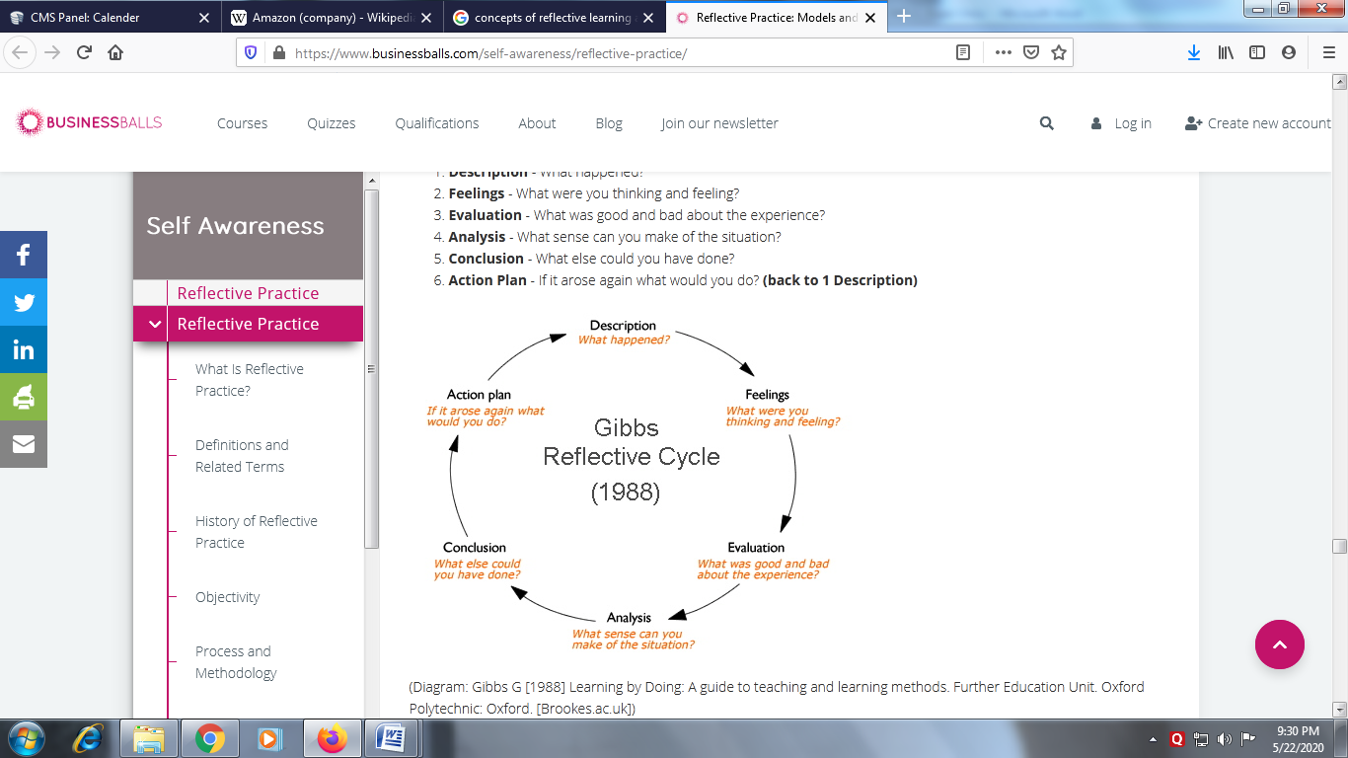
(Source: Gibbs - Reflective Cycle model, 2019)

Description – I have concluded that as a security manager, the main responsibility is to provide care and safeguarding to people. There is need to evaluate and manage the effectiveness of functioning so that organizational objectives are achieved. I have used different skills that have helped me to become better in my work.
Feelings – I have concluded that there is need to evaluate and manage the effectiveness of working. It is concluded that gaining new experience by adopting good skills and abilities wil help me to manage the working.
Evaluation – In this stage, there is need of understanding and evaluating different ways to manage the value of working. I have some positive and few negative attributes. All the negative skills have to be vanished so that goals are attained.
Analysis – In this, there are different levels that lead to proper management. It is important for me to analyze and evaluate the effectiveness of my own skills for managing the work of security.
Conclusion – When the conclusion is conducted, there is need to have effective management of activities (Stewart, 2016). These are to be controlled and managed properly. There is also requirement of enhancing the skills so that goals are attained.
Action Plan –In this after making the analyzing all the interpretation and after that the plan will make to get deal with the situation by which more effective outcome will get achieved. The action plan is developed for enhancing the skills and completing projects.

REFERENCES
Books and Journals
Lejeune, C., Beausaert, S. and Raemdonck, I., 2018. The impact on employees’ job performance of exercising self-directed learning within personal development plan practice. The International Journal of Human Resource Management, pp.1-27.
Maguire, W. and Blaylock, P., 2017. Preparing a personal development plan for all members of the dental team. British dental journal, 223(6), p.402.
Rubens, A. and et. al., 2018. Self-awareness and leadership: Developing an individual strategic professional development plan in an MBA leadership course. The International Journal of Management Education, 16(1), pp.1-13.
Salter, M. and Rhodes, P., 2018. On becoming a therapist: A narrative inquiry of personal–professional development and the training of clinical psychologists. Australian Psychologist, 53(6), pp.486-492.
Sergeeva, M.G. and et. al., 2018. Psychological and pedagogical support for the social workers professional development.
Shaheen, S. and Hameed, M., 2020. Personal Development Plan (PDP). Middle East Journal of Family Medicine, 18(4).
Stewart, J., 2016. Personal development plan. In Encyclopedia of Human Resource Management. Edward Elgar Publishing Limited.
Verweij, H. and et. al., 2018. Does mindfulness training enhance the professional development of residents? A qualitative study. Academic Medicine, 93(9), pp.1335-1340.
Wagner, J.P. and et. al., 2018. Professional use of social media among surgeons: results of a multi-institutional study. Journal of surgical education, 75(3), pp.804-810.
Wang, F.Y., 2018. An expert EFL reading teacher’s readers club: reader identity and teacher professional development. European Journal of Teacher Education, 41(4), pp.517-528.
Weller, J., 2019. Critical reflection through personal pronoun analysis (critical analysis) to identify and individualise teacher professional development. Teacher Development, 23(1), pp.139-154.

