Certificate in Higher Education Skills for the Workplace

Name: Nazneen Faryad
I.D: 1815085
Module Code: BMSW 4005
Module: Professional Career Development
Lecturer: Dr Janet Green
Assignment: Reflective Portfolio

Contents

Introduction…………………………………………………………………3

A Reflection of Self Awareness ………………………………………….4
Johari Window………………………………………………………………………………4
SWOT Analysis……………………………………………………………………………..5
Kolbs Experiential Model…………………………………………………………………..6

Reflection of the Mock Interview………………………………………….7
CV……………………………………………………………………………………………..7

Career Development Plan………………………………………………...10
SMART Goals……………………………………………………………………………...10
Personal Development Plan………………………………………………………………11
Plan-B Job…………………………………………………………………………………..12

Introduction
Hello, a short introduction about myself; my name is Nazneen Faryad and I currently reside in Birmingham, United Kingdom. I studied and achieved National Vocational Qualifications (NVQ) in Business Administration and Information Technology.
I have had several jobs throughout my work history, to name a few, I was a wedding planner in London for several years and I worked in a call centre for the Ministry of Defence for a while. I also worked as a receptionist and administrator for the NHS at a few General Practitioner (GP) surgeries for approximately 9 years. I trained in phlebotomy and stop smoking cessation and therefore also ran both clinics at the surgery.
At the moment I am studying at the University of Wales Trinity Saint David for my Certificate in Higher Education, Skills for the workplace.
This reflective portfolio will be in three sections and it will cover the following topics:
- Self-awareness.
- A reflection of the mock interview.
- Career development plan.
All three will be talked about in more clarified detail in this reflective portfolio.
With taking the first step to knowing myself by having self-awareness, I seek opportunities that are parallel to my aims and priorities and what job would be most suitable. (Maund, Schriek and Tinkler, 2017).

A reflection of self-awareness (part one)
Johari Window
One of the self-awareness tools that I learned about and used is the Johari window. As Morgan, (2017) outlines, that at times we tend to hide what we do not like about ourselves and, sometimes other individuals do not inform us of what we are really like because they do not want to be offensive. This led to Joseph Luft and Harry Ingham to create the Johari Window.
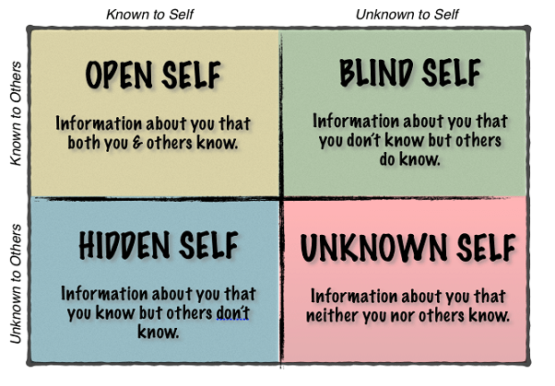
The Johari Window may be seen from different viewpoints, it stipulates four rudimentary systems of oneself, the Open, Hidden, Blind and Unknown self. By aligning yourself with the truth allows you, in due course to better yourself. To pursue, find and apply truth in your life is the best gift you could give yourself.
The Open Self is what both yourself and others perceive in you and you have no qualms about conversing this side of you with others, the Blind self is what you do not know or see about yourself but others do, for example you might see yourself as a calm mild mannered individual but others may perceive you as harsh and temperamental. The Hidden Self is what you observe about yourself and others do not, some areas of your life that you might want to keep private and not disclose, the unknown self is what you and others are not conscious of, these might be things both good and bad that yourself and others are not aware of.
The Johari Window is a both internal and external communication network, that you may consider beneficial as you advance forward into determining who you really are. (López De Victoria, S, 2018).

By implementing the Johari Window, I asked family, friends and former colleagues on what they thought of me as an individual and what they thought of my work ethics and to be honest with their answers. To my surprise I discovered varied answers to how I perceive myself and how they see me. With these wide-ranging responses, I decided to add a personal SWOT analysis to have a better understanding and to further explore my options.
SWOT Analysis
Strengths  Confident  Outspoken  Intelligent  Logical  Practical  Hardworking  Good communication skills  Punctual  Helpful  Good social skills/Sociable  Loyal  Capable  Reliable  Responsible  Caring  Kind  Loving  Rebellious  Curious  Polite | Weaknesses  Outspoken  Helpful  Caring  Impatient  Judgemental  Rebellious  Annoying  Lazy  Bossy  Sarcastic  Dramatic  Waste time  Rebellious  Greedy
Opportunities  Monitoring  Improvements  Plan  Goals  Organised | Threats  Impatient  Lazy  Waste time  Bossy  Outspoken  Helpful  Rebellious

By analysing and pondering over these I realised, that in order to better my personal and professional life, I need to make choices and go on to apply these choices in my life and to act upon them.
I found that sometimes I am bossy and can be overbearing, one experience which comes to mind is; whilst working at my previous job, I delegated small tasks to my colleagues including a relatively new trainee who was still on her work probation period. One of my colleagues approached me and informed me that the new trainee had stated that she felt slightly intimidated by how I delegated the work to her, I was very surprised, as to my knowledge I was same with everyone at work.
However, I did resolve the matter by having a discussion with the trainee and assuring her not to feel intimidated and she could come to me anytime if she needed help. This experience at the time, gave me food for thought and I gave myself a pep talk to be more pro-active on how I conduct myself to others and to watch my tone of voice, especially whilst at work.
Kolb’s Experiential Model
As Morgan, (2017) explains, Kolb’s experiential model of learning has been quoted often in learning and development writing. It is experiential as it is centred on people having and pondering about their experiences.

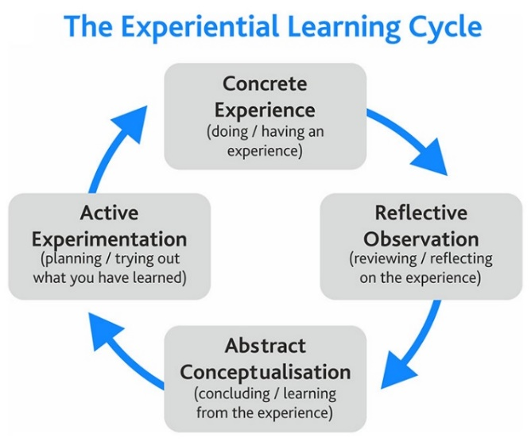
Reflection of Mock Interview (part two)
Undertaking a selection interview is frequently seen as nerve-wracking and a thought-provoking experience that a person is likely to face. The pressure of this experience can be daunting, but realistically it does not have to be so stressful. If given the chance to work for them, the interview will be a rare chance to find out about the company before you commit.
As well as holding a conversation, employers generally look out for candidates that are able to perform well and at an acceptable level within the company and if the candidate will fit into the ethos of the establishment. (Morgan, 2017).
For the purpose of my mock interview, which was to be held on 24th February 2020, I searched, found and applied for a job with a covering letter and updated and amended my Curriculum Vitae (CV).
Whilst searching for the job, I tried to look for jobs that were most suitable to me and my skills, a job which I enjoyed doing and which also gave me a sense of job satisfaction. For me personally I do think that that actually enjoying the work I do and having that job satisfaction at the end of the day is quite important, as it is what keeps me motivated and raring to go ready for another day at the office. So, I applied for the role of a medical receptionist because this is something that I have vast experience in, and it is a job role that I enjoy.
I researched on how to update and modernise my CV, I did follow some of the procedures but eventually I decided that I would keep my CV easy to read and follow and to keep the structure simple.
CV
A CV (the Latin phrase curriculum vitae, meaning “course of life”) is a thorough document emphasizing your professional and educational history. CVs usually consist of information about you, e.g. job skills, accomplishments you have earned and your educational history etc. Usually when applying for jobs you would submit a CV. In defining your CV ensure that it stands out to potential employers. (Indeed.com, 2020)
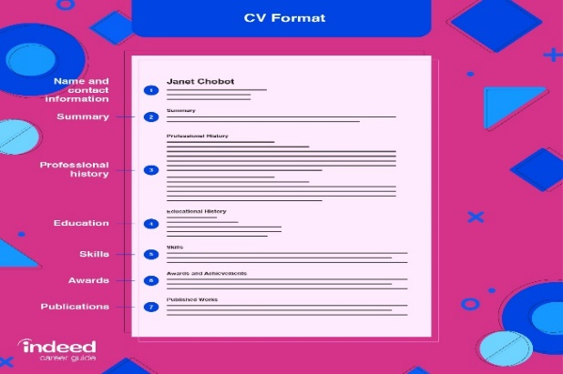
I did put some thought in the covering letter that I submitted with my CV. I wanted to keep it simple and to the point and not to advertise myself too much as I did not want to sound desperate or too keen in my covering letter. Also, I ensured that very briefly I add my work experiences, in the hopes that it would look impressive and catch the employers eye.
On the day of the interview I think understandably I was quite nervous and anxious on how the interview would go. I dressed appropriately in smart clothes and suitable footwear, making sure I arrived there early so I could go over the job application and notes, switch off my phone, take time to breath and to not have the added worry of being late.
There were a couple of candidates before me, but I was eventually called in for the interview. I greeted the panel with a smile and hello as I went in, although I did not take my coat off. I was asked to tell them a little about myself, so I introduced myself by stating my name and age and where I was from. The panel asked me a variety of questions, including my work experiences and why I had applied for this particular job, I tried to answer to the best of my knowledge by informing them of my long work history in that specific field and how I would be an asset for the company by being able to do both phlebotomy and stop smoking cessation clinics. I also gave an example of a scenario that happened whilst I was working and how it was imperative in this field to stay calm and professional.
They asked me about my strengths and weaknesses, to which I replied that my confidence and communication skills were a strength as both are key to working in this field and one cannot be a wallflower to say the least. Weakness would be that I get anxious and irritable if I do not meet deadlines and if the job is not done correctly.
The interview was rounded up by me asking if there was a uniform protocol and if there was potential for growth within the organisation, to which they answered in the affirmative. In all it lasted about 15 minutes or so and I thought it went well even though I did feel that I was waffling on a bit during the process.
In her online journal Jeffery's, (2019) acknowledges the fact that when she had a mock interview to her surprise, she was nervous as she found it a lot more daunting that what she had presumed. However, she did find it enlightening as it was a good practice run and it helped her to find her weak points, which she could improve on. She also stated that the whole point of interviews is to learn what the job is about and the responsibilities it entails as well as feeling if one can fit into the ethos of the department.
On reflection based on Kolb’s theory (which is also referred to in in part one) and from the feedback I received from both Yohan and Doreen, it is not too bad although I do feel that there are certain things I could have done better. In hindsight I could have had tailor made my CV and addressed my job skills in the covering letter more to the job applied. I do wish that I had taken off my coat before the interview started and I that I should have done more research on the organisation I applied to.
Although I am glad that I chose this job to apply, as I know that with the questions asked, I am the right candidate for this job, my experience speaks for itself. I am also relieved that I switched my phone off and I greeted the panel accordingly as I entered the room although I did not shake hands.
In her investigations Fitzpatrik, (2016) states that according to Goffman’s Theory of Self-Presentation (1959), people either knowingly or unknowingly signify themselves to others in an array of ways to manage their image. His research implies that people are actors and have the ability to select their props and costumes and put on a front before a particular audience. This acting comparison affords an awareness into characteristics of social interaction and the psychology of the person.

Career Development Plan (part three)
SMART Goals
Many individuals when they reflect on the last several years, feel as if they work hard but do not seem to be getting anywhere, and they feel as if they are wasting their lives gliding from one job to another. They can dash about attempting to get something done, when in reality not really achieving much.
Hence by setting SMART goals, you can refine and concentrate on your ideas, utilize your time and means constructively, and boost your chances of accomplishing what you want in life. (SMART Goals: – How to Make Your Goals Achievable, 2020).
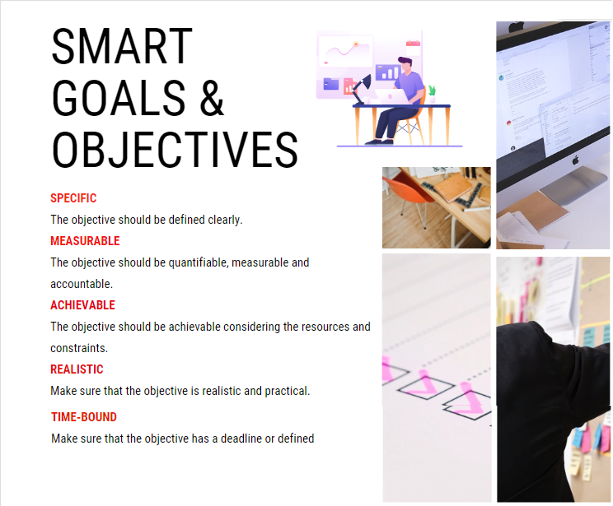
As this first year towards my degree comes to an end, I find that I am at a crossroads and I need to grasp who I am, where do I want to get to and what is important to me and my values. By applying to the Johari Window and a personal SWOT analysis, and taking into consideration the mock interview, I can reflect on setting SMART goals. My objective is to find a well-paid job where I will be happy and motivated and where there is potential for further growth. A job in the NHS, where there are a lot of training programmes and courses, as I would like to eventually go on to become a Health Care Assistant (HCA). By helping and taking care of patients, I do feel that I am giving back to society and that offers me job satisfaction
My goal is to see myself as a trained HCA in the next 4 to 5 years and working in an established organisation. Another objective is, that I hope to come back to higher education and by working, I can support my studies to achieve my degree in the not too far future.
After the mock interview experience, I intend to work on and improve my CV and covering letter, to be a little bit more detailed and interesting and to overall be better prepared for an actual job interview. I will do this by researching methodically online, attending job fairs, networking with ex colleagues and friends, for my dream job that I choose to apply for, specially a job that has good career prospects. To determine what I needed to do to amend, improve and set goals for myself, I made a self SWOT analysis (please see part one).
A personal SWOT Analysis can help you unearth opportunities that you would not have seen. By recognizing your weaknesses, you can reduce threats that might thwart you moving forward. It can develop your skills and capabilities for you to progress in your career goals. (Pasteur, 2019).
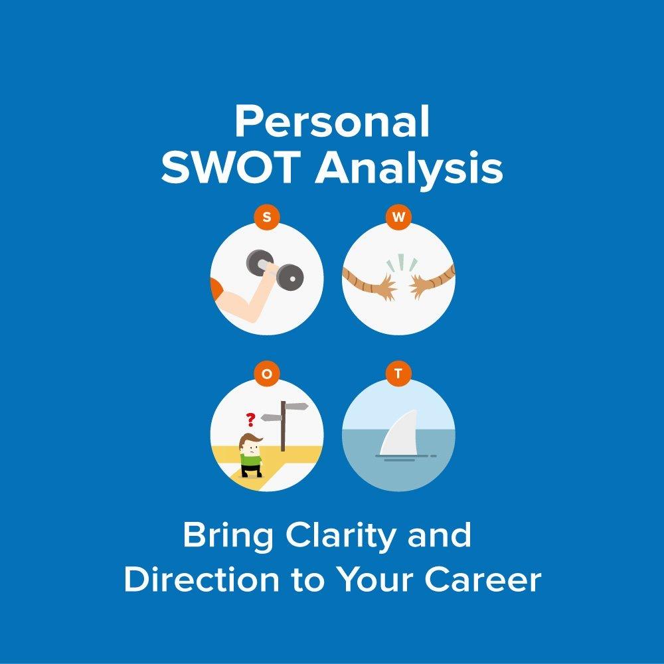

This showed me that I needed to work on myself, for example I can be impatient and outspoken at times and I can come across as bossy, I will reflect on these points and better myself amongst the other weaknesses. The best way to manage these negatives to my knowledge is by monitoring myself, have a set plan and start making small improvements towards achieving my goals. This being gradual but beneficial and adapting to certain roles and situations.
Personal Development Plan
A Personal/Professional Development Plan is a plan of action, this refers, to the individuals realistic objectives with regards to personal development. This plan permits one to set their specific goals and a means of accomplishing them. A PDP permits a person to build career resilience and allows them to adjust to a altering work environment. It also allows persons to target their abilities and job skills frequently and keeps the individual motivated. (Kumar, 2016)

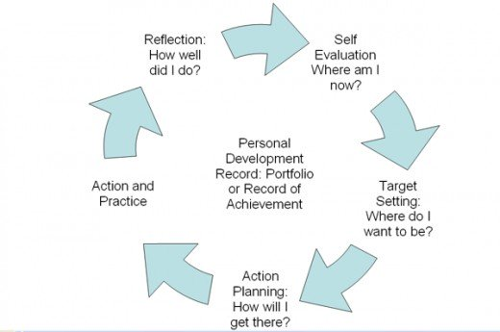

Plan-B Job
Making sure that I have a plan B is also one of my objectives, so I have something to fall back on and something that I enjoy too. In recent years I have trained and qualified in the hair and beauty industry, hence I am a beautician. My Plan-B job is, that for whatever reason I cannot get to my preferred job, I can always turn to the beauty therapy industry, and this is something that I enjoy and can do independently (self-employed).
These days many professionals find that landing the job of their dreams is harder than what they anticipated. By having a Plan-B job, they can make the best of an unstable economy with the skills they have and by downsizing, it could be more rewarding than their previous job. They may have a decrease in their wage, but the prospects for development and flexibility might be more. For a lot of Plan-B jobs, you may not need an any extra qualifications, but in either good or bad economy, it is essential to keep on gaining experience and skills to stay current and up to date within the work industry. (Buhl, 2020)


References
Buhl, L., 2020. If You're Finding It Harder To Land Your Dream Job, Learn How To Cast Your Net Wider To Snag A. [online] Monster Career Advice. Available at: <https://www.monster.com/career-advice/article/pursuing-a-planb-job-hot-jobs> [Accessed 2 April 2020].
Fitzpatrick, C., 2016. A Pilot Investigation Of Goffman’S Self-Presentation Theory As Applied To Linkedin | Response. [online] Responsejournal.net. Available at: <https://responsejournal.net/issue/2016-11/article/pilot-investigation-goffman’s-self-presentation-theory-applied-linkedin> [Accessed 1 April 2020].
Indeed.com. 2020. Curriculum Vitae (CV) Format Guide: Examples And Tips | Indeed.Com. [online] Available at: <https://www.indeed.com/career-advice/resumes-cover-letters/cv-format-guide> [Accessed 29 March 2020].
Jeffery's, N., 2019. Mock interview personal reflection. [online] Available at: <https://sites.psu.edu/nicolepjeffery/2019/04/04/mock-interview-personal-reflection> [Accessed 1 April 2020].
Kumar, M., 2016. How To Create A Personal Development Plan For Performance Reviews. [online] HubPages. Available at: <https://hubpages.com/business/How-to-Create-a-Personal-Development-Plan> [Accessed 2 April 2020].
López De Victoria, S., 2018. The Johari Window. [online] World of Psychology. Available at: <https://psychcentral.com/blog/the-johari-window/> [Accessed 19 March 2020].
Maund, A., Schriek, M. and Tinkler, P., 2017. Certificate In Higher Education: Skills For The Workplace Student Yearbook. 1st ed. London: SAGE, p.283.
Mindtools.com. 2020. SMART Goals: – How To Make Your Goals Achievable. [online] Available at: <https://www.mindtools.com/pages/article/smart-goals.htm> [Accessed 1 April 2020].
Morgan, P., 2017. Business Student's Guide To Study And Employability. 1st ed. Los Angeles: SAGE, p.29.
Morgan, P., 2017. Business Student's Guide To Study And Employability. 1st ed. Los Angeles: SAGE, p.33.
Morgan, P., 2017. Business Student's Guide To Study And Employability. 1st ed. Los Angeles: SAGE, p.367.
Pasteur, L., 2019. Personal SWOT Analysis: – Making The Most Of Your Talents And Opportunities. [online] Mindtools.com. Available at: <https://www.mindtools.com/pages/article/newTMC_05_1.htm> [Accessed 2 April 2020].

