- Define the term professional and explain what it means to be a ‘people professional.’ (AC 1.1) (2100 words)

A person who is qualified in their field of work and has the required experience and knowledge to finish their job is referred to as a "professional.". These experts might be connected to people who work in well-respected fields like law and nursing. A person with ambition and solid credentials can be regarded as a professional regardless of the sector they work in as long as they are fair and honest in their interactions with others.
In every industry, everyone plays an important position where they use their knowledge and abilities to represent their peers and serve the needs of the company. The CIPD profession map evaluates talents and enhances them as it includes the qualities required to be effective. People professionals take fairness, honesty, equality, and inclusion into consideration and value others.
“To take a fresh, critical look at people functions within the organisation, and encourages you to ask the difficult questions” (CIPD A, 2022)
When considering the term professional, one can see how behaviour has a significant impact on impacts and feelings. The outcome of a situation can be influenced by a person's behaviour, it's critical to be conscious of our actions and behaviour. The CIPD profession map stresses the importance of having solid, ethical principles that are consistent with an organization's vision and values. Ethical practise focuses on fostering confidence by setting an example of ethical behaviour and using those principles whenever making decisions. Professionals adhere to rules, ethics, and beliefs that may influence how they behave at work. A person will remember how you look, particularly if you are meeting them for the first time.
“The more someone identifies with their profession and its values, the more likely they are to demonstrate behaviours that are aligned with those professional values.” (CIPD B, 2017)
People will make sensible decisions if the right conditions are present. How a professional handle a person who is about to lose their job has a big influence on how that person responds to the news.

- Explore how the role of a people professional (either a generalist or a particular specialist) is evolving and the priorities this raises for continuing professional development (CPD) (AC 3.1).

The job of a people professional is constantly changing because of the growing diversity of both organizations and the workforce. The focus of the position has shifted from being more transferable to being more involved in corporate strategy. They must learn new skills and information if they want to stay current with trends and remain competitive. People specialists now work with management, involving staff in any changes' implementation, to successfully support and guide policies.
“Encompass multiple roles that support business results and implement talent strategies instead of focusing solely on managing employee benefits, policy development, and paperwork.” (Dessler, W 2019)
Continuous professional development facilitates updating of knowledge and skills and supports changing roles by assisting in the evaluation and documentation of all learnings. Filling in any knowledge gaps and making improvements require developing the required personal skills. CPD policy provides a means of setting up a schedule for learning with a goal in mind and producing a developmentally appropriate plan. By taking care of an employee's wellbeing and their lifecycle, the job has expanded to include additional areas like their lifecycle and more conduct-related work like grievances and investigations. With the development of technology this has been implemented within the role to enhance tasks and make work much smoother. “Digital transformation is an ongoing effort of aligning people, culture, structure, tasks and technology so that an organisation can thrive” (Mohdzaini, 2022) Since the pandemic, technology has made the job more efficient by enabling HR specialists to work independently and remotely. Making it possible for individuals to manage themselves in a professional manner virtually through disciplinary actions and investigations, enabling close working relationships and respect between employers.

- Discuss the concept of ‘ethical values’, and how at least three ethical values that you hold personally, impact (or could impact) on your work as a people professional. (AC 1.2)

Ethical principles look at how moral sensibility is applied to everyday decision-making. When decisions are backed by moral principles and logical thinking, people can make the lives of others better. One can develop confidence by consistently making decisions based on beliefs and values.
Consider looking at Deontological theory when examining ethical ideals and their potential to affect organizations, this theory uses rules to distinguish right from wrong, “at least some acts are morally obligatory regardless of their consequences for human welfare” (Britannica, 2018) This kind of ethical theory allows professionals to make decisions without considering the possible outcomes of their actions in addition to adhering to the rules, which is especially helpful in the healthcare sector, where physicians are urged to be honest with their patients, whether the information is positive or negative.
Professionals adhere to ethical principles, some of which include ethics, fairness, leadership, and honesty. As a professional my role includes upholding integrity and communication with colleagues. I make sure I have all the information I need from business systems and policies for the employees in every meeting. I can express my thoughts and opinions while being effective with the information I provide, which aids in my decision-making. My ability to conduct meetings and investigations truthfully and fairly influences my work. fostering positive connections because my colleagues trust my integrity.
I adhere to making sure I gain the respect of all my co-workers and peers by not only sharing information with them but also being able to support them when they need it and by being attentive to their worries. Enhancing our connection and making sure that my team members and the company I work for both hold me in high regard as a leader they can rely on.
Since I collaborate with people, honesty is a further ethical principle I uphold and consider to be similarly crucial. By assisting my co-workers and cooperating with them, I develop good working relationships that produce a positive work environment. Whilst also keeping my colleagues informed, I make them feel trusted since they know their concerns will be handled fairly and openly addressed.

- Explain why it is essential for people professionals to contribute confidently to discussions, and ways of doing this that are (AC 1.3):
- informed
- clear
- engaging.

One main behaviour shared by people professionals is the capability to persuade others, and by adhering to the codes of ethics, speak up in an informed manner. When you look at the profession map it is about the behaviours and knowledge that impacts work and being future fit.
“The Profession Map enables you to take a fresh, critical look at people functions within the organisation, and encourages you to ask the difficult questions” (CIPD B, 2017)
Being a professional entail having meaningful conversations which can influence for a variety of reasons. The success of these conversations depends on how well you express yourself; it is how you persuade others to act morally. People professionals make more informed choices by sharing their insight and expertise. “The ‘fairness’ lens considers that everyone should be able to agree to a decision regardless of their place in an organisation” (CIPD, 2019)
Another way people profession contribute can be done through being the specialists needed to possess critical thinking, effective communication, and relationship-building, that enable them to influence others and contribute confidently to discussions. All people professionals follow the code of conduct in any organisations allowing role modelling and honesty and professionalism to be followed. The consequence for this not followed can lead to someone unable to speak up when being bullied or when something ethically wrong is occurring. By being aware of how different influencing and communication strategies affect meetings, as well as how to use body language and speech tone to engage the audience.
When we look at the Betaris box, this model helps us understand the impact our emotions and behaviours have on those around us. “The mood affects our frame of mind, and it plays a vital role in our behaviour towards other people.” (Bhasin, 2020)

- Discuss when and how to raise concerns when issues such as organisational policies or leadership approaches conflict with ethical values or legislation. (AC 1.4)

The best moment and approach for raising an ethical issue at work depend on the organization's policies and interpersonal dynamics. Any workplace with issues that contravene legal requirements and moral standards has a serious issue. It is critical to understand how to approach this while upholding both your own ethical standards and standards of the organisation.
It's important to make it apparent which set of moral principles you're bringing up when bringing up an ethical conflict. You can determine the best course of action by applying the eight ethical views of fairness, merit, markets, democracy, wellbeing, right and duties, character, and handing down to any decision-making process.
Most companies have policies in place that can help colleagues raise concerns. Tesco as an organisation whose code of conduct is in place that helps colleagues feel safe. Colleagues can call protector line which allows them to voice concerns, anonymously if they feel unable to speak to their line manager, however you might not always be able to stop someone from acting unethically. “Doing the right thing ensures that we do not compromise ourselves or the business by our actions” (Tesco PLC, n.d.)
When thinking of ethical values, it is sometime hard to speak up as this can cause more issues resulting in an individual’s work being affected, for example when a store manager is bullying one of their line managers. In this situation it is hard to want to speak up as the person is higher up and if they found out, could make work harder. According to Taylor and Woodhams (2022) explains that organisational standards and codes that are violated and depart from what is right and wrong are more complex, and that based on how you approach the issue, you can identify the type of ethical conflicts that are present. On paper it’s easier to complain than it is in person, by putting that complaint in you can’t be sure if the bullying will stop or if it will get worse when all past complaints have not been dealt with. It raises concerns and ethical dilemmas on what is right and what is wrong.

- Provide a robust argument for ethical people practice that is supported by academic theory and details both the business and human benefits of people at work feeling included, valued and fairly treated. (AC 2.1)

Organisations must ensure that employees feel valued, included, and treated equally. An inclusive workplace is one where everyone feels valued and at home, regardless of their origin, identity, or situation. By being fair and open has a large impact on motivation and employee engagement.
“Diversity recognises that everyone is different in a variety of visible and non-visible ways, and that those differences are to be recognised, respected, valued, promoted and celebrated.” (CIPD F, 2022)
The better cared for an employee is, the higher the level of job fulfilment rises with increased retention and decreased turnover, increased productivity, and increased efficacy at work, many different ideas have been developed to explain why it is important to value people at work. According to Maslow's Hierarchy of requirements, there are few basic requirements that must be met for people to function at their best. According to Mcloed, S (2007) The five stages of Maslow's hierarchy of needs, examine defiance requirements and growth needs. These include the need for self-actualization, respect, affection, and belonging, as well as physiological and safety needs. A person's needs become more pressing the longer they go without something. When there is a lack of something, a deficiency need arises, and when there is a desire to develop, a need for growth arises. Prior to those whose needs are higher up the hierarchy being satisfied, someone's lower-level needs must be addressed more.
The pandemic created several challenges for organisations and difficult decisions had to be made such as redundancies, and furloughing. To make sure they were as transparent procedures were followed when dealing with this new workforce of remote workers who conducted investigations, handled disciplinary’s and filed grievances online.
According to Herbergs motivation two factor theory, hygiene factors and motivators are two key factors that affect employee happiness. Motivation factors are a part of job satisfaction and according to Herzberg he looked at 14. According to Nickerson, C (2021) The top six of these 14 are: achievement, responsibility, advancement, the nature of the job itself, and potential for growth. He claimed that the use of these motivators in the workplace results in employment satisfaction.

- Drawing on your own or a hypothetical example of providing a people practice solution to meet a particular need or introducing a new policy or initiative, describe:
- strategies for designing the solution/initiative so that it will be inclusive
- strategies for checking that, when in practice, the solution/initiative engages and meets the needs of all those it is aimed at. (AC 2.2)

When developing a new hybrid working policy, I would take inclusivity into account, ensuring that all pertinent parties have a voice and can concur on the best course of action. By collecting truthful input using an online survey, the best course of action can be determined. Co-workers could then respond openly about how they would feel about hybrid working, enabling them to collaborate on the ideas put forth and making it possible to collect a lot of information that could be shared with stakeholders aiding in the collaboration of the policy. Individual conversations with those who the new policy would impact would aid in putting the change into practice and aid in swaying their opinions to make the change work. For this approach to be successful, an organization's highest levels must make a commitment to inclusivity. To achieve, it is necessary to develop policies and practises that promote inclusion and set up training programmes that harmonise inclusion with organisational values.
When thinking of rotten apples technique, it is especially important in how ethically people behave as this will have a large impact on others and whether this is successful. For something new to be set up it is important to engage colleagues positively reducing their fear and frustration as they are less likely to act if their fear is reduced.
Prosci Methodology, follows the three phases to ensure the success of the policy. The model looks at success on a higher level. In these 3 phases of prepare approach, manage change, and sustain outcomes, by reviewing performance and sustain it we can make the change positively. By consulting employees after the policy is implemented can consider their input to see if hybrid working will be difficult. When conducting feedback, it is important to look at how the policy meets the needs, thinking about theory rotten apples consider those that sit under dark triad. Their personality are linked to unethical behaviour and have an impact on others. “Employees are also more likely to behave unethically if they are highly egocentric” (CIPD M, 2019)

Task two
ACTIVITY 1 (AC 2.3, AC 3.2). Using a range of information, including feedback from others, assess your practice against the FIVE CIPD Profession Map core behaviours listed below. The 5 core behaviours (all to be selected at associate level) are:

- Ethical Practice
- Professional Courage and Influence
- Valuing People
- Working Inclusively
- Passion for Learning

My associate level self-evaluation against the five essential core behaviours of the CIPD Profession Map is presented in the ensuing appendices, Ethical Practice, Professional Courage, and influence, valuing people, working inclusively and passion for learning. By handing out 360 forms to store manager, four managers and four colleagues I was able to gain some insight into my learning and development within my role. By respecting people as unique beings and actively searching out and listening to different points of view. I wanted a variety of feedback from my colleagues to see how I am as a manager but also from my piers to see how they see me as a manager.
I am able to complete these self-assessments using the CIPD self-assessment tool on the learning centre and create a strong plan for what to learn and how to improve by basing my answers on how I saw myself in my position and where I would like to improve.

Appendix 1

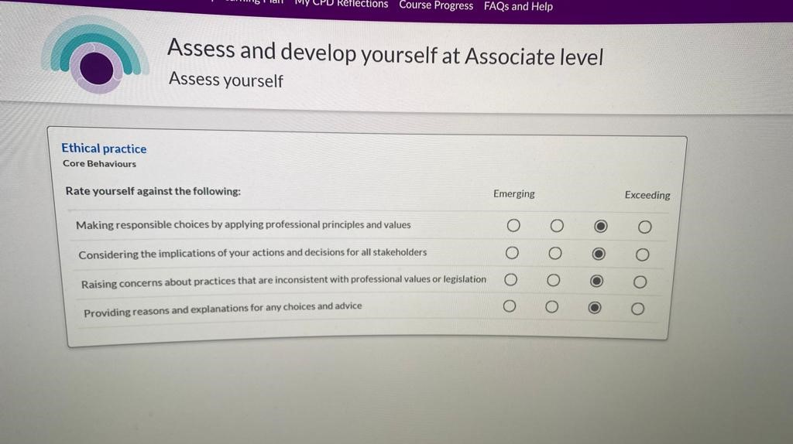

Appendix 2

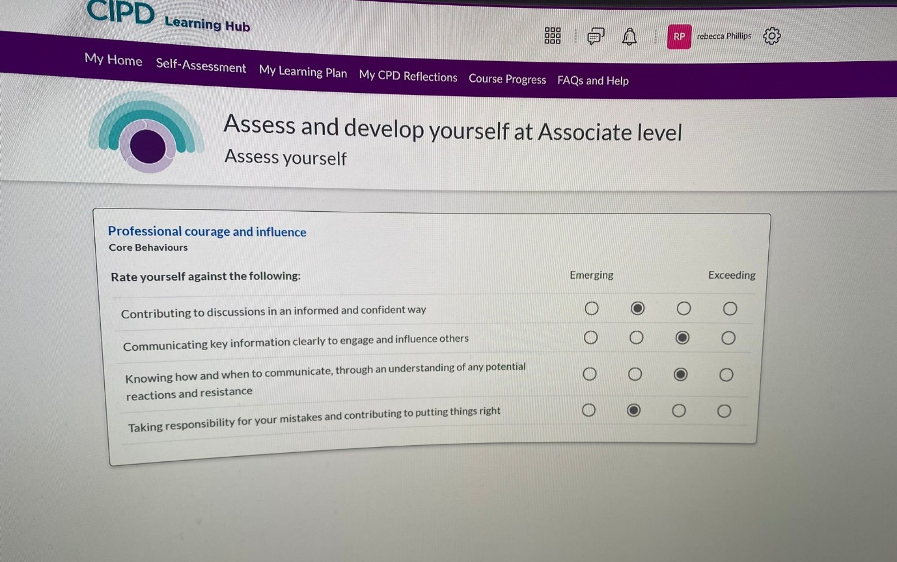

Appendix 3

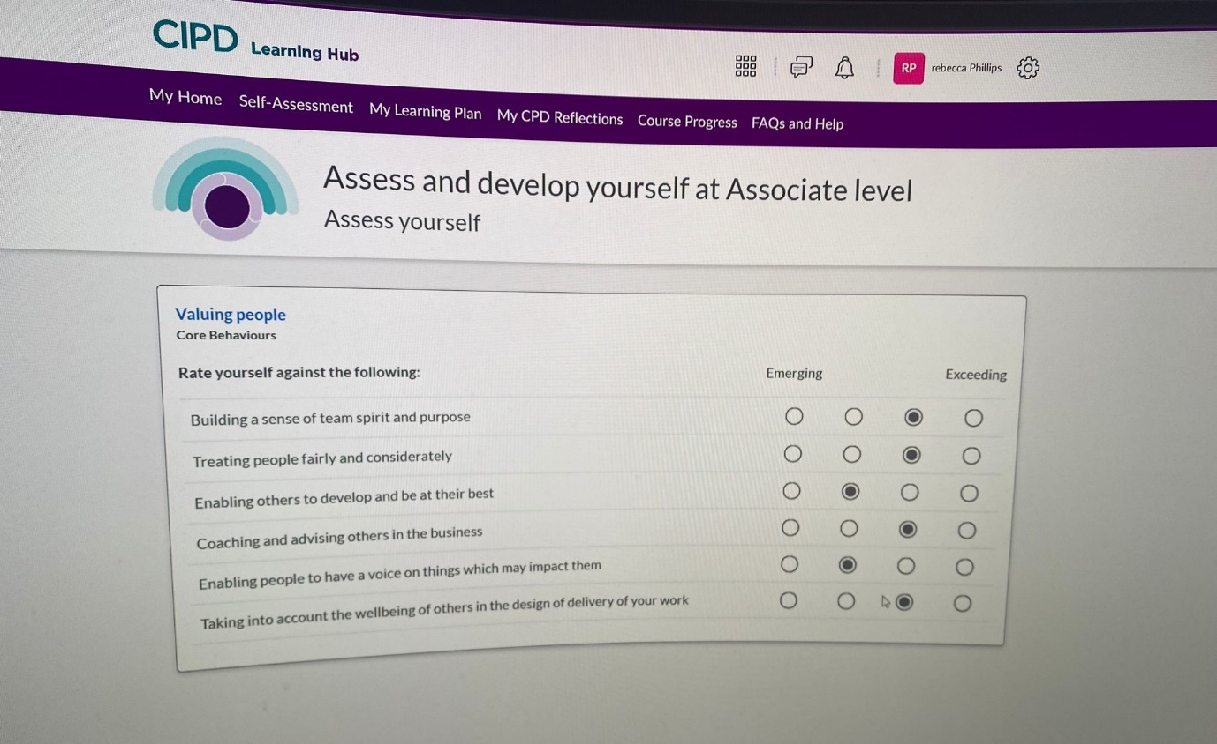

Appendix 4

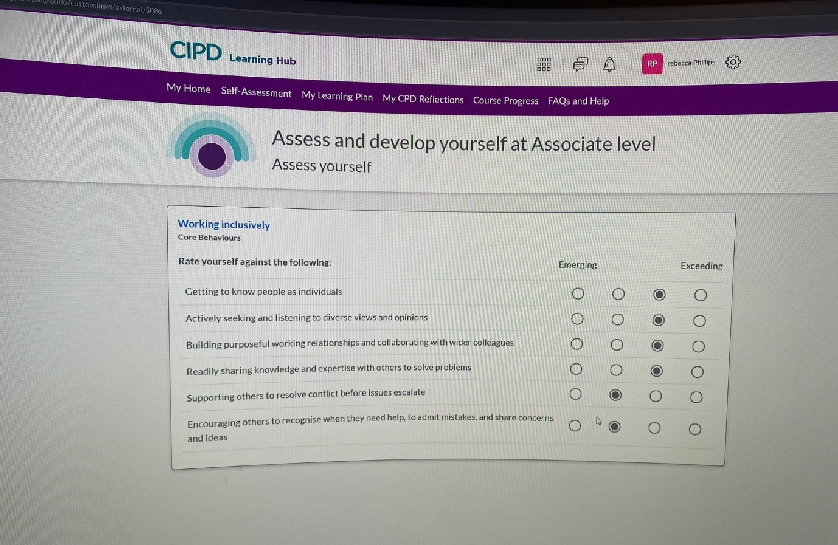

Appendix 5

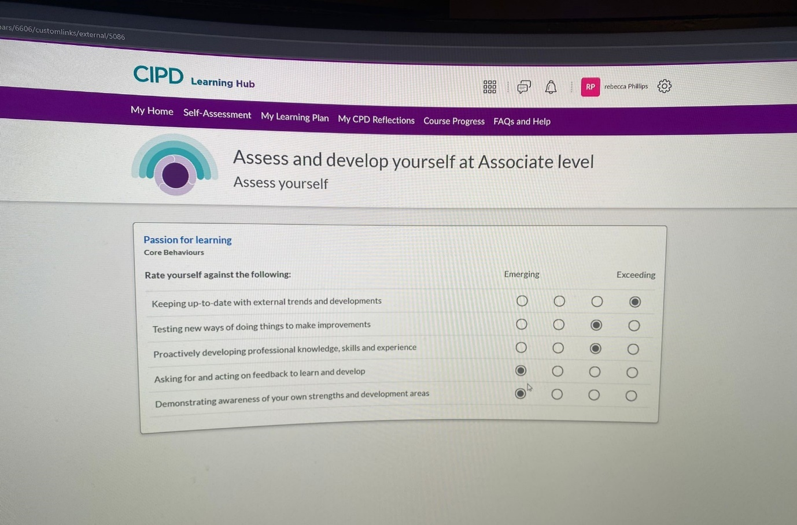

ACTIVITY 2 (AC 3.3) Having identified your main development needs in relation to these five areas, formulate appropriate development activities to meet these needs and add these to your professional development/learning plan.

The best way to comprehend any training requirements is to pinpoint areas of weakness and develop goals to support and help with ones learning plan.
“(L&D) needs starts with knowing the organisation’s current and future capability needs, and then assessing existing levels of skills, attitudes and knowledge” (CIPD N, 2020)
There are several criticisms of focusing on one's weaknesses that can have a significant effect on their development, such as productivity and constructive criticism. It can be argued that it is much better to concentrate on our strengths and develop them rather than on our weaknesses. “Focus on one thing at a time so the recipient can process the message” (Mathers, 2020)
With this in mind I wanted to carefully consider the recommendations from my self-assessment in order to create a learning plan that not only looked into the five CIPD core behaviours but also followed both formal and informal paths to my learning, as shown in appendices 1 and 2. By following the six stages of the CPD cycle—identify and plan, act, reflect, apply, share, and impact—I was able to make the appropriate goals and plans.
Taken the feedback from my peers and the CIPD assessment recommendations, The Johari Window model was the best theory that I found to help me better understand who I am and what the best course of action was. The purpose of this paradigm is to improve self-understanding and raise self-awareness. by opening and transitioning from your hidden self to your open self. As Hampson, S (2021) stated this model has the benefits to have an individual gain some self-awareness and help boost relationships.
As can be seen in appendices three through eight, I selected these subjects for the formal self-reflection to better organize my training sessions' learning and to use the CIPD workbooks and tools to advance my goals. I considered more flexible training techniques, like reading recommended literature to learn, some thought.

Appendix 1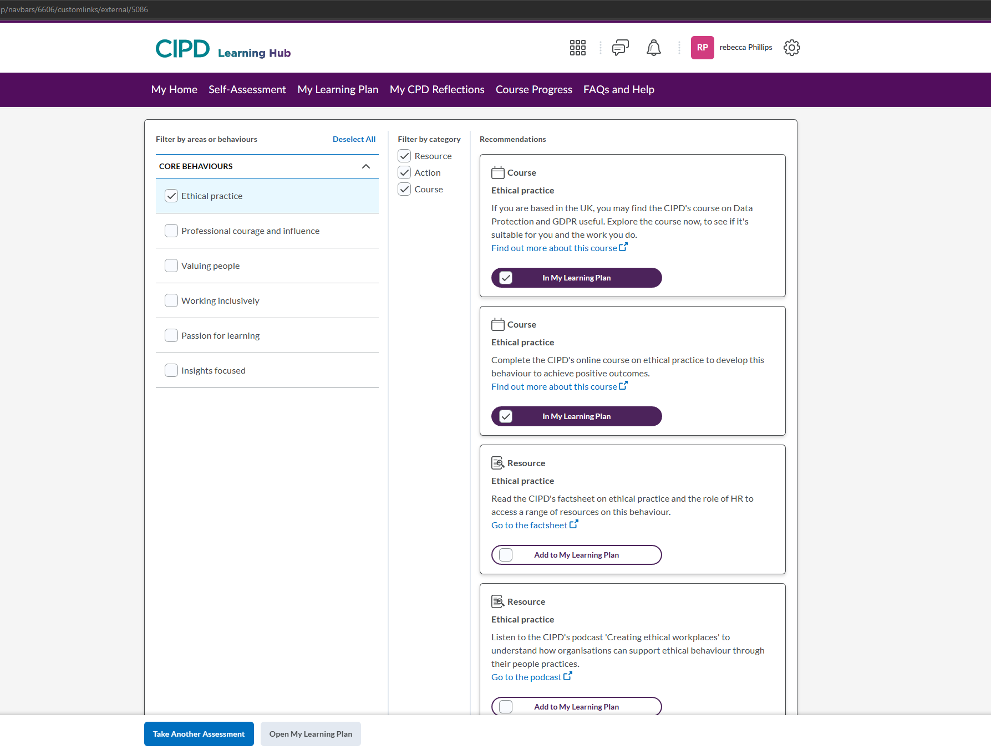

Appendix 2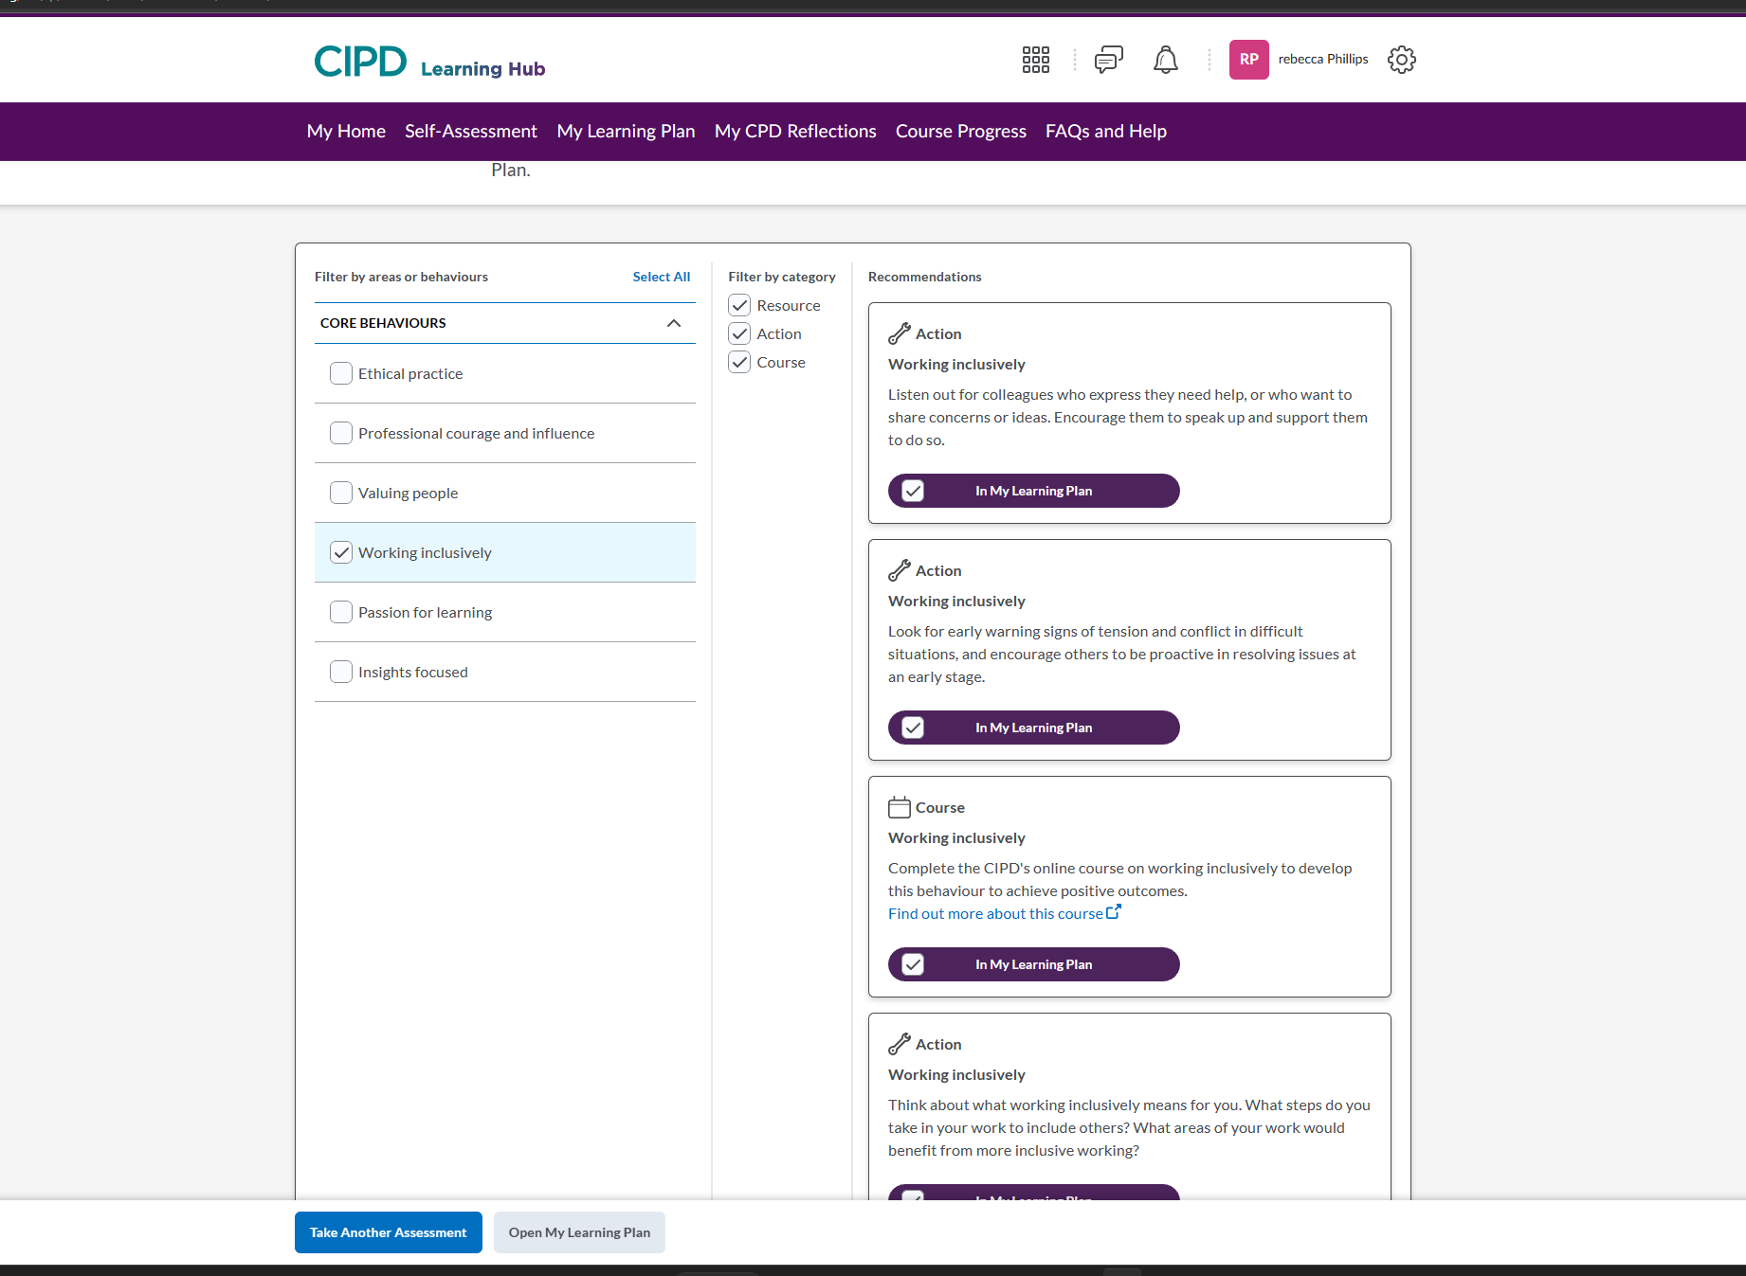

Appendix 3
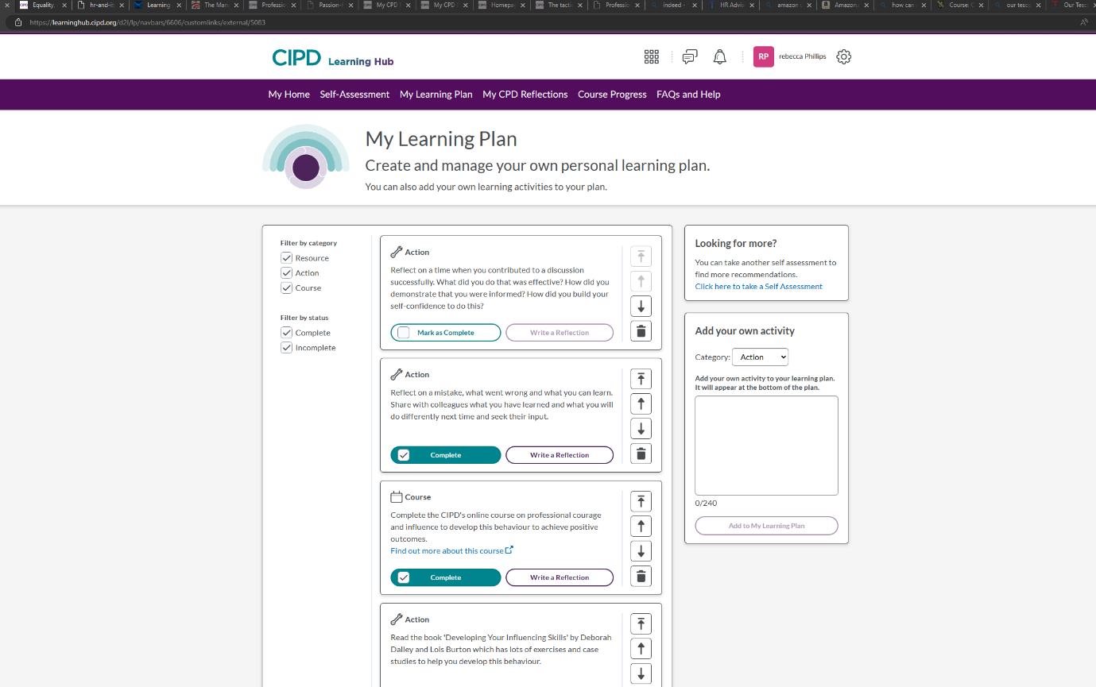

Appendix 4
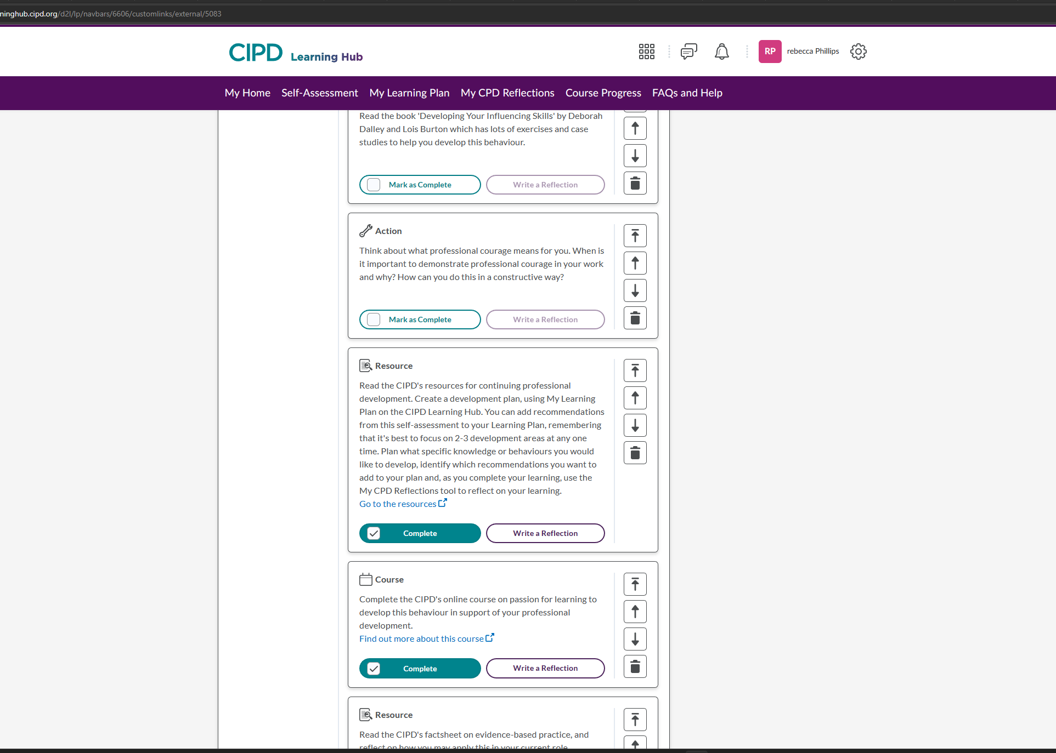

Appendix 5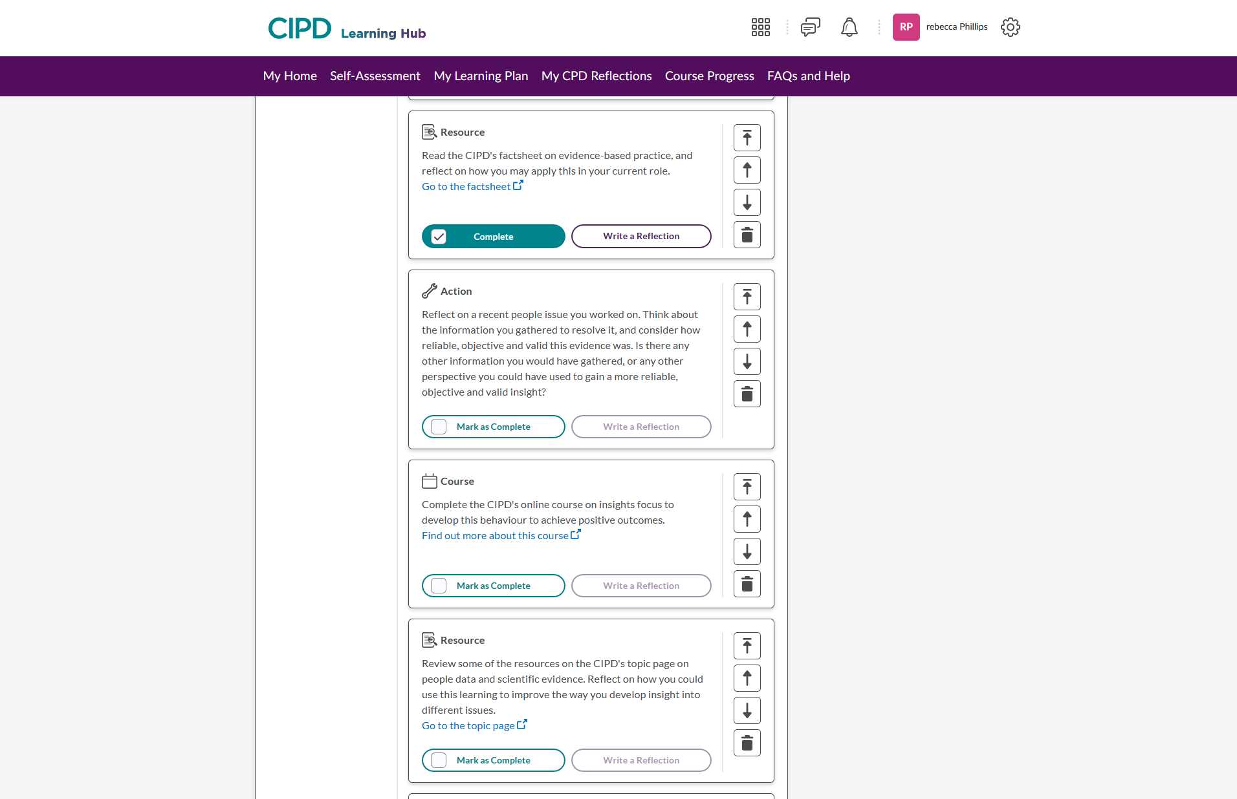
Appendix 6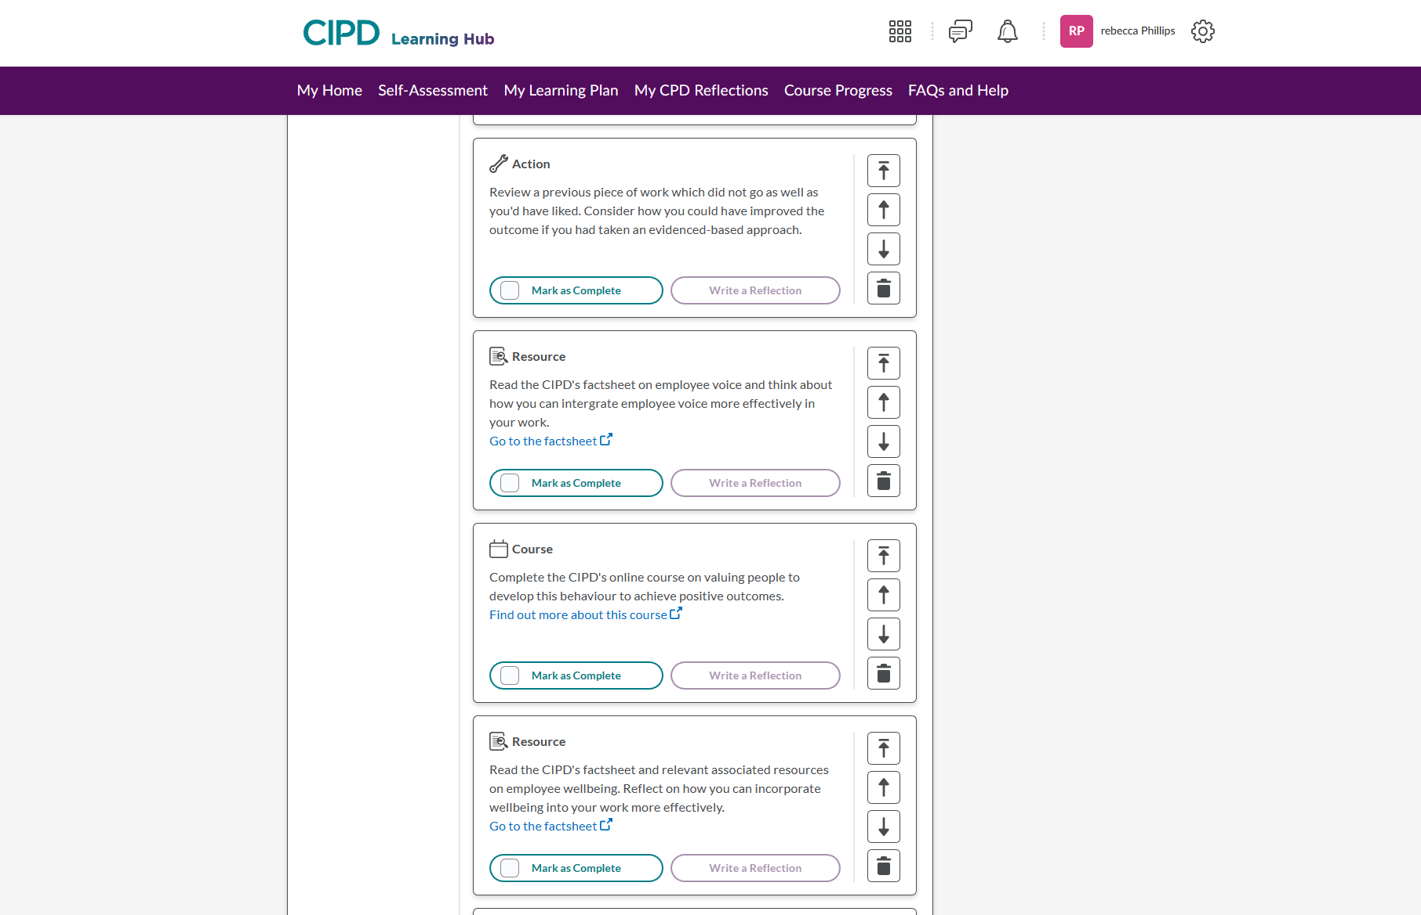

Appendix 7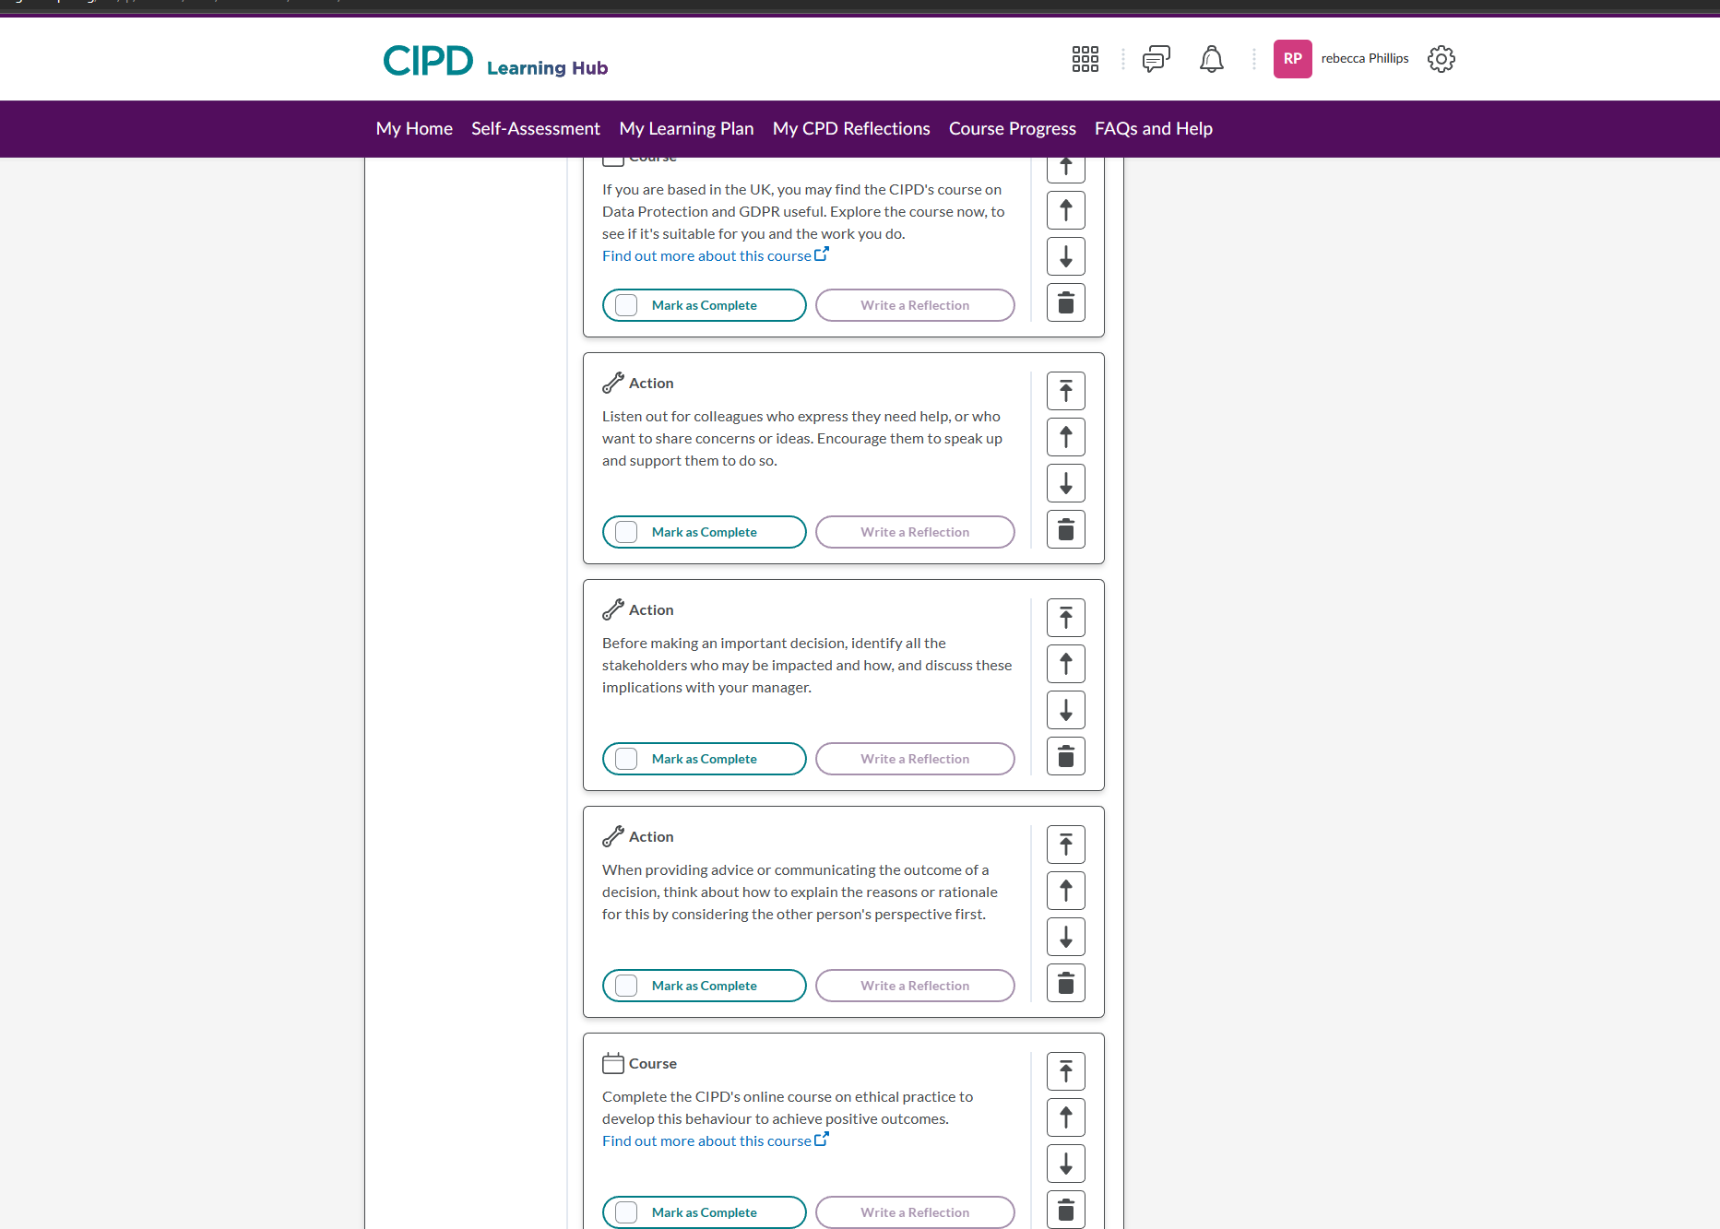

Appendix 8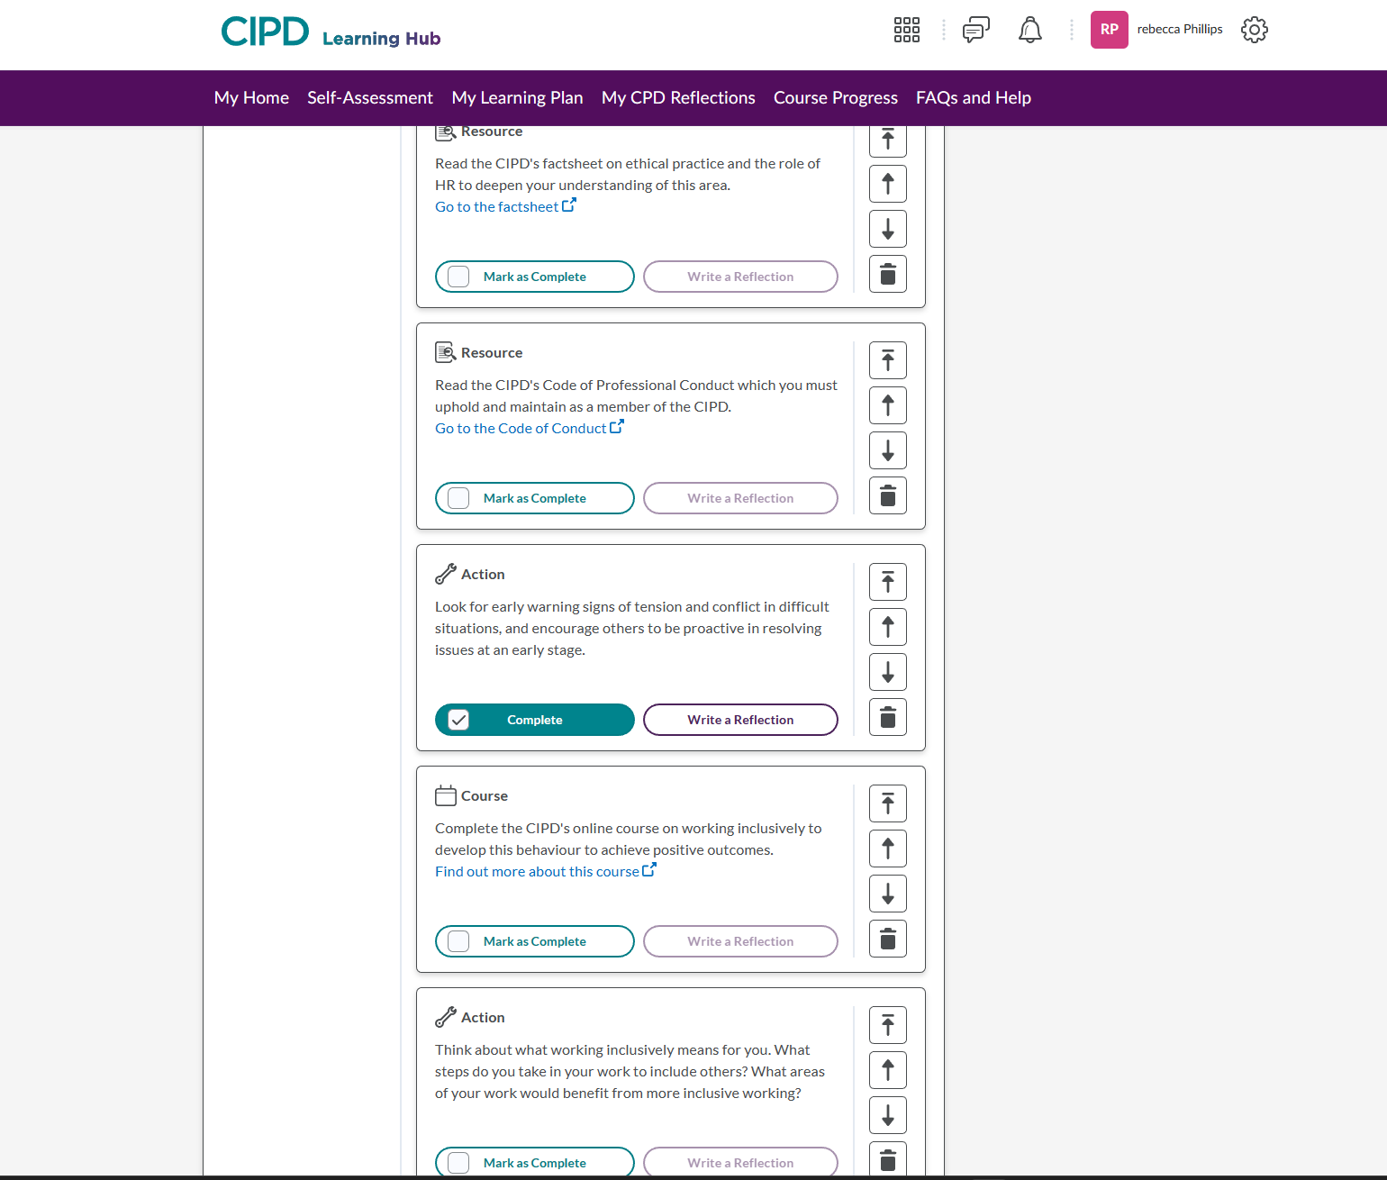
ACTIVITY 3 (AC 3.4) A key element of CPD is reflecting on the impact of our learning, so that we can make further decisions about how to progress. Select three formal or informal development activities you have undertaken over the last 12 months and reflect on how each of these activities has impacted your behaviour and performance. (Consider how effective the activity has been and the extent of its impact. You might also consider what new needs or action points the activity raised for you.)
My goals and learnings influence who I am as a person people and how I shape my career; how these concepts are handled, and the methods used aids in my personal development.
“(CPD) is a combination of approaches, ideas and techniques that will help you manage your own learning and growth” (CIPD H, 2021)
These goals can prepare a person for more responsibility, by keeping up with the latest information and skills by developing the proper CPD. When reflecting on one's training, one should evaluate one's thoughts and behaviours in order to further one's own learning and development.
“It is a set of ideas that can be used alongside many other concepts for training, learning, personal development, and self-improvement.” (BusinessBalls, 2001)
Reflect on past learnings situations and development helps shape where a person sees themselves in the future. Considering what I have discovered about myself through feedback and personal development has assisted in the creation of the tasks to enhance my performance and behaviour. By using a 360-degree feedback forms, which can be seen in appendix A, to help with my self-assessment on CIPD website, I was able to use the reflective practise concept of self-assessment and get the evidence I needed to create my own self-evaluation to expand my ideas and adapt my own personal purpose for a personal development plan. I made the decision to group my comments together and asked my store manager, four other managers, and four team members for feedback on how they perceived me as a boss and a colleague. I compiled the data into a single, comprehensive table to develop a CPD that would best support my performance and goals; the result is shown in Appendix B.
The Gibbs Reflective Cycle, which emphasizes own experience and how it influences how you analyse what happened and decide what you can do going forward, will be the tool utilized to satisfy the requirement and demonstrate how one can participate in progress.
“It offers a framework for examining experiences, and given its cyclic nature lends itself particularly well to repeated experiences, allowing you to learn and plan from things that either went well or didn’t go well” (The University of Edinburgh, 2020)
I can draw the conclusion that using the feedback provided, I can evaluate a broader description of myself by using the six steps of the description, emotions, evaluation, analysis, conclusion, and action plan.
Most of the comments demonstrates my abilities, and how I am skilled with computers, am knowledgeable about my job, and am very helpful to others, but there are three major development activities that I still need to work on. The reflection records displayed in appendix 1-3 are these.
The feedback and my self-evaluation revealed three areas of vulnerability. The first reflection focused on the time I spent with my staff; I received feedback from co-workers who felt underappreciated and learned that a specific staff member was to blame for the poor performance outcomes. I spent a few hours a week working shoulder to shoulder with each staff member on their areas to see how they performed their roles, observe how they were, and determine if there were any areas of concern to support their claims and examine the rationale. After spending time with them, I had one-on-one conversations with each of them to provide feedback on their performance and identify any ability gaps. By doing this, I was able to improve communication with my team, give top performers a sense of worth, and let others know that something was going on.
The second piece of feedback I got concerned my high level of productivity, which occasionally came at the expense of other areas of output. Although I am a strong leader with my team and am always willing to assist my peers when they ask, I lack the confidence to speak up and say no, which has an impact on my workload. I have considered this input, reflected on my lessons learned, and asked the senior team for coaching. Building on my personal development plan, I am able to see how my shortcomings don't just make my workload heavier but also show that I am a respected member of the community. However, I must have faith in myself to know when to say no.
The third thing that I have been working on considering feedback is the fact that in meetings I don't argue or take criticism well, even though it's not always my problem. Even though I am excellent at soliciting advice, I often choose not to heed it and disregard the suggestions made. It has taught me that to advance and improve in my job, I must strive to boost my self-assurance and work with my manager to get their input.

Appendix A

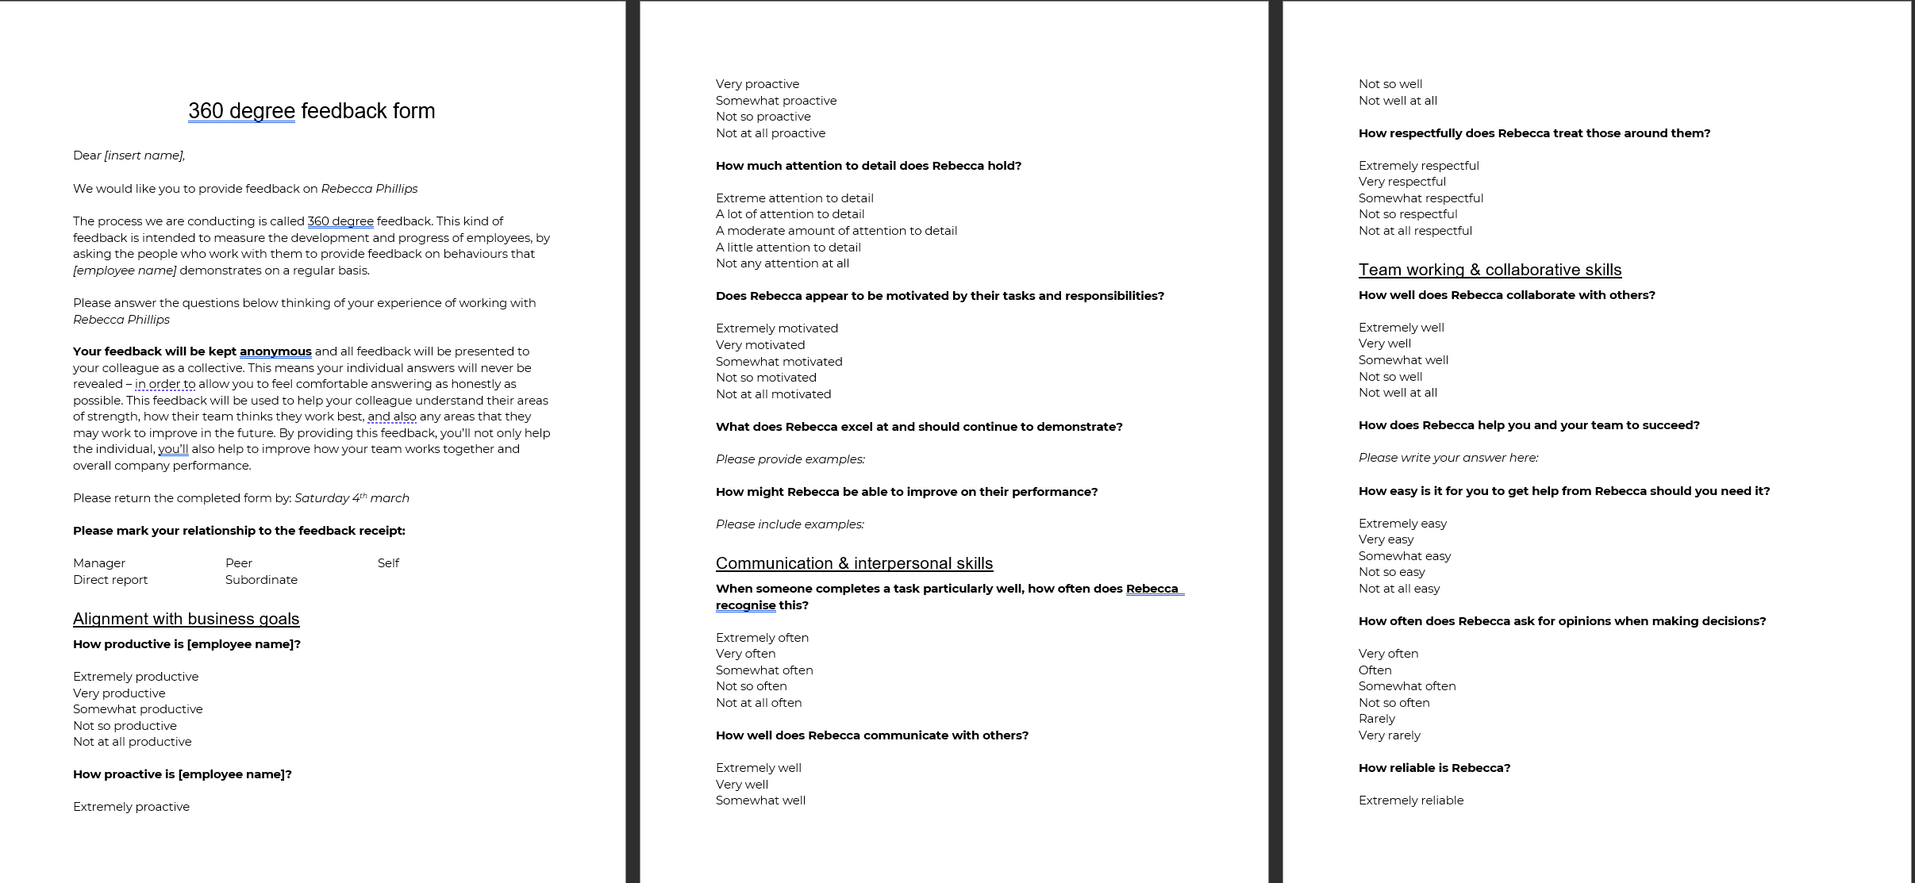

Appendix B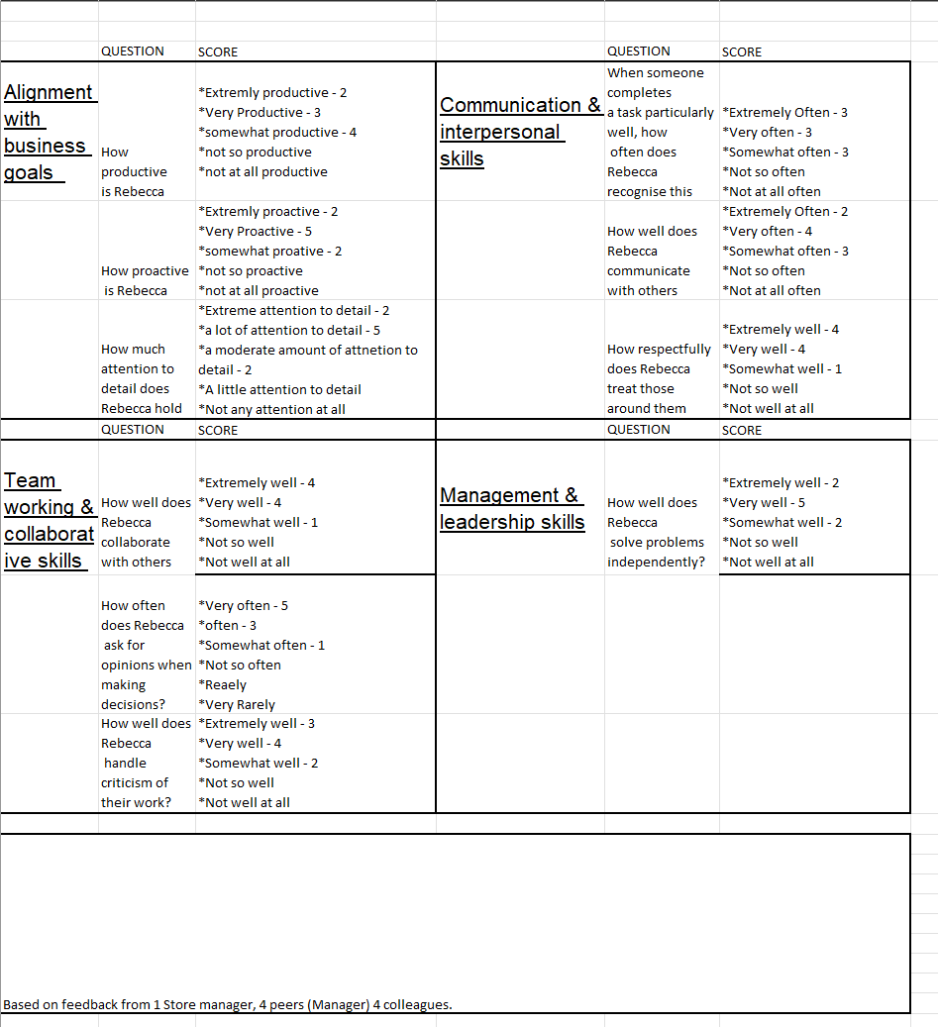

Appendix 1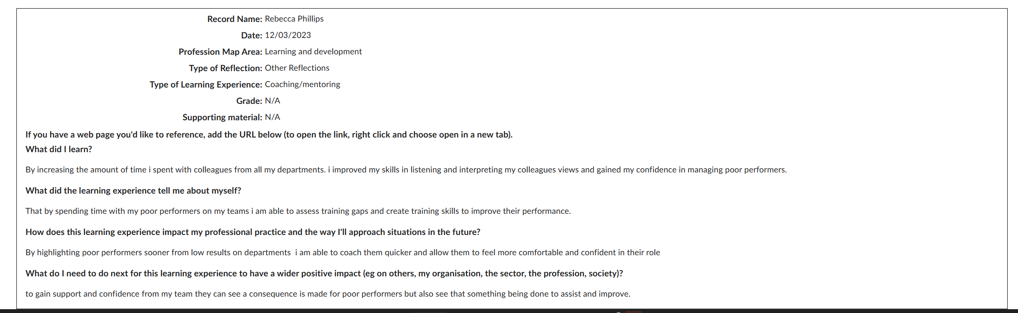

Appendix 2
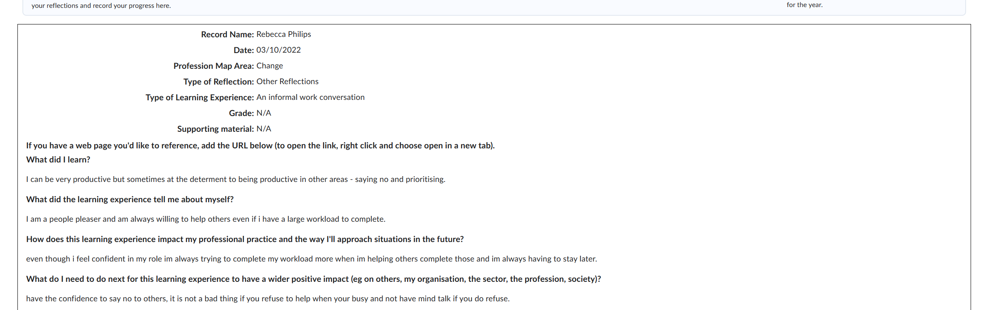

Appendix 3
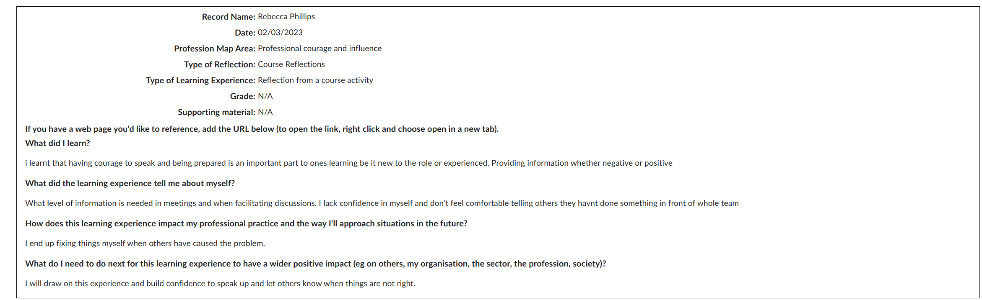

Bibliography
Bhasin, H. (2020). What is Betari Box Model and How to Break the Cycle of Conflict. [online] Marketing91. Available at: https://www.marketing91.com/betari-box/ [Accessed 26 Feb. 2023].
Britannica (2018). deontological ethics. In: Encyclopædia Britannica. [online] Available at: https://www.britannica.com/topic/deontological-ethics [Accessed 10 Mar. 2023].
BusinessBalls (2001). Reflective practice. [online] Businessballs.com. Available at: https://www.businessballs.com/self-awareness/reflective-practice/ [Accessed 5 Mar. 2023].
Cambridge International Education Teaching and Learning Team (2019). Getting Started with Reflective Practice. [online] Cambridge Community. Available at: https://www.cambridge-community.org.uk/professional-development/gswrp/index.html [Accessed 6 Mar. 2023].
CIPD (2019). Ethical Practice and the Role of HR | Factsheets | CIPD. [online] CIPD. Available at: https://www.cipd.co.uk/knowledge/culture/ethics/role-hr-factsheet#23816 [Accessed 19 Feb. 2023].
CIPD A (2022). New Profession Map | CIPD Profession Map. [online] CIPD Profession for the Future. Available at: https://peopleprofession.cipd.org/profession-map [Accessed 19 Feb. 2023].
CIPD B (2017). professionalism: what do we stand for? [online] Available at: https://www.cipd.co.uk/Images/professional-identity-research-report-updatedPFFMay20_tcm18-17960.pdf [Accessed 19 Feb. 2023].
CIPD C (2020). Why we call it the people profession | CIPD. [online] CIPD People Profession. Available at: https://peopleprofession.cipd.org/insights/articles/why-people-profession [Accessed 19 Feb. 2023].
CIPD D (2019). Professional courage and influence | CIPD Profession Map. [online] CIPD Profession for the Future. Available at: https://peopleprofession.cipd.org/profession-map/core-behaviours/professional-courage-influence [Accessed 26 Feb. 2023].
CIPD E (2020). Managing conflict in the modern workplace REPORT |. [online] CIPD. Available at: https://www.cipd.co.uk/Images/managing-conflict-in-the-workplace-2_tcm18-70655.pdf [Accessed 26 Feb. 2023].
CIPD F (2022). Diversity and Inclusion in the Workplace | Factsheets | CIPD. [online] CIPD. Available at: https://www.cipd.co.uk/knowledge/fundamentals/relations/diversity/factsheet [Accessed 27 Feb. 2023].
CIPD G (2022). CPD Cycle Stages. [online] CIPD. Available at: https://www.cipd.co.uk/learn/cpd/cycle#gref [Accessed 5 Mar. 2023].
CIPD H (2021). What is Continuing Professional Development (CPD) | CIPD. [online] CIPD. Available at: https://www.cipd.co.uk/learn/cpd/about [Accessed 5 Mar. 2023].
CIPD J (2019). Understanding and tackling the causes of unethical behaviour in the workplace | Reports | CIPD. [online] CIPD. Available at: https://www.cipd.co.uk/knowledge/culture/ethics/ethical-behaviour [Accessed 9 Mar. 2023].
CIPD K (2019). People practice | CIPD Profession Map. [online] CIPD Profession for the Future. Available at: https://peopleprofession.cipd.org/profession-map/core-knowledge/people-practice [Accessed 8 Mar. 2023].
CIPD L (2022). Planning for hybrid working. [online] CIPD. Available at: https://www.cipd.co.uk/knowledge/fundamentals/relations/flexible-working/planning-hybrid-working [Accessed 9 Mar. 2023].
CIPD M (2019). ROTTEN APPLES, BAD BARRELS AND STICKY SITUATIONS An evidence review of unethical workplace behaviour. [online] Available at: https://www.cipd.co.uk/Images/unethical-behaviour-in-the-workplace_report-2_tcm18-57022.pdf [Accessed 9 Mar. 2023].
CIPD N (2020). Identifying Learning & Development Needs | Factsheets | CIPD. [online] CIPD. Available at: https://www.cipd.co.uk/knowledge/fundamentals/people/development/learning-needs-factsheet [Accessed 12 Mar. 2023].
CPD News Team (2020). Why CPD is important for HR Professionals - News | The CPD Certification Service. [online] cpduk.co.uk. Available at: https://cpduk.co.uk/news/why-cpd-is-important-hr-professionals-human-resources [Accessed 10 Mar. 2023].
Dessler, W. (2019). How the Role of HR Professionals Is Evolving. [online] Cayenne Consulting. Available at: https://www.caycon.com/blog/how-the-role-of-hr-professionals-is-evolving [Accessed 7 Mar. 2023].
EPM (2017). Equity theory – keeping employees motivated. [online] Expert Program Management. Available at: https://expertprogrammanagement.com/2017/06/equity-theory/ [Accessed 24 Feb. 2023].
Green, M., Peters, R. and Young, J. (2020). People Profession 2030 A collective view of future trends. CIPD.
Hailey, V., Carter, J. and Jacobs, K. (2022). Has COVID-19 changed responsible business forever? [online] CIPD. Available at: https://www.cipd.co.uk/news-views/changing-work-views/future-work/thought-pieces/has-covid-changed-leadership [Accessed 27 Feb. 2023].
Hampson, S. (2021). The Johari Window model: How to improve communication and productivity at work. [online] www.tsw.co.uk. Available at: https://www.tsw.co.uk/blog/leadership-and-management/the-johari-window/ [Accessed 5 Mar. 2023].
Mathers, C. (2020). 9 Constructive Criticism Examples for Your Workplace. [online] Develop Good Habits. Available at: https://www.developgoodhabits.com/constructive-criticism-examples/ [Accessed 12 Mar. 2023].
McCombs School of Business (2019). Deontology. [online] Ethics Unwrapped. Available at: https://ethicsunwrapped.utexas.edu/glossary/deontology [Accessed 24 Feb. 2023].
McLeod, S. (2022). Maslow’s Hierarchy of Needs. [online] Simply Psychology. Available at: https://www.simplypsychology.org/maslow.html [Accessed 27 Feb. 2023].

Mcleod, S. (2023). [Kolb’s Learning Styles and Experiential Learning Cycle]. www.simplypsychology.org. [online] Available at: https://simplypsychology.org/learning-kolb.html [Accessed 5 Mar. 2023].
Mohdzaini, H. (2022). Redefining the role of people professionals in the digital era. [online] CIPD. Available at: https://www.cipd.co.uk/knowledge/work/technology/digital-transformation-insights/people-professionals-digital-era [Accessed 7 Mar. 2023].
Nickerson, C. (2021). Herzberg’s motivation theory (two-factor theory). [online] Simply Psychology. Available at: https://www.simplypsychology.org/herzbergs-two-factor-theory.html [Accessed 27 Feb. 2023].
Prosci (2021). Prosci Methodology. [online] www.prosci.com. Available at: https://www.prosci.com/resources/articles/prosci-methodology [Accessed 9 Mar. 2023].
Sharp, R. (2019). HR Magazine - Ethics and HR. [online] HR Magazine. Available at: https://www.hrmagazine.co.uk/content/features/ethics-and-hr/ [Accessed 24 Feb. 2023].
Simon, B. (2016). What Is Stakeholder Theory? | Smartsheet. [online] Smartsheet. Available at: https://www.smartsheet.com/what-stakeholder-theory-and-how-does-it-impact-organization [Accessed 24 Feb. 2023].
TAYLOR, S.W., CAROL (2022a). STUDYING HUMAN RESOURCE MANAGEMENT a guide to the study, context and practice of hr. third edition ed. [S.l.]: KOGAN PAGE.
Tesco PLC (n.d.). Our Code of Business Conduct. Contents. [online] Available at: https://www.tescoplc.com/media/756681/code-of-business-conduct.pdf [Accessed 26 Feb. 2023].
The University of Edinburgh (2020). Gibbs’ Reflective Cycle. [online] The University of Edinburgh. Available at: https://www.ed.ac.uk/reflection/reflectors-toolkit/reflecting-on-experience/gibbs-reflective-cycle [Accessed 5 Mar. 2023].
Tina Russell (2019). Ethical practice | CIPD Profession Map. [online] CIPD. Available at: https://peopleprofession.cipd.org/profession-map/core-behaviours/ethical-practice [Accessed 24 Feb. 2023].

