Understanding and Engaging in Customer
Experience

Module BMSW 5003
Student: Georgiana Florentina Andronache (1711205)
Lecturer: Charles Oham
Level 5: BA Leadership and Management (Skills for the Workplace)
Introduction:
The purpose of this assessment is to do a critically analyse and to identify the system that supports an organizations quality process and to provide a critical understanding on what systems are effective in meeting the customer requirements. This paper will be about the customer service, buyer seller relationship, managing customers expectations, buying decision making process: ethical considerations such as fair-trade, sustainable resources, customer value.
As an organization for my assessment I am going to write about the organization I am working for ‘’Sainsbury’s’’. In my assessment I will describe the organization, as in how it started and where is today, why Sainsbury’s is a good place to work and how it meets the customers requirements and also why in certain moments the company cannot satisfy all their customers expectation. The relationship between the organization and it’s customers, how should the customers be treated. In addition to all this will be how the company attracts the customers by analysing their profile with the help of their loyalty card. This paper will be based mainly on the store and my colleagues , it is a small store with a ‘’big personality’’.
At the end of this term and assessment I should be able to understand and demonstrate the ability to evidence a critical understanding about the workplace, analyse the customer experience and critically evaluate the benefits and the challenges within the organization.

Case study: Sainsbury’s,
All the information about Sainsbury’s in my assessment will come from my workplace, from my colleagues and managers and from my ‘’Sainsbury’s account’’ which all the Sainsbury’s staff have, there are information and also the Sainsbury’s history written by stakeholders.
Sainsbury’s opened their first store in London’ s Drury Lane ,having their 150th anniversary this year,( as part of their festivities Sainsbury’s gave free tea and biscuits to their customers), in 1869 by the owner John James Sainsbury and it’ s wife Mary Ann. The business flourished very quick due to their quality and popular products yet affordable and on offer. The years have past and by 1881 Sainsbury’s opened their third store and in 1882 they opened their first store outside of London ‘’walls’’ in Croydon .
In the mean time Sainsbury’s started to develop their own brand of food. Despite the business being successful the first challenges appeared with the ‘’First World War’’ in 1914, due to the shortage of male colleagues so they had recruit female colleagues. By 1918 there were 39 female branch managers. Due to the war rage the sugar was rationed by 1917 and 1918 the butter and many more products were rationed. Only by 1921 the food became free of restrictions and Sainsbury’s was able once again to take the cost of goods down for their customers.
As we all know in Sainsbury’s and many other shops we benefit the self-service which makes our lives as customers or staff easier and less busier in rush hours. The first self-service was introduced in 1950 in Croydon ,as the self-service become more common Sainsbury’s was able to produce more of their own brand products.
By the 1970 Sainsbury’s established itself as a truly national retailer, opening stores in Yorkshire and the North after expanding in Wales, North Ireland and Scotland. The business continued to innovate into the 80s and 90s by introducing recyclable bags and being one of the first to sell ‘’Fairtrade products ‘’. In the mean time the company opened their own clothing brand, bakery in-store and supermarket delicatessen. Also the computer checkout experiment was introduce followed by the discount operation.
By the 2000 the company has seen that during all these years and 432 stores later, decide to re-build the brand finding new ways to make shopping easier.
In addition to the fact that Sainsbury’s was and is a well know and appreciate brand they also started helping and involving with different non-profit charity organizations. In 2004 with Midland Trust, they have planted around two million trees. The business also looks after their customers by labelling all the nutritional value of the products. Also Sainsbury’s opened the first of six food colleges by2010, training around 18000 colleagues.
With other words Sainsbury’s made their way into ‘’the business world’’ and becoming the successful business that is today by working hard and giving the best of their services to the customers.

Customer service:
Organisations depends on their customers in order to be successful, this means that the organisation has to keep their customers satisfied. (Goodman, J. A.)
According to Abbott (1955. P. 40) and Alderson(1957) ‘’ what people really desire are not the products but satisfying experiences’’. My role at Sainsbury’s is as Services Assistant, the role I have within the company from the outside looks like an easy job but it can be a stressful and demanding job. The nature of the job is to assist the customers all the way with what they need and try to make their shopping experience as pleasant as it can be. However despite our efforts as a customer assistant you cannot please everyone, does not matter how much effort you put in. This duty is not just helping and making a pleasant shopping experience is about you as a member of staff to take the responsibility of being an adviser to your customer, to respond as better and polite to their inquiries and complaints. Due to the nature of this job a customer assistant is the first point of contact when a customers has a problem and is looking for solutions.
However as a customer assistant there are more factors to describe the job , handling money and being responsible of, helping customers to pick a good product as in quality and money wise, doing refunds when is needed. Moreover a customer assistant needs a set of skills in order to provide good services;
- communications skills
- people skills ; this type of skills is very important in this job as you have to make yourself pleasant and easily to get along with the customers.
- IT knowledge; as many services are done on computers
- Patient is also a very important skill in this job as you need to be calm in any situation and handle it professional
- Professionalism
- Working under pressure
- Being friendly. etc
Moreover we cannot all have these skills but we can easily improve and develop them at the job with the help of managers, colleagues and the training provided by the company. Training plays a very important role in this job as in any other jobs. By having your training done in time you can be on top of the newest needs and expectation of your customers. The customers are playing a very important role, that’s why we thrive to please and meet their expectations, without the customers to buy the products there is no such a successful business, as my managers says ‘’ the customers pays our wages’’, that’s why we have to do our best to meet their expectations.

Customer relationship management (CRM)
CRM is the process of managing aspects of interaction of the company with the customer. However is also a business strategy that helps maximizing the profit of the company , revenue and the customer satisfaction.
Business are also developing new ways of attracting customers, by their loyalty card, this is a way of getting to know the customer by analysing what they are buying and giving them discount. Sainsbury’s has their own card,’’ Nectar Card’’, this card can be used not only in the store but also in many other different brands, such as Argos, Europcar, Debenhams etc. The nectar card is not just a usual card where you get discount or money off to your favourite products, it also allows the customer to save money, for every 500 points the customer gets £2.50 to spend in store or at Argos. Our customers are very happy with the nectar card as is as way to save money and also add more points with each shopping trip they do.
CRM can also be used as a information system that it helps planning , schedule and control the pre-sales and post-sales within the organisation.(Buttle.2008, table 1.1)
There are many types of CRM:
- Strategic -is a customer-focusing business strategy that aims to win and keep profitable customers.
- Operational -is focusing on the customer services, selling and marketing.
- Analytical -is the intelligent mining data for strategic and tactical purpose regarding customers.
- Collaborative -is the technology that applies across organisational boundaries that has a goal to optimise the company and customer value.
(Buttle.2008, table 1.2)
However not all the customers can be treated the same way, as not all the customers are the same. This paper is related to a small store, the Sainsbury’s where I work is one of the small stores Sainsbury’s has, it is a store where you can find the basic items you need, yet there are no clothes or deli counters as the bigger stores have. This is an issue for some of our customers as they wish to find in our store their favourite items, but due to the size of the store there are items that are not ranged there. However there is a way to comply with our customers wishes when it comes to their clothes shopping from the ‘’TU’’ range, we have a click and collect point. Click and collect is a great strategy to keep our customers loyal and happy, they can order their favourite clothing online and came to the nearest store to collect their parcel. Yet at Sainsbury’s we do our best to keep our customers happy and show them how valuable are for us, this also includes the many times that a customer breaks the policy or by being aggressive with the staff. When things like that occur we were taught to react professional and to keep our calm, this is part of our training and part of the job.
A tool used in our store is the ‘’Customer Purchase Cycle’’, as learned during the class this is when a customers repeats their purchase and the services ad also to analyse the value of customer present and future purchase.

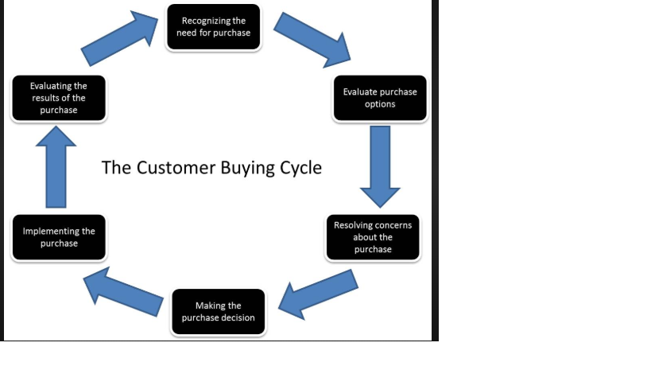

Customer value:
According to Kotler P., each organisation has to create a superior customer value, however in the mind of the customer the sense of value may be different from the business sense. The sustainability of a business depends on their customer satisfaction, that’s why is important to meet the customer expectation every time when possible as there are at heart of the business. As noticed in my lane of work when the customers gets full value they return and become loyal. Moreover when we listen and solve a query coming from the customer, by take it as a positive and constructive complaint the customer tends to be happy with the services and return to our store to do their shopping.
Having the maximum number of loyal customers is important for each business, Sainsbury’s is one of the oldest and popular stores with values such as being one of the most trusted retail across UK. In order to keep their customers happy and show their appreciation Sainsbury’s have a number of key factors playing an important role in the businesses success and this are Sainsbury’s values:
- Health- Sainsbury’s is contributing to the UN Global Goals, helping their customers to eat healthier and introducing healthy food with less sugar.
- Source- Sainsbury’s is working very closely with farmers around UK and internationally, this helps reducing poverty in the poorer countries by sourcing their products ethically
- Community – each store gets involved in food donation and volunteering
- Accessibility- at Sainsbury’s is important for the customer to get their desired product, that’s why there is always someone on the shop floor to help and deliver the best service
- Etiquette and friendliness – from experience the customer appreciate kindness and professionalism in the same time, is important for the customer to be treated with respect and a friendly attitude, this makes them to come back and to become loyal.
- Customer service- the customers likes to have an easy way to put their complaints in, at Sainsbury’s each complaint is taken as positive, this helps to improve the services
The customer is valued at Sainsbury’s as they are the ones that sustain the business and make it successful.
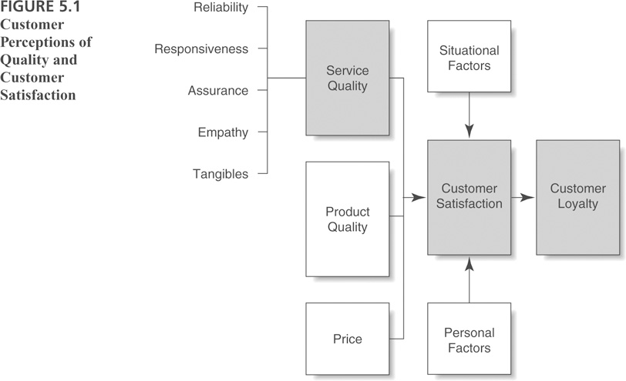
Buyer- seller relationship:
The connection link between the buyer and the seller is created by the customer value, as Vargo and Lusch (2011) agree that the customer value has been studied for many years. In addition Anderson and Narus (1998, 2004), add to this idea that the companies have to understand the customer value in order to perform better services for their customers. However each organisations built their relationship with their customer in different ways, as we have seen above Sainsbury’s customers are important that’s why they pay attention to details such as the community they are part of, the suppliers where they get the best products and many more.
Speaking of the community Sainsbury’s recently launched a new way to help and communicate with the people with hidden disabilities which they do not feel comfortable to speak about. This is called the ‘’Lanyard’’ , this is a symbol for hidden disabilities, this works like this: when a customer is approaching a member of staff wearing the lanyard symbol all we have to do is greeting them friendly and offer our services, also some members of the staff will be wearing the lanyard in order for the customers to see on whom they can rely by having the appropriate training for this type of ‘’mission’’. This helps Sainsbury’s to improve their relationship with the community and also gain more customers as they know they will be welcomed and always helped when needed, without telling us why they need our help. Sainsbury’s goals is to be the most trusted retailer, in this way we work hard to build a good relationship with our customers, to be one big family. However we cannot please all our customers, this is due to the size of the store where I am working, there cannot be many items ranged as there is no much space, this can be unpleasant for some of our customers because Sainsbury’s is the only supermarket in an area where they can walk, get the bus or a taxi and do not have to pay much for it. However there is home delivery service and customers can order their shopping at home. A good buyer-seller relationship is built in time and it takes passion for what we do, trust from both sides, the customers and us, and professionalism from both sides also.

Managing customer expectations:
Meirovich, G and Little, L., (2013) agree that understanding how to meet the customer expectations is long recognised in the market industry.
However in retail is hard to please everyone as everyday we get new customers in addition to the ones that are coming in daily. This paper is mainly based on the store I am working on, it is situated in a shopping centre, is the only supermarket in the area which means we do have our loyal customers. We aim to please everyone however this is hard, as all our customers are different, age, culture and the interest in the desired product. At our little store we will shortly be launching a new and quicker way to shop, this is called ‘’smart shopping’’, the customers will be able to scan their products while shopping with their mobile phones by downloading an applications. This is going to be a new innovation in our community and saving people queuing, will quicker and hopefully will please our customers by this easier way to shop. Sainsbury’s goal and aim is to be the most trusted retailer, this means that the management is doing their very best to train the employees to be professional, friendly and reliable in order to achieve this. As seen above the ‘’Nectar Card’’ is a very good way to attract the customers by giving them coupons with reduction or extra points when buying their desired products. Also the customers get to save money on their Nectar Card by collecting the points, they can use the money on shopping at Sainsbury’s, Argos, Vue Cinema, certain fast food restaurants and many more. Moreover the customers are attracted by the quality of the product, not everyone can afford to buy the most expensive items that’s why Sainsbury’s has their own brand food, at a fair price and as much quality as possible. The management have to find the gaps in the customer service quality and make sure they ‘’fill it’’. In order to find this gaps they have to understand the customer and their needs, to communicate with the customer and establish the right service to commit to the customer’s expectations. That’s why not only the quality of the product is important but the service provided also.

Corporate social responsibility (CSR):
The CSR term originated from USA and has been promoted in Europe in the 1980s. In the year of 2006 the European Commission understands the CSR a concept where a company integrate social and environmental concerns in their business. According to Baskentli, S., et all,(2019), sustain that CSR is spreading widely in the business world. In addition McKinsey and Company(2014), agree that the business are driven by the CSR strategies in order to please the customer demand. Moreover Mallenbaker sustains that CSR is something that will never escape from the business world. Also Mallenbaker(2003) states that CSR is about the managing of the business to have a positive impact on society. However according to Lunheim( 2003), the CSR has no clear definition and it is embracing a variety of concepts as an environmental concerns, public relations, HRM, and community relation. Moreover The World Business Council for Sustainable Development states that the CSR helps business to behave and to commit to contribute to economy, while improving the quality of life of the employees and their families and also to the community.
According to the European Commission (2001) the CSR agenda has several dimensions such as:
- Internal dimension is about interacting with the employees and relate to investigating issues such as human capital, health and safety.
- External dimension is when CSR extends within the community involving a wider range of stakeholders such as business partners and suppliers, customers, public relations, etc.

Below will be a table that shows the generic content of the CSR agenda, this is adapted from the European Commission’s Green Paper :

Internal dimension –
- Human capital management
- Working environment health and safety
- Quality of management
- Adoption to change and innovation
- Managing environmental impacts and natural resources
- Managing finances

External dimension-
- Stakeholder relations (business partners, community,etc)
- Corporate governance structure
- Human rights
- Global environmental concerns

CSR plays a very important role in any business as well in Sainsbury’s, without the CSR regulations to be followed there will be nothing such as health and safety or the importance of the employees, suppliers and the community. The CSR is about what a business can do, about opportunities. At Sainsbury’s both internal and external dimension are important as the organisation is focusing on their success but also on their employees and customers whom make their business flourish.

Ethical considerations:
According to Ross, A. D., et all,(2015) is that for each research that involves humans there should be considerate the ethical issues that may arise. Most ethical issues arise from conflicts between a set of values. At Sainsbury’s when it comes to ethical considerations we can say that the business is all about ethic, such as ethical trading; the organisation has a policy about the ethical trading and is making sure that their suppliers are not exploited or unfairly treated. Sainsbury’s is committed to respect humans rights across their value chain, by providing training and sharing their knowledge. Also the suppliers the business is working with are the ‘’key own-brand’’ suppliers which Sainsbury’s is working with closely in order to reduce waste and to improve water efficiency. Suppliers are an important part in the business as the trust relationship between the business and suppliers is a long term one, which at Sainsbury’s is an open and fair relation, this ensure that they have the right skills and that they can manage their responsibilities. In addition Sainsbury’s is one of the first retailers to sell Fairtrade items, 20 years later is the world’s largest retailer of Fairtrade products. The aim of the organisation is to provide to their customers qualitative products at fair prices, offering a wide range of Fairtrade items. By selling the Fairtrade-certified products ensures that their suppliers gets guaranteed the minimum price, this is important specially when the market price falls. The Fairtrade items sold by Sainsbury’s are products such as coffee, bananas, wine etc.
For the customers is important to know that they can buy good quality products at a fair price and also that they know where their products are from. Ethics are important at Sainsbury’s as they are focusing on values and principles, which Sainsbury’s appreciate at their employees and at their customers.

Conclusion:
From this paper we see that Sainsbury’s does appreciate and value their customers and their employees. The vision of the organisation is ‘’to be the most trusted retailer’’, in order to achieve this Sainsbury’s focuses on their employees training and high performance, they try to provide quality products and services also. However is not easy to please everyone in this type of business as it is particularly difficult to meet each customer expectations, but all the complaints that we are getting we received them happy and take them as positive and constructive for the business and its services. We see that our customers are the heart of the business and that we have to provide great services in order to keep them loyal and happy, there are always new ways and innovations to attract more customers and to keep the old ones. We can see that the Nectar Card is a ‘’must’’, as majority of our customers are using it and they declared themselves happy with this way of saving some money and the way they can spend. Sainsbury’s a management is researching on daily basis on how to meet their customers expectations and how to keep the business to continuing flourish.

References:
(Online) available at : https://sainsburyarchive.org.uk/#0 , (accessed 10th of July, 2019).
Lemon, K. N and Verhoef, P.C Understanding Customer Experience Throughout the Customer Journey ,Journal of Marketing,2016, ,Vol.80 (6), p. 69-97. American Marketing Association
Buttle, F. Customer Relationship Management, Concepts and Technologies, 2008, 2nd edition.Hoboken: Taylor and Francis
John, A. Goodman, 2009, Strategic customers service managing the customer experience to increase positive word of mouth, build loyalty, and maximise profits, New York.
Kotler, P., 2017, Customer Value Management, Journal of Creating Value, Vol.3 (2),p 170-172, Saga Journals.
(online) Available at: https://about.sainsburys.co.uk/making-a-difference/our-values, (accessed on 15th of August 2019)
Sullivan, U. Y., Peterson, R. M., Krishnan, V., 2012, Value creation and firm sales performance: The meditating roles of strategic account management and relationship perception, Industrial Marketing Management, p.166-173, Elsevier.
Meirovich, G., Little, L., 2013, The Delineation and Interaction of Normative and Predictive Expectations in Customer Satisfaction and Emotions, Journal of Satisfaction, Dissatisfaction and Complaining Behaviour, Vol.26, p.40-54, ProQuest LLC.
Zait, D., et all., 2013, An Empirical Perspective on the Culture -Corporate Social Responsibility Relationship, Cross- Cultural Management Journal, Vol. XV(2), p. 67-75, Directory of open access journals.
Baskentli, S., et all, 2019, Consumer reactions to corporate social responsibility: The role of CSR domains, Journal of Business Research, Vol.95, p. 502-513, Elsevier
Castka,P., et all, 2004, How can SMEs effectively implement the CSR agenda? A UK case study perspective, Corporate Social- Responsibility and Environmental Management, Vol.11(3), p.140, ProQuest LLC
Anonymous author, 2003, Enron; The ultimate lesson in irresponsibility, Strategic Direction, Vol.19(6), p.10-13., ProQuest LLC
(European Commission, 2001); the Dow Jones Sustainability Group Index (Knoepfel,2001, Mallenbaker(2003), and Kok et all.(2001)
Ross, A.D., et all, 2015, Ethical considerations, Oxford University Press.
(online) Available at : https://www.about.sainsburys.co.uk/~/media/Files/S/Sainsburys/SP003%20-%20Supplier%20Policy%20on%20Ethical%20Trade%20v7.pdf (accessed on 19th of August 2019)
(online) Available at: https://www.fairtrade.org.uk/en/buying-fairtrade/tea/sainsburys (accessed on 19th of August 2019)

