Piotr Czubinski 2237463
Word count 1509

Muhammad Cassamo
Submission deadline: Friday 31st May 2024
Professional Career
Development Reflection
Professional Career Development (BMSW4012_SWAN)

Graham Gibbs came up with Gibbs' Reflective Cycle in 1988 as a way to organize learning from experience. It gives us a way to think about our experiences, and because it is cyclical, it works especially well for repeated experiences, letting us learn and plan from things that went well or poorly (The University of Edinburg,2020). It is composed of six stages: Description, Feelings, Evaluation, Analysis, Conclusion, and Action Plan (Ningrum, Ariani, 2020). According to Gibbs, students will not be able to develop going forward until they reflect on and acknowledge their own mistakes. By reflecting, we will look back at something that happened to show what we have learned from it (The Library, 2019).

Description

The Professional Career Development classes were meant to teach students skills that will help them in their future jobs. These classes talked about different models including SWOT (Strengths, Weaknesses, Opportunities, Threats), SMART (Specific, Measurable, Achievable, Relevant, Time-bound) goals, the Johari Window, Personal Development Plan (PDP), Learning Styles, and Johari Window. These models gave organized ways to evaluate oneself, set goals, communicate with others, and grow as a person.
In the first two lessons, we worked with a small group of students who were of mixed nationalities. We were paired with a new group of students in the third week, people we had never met before, and a new lecturer who used a different method of instruction. Given that we had not yet had time to get to know one another, the shyness of many of the students discouraged me from being open and asking questions. For this reason, I like to make most of the models like Johari Window at home or with the help of colleagues from work.

Feelings

At first, the substantial number of models and the level of detail I needed to understand to use them correctly made me feel overwhelmed. I was worried about whether I could understand these ideas and use them in real life since I was one of the oldest students in the class. Furthermore, I was worried by the fact that our classes were so brief for a variety of models, but I found it both challenging and inspiring, so I continued to work on it at home. I knew some of my weaknesses like not being determined or patient, which made me worry about my ability to make it through. As I saw actual improvement, my initial worry turned into a sense of power over time.

Evaluation

I really liked how the SWOT (Strengths, Weaknesses, Opportunities, and Threats) analysis helped me figure out my skills and weaknesses, which I could then use or work on when planning my academic and career path. (Learn Management (2023). This analysis helped me figure out what I needed to work on to get better and build on my skills (Gürel & Tat, 2017). For example, I found that one of my strongest interpersonal abilities is being an open and understanding listener through a SWOT analysis. I know I need to work on my determination and patience because I often want results immediately and get irritated when things take too long. Using the SMART approach for setting goals has been both helpful and hard. The good thing is that making clear, measurable goals gave me direction and helped me stay on track (Cottrell, 2021). For example, one of my main SMART goals was to become an Area Manager at Amazon. I broke that goal down into a couple of steps, which made them more Specific, Measurable, Achievable, Relevant, and Time-bound. What I know and what I do not know about myself and what other people know is shown by the Johari Window (Strategic Management Insight,2024). Using the Johari Window I became much more self-aware and improved my communication abilities. Some of my strong qualities, like confidence, empathy, and an open mind, were proven by the people I work with. These traits are necessary for good teamwork and leadership. Also, the comments about my blind spot of being a fair peacekeeper were helpful. It made me think about how I tend to avoid conflict, which can be a strength, or a weakness based on the situation.

Analysis

Each of the parts of SMART goals had its own benefits. Making my goals clear gave me a sense of direction. For instance, applying to the Lead pool or graduating from this university showed me the way to my job goal. Measurability helps me keep track of my work. Making sure my goals were fair and achievable kept me from getting frustrated and motivated. By completing a SWOT analysis, I was able to get a full picture of my personal and work traits. Communication and caring skills that I am good at have helped me build strong relationships and encourage teamwork. For instance, my ability to listen and understand what other people are saying helped make the setting more supportive during days when I worked as an instructor in our department. Admitting my weaknesses was hard, but it is important for me to grow. I was able to deal with my tendency to put things off and my lack of patience by recognizing these traits, friends from work who had dealt with similar issues gave me useful advice that helped me get better at being organized. For example, I would break tasks down into smaller parts and set short-term deadlines to keep myself focused and on track. Because of using Johari's window, I grew as a person and regained faith in myself after my divorce. I was surprised to learn that my coworkers think I am a trustworthy and funny person. Looking at my hidden area, I tried to talk more about my personal problems and habits, like how sentimental I am. This was hard, but it was good because it gave me a chance to get help from my friends. By talking about my emotional side, I was able to better control my feelings at work and keep them from getting in the way of making decisions. The unknown area includes things I do not know, and other people do not know about. Doing different things and asking for feedback helped me find skills and potential I did not know I had. For example, working at an Amazon Associate Forum showed me that I could encourage and inspire other people, which was a skill I had not fully understood. This experience helped me learn more about my skills and job paths.

Conclusion

The Professional Career Development classes helped me learn a lot more about the skills and information I need for my job. When I used the Johari Window model, I became more self-aware, got better at communicating, and made my relationships with my friends stronger. It was challenging work but very satisfying to make the Open area bigger and the Blind and Hidden areas smaller. It taught me a lot about my strengths and weaknesses and helped me produce plans for growth in both my personal and work life. SMART goals and SWOT analysis helped me set important goals, figure out how to The Professional Career Development classes helped me learn a lot more about the skills and information I need for my job. When I used the Johari Window model, I became more self-aware, got better at communicating, and made my relationships with my friends stronger. It was challenging work but very satisfying to make the Open area bigger and the Blind and Hidden areas smaller. It taught me a lot about my strengths and weaknesses and helped me produce plans for growth in both my personal and work life. SMART goals and SWOT analysis helped me set important goals, figure out how to improve my communication and leadership skills, and make real progress toward my goal of working at Amazon as an Area Manager.

Action Plan

In the future, I intend to continue utilizing the Johari Window as a guiding tool for both my personal and professional growth. I will establish a routine of asking for feedback from colleagues, teachers, and supervisors to continuously increase my self-awareness and interpersonal skills (Positive Psychology,2020). This will help me to establish a pattern that will allow me to constantly improve. I will Increase the area's openness by sharing relevant personal facts and experiences with coworkers and team members. This will help to improve transparency. People will start to trust me more, which will lead to a helpful environment. In order to strike a balance between my job as a fair peacekeeper and my ability to make effective decisions, I need to develop my assertiveness and work on becoming more forceful and proactive in addressing disagreements. Implementing practical tactics for improved time management, such as breaking down work into smaller, more manageable sections and setting short-term deadlines, which can help reduce procrastination and stress at the last minute (Cottrell, 2019), is one way to improve time management. I will take advantage of new opportunities: Participate in a wide range of activities and positions to discover previously unknown skills and broaden my understanding of my capabilities. As a result, the Unknown area will be reduced, and new opportunities for both personal and professional development will become available. I will regularly self-reflect, taking the time to do so. This will allow me to assess my progress and identify areas where I could improve. For this reason, both growth and progress will be consistent. (Moon, 2004). I want to keep improving my self-awareness, social skills, and work relationships by making this model a regular part of my life. The Professional Career Development classes have given me a base, and I am sure that these tools will help me continue to grow and be successful.

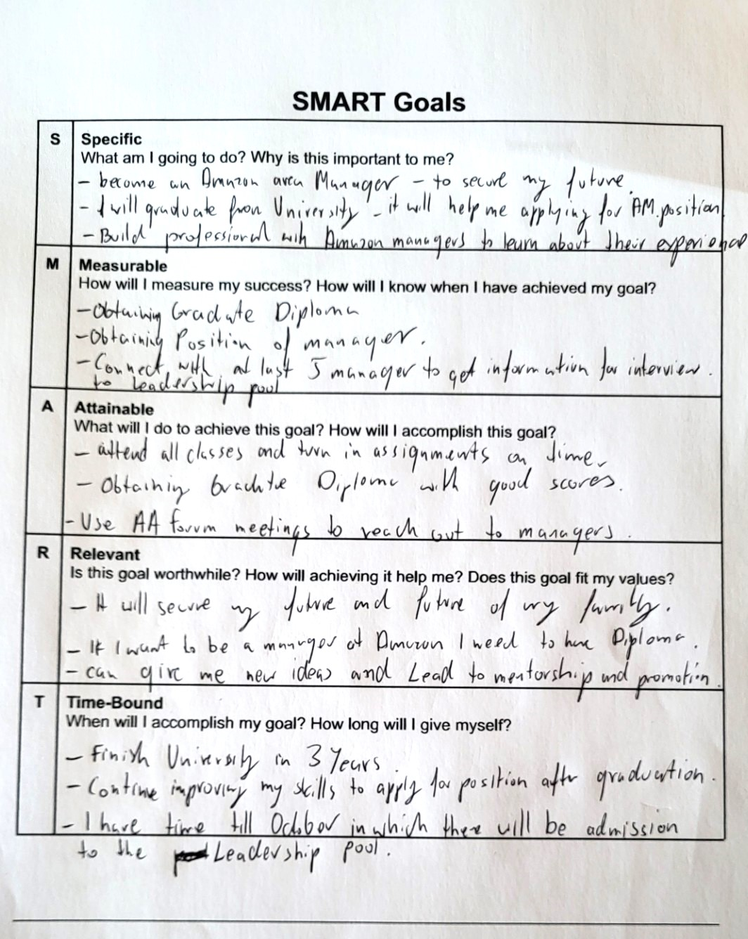

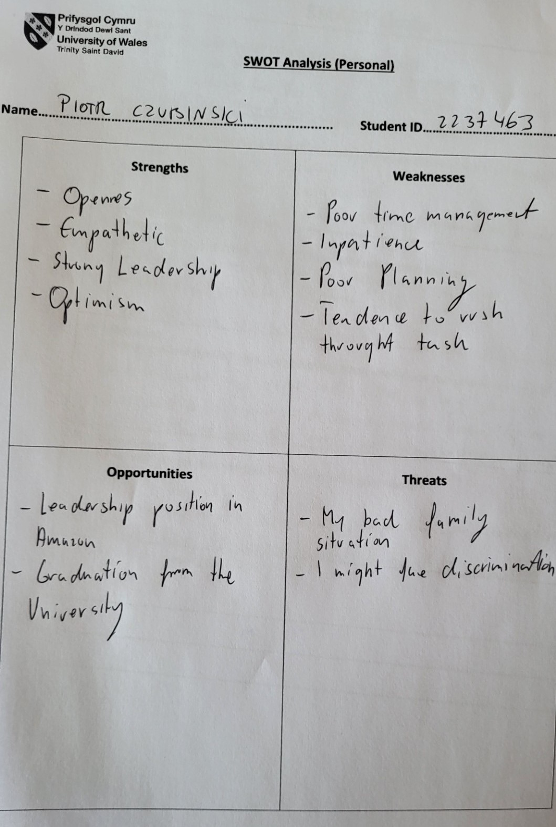
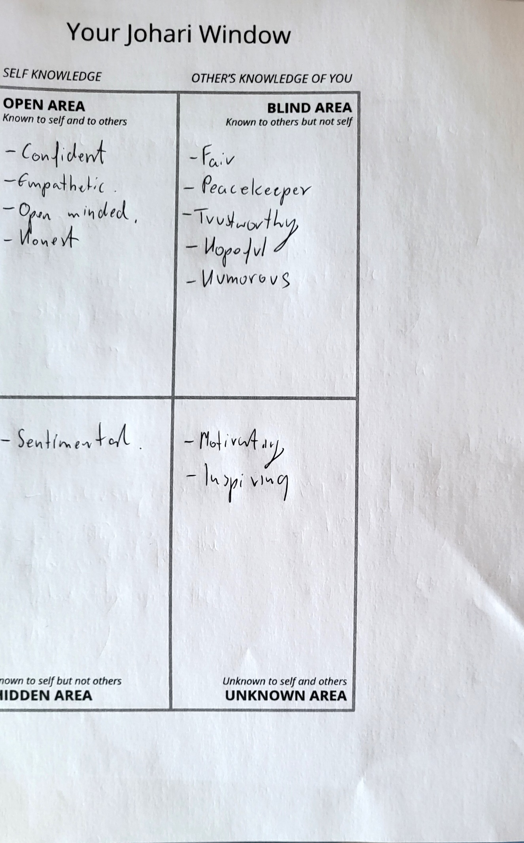

References:
Cottrell, S 2019, The Study Skills Handbook, Bloomsbury Publishing Plc, London. Available from: ProQuest Ebook Central. (Accessed: 31 May 2024).

Cottrell, S (2021), Skills for Success: Personal Development and Employability, Macmillan Education UK, London. Available from: ProQuest Ebook Central. (Accessed: 31 May 2024).

Gürel, E., & Tat, M. (2017). SWOT analysis: A theoretical review. Journal of International Social Research https://www.academia.edu/42239122/SWOT_ANALYSIS_A_THEORETICAL_REVIEW
(Accessed: 31 May 2024).

Jennifer A. Moon (2004) A Handbook of Reflective and Experiential Learning: Theory and Practice. London: Routledge. Available at: https://search-ebscohost-com.ezproxy.uwtsd.ac.uk/login.aspx?direct=true&db=nlebk&AN=102749&site=ehost-live (Accessed: 31 May 2024).

Learn Management (2023) Project Management https://www.learn-management.com/swot-analysis-examples-for-students/ (Accessed: 31 May 2024).

Positive Psychology (2020) Self Awareness https://positivepsychology.com/building-self-awareness-activities/ (Accessed: 31 May 2024).

Strategic Management Insight (2024) The Johari Window Model
https://strategicmanagementinsight.com/tools/johari-window/ (Accessed: 31 May 2024).

The library (2019) Reflective writing https://www.salford.ac.uk/sites/default/files/2021-02/Reflective-writing.pdf (Accessed: 31 May 2024).

University of Edinburg (2020) Gibbs' Reflective Cycle https://www.ed.ac.uk/reflection/reflectors-toolkit/reflecting-on-experience/gibbs-reflective-cycle&nbsp; (Accessed: 31 May 2024).
Yuniatri Intan Kusuma Ningrum, Nova Ariani (2020) REFLECTIVE JOURNAL WRITING: A REVIEW OF THE LITERATURE
http://inggris.sastra.um.ac.id/wp-content/uploads/2021/05/Copy-of-043-P313-Yuniatri-Nova..pdf
(Accessed: 31 May 2024).

