
Cover page

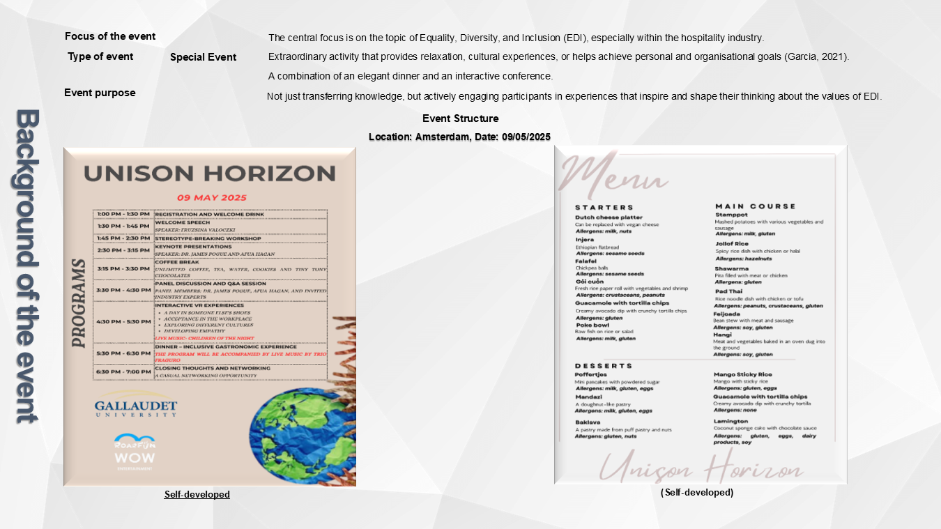
Slide 1

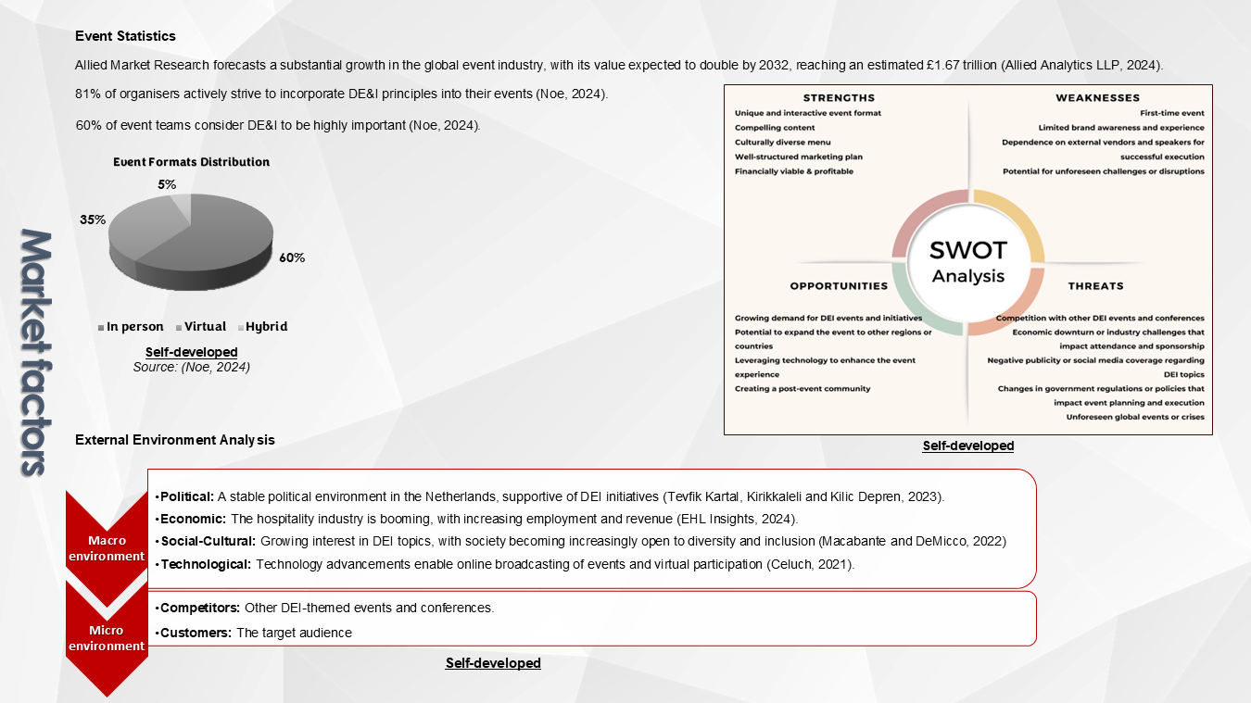
Slide 2

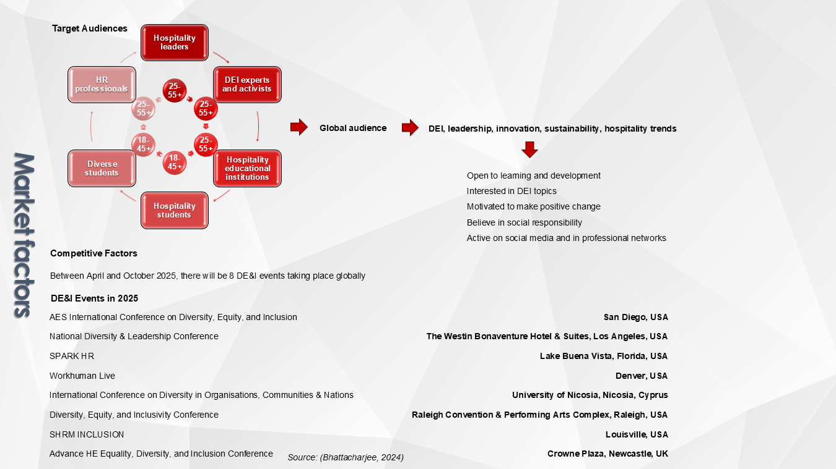
Slide 3

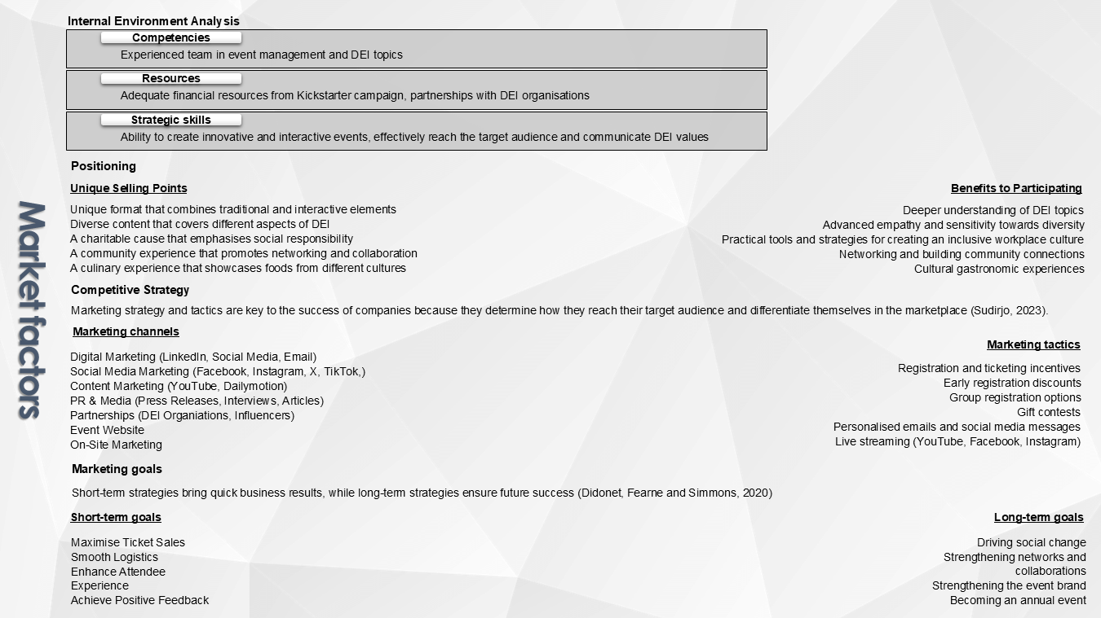
Slide 4

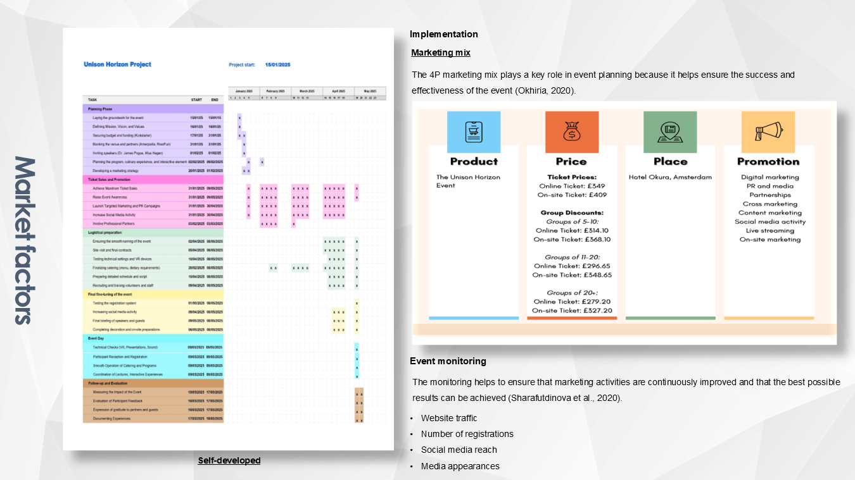
Slide 5

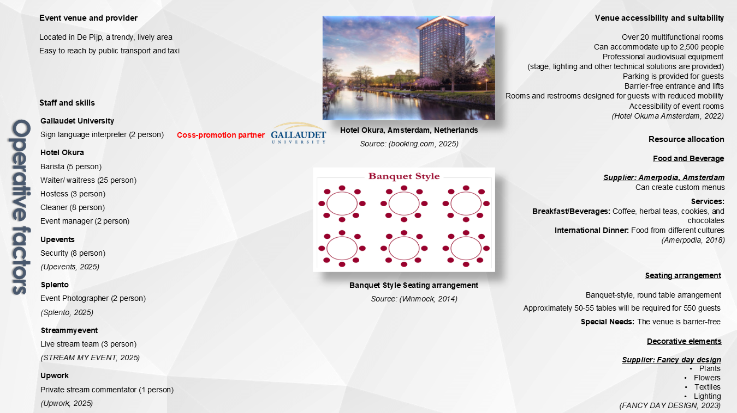
Slide 6

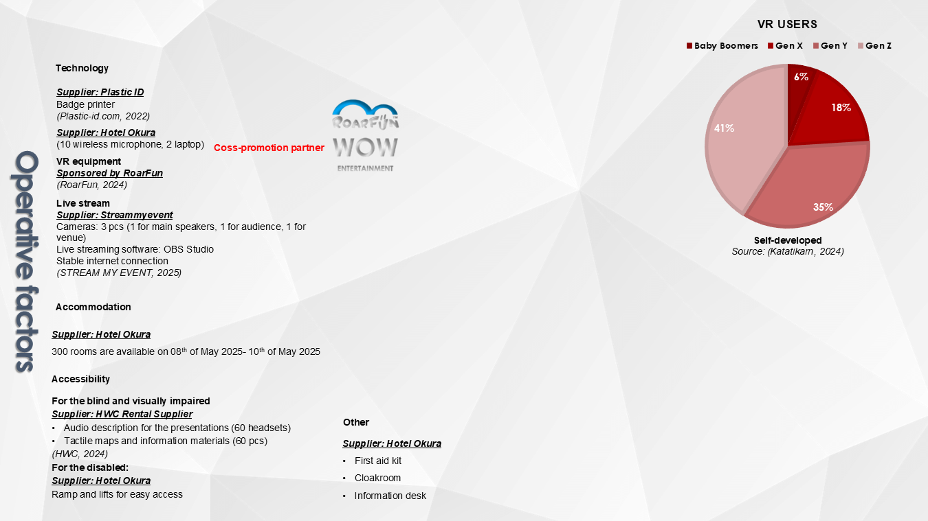
Slide 7

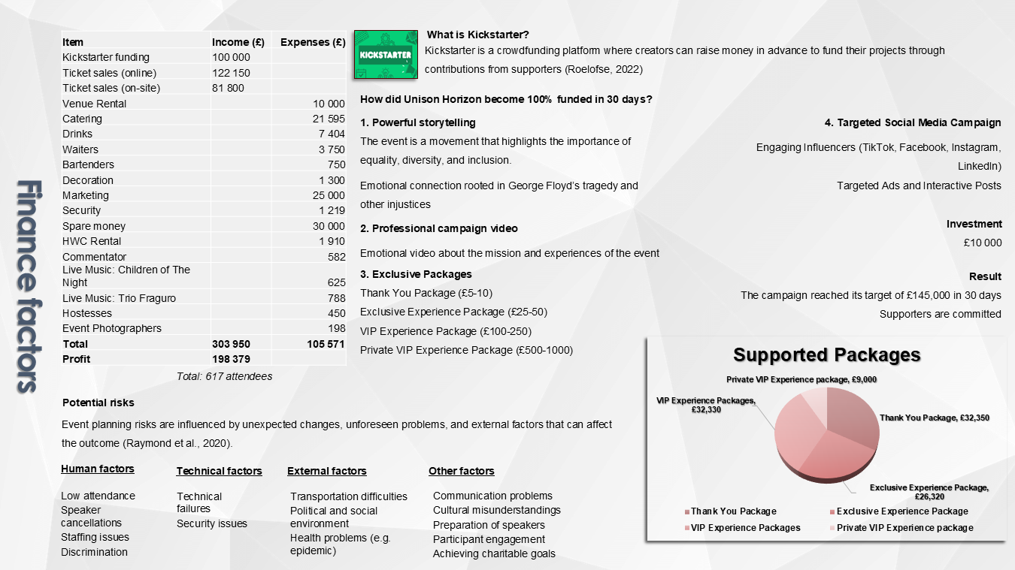
Slide 8

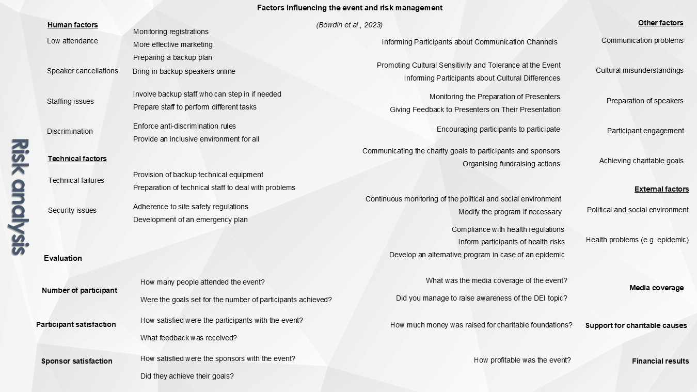
Slide 9

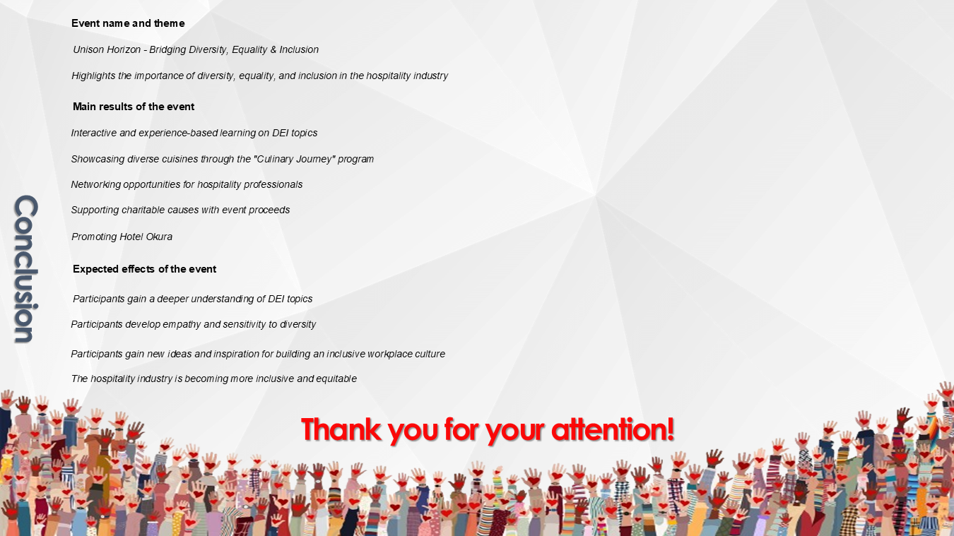
Slide 10

Reference list
- Allied Analytics LLP (2024). Events industry market to reach $2,046.7 billion, globally, by 2032 at 6.4% CAGR: Allied Market Research. GlobeNewswire Newsroom. Available at: https://www.globenewswire.com/news-release/2024/09/20/2949762/0/en/Events-Industry-Market-to-Reach-2-046-7-Billion-Globally-by-2032-at-6-4-CAGR-Allied-Market-Research.html [ [Accessed 27 January 2025].
- Amerpodia (2018). Catering. Available at: https://www.amerpodia.nl/en/wp-content/uploads/sites/2/2018/10/EN_Catering-Amerpodia_LR.pdf [Accessed 23 January 2025].
- Bhattacharjee, M. (2024). Top DE&I events to attend in 2025. Airmeet. Available at: https://www.airmeet.com/hub/blog/top-dei-events-to-attend-in-2025/ [Accessed 31 January 2025].
- Bowdin, G., McDonnell, I., Harris, R., O’Toole, W., Allen, J. and Jago, L.K. (2023). Events management. Routledge. DOI: https://doi.org/10.4324/9781003044963.
- Celuch, K. (2021). Event technology for potential sustainable practices: a bibliometric review and research agenda. International Journal of Event and Festival Management, 12(3). DOI: https://doi.org/10.1108/ijefm-08-2020-0051
- Didonet, S.R., Fearne, A. and Simmons, G. (2020). Determining the presence of a long-term/short-term dilemma for SMEs when adopting strategic orientation to improve performance. International Small Business Journal: Researching Entrepreneurship, 38(2), pp.90–110. DOI: https://doi.org/10.1177/0266242619879369.
- EHL Insights (2024). Hospitality industry: all your questions answered. Hospitality Insights. Available at: https://hospitalityinsights.ehl.edu/hospitality-industry [Accessed 1 February 2025].
- Fancy Day Design (2023). The most beautiful decoration hire for parties #1 see here! Fancy Day Design. Available at: https://fancydaydesign.nl/en_en/decoration-hire/ [Accessed 25 January 2025].
- Garcia, D.B. (2021). Why festivals and special events matter now more than ever. Medium. Available at: https://medium.com/cultural-mega-events/why-festivals-and-special-events-matter-now-more-than-ever-a8ba04554f31 [Accessed 28 January 2025].
- Hotel Okura Amsterdam (2022). Events. Available at: https://www.okura.nl/events [Accessed 24 January 2025].
- HWC (2024). Translator equipment hire - Translation set 3 - Rental shop Amsterdam. Rental Supplier. Available at: https://www.hwc-er.nl/en/verhuuritem/translation-set-3/ [Accessed 30 January 2025].
- Katatikarn, J. (2024). Virtual reality statistics: the ultimate list in 2022. Academy of Animated Art. Available at: https://academyofanimatedart.com/virtual-reality-statistics/ [Accessed 29 January 2025].
- Macabante, I. and DeMicco, F. (2022). Belonging: the critical driver of happiness, engagement & retention in hospitality. Hospitality Net. Available at: https://www.hospitalitynet.org/opinion/4112199.html [Accessed 24 January 2025].
- Noe, K. (2024). 2021 event marketing statistics, trends, and data. Bizzabo. Available at: https://www.bizzabo.com/blog/event-marketing-statistics [Accessed 26 January 2025].
- Okhiria, A. (2020). The role of strategic marketing in successful event management. National College of Ireland. Available at: https://norma.ncirl.ie/4704/1/abrahamokhiria.pdf [Accessed 25 January 2025].
- Plastic-ID.com (2022). Printer rentals. Available at: https://www.plastic-id.com/printer-rentals [Accessed 31 January 2025].
- Raymond, C., Horton, R.M., Zscheischler, J., Martius, O., AghaKouchak, A., Balch, J., Bowen, S.G., Camargo, S.J., Hess, J., Kornhuber, K., Oppenheimer, M., Ruane, A.C., Wahl, T. and White, K. (2020). Understanding and managing connected extreme events. Nature Climate Change, 10(7), pp.611–621. DOI: https://doi.org/10.1038/s41558-020-0790-4.
- RoarFun (2024). #1 service to rent VR for your event. RoarFun.com. Available at: https://roarfun.com/virtual-reality-rental/ [Accessed 30 January 2025].
- Roelofse, R. (2022). Kickstarter. ProQuest. Available at: https://search.proquest.com/openview/d2f7168c1acb8548bb0b2311cefc1095/1?pq-origsite=gscholar&cbl=2044544 [Accessed 31 January 2025].
- Sharafutdinova, N.S., Xametova, N.G., Novikova, E.N., Shnorr, Z.P. and Rolbina, E.S. (2020). Event marketing as an effective tool for building long-term customer relationships. Atlantis Press. DOI: https://doi.org/10.2991/aebmr.k.200324.104.
- Splento (2025). Hire an event photographer in Amsterdam. Splento. Available at: https://www.splento.com/nl/hire-an-event-photographer-in-amsterdam [Accessed 29 January 2025].
- Stream My Event (2025). Stream my event - View our prices. Stream My Event. Available at: https://streammyevent.com/en/pricing?type=event [Accessed 1 February 2025].
- Sudirjo, F. (2023). Marketing strategy in improving product competitiveness in the global market. Journal of Contemporary Administration and Management (ADMAN), 1(2), pp.63–69. Available at: https://www.researchgate.net/publication/373104627_Marketing_Strategy_in_Improving_Product_Competitiveness_in_the_Global_Market [Accessed 28 January 2025].
- Tevfik Kartal, M., Kirikkaleli, D. and Kilic Depren, S. (2023). Investigating political stability effect on the environment in the Netherlands by Fourier-based approaches. International Journal of Sustainable Development and World Ecology, 31(2), pp.1–12. DOI: https://doi.org/10.1080/13504509.2023.2256716.
- UP Events (2025). UP events. Available at: https://upevents.nl/en/event-upgrades/services/security/ [Accessed 30 January 2025].
- Upwork (2025). Upwork - Commentator. Upwork. Available at: https://www.upwork.com/nx/search/talent/?loc=netherlands&nbs=1&q=Commentator [Accessed 29 January 2025].
- Winmock (2014). Room configuration 101. Winmock. Available at: https://winmock.com/2014/04/22/room-configuration-101/ [Accessed 24 January 2025].

