BREWDASH
Student Coffee & Quick Bites
BUSINESS PLAN

Programme of Study: Certificate in Higher Education Business Skills for the Workplace
Module Name & Code: LCLM4006 Enterprise and Entrepreneurship
Assignment Title: Task 1: Individual Written Business Plan.
Student Name: Emil-ionut Cacicovschi
Student ID: 2229348
Lecturer's Name:
Date: March 2026

1. Executive Summary
BrewDash is a college-based coffee shop and quick bite delivery business that is planned to target students at universities when they are on short academic breaks. The gap identified by the business concerns a lack of time between lectures and the inability of students to access fast, inexpensive, and high-quality food and beverages on or within the campus (Mintel, 2024). BrewDash is a company that is going to have a small operation that will be close to a university campus that will provide a pre-selected menu of hot and cold beverages, sandwiches, wraps, and snacks, all of which will be available within five minutes of ordering. The pre-ordering will be carried out with the help of a plain mobile-friendly web application, which will shorten the wait time. The type of legal organisation will be a sole trader, which will allow the company to pay minimal headaches in terms of regulation in the initial expansion stage (Companies House, 2024). The age group of 18-25 is the target market- in the United Kingdom, there are more than 2.3 million full-time students (HESA, 2024). A PESTEL analysis indicates a generally favourable macro-environment, whereby the power, and rising dependency of students on digital ordering platforms are on the rise (Statista, 2025). The major competitive edge has been speed of service and low-cost pricing model, with average value per transaction being equal to £3.50. The amount of start-up capital to start up will be required is £6,100 which will be provided by personal savings amounting to £2,000, small business bank loan amounting to 2,600 and investor funds amounting to 1500. The projected monthly fixed costs will include 1,800, and the breakeven level will be 900 units per month. The company will break even in the fourth month of operation.

Table of Contents
1. Executive Summary 1
Table of Contents 1
2. Overview of the Business Idea 1
2.1 Product and Service Offering 1
2.2 Management Structure 1
2.3 Legal Format 1
3. Market Research 1
3.1 Environmental Analysis (PESTEL) 1
3.2 Competitive Analysis 1
4. Marketing Communications 1
4.1 Target Market 1
4.2 Marketing Mix (4Ps) 1
4.3 Digital Marketing 1
5. Financials 1
5.1 Funding Requirements and Sources 1
5.2 Startup Expenses – Month 1 1
5.3 Projected Cash Flow – 6 Months 1
5.4 Break-Even Analysis 1
Reference List 1

2. Overview of the Business Idea

2.1 Product and Service Offering
BrewDash also has a narrow menu to ensure speed. The products are divided into two groups, namely beverages (espresso-based coffee, teas, smoothies), and quick bites (sandwiches, wraps, granola bar, and fruit pots). Everything is ready or already put together out of the peak to facilitate less than five minutes’ fulfilment. The British Coffee Association (2024) reports that more than 95 million cups of coffee are being taken in the UK every day, which confirms the presence of high baseline demand.
The orders are made through a mobile friendly site at least ten minutes before picking up, thus it does not involve a queue. The sitting capacity of students who want to sit is also very low with a seating space of eight. The competition of the average meal deal, including coffee and a snack, is already priced at 3.50 pounds, which is very competitive with the well-known coffee shop chains the Costa Coffee or Pret a Manger (Euromonitor International, 2024).

2.2 Management Structure
The first team will involve the founder-manager and the two part-time employees. The founder manages activities, relations with suppliers, and marketing. The service and order preparation is done by part-time personnel. A team leader will be hired to run the day-to-day activities as the business expands (Scarborough, 2023).

2.3 Legal Format
BrewDash shall be incorporated under a sole trader, as this is the simplest form of legal entity in the UK and a new micro-enterprise. This involves straight forward registration with HM Revenue Customs (HMRC) and the founder can maintain the complete control. The most important risk is the unlimited personal liability, which will be eliminated with the help of the public liability insurance (GOV.UK, 2024).

3. Market Research

3.1 Environmental Analysis (PESTEL)
A PESTEL analysis identifies the macro-environmental forces shaping the opportunity for BrewDash (Johnson et al., 2023):

Factor | Key Implications for BrewDash
Political | Supportive SME policy in the UK; food hygiene regulations under the Food Standards Agency (FSA, 2024).
Economic | Student spending on food and drink estimated at £3.4 billion annually (Statista, 2025). Post-pandemic recovery boosting café footfall (IBISWorld, 2024).
Social | Growing café culture among Gen Z; 79% of students eat out at least once a week (Mintel, 2024). Preference for speed and convenience.
Technological | Rise of mobile pre-ordering apps; contactless payments adopted by 83% of UK consumers (UK Finance, 2024). Social media as primary marketing channel.
Environmental | Increasing consumer demand for sustainable packaging (WRAP, 2023). Opportunity to use recyclable and compostable materials.
Legal | Compliance with Food Safety Act 1990, Allergen Information regulations, and GDPR for app user data (FSA, 2024; ICO, 2024).
Table 1: PESTEL Analysis – BrewDash

3.2 Competitive Analysis
The cafe and the quick-service restaurant (QSR) business is competitive. The major direct and indirect competitors within the close proximity to universities are university canteens, national chain stores (Costa Coffee, Pret A Manger), and street-foods. BrewDash is differentiated by three pillars such as speed, affordability, and proximity to the campus. As IBISWorld (2024) observes, the market share to the large chains is being taken by independent coffee shops that have a niche of convenience and are, especially among young consumers with a cost-sensitive focus, gaining market share.
The pre-order system is one of the main competitive advantages. The National Restaurant Association (2024) research clarifies that two-thirds of the clients would want to place their orders in advance in order to save waiting time, a trend that is particularly common among time-sensitive student groups.
Competitor mapping exercise also explains how BrewDash is strategically positioned. Although their price per unit is high of £5.20 on average, Costa Coffee and Pret A Manner provides good brand awareness and high-quality product line (Euromonitor International, 2024). The canteens in the universities, though cheap, have often been criticised by the students to have long queues and close during the duration of prime-time study hours. Street food hustlers are convenient, but they do not have the digital infrastructural effort to support pre-ordering and contactless delivery. BrewDash takes a specific niche in this terrain by merging low prices with convenience on technology - a formula that has been slow to withstand at a localised campus level in the established chains. The generic strategies framework provided by Porter (1980) underlines that approach because the BrewDash company follows a narrow cost leadership strategy, where it tries to dominate a well-defined niche in the market instead of operating in a wide market. Moreover, switching costs of students are somewhat low, and the brand loyalty needs to be achieved by stable quantity, quality, and value, which is incorporated into the working model of BrewDash. This is a deliberate strategy to ensure that larger competitors find this positioning hard to duplicate until they change their organisational structures to enable service delivery models.

4. Marketing Communications

4.1 Target Market
BrewDash is aimed at students of universities who are 18-25 years old. The highest number of full-time students in the UK is reported by HESA (2024) to be more than 2.3 million. The key subject of interest is a time-starved undergraduate student and having a small yet constant amount of money totalling £5-£10 on food and beverages a day.

4.2 Marketing Mix (4Ps)
Product: A simple menu that is updated every season according to the preferences of students and availability of ingredients.
Price: Penetration pricing plan with a mean of transactions of £3.50 -which is estimated as 30% below the prices of the high-street cafe chains (Euromonitor International, 2024). A loyalty programme will provide a free beverage in every tenth beverage.
Place: A physical structure (store) that is located next to the main university entrance and is complemented by pre-order contactless collection on a web application.
Promotion: Interactive promotion in digital platforms among the students in the Instagram, Tik Tok, WhatsApp chat. According to Kotler and Keller (2022), the use of social media in communication is paramount when it comes to encountering Gen Z consumers. During launch week, the influencer collaboration with student ambassadors will be engaged. Sign-ups will be made in campuses through flyering and posting QR-code posters at the entrance of lecture theatres.

4.3 Digital Marketing
It will be releasing weekly Instagram Reels that demonstrate menu items and behind-the-scenes contents. Word-of-mouth will be fastened by a referral scheme of a free drink in every 3 friends who register. Each week, email communication will be applied to the student union mailing list (Chaffey and Ellis-Chadwick, 2022).

5. Financials

5.1 Funding Requirements and Sources
The total startup capital required for the first month of operations is £6,100. The funding will be sourced as follows:
Funding Source | Amount | Rationale
Personal Savings | £2,000 | Low cost; demonstrates founder commitment
Small Business Bank Loan | £2,600 | Leverages Start Up Loans scheme (British Business Bank, 2024)
Investor Funding (Sought) | £1,500 | Equity stake in exchange for capital and mentorship
Total | £6,100
Table 2: Funding Sources
The Start Up Loans scheme, backed by the British Business Bank (2024), provides unsecured loans of up to £25,000 at a fixed 6% interest rate for early-stage entrepreneurs, making it an accessible and low-risk source of debt finance.

5.2 Startup Expenses – Month 1

Expense Item | Amount (UKD) | Notes
Coffee Machine & Grinder | £1,800 | Core operational equipment
Refrigeration Unit | £700 | Food storage compliance
Counter, Shelving & Fixtures | £500 | Shop fit-out
First Month Rent | £800 | Premises cost
Initial Inventory (stock) | £500 | Coffee beans, milk, food items
Staff Wages (2 × part-time) | £600 | Month 1 labour cost
Branding, Signage & Packaging | £250 | Visual identity
Social media & Launch Marketing | £300 | Digital ads, print flyers
Website / Pre-Order App Setup | £400 | One-off development cost
Licences & Permits (FSA) | £200 | Food business registration
Public Liability Insurance | £150 | Risk mitigation
Miscellaneous / Contingency | £200 | 5% buffer
TOTAL | £6,100
Table 3: Startup Expenses – Month 1
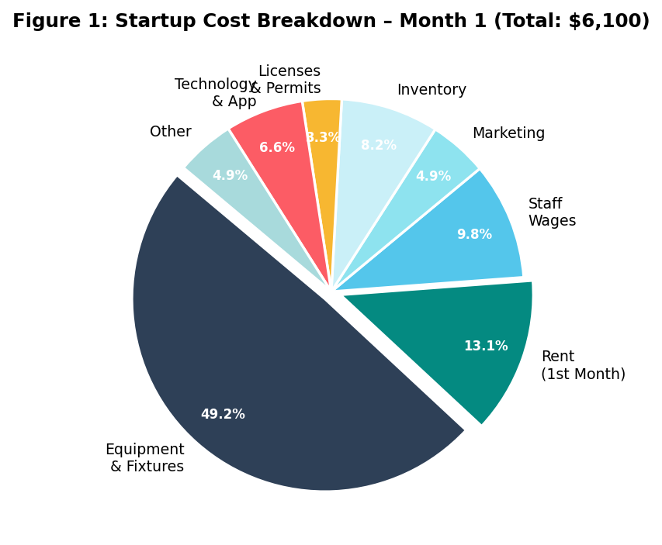
Figure 1: Startup Cost Breakdown – Month 1 (Total: £6,100)

5.3 Projected Cash Flow – 6 Months
Revenue is projected conservatively, growing as word-of-mouth spreads and the pre-order user base expands. Operating costs stabilise from Month 2 at approximately £2,100–£2,300 per month.
 | Month 1 | Month 2 | Month 3 | Month 4 | Month 5 | Month 6
Revenue (£) | 1,500 | 2,800 | 3,800 | 4,500 | 5,200 | 6,000
Startup Costs (£) | 6,100 | — | — | — | — | —
Operating Costs (£) | — | 2,100 | 2,200 | 2,200 | 2,300 | 2,300
Net Cash Flow (£) | -4,600 | +700 | +1,600 | +2,300 | +2,900 | +3,700
Cumulative (£) | -4,600 | -3,900 | -2,300 | 0 | +2,900 | +6,600
Table 4: Projected Cash Flow – Months 1 to 6
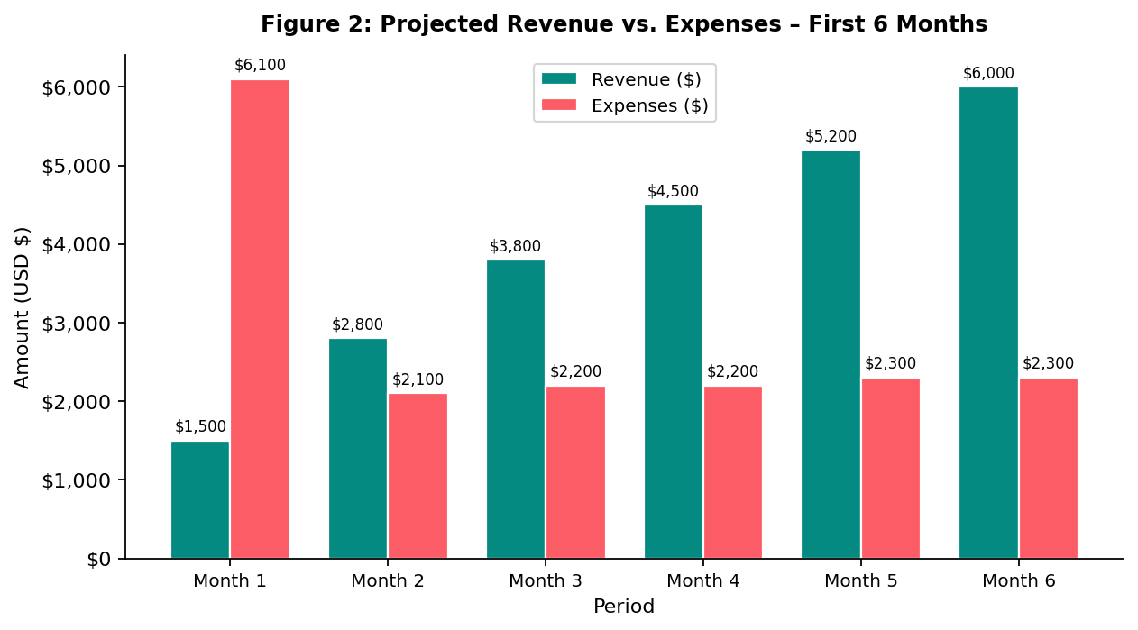
Figure 2: Projected Revenue vs. Expenses – First 6 Months

5.4 Break-Even Analysis
Break-even analysis determines the minimum number of units (drinks/snacks) to be sold monthly to cover all fixed costs.
Fixed costs: £1,800/month (rent, wages, insurance, utilities)
Variable cost: £1.50 per unit (ingredients, packaging)
Selling price: £3.50 per unit (average transaction value)
Contribution margin: £3.50 − £1.50 = £2.00 per unit
Break-Even Point (BEP): Fixed Costs ÷ Contribution Margin = £1,800 ÷ £2.00 = 900 units per month
At an average of 6 trading days per week (approximately 26 days/month), this equates to just 35 transactions per day, a realistic and achievable target for a campus-adjacent outlet (Scarborough, 2023). The business is projected to exceed break-even from Month 4.

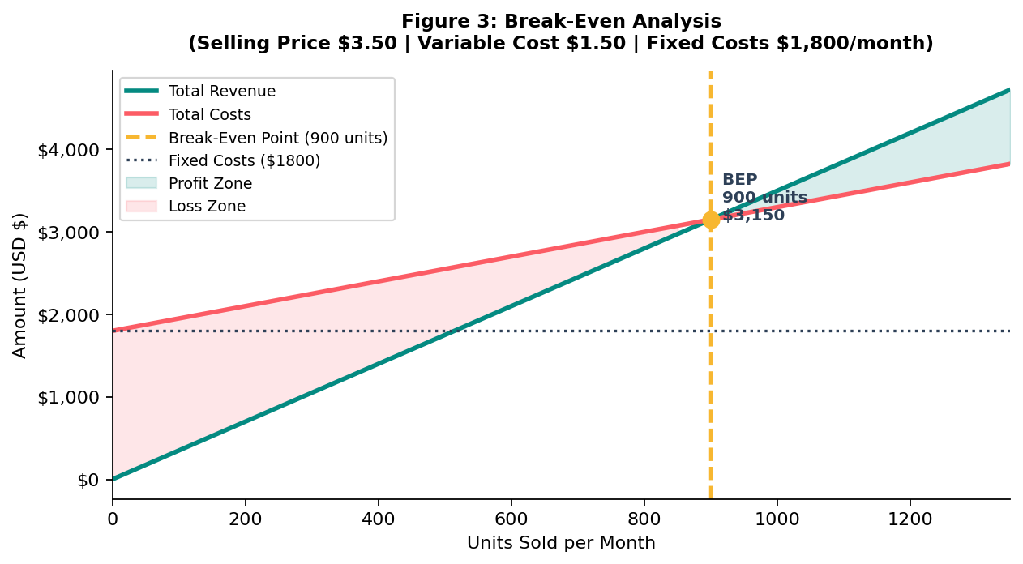
Figure 3: Break-Even Analysis (BEP = 900 units/month)

Reference List
British Business Bank (2024) Start Up Loans. Available at: https://www.startuploans.co.uk (Accessed: 15 February 2026).
British Coffee Association (2024) UK coffee industry statistics. London: British Coffee Association.
Chaffey, D. and Ellis-Chadwick, F. (2022) Digital marketing: strategy, implementation and practice. 8th edn. Harlow: Pearson.
Companies House (2024) Set up a business: sole trader. Available at: https://www.gov.uk/set-up-sole-trader (Accessed: 10 January 2026).
Euromonitor International (2024) Coffee shops and independent cafés: UK industry overview. London: Euromonitor International.
Food Standards Agency (FSA) (2024) Food hygiene ratings and registration. Available at: https://www.food.gov.uk (Accessed: 12 January 2026).
GOV.UK (2024) Public liability insurance for businesses. Available at: https://www.gov.uk/liability-insurance (Accessed: 8 February 2026).
Higher Education Statistics Agency (HESA) (2024) Higher education student statistics: UK 2022/23. Cheltenham: HESA.
IBISWorld (2024) Coffee shops in the UK: industry report. London: IBISWorld.
Information Commissioner's Office (ICO) (2024) Guide to GDPR. Available at: https://ico.org.uk/for-organisations/guide-to-data-protection (Accessed: 14 January 2026).
Johnson, G., Whittington, R., Scholes, K., Angwin, D. and Regnér, P. (2023) Exploring strategy: text and cases. 13th edn. Harlow: Pearson.
Kotler, P. and Keller, K.L. (2022) Marketing management. 16th edn. Harlow: Pearson.
Mintel (2024) Cafés and coffee shops: UK market report 2024. London: Mintel Group.
National Restaurant Association (2024) Restaurant industry 2024 outlook. Washington, DC: National Restaurant Association.
Scarborough, N.M. (2023) Essentials of entrepreneurship and small business management. 9th edn. Harlow: Pearson.
Statista (2025) Student consumer spending in the United Kingdom 2025. Available at: https://www.statista.com (Accessed: 20 January 2026).
UK Finance (2024) UK payment markets summary 2024. London: UK Finance.
WRAP (2023) Packaging and sustainable design guide for food businesses. Banbury: WRAP.

