

Name: Alina Don
Student ID: 2209918
Module code: LCMB7034
Module name: International Business Concepts
Assessment Title: Report
Lecturer: Akshay Narayanan

Table of Contents
1. Introduction 3
2. Overview of Industry and Country 3
2.1 About UK Fashion Industry 3
2.2 Financial Magnitude and Economic Significance 4
2.3 Scope: Domestic vs Multinational Operations 4
2.4 Competitive Positioning and Strategic Comparison. 5
3. Porters Diamond Analysis of the UK Fashion Industry Competitiveness in the World 5
3.1 Factor Conditions 6
3.2 Demand Conditions 6
3.3 Supporting and Related Industries 6
3.4 Firm Strategy, Structure and Rivalry 7
4. Significant Foreign MNC that has been in the UK Fashion Industry: Zara 8
4.1 Company Background and Ownership Structure 8
4.2 Critical Analysis of the Conditions that influenced the success of Zara in the UK Market 9
4.2.1 Political Factors 9
4.2.2 Economic Factors 10
4.2.3 Legal and Regulatory Factors 10
4.2.4 Culture and Social Factors 11
4.2.5 Factors of Technological and Market Infrastructures 11
4.3 Market attractiveness Evaluation 11
5. Conclusion 13
Section 2: Reflection 14
Introduction 14
Description 14
Feelings 14
Evaluation 15
Analysis 15
Conclusion 16
Action Plan 16
Conclusion 16
References 17

1. Introduction
The UK fashion industry is a crucial and complex sector of the national economy including the luxury, high-street, and fast-fashion markets underpinned by the more and more digitalised retail-based models. The industry has a complicated environment since it is one of the largest apparel markets in Europe, with a dynamic consumer behavior, an increased focus on sustainability, and demands of post-Brexit regulations. The recent questioning by the BBC News shows increased responsibility of the environmental and ethical allegations, which require companies to reassess the sourcing, pricing, and transparency policies. The present report summarises the UK fashion industry in terms of its economic importance and competitive framework and critically examines its competitiveness in the global market framework in terms of the Diamond Model developed by Porter. It then concentrates on Zara as a major multinational in the UK, where it will be analysed in terms of the political, economic, legal, cultural and technological forces that have affected its performance. The purpose of the study is to evaluate the interaction between national conditions and firm-level strategies to determine the influence on firm competitiveness in the constantly changing fashion environment

2. Overview of Industry and Country

2.1 About UK Fashion Industry
Fashion in the United Kingdom is a significant sphere of the economy, which includes design of apparel, its production, sale, and more and more digital commerce. It comprises luxury brands, high-street brands and international fast fashion retailers with a sophisticated supply chain connecting fabric construction, logistics, marketing, and retail distribution. London is popularly known to be a capital of fashion and is home to major seasonal events in the form of London Fashion Week and also international investment, designers, and buyers. Some of the UK firms have been hit in recent years by economic pressures such as low consumer spending growth rates, supply chain volatility, etc. Meanwhile, the sustainability issue and regulatory analysis of environmental claims have influenced strategic reactions in the industry (BBC News, 2024). The fashion textile market in the UK earned USD 32,618.1 million in 2022 and has a projected growth of USD 56, 284.2 million by 2030. UK market is likely to increase at a CAGR of 7.1 between 2023 and 2030 (Grand view research, 2025).
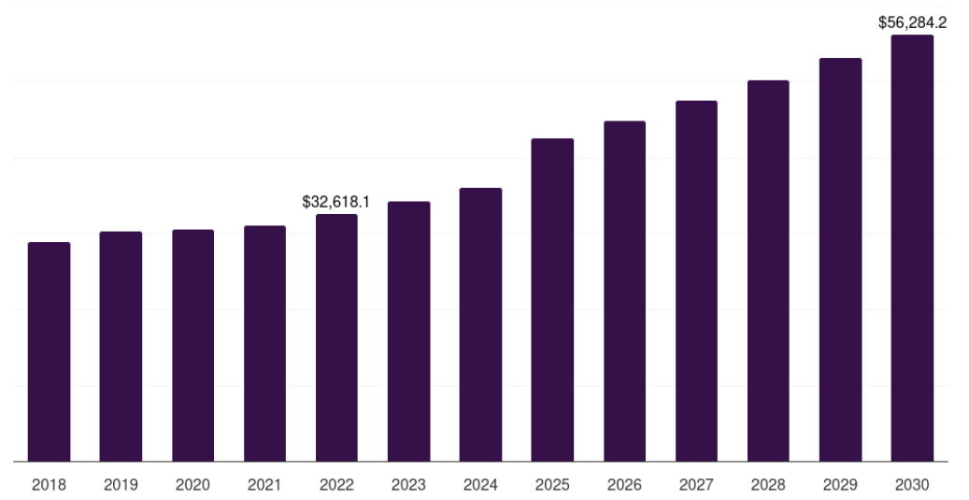
Figure 1: UK fashion industry, market
(Source: Grand view research, 2025)

2.2 Financial Magnitude and Economic Significance
The fashion and apparel industry of the United Kingdom is a significant portion of the national economy. Statista (2025) further reports that, in 2024, the UK apparel market was estimated to be worth about £62.6 billion which is among the highest clothing markets in Europe. This valuation encompasses sales of retail services of apparel, footwear and other fashion accessories in both offline and online stores. Among this amount, the proportion of online fashion store is increasing. According to Statista, e-commerce is estimated to have up to 46 percent of all fashion sales in 2024, which was approximately 40 % in 2021, and it is possible to note a structural change in purchase behavior towards digital channels in consumers (Statista, 2025). This digital move has especially benefited the online-first retailer like ASOS but difficult to the traditional brick and mortar companies that have to deal with increasing rents and less foot traffic. The industry has been under pressure in regard to profitability despite its size. The Financial Times (2025) reports that a number of suppliers in the UK fashion industry have stated that they experienced a reduction in profit margins thanks to inflationary material prices, increasing labour costs, and declining consumer demand growth during the end of 2024.
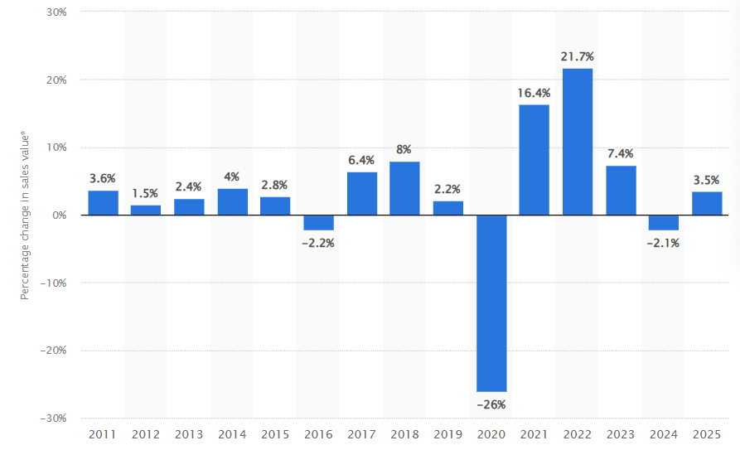
Figure 2: Fashion sales value in UK
(Source: Statista, 2025)

2.3 Scope: Domestic vs Multinational Operations
UK fashion industry comprises of a wide variety of local and international players who hold a certain market segment.
Domestic Firms
Burberry is a leading luxury brand, and based on the company reports, has over 2.6 billion in revenues globally in 2024 and profitability based on its premium prices, retail stores throughout the world, and online platforms. The ability to concentrate on the high-end consumer market and international markets makes Burberry stand out among mass-market retailers. As a mid-market clothing retailer, Marks and Spencer is a large business with a total revenue of more than 10 billion in the clothing, food, and home divisions in FY 2024 (Financial time, 2025). Its clothing business has however grown at a slow pace than its competitors because of price wars and stock shortages. In 2024, ASOS registered gross sales of over 3.5 billion as a result of the international online sales and a substantial number of youth customers. ASOS has been able to use data analytics and targeted marketing to maintain market share over the wider industry slowdowns.
Multinational Firms
Zara (Inditex) has hundreds of stores in the UK and is making up the global revenues of Inditex, that in 2024 were over 32.5 billion (Zara, 2025). Zara supplies fast and responsiveness to trends help the company to have competitive advantages in high volume, low margin segments. H&M is also a fierce competitor in the UK with massive physical and online presence. Despite the slight decrease in its global revenues in 2024 in connection with the clearance of inventories and the pressure on discounts, the strong brand and cost-leader model of H&M still help to attract price-sensitive clients (H & M, 2025). Nike enjoys a good UK market with sports and athleisure products, which forms a significant proportion of its global revenues of more than 53 billion dollars in 2024 both through wholesale and direct retail.

2.4 Competitive Positioning and Strategic Comparison.
With respect to strategic positioning:
- Luxury brands like Burberry are brand exclusive, premium, international, and distribution controlled so that they can enjoy greater profit margins even in times of market slowdowns.
- Online fashion retailers such as ASOS focus more on high product turnover, digital interactions and diversification of their markets across the globe which helps to soften the blows of changes in the UK high-street requirements (Mintel, 2024).
- Global sourcing, economies of scale and efficient inventory systems used by fast fashion multinationals like Zara and H&M have helped them compete on price and speed (GlobalData, 2024).
- Brand heritage and value based retailers like Marks and Spencer depend on their ability to maintain share against online competitors who have been faster moving.

3. Porters Diamond Analysis of the UK Fashion Industry Competitiveness in the World
Competitiveness of the UK fashion industry on the global arena can be evaluated with critical application of the Diamond Model of National Advantage created by Michael Porter who analyses the impact on national conditions on the success of firms in international competition. The model emphasises four simultaneous determinants, factor conditions, demand conditions, related and supporting industries and firm strategy, structure and rivalry as well as the role of government and chance. As stressed by Kuloğlu (2023) and Mweemba et al., (2022), individual benefits do not drive competitiveness; rather, it is the combination of the national-level aspects that produces the effect of competitiveness.
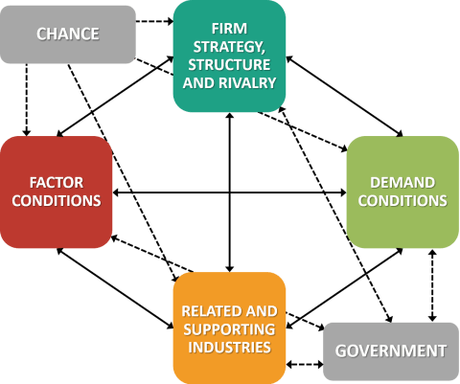
Figure 3: Porters Diamond Analysis
(Source: Self-created)

3.1 Factor Conditions
Factor conditions describe the accessibility and quality of factors of production including labour, capital, infrastructures and knowledge. The UK fashion sector enjoys the favorable conditions of its factors especially in terms of design skills, branding skills, marketing skills and access to institutions of creative learning. The innovation and differentiation proposed to be supported by these advanced skills are essential sources of competitive advantages in fashion-driven industries (Beltrán et al., 2025). According to Hanafi (2025), cost structures contribute hugely to the competitiveness of the industries and in the UK fashion scenario, the factor restricts the ability to compete through price when there is an emphasis on value-based operations like design, retailing and brand management. Therefore, the UK is a more competitive country in both up-stream creative and down-stream retail operations than in manufacturing.

3.2 Demand Conditions
The demand conditions refer to the development of the home market and its sophistication. The UK fashion market enjoys a huge population of affluent and fashionable customers that promotes high product turnover and sensitivity to the trends. The theory of Porter also asserts that because of the pressure of domestic customers, firms have to move faster in innovations and quality, to achieve a better standing in the global market. The UK consumers are becoming more and more conscious of sustainable, ethical, and transparent fashion, which puts pressure on companies to become environmentally conscious in their practices. This coincides with Bosso, Senayah and Biney-Aidoo (2025), who point out that sustainability-oriented demand may be a driving force of competitiveness by promoting innovation and long-term efficiency.

3.3 Supporting and Related Industries
One of the important factors of national competitiveness is the strength of related and supporting industries. The UK fashion industry also enjoys a highly mature support industry which includes advertising, digital marketing, logistic, financial services as well as e-commerce system. These sectors increase speed to market, global presence and efficiency. According to Tran et al., (2025), one of the major sources of competitive advantage is organisational culture and collaboration within the supply chain. The UK fashion industry is arranged in such a way that high-form logistics contractors and digital retailing platforms allow close coordination between the designers, suppliers and retailers.

3.4 Firm Strategy, Structure and Rivalry
The fashion market in the UK is typified by a stiff competition both domestically and internationally especially between luxury brands, fast fashion retailer and multinational companies. The intense rivalry compels companies to keep on perfecting their brands, engaging in digital approaches and diversification of foreign markets. The Diamond Model by Porter indicates that this type of rivalry will increase productivity and innovation. The UK-based companies are usually engaging in differentiation strategies, on the basis of brand heritage, design quality, and customer experience instead of cost leadership. Beltran et al., (2025) suggest that competitiveness through differentiation is especially applicable in fashion and textile industries where symbolic value and reputation of brands have a strong impact on the demand.
The role of government and chance
The government has an indirect yet significant role in the competitiveness. The trade policies of UK, sustainability policies and labour policies influence the cost of operations and access to the market. The Brexit trade structures have caused more administrative overheads and supply chains friction, which have deteriorated some facets of international competitiveness. Structural vulnerabilities have also been revealed due to chance events like the COVID-19 pandemic and global supply chain disruption. According to Mweemba et al., (2022), external shocks are capable of quickly changing the competitive positions since they increase or decrease the strengths and weaknesses. Such shocks in the fashion industry were accelerating digital transformation in the UK, but were also increasing financial pressures in the supply chain.
Competitive analysis
Comprehensively, the Diamond Model of Porters shows that the global competitiveness of the UK fashion industry is innovation- and differentiation-based and not cost-based. The high level of demand sophistication, superior skills and ancillary industries improve international positioning whilst the presence of high costs, reliance on the supply chain and regulatory pressures limit competitiveness. According to Bosso et al., (2025), the competitiveness will more and more rely on the alignment of innovation, sustainability, and strategic adaptation in outlining the national agenda.

4. Significant Foreign MNC that has been in the UK Fashion Industry: Zara

4.1 Company Background and Ownership Structure
Zara is a popular global fashion brand that has high penetration in the United Kingdom and is the largest brand of Inditex that is among the largest clothing conglomerates in the world. Zara is present in UK where it has a wholly owned subsidiary structure and strategic and operational control is retained by Inditex. The UK is a prime European market of the group because of the high level of consumer spending on fashion and good digital retail infrastructure (Zara, 2025).
Operational and Financial Performance Scale
As noted in the Inditex Group Annual Report, 2024, Inditex had a revenue of 35.9 billion in the year 2024 globally, and this is a good indication that the financial performance of Inditex is under good pressure even when there are uncertainty and inflationary forces around the European region (Inditex Group Annual Report, 2025). Inditex is dominated by Zara in terms of its financial power as it contributes to the company about 70 percent of all sales. Europe has contributed in excess of 45 percent of the group revenues with the UK being one of the largest single markets other than Spain. The UK fashion market is rated at more than 60 billion per year and this is one of the largest clothing markets in Europe (Financial Times, 2025). The scale of Zara, sourcing abilities across the globe and economies of scale allow it to keep prices competitive and stable margins as compared to a large number of UK-based retailers that are experiencing a decline in profitability.
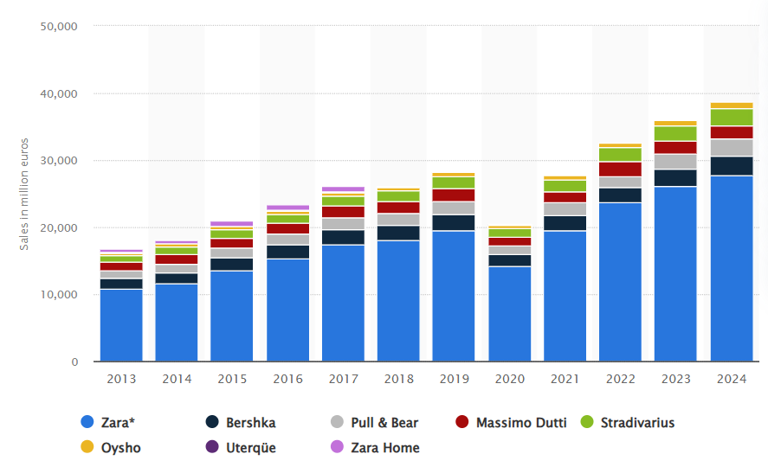
Figure 4: Net sales of Inditex Group on Zara
(Source: Inditex Group Annual Report, 2025)
Competitive Positioning and Business Model in the UK
The fast-fashion business model and the vertically integrated supply chain to Zara give it the competitive advantage in the UK market. The company can have the product designed to store in two to three weeks; this is very quick when compared to the traditional fashion retailers. Such a fast production cycle enables Zara to react immediately to the UK customer trends, minimise the risks of inventory issues and minimise markdowns to enhance higher operational efficiency (Inditex Group Annual Report, 2025). The global size enables Zara to internalise the increasing labour, logistical and post-Brexit trade tensions in a better manner than their domestic rivals. According to the Financial Times (2025), a significant number of fashion suppliers in the UK are under a lot of financial strain, but multinationals like Zara have alternatives and well-established balance sheets due to global diversification.
Sustainability, Ethics and Regulatory Pressure
Ethical sourcing and sustainability are becoming key issues in the UK fashion business. The public outcry arose after the disclosures of exaggerating Made in UK labelling in various areas of the industry (BBC News, 2025). Transparency and compliance in the supply chain in the UK by Zara as a part of global sustainability strategy of Inditex has strengthened. Inditex has also made a pledge of utilising 100 percent sustainable cotton, linen and polyester by 2030 and cutting down emissions and supply chain traceability (Inditex Group Annual Report, 2025). Such efforts are highly significant in the UK, where ethical fashion is highly scrutinised by regulators and the consumer awareness of ethics.
Digital Presence and Market Adaptation
The UK digital platform is one of the core aspects of the market strategy of Zara. Over a quarter of Inditex sales are made through online channels and the UK has been indicated as the leading market in terms of incorporating omnichannel retail stores (Inditex Group Annual Report, 2025). The UK site (Zara, 2025) allows click-and-collect, fast shipping and stock information, which increases the convenience of customers and loyalty to the brand.

4.2 Critical Analysis of the Conditions that influenced the success of Zara in the UK Market

4.2.1 Political Factors
The environment of the United Kingdom is politically stable, and it is one of the main requirements of foreign direct investment by multinational retailers like Zara. Long term retail planning and political stability of sovereign reduce sovereign risk. But the post-Brexit political environment has brought structural trade friction that has a direct impact on the fast-fashion model of operation within Zara (Zara, 2025). With the departure of the UK out of the European Union, new customs, rules-of-origin, and border inspections have added to the administrative burdens experienced by the imports of fashion to the UK. The supply chain of Zara relies on the frequent cross border operations between the UK and distribution centers located in the EU and mostly Spain. Zara competitive advantage is established on the basis of quick response manufacturing (QRM) and fast replenishment cycles which can be as short as 2-3 weeks (Nguyen, 2023). Any political interference that raises the lead times compromises this model. Although Zara is large and has the logistics strength to absorb some extra expenses, a long-term political uncertainty will result in a loss of operational flexibility than before the Brexit.

4.2.2 Economic Factors
Economically, the UK is a desirable and difficult market. The Office for National Statistics (2025) cites that the UK has a GDP of above 2.3 trillion, which is nominal, thus it is among the largest consumer markets in Europe. The macroeconomic significance of the fashion industry is that it has contributed more than 60 billion UK pounds in the economy annually (Financial Times, 2025). This share size justifies Zara further investment in both physical retailers and online retailers. Nevertheless, there are economic pressures that are very dangerous. Discretionary spending has been lower because of high inflation, increasing interest rates and declining real wages. Retailers of fast-fashion require special vulnerability since the demand in clothes is price-elastic. The mid-range pricing policy of Zara places the company between the end of ultra-low-cost brands and high-end fashion, which is a two-sided sword. Aleem (2026) posits that the strategic flexibility of Zara can be identified in its capacity to offer at affordable prices and at the same time, directly experienced quality, but in the long-term, economic recessions can lead the UK consumers to choose lower-priced options, increasing the rivalry in prices.
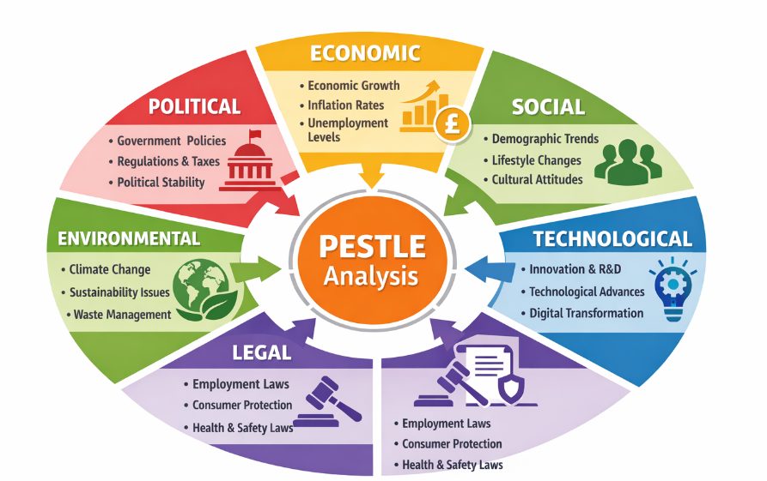
Figure 5: PESTLE analysis of UK fashion
(Source: Self-created)

4.2.3 Legal and Regulatory Factors
The legal framework in UK is highly developed and has got stringent regulations in labour standards, consumer protection and environmental responsibility. This has heightened regulatory pressure in recent studies into false Made in UK labelling in the fashion sector (BBC News, 2025). In the case of Zara, such a regulatory environment results in higher compliance costs and at the same time provides an opportunity to develop reputational differentiation. Zara can track suppliers better than its national competitors due to the governance structure and compliance systems of Inditex used by the company. Aleem (2026) argues that bigger fast-fashion MNCs that have centralised compliance systems are in a better position of adjusting to stricter regulatory measures. Nevertheless, regulations and reporting standards in the sphere of the environment are getting tougher to comply with, and long-term operational expenses of the fast-fashion companies are rising. This puts a strain on the fast production cycles in Zara and the increasing legal demands related to the concept of sustainability and transparency.

4.2.4 Culture and Social Factors
The UK is culturally very accommodative to international fashion brands with high sensitivity in trends and consumption of fashion. This is in tandem with the brand positioning and high turnover of designs in Zara. Zhang (2024) emphasises that the marketing success of Zara is based on trend immediacy as opposed to the classic advertisement method, which is well accepted by the consumers of the UK that appreciate newness and fastness. Nevertheless, the attitudes of culture toward fast fashion are changing. According to Tunceli (2025) there is increasing consumer activism and boycott behavior against fashion brands based on perceived ethical or marketing shortcomings. The reputational risk is increased with social media, especially in the mature markets like the UK. Based on Hofstede-related cultural interpretations, the UK consumers have a rather high individualism score, which is becoming more sensitive to ethical identity and brand values (Okafor and Wang, 2024). In case Zara does not match sustainability communication with actual organisational change, brand loyalty may be called into question by cultural rejection.

4.2.5 Factors of Technological and Market Infrastructures
UK has a well-developed digital and retail infrastructure which strengthens the omnichannel strategy at Zara. More than 25 percent of the total revenues that Inditex receives globally are attributed to online sales, with the UK having been determined as one of the best digital markets in Europe (Inditex Group Annual Report, 2025). The information-based inventory practices adopted by Zara help the company to trace the demand of consumers in real-time, allowing it to make fast design and replenishment decisions. According to Medium (2025), Zara utilises improved data analytics to track customer behavior at both store and online levels to reduce inventory waste and enhance accuracy of the forecasting. Nevertheless, the extremely competitive digital landscape in the UK puts a strain on the necessity to invest in last-mile delivery, compliance with cybersecurity and data protection on a continuous basis. There is a reduction in legal risk because Zara has privacy and data governance policies (Zara Policy, 2024), but continued technological investment increases fixed costs of operation.

4.3 Market attractiveness Evaluation
United Kingdom is a strategic but convoluted market to the activities of Zara. On the one hand, the high economy of the UK, developed consumer base and developed digital infrastructure makes the strong competitive advantages. Conversely, growing political uncertainty, stricter control and changing cultural demands are also a major threat to the sustainability of Zaras fast-fashion model in the long term. Economically, the UK has remained among the largest fashion markets in Europe. The Financial Times (2025) notes that in the UK, apparel retail is estimated at more than 60 billion every year, and in 2025, the gross domestic product stood at more than 2.3 trillion (Office for National Statistics, 2025). This intensity of economic operation means that Zara is enjoying a significantly large market to address with demand which is unlikely to be exhausted soon on fashion products, especially in cities like London, Manchester and Birmingham. Furthermore, the high level of digital penetration in the UK promotes omnichannel retailing: the share of online sales of fashion items is growing in shares of total revenues, and the online platform of Zara and the online systems of the UK utilise this regularity successfully, and Inditex has an online ratio in revenues of more than 25 percent around the globe (Inditex Group Annual Report, 2025). Nevertheless, one can not disregard economic headwinds. Increasing problems with inflation and the cost of living have reduced the discretionary consumer spending, diverting some of the demand into the discount outlets. The middle range strategy of pricing, deployed between low end fast fashion and high-end retail, offers flexibility to Zara, although continued periods of economic decline would undermine its competitive edge since UK shoppers are more price conscious rather than fashion reactive. A study by Aleem (2026) indicates that during a stagnating real incomes, the fast-fashion brand with a stronger price elasticity can lose its same-store sale against the discount competitors.
The UK is relatively stable politically and in terms of regulations, unlike most of the emerging markets. Good functioning environment is provided by stable property rights, good contracts and well-established trade systems. However, the post Brexit trade conditions have significantly changed the cost and complexity of imports of fashion products. Other practices necessitate may raise the cost of operation and delay the quick responsiveness of the supply-chain of Zara, which is a fundamental competitive edge highlighted by Nguyen (2023). Although the global logistics network of Zara alleviates some of these burdens, the negative effect of political uncertainty in the long term may make the UK less attractive than the EU markets are. The legal and regulatory pressures also make the situation more complicated. In the recent years, legislation on labour standards, sustainability reporting and consumer protection in the UK has been tightened. The research on the misleading labeling of Made in the UK has increased the compliance demands among the fashion retailers (BBC News, 2025). On a cultural and social level, the UK shoppers are digital and trend conscious which matches perfectly with the fast-fashion of Zara. According to research carried out by Zhang (2024) and Tunceli (2025) younger UK audiences value trends adoption speed and digital convenience highly, which is the domain where Zara performs well.

5. Conclusion
Notwithstanding, this report has shown that the UK fashion industry has competed majorly based on innovation, differentiation and sophistication in the market as opposed to the cost leadership. The industry enjoys superior factor conditions in form of high design capacities, branding, well developed digital and supporting industries. Also, advanced domestic demand, especially the increased demands towards sustainability and ethical transparency remain a source of innovation and strategic change. Nevertheless, the increase in operation cost, regulatory oversight, and post-Brexit trade tensions are ongoing structural issues as indicated by Financial Times warning about the strain on supplier profitability. Using the Porters Diamond Model, it has been seen that although the UK is competitive in the global market in terms of creative and retail oriented activities, its dependence on global supply chains presents weaknesses when there is a disruptive economic and political environment. The case of Zara depicts these dynamics well. Being a company of the Inditex, Zara has used the scale, vertical integration, and state-of-the-art to remain competitive in the challenging market of the UK. Its rapid production model, omnichannel approach, and increasing sustainability have made it competitive in most aspects relative to other local firms. However, the increasing environmental policies, changing cultural views regarding fast fashion, and the consumer price sensitivity are the threats to its operating model in the long-term.

Section 2: Reflection

Introduction
This reflective description analyses the process of conducting, analysing and compiling the earlier evaluation part of the UK fashion industry and operations of one of the leading and multinational companies. The reflection is also done through the Reflective Cycle of Gibbs, as it allows putting in place a systematic thought on the experience that took place, emotions, results, and ways that can be improved in the future. The assignment entailed the involvement of academic theory, industry statistics, and reliable media outlets, such as BBC News, Financial Times, Encyclopaedia Britannica, and GlobalData. Critical thinking and academic competence development requires reflection especially when handling multi-faceted themes like sustainability, competitiveness and multinational strategy within a dynamic industry setting.
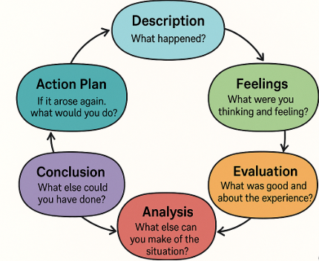
Figure 6: Gibbs reflective cycle
(Source: Self-created)

Description
The research process commenced by locating dependable secondary sources that were capable of giving a contextual as well as an analytical layer. The macro-level knowledge about the political and economic environment in the UK was obtained by means of Encyclopaedia Britannica (2024), whereas market size, sustainability tendencies, and competitive forces were acquired with the help of GlobalData (2024) and Financial Times (2025). The article published by the BBC News (2024) about sustainability claims in the UK fashion was used in the middle of the analysis, as it formed the regulatory and ethical aspect of it. After gathering data, the Diamond Model of Porter was used to evaluate the competitiveness of nations with academic literature backing the model (Bosso et al., 2025). The last process was making industry level understanding and firm level analysis synthesise with each other so that there could be logical flow, critical assessment and proper reference of academic literature. Much focus was placed on the correspondence of evidence to the theory and consistency between sections.

Feelings

To begin with, I was confident because of the previous experience of business and industry analysis. Yet, this trust was also coupled with the fear of how to handle the amount of information and be able to provide critical depth as opposed to descriptive writing. The idea of sustainability scrutiny represented by the BBC News (2024) discussion provided a feeling of obligation to take ethical and regulatory matters seriously and not to engage in quick and shallow analysis. The further the research was conducted, the more confident I grew, especially when I managed to connect real world processes and developments, e.g., my supplier margin pressure stemmed in Financial Times (2025) reports, with theoretical frameworks of competitiveness and cost structure. Meanwhile I was challenged by the necessity to unite a variety of views into a unity. In general, my mood changed to that of uncertainty to cautious confidence as the structure and the argument became more vivid.

Evaluation
The quality and credibility of the sources also presented to be one of the strengths of the process. Integrating journalistic and academic literature gave the opportunity to have a balanced analysis that indicated the challenges of the industry in real time and the theoretical perspectives. The use of the Diamond Model presented by Porter was especially successful in organizing the analysis of competitiveness and preventing the disjointed arguments. There was however a limitation of time-consuming nature of synthesising various materials. Sometimes, they risked overloading sections with data over and above focusing on analytical relevance. Also, the interpretation of sustainability claims had to be done with great discretion to ensure that they are not biased particularly when utilizing media sources. Although available information on BBC News (2024) was valuable, I needed to be critical of it and not take it literally.

Analysis
The experience showed the relevance of critical source triangulation. The evidence of regulatory and reputational pressure was presented by BBC News (2024), and the views centered on financial and suppliers were given by Financial Times (2025), which collectively demonstrate the intersection of sustainability and cost pressures. This supported the notion of Bosso et al. (2025) that competitiveness is a result of the interplay of various national and institutional conditions and not individual benefits. In addition, the implementation of the ideas presented by Tran et al. (2025) helped me to develop my knowledge on the role of supply chain partnerships in competitive edge especially among multinational companies in the UK. The discussion of cost structures by Hanafi (2025) also contributed to the understanding of the competitiveness of the UK fashion industry in the aspects of design and retail more than manufacturing. The overall analysis of these sources was empowering my skills to relate theory with practice and enhanced the level of the overall standard of the work.

Conclusion
Finally, the research and preparation process has improved my analytical and academic skills to a great extent. The assignment enriched my knowledge of the strategic dilemma within the UK fashion industry, in particular, sustainability regulation, cost pressures, and world competition. The application of the Reflective Cycle developed by Gibbs enabled me to critically evaluate not only what I learned, but also the way I learned it. This experience revealed the sense in the combination of credible media sources and academic theory to create balanced and informative analysis. Nevertheless, the information management and critical evaluation issues were successfully overcome, and the overall effect was positive and helped me to become a self-reliant and reflective learner.

Action Plan
To enhance my efficiency in future research, I will create a more effective evidence hierarchy at the beginning and will focus on those sources that can be used to accomplish analytical goals. I shall also dedicate more time to factoring the findings and not gathering much data. In order to enhance critical analysis, I will be more overt when comparing contrasting opinions of various sources, especially when I will utilize media reports. Lastly, I will keep applying structured reflective frameworks like the Gibbs cycle to facilitate the continuous growth as an academic and understanding of myself.

Conclusion
Conclusively, this reflective process has improved my critical research and analysis skills on the UK fashion industry based on credible resource and theory. The use of the Reflective Cycle by Gibbs helped me to be more self-aware, have better academic judgment, and recognize the role of incorporating sustainability, competitiveness, and evidence-based analysis in my work in the future.

References
Aleem, A., 2026. Strategic Resilience in Fast Fashion: A Critical Analysis of Zara’s Competitive Positioning. Social Science Review Archives, 4(1), pp.1002-1015.
BBC News (2024) UK fashion retailers face pressure over sustainability claims. BBC News. Available at: https://www.bbc.com/news/articles/c4g0ke64v3no [Accessed 21 February 2026].
BBC News (2025) Boohoo mis-labelled garments as Made in UK – BBC investigation. BBC News. Available at: https://www.bbc.com/news/articles/c62j2dxe9zyo [Accessed 21 February 2026].
BBC News (2025) Europe tackles fast fashion waste problem. BBC News. Available at: https://www.bbc.com/news/world-europe-18023389 [Accessed 21 February 2026].
Beltrán, L., Calderón, L., Guerra, V., Acosta, B. and Aguilar, J.A.V., 2025. Competitiveness Analysis of the Textile Sector. Journal of Globalization, Competitiveness and Governability, 19(2).
Bosso, C.T., Senayah, W.K. and Biney-Aidoo, V., 2025, February. Analysing the Competitiveness. In Sustainable Education and Development—Clean Energy: Proceedings of the Applied Research Conference in Africa (ARCA), 2023, Volume 1 (Vol. 1, p. 15). Springer Nature.
Encyclopaedia Britannica (2024) United Kingdom. Encyclopaedia Britannica. Available at: https://www.britannica.com/place/United-Kingdom [Accessed 21 February 2026].
Financial Times (2025) UK fashion market / UKFT report on competitiveness [premium]. Financial Times. Available at: https://www.ft.com/content/53fc1479-f276-4c9f-aa0f-1617c2d44c9d [Accessed 21 February 2026].
Financial Times (2025) UK fashion suppliers warn of wipeout. Financial Times. Available at: https://www.ft.com/content/3f5dd169-2999-40c7-9064-0d94e2f14747 [Accessed 21 February 2026].
Grand view research, (2025), About UK fashion, Available ta: https://www.grandviewresearch.com/horizon/outlook/fashion-textile-market/uk [Accessed on 21.02.2026]
GlobalData (2024) UK green fashion market analysis. GlobalData. Available at: https://www.globaldata.com/store/report/uk-green-fashion-market-analysis/ [Accessed 21 February 2026].
H & M, (2025), About company, Available at: https://www2.hm.com/en_in/index.html?srsltid=AfmBOoov8vORqqHT12FiPv7FWBUbzD-Yv0AW75FVqQG5Jw5wvXP_oYgc [Accessed 21 February 2026].
Hanafi, M., 2025. Designing nickel smelter industry investment competitiveness policy in Indonesia through system dynamics model. Journal of Science and Technology Policy Management, 16(9), pp.1497-1526.
Inditex Group Annual Report (2025) Inditex Group Annual Report 2024. Inditex. Available at: https://www.inditex.com/itxcomweb/api/media/604197b9-50de-4f4f-ab84-c1e379cb3fd0/Inditex_Group_Annual_Report_2024.pdf?t=1741989136588 [Accessed 21 February 2026].
Kalsi, A.R., 2023. Investigating the impacts of digital marketing on consumer buying behavior in the fast fashion industry of Ireland–a case study of ZARA (Doctoral dissertation, Dublin, National College of Ireland).
KULOĞLU, A., 2023. Approaches to Competitiveness and Porter Diamond Model1. International Academic Research and Reviews in Social, Human and Administrative Sciences.
Medium, (2025), About Zara fashion., Available at: https://medium.com/thedeephub/zaras-fashion-revolution-through-data-insights-28f8fa728a0f [Accessed 21 February 2026].
Mintel (2024) UK fashion sustainability market report. Mintel. Available at: https://store.mintel.com/report/uk-fashion-sustainability-market-report [Accessed 21 February 2026].
Mweemba, B., Mukosa, F., Matoka, W., Chikwanda, J. and Muhyila, M., 2022. The Competitiveness of Nations: Literature Review. International Journal of Innovative Science and Research Technology, 7, pp.1007-1013.
Nguyen, T., 2023. Zara’s organization apparatus: what is the key behind Zara's fast fashion success?.
Office national statics, (2025), UK GDP, Available ta: https://www.ons.gov.uk/economy/grossdomesticproductgdp [Accessed 21 February 2026].
Okafor, A. and Wang, Y., 2024, October. Quick response manufacturing (QRM) in Zara. In International Workshop of Advanced Manufacturing and Automation (pp. 409-415). Singapore: Springer Nature Singapore.
Rawshot AI (2025) UK fashion industry statistics. Rawshot AI. Available at: https://rawshot.ai/statistic/uk-fashion-industry [Accessed 21 February 2026].
Ruan, T., Sang, D. and Zeng, Q., 2022, July. Research on ZARA’s business environment and marketing strategies in China. In 2022 2nd International Conference on Enterprise Management and Economic Development (ICEMED 2022) (pp. 659-672). Atlantis Press.
Statista (2025) Apparel market in the United Kingdom (UK). Statista. Available at: https://www.statista.com/topics/3348/apparel-market-in-the-uk/ [Accessed 21 February 2026].
Tran, D.T.M., Thai, V.V., Duc, T.T.H. and Nguyen, T.T., 2025. Organisational culture as the antecedent of supply chain collaboration and its relationship with competitive advantage. The International Journal of Logistics Management, 36(3), pp.720-746.
Tunceli, A., 2025. Boycott Zara: Analysing Consumer Behaviour and Social Media Backlash After Marketing Failures.
Zara policy, (2024), Policy, Available at: https://www.zara.com/static/pdfs/US/privacy-policy/privacy-policy_en_US-20241209.html [Accessed 21 February 2026].
Zara, (2025), About Zara, Available at: https://www.zara.com/uk/ [Accessed 21 February 2026].
Zhang, E., 2024. Behind Zara’s success: An analysis of brand marketing and management in fast fashion. In SHS Web of Conferences (Vol. 199, p. 02005). EDP Sciences.

