Module: Developing Relationships and Workplace Achievement
Code: BMSK 5002
Group One
Student: Ubaidullah Shameem
Student number: 1711708
Lecturer: Domnan Miri
Submission Deadline: 09/08/2019

Contents
Introduction 3
Brief introduction of Tesco 3
Motivation 3
How does Tesco motivate their staff? 5
Employee engagement 6
What is employee engagement? 6
Employee engagement in Tesco 7
Feedback 8
What is feedback? 8
What is 360- Degree Feedback? 8
Diagram for 360-degree feedback 9
Figure 1.3 360 feedback diagram 9
Benefit of 360-degree feedback 9
Task two 10
Benefit of motivation to the Tesco 10
Benefit of motivation to the employee 10
Benefit of employee engagement to Tesco 11
Benefit of engagement to the employee: 11
Benefit of feedback to Tesco 11
Benefit of feedback to the employees 11
Benefit of using 360-degree feedback to Tesco and its employees 12
Task Three 12
Personal Development plan 12
How personal development plan works 13
Personal Development Cycle 14
Personal Development plan for Tesco employees 14
Conclusion 16
Reference 17

Introduction

This assignment will focus on three development vehicles that Tesco supermarket uses to meet their employee’s needs and how these tools benefit the staff and the organisation. Also, a plan to demonstrate development needs and expectations of an individual.
The three development vehicles in Tesco are: Motivation, employee engagement and feedback.

Brief introduction of Tesco
Tesco is a British grocery supermarket founded by Jack Cohen in 1919. The name Tesco was taken from the initials of TE Stockwell who was the partner in the farm of tea supplier and CO is taken from Jack’s surname Cohen, both combined as TESCO (Tesco, 2019)
First Tesco shop was opened in north London in 1929. Since then the business expanded rapidly in UK and by 1939, the number of stores reached over 100. Over time Tesco has introduced different services for its customers. In 1973 Tesco introduced their petrol station and in 1995 launched Club card, over 16 million customers use Tesco club card today (Fleming,2019). Tesco offers other services such as Tesco Bank, Tesco home and motor insurance. Besides being a grocery shop, there are other sections such as stationary, clothing, home entertainment, electrical goods, kitchen utensils, meat and fish and health and beauty
At present, Tesco has branches in more than twelve countries including India, Malaysia Ireland, Poland, Slovakia, China, Hungary and in many other countries.
Currently, Tesco has more than 6800 stores worldwide with a total number of 450000 staff working. This year, Tesco is celebrating its 100 years of success and values.

Motivation

Motivation is derived from the word ‘motive’ which means a reason for doing something. Motivation can refer variously to the goal individuals have, the ways in which individuals choose their goals and the ways in which others try to change their behaviour.
People are motivated when they find that certain actions will lead to achieve their goals and fulfils their needs. Motivated employees perform well in their workplace.
People are motivated for different reasons: some people are motivated for a financial reward for example when they get their regular wages and bonus, as Fredrick Taylor’s (1911) theory suggests that people mainly work for money, though it can be argued that not everyone is motivated for money.
For others, money is not a motivation factor. They are motivated when their needs are met; this could be their essential needs like air, food, water and shelter, or their security needs like being safe, secure and protected. Other people are motivated when their social needs are fulfilled like friendships and having a sense of belonging. Many people are motivated to get a title or status, for self-praise and recognition, as Abraham Maslow’s (1954) theory suggests that people are motivated by five essential needs, he named these needs as ‘hierarchy needs.



Figure 1.1 hierarchy needs

Training and development opportunities are another factor of motivation, similarly, flexibility in the workplace, holiday entitlement and sickness pay are also aspects of motivation. Female staff are motivated if they get their maternity leave and child care facilities.
There are two types of motivation; intrinsic and extrinsic. Extrinsic motivation is when you are motivated to do something, not because you enjoy it, but because you will get a reward in return, such as a pay rise or a promotion. Whereas, intrinsic motivation is when you are motivated to perform an activity for its own sake or for self-esteem.

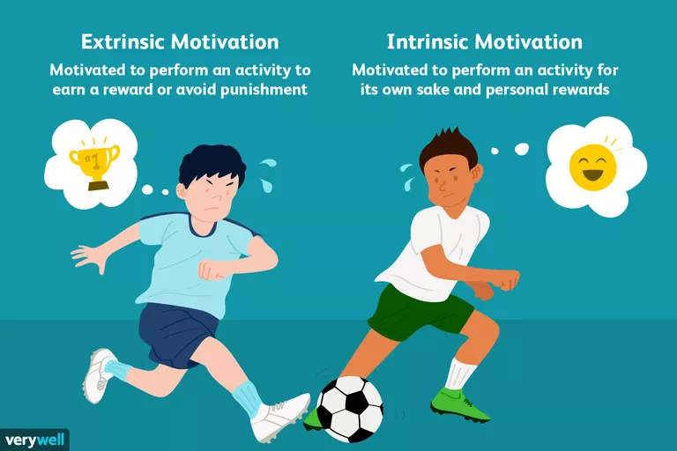

Figure 1.2 intrinsic vs extrinsic

How does Tesco motivate their staff?
Business markets are in competition today, every employee wants their company to provide better training and personal development plan so they can perform better in their workplace. Therefore, employee development is vital for the success of the company.
This training development will help staff to perform better in their position because they will learn new skills and knowledge. This will also help them to change their attitude and behaviour in their workplace.
Every company has different training and development programs in place based on what materials and facilities are available to them.
Tesco motivates its staff with different approaches:
- They pay their staff with competitive salaries. Tesco increased its staff pay to 10.45% which is about £9 an hour (The Guardian, 2019).
- Tesco offers apprenticeships to the students who just left school to gain experience, skills and knowledge, at the same time they get paid. (Tesco Bank/careers,2019).
- Tesco gives discount to its staff and club card holders for their benefit. They are offered up to 50% discount to its club card holders between 7 and 26 of May this year. This was part of Tesco’s 100 years anniversary celebrations (Retail Gazette, 2019).
- Tesco staff are from diverse cultures. This helps them to develop an inclusive culture, where employees feel that they are welcomed and valued. They can work freely without fear and pressure.
- Tesco provides colleague club card to its staff. This card gives 10% discount on buying anything over £1 in the store and online. Tesco provides this card to motivate its staff. This scheme benefits the organisation financially, because staff will purchase its products. Staff will also benefit as they will get 10% discount, whereas if they shop at a different store, they would have to pay the full price.

Employee engagement

What is employee engagement?

“Engagement is about creating opportunities for employees to connect with their colleagues, managers and wider organisations. It is also about creating an environment where employees are motivated to want to connect with their work and really care about doing a good jo. It is a concept that places flexibility, change and continuous improvement at the heart of what it means to be an employee and an employer in a twenty-first century workplace” (Truss, 2009).
Employee engagement is workplace relationship. It is what an employee does in his or her role and how they behave to achieve organisational and individual objectives.
From the above definition it is clear that employee engagement is a two-way relationship between the employee and the employer. Both sides have to cooperate with each other for the success of the company. This increases productivity and profit. So, the employer must create such an atmosphere in the workplace where employees feel that they are recognised, respected, valued and that they are involved in decision making and feel secure. This will drive them to do hard work for the organisation.
Employee engagement is important for the organisation for its productivity and profitability. It is also important for the well-being of employees. This will increase job performance (Mathieu and Zajac, 1990), increase job satisfaction (Vandenberg and Lance, 1992), decrease intention to search for alternative employers (Cohen, 1993) and increase sales (Barber et al,1999).
Furthermore, engaged employees will work hard, respect each other, try to do things better and would be willing to ‘go the extra mile’ (Robinson et al, 2004)

Employee engagement in Tesco
Tesco employees are engaged in many ways;
Communication: Tesco has very good communication channels to communicate with, between staff, managers and with the wider stakeholders. This is often a 1-to-1 dialog with managers as well as through the company’s internet and newsletters.
They also use notice boards, TV screens, emails and social media to communicate with one another, this is employee engagement (Sengupta,2017).
Another way of engagement is that, everyday line managers hold meetings to update staff about the activities on that day. They spend an hour or two discussing the company performance, financial results or any events and activities. During the discussion, they also take employee’s opinions and questions.
Tesco Bengaluru India has introduced different colleague engagement activities, among them are;
Talent showcase where colleagues show their talent by singing, painting, stand- up comedy and with other activities. These activities help them to share their ideas, skills and experience with their colleagues. This helps them to socialise so in the workplace they perform better.
Celebration of events: As part of employee engagement, employees celebrate events with great fun. Events like international women’s day, children’s day and world environment day.
Yammer chat is a platform where leaders discuss and share views with their colleagues for over an hour as part of employee engagement (Sengupta, 2017).

Feedback

What is feedback?

Feedback is information or statements of opinions about something, such as a new product that can tell you if it is successful or liked (Cambridge Dictionary,2019).
Feedback is to provide information to people on their performance. This could be after completing a test, event or on behaviour.
In business, managers normally provide feedback to their employee throughout the year or in performance meetings, this feedback could be as part of 360- degree feedback system.
Providing feedback is important as it helps to improve performance, correct mistakes and faults which benefits for the feedback provider, feedback receiver and for the wider organisation. Furthermore, giving feedback can motivate employees to perform better (DeFranzo, 2015; University of Leicester, 2019)
Feedback can be negative or positive. When the feedback is provided, the provider should not judge, but should focus on key issues, provide feedback on actual events or on specific behaviour that needs to be improved. Avoid giving sandwich feedback (Giving negative feedback between two pieces of positive feedback) as it undermines your feedback (Roger Scwarz,2013). Also, it brings negative consequences to the employees. A research was carried out by the Journal of Behavioural Studies in Business, where they found that the sandwich feedback can damage in many ways; this can create distrust to employees or safety concern. This may give employees weak or wrong understanding about their performance and changes that they need to improve (Southeastern Oklahoma State University,2014).

What is 360- Degree Feedback?

360-degree feedback is also known as Multi Source feedback. It provides more accurate assessment of performance and behaviour from many assessors.
Ward (1997) defined 360-degree feedback as ‘The systematic collection and feedback of performance data on an individual or group derived from a number of the stakeholders on their performance’.
This includes managers, colleagues, subordinates, customers (internal and external), as receiving feedback from different source, will give accurate information.

Diagram for 360-degree feedback
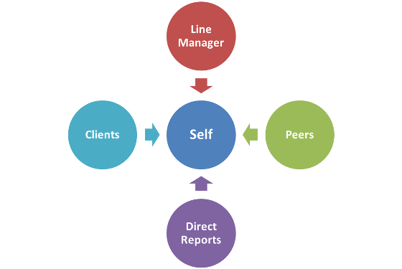

Figure 1.3 360 feedback diagram

Benefit of 360-degree feedback
Evidence from the literature regarding the effectiveness of 360-degree feedback in enhancing performance has shown that when 360-degree feedback is designed, implemented and conducted in a professional manner, it can have a number of beneficial effects (The Feedback Project, 2001). These include:
- Increased employee self-awareness.
- Enhanced understanding of behaviour needed to increase individual and organisational performance.
- The creation of development activities that are more specific to the employee.
- Increased involvement of employees at all levels of the organisational hierarchy.
- Increased devolution of self-development and learning to employees.

Task two

Benefit of motivation to the Tesco
- Tesco gives a discount card to its staff, gym membership and holiday discount etc, in return Tesco receives revenue from its staff because they spend money in Tesco to get a discount so the company’s profit increases.
- Tesco staff are from diverse cultures. This helps improve productivity levels, because the diverse team can make decisions better and faster so they have an advantage over other companies. As a result, Tesco’s profit has increased. According to the research of McKinsey & Company (2012), they found that between 2008 and 2010, companies with more diverse top teams were also top financial performers.
- Diverse teams can solve problems sooner and faster because different background employees bring different ideas and skills. As a result, problems will be solved faster. This will reduce company cost, time and bad reputation (Reynolds and Lewis, 2017)

Benefit of motivation to the employee
Tesco’s apprenticeship scheme attracts many youngsters to join Tesco as they can build up their experience, skills and knowledge as well as money to survive.
As part of motivation, Tesco provides its employees with a discount card, holiday discounts, gym membership etc. this helps employee benefit financially as they get discount.
Having a diverse culture helps employees to know different culture and tradition. They bring different experience and ideas.
Diverse culture also helps employees to feel secure, peaceful and comfortable in their workplace. This will create harmony between the team. This drives them to go the extra mile. They will work hard to achieve organisational goals.

Benefit of employee engagement to Tesco
Tesco has many ways to engage employees, as mentioned above; through communication, working as a team, dealing with the customers and stakeholders.
Engaged employees work harder and faster because they enjoy doing their job. If they want to complete a task, they would do it properly and nicely without wasting time. Employees feel that they are attached to their work and company. They do everything for the success of their company. This benefits the company as well as for the individual (MacLeod and Clarke, 2009). It will also bring higher productivity to the company.
According to the study by Gallup Organisation in 2012, they found out that the company whose employees are fully engaged, bring 12% more profit to the company than the company whose employees are not fully engaged.

Benefit of engagement to the employee:
With the employee engagement, employees feel a higher degree of satisfaction. When employees are satisfied in their job, they feel that they belong to the company so they are motivated, they would not do anything that damages their company. They would work with each other to achieve the company’s objectives.

Benefit of feedback to Tesco
When feedback is provided to the employee, they would know their weaknesses, error and mistakes and improve them. The employee will be more confident in their job and perform better in their workplace. This will help Tesco save money, as to hire a new one would cost more. Employees that received feedback will do a good job for the company, make less mistakes and the company will achieve its goals and objectives.
Benefit of feedback to the employees:
Feedback helps employees to be more aware of themselves, discover their strength and weaknesses so they can improve it. When employees ask for feedback from their manager and colleagues it actually motivates them to perform better in their workplace, because when employees ask for feedback that means that they feel they are valued. This encourages them to do hard work for their company.
By receiving feedback, employees will learn what to improve, how to improve and what types of training they need to do. Feedback may lead employees to a promotion, because after providing feedback to the employee, the employee will improve his or her weaknesses. This would help the employee to go for a higher position.

Benefit of using 360-degree feedback to Tesco and its employees
All employees at Tesco have a 360-degree feedback system. This is one of the tools of the personal development plan where managers, directors, business leaders and colleagues in all Tesco stores gives their feedback. This feedback system helps employees to know their strengths and weaknesses as well as their behaviour, because this feedback is provided by others. This helps them to improve so they can perform better in their workplace, it also has organisational benefits such as, they would do things effectively and would make less mistakes.

Task Three

Personal Development plan
Every employer wants to achieve their organisational objectives and goals. They achieve this through the effort and hard work of their employees. If they want their employees to perform better in the workplace, employees need training and personal development plan. With the personal development plan, employees develop themselves to do better in the future. So personal development is a continuous lifetime process of development to improve skills and knowledge to perform better in the workplace.
According to Coaching Positive Performance (2018), there are 6 benefits of personal development; it helps to be more self-aware, who you are and what your values and beliefs are. Self-awareness is the first step in the personal development plan.
It gives you a sense of direction, it will be clear to you about what you want to achieve and how you want to achieve it. You will be focusing on things that lead you towards achieving your objectives.
It will give you clarity. Even with the right direction, there will be multiple tasks looking for your attention. As your personal development improves, prioritising the tasks will become easier.
Personal development will help you to be more motivated. When you realise what you need to achieve, it is far simpler with the intention to see the advantages of taking action. Even when the task beforehand isn't exciting; if you can see a clear advantage, you are more motivated to take the necessary action.
It gives you greater Reliance. There will be tough times ahead but personal development process will give you confidence to deal this with better.
Personal development will give you more fulfilling Relationships. You will be able to see which relationships are worth investing time in and you will develop the skills to make the most of these relationships thereby making a more positive impact on your life.

How personal development plan works

First find out what development needs are, some people already know what they are good at and what they need to improve on, for others, they can find out by discussing with their manager or asking their colleagues.
These needs can also be identified using different test tools such as self-assessment test or The Myers–Briggs Type Indicator (MBTI) test or any other self-awareness tools to assess your skills.
Once you have identified the skills and knowledge you need to improve on, set a development objective. These objectives should be SMART: Specific, Measurable, Achievable, Realistic and Timely.
Next, plan how to meet your target. This could be met by taking a range of learning activities such as attending training courses or other ways to improve. In setting targets, some objectives may need to be met immediately so their priority is high, these should be done as soon as possible. Others could be met gradually so their priority is medium followed by low priority.
Finally, evaluate and review to see whether you met your objectives or not, or need more time achieve your target (Accreditation Council for Pharmacy Education,2015)

Personal Development Cycle

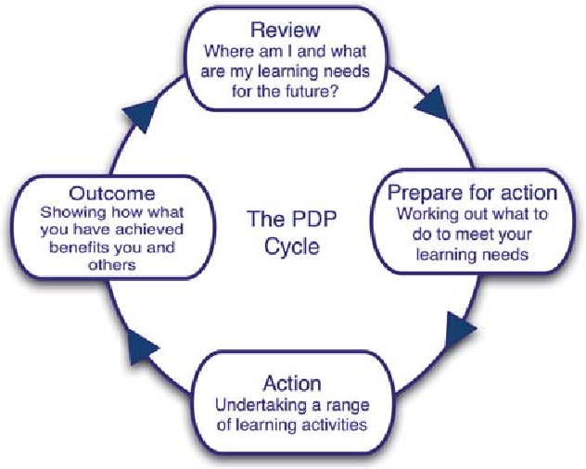
Figure 1.2 personal development cycle

Researcher has identified that Tesco employees need to improve in some areas such as: their communication skills, team working skills and need more training for their personal development. Therefore, the researcher has developed an action plan to meet the skills mentioned above.

Personal Development plan for Tesco employees

Objectives/Target | Action Plan | Priority | Review date
Communication skills | For written communication;  - practice writing letters and Emails.  - Learn five vocabularies daily  For verbal communication;  - Practice with other colleagues daily for 15 minutes | High | As soon as possible
Team Working | Attend classes/ Trainings. Practical group work. | Medium | 3 weeks
Training | Attend training courses e.g. leadership and management training. Online training. | Medium | 2 weeks

Communication skills: Manager and Customer Service Assistant communicates daily with colleagues and customers. They communicate with different channels such as by telephone via Email, social media, meetings and one to one. Ineffective communication to the customers can have negative views about the company, this may damage the company’s reputation as Harvard Business Review survey (2016) found that effective communication can bring 73% success to the company and the highest rate of success bring to the company with 80%, is the high level of customer service. Therefore, the priority is high. This must be done as soon as possible.
Team working: As employees at Tesco work as a team, this is their daily routine and employees have some previous skills working with the team. To enhance this skill further, employees need to attend classes, trainings as well as engage in practical team working, so the priority level is medium. To achieve this, three weeks is enough.
Training: All employees including leaders and managers need training for their personal development so they perform well in the workplace. There are different types of training such as team leader or supervisory training, leadership and management training, health and safety training, fire and safety training etc. some of these training needs to be updated annually. So, the priority for this is medium. Two weeks for this training is fine.
Review date: This is the time that should take to achieve the objectives until the review is done. If the objectives are not achieved, find out what can be done to achieve next time.

Conclusion
Tesco uses three development tools as part of their employee’s personal development plan. Motivation, employee engagement and training. Tesco’s motivation strategy is the most effective, as Tesco motivates their employees in many ways. Tesco’s 360-degree feedback system is also very fruitful, as it gives feedback from multi sources, colleagues, managers and stakeholders. As a result, Tesco’s employees are more self-aware and more skilled. For this reason, Tesco is believed to be the most successful and profitable company in the UK.
The researcher further demonstrated a personal development plan for the employee where he identified three key areas where employees need more improvement so they can perform better in the future.

Reference

Accreditation Council for Pharmacy Education. (2015) Guidance on Continuing Professional Development (CPD) for the Profession of Pharmacy. Available from: https://www.acpe-accredit.org/pdf/CPDGuidance%20ProfessionPharmacyJan2015.pdf (Accessed on 20/07/2019)
Barber, L. Hayday, S. and Bevan, S. (1999) From people to profits. Brighton: Institute for Employment Studies.
Cohen, A. (1993) ‘Age and tenure in relation to organisational commitment: A meta-analysis’, Basic and Applied Social Psychology, Vol. 14, pp. 143-159
Cambridge Dictionary. (2019) Feedback. Available from: https://dictionary.cambridge.org/dictionary/english/feedback (Accessed on 15/072019)
C. W. Von Bergen, Martin S. Bressler, Kitty Campbell. (2014). The sandwich feedback method: Not very tasty. Journal of Behavioural Studies in Business Volume 7. Available from: http://www.aabri.com/manuscripts/141831.pdf (Accessed on 12/07/2019).
Coaching Positive Performance. (2018) 6 Core benefits of Personal Development. Available from: https://www.coachingpositiveperformance.com/6-core-benefits-personal-development/ ( Accessed on 28/07/2019)
Fleming, M. (2019 How Tesco revolutionised loyalty with Clubcard. Marketing week. (Available from: https://www.marketingweek.com/tesco-clubcard-loyalty/
Gallup (2012) Employee Engagement. Available from: https://www.gallup.com/topic/employee_engagement.aspx (accessed on 14/07/2019).
The Feedback Project. (2001) 360 Degree Feedback: Best Practice Guidelines, SHL, CIPD; University of Surrey Roehampton, pp. 68-82
The Guardian. (2019) Tesco raises wages for store and warehouse workers by 10.45%. available from: https://www.theguardian.com/business/2019/jun/10/tesco-raises-wages-for-store-and-warehouse-workers. (Accessed on 16/07/2019)
Gatenby, M. Rees, C. Soane, E. & Truss, C. (2009) Employee engagement in context. London: Chartered Institute of Personnel and Development.
Harvard Business Review. (2016) The Impact of Employee Engagement on Performance. Available from: https://hbr.org/sponsored/2016/04/the-impact-of-employee-engagement-on-performance. (Accessed on 23/07/2019)
MacLeod, D. & Clarke, N. (2009) Engaging for success: enhancing performance through employee engagement. A report to Government. Available from: https://dera.ioe.ac.uk/1810/1/file52215.pdf (Accessed on 12/07/2019)
McLeod, S. (2007) Maslow's hierarchy of needs. Simply psychology, 1.
Mathieu, J. Zajac, D. (1990) ‘A review and meta-analysis of the antecedents, correlates, and consequences of organisational commitment’, Psychological Bulletin, Vol. 108, pp. 171-194
McKinesy & Company. (2012) Is there a payoff from top-team diversity? Available from: https://www.mckinsey.com/business-functions/organization/our-insights/is-there-a-payoff-from-top-team-diversity. (Accessed on 27/072019)
Raynold, A, Lewis. (2017) Teams Solve Problems Faster When They’re More Cognitively Diverse. Harvard Business Review. Available from: https://hbr.org/2017/03/teams-solve-problems-faster-when-theyre-more-cognitively-diverse. (Accessed on 28/07/2019)
Retail Gazette. (2019) Tesco to offer Clubcard holders 50% discounts amid 100th birthday. Available from: https://www.retailgazette.co.uk/blog/2019/04/tesco-offer-50-discounts-clubcard-holders-amid-100th-birthday/. (Accessed on 11/07/2019)
Robinson, D. Perryman, S. & Hayday, S. (2004) The drivers of employee engagement. Report-Institute for Employment Studies.
Sengupta, S. (2017) employee engagement: How Tesco creates opportunities to boost employee engagement. Available from: https://www.peoplematters.in/article/employee-engagement/how-tesco-creates-opportunities-to-boost-employee-engagement-16538. (Accessed on 24/07/2019)
Schwarz, R. (2013) The Sandwich Approach undermines your feedback. Harvard Business Review. Available from: https://hbr.org/2013/04/the-sandwich-approach-undermin. (Accessed on 17/07/2019)
Susan, E. DeFranzo. (2015) 5 Reasons Why Feedback is Important. Snap Surveys. Available from : https://www.snapsurveys.com/blog/5-reasons-feedback-important/. (Accessed on 22/07/2019)
Tesco Bank/careers. (2019) Apprenticeships. Available from: https://careers.tescobank.com/apprenticeships. (Accessed on 24/07/2019)
TESCO. (2019) Annual Report and Financial Statements 2019.Serving shoppers a little better every day Available at: https://www.tescoplc.com/media/754415/tesco_ara2019_full_report_web.pdf. (Accessed on 25/07/2019)
Tesco (2019) History. Available from: https://www.tescoplc.com/about-us/history/ (Accessed on 26/07/2019)
Taylor, F.W, (1911) The principles of scientiﬁc management. New York, 202.
University of Leicester (2019) Feedback. Available from: https://www2.le.ac.uk/offices/ld/resources/writing/feedback_five/4.-feedback-forward. (Accessed on 28/07/2019)
Vandenberg R, Lance C. (1992), Satisfaction and organisational commitment,’ Journal of Management, Vol. 18, pp. 153-167
Ward, P. (1997). 360-degree feedback. CIPD Publishing.

