With reference to specific examples from Chalcolithic or Bronze Age Cyprus critically evaluate how theoretical approaches together with the archaeological evidence enable our reconstruction of ancient household activities and organisation.

Applying theory to Chalcolithic and bronze age Cyprus allows us to form ideas of what the household activities and organisation may have possibly looked like, they allow us to form ideas of what life may have looked like in this period. Focusing on Processual, Post-Processual, Feminist and Experimental archaeology on Cyprus, we can craft an understanding what the household may have looked like.

The concept of Processual archaeology was formed in the 1960s and 1970s, it was done in the hopes of including the scientific method in the methodology of Archaeology and linking the study of Archaeology and Anthropology more closely. The study preposes that we should focus on using the scientific method to determine what life may have looked like. They believe that culture adapts to the outside environment. Archaeologists should try to focus on what things mean, and how they can help to explain the culture we are looking at.

Post Processual archaeology is a direct criticism of Processual Archaeology, also referred to as interpretive Archaeology, originated in the 1970s and 1980s, it used a more subjective approach. It argues that each culture should be seen as unique from the other, and concepts such as religion, gender and inequality are what shapes the underlying ethos, we shape the world around us with our own agency, a bottom-up way of considering development.
Feminist archaeology emerged in the 1970s and 80s, and was another criticism of Processual archaeology, focuses on the importance of gender in the past, it employs feminist thinking and understanding to these discoveries and aims to remove the bias towards men in archaeology. Using the terminology of feminist archaeology is a bit of a misnomer as the modern concept of feminism doesn’t define their field of study entirely. They aim to avoid gender bias in their study, they critique the application western gender ideals on non-western cultures.

Experimental archaeology, sometimes referred to as reconstruction archaeology, is much more practical than these other theories, it aims to test the hypothesis made by archologists, they apply the tools and techniques from the period to recreate what would have been done at the time they study. One of the major forms of this is the creation of replicas of historical structures using period accurate technology and techniques.

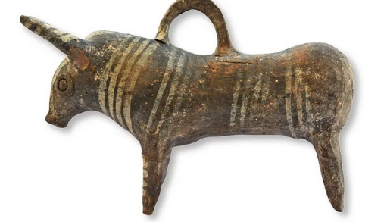
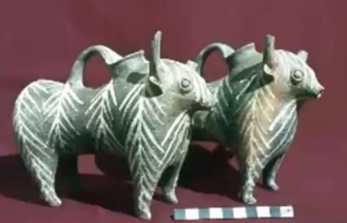
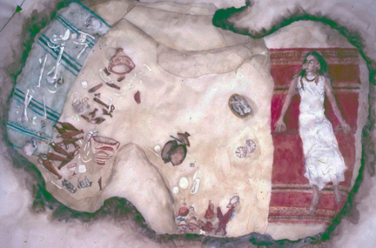
In this tomb from Kalavasoss, is the grave is of three women, who have been buried with extensive grave goods. Some of the pots found in this grave are from Macedonia, some of the jewellery is decorated with Egyptian gods. These women can be seen as significant members for their household and community and are buried with a significant amount of wealth. A tomb with similar grave goods can be found in Hala Sultan Tekke, where there were many similar items in use, focusing in on tomb SS, the tomb housed eleven bodies, of varying ages although most seemed to be articulated, evidence suggests that these tombs were used was places for worship, there is evidence of ritual use of fire, and there are feasting implements implying people used to visit these tombs to commemorate the deceased.
Figure 3 – the bull pouring vessel from Tomb ss at Hala Sultan Tekke
Figure 2 – two bull pouring vessels from Tomb 11 at Kalavasoss
Figure 1- Artistic representation of the tomb 11 at Kalavasoss

There is a similar argument for the tomb in Kalavaoss, an administrative building was built incredibly near to the tomb, which has been used as evidence that these women were worshiped or were seen as significant to the society they were from, while not indicative of the household organisation or activities these women are seen on a similar or with higher importance to men in the same area. There is no known evidence that the tomb in Kalavasoss was used for feasting, however the full discoveries from this tomb are yet to be published and so this may change.

Both tombs have similar Cypriot goods inside, notably a bull shaped hollow figurine. They also have artefacts from similar areas around the Mediterranean, both have objects from Egypt, a faience scarab, and a signet ring in the woman’s tomb.Both show the incredibly trade routes between the two areas, procedural archaeology would argue that these discoveries are linked to the environmental changes in the area, and the cultural changes brought around by the emerging trade routes.

To counter this however Feminist, or Post-procedural archaeology, would perhaps uses these items to argue that women were of equal social importance, Feminist archaeologists criticise the view that patriarchy appeared with the transition to the bronze age. Women are often presented as ‘divine life bringers’ many statues are crafted with feminine figures being pregnant or in the stages of labour, creating an idea that women in this period were revered for there ability to have children, which can be used as an explanation why the tomb in Kalavasos is so well decorated – the woman are interred with the bones of several infants, perhaps in reference to this ideology.

The religion of bronze age Cyprus was twofold, ancestor veneration and the importance of fertility. During the Chalcolithic period they would create cruciform figures used as fertility symbols. As travel began to expand around the Mediterranean and Cyprus began to get involved in trade these ideas developed, expanding to include images of bulls – like the jugs in both burials, and snakes. The theories of processual archaeology are also applicable here, as this shows the development of Cypriot culture affected by the environmental factors of developing trade routes. The movement and development of settlements would also be affected by this factor, many of the culturally rich sites in Cyprus are built around the coast of the island, for example of PoUtiko-Trouliia.
Figure 7 – Known as the Vounous bowl, this sculpture represents some form of religious ceremony, including sacrificial bull, and possibly child sacrifice.
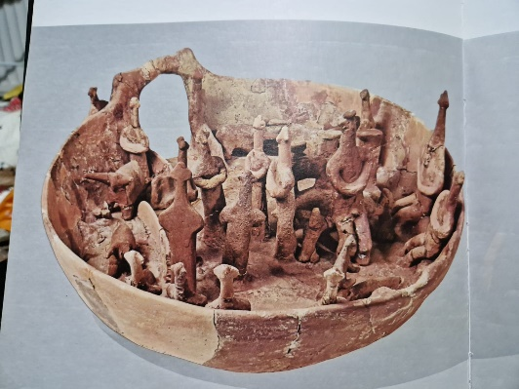

The vounous bowl is also a significant source to show differing and changing ideas around religious practice, there is a figure in the bowl wearing a bull mask with their arms covered In snakes, with someone knelt down in front of them, this change, as discussed by procedural archreology would argue it was affected by wider society, which is true here, the influence coming from areas of the levant.
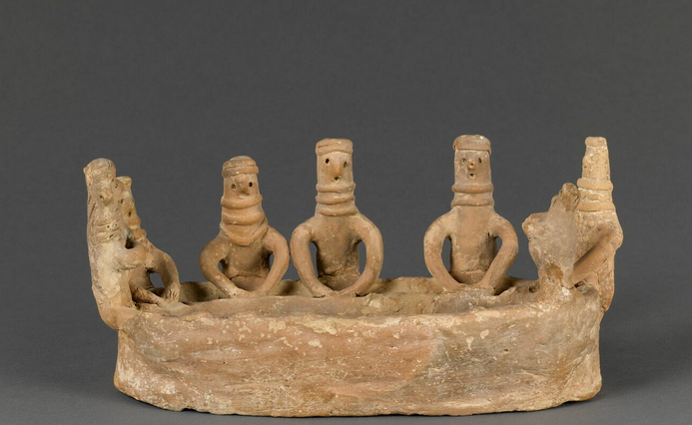
Figure 4 – labelled the figurine by the Louvre, this artifact is of unknown provenance, but represents a series of people at work

This artefact, currently in the Louvre, shows a series of figures at work around a trough. There are seven figures, all of which look identical, one is also holding a baby, this particular figure is identified as feminine, due to the fact that all the figures are designed the same there is a evidence that they are meant to represent the same gender. The exact activity they are performing is not entirely clear. The Louvre labels the activity as either bread making or beer. We can determine that these figures are women based on other identifying factors, they are similar in shape language to other figurines from the same period, and a few of the figures have raised sections which could be representative of breasts, there placement is high on the bodies of both examples. From these we can understand that women in Cyprus used to perform manual labour tasks like these and there was a sense of community around these women. This is also a decorative piece of pottery; this implies something about this task was culturally significant enough to be immortalised. Post-processual archaeology dictates that our agency affects culture we create, the necessity of the actions these women being forever immortalised in clay could be reference to this activity been seen as an intensely important household activity.
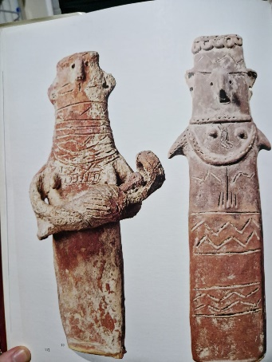
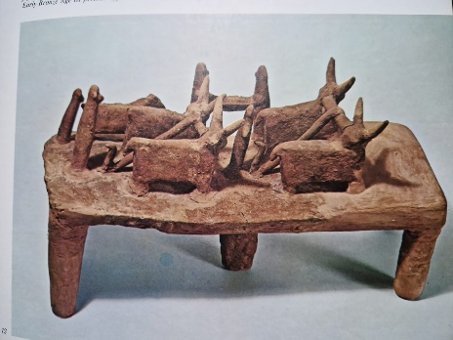
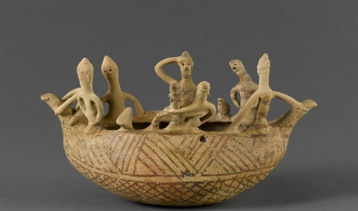
Figure 8 – Plank shaped red polish ware both are waring feminine clothing and have defined breasts, which seem high up on their bodies. The Left figure is holding a child, with an unidentified arch above his head.
Figure 5 – also called figurine by the louvre, this piece is supposed to represent a boat.
Figure 6 – a red polish ware figure of someone moving cattle for ploughing, a representation of farming practices.

Similar redware pottery can be used to determine daily activities during this period of Cyprus, there is a pottery piece representing a ploughing scene, which both indicates an aggregate culture, but also the household activities were most likely around food production, the gender of the figures is not identified, perhaps indicating the figure could be representative of any member of society. Similarly, the Vounous bowl shows an open-air sanctuary, showing some form of religious ceremony. In a white painted ware, we can see a model of a ship, maned by masculine figures. Each of these items are deliberate efforts to create reference to something of cultural significance, the problem stems from determining what, we cannot determine where the women with the trough were from as the provenance is currently unknown, and so dating it is also difficult, if it was a funerary piece for example we could use it to determine that the inhabitant of the tomb partook in this activity, or depending on their bone structure what the activity was, if the figures were actually gendered as feminine.

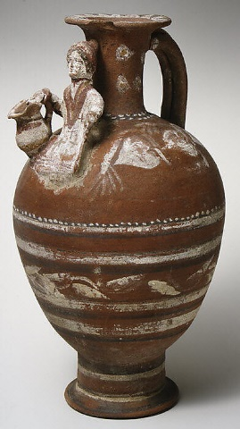
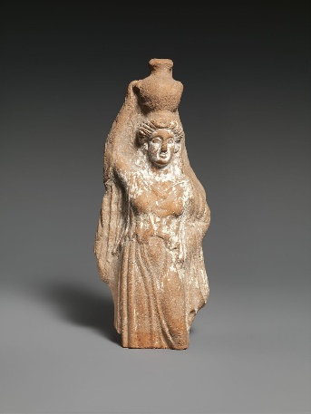
Figure 9 – a woman carrying a hydria.
Figure 10 – terracotta jug with a woman near the spout.

In Processual archaeology collected data is used to compare a modern groups adaptation to their environment, which is then applied to a ancient culture of a similar environment, in order to explain its systems. To start in our current understanding in modern day, many cultures rely on women to gather there water from around the world, an estimate made by UNICEF In 2016 stated that 13.54 million women are the ones to gather water for their households, to extrapolate this backwards there is a jug from Cyprus in the 300s BCE with a woman depicted, there is no way to determine what exactly this jug would have been used for, however, there is a educated guess that whatever it was seen as something women were responsible for, and based on the decorative nature of this piece, with attaching spout, this was used as a vessel for pouring drinks for others. There is also a statue of a woman, carrying a Hydria, the Greek word used for water jugs. From this we can work backwards, women would have been the ones to carry water in Bronze age Cyprus. This in turn can tell us a lot about household organisation, if women were tasked to gather water for there family then a great deal of there day would have been spent travelling to places to gather water, in a similar way to modern women who have to do this as well, this often means they have less chances for greater education, and their lives have to be structured around when they can perform this task.

Applying theory works well but it is also significant to look at the sources for themselves in the context they were found as this can help to identify physical household organisation. For instance, we know that bronze age Cypriot houses had a fire pit ion the centre, which implies there was a level of significance to fire for this culture, this can be seen in several examples in Cyprus, determining why the household structure is created in this way falls under post-processualism, the importance of fire is seen across several cultures in the world, and is something used to signify home for many people, the term ‘hearth and home’ applies here,

Cyprus the most prevalent example of experimental archaeology is the cite at Lemba. Entitled the Lemba experimental village, the experiment was focused on testing aspects of prehistoric construction. The first roundhouse was created with a mix of local mud and seaweed, formed into rings. The roof was flat earth, supported by a mat of wood and radial timbers. Over the several years this has been active, they have discovered that the roof is not incredibly stable, due to both birds nesting and the choice of materials. They have determined the strength of the walls is from the ‘restructuring of the clay and ash particles to form an interlocking mass when mixed as mud.’
The site was expanded throughout the 1990s to include houses from throughout the Chalcolithic period, demonstrating the differences in size depending on when they were built. We can see the increase in the size throughout the chalcolithic, perhaps indicative of changing resources and the importance placed on households. A physically larger house is often a signifier of social stratification, which could be seen to be emerging here. The larger households could also symbolise a move away from a community mentality and moving the focus onto one of household importance, a change in the environment.
This has allowed for development in understanding how the physical houses would have been built, what materials they used and how the construction process would have been performed, it was understood before this study was conducted that walls in Bronze age Cyprus were formed in the pise de terre style would not have worked in Cyprus on the time, as the packed earth requires extra supports, which the carpentry evidence at the time does not support.
The information from this site has also suggests that households would be built by the communities they were from, what was suggested to be a specialised process in the making of lime plaster flooring is more likely to have been done by anyone involved in the creation of a house, in turn suggesting this to be a household activity.
Experimental archaeology has the capacity to tell us a great deal about household organisation, however it is an incredible time sink, the studies at Lemba began in the 1990s and the studies are still ongoing, and they currently cannot tell us a great deal about structure as the study was done to see what was affective when building not activities.

Overall, applying theoretical approaches to Cypriot archaeology allows us to form a varied interpretation of household activities and organisation, however relying to heavily on theories can stop the importance of the sources themselves from being seen. Using theories individually without recognising the criticisms of each one is also an issue which archaeologists face when applying these things. Each theory runs the same risk of applying modern norms and cultural understanding is difficult at best and impossible at worst.

The concept of Processual Archaeology works well; however, it works on the idea that progress through society has been almost entirely linear and can ignore differing speeds or factors in development. Cyprus is a relatively isolated island in the Mediterranean, applying information from the experiences on mainland Africa may not be applicable as the climate, landscape and population density affects they development of culture and household organisation. By working backwards from the modern, we can overlook the significant effects of globalisation and the rise of the internet in our shared cultural identity, and how things specific to certain areas of the world would not be influenced or affected by there neighbours.

Applying feminist theory to ancient history runs into many of the same problems as I outlined in sections of Bourdieu’s theory, by applying modern concepts of gender on this in older societies does not work as their concepts of gender differ greatly. Applying feminist theory to Egypt for example can limit our understanding greatly. Hatshepsut performed the job of a Pharoh as a woman, which was seen as a masculine job, applying our very strict sex-based gender roles would imply that she had gone against the rules of her gender to perform the job, whereas the ancient Egyptian refereed to her pharaonic identity with masculine identifiers. Something foreign to modern understanding.

Image credits –

Figure 1 – Assessment brief

Figure 2 – Credit to Allison south, photo taken from her lecture, Allison South CAARI lecture.

Figure 3 – credit Peter M Fischer and Teresa Bürge, in Life and death in a Cypriot Bronze Age society

Figure 4 – figurine, © 2010 RMN-Grand Palais (musée du Louvre) / Franck Raux

Figure 5 – figurine ; modèle, © 2010 RMN-Grand Palais (musée du Louvre) / Franck Raux

Figure 6 – Illustration 72, in The civilisation of prehistoric Cyprus

Figure 7 - Illustation 71, in The civilisation of prehistoric cyprus

Figure 8 – Illustration 79, AM 1459, in The civilisation of prehistoric Cyprus

Figure 9 – Terracotta statuette of a female votary carrying a hydria, https://www.metmuseum.org/art/collection/search/241275

Figure 10 – Terracotta jug, https://www.metmuseum.org/art/collection/search/240160

Bibliography –
- Bolger, D, C. McCartney, E. Peltenburg, ‘Regional Interaction in the Prehistoric West: Lemba Archaeological Project Western Cyprus Survey, in ARCHAEOLOGICAL FIELD SURVEY IN CYPRUS: PAST HISTORY, FUTURE POTENTIALS Vol.11 (British School at Athens Studies, 2004)
- Calinescu, A. - Ancient jewellery and archaeology (Indiana University press, 1996) pg.29
- Falconer, S. E., and P. L. Fall, ‘Household and community behavior at Bronze Age Politiko-Troullia, Cyprus,’ in Journal of Field ArchaeologyVol. 38, No. 2 (Taylor & Francis, Ltd, 2013)
- Karageorghis, Vassos, The Civilization of Prehistoric Cyprus, (Ekdotike Athenon S.A., 1978)
- Klinkenberg, M. V., B. S. Düring, ‘Inequality before the Bronze Age: the case of Chalcolithic Cyprus,’ in Oxford Journal Of Archaeology (University Liden, 2022)
- Knapp, A. B., M. Given, Social landscapes and social space: the Sydney Cyprus Survey Project in ARCHAEOLOGICAL FIELD SURVEY IN CYPRUS: PAST HISTORY, FUTURE POTENTIALS Vol.11 (British School at Athens Studies, 2004)
- Mina, Maria, Was It a Man's World? Gender Relationships at the Transition to the Bronze Age in Cyprus, in Near Eastern Archaeology, Vol. 79, No. 3, Special Issue: Gender Archaeology (The University of Chicago Press, 2016)
- Donavon, A, Cypriot Religion of the Early Bronze Age: Insular and Transmitted Ideologies, ca. 2500-2000 B.C.E.Ideologies, ca. 2500-2000 B.C.E.( University at Albany, State University of New York, 2013)
- Thomas, G, ‘The role of research and education in site management at the Lemba Experimental Village, Cyprus, in Conservation and Management of Archaeological Sites, 3:1-2,( Routledge, 1999)
- Tyldesley, J., Hatchepsut the Female Pharaoh, (Penguin Books, 1998)
Webliography –
- CAARI Cyprus, (2021) Allison South CAARI lecture, Available at: https://www.youtube.com/watch?v=J_JW4qWwAMw (Accessed 15/1/2024)
- Caruso, Bethany, ‘Women still carry most of the world’s water,’ https://theconversation.com/women-still-carry-most-of-the-worlds-water-81054 [accessed 21/1/2024]
- Chandler, Nathan, How Bioarchaeology Works, https://science.howstuffworks.com/environmental/earth/archaeology/bioarchaeology.htm [Accessed 21/1/2024]
- Dempsey, Karen, ‘Gender and Archaeology,’ https://www.oxfordbibliographies.com/display/document/obo-9780199766567/obo-9780199766567-0274.xml?rskey=daYDix&result=1&q=feminist+archeology#firstMatch [Accessed 21/1/2024]
- Fischer, P.M., Teresa Bürge, ‘Life and death in a Cypriot Bronze Age society,’ https://the-past.com/news/life-and-death-in-a-cypriot-bronze-age-society/ [Accessed 21/1/2024]
- Kriger, William, ‘Processual Archaeology’, https://www.oxfordbibliographies.com/display/document/obo-9780199766567/obo-9780199766567-0056.xml [Accessed 21/1/2024]
- Outram, Alan, Linda Hurcombe, ‘Experimental archeology’ https://www.oxfordbibliographies.com/display/document/obo-9780199766567/obo-9780199766567-0271.xml?rskey=jmoJPm&result=1&q=experimental+archeology#firstMatch [Accessed 21/1/2024]
- Preucel, Robert W. , ‘Post Processual Archaeology,’ https://www.oxfordbibliographies.com/display/document/obo-9780199766567/obo-9780199766567-0188.xml?rskey=VN2Y0j&result=1&q=post+processual+archeology#firstMatch [Accessed 21/1/2024]
- UNICEF, ‘UNICEF: Collecting water is often a colossal waste of time for women and girls,’ https://www.unicef.org/press-releases/unicef-collecting-water-often-colossal-waste-time-women-and-girls [accessed 21/1/2024]
- The university of British Columbia, ‘Kalavasos-Ayios Dhimitrios,’ https://kambe.cnrs.ubc.ca/the-sites/kalavasos-ayios-dhimitrios/ (Accessed 15/1/2024)

William Kriger, ‘Processual Archaeology’, https://www.oxfordbibliographies.com/display/document/obo-9780199766567/obo-9780199766567-0056.xml [Accessed 21/1/2024]
Robert W. Preucel, ‘Post Processual Archaeology,’ https://www.oxfordbibliographies.com/display/document/obo-9780199766567/obo-9780199766567-0188.xml?rskey=VN2Y0j&result=1&q=post+processual+archeology#firstMatch [Accessed 21/1/2024]
Karen Dempsey, ‘Gender and Archaeology,’ https://www.oxfordbibliographies.com/display/document/obo-9780199766567/obo-9780199766567-0274.xml?rskey=daYDix&result=1&q=feminist+archeology#firstMatch [Accessed 21/1/2024]
Alan Outram, Linda Hurcombe, ‘Experimental archeology’ https://www.oxfordbibliographies.com/display/document/obo-9780199766567/obo-9780199766567-0271.xml?rskey=jmoJPm&result=1&q=experimental+archeology#firstMatch [Accessed 21/1/2024]
A. Calinescu - Ancient jewellery and archaeology (Indiana University press, 1996) pg. 29
Ibid. 30
Peter M Fischer, Teresa Bürge, ‘Life and death in a Cypriot Bronze Age society,’ https://the-past.com/news/life-and-death-in-a-cypriot-bronze-age-society/ [Accessed 21/1/2024]
The university of British Columbia, ‘Kalavasos-Ayios Dhimitrios,’ https://kambe.cnrs.ubc.ca/the-sites/kalavasos-ayios-dhimitrios/ (Accessed 15/1/2024)
The tomb’s findings are currently unpublished, as explained by the excavator in CAARI Cyprus, (2021) Allison South CAARI lecture, Available at: https://www.youtube.com/watch?v=J_JW4qWwAMw (Accessed 15/1/2024)
CAARI Cyprus, (2021) Allison South CAARI lecture, Available at: https://www.youtube.com/watch?v=J_JW4qWwAMw (Accessed 15/1/2024)
Peter M Fischer, Teresa Bürge, ‘Life and death in a Cypriot Bronze Age society,’ https://the-past.com/news/life-and-death-in-a-cypriot-bronze-age-society/ [Accessed 21/1/2024]
A. Calinescu - Ancient jewellery and archaeology (Indiana University press, 1996) pg.29
Maria Mina, Was It a Man's World? Gender Relationships at the Transition to the Bronze Age in Cyprus, in Near Eastern Archaeology, Vol. 79, No. 3, Special Issue: Gender Archaeology (The University of Chicago Press, 2016), pp. 140)
A Donavon, Cypriot Religion of the Early Bronze Age: Insular and Transmitted Ideologies, ca. 2500-2000 B.C.E.Ideologies, ca. 2500-2000 B.C.E.( University at Albany, State University of New York, 2013) p. 22
Ibid. 24-30
A Donavon, Cypriot Religion of the Early Bronze Age: Insular and Transmitted Ideologies, ca. 2500-2000 B.C.E.Ideologies, ca. 2500-2000 B.C.E.( University at Albany, State University of New York, 2013)
Louvre, ‘Figurine,’ https://collections.louvre.fr/ark:/53355/cl010118436 [accsessed 21/1/2024]
Figure 5,
Figure 7
Nathan Chandler, How Bioarchaeology Works, https://science.howstuffworks.com/environmental/earth/archaeology/bioarchaeology.htm [Accessed 21/1/2024]
UNICEF, ‘UNICEF: Collecting water is often a colossal waste of time for women and girls,’ https://www.unicef.org/press-releases/unicef-collecting-water-often-colossal-waste-time-women-and-girls [accessed 21/1/2024]
Figure 10
Figure 9
Bethany Caruso, ‘Women still carry most of the world’s water,’ https://theconversation.com/women-still-carry-most-of-the-worlds-water-81054 [accessed 21/1/2024]
G Thomas, ‘The role of research and education in site management at the Lemba Experimental Village, Cyprus, in Conservation and Management of Archaeological Sites, 3:1-2,( Routledge, 1999) p.115
Ibid. 116
Ibid. 116
Ibid. 116
Ibid. 117-118
Ibid. 118
Ibid. 119
J. Tyldesley, Hatchepsut the Female Pharaoh, (Penguin Books, 1998) p. 1

