
Managing Enterprise in the 21st Century
Business Plan

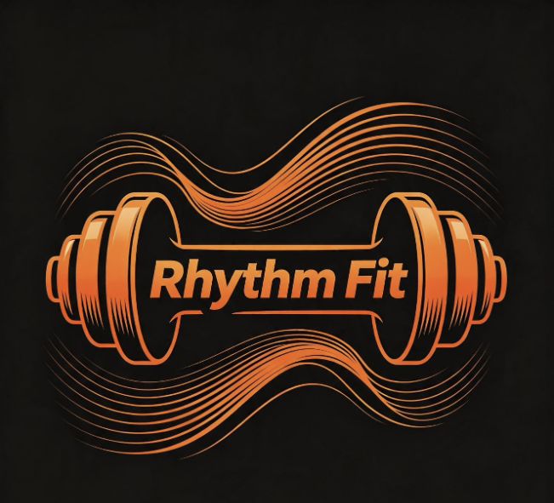
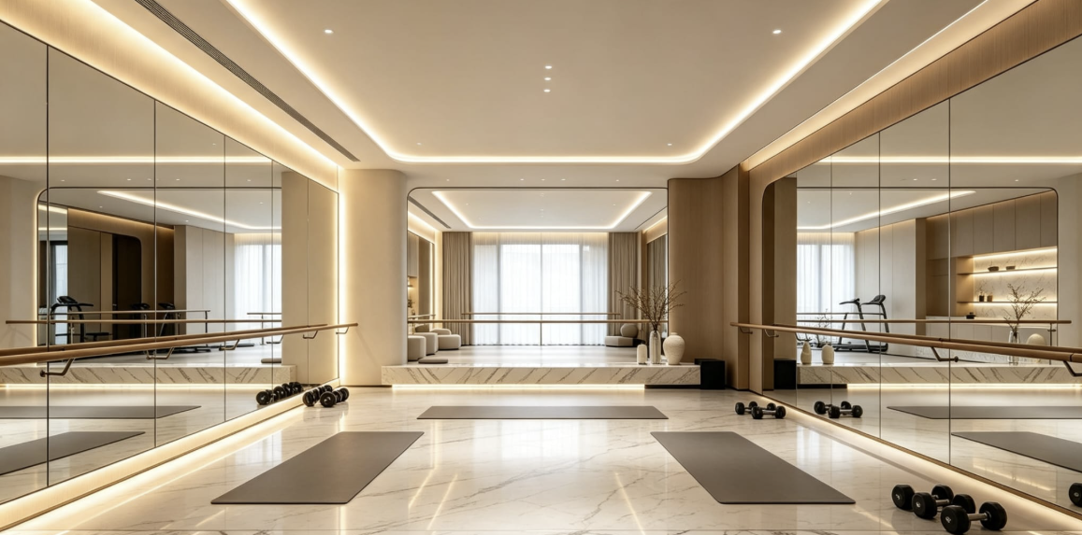
www.movewithrhythmfit.co.uk

Submission Date:27/07/2026
Lecturer: Mustakkima Afrin

Table of Contents
Group Information 2
Executive Summary 4
Business Concept 5
Business Description 5
Product Description 5
Business Objectives (SMART Objectives) 5
Short-Term Objectives (less than a year) 5
Long-Term Objectives (less than a year) 5
Market Analysis and Marketing Plan 6
Market Analysis (Competitors, Customers, Target Groups) 6
PESTEL Analysis 6
SWOT Analysis 6
Marketing Mix (4Ps) 6
Management Team 6
Management Team and Their Background 7
Organisational Chart 7
Key Milestones 7
Financial Plan (One Year) 7
Sources of Finance 7
Cash Flow Forecast 7
Sales Forecast 7
Cost of Production Forecast 7
Break Even Analysis 7
Operations and Management Plan 7
Production of Good and Service 7
Technology Plan 7
Human Resource Plan 7
Expansion Plan 8
Reference List 8
Appendices: 9

📝 Executive Summary

Rhythm Fit Training is a dance-infused personal training service designed to transform traditional exercise into an expressive, enjoyable, and confidence-building experience. The business blends structured fitness coaching with choreographed movement, creating a unique hybrid model that appeals to individuals who want results without having to use traditional gym environments. Rhythm Fit aims to support adults aged 18–50 improving their physical health, coordination, emotional wellbeing, and self-confidence, through music-driven workouts that feel more like dance sessions than standard exercise routines. The business will operate through community venues, dance studios and online platforms, supported by a strong digital presence and a brand identity centred on rhythm, empowerment, and inclusivity. With a growing demand for alternative fitness formats, Rhythm Fit is positioned to become a distinctive and accessible option within the UK fitness market.

💡 Business Concept

Rhythm Fit Training is a dance-infused personal training service that merges structured fitness coaching with expressive, music-driven movement. The concept is built on the belief that exercise should be enjoyable, confidence-boosting, and emotionally uplifting rather than intimidating or repetitive. Rhythm Fit transforms traditional workouts by integrating choreographed routines, rhythm-based cardio, and functional strength training into a seamless, high-energy experience. This hybrid model appeals to individuals who want to improve their physical health while also enhancing coordination, creativity, and self-expression.
The business is designed to support adults aged 18–50, aimed to target beginners and returning exercisers who may feel uncomfortable in conventional gym environments. Rhythm Fit prioritises enjoyment, accessibility, and personal transformation. By combining the motivational power of music with the structure of personal training, Rhythm Fit offers a unique fitness experience that encourages long-term engagement.

🏢 Business Description

Rhythm Fit Training offers a unique model that merges personal training with dance-based fitness. Unlike traditional PT services that focus solely on structured exercise, Rhythm Fit offers more uplifting, non-intimidating workouts that help build strength and confidence.
The business will provide one-to-one coaching, small group classes, and themed dance-fitness sessions that combine functional strength training, cardio intervals, and rhythm-based movement. Open to all genders aged 18-50, beginners, returning exercisers, and individuals seeking a fun, confidence-boosting approach to fitness. Rhythm Fit’s brand stands for empowerment, joy and personal transformation – a refreshing new choice for fitness.

🎵 Product Description
Rhythm-Fit training brings you fitness reimagined; expert personal training blended with dance infused movement. Every session has a mixture of rhythm driven cardio, functional strength and choreographed routines, all tailored exactly to individual’s abilities and goals.
At Rhythm-Fit you can choose from one-to-one sessions, small groups, themed classes, or online workouts, each class set with music, designed to feel more like fun, enjoyable exercises and not a chore. We prioritise confidence building, self-expression and holistic health, making us an exciting and refreshing alternative to fitness training.

🎯 SMART OBJECTIVES.
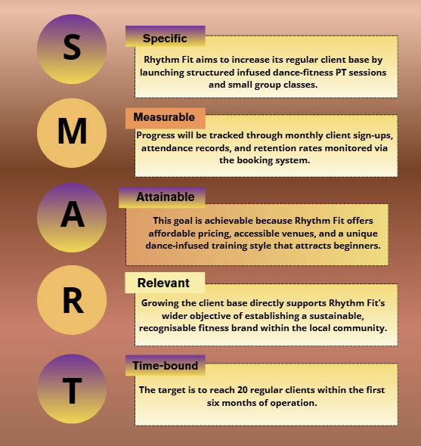
Table 1: Smart Objectives. Source: (Self-Produced)
⏳ Short-Term objectives (less than a year)
Within the first year Rhythm-Fit plans to launch in 2 months, partner with at least two local venues, gain 20-30+ regular clients, 1,000 followers, run our first themed event, by month 6 add online classes, hit break-even by month 9. Rhythm-Fit will help to build back the community with energy, inclusivity and heart.

📆 Long-Term objectives (more than a year)
Over a period of three years Rhythm – Fit plans to become the leading local dance – fitness provider with steady growth and a loyal client base. The business aims to open a dedicated studio, launch an online membership platform, and build strong partnerships with local community hubs, Councils, mental health charities, schools/colleges, and other local gyms.

📊 Market analysis and Marketing Plan.

Rhythm Fit serves all genders aged 18-50, standing out with personalised dance-fitness, accessible venues and digital outreach amid rising demands (Mintel,2026). Targeting mainly beginners and those who find conventional gyms unappealing (Sport England,2025), we offer inclusive dance infused, music-led fitness training across Hackney and East London.

🔍 Market Analysis (Competitors, Customers, Target Groups)

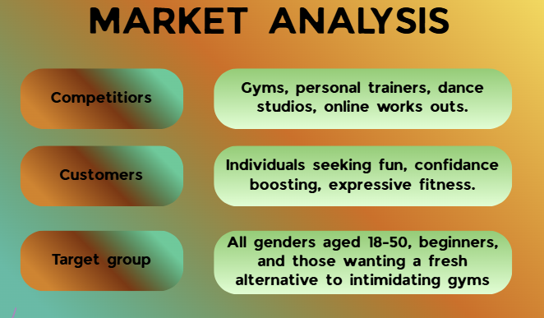
Table 2: Market Analysis. Source: (Self-Produced)

🌍 Pestle Analysis.

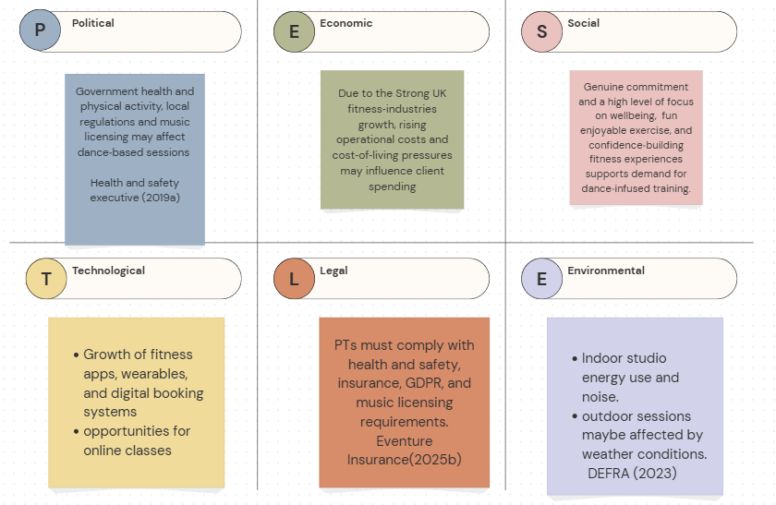
Table 3: Pestle Analysis. Source: (Self-Produced)

🧭SWOT ANALYSIS.
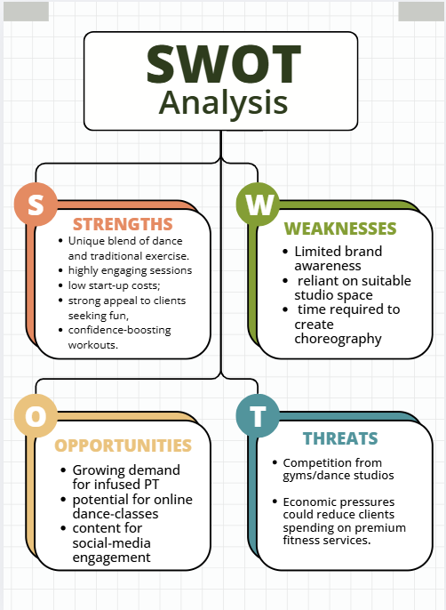

📦 Marketing Mix (4Ps)
Product
Rhythm Fit offers one-to-one and small group-based dance-fitness classes. The business provides beginner, intermediate and advanced sessions, we promote confidence-building, and self-expression through music-driven movement sessions.
Price
PT sessions will cost from £30–£45, depending on level of class, while group classes range from £8–£15. Monthly packages, introductory offers and loyalty discounts will help ensure affordability and maintain value.
Place
Sessions will operate in community halls, dance studios and partnered leisure centres. Clients will be able to book through online platforms and engage via social media, Instagram, TikTok, Snapchat.
Promotion
Marketing uses TikTok and Instagram Reels to promote and showcase routines and attract more clientele. Collaborations with other brands, testimonials, referral incentives, and community events will help build brand awareness.

👤 Management Team

Rhythm-Fit is led by a small, skilled team focused on delivering high-quality dance-fitness training and strong community engagement.
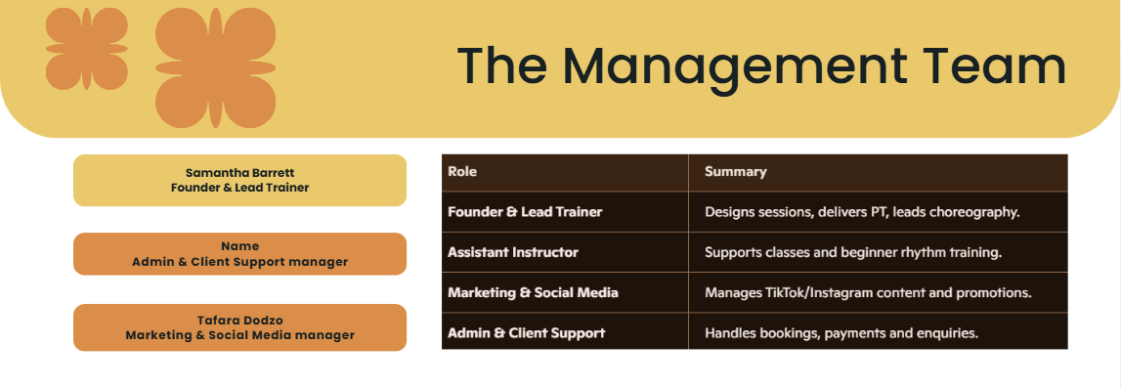
Table 4: Management Team. Source: (Self-Produced)
👥 Management Team and Their Background
- Founder & Leader Trainer – Experienced street-dance instructor and qualified personal trainer, specialising in beginner friendly rhythm training, and confidence building.
- Assistant Instructor – Strong background in street dance, skilled at guiding new participants and supporting small group sessions.
- Marketing & Social media Coordinator – Expert in fitness content creation, short form video and a commitment to building engaged, welcoming online communities.
- Admin & Client support – Experienced in customer care, managing bookings, and ensuring a friendly, smooth, positive client experience.

Organisational Chart

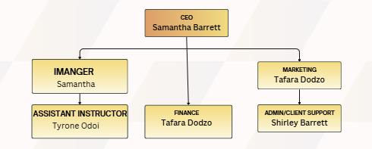
Table 5: Organisational Chart. Source: (Self-Produced)

🚀Key Milestones
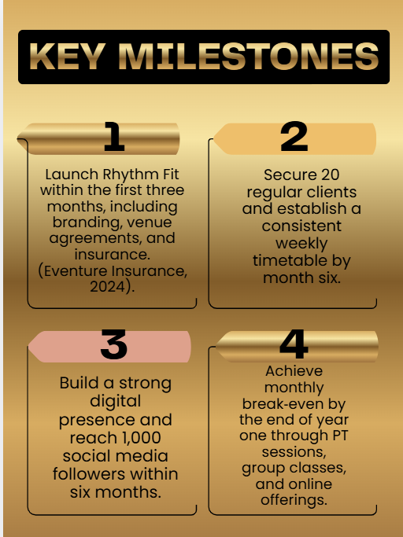
Table 6: Key Milestones. Source: (Self-Produced)

💷Financial Plan (One Year)

Rhythm-Fit’s first-year finance will come from personal savings, early client revenue, and a government- backed Start-Up Loan. Family support and additional local grants will cover startup costs including equipment, insurance, and venue hire, ensuring a steady cash flow.
(Department for Business and Trade, 2026).

💰Sources of Finance

Personal savings, early client revenue, a government-backed Start-Up Loan, small family contributions, and local wellbeing grants will provide Rhythm-Fit’s initial funding, supporting launch costs, marketing, equipment, insurance and venue hire. (Burns,2023).

💸Cash Flow Forecast

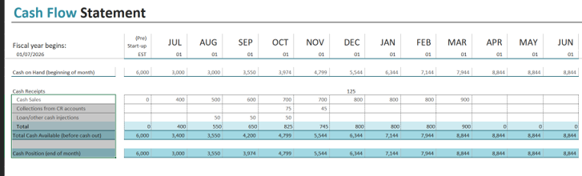

📈 Sales Forecast

- Jan - March: 8–12 clients per week (mix of PT + classes)
- April - June: 15–20 clients per week as brand awareness grows.
- Aug - Oct: 20 regular clients (SMART goal).
- Year 1 Revenue Estimate: £18,000–£25,000 depending on class uptake and PT block bookings.

A sales forecast is crucial because it enables Rhythm-Fit to predict future revenue, allocate resources effectively, and make informed financial decisions that support sustainable growth, which is essential for small business planning (Atrill and McLaney, 2022).

💰 Cost of Production Forecast
As a service-based business, Rhythm-Fit’s costs remain low. Venue hires averages £15–£25 per hour. Insurance and licensing total £300–£600 annually. Equipment costs are £300–£500, while marketing averages £50–£150 monthly. Admin software ranges from £10–£30 monthly. Total Year 1 costs are forecast at £4,000–£6,000.

⚖️ Break Even Analysis

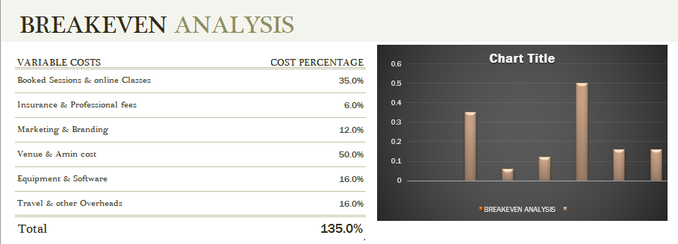
Table 7: Break-Even Analysis. Source: (Self-Produced)

🛠 Operations and Management Plan

- Sessions delivered in community halls, leisure centres, and online.
- Weekly schedule includes PT sessions, group classes, and kids’ street-dance sessions.
- Founder manages training, choreography, client progression, and quality control.
- Admin support handles bookings, payments, and customer communication.
- Marketing coordinator manages social media, promotions, and brand engagement.

🎵 Production of Good and Service

Rhythm-Fit provides dance-infused fitness services, with 6- week programmes, monthly choreography updates, and online content – centred on rhythm, fitness, enjoyment and personal transformation

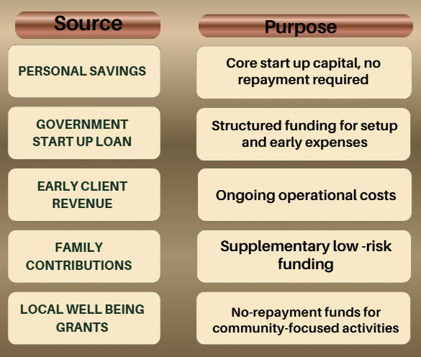

💻 Technology Plan

Technology supports delivery, marketing, and client management.
- Social media platforms (TikTok, Instagram) for promotion and engagement.
- Booking system or simple website for scheduling and payments.
- Music and choreography tools (Spotify playlists, editing apps).
- Video equipment for online classes and content creation.
- Data tracking for client progress and attendance.

👥 Human Resource Plan

- Founder + Lead Trainer – Leads personal training, programme designs, in charge of handling choreography and overall business directions

- Marketing & Social Media coordinator – Manages digital engagement, content creation and brand visibility

- Assistant Instructor – Supports group sessions and youth classes

- Admin & Client support – Handles bookings, enquiries and customer service

Future growth
Rhythm-Fit’s small team offers dance-fitness, marketing, and admin, aiming to add more additional classes and instructors as the business expands. We will also recruit dedicated digital content creators to meet rising demands.

🚀 Expansion Plan

Year 1: Build client base, launch online classes, and strengthen social media presence.
Year 2: Introduce membership platform with recorded routines and structured programmes.
Year 2–3: Partner with schools, youth centres, and wellness hubs.
Year 3: Assess feasibility of a dedicated Rhythm-Fit studio.
Long-Term: Franchise model or multiple Rhythm-Fit instructors delivering sessions across regions.

Reference List

DEFRA (2023). Department for environment, food & rural affairs. [online] GOV.UK. Available at: https://www.gov.uk/government/organisations/department-for-environment-food-rural-affairs [Accessed 27 July 2026].
Eventure Insurance (2025b). Event insurance made simple | eventure insurance. [online] Eventure insurance. Available at: https://eventureinsurance.com [Accessed 26 July 2026b].
GOV.UK (2022a). Set up as a sole trader. [online] GOV.UK. Available at: https://www.gov.uk/set-up-sole-trader [Accessed 27 July 2026a].
Health and Safety Executive (2019a). Health and safety made simple: The basics for your business - HSE. [online] Available at: https://www.hse.gov.uk/simple-health-safety/index.htm [Accessed 27 July 2026a].
IBISWorld (2025a). Personal trainers in the UK - market research report (2016-2031). [online] Ibisworld.com. Available at: https://www.ibisworld.com/united-kingdom/industry/personal-trainers/6042/#AboutThisIndustry [Accessed 26 July 2026a].
Met Office (2020a). Learn about weather. [online] Met Office. Met Office. Available at: https://www.metoffice.gov.uk/weather/learn-about/weather [Accessed 27 July 2026a].
PPL PRS Ltd (2019). What is TheMusicLicence? | Music licence | public performance | PPL PRS. [online] PPL PRS. Available at: https://pplprs.co.uk/themusiclicence/ [Accessed 27 July 2026].
].

Appendices:

