Optimising the use of the All Wales Speech Sound Pathway
clinical decision support tool.

Introduction
The All Wales Speech Sound Pathway (AWSSP) includes a signposting clinical decision support tool (CDST) (see fig. 1) designed to promote a consistent approach to optimising care for children with speech sound difficulties across Wales. The AWSSP is currently undergoing a review and update with the proposal to digitalise the CDST to enable it to be more easily accessible and to improve the user experience in order to facilitate better clinical decision making around intervention options for all NHS Speech and Language Therapists (SLTs) across Wales.

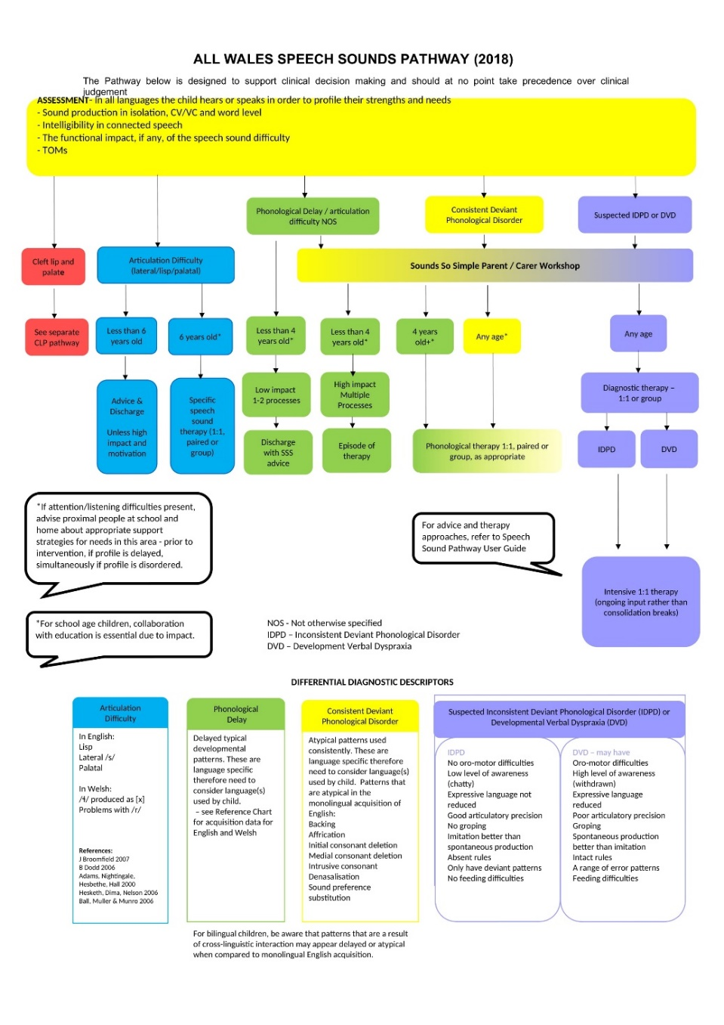
Figure 1: All Wales Speech Sound Pathway (2018 update) clinical decision support tool

Background to the AWSSP
The AWSSP sits alongside several other Speech and Language Therapy All Wales pathways (see fig. 2). SLTs collate information from assessments, observations and information from more proximal adults in order to form their clinical judgment regarding the primary area of need for the child and their family, and therefore which pathway to subsequently follow.

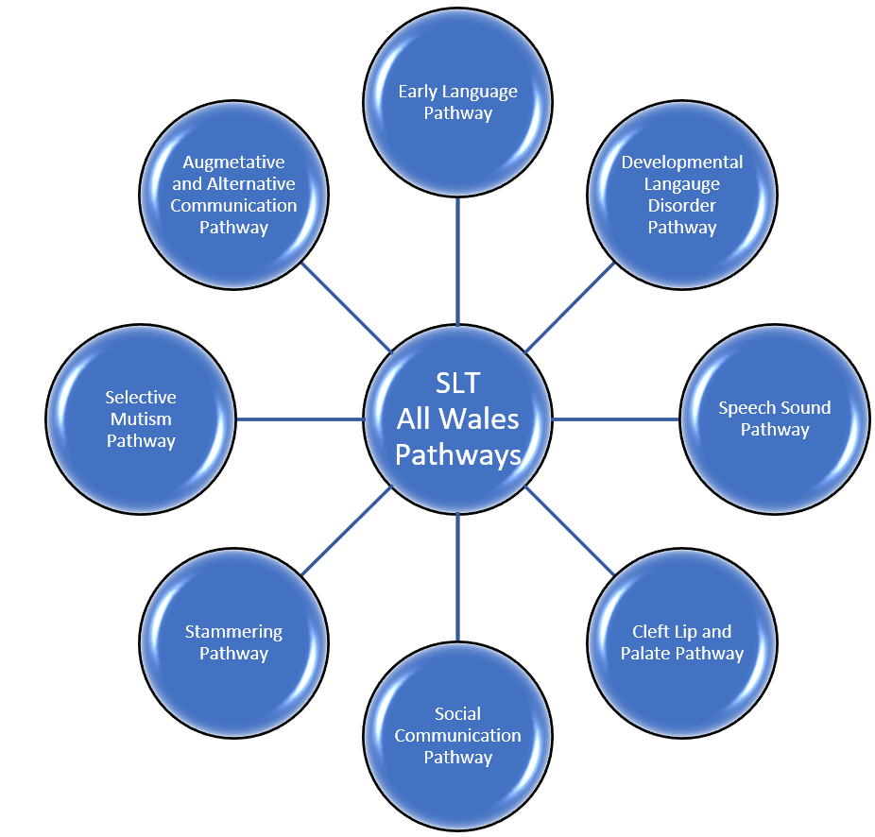
Figure 2: Speech and Language Therapy All Wales Pathways

The AWSSP was created in 2013 through collaborative working by Children’s SLTs across all Health Boards (HBs) in Wales (AWSSP, 2018). It aimed to provide guidance for NHS Speech and Language Therapy services providing intervention for children with speech sound difficulties through signposting to best practice and evidence-based practice interventions. The original pathway, and the 2018 update, were distributed to NHS SLTs via e-mail networks across all HBs in Wales as .pdf documents. It included a flow chart diagram (fig. 1) as a CDST to support SLT’s decision making around whether intervention was indicated and to create a common clinical pathway of care across Wales. The AWSSP documentation also signposted to evidence-based therapy approaches for different speech sound difficulties and briefly discussed the validity of each intervention option.
The AWSSP working group is currently in the process of reviewing and updating the AWSSP to include updated evidence-base and references for therapy approaches, updated normative developmental data, to include more information and guidance in relation to the Welsh language, new modes of service delivery (e.g. virtual / video-link sessions), and to provide guidance in relation to the recent Additional Learning Needs and Education Tribunal (Wales) Act (ALNET, Welsh Government, 2018).

Signposting CDST
CDST have been used within healthcare settings for many decades to aid clinical decision making. Sutton et al. (2020) described CDST as intending to ‘improve healthcare delivery by enhancing medical decisions with targeted clinical knowledge, patient information and other health information’.
Computer-based clinical support systems emerged in the 1960s (Yamada, 1968) however with increasing technological advances in the last few decades, the complexity and scope of CDST has increased enormously (Wasylewicz and Scheepers-Hoeks, 2019, p153) with significant financial implications for developers and healthcare providers (Singhal and Carlton, 2019).
Although there have been technological advances and increases in security governance, there remains concerns over the safety and reliability of some systems (Jia at al., 2016). The AWSSP CDST does not use or hold patient identifiable information therefore advice regarding the governance of patient data is not critical to this project.
Muhiyaddin et al. (2020) highlighted issues around the lack of interoperability of CDST with electronic health record (EHR) systems. Across Wales, the HBs use different EHR systems (including ‘Clinical Work Station’ in Aneurin Bevan HB, ‘PARIS’ in Cardiff and Vale HB, and ‘Therapy Manager’ in Betsi Cadwaladar HB); the time and financial cost could not be justified at this time to create a digital version of the AWSSP that is able to be integrated into each HBs EHR system, therefore as a simpler, more cost-effective solution, the AWSSP would be a stand-alone CDST that all SLTs will be able to access at a central point.

Signposting CDSTs are used across a wide range of settings in health care, including chest pain (Smulowitz, et al., 2017, p408), chronic kidney disease (Donald, et al., 2016, p2), opioid use disorder (Ray, et al., 2019, p2), and musculoskeletal disorders (Gross, et al., 2016, p287).
The AWSSP is a clinical management style of signposting decision support tool (Sutton et al., 2020, p3) designed to support adherence to evidence-based practice and best practice; the decision support tool is based on an if-then decision tree structure (Podgorelec, 2002, p2; Wasylewicz and Scheepers-Hoeks, 2019, p155). The rules of the decision tree are based on evidence-based and best practice approaches as researched by the AWSSP working group.
Sutton et al. (2020) highlighted the concern of clinical management decision support tools creating a reliance on the tool and therefore having a negative impact on the clinician’s skills. The aim of the AWSSP CDST is to support the SLT’s clinical decision making, but it should never replace their clinical judgement (AWSSP, 2018) as this will include the SLT’s mindlines knowledge and take into account wider holistic information regarding the child and their family (including factors such as the child’s readiness for intervention, evaluating the child’s speech sound difficulties in the context of their overall learning and development, and collaborative decision making with the child and their family regarding areas of priority).

Optimising user experience of the AWSSP CDST
Currently, use of the AWSSP is variable across different HBs depending on local constraints, ease of access to the information and support to use the pathway within the HB. The current update by the working group will look to re-launch the AWSSP and optimise the user experience through:
- enabling easier access to the AWSSP information. It is proposed the updated AWSSP is made available digitally via a Microsoft SharePoint site enabling easy access to all NHS SLTs across Wales.
- ensuring the information is up to date reflecting best-/evidence-based practice. A digital version of the AWSSP will enable the working group to maintain and update the information when needed more efficiently, and enable all SLTs to access the most recent version of the pathway.
- supporting SLTs to make the right decisions at each stage of the pathway. The SharePoint site will have a link to an interactive CDST (created with a software programme such as Microsoft PowerApps) which guides SLTs through the decisions at each level of the tree structure, with options for providing further information and guidance on how to make the decision, and how to gather further information if needed. For example, when deciding if deviant speech sound processes are consistent or inconsistent (i.e. deciding between the ‘yellow’ and ‘purple’ branches of the AWSSP decision tree as shown in fig. 1), the interactive CDST can give a prompt to remind SLTs of the 40% inconsistency threshold for single word productions, and to signpost to the inconsistency subtest of the Diagnostic Evaluation of Articulation and Phonology (DEAP) assessment (Dodd et al., 2006) if further information is needed for the SLT to make this decision.
Van de Velde et al. (2018) stated how computerised CDST can contribute to addressing poor health care through improving knowledge. An easily accessible digital version of the AWSSP CDST will support SLTs to select the most effective therapy approach resulting in a positive outcome for the child and family, and impact on caseload demands for the service. For example, the selection of the core vocabulary approach for inconsistent deviant phonological disorder (IDPD) can impact a child’s phonological system within 14 weeks with them potentially being discharged from the service at that time, whereas a different therapy approach for this client group, or the use of the core vocabulary approach for a different client group, will not have the same impact resulting in the child making slower progress and remaining on the caseload for longer (Dodd and Bradford, 2000, p208). Ensuring the selection of the most appropriate therapy approach also links to the wider contemporary aims of healthcare as described by Nundy, Cooper and Mate’s (2022) quintuple aims of healthcare (see fig. 3).
The rich picture in fig. 4 summarises the current AWSSP implementation and the desired outcome following the digitalisation of the CDST.

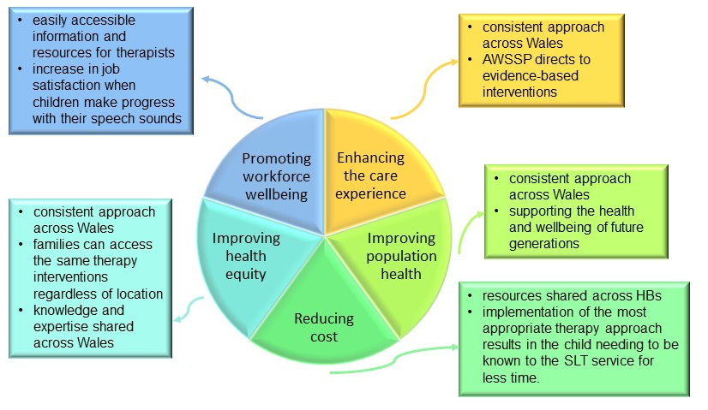
Figure 3: how the AWSSP CDST contributes to the wider contemporary aims of healthcare described in the quintuple aim (Nundy, Cooper and Mate, 2022)

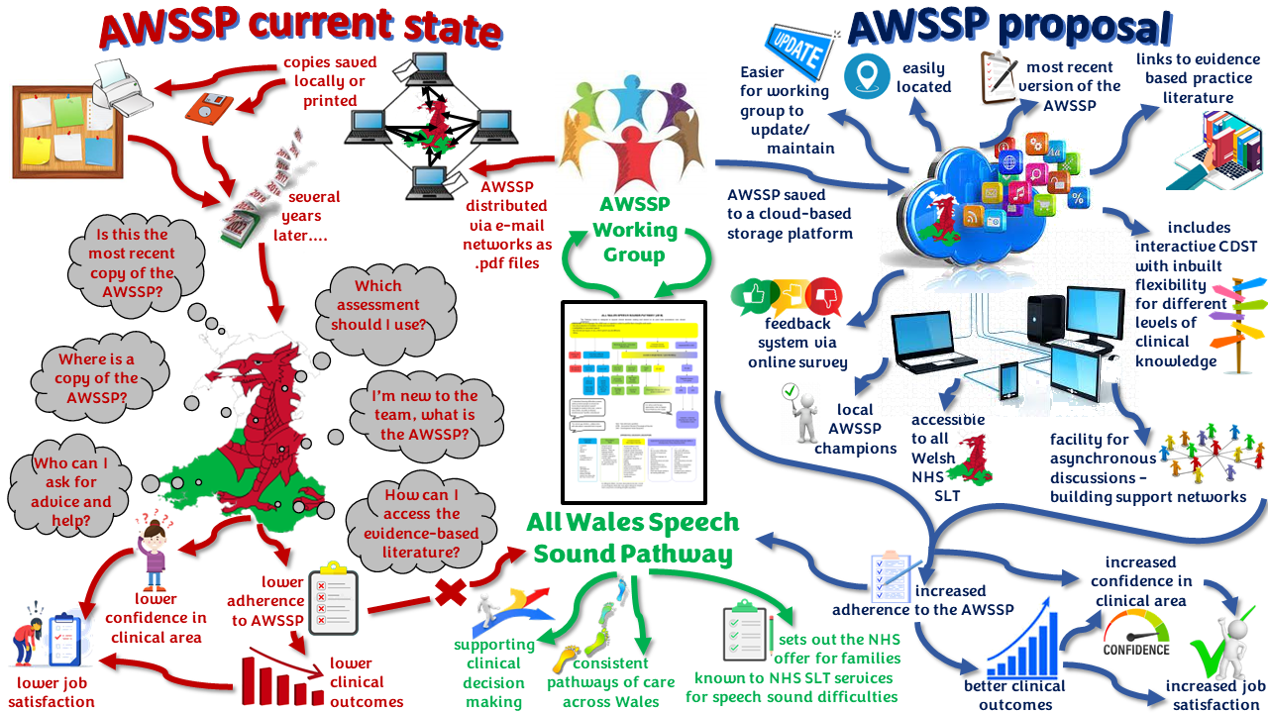

Figure 4: Rich picture summarising the current AWSSP state, and the proposed outcome following the digitalisation of the CDST.

Evidence Review
A literature review was undertaken to gain further insight into the use of CDST in healthcare, in particular the facilitators and barriers to the use of CDST for the implementation of clinical pathways, and how the use of CDSTs can be optimised through challenging and breaking down the barriers identified.
A literature search was conducted using the University of Wales Trinity Saint David online library database which includes access to ProQuest, PubMed, Elsevier, ScienceDirect, Sage Journal Collections, and Wiley Online Library databases. An initial search using the phrase ‘clinical decision support tool’ returned 19,435 entries. The search was narrowed by selecting documents available in English, and setting the publication boundaries within the last twenty years. The search terms ‘health’, ‘pathway’ and ‘intervention’ were also included; this resulted in 175 returns. The abstracts for these 175 returns were read; articles were rejected for either not being available online, duplications of articles, the abstract did not refer to a clinical decision support tool (or similar phrase), or the information in the abstract did not appear relevant to the focus of this search. Inclusion criteria for further reading was based on CDSTs being used for clinical pathways for intervention/treatment, in particular what facilitated or caused a barrier to the implementation of the pathway. This resulted in 18 articles being selected to be read in full for the review (fig. 5). The usefulness and effectiveness of these papers in relation to this search is summarised in table 1.

Use of clinical pathways and CDST
There is a general consensus that clinical care pathways used in the health domain improves the quality of care (Laleci Erturkmen et at., 2018, p751; Donald et al., 2016, p2; Evans-Lacko et al., 2010, p1), consistency of care (Donald et al., 2016, p2), and reduces variation in clinical practice (Evans-Lacko et al., 2010, p1) resulting in improved value of patient care (Flores et al., 2019, p476).
Clinical pathways are typically based around high-volume groups of patients with similar and predictable conditions or needs (Harris and Bridgman, 2010, p237), and often represent the ‘ideal’ patient journey (Hunter and Segrott, 2010, p228).
Hunter and Segrott (2010) stated clinical pathways are a key quality service agenda tool within the UK NHS, and are increasingly promoted as a means of ‘achieving clinical quality by increasing local adherence to national standards and reducing unacceptable variation in practice’. Smulwitz et al. (2017) used an interrupted time series analysis to show a positive difference in outcomes from the utilization of a clinical pathway regarding chest pain.

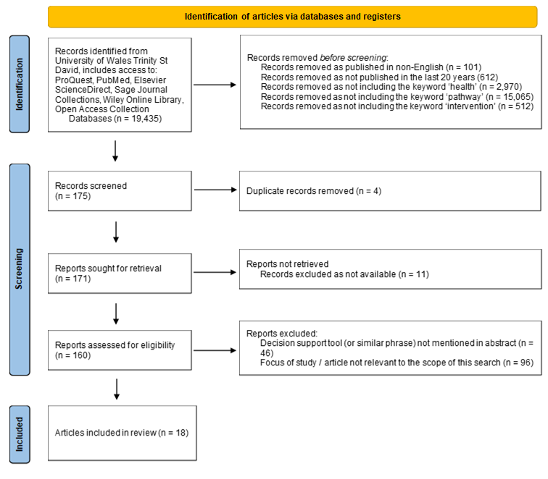
Figure 5: PRISMA search for literature focusing on CDSTs being used for clinical pathways for intervention/treatment, in particular what facilitated or caused a barrier to the implementation of the pathway.

Article | Area of focus | Grading of effectiveness and relevance in relation to this literature review (high, medium or low)
Artificial intelligence with multi-functional machine learning platform development for better healthcare and precision medicine  Ahmed, Z. et al. (2020) | Discussion of use of artificial intelligence in the analysis of clinical data | low
Reduced admission rates and resource utilization for chest pain patients using an electronic health record‐embedded clinical pathway in the emergency department  Dhaliwal, J.S. et al. (2020) | Comparing paper-based and computerised use of a CDST | medium
Development and implementation of an online clinical pathway for adult chronic kidney disease in primary care: a mixed methods study  Donald, M. et al. (2016) | Implementation and evaluation of a CDST; discussion of facilitators and barriers to its use | medium
The design of patient decision support interventions: addressing the theory-practice gap  Elwyn, G. et al. (2011) | Review of theories to influence the design of CDST | medium
Facilitators and barriers to implementing clinical care pathways  Evans-Lacko, S. et al. (2010) | Review of literature around the facilitators and barriers to implementing clinical pathways | high
Using a 10-step framework to support the implementation of an evidence-based clinical pathways programme  Flores, E.J. et al. (2019) | Development of a framework to develop and disseminate pathways via a cloud-based platform. Some mention of barriers and facilitators | medium
Clinical Decision Support Tools for Selecting Interventions for Patients with Disabling Musculoskeletal Disorders: A Scoping Review  Gross, D.P. et al. (2016) | Literature review of CDST for musculoskeletal disorders and a summary of the outcomes of the studies | low
Introducing care pathway commissioning to primary dental care: the concept  Harris, R. and Bridgman, C. (2010) | Development of a care pathway in primary dental care | medium
A web-based clinical decision tool to support treatment decision-making in psychiatry: a pilot focus group study with clinicians, patients and carers  Henshall, C. et al. (2017) | Clinician and patient evaluation of a computerised CDST | low
Using a Clinical Pathway to Support Normal Birth: Impact on Practitioner Roles and Working Practices  Hunter, B. and Segrott, J. (2010) | Implementation of a national pathway; discusses the need of flexibility of CDST in relation to clinician experience | low
Strategies for sustaining high‐quality pediatric asthma care in community hospitals  Jaladanki, S. et al. (2022) | Aiming to identify strategies associated with sustained guideline adherence; reference to facilitators and barriers in different settings | high
A decision support tool with health economic modelling for better management of DVT patients  Lebcir, R., Yakutcan, U. and Demir, E. (2022) | Development of a CDST; evaluated for clinical effectiveness and cost | low
Personalised Care Plan Management Utilizing Guideline-Driven Clinical Decision Support Systems  Laleci Erturkmen, G.B. et al. (2018) | Integration of care plan and clinical guidelines into EHR system for integrated care | high
Computer protocols: how to implement  Morris, A.H., Hirshberg, E. and Sward, K.A. (2008) | Discussion of protocols around the use of computerised CDST | low
Computerized Clinical Decision Support System for Emergency Department-Initiated Buprenorphine for Opioid Use Disorder: User-Centered Design  Ray, J.M. et al. (2019) | Description of development of CDST; detailing user-centered design and some indication of facilitators and barriers | medium
Clinical Decision Support Tool: A rational needs-based approach to making clinical decisions  Self, R. et al. (2008) | Scoping of patient needs in order to develop a CDST for a mental-health service | low
Impact of implementation of the HEART pathway using an electronic clinical decision support tool in a community hospital setting  Smulowitz, P.B. et al. (2018) | Evaluation of the implementation of a computerised CDST for chest pain in an emergency department setting | medium
PP53A qualitative study of the adoption of computerised clinical decision support (CCDS) by paramedics and its impact on their role and practice  Wells, B., Porter, A. and Snooks, H. (2014) | Implementation of a computerised CDST within an ambulance service.  Full text not available, however abstract included as it included summary of facilitators and barriers to the use of the CDST | medium

Table 1: grading of the usefulness and effectiveness in relation to the search criteria for this literature search.

Although care pathways are used as a means to improve the quality of care, they are also increasingly being used as part of the commissioning process (Harris and Bridgman, 2010). The AWSSP defines the NHS offer to families known to NHS services for speech sound difficulties; this is increasingly important following the introduction of the recent ALNET Act (Welsh Government, 2018) where future case law will define some areas of the Act currently open to interpretation.

Clinical pathways are often developed into CDST to support clinicians at the point of care regarding decisions around optimal treatment choices and patient management decisions (Gross et al., 2015, p287).
While CDSTs improve clinician’s knowledge and supports the streamlining of clinician’s responses (Evans-Lacko et al., 2010, p4), Dhaliwal et at. (2020) suggested computerised CDST can be an effective way for improving adherence to evidence-based guidelines and therefore a means to closing the evidence-to-practice gap.
Hunter and Segrott (2010) highlighted that high quality care can only be achieved by acknowledging the complexity of some patients. Patients frequently have more than one condition resulting in increasing the complexity of the clinical pathway (Harris and Bridgeman, 2010, p238); this has implications for the design and ease of use of CSDT. Ray at al. (2019) stated building usable systems is crucial to improving efficiency and reducing errors.
Children following the AWSSP typically use more than one speech sound error process and therefore could potentially follow several branches of the pathway; areas to be prioritized will then need to be discussed and agreed upon with the child and their family.

Utilising design theory when building CDST
Elwyn et al. (2010) stated the specific use of design theory when planning CDST is not used sufficiently; they suggested designers need to think about why and how people make decisions. They said CDST support clinicians to think about the choices they face and information about the different options, however CDST also need to take into account the emotional, cognitive, environmental and time constraints people face when making decisions. Dhaliwal et al. (2020) indicated that human factors research has shown that clinicians’ decisions are often influenced by the structure of their practice environment, resulting in the path of least resistance being the most taken.
Elwyn et al. (2010) suggested that CDST design needs to focus on how the tools can be designed to help clinicians make decisions. In their paper, Elwyn et al. (2010) outlined eight styles of decision theory with the pros and cons of each, however they did not make any specific conclusions or recommendations on design components that need to be included to help clinicians to make decisions.
Ray et al. (2019) advocated for user centered design to CDST. They stated ‘designing for humans requires uptake and continued use of workflows, information needs, priorities, and preferences; user centered design captures this through use engagement across the design and development life cycle’. They suggested consideration of the sociotechnical environment and the 5-rights (the right information, to the right person, in the right format, through the right channels, at the right time) supports user centered design.

Guidance vs. autonomy of decisions when using CDST
Wells, Peter and Snooks (2014) suggested the use of computerised CDSTs supported the assessments of patients and decision making about onward care as well as aligning policies to standardized patient care, enhance the clinicians’ decision-making skills and improve the quality of care. Although the balance between standardisation and autonomy from following a clinical pathway can be challenging, Harris and Bridgman (2010) argue that this is not impossible to resolve. The AWSSP is designed to give guidance on best practice and evidence-based practise however it always stipulates that it should not override the SLT’s clinical judgement, particularly when considering the heterogeneity, of the client group.
Hunter and Segrett (2010) suggested recently qualified and early career clinicians were more likely to view a pathway positively than more experienced clinicians. This is likely to apply to the AWSSP too as the pathway is more likely to support the development of knowledge and mindlines around clinical decision making for this client group for early career clinicians, whereas more experienced clinicians may use the pathway to check and confirm their decision making.

Facilitators for the use of computerised CDST
The literature reviewed tended to use mixed-methods of gathering information regarding facilitators and barriers to the use of computerised CDST; these methods included user perspectives and experiences through individual interviews, online surveys, and using website analytics. The results tended to be grouped into themes around communication, work efficiency, and confidence. Jaladanki et al. (2022) aimed to identify strategies associated with sustained guideline adherence; they concluded the facilitators they identified as part of an on-going study were similar to those found at the initial implementation stages of a new CDST.

The key facilitators identified are summarised in table 2. Although some studies gave a clear description of the facilitators to the use of computerised CDST (e.g. the use and role of local champions to provide on-going support and reminders of evidence-based practice and the use of the CDST, Jaladanki et al. (2022)), most studies did not suggest what changes could be made to increase or support user uptake.

Barriers to the use of computerised CDST
The key barriers identified are summarised in table 3. The key themes centered around workflow disruptions, alert fatigue, and difficulties around sustaining long-term engagement. Evans-Lacko et al., (2010) suggested that to improve use and engagement, no intervention works in isolation to give large scale change, and even multifaceted interventions may only provide moderate levels of improvement. Although several studies go some way to suggest how barriers could be overcome, these tended to be theoretical as suggested areas of further study rather than evaluating tested methods.

Technology used for CDST
The embedding of CDST into EHR systems was a theme that arose several times as one of the facilitators for CDST use. However, although the possible benefits of computerised CDST are vast, there continues to be a high level of uncertainty about how to optimally design and implement them within EHR systems (Dhaliwal et al., 2020, p1604).
Some studies outlined elements of the technology used. For example, Flores et al. (2019) stated they used a cloud-based technology platform to disseminate the information across multiple sites in a geographical area. They said the platform stored metadata for each pathway including evidence based references, version information, developers names and a way to provide feedback. This appears similar to the system proposed for the AWSSP; the pathway will be available via a cloud-based platform enabling SLTs across Wales to access it, and will also embed evidence -based references. Flores et al. (2019) also indicated the platform they reviewed contained functionality to facilitate asynchronous collaboration; this is an area to consider for the AWSSP to enable discussions between SLTs across Wales.
Dhaliwal et al. (2020) stated that a third part vendor intervention site would be used to embed guidelines into EHR without altering its decision logic or content, however they did not give further details as to how this would be integrated into the EHR system.

Authors | Areas identified as key facilitators
Donald et al. (2016) | - integration of the CDST into the EHR
Evans-Lacko et al. (2010) | - attitude of staff towards the CDST  - design  - involvement from clinical staff and management  - clear language  - context-specific  - intervention allows for measurable outcomes  - implementation  - staff training  - allows for flexibility  - provides financial incentives  - support from managers and other clinical staff  - evaluation  - include process and outcome measures  - monitoring for potential barriers  - examine the need for system or orgainisational level change  - involvement of clinical staff and management
Jaladanki et al. (2022) | - a designated local champion who:  - consistently gave ongoing reminders of evidence-based practice  - expressed firm expectations that evidence based practices would be followed without exception  - delivered education on evidence-based care (1:1 support, reminders in meetings, and education for new staff),  - modified / developed EHR tools to support clinicians in using evidence-based care  - a culture that was receptive to practice change and collaboration,
Ray et al. (2019) | - the location of CDST link in the EHR system so it is easy to find and use
Smulowitz et al. (2018) | - the use of a simple, clinically meaningful computerised decision support tool was essential for good compliance.  - gaining user buy-in and consistency of use through:  - provision of training/education at staff meetings  - embedding the CDST into the dashboard  - a pathway flag on the dashboard to prompt users to consider the pathway at multiple points.
Wells, Porter and Snooks (2014) | - uptake of computerised CDST was higher in locations that had existing technology support.  - the use of computerised CDST was influenced by:  - policy content,  - organizational context,  - the users own skills and attitudes,  - the technology itself

Table 2: key areas identified that facilitate the use of computerised CDST.

Authors | Areas identified as key barriers
Donald et al. (2016) | - time constraints of the clinician  - lack of integration into EHR system  - varying levels of computer experience and use of online clinical tools by clinicians
Evans-Lacko et al. (2010) | - design  - lack of staff involvement  - lack of awareness / familiarity  - lack of applicability to certain clinicians  - conflicting information  - mixed attitudes regarding standardisation of practice  - use of complex medical terminology  - time constraints  - available resources  - insufficient staff  - increased cost  - implementation  - lack of outcome expectancy  - inertia of previous practice  - unconvinced of rationale for implementing the pathway  - overly prescriptive leading to workplace rigidity  - resistance due to lack of involvement at the design level  - time constraints  - gap between care pathway expectations and actual care given  - staff turnover  - lack of training in use of pathway  - evaluation  - time constraints  - available resources  - staff turnover  - lack of evaluation  - lack of feedback  - lack of staff involvement
Jaladanki et al. (2022) | - lack of on-going support  - lack of feedback  - attitudes of individual clinicians  - environment and culture of the team; difficult to get staff on board  - concerns over practice change
Ray et al. (2019) | - workflow interruptions; if the alert was activated at the incorrect stage of the process  - time taken to complete the CDST  - the number of steps within the CDST  - inflexibility of systems for clinicians with different levels of knowledge  - increased cognitive load
Wells, Porter and Snooks (2014) | - time-based performance pressures  - lack of technology readiness (of the organisation and individuals)  - the usability of the CDST

Table 3: key areas identified that are barriers to the use of computerised CDST.

Of the literature reviewed, Laleci Erturkmen et at., (2018) gave the most detail on the technology that would be used, however their proposal was in the development phase and therefore was yet to be evaluated. They proposed integrating clinical guidelines into EHR using a web-based portal using an interoperability layer based on HL7 FHIR to link the care plans and clinical guidelines to EHR systems. Although integrating clinical guidelines and CDST into EHR systems is the ideal, due to the cost (the AWSSP has a non-budget holding All Wales working group) this is not a feasible option for the AWSSP at this time and therefore a stand-alone cloud-based platform will be utilised.

Long-term utilisation of computerised DCST
Several studies emphasised the need for on-going sustainability and dissemination in order for CDST to be embedded within clinical practise (Donald et al., 2016, p9). Regular feedback should be sought from staff to identify existing or potential barriers (Evans-Lacko et al., 2010, p4) and to address ongoing concerns regarding practice change (Jaladanki et al., 2022, p130X).
Jaladanki at al. (2022) also highlighted the need for ongoing engagement from local champions to maintain the awareness or, and compliance in using the CDST.

Implementation Issues
Transition from paper-based to digital
The AWSSP is currently available across all HBs in Wales in a .pdf format stored on HB shared drives, on SLT’s individual storage drives, or printed copies in clinic locations. As part of the current update of the AWSSP it is proposed the pathway and CDST are made available digitally for all NHS SLTs across Wales.
The GUIDES checklist (van de Velde, et al., 2018, p4-5) has been used to evaluate the readiness of the AWSSP to be digitized (fig. 6); the GUIDES checklist has been scored on the basis of the current accessibility to the CDST. Although the GUIDES checklist is helpful to consider the factors that may impact on the success of a CDST, the checklist will only identify areas that may need further consideration rather than giving a threshold score to indicate if the CDST is ready to be implemented.
The areas requiring further consideration identified on the GUIDES checklist in relation to the AWSSP can be addressed through the proposed digitalisation of the pathway. As part of the review, the evidence-base will be reviewed and updated (GUIDES point 2.1), and moving forwards, the working groups will be able to maintain and update the digital version of the pathway more easily than a paper-based version.
The proposed digital version on a cloud-based platform will improve ease of access as the information will be consistently in one location (GUIDES point 3.1); the digital platform will also enable a more interactive layout and links to evidence-based literature (GUIDES point 3.2) to improve the user’s experience.

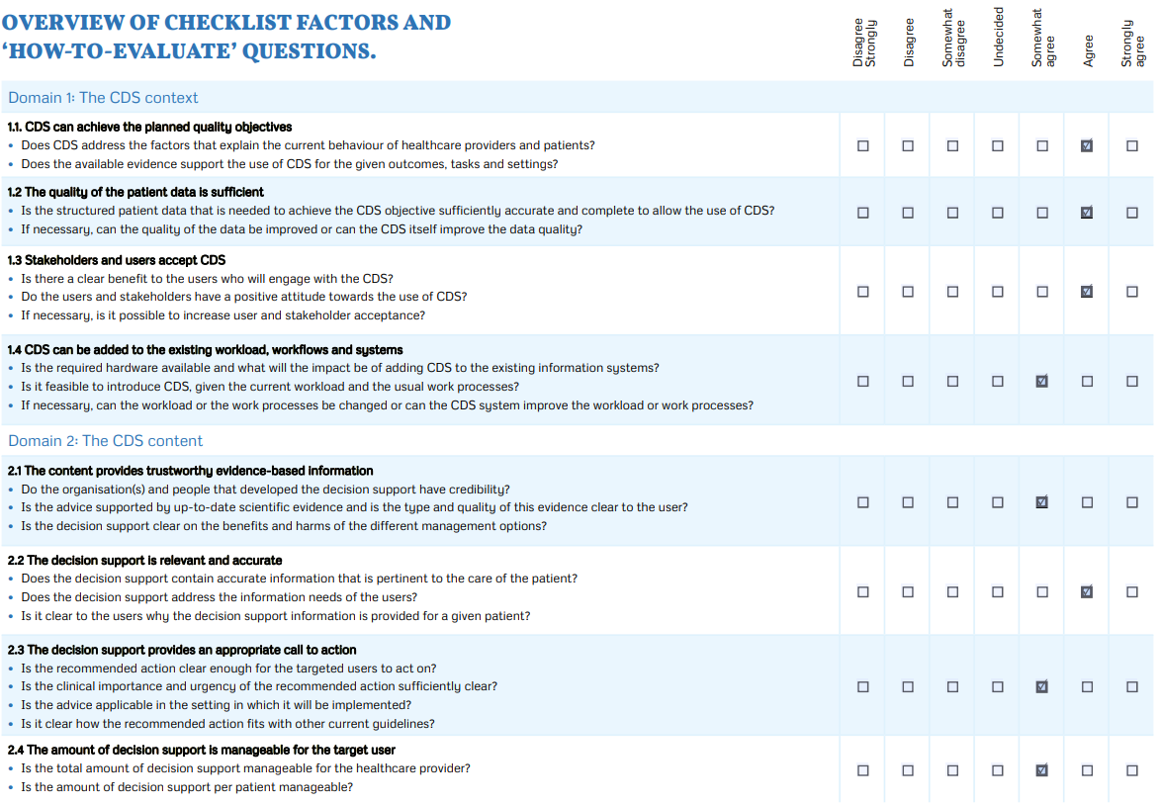
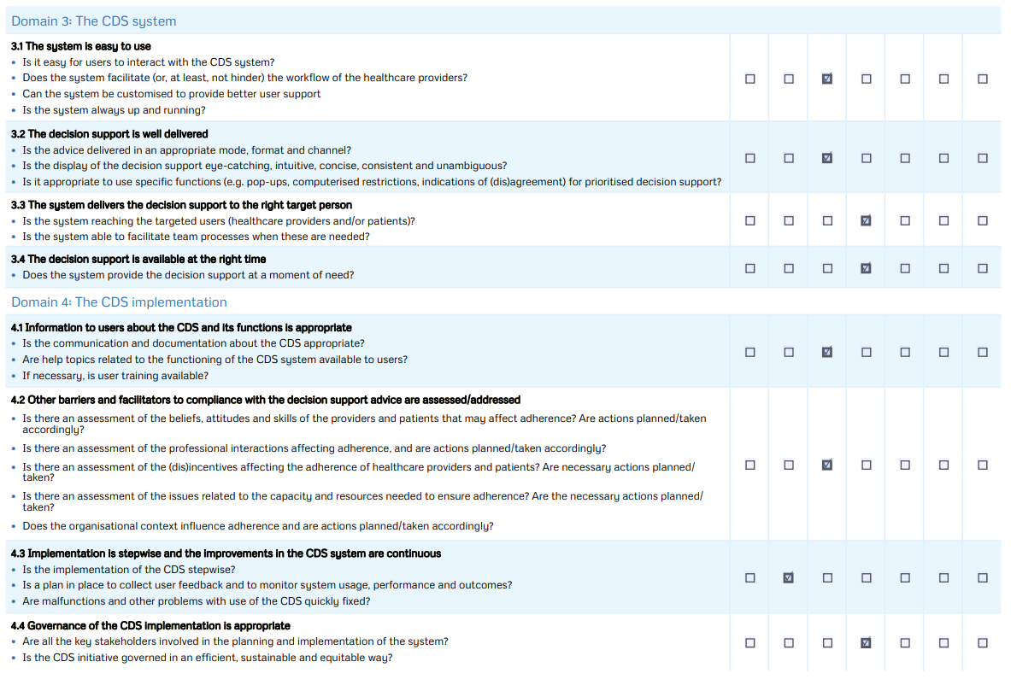
Figure 6: GUIDES checklist (van de Velde, et al., 2018) scored on the basis of the current accessibility to the AWSSP CDST

Hunter and Segrett (2010) indicated early career clinicians were more likely to view a pathway positively. This group of SLTs are likely to benefit the most from using the CDST to develop their clinical knowledge and mindlines, however new team members are unlikely to be aware of the AWSSP and the location of the CDST unless it is mentioned in their induction or in conversation with another therapist. Under the proposal, the AWSSP and CDST will be located in an easily accessible location (all HBs across Wales have access to Microsoft 365 and SharePoint since 2020) and the use of local champions will remind teams of any updates, where the information is located, and in particular offer advice and support to new team members (GUIDES points 3.3, 3.4).
Currently, there is no method for SLTs to give feedback regarding any issues or suggestions for the AWSSP (GUIDES section 4). Ray et al. (2019) highlighted the importance of sampling participants across a range of user experience levels to feed into the design process. Under the proposed update, there needs to be opportunities for SLTs across the spectrum of digital experience to input and feedback on the design process of the digital version of the CDST, and an on-going means to report any errors, issues or to suggest additions.

Risks and constraints associated with the digitalisation of the AWSSP
One of the biggest constraints for the digitalisation of the AWSSP is the budget; any developments that are made are by the working group which consists of SLTs representing HBs across Wales. The HBs agree to SLTs having time to participate in the working group, but there is no other budget available. Although one of the common facilitators raised regarding the implementation of a CDST is the integration into the EHR system (Donald et al., 2016; Jaladanki et al., 2022; Ray et al., 2019; Smulowitz et al., 2018), this is unfortunately not feasible for the AWSSP at this time. Therefore, a standalone system via a SharePoint site is a viable option as the infrastructure for this is already available to the HBs.
Constraints around the design of the digital version of the AWSSP will be determined by the limitations of the platform and the skills of the AWSSP working group. The working group can seek additional support from colleagues with experience of building SharePoint sites, and from HB IT departments who may be able to support with this. Optimisation software could be considered where available to assist with the development of the interactive CDST in order to simplify the process and support user experience.
As no patient data will be entered/held/saved in the AWSSP, there is no risk associated with patient identifiable information and therefore data governance for this area is not required for this project.
All HBs across Wales have access to Microsoft 365, and therefore all SLTs will be able to access a SharePoint site. Web-browsers enable access to the cloud-based storage, and therefore accessibility is not reliant on local HB servers. There is a degree of risk that the pathway and CDST will be unavailable due to network issues within HBs, or wider internet connectivity issues, however the likelihood of this occurring is low.
Donald et al. (2016) cited the varying levels of computer experience as a potential barrier to the implementation of a CDST. There is likely to be a wide variety in SLT skills and confidence levels in using computer software programmes and digital CDST which may impact on the uptake or use of the pathway in the new format. As part of the digitalisation of the AWSSP, a simple video user guide can be created to demonstrate how to navigate through the site, how to access and use the CDST, and how to use additional features such as the links to the evidence-based literature.
A further risk is that the usage of the AWSSP will decline over time. Flores et al. (2019) developed a ten-step process for the implementation of clinical pathways; step nine of this process focused on creating clinicians awareness and supporting the implementation of the pathway both in the short term and long term. They stated relying on clinician’s memory to remember it exists and to use it, is inadequate for widespread and long-term adoption; they stated there needs to be active promotion of the pathway in order to ensure its long-term implementation. Jaladanki et al. (2022) advocated the use of local champions to promote the sustained use of clinical guidelines. The implementation of local champions in each HB will be important to the on-going use of the AWSSP, to raise awareness of the pathway, alert teams regarding updates and support new team members to become familiar with the CDST; however, there is also the challenge around sustaining the enthusiasm of the local champion long-term and ensuring the role is re-filled if the champion changes role.

Evaluation
In order to be effective, it is essential the design of a CDST enables clinicians to access the right information, at the right time, in the right format, and through the right channels in order to support and enhance their clinical decision making. The current AWSSP format is able to give the right information (information regarding the clinical pathway and support in deciding optimal treatment options), to the right people (NHS SLTs across Wales), at the right time (when support is needed as part of their clinical decision making), however it is currently not in an optimal format or available through optimal channels; the digitalisation of the AWSSP will aim to improve these areas.
Dhaliwal et al. (2020) took an evidence-based pathway that had already been clinically validated, and evaluated the digitalisation of the pathway. This is similar to the current AWSSP update; the pathway (other than some updates to the evidence-based practice literature and guidance around ALNET) will remain the same as the existing information, but the presentation of the information will be updated to enable it to be accessed online and with an interactive CDST. Therefore, the evaluation of the AWSSP update will focus on the digitalisation of the pathway/CDST rather than the structure of the pathway itself.
The AWSSP states that if is intended to be used by SLTs as part of their clinical decision making, however it should not replace the SLT’s autonomous clinical judgement. The therapist’s reasons for selecting, or rejecting, a particular intervention approach should be documented within the child’s casenotes.

Evaluation through the design and development phases
Russ et al. (2013) stated ‘the goal of human factors in health care are twofold: 1) support the cognitive and physical work of healthcare professionals, and 2) promote high quality, safe care for patients’. The principles of human factors need to be taken into account when designing the digital version of the AWSSP to ensure it meets the needs of the users to support their clinical decision making (cognitive work) and promote the optimal intervention options (promote high quality, safe care).
The design and development phase of the digital AWSSP CDST needs to be an iterative process incorporating usability tests at multiple stages of the process in order to maximise usability (Donald et al, 2016, p4). The interactive CDST needs to be intuitive to use with a clear structure that enables flexibility between progressing through the CDST to the recommended intervention outcomes and user-initiated decision support to seek more information about each stage of the decision tree (Ray et al, 2019, p7).The iterative evaluation and feedback cycles through the design and development phases should be from a combination of clinical leads for speech sound difficulties to ensure the precision of the CDST and that it accurately reflects the clinical pathway, and feedback from clinicians with a range of knowledge and experiences to evaluate the ease of use and whether the range of flexible support available meets their needs (Ray et al., 2019, p9).
Donald et al. (2016) reported that 80% of usability issues can be identified and fed back from a sample of six to eight users. They described an evaluations system where clinicians were provided with three clinical scenarios to work through while engaging in a ‘think aloud’ exercise. They also advocated the use of the System Usability Scale questionnaire as part of the evaluation process. Ray et al. (2019) also suggested that users should be engaged throughout the process of CDST development to anticipate and avoid pitfalls, in particularly around increased cognitive load and lack of user engagement. They also suggested that including user feedback in the design phase led to better effectiveness and efficiency, and an increase in update and continued use through a sense of clinician contribution and ownership of the CDST.
Ideally a mixed-methods approach should be used to evaluate user experience with the digitalised AWSSP. A combination of online-surveys, semi-structured interviews across the spectrum of SLT experience levels, and observations of the CDST being used. Ray et al (2019) described how in their study, all sessions of user testing included direct observation, ‘think about’ working processes, and observational note taking. Each type of evaluation feedback has drawbacks regarding the accuracy of information given compared to how the AWSSP may be viewed and implemented in normal clinical practice. For example, online surveys may have a bias between work as perceived versus work as done, and observation of user testing may show the bias of work as observed versus work as done (Deutsch, 2017).

Implementation and on-going evaluation.
Ongoing evaluation of the pathway implementation and CDST is essential to establish its effect and help to identify any unintended consequences (Hunter and Segrott, 2010, p235). A link should be embedded within the online AWSSP to enable users to provide feedback regarding any issues they have identified, suggestions for future development, or any comments on the presentation of the pathway and CDST.
Flores et al. (2019) stressed the importance of developing a monitoring and maintenance plan to review and update pathways and CDST. A schedule of regular online surveys should established to be distributed to all SLTs across Wales to gather information regarding their views on the ease of use of the AWSSP, how often they access the CDST, the circumstances that lead them to seeking support from the CDST, their confidence in accessing the AWSSP online, their confidence in using the interactive CDST and if there is anything they feel is currently missing from the online information. The online surveys could also gather information regarding how often they feel their clinical work complies with the AWSSP information, and what circumstances may lead them to make an alternative decision. Further to this, clinicians could be asked to rate if they felt the support given by the CDST led to a positive clinical outcome / effective intervention being used, and the impact of this on their job satisfaction. Over time, these surveys can be compared to monitor the adherence to the AWSSP, the impact on perceived clinical outcomes and how supported clinicians felt by the CDST.

Future developments and considerations
Digitalisation of the AWSSP enables future updates of the pathway to be implemented and disseminated in a more efficient and time effect manner. Further developments of the AWSSP could be to include other CDST as part of the decision tree (for example, decision making tree for speech sound disorder, Stringer, 2019), or to develop the scope of linked resources to facilitate each therapy approach.
Future evaluation can be undertaken to look at how each HB implements each stage of the pathway due to local constraints (for example, staffing levels impacting on the ability to deliver the parent information programme) and whether there could be a digital solution to this (for example, parent information videos that can be accessible on an All Wales basis, so parents can access the information at a time convenient for them).
Donald et al. (2016) commented that CDST can also be useful as part of student training. Links can be developed with the two universities in Wales who offer SLT certified degrees for the AWSSP pathway to be incorporated into the training information; this gives students access to AWSSP information to support them on placements, but also gives them a knowledge and awareness of the AWSSP before working as an autonomous professional.
If the feedback and evaluations of the online AWSSP are positive in terms of user experience and supporting adherence to the pathway, information around the design and development of the digitalisation can be shared with the working groups for the other All Wales pathways (fig 2.) for them to consider digitalizing and making an inline network for all of the All Wales pathways.

Word count (excluding tables, figures, references) =

References:

Ahmed, Z. et al. (2020) ‘Artificial intelligence with multi-functional machine learning platform development for better healthcare and precision medicine’, Database : the journal of biological databases and curation, 2020. Available at: https://doi.org/10.1093/database/baaa010.

AWSSP (2018) The All Wales Speech Sound Pathway. Unpublished

Deutsch, E. (2017) Bridging the gap between work-as-imagined and work-as-done. Pennsylvania Patient Safety Advisory, 14 (2), pp80-83
Available at: https://collections.nlm.nih.gov/master/borndig/101711396/201706_80.pdf

Dhaliwal, J.S. et al. (2020) ‘Reduced admission rates and resource utilization for chest pain patients using an electronic health record‐embedded clinical pathway in the emergency department’, Journal of the American College of Emergency Physicians Open, 1(6), pp. 1602–1613. Available at: https://doi.org/10.1002/emp2.12308.

Dodd, B. and Bradford, A. (2000) ‘A comparison of three therapy methods for children with different types of developmental phonological disorder’, International journal of language & communication disorders. 35(2), pp. 189–209.
Available at: https://doi.org/10.1080/136828200247142

Dodd, B., Hua, Z., Crosbie, S., Holm, A. and Ozanne, A. (2006) The Diagnostic Evaluation of Articulation and Phonology (DEAP). Pearson Clinical.
Available at: https://www.pearsonclinical.co.uk/store/ukassessments/en/Store/Professional-Assessments/Speech-%26-Language/Diagnostic-Evaluation-of-Articulation-and-Phonology/p/P100009266.html

Donald, M. et al. (2016) ‘Development and implementation of an online clinical pathway for adult chronic kidney disease in primary care: a mixed methods study’, BMC medical informatics and decision making, 16(1), pp. 109–109. Available at: https://doi.org/10.1186/s12911-016-0350-z.

Elwyn, G. et al. (2011) ‘The design of patient decision support interventions: addressing the theory-practice gap’, Journal of evaluation in clinical practice. Accepted for publication: 11 June 2010, 17(4), pp. 565–574. Available at: https://doi.org/10.1111/j.1365-2753.2010.01517.x.

Evans-Lacko, S. et al. (2010) ‘Facilitators and barriers to implementing clinical care pathways’, BMC health services research, 10(1), pp. 182–182. Available at: https://doi.org/10.1186/1472-6963-10-182.

Flores, E.J. et al. (2019) ‘Using a 10-step framework to support the implementation of an evidence-based clinical pathways programme’, BMJ quality & safety, 28(6), pp. 476–485. Available at: https://doi.org/10.1136/bmjqs-2018-008454.

Gross, D.P. et al. (2016) ‘Clinical Decision Support Tools for Selecting Interventions for Patients with Disabling Musculoskeletal Disorders: A Scoping Review’, Journal of occupational rehabilitation, 26(3), pp. 286–318. Available at: https://doi.org/10.1007/s10926-015-9614-1.

Harris, R. and Bridgman, C. (2010) ‘Introducing care pathway commissioning to primary dental care: the concept’, British dental journal, 209(5), pp. 233–239. Available at: https://doi.org/10.1038/sj.bdj.2010.770.

Henshall, C. et al. (2017) ‘A web-based clinical decision tool to support treatment decision-making in psychiatry: a pilot focus group study with clinicians, patients and carers’, BMC psychiatry, 17(1), pp. 265–265. Available at: https://doi.org/10.1186/s12888-017-1406-z.

Hunter, B. and Segrott, J. (2010) ‘Using a Clinical Pathway to Support Normal Birth: Impact on Practitioner Roles and Working Practices’, Birth (Berkeley, Calif.). Accepted February 10, 2010, 37(3), pp. 227–236. Available at: https://doi.org/10.1111/j.1523-536X.2010.00410.x.

Jaladanki, S. et al. (2022) ‘Strategies for sustaining high‐quality pediatric asthma care in community hospitals’, Health services research, 57(1), pp. 125–136. Available at: https://doi.org/10.1111/1475-6773.13870.

Jia P, Zhang L, Chen J, Zhao P, Zhang M (2016) The Effects of Clinical Decision Support Systems on Medication Safety: An Overview. PLOS ONE 11(12): e0167683.
Available at: https://doi.org/10.1371/journal.pone.0167683

Laleci Erturkmen, G.B. et al. (2018) ‘Personalised Care Plan Management Utilizing Guideline-Driven Clinical Decision Support Systems’, Studies in health technology and informatics, 247, p. 750–. Available at: https://doi.org/10.3233/978-1-61499-852-5-750.

Lebcir, R., Yakutcan, U. and Demir, E. (2022) ‘A decision support tool with health economic modelling for better management of DVT patients’, Health economics review, 12(1), pp. 65–65. Available at: https://doi.org/10.1186/s13561-022-00412-9.

Morris, A.H., Hirshberg, E. and Sward, K.A. (2008) ‘Computer protocols: how to implement’, Best practice & research. Clinical anaesthesiology, 23(1), pp. 51–67. Available at: https://doi.org/10.1016/j.bpa.2008.09.002.

Muhiyaddin, R., Abd-alrazaq, A., Househ, M., Alam, T. and Shah, Z. (2020). The Impact of Clinical Decision Support Systems (CDSS) on Physicians: A Scoping Review. Studies in Health Technology and Informatics. 272. 470-473. 10.3233/SHTI200597.
Available at: https://www.researchgate.net/publication/342639467_The_Impact_of_Clinical_Decision_Support_Systems_CDSS_on_Physicians_A_Scoping_Review

Nundy, S., Cooper, L. A., & Mate, K. S. (2022). The Quintuple Aim for Health Care Improvement: A New Imperative to Advance Health Equity. JAMA, 327(6), 521–522.
Available at: https://doi.org/10.1001/jama.2021.25181

Page MJ, McKenzie JE, Bossuyt PM, Boutron I, Hoffmann TC, Mulrow CD, et al. The PRISMA 2020 statement: an updated guideline for reporting systematic reviews. BMJ 2021;372:n71. doi: 10.1136/bmj.n71 Available at: http://www.prisma-statement.org/

Podgorelec, V., Kokol, P., Stiglic, B. and Rozman, I. (2002). Decision Trees: An Overview and Their Use in Medicine. Journal of Medical Systems. 26. 445-63. 10.1023/A:1016409317640.
Available at: https://www.researchgate.net/publication/11205595_Decision_Trees_An_Overview_and_Their_Use_in_Medicine

Ray, J.M. et al. (2019) ‘Computerized Clinical Decision Support System for Emergency Department-Initiated Buprenorphine for Opioid Use Disorder: User-Centered Design’, JMIR human factors, 6(1), pp. e13121–e13121. Available at: https://doi.org/10.2196/13121.

Russ, A., Fairbanks, R., Karsh, B., Militello, L., Saleem, J. and Wears, R. (2013) The science of human factors: separating fact from fiction BMJ Quality & Safety 22:802-808.
Available at: https://qualitysafety.bmj.com/content/qhc/22/10/802.full.pdf

Self, R. et al. (2008) ‘Clinical Decision Support Tool: A rational needs-based approach to making clinical decisions’, Journal of mental health (Abingdon, England), 17(1), pp. 33–48. Available at: https://doi.org/10.1080/09638230701505806.

Singhal, S. and Carlton, S. (2019) The era of exponential improvement in healthcare? McKinsey & Company
Available at: https://www.mckinsey.com/industries/healthcare-systems-and-services/our-insights/the-era-of-exponential-improvement-in-healthcare

Smulowitz, P.B. et al. (2018) ‘Impact of implementation of the HEART pathway using an electronic clinical decision support tool in a community hospital setting’, The American journal of emergency medicine, 36(3), pp. 408–413. Available at: https://doi.org/10.1016/j.ajem.2017.08.047.

Stringer, H. (2019) Decision making tree for speech sound disorder. Newcastle University. Unpublished.

Sutton, R., Pincock, S., Baumgart, D., Sadowski, D., Fedorak, R. and Kroeker, K. (2020) ‘An overview of clinical decision support systems: benefits, risks, and strategies for success’, NPJ Digital Medicine, 3(1), pp. 17–17.
Available at: https://doi.org/10.1038/s41746-020-0221-y

van de Velde, S., Kunnamo, I., Roshanov, P., Kortteisto, T., Aertgeerts, B., Vandvick, P. and Flottorp, S. (2018) ‘The GUIDES checklist: development of a tool to improve the successful use of guideline-based computerised clinical decision support’, Implementation science : IS, 13(1).
Available at: https://www-proquest-com.ezproxy.uwtsd.ac.uk/intermediateredirectforezproxy

Wasylewicz, Arthur.T.M. & Scheepers-Hoeks, Anne-Marie. (2019). Clinical Decision Support Systems. Fundamentals of Clinical Data Science. pp153-169
Available at: https://www.researchgate.net/publication/329872792_Clinical_Decision_Support_Systems

Wells, B., Porter, A. and Snooks, H. (2014) ‘PP53A qualitative study of the adoption of computerised clinical decision support (CCDS) by paramedics and its impact on their role and practice’, Journal of epidemiology and community health (1979), 68(Suppl 1), pp. A68–A68. Available at: https://doi.org/10.1136/jech-2014-204726.148.

Welsh Government (2018) Additional Learning Needs and Education Tribunal (Wales) Act
Available at: https://www.legislation.gov.uk/anaw/2018/2/contents

Yamada, R. (1968) An overview of computers in medicine. Canadian Family Physician. Mar;14(3):15-7. PMID: 20468194; PMCID: PMC2280996.
Available at: https://www.ncbi.nlm.nih.gov/pmc/articles/PMC2280996/

