

Critical Evaluation of Non-Traditional Machining Equipment for the Manufacturing Industry

Name: Aqeel Albar
Student Number: P142647
Module: Advanced Processes and Materials (M6X00414)
Lecturer: Greg Owen/Rachel Alexander

Abstract

This report will critically evaluate the non-traditional methods for machining, in particular waterjet cutting and ultrasonic machining. The report will discuss these two methods in terms of advantages and disadvantages. Moreover, a comparative study between the two methods will be carried out in order to decide on the best and optimum method. The Cambridge Engineering Selector (CES) will also be used in order to evaluate the performance of these two methods for industrial operations. This report will provide a useful guide so as to choose the optimum machining method for future applications.

- Introduction

Metallic parts are cut and machined based on 2D models in order to obtain the final product. However, such a method is time consuming and requires a high level of skills. Over the years, engineering efforts have been focusing on developing new techniques that provide precise measurements at the lowest time possible. There have been several improvements in this area of research and this has led to 3D prototyping technologies, or additive manufacturing, which are capable of producing parts with a high level of accuracy based on computer models. However, there are limitations on the type of material as well as durability of the product which might restrict the use of such techniques for various applications (Jeremy, 2014). This means that it would be difficult to replace metal cutting techniques with the newly developed additive manufacturing approaches due to the fact that the produced part will not have the same mechanical properties when the two methods are employed to manufacture a certain product. In order to overcome the issues with cutting methods, advanced methods have been developed to suit the aerospace and automotive applications as such applications require high speed machining technique with a high level of accuracy. Amongst these methods is the waterjet cutting technique and the ultrasonic machining. These methods provide a faster and more accurate tool when compared to the old and traditional machining methods. For this reason, modern industries have started to adopt such methods to produce high quality products at a reduce amount of time and possibly cost (Lacalle, 2018).
In general, metal parts are being cut and machined by skilled people from 2D models and drawings to produce the actual metal part which is a time consuming and very expensive process. Recently, there have been improvements to explore new technologies and this In general, metal parts are being cut and machined by skilled people from 2D models and drawings to produce the actual metal part which is a time consuming and very expensive process. Recently, there have been improvements to explore new technologies and this In general, metal parts are being cut and machined by skilled people from 2D models and drawings to produce the actual metal part which is a time consuming and very expensive process. Recently, there have been improvements to explore new technologies and this

- The Waterjet Machining Method

This is one of the modern methods for cutting metallic and no-metallic materials at a high level of precision during a short time relative to the traditionally used methods, Figure 1. This method utilises a high velocity stream of water mixed with abrasive particles that hit the surface of the material and therefore cause an immediate cut into the surface. This means that the method works based on the principle of converting the high kinetic energy into pressure energy that produces a significant amount of stress on the material and therefore removes the material from the surface and provides a precise cut. The waterjet machining device contains several parts such as (Dixit, 2015):

- A pump that draws water from the reservoir and adds pressure to the stream of water.
- An intensifier that adds more pressure to the water before discharge from the nozzle.
- An accumulator that temporarily stores water before discharge.
- A control valve that controls the direction of the discharged water.
- A nozzle that is made from Sapphire, a very hard material, that allows the water to leave at elevated speeds.
- Mixing tubes that combines the water with the abrasive particles and this is normally made of tungsten carbide, a very hard material.
- A catcher that collects the water and abrasives after hitting the workpiece for further use.

It is worthwhile mentioning that the diameter of the nozzle is dependent on the application and any wear of the nozzle affects the cohesion of the water particles and might cause some deviation from the workpiece leading to a poor cut. It is recommended to change the nozzle every 200 hours of operation. The mixing tubes as well as the nozzle are made of very hard materials in order to resist wear and erosion as a result of the abrasive particles (Dixit, 2015).

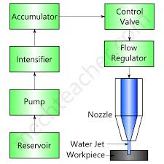
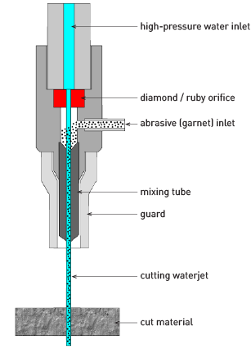

Figure 1: The working principle of the waterjet cutting method.

There are several advantages of the waterjet cutting approach and this includes (TECHNI, 2018):
- It is a cold cutting technique which means that no heat is generated as heat might affect the mechanical properties of the product.
- This method is flexible and can cut in any direction required.
- It can cut metals and non-metals.
- The cuts produced are very precise, i.e. net shape or near net shape.
- Environmentally friendly.
- Stress-free method so the workpiece is not affected.
- Waste is very minimal.
- A fast cutting method.
On the other hand, this method has several disadvantages and this includes (BALLARD, 2018):
- Material wears such as nozzle and orifice.
- The thickness of the workpiece is limited (the thicker the workpiece the lower the accuracy).
- Expensive initially to optimise the type of abrasive for a certain material.

- The Ultrasonic Machining Method

This method utilises a tool of a certain shape that vibrates at ultrasonic frequencies over the surface of the workpiece, Figure 2. This vibrating action alongside a force that is directed downwards towards the workpiece causes the removal of the material from the surface of the sample. There is a gap between the vibrating tool and the surface of the workpiece, i.e. the machining zone, which contains particles of a hard abrasive material in the form of slurry that rubs against the surface at a specified frequency as that of the tool. This causes an indentation action on the workpiece as well as the tool. This means that the machining method is better when the workpiece is brittle as it will help with easy cracking and removal of the material. In other words, the indenting particles hit the surface, cause cracking of the surface of the workpiece and hence remove the material at a certain removal rate. The tool should be manufactured from a ductile material which reduces the abrasion of the tool material and hence provide durable tool for further machining (Kharagpur, 2018).

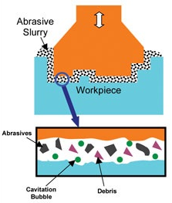
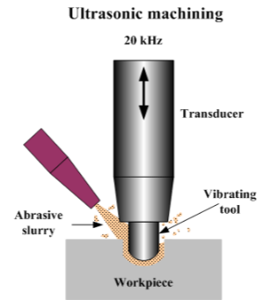

Figure 2: The working principle of the waterjet cutting method.

There are several advantages to this technique and these include (Jagadeesha, 2016):

- This method does not involve any heat or chemicals and this keeps the workpiece unaffected.
- This method can machine very hard and brittle materials.
- This method can machine non-conductive materials.
- This method produces a small amount of burr and result in less distortion of the workpiece.

On the other hand, the disadvantages include (Novel_Mech, 2016):
- Low material removal rate.
- Initial machining is expensive.
- This method is not suitable for heavy metal removal rate.
- This method is difficult to machine soft materials.
- The abrasive slurry has to be changed for better cutting efficiency.
- High power consumption.
- Cavities might form at the surface of the workpiece.
- A Comparative Study (Waterjet vs. Ultrasonic Machining)

The comparison between waterjet and ultrasonic machining is based on the accuracy of the machining process, materials of the tool, cost and wear as well as the type of the workpiece material, Table 1. Overall, the waterjet is more accurate due to the use of a nozzle and hence the narrow stream of water that cuts very precisely. The waterjet method provides a quicker method for cutting when compared to the ultrasonic technique and this reduces the running cost of the machine. In both methods, the tool is subjected to wear and this requires replacement of the tool after a certain amount of use. The waterjet is capable of machining any material whereas the ultrasonic machining method is restricted to brittle and hard materials (Sinha, 2018), (Machining, 2018).

Table 1: A comparative study (waterjet vs. Ultrasonic machining).

Criterion for Comparison | Machining Technique
Criterion for Comparison | Waterjet Method | Ultrasonic Method
Accuracy of cut | Very precise | Less precise
Tools to be used | Nozzle + Pump+ Mixing chamber | Vibrating tool and transducer to produce the frequency
Cost of Machining | Relatively cheap | Relatively Expensive
Time of Machining | Quick | Slow
Tools and Wear | The nozzle and mixing chamber are subjected to wear from abrasive particles | The vibrating tool is subjected to wear due to direct contact with the abrasives
Type of Workpiece | Can cut any material | Can cut brittle materials only

- The CES Analysis of Methods

The Cambridge Engineering Selector (CES) can provide the most appropriate method for machining based on certain criteria such as cutting speed and thickness of materials as well as the produced roughness and minimum cut width, Figure 4 and Figure 5. It can be seen that the waterjet machining can cut thin sections at a very high speed. Also, the results suggest that the waterjet provides a surface with low roughness which means that secondary machining operations are eliminated. This means that the waterjet machining is very acceptable in terms of the various advantages as discussed earlier in the report.
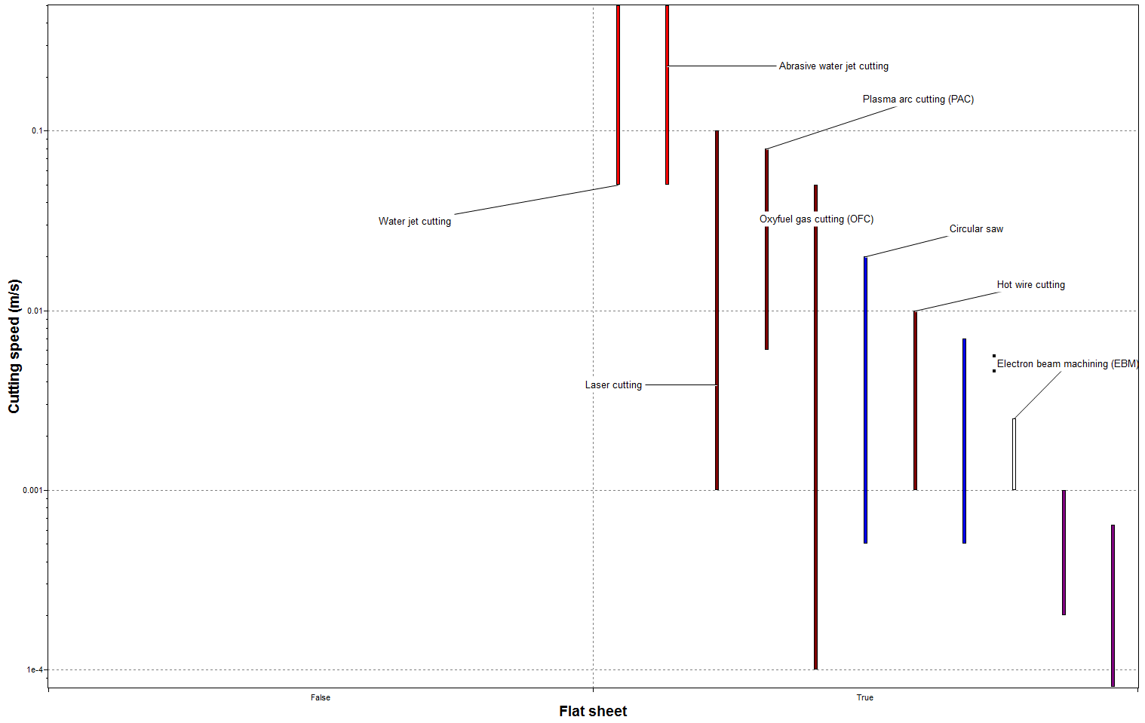
Figure 4: The CES results (thickness of the workpiece vs. speed of cut).

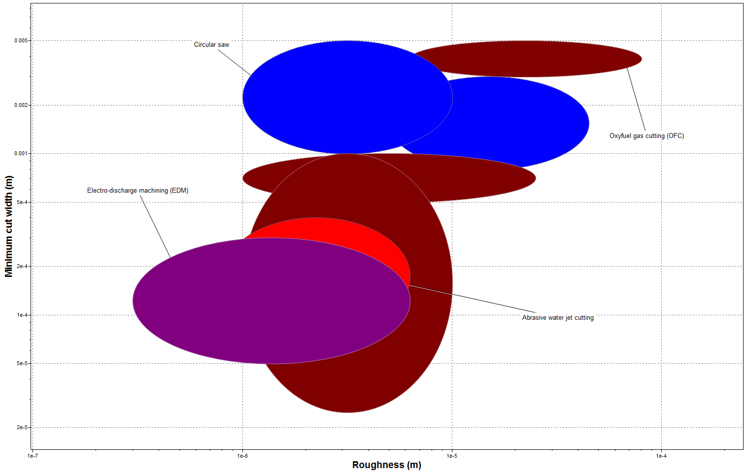
Figure 5: The CES results (cut width vs. roughness of the machined surface).

- The Machining Method and Industrial Response

In general, most industries would prefer a high speed machining method in order to increase the production rate and reduce the running costs. This is achieved by employing advanced machining methods such as waterjet and ultrasonic machining. These methods produce parts of high accuracy where the workpiece is not influenced by the heat of the machining method. It is very important to utilise a method that does not affect the mechanical properties of the produced part in terms of induced stresses or heat affected zones. Such speedy methods mean that industries can increase their production rate and reduce the cost of products which makes them capable of competing in the market. Moreover, such methods reduce the amount of waste of the workpiece material and this means savings in terms of money and resources. Such reduced amount of waste mean that the environment is not affected by the disposal of such waste and this is very desirable. Advanced machining can provide accurate parts and this attracts businesses and other industries especially aerospace and automotive where accuracy of parts is a priority. When such methods are adopted by certain industries, it will attract businesses and improve the quality of products. This will also reflect on the performance of such industries in terms of professionalism and reputation in the market. Moreover, such employment of these methods will boost the research and development in the machining industry and will provide a mean to further optimise such methods and reduce the negatives features of these techniques. This will mean that industries will compete in terms of quality of products and this will attract customers to such industries and therefore provide more profit to industries (NST, 2009), (Alcaraz, 2012).

- Conclusions

Advanced machining and non-traditional cutting methods are those which provide very high speed machining methods as well as high accuracy. It has been shown that waterjet and ultrasonic machining techniques provide an alternative cutting and machining tools to other traditional approaches. These advanced methods provide high quality products at a reduced cost which is desirable. Moreover, they provide industries with professional and advanced tools which reflect on the reputation and profit of such industries. These advanced methods have started to dominate some industries and this will open new areas for research and optimization to increase the efficiency and reduce waste and therefore save money and resources.

References

Alcaraz, J. (2012). Benefits of advanced manufacturing technologies . African Journal of Business Management.
BALLARD. (2018). THE ADVANTAGES AND DISADVANTAGES OF WATERJET CUTTING. Retrieved 3 4, 2018, from http://ballardmachineworks.com/2016/07/02/advantages-disadvantages-waterjet-cutting/
Dixit, A. (2015). WATER JET MACHINING: AN ADVANCE MANUFACTURING PROCESS. International Journal of Engineering Research and General Science.
Jagadeesha, T. (2016). ULTRASONIC MACHINING. MED, National Institute of Technology.
Jeremy, F. (2014). Comparing Environmental Impacts of Additive Manufacturing vs. Traditional Machining via LifeCycle. Rapid Prototyping Journal .
Kharagpur, I. (2018). Ultrasonic Machining (USM). Version 2 ME, IIT Kharagpur.
Lacalle, L. (2018). Modern Machining Process. http://www.iste.co.uk/data/doc_ayupatunrlmy.pdf.
Machining. (2018). Non-Traditional Machining. http://www.me.iitb.ac.in/~ramesh/courses/ME338/non_trad.pdf.
Novel_Mech. (2016). Ultra Sonic Machining Working, Characteristics, Advantages, Disadvantages and Applications. Retrieved 1 14, 2016, from http://novelmech.com/2016/03/complete-guide-to-ultra-sonic-machining.html
NST. (2009). Challenges to Innovation in Advanced Manufacturing: Industry Drivers and R&D Needs. https://www.nist.gov/sites/default/files/documents/el/whitepapers.pdf.
Sinha, N. (2018). Introduction to Non-Traditional Machining. http://home.iitk.ac.in/~nsinha/Non-traditional-machining.pdf.
TECHNI. (2018). Waterjet Advantages. Retrieved 3 4, 218, from http://www.techniwaterjet.com/waterjet-advantages/

