

Counselling studies & Psychology
Research design and Analysis
M5X00913

Coping with change: exploring the lived experience of moving to a new University campus

The exploration of how students are coping with the move to their new university campus has been demonstrated throughout this study. Various pieces of equipment were used within this study which included a university lab, a consent and debrief form and a piece of recording equipment. This study included 3 participants who were asked 4 questions by the researcher, in relation to how they feel about the new campus. These results were then recorded and transcribed, allowing the researcher to have a clear of an understanding of how each of the 3 participants are coping with their move to the new University Campus.

Introduction

This qualitative report will attempt to explore how university students are coping with the move from their old university campus to their new campus. The study questions attempted to allow the participants to express their thoughts and feelings on the new university campus, in relation to the old one and the questions were not bias or one-sided. The results of the participants included common themes such as the parking facilities, the library, and the electrical equipment (computers, printers, etc). These results were then recorded and transcribed by the researcher, allowing the researcher to have a much clearer understanding of the participant's thoughts and feelings on their recent move to the new campus. These results will be displayed within the results section of this qualitative report. Based on the question the researcher is exploring within this report, there have been previous literature-based studies, reports, and articles. These previous-based pieces of work will allow the researcher's results to become much more effective and accurate as they can be compared and contrasted with other previous studies. A piece of previous-based literature may include, (Bridges, 2011). Bridges theory includes three stages, the firsts of these include the ending, losing and letting go stage. This stage relates to a university student's first few weeks of transitioning, where they face environmental and cultural change. The second stage of this theory is known as the neutral transition zone, which involves the confusion and anxious feelings of the university students. This may be due to both the environmental and cultural stage, but also the aspect of meeting new people, the stress of academic results and much more. The third and final stage of this theory is known as the new beginning stage. This stage is where the university student begins to challenge themselves with their new way of life and start to develop personal skills and ways of adapting to their transition. An article from the USA has stated that some students mature faster than others. Students who are developmentally behind typically experience more stress than their counterparts. Consequently, they may earn lower grades and display decreased academic motivation, which may increase the rate of dropping out of school, (Cauley & Jovanovich, 2006; Eccles & Wigfield, 1997; U.S. Department of Education, 2008). It has been claimed that transitioning programs have been put into place for university students, in order to allow the process to become much more comfortable for them. However, many of these programs have been known to fail due to taking little consideration of the social aspects of the students, (Cauley & Jovanovich, 2006; Akos, 2002).

Method

These participants were notified of the study by the researcher and were asked in person if they would take the time to participate. This study included three participants, Chase Chandler, Alex Harries, and James Gregory, who were all second-year students at the new campus, aged between 20-21. Each participant was given the same questions of interest, and the interview’s lasted between 07:35 to 04:06 minutes.
This was a qualitative-based study, including a semi-structured interview where the researcher asked each participant four questions relating to the studies question. The topic of interested in relation to the study was the exploration of how university students are coping with the transition of moving from their old campus to their new campus. Each of the participant's results were then recorded and transcribed, (appendix A1, Chase, A2 Alex, A3 James).
There were various materials used within this study, which include a lab in order for the study to be conducted in a secure and quiet environment, a piece of recording equipment to allow the participants results to be saved, in preparation for transcribing, a consent form, (Appendix B), provided to the participant before the study takes place, informing them of the studies purpose, the questions were provided by the researcher, (appendix C) allowing them to thoroughly explore the participants thoughts and feelings of the new campus, in comparison to the old campus. A debrief form was then made available to the participant once the recording had finished and the study was completed, (Appendix D).
The participants were escorted into the provided psychology lab, where they were seated and read the consent form by the researcher, informing them that the study was attempting to explore how university students are coping with the transition from the old university campus, in comparison to the old campus. Once the participants were made aware of this, they were asked to sign and date the consent form, providing they were satisfied and willing for the study to commence. The participant was then asked if they had any questions or concerns, they needed to ask before the recording began and once this had been settled, the piece of recording equipment was placed onto the provided table and switched on, along with the question paper they had prepared. The participant was then asked the first question by the researcher, who then continued to ask further questions at the relevant stages of the recording. Once each question had been covered and answered, the participant was then asked if they had any further queries about the study and once this had been settled, the piece of recording equipment was switched off. The participant was then thanked by the researcher for taking the time to complete the study and was handed a debriefing form.

Results

The table of these themes will be provided, (Appendix E). The canteen was one of the themes noted in the study. Participant Chase Chandler described the new campus as, ‘so there are issues within the canteen is that it’s very small considering more students come here than the old campus and it can get quite crowded very quickly so there are issues like that’(18-20, A1) and the old campus canteen as, ‘for instance now umm back in the old campus the canteen we use to have, we had one canteen which was quite sizable, we had also a café type thing as well’, (10-12, A1). This same issue was also noted with participant James Gregory who stated that ‘Umm the only problem I have is the canteen. It is not big enough to accommodate the students that are here at the new campus’, (3-4, A3). The positive feedback of the old campus canteen was also carried through to participant Alex Harries, stating that it was, ‘They had a much bigger canteen, just nobody in there’, (44-45, A2). It does not appear to be a coincidence that there may be potential issues surrounding the new campus canteen, in comparison to the old campus canteen.
The educational facilities were another theme appearing throughout each participant’s interview. Chase described the computer facilities as ‘computer availability wasn’t great in the old campus as compared to here. You’ve got computers on the ground floor, you have more in the library, there is more than enough here’, (53-55, A1). Participant Alex Harries described the facilities as ‘I am finding the facilities here at the new campus good. They’re very modern, very spacious and there’s a lot of modern features that you’d expect from a university establishment at a new campus, which weren’t at the old one’, (3-5, A2), as well as participant James Gregory who stated that, ‘The new computers are up to a better standard and amount, (5-6, A3). As a result of these statements, it is clear to note that the facilities at the new campus have not only improved but had a positive impact on their transition to the new campus.
Transportation has also become a common theme between the three participants. Chase related his transportation experiences in a positive manner, stating that, ‘Because more students come in, there’s less parking but I have noticed today that they have extended the car park right outside the campus for students’, (67-69, A1). Alex Harries didn’t relate any of his statements to the transportation facilities but did however mention how, ‘parts of the outside of the campus are still like a building site’, (27, A2). This issue may have been part of the reason that the car parking facility was not up to the standard expected at first. This was noted in James Gregory’s statement who claimed that ‘The car park is also a problem for some of my friends who are struggling to find spaces, whereas the staff car park is much bigger and spacious’, (7-8, A3). Despite the original negative statements surrounding the transportation elements of transitioning to the new campus, these were clearly noted by the university and improved upon, as mentioned in Chase Chandler’s statement.

Discussion

Taking all elements of the statements provided by the participants into consideration, it seems evident that the overall transition was positive, even to the extent where Chase stated that, ‘Sometimes I get annoyed when the classes end because I enjoy being here that much’, (92-93, A1). The new education facilities and modernized campus were a common theme between each participant, claiming that they have improved a lot in comparison to the old campus. This specific element may be recognized as the most important due to how important educational facilities are for university students and their academic performance. However, negative details surrounding the participants transition such as the parking facilities and the canteen. Despite these not being exactly educational related, they can potentially have an impact on their academic performance, which as a result, can impact their transition period in a negative manner. As an overall result, based on the statements made by each participant, they all claimed to have transitioned well and suggested improvements to the campus, which did not affect their transition heavily.

Appendices
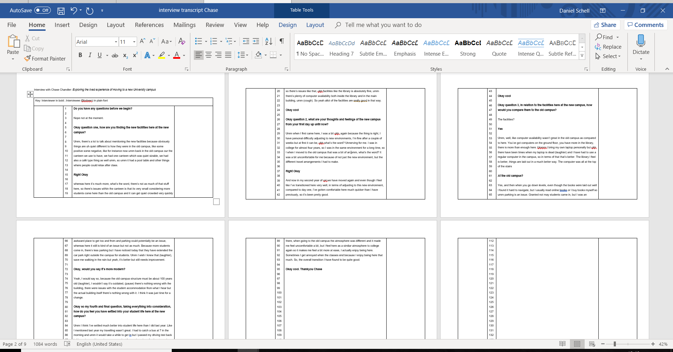
Appendix A1

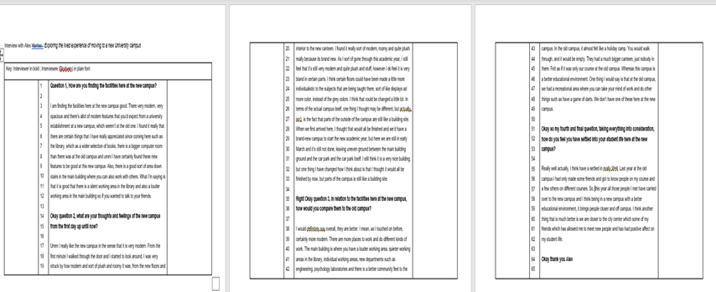
Appendix A2

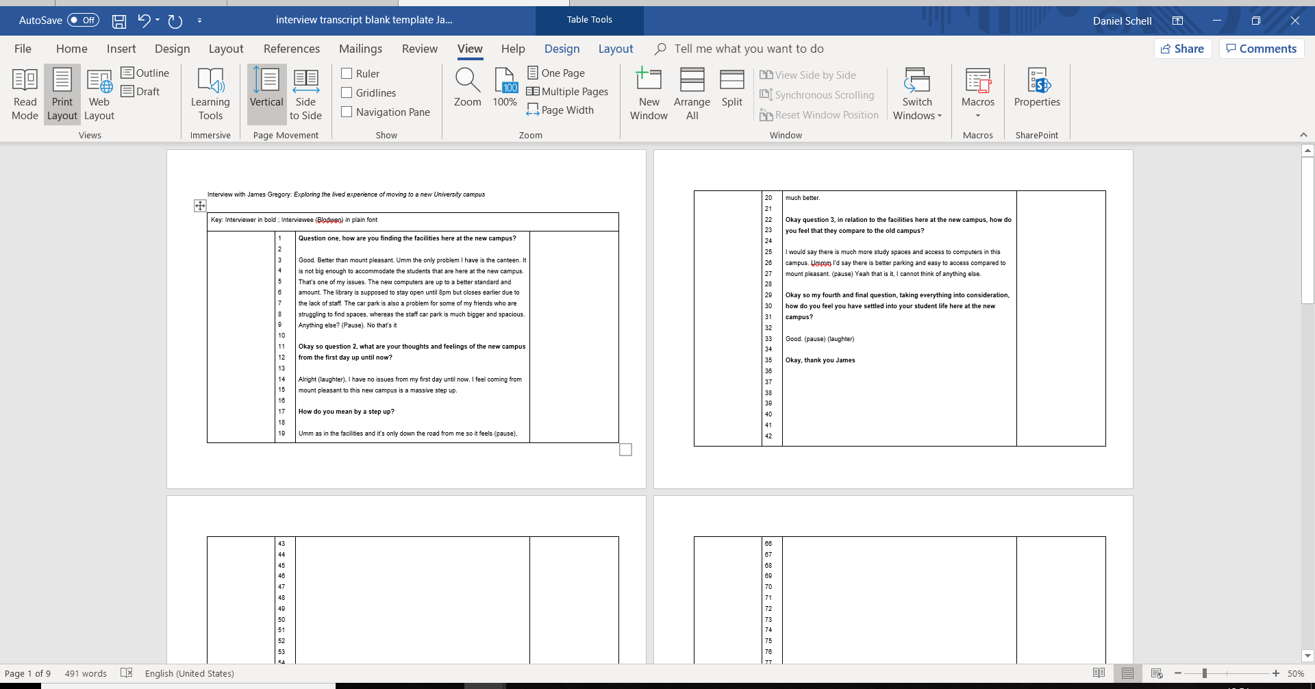
Appendix A3

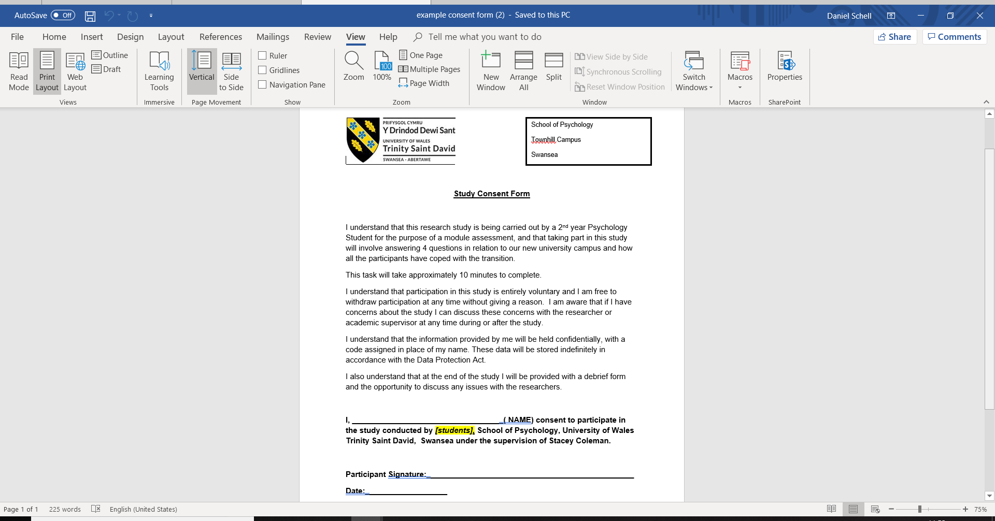
Appendix B

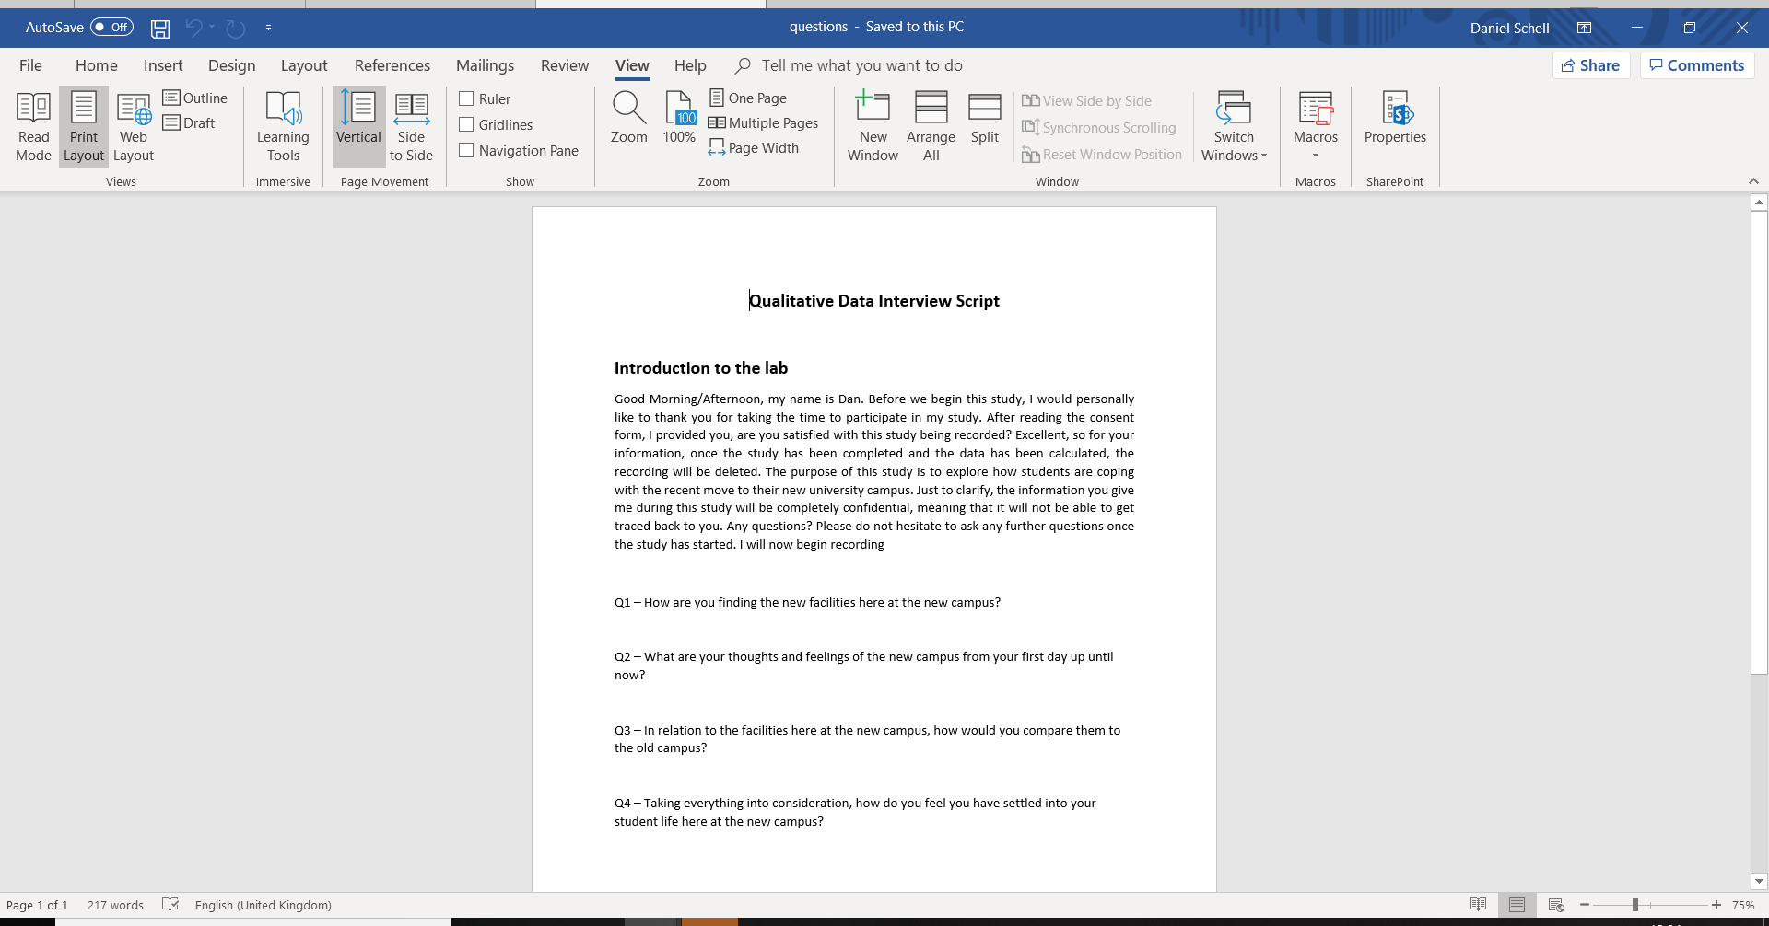
Appendix C

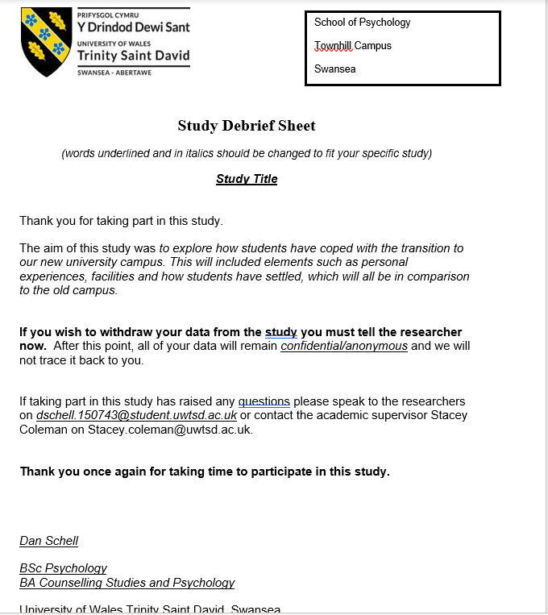
Appendix D
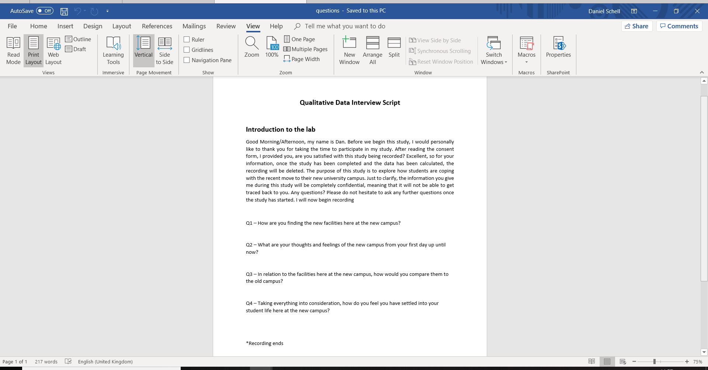

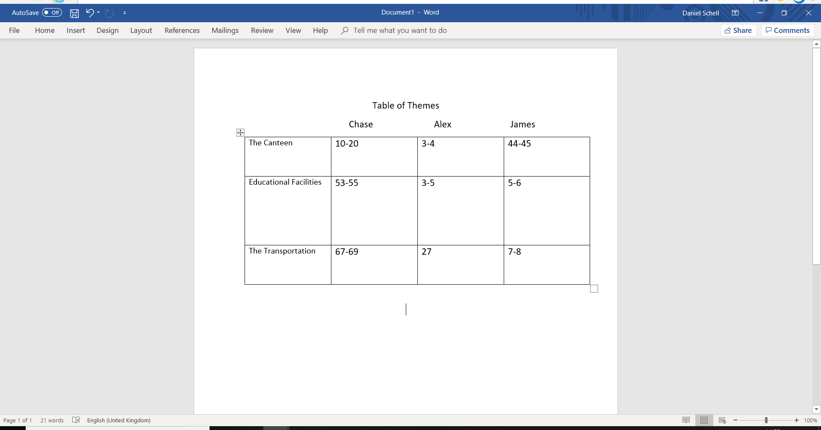
Appendix E

Reference List
- Risquez, A. Moore, S and Morley (2008) Welcome to college? Developing a richer understanding of the transition process for adult first year students using reflective written journals. Journal of College Retention, 9 (2), pp 183-204
- Briggs, A R J, Clark, J and Hall, I (2012) Building bridges: understanding student transition to university, Quality in Higher Education, 18 (1), pp 3-21
- Cauley, K., & Jovanovich, D. (2006). Developing an effective transition program for students entering middle school or high school. Clearing House, 80(1), 15-25.

