  Component One: Student Journal (learning log) 750 words +/- 10%  Contribution to Overall Module Assessment: 25% | Student No: | 2235640
 | Module Title: | Hotel Administration and Front Office
 | Module Code: | BMIH4004
 | Lecturer: | Ben Chong

Introduction
The aim of this journal is to critically evaluate my placement experience within the front office department. I will complete a detailed and critical analysis of my own experience by using the Gibbs Model of Reflection. Accordingly, I will also discuss the importance of communication and other professional skills to improve the overall guest service experience.

Personal experience
Gibbs's Model of Reflection is one of the popular theories of reflective learning which has six stages. Description, feelings, evaluation, analysis, conclusion and action plan are the six stages which help to develop a concrete experience (Gibbs, 1988). Graham Gibbs developed the model in 1988 in his book ‘Learning by Doing’ (Gibbs, 1988). This theory has explained the importance of active experimentation and hands-on experience in learning. I will discuss my placement experience critically through these six stages.
Description: During my placement within the front office department, I worked in the front office area of the Premier Inn Hotel. I was in the reception area and mainly responsible for guest welcoming as well as communication. During this placement I also manage guest reservation, check-in and check-out; customer service and other duties as well. As a front desk staff, I was responsible for receiving messages from visitors, recording them and resolving their issues as soon as possible. Effective communication is the most important skill for offering a positive guest service experience (Heyes, 2017). The front desk staff can enhance overall customer satisfaction by 40% in a hotel (Gebbels et al., 2020). Offering quick guest services such as reservation billing and room inventory can increase the repeat consumer number as well. I mainly greeted customers using their names and also maintained a positive attitude such as direct eye contact with them (Carlisle et al., 2030). Sometimes I have also provided various information to guests about local restaurants, attractions and other areas.
Feelings: During my placement, I have enjoyed my duties and responsibilities very much. However, I have also faced some communication issues with customers. As a large hotel chain, foreign guests from non-English countries often arrive in Premier Inn. My senior attended them and maintained positive communication through different languages including German, French and Italian. During this time, I was responsible for managing guest enquiries where I was not able to communicate with the guests in German and Italian language. Apart from that, during my placement, I have also faced issues handling check-ins and check-outs due to high guest arrivals during the festive seasons.
Evaluation: From the overall situation, I was able to analyse my performance and skills during my placement. Professionalism, communication, time management and teamwork are my key strengths. I can manage my time and maintain multi-tasking which is important as a front desk staff in a hotel. On the other hand, my problem-solving and conflict-resolution skills are not good enough as I need to improve them for my future career.
Analysis: During my Placement in the front office area of Premier Inn Hotel, I have understood the role and responsibilities of a front office staff. My warm and positive interactions with guests impressed customer satisfaction. I also did proper teamwork with my colleagues and together we have created and welcomed as well as an efficient work environment (Nguyen, 2019). During this time, I also maintained the ethical and cultural policies of my workplace. I equally treated every guest during my placement. Some indigenous tourists from Australia have arrived and I considered their cultural as well as traditional values while communicating with them. I also shook hands with every guest and maintained professional behaviour as well (Sayin and Karaman, 2019).
Conclusion: From the placement experience, I have learned about detailed tasks in the front office area of a large UK hotel. I have also learned about the benefits of effective communication, professionalism and positive behaviour as a front office staff. Therefore I have identified that I need to improve my language skills and learn different languages to become a successful professional in the hotel industry. The placement experience will help me to improve my weak ideas and also provide extra advantages in my future career.
Action plan: I will learn German, French and Italian languages online. I will enrol my name in an online language learning workshop to improve my linguistic skills. Similarly, I am also interested in improving my problem-solving and critical-thinking skills. I will participate in role-play and group discussion activities to enhance these skills. Apart from that, I will improve my digital literacy as well through a six-month software learning workshop.

Conclusion
This journal has briefly explained my overall learning experience during my placement as a front office staff in the Premier Inn Hotel. I work as a receptionist and can develop knowledge about the front office activities in a large hotel chain. I have used the Gibbs Reflective Model in this journal to evaluate my personal experience and improvement areas as well.

Component Two
Contribution to Overall Module Assessment: 25%
Trip Advisor Review Response 150 words +/-10%
Thank you for your positive review and the precise time you have considered for giving the feedback. We are very happy to know that you are our repeat customer and have enjoyed your stay with us. We are extremely happy that you had a positive experience with us and enjoyed our breakfast services. All our staff are well-trained and very considerate of every guest. Our restaurant services are a good choice for vegan and vegetarian customers. We are glad that you liked our guest services. We try to offer customised and comfortable services to our repeat customers to improve their satisfaction. We are very glad to know that you chose us and spent your time in our Canterbury location. We do not support any unethical or illegal practices as well as always try to provide a diversified service experience to all customers. We really work hard every day to make you and other visitors special and satisfied as well. Your comments, reviews and feedback always help us to improve our services. Always feel free to reach out to us and comment on any suggestions which could be improved. Hope we can welcome you again. Thank you.

Screenshot of referenced Trip Advisor review used:
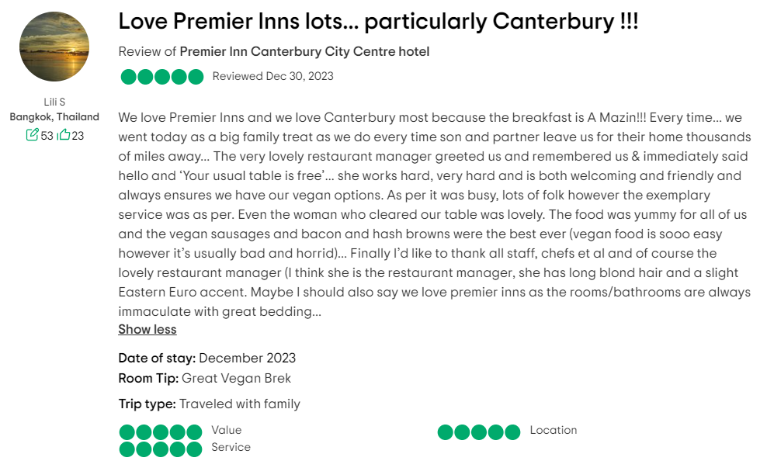
(Source: TripAdvisor, 2024)
Letter of complaint response 500 words +/- 1-%
29 January 2024
Premier Inn Hotel
London, UK

Subject: Response letter about the service complaint at Premier Inn.
Dear Jonna Blake,
Hello madam, I am writing this letter in response to your recent complaint Letter about our guest services in Premier Inn, London. First of all, we are extremely sorry about your poor service experience with our hotel. We want to thank you for taking the time to share your feedback with us and we will definitely work on this. We value our customers most and constantly try to improve to provide you with a high-quality guest experience. We are extremely sorry for the inconvenience you have experienced during your recent stay.
We have investigated your complaint properly and analysed some key issues including the cleanliness of your room number 330, the poor wi-fi service, staff behaviour and the noise issue inside the hotel. We would like to discuss all the steps with you which are considered for resolving every issue. I have discussed with my senior as well about your complaint and we hope we will meet your expectations next time.
We are a professional team and never compromise with our guest experience as well. There were some critical situations and I want to inform you about the main causes of the poor services. After the holiday season, there was a lack of employees as most of them were on their holidays. In the meantime, some of our house cleaning staff were sick during that time. Due to this issue, you have to face cleanliness issues in your room. Besides that, currently, we are working to improve the wireless network infrastructure to improve the wifi services for our guests. Due to the infrastructure development, you have to face poor wi-fi connections in your room. We apologise for that and also assure you that you will experience a better wifi service next time.
I have already spoken to the employees and hotel staff who were involved in your guest service. I assure you that I have discussed the issues with them and you will not face these inconveniences again. I have communicated with the housekeeping manager at our hotel and arranged a deep cleaning session for the room. We are also assuring that next time you will always get a properly clean and sanitized room. We are concerned about your hygiene and wellness as well.
I also have talked about the issue of staff behaviour with the guest service manager. Due to excessive workload and staff shortage, employees were unable to respond to every guest quickly. Our staff issue has been resolved and the guest service manager has ensured that it will not happen again.
We have recently implemented soundproof doors and panels in windows to resolve the sound issues in our rooms. Some of those rooms have also been renovated with acoustic panels which can reduce external noise by 95%.
On behalf of Premier Inn Hotel, I would like to offer you a flat 20% discount on your next booking within the next six months. Due to your inconvenience, I also enclose a free dining voucher for two at our newly renovated fine dining restaurant.
Sincerely,
The Hotel Manager
Premier Inn Hotel
London

Component Three:
Contribution to Overall Module Assessment: 50% (1000 words +/- 10%)
Writing in essay format

Introduction
The front office operations are the face of a hotel. It creates the first contact with guests and the first impression as well. The front office employees play a vital role in ensuring guest satisfaction as well. The front office of a hotel performed various functions including queries Complex coordinating guest services reservation room assignment bill settlement and many more. A front office employee required some key skills to provide high-quality guest services. This essay will critically evaluate the importance of the top four skills such as communication, customer service, organisational and problem-solving skills in working within the hotel’s front office operation.

Description
One of the important skills for front office operations is customer service skills. It includes adaptability, self-management, time management, empathy, problem-solving and technical skills. As per the view of Tewan (2009), customer service of a hotel directly affects its business reputation, sales growth and repeat consumer number. A hotel with high-quality customer service always attracts repeat customers and new customers. Visitors or guests always prefer to stay in hotels which have high-quality customer service. This is an important skill for front office staff in a hotel which helps them to easily communicate with customers and guide them as well. Employees with customer service skills can easily identify the issues or problems of a guest and try to resolve them as soon as possible. Strong product and service knowledge about the hotel is highly required for every employee. Production knowledge is a part of customer service skills which helps individuals to create positive customer experiences. As per the view of Wood (2013), the customer service skills of employees set the basic standards of a hotel. Warm greetings, regular questions, offering basic services and collecting customer feedback are included with customer service skills. Along with this, hotel employees also need to conduct proper market research as well to identify current needs, market trends and consumer expectations. According to Tesone (2010), good customer service skills help employees to improve relationships with visitors as they learn to value and treat every guest. Every small accommodations to medium and large hotel chains always consider high-quality customer service. Hilton Hotels has recently reported that high-quality customer service has increased repeat customer rates by 23% in 2023 (Faster Capital, 2023). Britannia International, Travelodge and Park International are other 4-star hotels in the UK which maintain high-quality customer services for business growth. As per the view of Wood (2013), technical skills are required to improve customer service as well. Employees with strong technical efficiency can analyse online customer reviews, their previous purchase decisions and buying behaviour to provide more personalised hotel guest services. Employees can conduct online customer satisfaction surveys through technical skills and use property management software (PMS) as well. Along with this, making online payments and sending emails to customers also requires technical efficiency. Walt Disney Parks and Resorts conducts employee training every year to improve their customer service skills (Daoust, 2021). Savoy Hotels, Marriott Hotels and other UK hotel chains consider gusset feedback to improve their customer services as well.
Another important skill of front office operations is communication skills. According to Fallon and Rutherford (2011), hotel industry professionals, especially front office employees, need to be excellent communicators to maintain proper guest services as well as create customer engagement. Communication skills are not only language skills but also maintaining positive behaviour, professionalism and understanding the needs of individual guests. Front office staff can use their verbal and nonverbal communication skills to resolve issues of customers and guide them with their requirements. As per the view of Hammer (2016), verbal communication is one of the most popular and common forms of communication in hotels’ front offices. Premier Inn, Savoy Hotels, Travelodge, Hyatt Hotels and other hotels always recruit experienced employees in their front office who are also efficient communicators. Verbal communication helps employees communicate with colleagues, business stakeholders and customers. Voice tone pronunciation and vocabulary are important in verbal communication for front office employees. They need to practice active listening and learn new languages as well to improve verbal communication skills. The receptionist of a hotel is responsible for greeting guests with warm smiles and polite tones which are examples of verbal communication. It makes the conversation more accessible and guests feel welcomed at the front desk. On the other hand, nonverbal communication includes facial expression, body language and gestures of the speaker. As per the view of Fallon and Rutherford (2011), front desk employees need to control their emotions and offer a positive attitude through nonverbal communication. Maintaining direct eye contact and considering proper body language can increase their self-confidence while communicating with guests as well. Eventually, written communication is another essential part of front office operations. Front office employees are responsible for sending emails to customers and preparing memorandums for guests (Mizzi, 2022). Maintaining paper grammar, proofreading spelling errors and following the formatting guidelines of the hotel are important in written communication. Including this, active listening skills are also included with communication for front office employees. Paying attention to customers and appropriate responses can improve the overall customer satisfaction rate in a hotel.
As per the view of Solomon (2018), organisational skills are essential for front office employees of a hotel which help them to maintain working efficiency and accuracy. Organisational skills include customer handling, time management, leadership, industry knowledge and financial management. Apart from that, problem-solving, attention to detail and planning are also required for front-office employees. According to the view of Tesone (2010), organisational skills basically help front-office employees handle the demanding and dynamic nature of the job. Front office operation employees need to manage multiple tasks in a fast-paced environment. Good time management can help employees in multitasking and planning. They also need to pay attention to every detail to improve customer satisfaction. According to Corgel et al., (2011), front office staff are responsible for organising all customer documents both online and offline. Technical efficiency is similarly required as they need to use different software and digital tools in front-office operations. Using Google Calendar, online databases, email and spreadsheets can improve the overall working efficiency of the employees (Faster Capital, 2023). Along with this, customer handling is also included in organisation or skills for Hotel employees. Proper planning, problem-solving and critical thinking skills help individuals to handle customers properly. As a front desk employee, an individual needs to work with other functions of the hotel and also maintain bills which require financial knowledge as well. Along with this, proper service and market knowledge are also required for hotel industry employees as they provide proper details to guests about the service features with their prices (Mizzi, 2022). Dukes Bath, South Lawn Hotel, The Falstaff, The Wheatsheaf Inn, Port Hotel and other hotels recruit front office employees with high organisational skills to ensure customer satisfaction as well as business reputation.
According to Bardi (2011), problem-solving skills are one of the main skills of front office operation employees. The front desk of a hotel is all about providing proper guidelines to guests and resolving their issues. Problem-solving skills are also included with critical thinking, research, industry knowledge and decision-making skills. Front office employees with good problem-solving skills can quickly identify problems and efficiently work on them to provide high-quality customer service. Proper communication and customer service skills also help an employee to resolve the issues of guests. As a fast-paced environment, the hotel industry has to deal with various uncertainty and complexity. According to Solomon (2018), problem-solving skills help to create proper action plans for resolving problems. Front office staff also need to follow through with guests to ensure their satisfaction after dissolving the problems. According to reports, Employees with good problem-solving skills can increase customer satisfaction rate by 35% (Faster Capital, 2023). 63% of customers always consider revisiting previous hotels which have good problem-solving and staff behaviour. In most cases, the front desk employees of hotels have to solve problems by their own experience and considerations. Responding promptly and creatively during challenging situations establishes the professionalism as well as good customer service of a hotel. As per the view of Daoust (2021), problem-solving skills are not only identifying and resolving problems. During critical situations, the front office employees need to analyse the situation first and generic possible solutions to the particular problem. In certain situations, they cannot even ask their seniors and need to use their own problem-solving efficiency to implement the best solution for customers. Travelodge has recently reported that good problem-solving efficiency among front of its employees has improved the operation of efficiency by 31% in 2022 after the pandemic (Mizzi, 2022). Efficient employees of the hotel chain can easily handle various situations including dealing with customers, stakeholders, suppliers and managers as well. The Hoste has seen a huge change in its operations after recruiting efficient employees with strong problem-solving efficiency.

Conclusion
This essay has critically demonstrated the importance of four key skills for a front office operation employee in a hotel. The skills are also related to the hotel's reputation, employee efficiency and operational efficiency as well. The benefits of communication, problem-solving, organisational and customer service skills have been evaluated here with real examples.

Reference List

Bardi, J. (2011) Hotel Front Office Management, Wiley, London
Carlisle, S., Ivanov, S. and Dijkmans, C., (2023). The digital skills divide: evidence from the European tourism industry. Journal of Tourism Futures, 9(2), pp.240-266.
Corgel, JB, Sturman, MC & Verma, R. (2011) The Cornell School of Hotel Administration on Hospitality: Cutting Edge Thinking and Practice, John Wiley & Sons, Incorporated, Hoboken.
Daoust, C., (2021). The importance of customer service in the hospitality industry. Available at: https://hotello.com/en/customer-service-hotels/ [Accessed 19 January 2024]
Fallon, M. & Rutherford, D. (2011) Hotel Management and Operations, Wiley, London
Faster Capital, (2023). Communication Skills: Key to Success in the Front Office. Available at: https://fastercapital.com/content/Communication-Skills--Key-to-Success-in-the-Front-Office.html [Accessed 19 January 2024]
Gebbels, M., Pantelidis, I.S. and Goss-Turner, S., (2020). Conceptualising patterns of career commitment: the leaving process in hospitality. International Journal of Contemporary Hospitality Management, 32(1), pp.126-147.
Gibbs G (1988). Learning by Doing: A guide to teaching and learning methods. Further Education Unit. Oxford Polytechnic: Oxford.
Hammer, J. (2016) Revenue superstar! The simple rules of hotel revenue management. Great Britain: Amazon.
Heyes, A., (2017). Hotel front office management. In Hotel Accommodation Management (pp. 57-69). Routledge.
Mizzi, M., (2022). 12 Customer Service Skills in Hospitality That Will Surprise and Delight. Available at: https://vervoe.com/customer-service-skills-in-hospitality/ [Accessed 19 January 2024]
Nguyen, H.H.M., (2019). Optimizing the role of hotel front office staff in modern-day revenue management.
Sayin, O.G.K. and Karaman, A., (2019). Communication and productivity with guests at front office; A qualitative study on hotels. Journal of International Management and Social Researches, 6(11), pp.186-196.
Solomon, M. (2018) The Heart of Hospitality. New York: SelectBooks, Inc.
Tesone, D. (2010) Principles of management for the hospitality industry. London: Routledge.
Tewan, J. (2009) Hotel Front Office: Operations and Management, Oxford Higher Education Press
TripAdvisor, (2024) Premier Inn Canterbury City Centre hotel. Available at: https://www.tripadvisor.com/ShowUserReviews-g186311-d5860385-r931643890-Premier_Inn_Canterbury_City_Centre_hotel-Canterbury_Kent_England.html [Accessed 19 January 2024].
Wood, R. (2013) Key Concepts in Hospitality Management, Sage, London

