Assessment component 1: Individual report

Student Name : Dipak Modhavadiya
Student ID : 2506701
Module Name: Human Capital Management
Module Code: LCMB7023
Lecturere’s Name: Gladius Kulothungan (London)
Word Count : 2,928 words (± 10%)
Term 1

Executive Summary
This report has critically examined the impact of technological innovations, globalisation and demographic as well as geopolitical developments and how it has impacted the labor markets and Human Resource Management strategies. It has examined how Generative AI and automation has shortened the half-life of skills resulting in skill gaps and talent shortages. HR leaders are required to use AI tools to plan and predict workforce requirements and streamline recruitment processes. Aging workforce, geopolitical instability and migration are posing challenges in talent management. This report shows how organisations can fill talent gaps through skill-trainng, re-skilling and other retention strategies using “build, buy, borrow “ framework by Cappelli(2008) with sector specific examples. At the end, author has evaluated personal development in core skills like leadership, digital literacy, communication skills and concluded that inclusive adaptive HRM practices with data-driven approach is the key to sustain the organisational culture and workforce.
Table of contents
Introduction 3
1.0. Reshaping of Labour Markets 3
1.1 Automation, AI and Technological Innovations 3
1.2 Gig Economy and Digital Platforms 4
1.3. Implications on Human Resouce Management 6
2.0. Demographic and Geopolitical Factors 7
2.1 Demographic Factors 7
2.2 Geopolitical Factors 7
2.3 Challenges for Human Resurce Professionals 8
3.0. Skill Shortages and Strategic HRM 9
3.1 Cause of Skill gaps 9
3.2 Strategic HRM 12
3.3 Sector Specific Examples 13
4.0. Author’s Reflection 9
4.1 SWOT Analysis 9
4.2 SMART Action Plan for Future 12
4.3. Outlook for Future
7.0 Conclusion 15
8.0 References 16

2.0. Introduction
The global employment market is going through massive transformation.According to the Future of Jobs report, technological advancements, economic uncertainty and demographic shifts are driving this transformation(WEF, 2025). While these developments create new opportunities for innovation and global collaboration, they also increase the risks among the workforce and create skill shortages in critical sectors. These shifts are going to affect 22% of the current global job market roles by simultaneously creating, destroying and altering jobs in various sectors(WEF, 2025).
As the structure of work is being redefined, organizations are compelled to rethink how they attract,develop and retain the talent. These disruptions are challenging the traditional models of human resource management and international human resource management by demanding more agile and data-driven strategies that are more inclusive and ethically grounded (CIPD 2024).
This report critically examines how these factors influence HRM and IHRM strategies, and concludes with a SWOT analysis of the author’s readiness in this evolving international labor market.

1.0. Technology and Labour Markets

1.1. Artificial Intelligence, Automation and Digital Innovations
Technological progress in artificial intelligence (AI), automation, and digital platforms is redefining job structures, altering skill demands, and ultimately transforming the global employment markets at a fundamental level (WEF, 2025). Unlike previously , this generative AI-powered revolution could significantly affect high-skilled workers as well (EU Report, 2025). While this displacement tends to lower the demand for labor in routine tasks, it will also create new high-skill jobs that are more aligned with technology, digital literacy, and skills more unique to humans. The WEF report estimates that this trend will create around 170 million new jobs . It will also displace around 90 million jobs, resulting in a net growth of 78 million by 2030. Brynjolfsson and McAfee (2014) conceptualize that while digital innovation and technology will increase productivity and create new jobs, it will simultaneously shift the demand toward high-skill, non-routine work. (Brynjolfsson and McAfee, 2014).
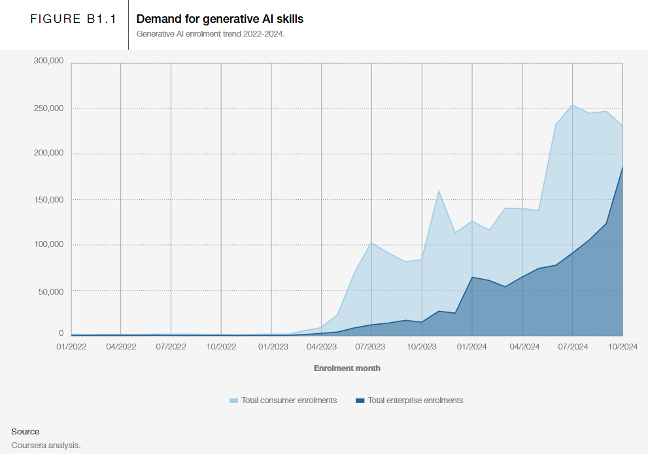

1.2. Digital Platforms
Digital platforms are allowing businesses to quickly source labor with in-demand skills, making them more adaptive and agile (OECD, 2023). Upwork's report shows that remote hiring improves hiring time by 16% while delivering 340% larger candidate pools (Upwork, 2025). It also allows qualified talent to overcome local employment market constraints.
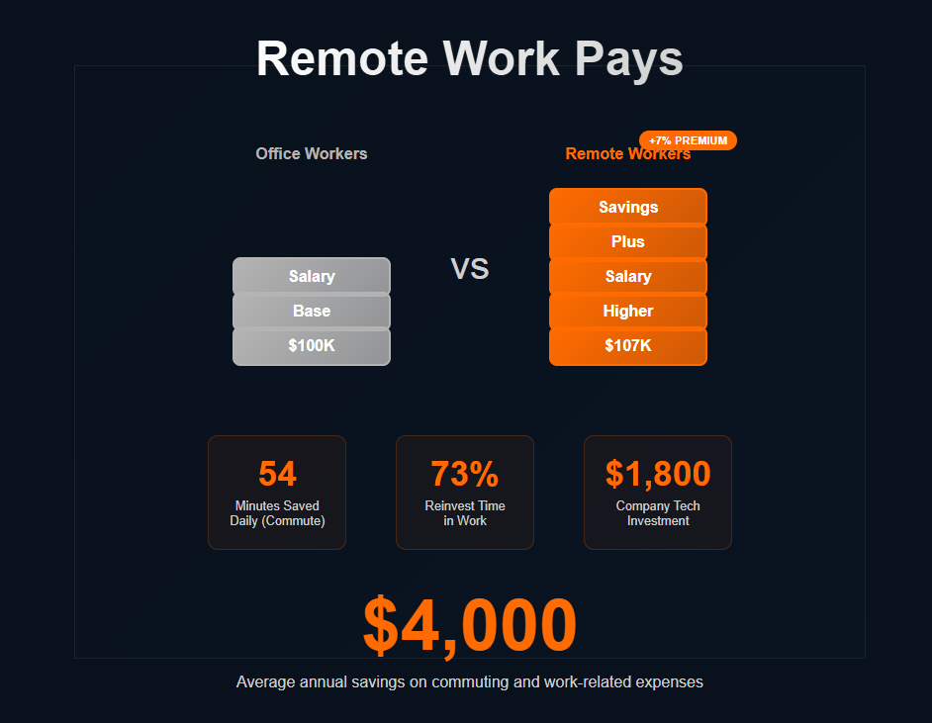
(Souce: Upwork remote work statistics)

1.3. Gig Economy
The gig economy has been expanding rapidly. 36% of U.S. workers identified as gig workers, up from 27% in 2016 ( McKinsey , 2023). It also reported that only 32% of independent workers received employer- provided health insurance, which raises a legal concern. As these workers are often classified as independent contractors, this raises long-term concerns such as job security, employee benefits, and legal protection (Mbonigaba and Vanitha, 2023). Similarly, a UK study found that 52% of gig workers earned below the National Minimum Wage (CIPD, 2023).
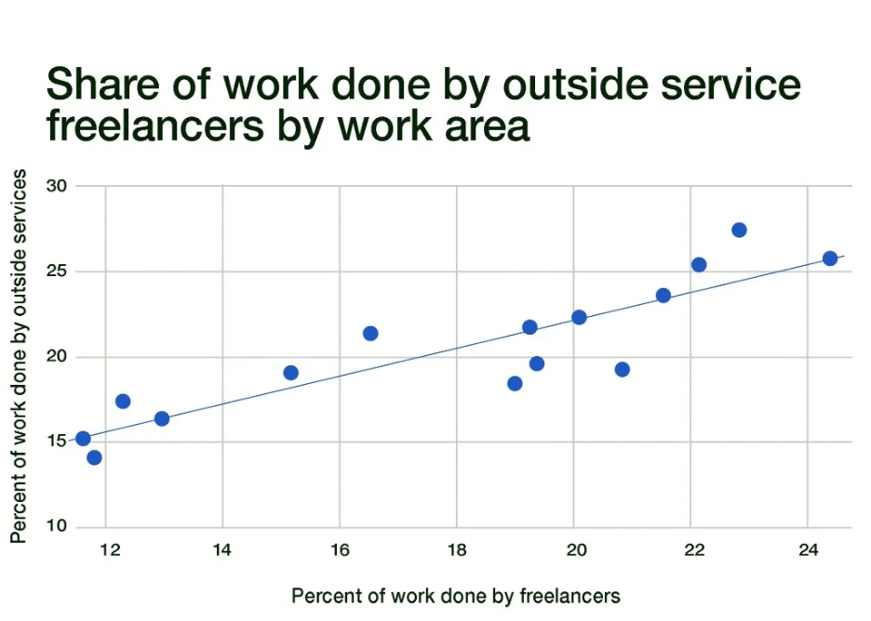
(Source: Upwork future workrforce report)

1.4. Implications on Human Resouce Management
1.4.1 Hiring Process
AI-assisted hiring platforms are the new normal for human resource professionals, with 90% of employers using them to screen and rank applicants (Goergen et al., 2025). HireVue - an automated screening platform - helped Unilever save 50,000 hours and more than $1 million in the process (HBR, 2025). On the contrary, a Harvard study found that 94% of HRM executives believe that automated screening filters out qualified candidates who could have been great hires (Harvard, 2021). So, while AI and digital platforms will streamline and accelerate the process, HR professionals need training to utilize these tools, and the tools need technical improvements.

1.4.2 Talent Retention
Job security is a big concern for remote workers, as the 2025 Gallup study shows that 57% of remote workers are actively looking for jobs. 56% of UK employers reported that retaining staff is harder than hiring new talent (Hooray, 2025). A similar trend is happening in the US, as 63.3% of firms stated the same (2025). One of the major reasons for this could be job security and compensation, as 73% of employees admitted they would consider leaving their current job for a higher paycheck (Bamboohr, 2024).
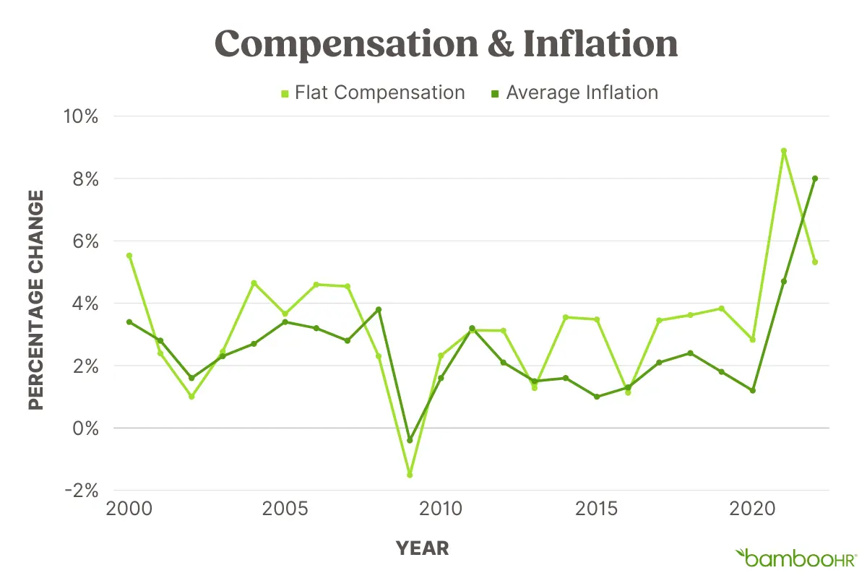
(Chart Data Source: Social Security Administration and Current US Inflation Rates)

1.4.3 International Human Resource Management
Managing and motivating a cross-national remote working team is the big challenge for IHRM professionals. Fully remote workers are more likely to be engaged but feel less secure (Gallup, 2025). On the other side, 71% of organizational leaders feel pressure from executives to strengthen employee productivity and 42% of employees admitted they were multitasking during staff meetings (SelectSoftwareReviews, 2025).
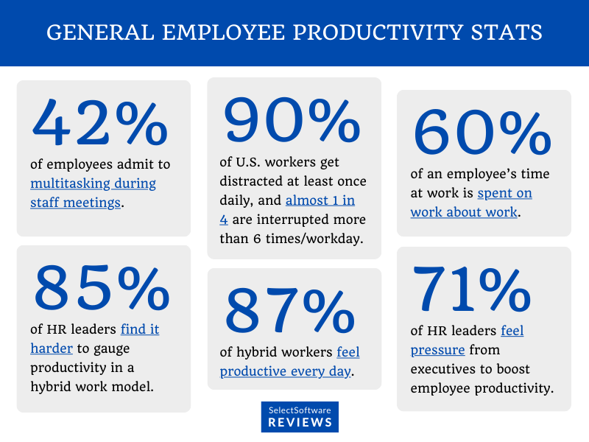
( Souce: SelectSoftwareReviews, 2025)

2.0. Demographic and Geopolitical Factors

2.1 Demographic Factors
2.1.1 Aging population
While some parts of the world are facing population decline and shrinking workforces , countries such as Africa and India are expected to have a surge in their younger working populations . This will have a significant impact on consumption patterns, cultural shifts, and labor supply instability (ILO, 2024). Institutional knowledge loss will intensify as a large number of the aging population reaches retirement age in many developed countries (Gloat, 2024). Combined with already existing skill shortages, organizations will have to diversify their workforce through remote work, migration, and phased workforce planning.
2.1.2 Migration
Migration creates a dual effect in the employment markets; it can fill the labor shortages in host countries, but it often involves political and regulatory challenges. Young migrants often struggle to fit into new markets and cultures (ILO, 2024). Migrants are already playing a key role in reducing the labor shortage in certain sectors of OECD countries (OECD, 2025). Hence, HR professionals are required to create migrant-friendly policies.
2.1.3 workforce diversity
Diverse workforce brings complementary skills, experiences, and perspectives, which enhance creativity and problem-solving skills. Age diversity creates multi-generational workplaces that boost productivity and knowledge transfer fosters company culture. Older workforce provides stability, and younger workers bring new creative ideas and technological skills to the organizations (OECD, 2025). HR professionals play a crucial role in developing these inclusive strategies through skill development initiatives, addressing gender disparities, and flexible working environments.

2.2 Geopolitical Forces
2.2.1 Tradewars
Tradewars reduce trade flows, resulting in declining employment and wage effects, and sanctions create volatility in labor markets. The U.S. labor market experienced 245 ,000 job losses due to U.S. -China trade tensions, which are projected to reduce an additional 145 ,000 jobs if they continue (Oxford, 2021). HRM professionals must develop foresight to counteract these uncertainties through strategic planning, redeployment of the workforce, and diversification effects.
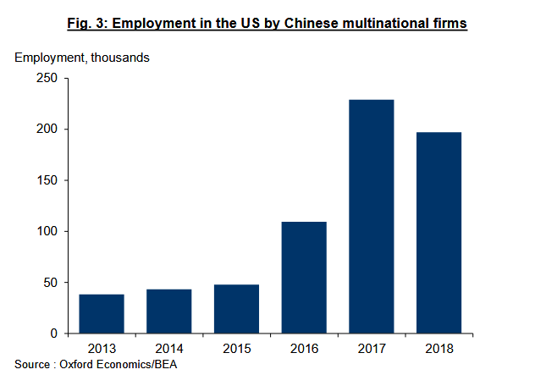
2.2.3 Political Instability and sanctions
Political instability is often associated with less regulated labor markets, lower replacement rates, and overall less worker protection and benefits. For HR professionals, this volatility creates challenges in workforce planning, talent retention, and compliance issues (Lucifora & Moriconi, 2012). Geopolitical tensions and changing policies disrupt the talent pipelines and restrict talent mobility (WEF, 2024).

2.3 Challenges for Human Resurce Professionals
2.3.1 Labor Market shocks
Develop foresight for geopolitical developments and prepare for the best and worst-case scenarios accordingly. Maintain a hybrid workforce with core permanent staff for the long term and temporary staff on a contract basis for short-term urgent needs. Pre-evaluate the rapid redeployment of the workforce and reskilling needs in case of contingency scenarios.
2.3.2 Regulatory compliance
HR must conduct compliance studies for targeted countries and define legal criteria such as data security, tax, and labor laws to ensure smoother operations. Assessment of political stability and labor market volatility should also be done to weigh risks and opportunities (EY, 2025). More than 40 countries are offering some kind of digital nomad or remote worker visas and permits. 41% of these are in the Americas, 31% are in Europe, 14% are in the Asia-Pacific region, and another 14% are in Africa and the Middle East (EY,2025).
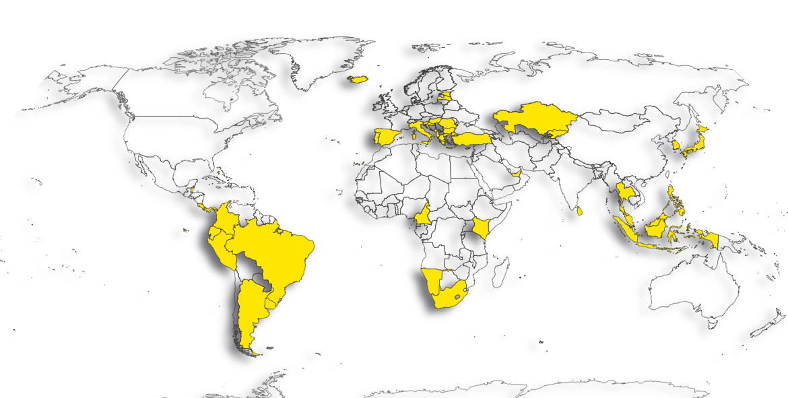
(Digital nomand visa countries, Source : EY, 2025)
2.3.3 Magaing the workforce
47% of employers believe tapping into diverse talent pools is a viable strategy, while 27% show interest in enabling remote work (WEF, 2025). Gen Z and workers from low-income backgrounds are considered by 52% and 24% of employers as diversity and inclusion measures (WEF, 2024). HR professionals have to adapt to these realities and create policies that are inclusive while protecting the company culture at the same time.

3.0. Skill Shortages and Strategic HRM

3.1 Cause of skill gaps
Skill gaps in the labor market are the primary barrier to business transformation for 63% of surveyed employers (WEF, 2025). As technology innovations accelerate, skills will become outdated more quickly and business progress will suffer (Gloat, 2024). Apart from demographic shifts, rapid innovations, education and industry skills mismatch, and changing consumer demands are the key forces.
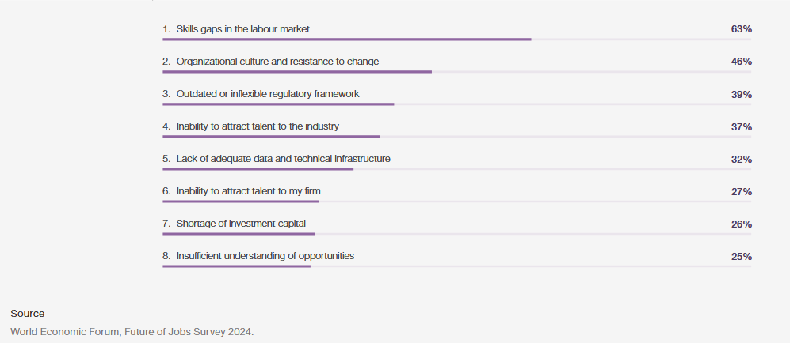
(Barriers to organisational transformation 2025-2030)

3.2 Strategic approach to navigate skill shortages
Build - Buy - Borrow Model by Cappelli (2008) is the best approach to navigate these complex and unpredictable challenges.
HRM Strategy | Details
Build | Companies invest in training and mentorship of their own emplyees to fill future skill gaps
Buy | Organizations recruit permanent employees from external markets or global talent pools
Borrow | Global firms laverage digital platforms to hire freelancers, consultants for project based work or to fill short term skill demands

3.3. Sector specific trategic responses
3.3.1 Fintech
The finance sector is particularly vulnerable to a skill shortage in AI, with demand for AI, big data, and cybersecurity specialist roles (WEF, 2025). Because of this, the industry could lose $1.3 trillion in annual revenues by 2030, estimated by Korn Ferry. Seventy-one percent of employers are planning to reinvest in upskilling and reskilling efforts, while 50% of participants are calling for remote work-friendly labor laws.
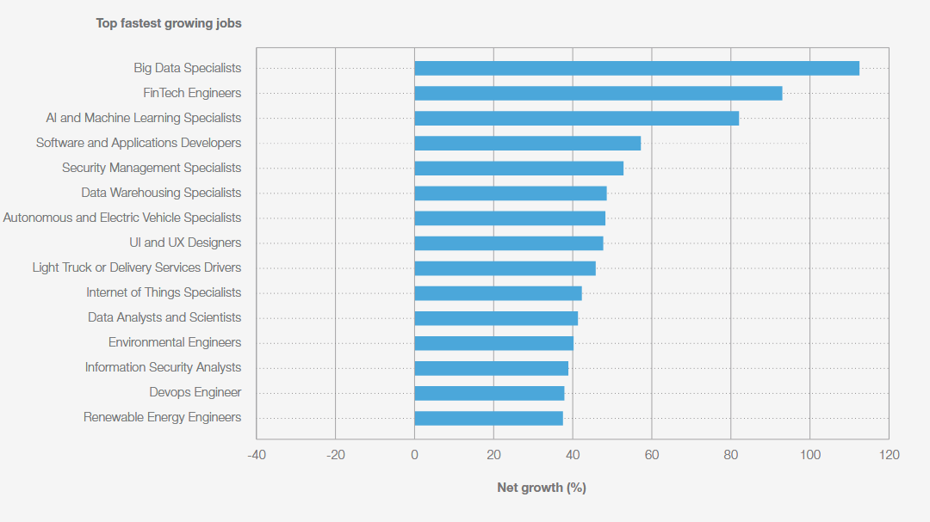
( WEF, Fastest-growing jobs, 2025-2030)
3.3.2 Healthcare
The Bureau of Labor Statistics states that the USA will face a shortage of 195 ,400 nurses by 2031. The 'Build' strategy offers a much-needed long -term solution by implementing a multi-layered approach with improved workforce planning and enhanced retention strategies . Healthcare organizations have to directly engage with academic institutions to attract younger talent and build robust talent pipelines.
3.3.3 Industrial
Only 14% of Generation Z members consider a career in the industrial sector due to a false perception of low pay and difficult working conditions. Organizations have to offer attractive working conditions by promoting a healthy and safe work environment, positive company culture, and training the younger workforce to meet new skill demands.

4.0. Author’s reflection
Although I'm starting my MBA in the UK, initial sessions, peer interactions, and international exposure made me reflect on my technology, communication, teamwork, leadership, and self-directed learning skills. It has made me realize how much these skills matter. This report outlines my strengths, development needs, and an action plan.

4.1 SWOT analysis
4.1.1 Strengths
I am confident in using AI tools for research, Excel, and MS Teams to analyze and collaborate on data-driven projects. My prior professional background as a medical representative helped me develop strong communication and leadership skills. My colleagues appreciated me for taking responsibility and managing the team to meet targets. My habit of learning new concepts every day shows motivation and adaptability.
4.1.2 Weaknesses
Despite all this , my real-world exposure in both business and classrooms is limited. I need hands-on experience in long-term project management and to strengthen my skills in business analytics tools .
4.1.3 Opportunities
My MBA program offers exposure to different workshops and diverse classmates that can help me gain hands-on experience. I live in one of the world 's top finance capitals , which can help me with business exposure.
4.1.4 Threats
Automations can replace analytical roles, and my limited exposure to international work culture and multicultural interactions can affect my career growth. I will have to actively work on these to stay relevant in this fast-paced work environment.

4.2 SMART action plan
Goal | Specific Action | Time-frame
Develop Business Analytical skills | Complete AI fundamentals course by IBM | By March 2026
Hands-on Experience | Attend 3 netowrking events | Within 3 months
Enhance communication and storytelling skills | Documenting my HRM journey via Video Journal | Ongoing

4.3 Future Outlook
As I progress through my MBA program, I would like to work on my weaknesses and sharpen my strengths. By continuously adapting and continuous development, I hope to be in a leadership role at a multinational firm working in global supply chains.

7.0. Conclusion
In conclusion, this report has shown how demographic shifts, technological innovation, and geopolitical instability are reshaping global labor markets. Because of AI, automation, and digital platform advancements, talent pipelines and job roles changing significantly. HRM and IHRM has to take more flexible, data-driven approaches to workforce planning. Demographic pressures such as growing diversity, aging populations, and migration patterns are requiring inclusive and forward-thinking HR strategies that can maintain organizational resilience. Geopolitical unpredictability makes these issue worse by impeding talent mobility.
To tackle the growing global skills gap, the report highlighted Cappelli’s Build–Buy–Borrow–Bind model as a strategic perspective. Organizations can develop internal skills, tap into global talent markets, and maintain essential expertise using the same model. The report has also demonstrated evidence-driven spector specific responses from the technology, healthcare, and industrial sectors to address rapidly growing workforce needs. Ultimately, successful HRM career in this changing environment needs flexibility, strategic vision, and a dedication to ongoing education—at both the organisational and ndividual levels. These abilities will be essential for managing the future of work and maintaining a competitive edge in an ever more complicated global job market

References
1. World Economic Forum, 2025. The Future Of Jobs Report 2025, pp. 5 - 18.https://www.weforum.org/publications/the-future-of-jobs-report-2025/in-full/
2. Brynjolfsson and McAfee, 2014. The Second Machine Age: Work, Progress, and Prosperity in a Time of Brilliant Technologies, pp.4-20.https://www.researchgate.net/publication/ 266742603_The_Second_Machine_Age_Work_Progress_and_Prosperity_in_a_Time_of_Brilliant_Technologies
3. European Commission: Directorate-General for Employment, Social Affairs and Inclusion, Labour market and wage developments in Europe – Annual review 2025, Publications Office of the European Union, 2025, https://data.europa.eu/doi/10.2767/1810636

4. Daron Acemoglu and Pascual Restrepo, "Artificial Intelligence, Automation and Work," NBER Working Paper 24196 (2018), https://doi.org/10.3386/w24196

5. Digitalisation, platformisation and the transformations of local labour markets (2025),Papers in Regional Science,Volume 104, Issue 4, https://doi.org/10.1016/j.pirs.2025.100103

6. Integrating artificial intelligence into a talent management model to increase the work engagement and performance of enterprises. Rožman M, Oreški D and Tominc P (2022). https://doi.org/10.3389/fpsyg.2022.1014434

7. Mbonigaba Celestin & N. Vanitha, “The Gig Economy Takeover: What it Means for the Future of HR Management”, International Journal of Computational Research and Development, Volume 8, Issue 2, July - December, Page Number 39-47, 2023 . https://www.researchgate.net/publication/386381384_THE_GIG_ECONOMY_TAKEOVER_WHAT_IT_MEANS_FOR_THE_FUTURE_OF_HR_MANAGEMENT

8. OECD (2025), OECD Employment Outlook 2025: Can We Get Through the Demographic Crunch?, OECD Publishing, Paris, https://doi.org/10.1787/194a947b-en.

9. Graham, M., Hjorth, I., & Lehdonvirta, V. (2017). Digital labour and development: impacts of global digital labour platforms and the gig economy on worker livelihoods. Transfer: European Review of Labour and Research, 23(2), 135-162. https://doi.org/10.1177/1024258916687250 (Original work published 2017)

10. What is the gig economy? Mckinsey (2023). https://www.mckinsey.com/featured-insights/mckinsey-explainers/what-is-the-gig-economy

11. Cockett, J. and Willmott, B. (CIPD, 2023) The gig economy: What does it really look like? . https://www.cipd.org/globalassets/media/knowledge/knowledge-hub/reports/2023-pdfs/2023-cipd-gig-economy-report-8453.pdf

12. OECD/ILO/European Union (2023), Handbook on Measuring Digital Platform Employment and Work, OECD Publishing, Paris,https://doi.org/10.1787/0ddcac3b-en.

13. Top 100+ Remote Work & Hiring Statistics 2025 & Beyond, Elton Chan (2025). https://www.secondtalent.com/resources/remote-work-hiring-statistics/

14. How AI assessment tools affect job candidate’s behavoiour, HBR (2025). https://hbr.org/2025/07/how-ai-assessment-tools-affect-job-candidates-behavior

15. The Remote work paradox: Higher engagement, Lower wellbeing, Gallup (2025). https://www.gallup.com/workplace/660236/remote-work-paradox-engaged-distressed.aspx

16. Fuller, J., Raman, M., Sage-Gavin, E., Hines, K., et al (September 2021). Hidden
Workers: Untapped Talent. Published by Harvard Business School Project on Managing the Future of Work and Accenture. https://www.hbs.edu/managing-the-future-of-work/Documents/research/hiddenworkers09032021.pdf

17. Globak skill gap, Gloat (2024). https://gloat.com/blog/global-skills-gap/

18. The US-China economic relationship, Alex Mackle, Oxford ( 2021). https://www.uschina.org/wp-content/uploads/2021/01/the_us-china_economic_relationship_-_a_crucial_partnership_at_a_critical_juncture.pdf

19. Political Instability and Labor Market Institutions, Lucifora & Moriconi (2012). https://docs.iza.org/dp6457.pdf

20. A global immigration index for digital nomads and remote workers, Shawn Orme, EY (2025). https://www.ey.com/en_us/insights/workforce/a-global-immigration-index-for-digital-nomads-and-remote-workers
21. Employee benefits stats: trends, costs, and opportunities 2025, Hooray (2025). https://hoorayinsurance.co.uk/employee-benefits-stats-trends-costs-and-opportunities/

22. 100+ Key Employee Productivity Statistics for 2025, J.R. Johnivan (2025). https://www.selectsoftwarereviews.com/blog/employee-productivity-statistics

23. Compensation Trends for 2024: Deflation, Transparency, and Benefits, BambooHr (2024).https://www.bamboohr.com/resources/data-at-work/data-stories/2024-compensation-trends

24. The Global Risk Report (2024). https://www3.weforum.org/docs/WEF_The_Global_Risks_Report_2024.pdf

