Rachid Aboulachouaq - 2237654
2237654@student.uwtsd.ac.uk
RESEARCH, BUILD, AND DEPLOY, A VIRTUALISED NETWORK
Network Operating Systems and Services - ACCA5023
Table of Contents
Task 1 2
Hypervisors 2
IP Addressing 4
Routing 6
Network Services 8
TASK 2 10
TASK 3 20
Reflection 20
References 21

Task 1
Hypervisors
Virtualisation is a virtual representation of an IT infrastructure that can include networks, devices, applications etc. Virtualisation separates the physical resources of a hardware into simulated environments by abstracting a layer from the physical hardware with the use of virtualisation software, such as a hypervisor [3][4].

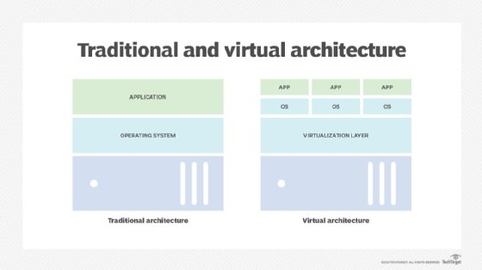
Figure 1: Traditional & Virtual Architecture [3]

There are two types of hypervisors in use: type 1 and type 2. Type 1 hypervisors run directly on the host device’s system with no operating system (OS) or software layer in between the host system and the hypervisor/virtual machines, type 1 hypervisors being known as ‘Bare-Metal Hypervisors’ [5][6]. An example of one is the Microsoft Hyper-V.
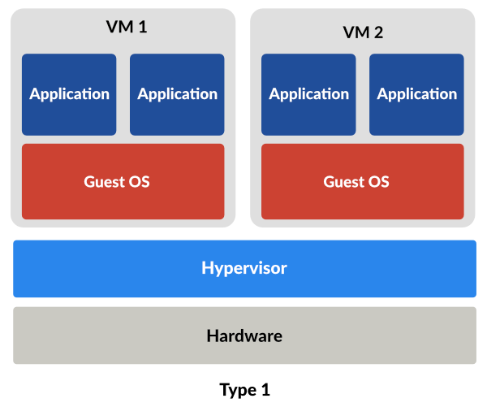
Figure 2: Type 1 Hypervisor Architecture [5]

An advantage of type 1 hypervisors is the fact that they are very efficient and offer great performance due to the direct access of hardware resources such as CPU, memory etc [6]. Due to running directly on the physical hardware, this makes the type 1 hypervisors very secure due to lacking the vulnerabilities that come with an underlying OS e.g. software vulnerabilities [5].
However, due to the type 1 hypervisor being installed on top of the physical hardware, the host machine will only be able to be used to run virtual machines (VM) [5]. As a result, they usually need a separate machine to manage the VMs and host resources [6].
Better performance and security mean type 1 hypervisors are the preferred choice for business in the industry. Multiple VMs can be run off a single dedicated device, for example a server, also make it an ideal choice for companies that may want to scale up their operations by simply adding additional hardware resources to that machine, instead of purchasing an entirely new machine.
In contrast, type 2 hypervisors hosted run on the host system’s OS, becoming an additional software layer to be able to run the creation of VM instances [5]. As they run as an application, they are known as ‘Hosted Hypervisors’ [6]. Again, host hardware resources will need to be allocated to the guest systems when in use. Examples include VMWare and Virtual Box VMs.

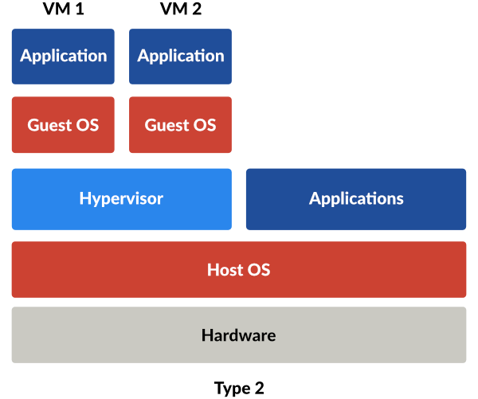
Figure 3: Type 2 Hypervisor Architecture [5]
These hypervisors are useful as they allow ease of use and access to the VMs on the host machine, as well as the host machine itself [6]. Compared to type 1, performance is lacking, and they have the inherent security vulnerabilities of software [6].

IP Addressing
From the discussion, Data is communicated between devices on the internet through the use internet protocols and networking, such as TCP/IP. Within a network, each device is assigned an IP address, which uniquely identifies the device on that network. Data packets are sent between these devices, which is guided by the IP address of that device which is identified by a switch. This works much the same way with multiple networks as each network will have an IP address, however a router is needed to communicate between networks, storing IP addresses and identifying pathways.
Switches and routers are key elements of a network. Switches operate on a local area network (LAN) by storing the MAC addresses of connected devices and facilitating data transfer between them. However, routers facilitate data transfer between multiple networks by identifying a target IP address and choosing the most efficient route for the packet. As such, routers and switches work in tandem to identify the correct destination of a data packet.

IP addresses are essential to allow devices on a network and for the network itself networks to communicate with others and connecting to the internet. When connecting to the internet, an internet service provider (ISP) will assign the device an IP address, or it will assign a router that IP address and create a subnet for all devices that fall under the router’s network [1]. A subnet divides an IP address into a network and a node (host). The network identifies the subnet, while the node connects to it with a unique address, distinguishing between the two. [1].
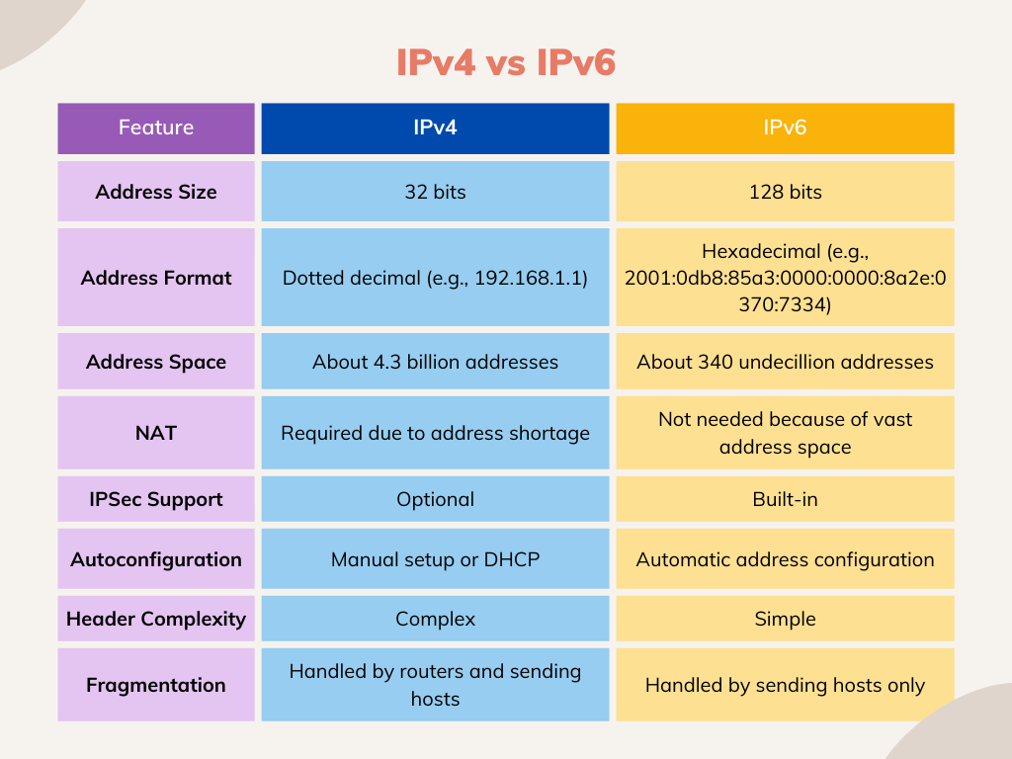 Figure 4: IP Addresses [7]
There are two types of IP addresses, IPv4 and IPv6. IPv4 consists of four numbers, known as octets, separated by dots with each number ranging from 0-255 [1][2]. Each number representing a different aspect of the network, such as the network itself and the exact device on that network.

As a result, the many devices growing in the world, IPv6 addresses were created to deal with the shortage of IPv4 addresses. By using, a hexadecimal format, many more addresses could be created, not to mention the increased security and performance.

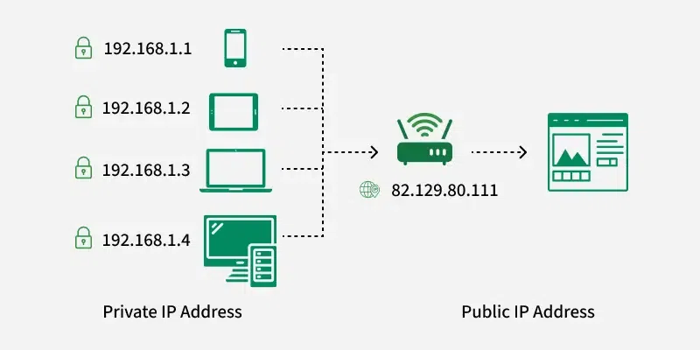
Figure 5: Private and Public IP Address [2]
Due to address constraints, there are private and public IP addresses. This allows for the same IP address to be assigned multiple times, but only on private networks, with the public address being the unique one [2].

Routing
Routing is the process of finding and selecting paths for data packets to travel within and networks, and essentially the management of network traffic overall [8]. By identifying the destination IP of a data packet, a router can direct it. This is done using a ‘Routing Table’, which is table used to store the IP addresses and other information needed to select the best data path [9].

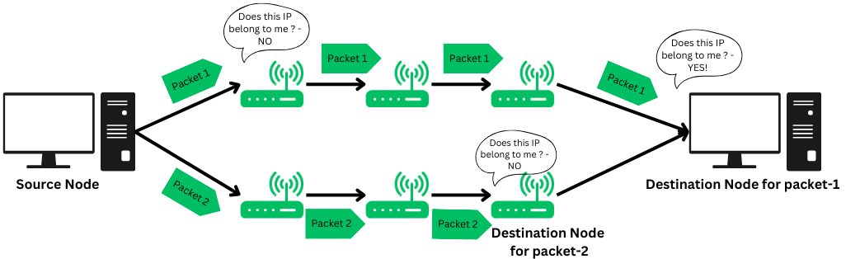
Figure 6: Visualisation of packet transfer [8]

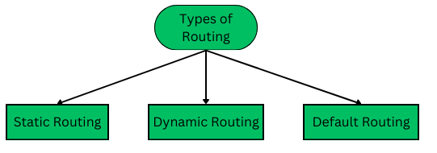
Routing is split into three categories. Static routing is when the network routing configuration is done manually by the network administrator, ideal for maintaining secure control over a small network [9]. However, this is not ideal for businesses seeking to scale-up their network.
Dynamic routing is procedure that is autonomous and does not require manual interaction. Packets are transferred based upon a pre-determined topology and the use of shortest path algorithms [9]. This is preferred as it is adaptive and scalable, due to changes in topology being automatically updated. However, this provides less control over the network, so security and accurate resource management may be an issue, not to mention more expensive [9].
Figure 7: Types of Routing [9]
Default routing is when a router transmits data packets to a default route, usually used when a network has only one exit point [9].
To select the best route, routing protocols may operate on different metrics to achieve this goal.
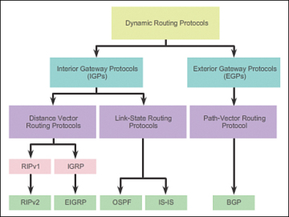
Figure 8: Routing Protocols [10]
Distance vector is used when all nodes on the network are known, and so are the nodes adjacent. Their routing tables are advertised regularly, allowing for the use of the Bellman Ford Algorithm to identify the shortest path to the target node/device [9].
Link-state routing is like distance vector, as it also updates routing tables. However, the tables are only updated when there are new updates or additions to the network, allowing for an effective use of bandwidth [9]. Link state routing considers several metrics when deciding the best path for data such as hop-count, bandwidth, delay etc. As a result of this, these protocols are ideal for larger businesses seeking to expand their networks due to the automatic updates to addressing as well as the bandwidth cost savings [9].

Network Services

VPNs
A virtual private networks method for maintaining a secure connection between networks. It establishes a virtual connection between a device and a remote server, it does this by creating a point-to-point connection and encrypts that connection, known as ‘tunnelling’. This encrypts personal data from external threats, masks IP addresses, and it is also possible to access blocked websites [11]. There are several different types of VPN connections methods, each slightly different. A large company may use site-to-site connections to maintain a secure internal network over multiple business sites [11]. This would be important for multi-national business to make use of. A VPN application may also be downloaded onto a device to be used, with dedicated servers providing a secure connection to that device.

DHCP
Dynamic Host Configuration Protocol (DHCP) automatically assigns devices IP addresses when connecting to a network, making things easier and reducing errors. It also provides other important network details like the gateway, subnet mask, DNS etc [12].

Active Directory Domain Services
Active Directory Domain Services (ADDS) are the main components of Active Directory that handle user and computer management, enabling system administrators to structure data in a clear, organized way [13]. ADDS supports security features like certificates, Single Sign-On (SSO), LDAP for directory access, and rights management to control permissions and access in the organisation [13]. An AD must have a domain controller, which act as containers for domains. A domain belongs a to an AD forest, which can contain a single or multiple domains which can be grouped into units. ADDS allows for the management of access and user permissions between users in different domains, which is essential in large organisation with multiple departments and security levels [13].

TASK 2

Due to hardware constraints, the decision to use a type 2 hypervisor was deemed necessary. This was chosen due to it’s ease of use, being able to run above the underlying host system as an additional software layer. As such Oracle VirtualBox VM was the selected hypervisor software. This allowed for testing in simulated environments without risking the host device functionality.

VirtualBox was already installed on the device, so it was a simple matter of setting up the VMs.
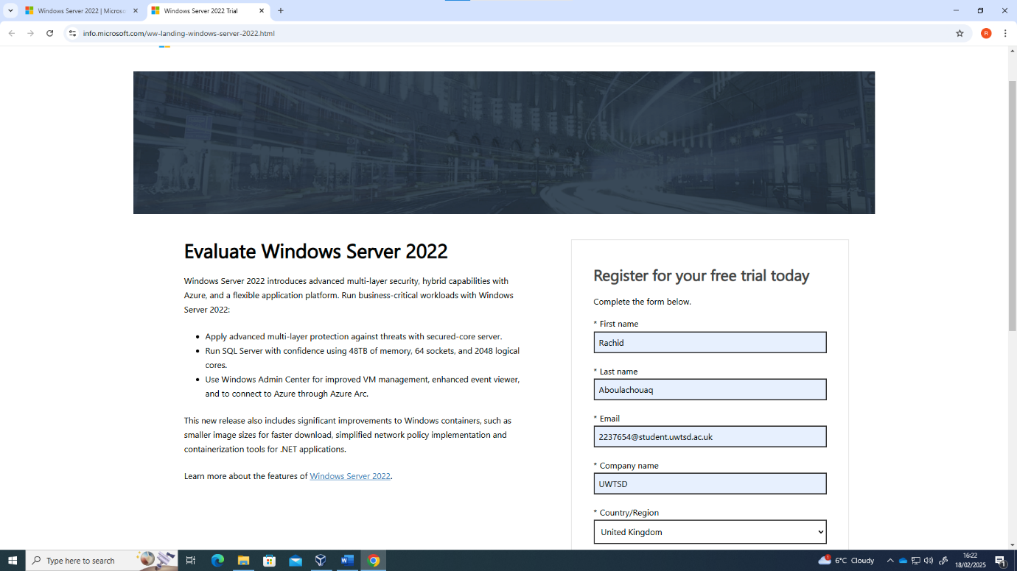
Figure 9: Windows Server 2022 Download source

As guest OS was needed for the virtual machines being set-up, they would need to be downloaded. As seen above, the ISO for chosen was Windows Server 2022 downloaded form the official Windows website.

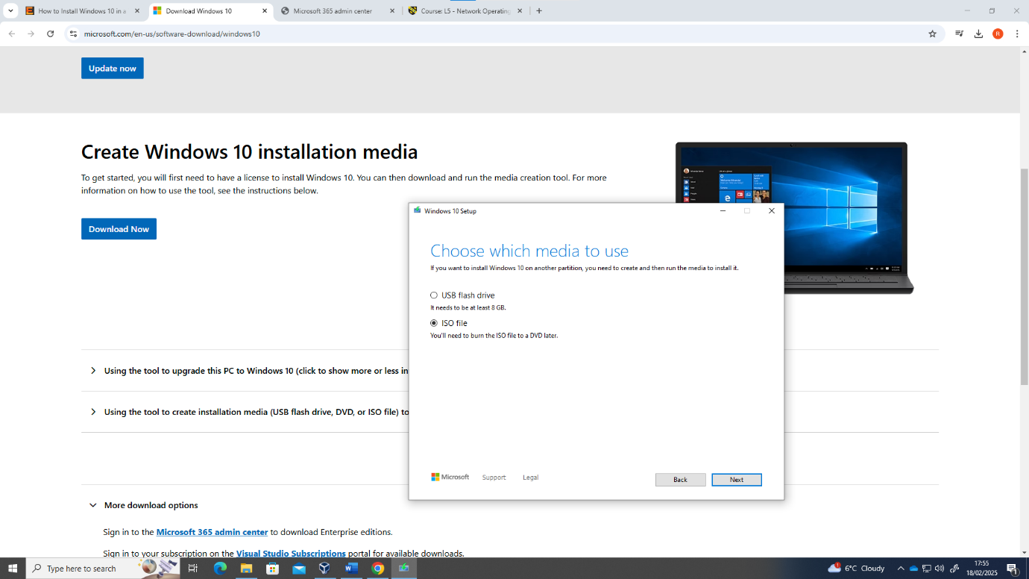
This was followed by the client device, choosing to install Windows 10 desktop ISO downloaded again from the official website.

For the Linux machines, the decision was made to go with the open-source Ubuntu operating systems due to their ease of use and interactivity.
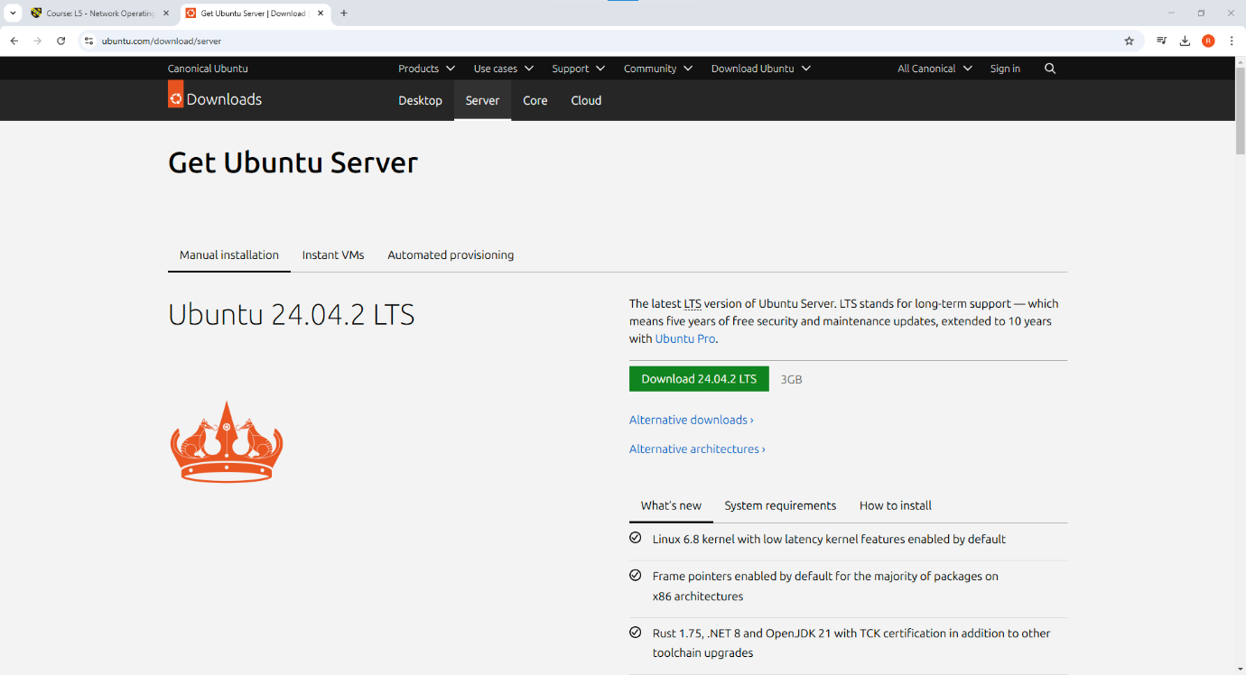
As seen above, Ubuntu Server ISO was downloaded from the Ubuntu website.
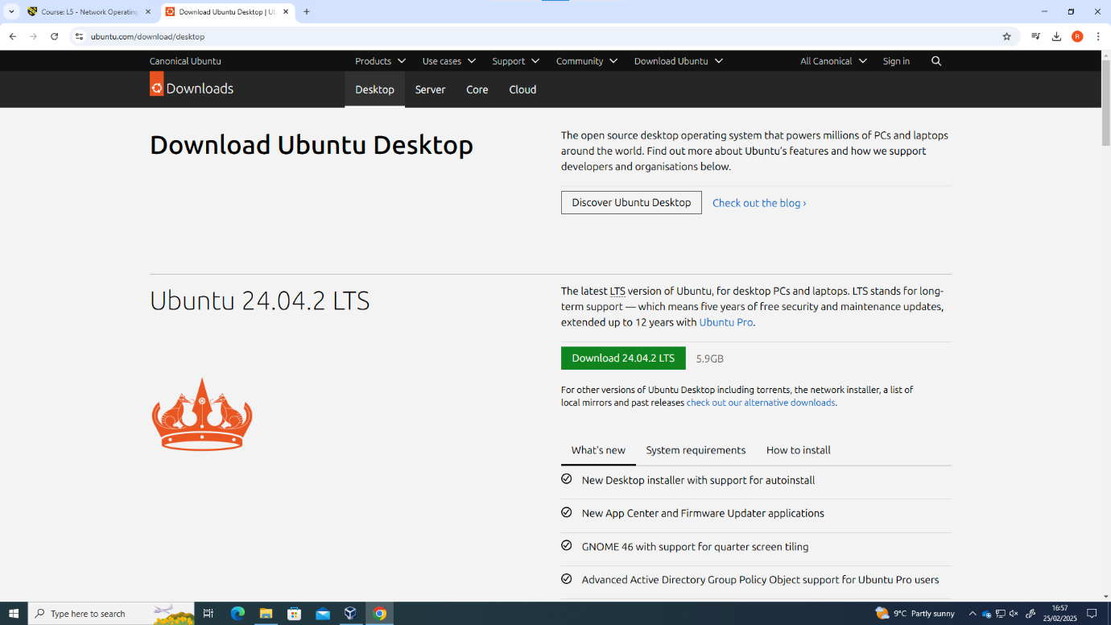

Also, the source for the Ubuntu Desktop ISO seen above. The timestamp between sources is due to the stage at which the Linux and Windows VMs were set-up.

The Windows server was chosen to be set-up first.
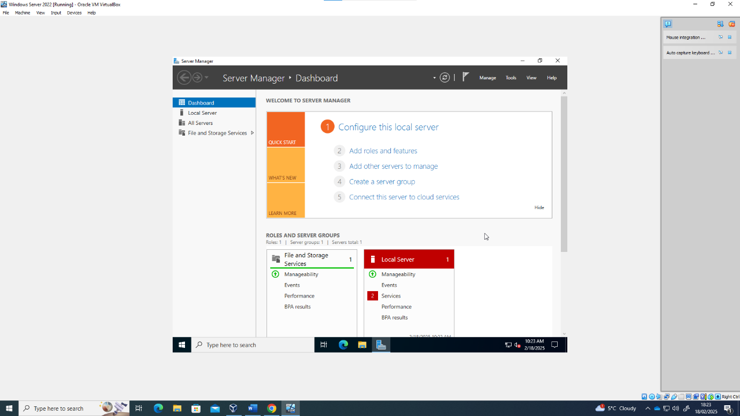
After configuring the hardware resources to the VM and installing the ISO, the Windows Server VM booted up successfully as seen above. The next step was setting up the Windows 10 desktop VM.

This was successful. However, screenshot was misplaced.

Next was the set-up of the ubuntu server. 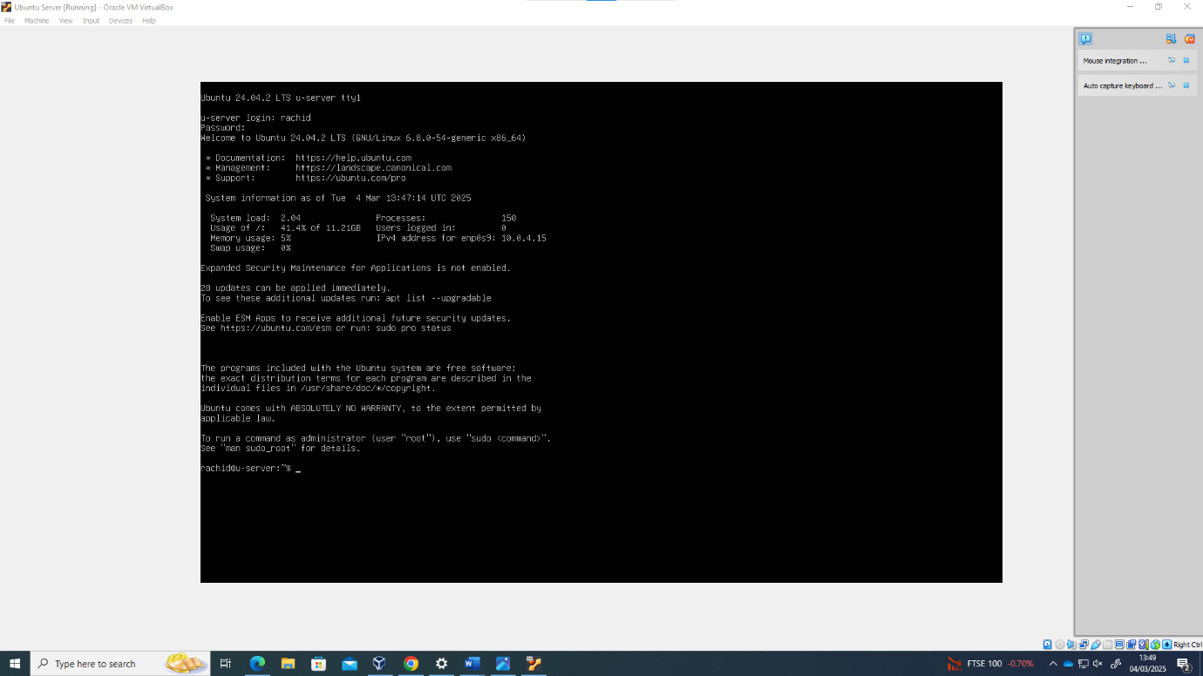
After the same process of resource allocation, admin profile was created and set up was successful.

Alongside, the ubuntu desktop was also set up, with the iso being installed and booted correctly, however screenshot was misplaced.

Using a basic, personally crafted topology to follow, the IP addressing of the network was set up this way .
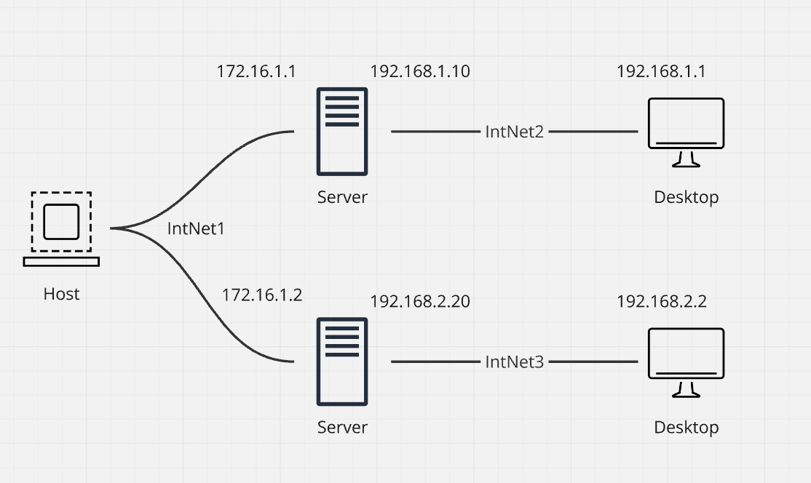
Figure 10: IP Addressing Schema
Private IP addresses were selected for the server-client connections and a static server IPv4 address was selected for the servers.

First, the Windows VMs.
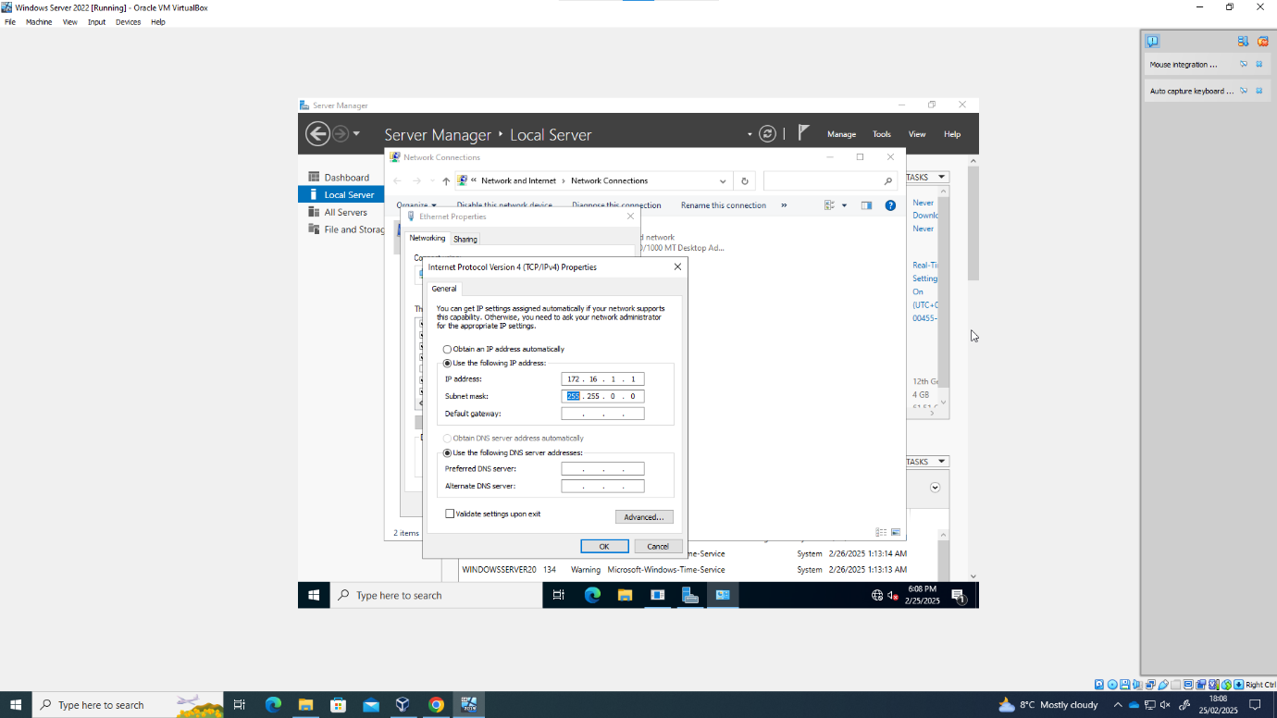
Server IP addressing for the windows server was input with an appropriate subnet in range.
Windows desktop was also input with the desired IP address successfully. However, screenshot was misplaced.
Next was the Linux VMs
Choosing to set up the desktop first.
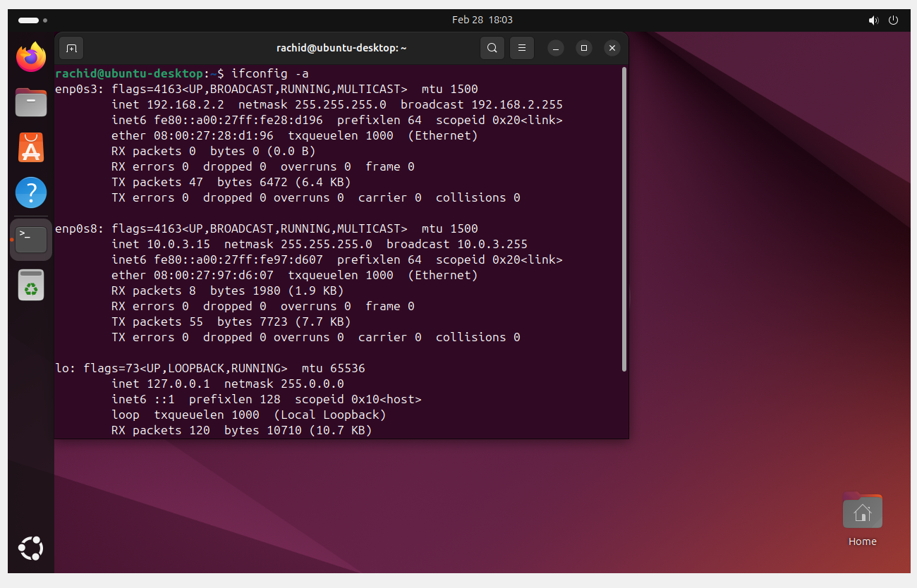
IP address was set up according to the topology and was successful on the internal network adapter.

Next was the more difficult Ubuntu server.
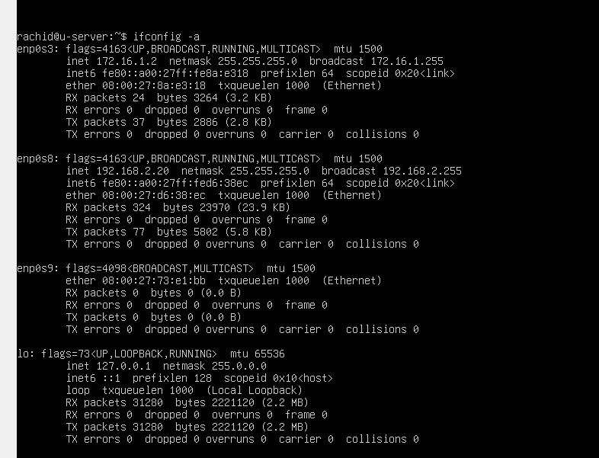
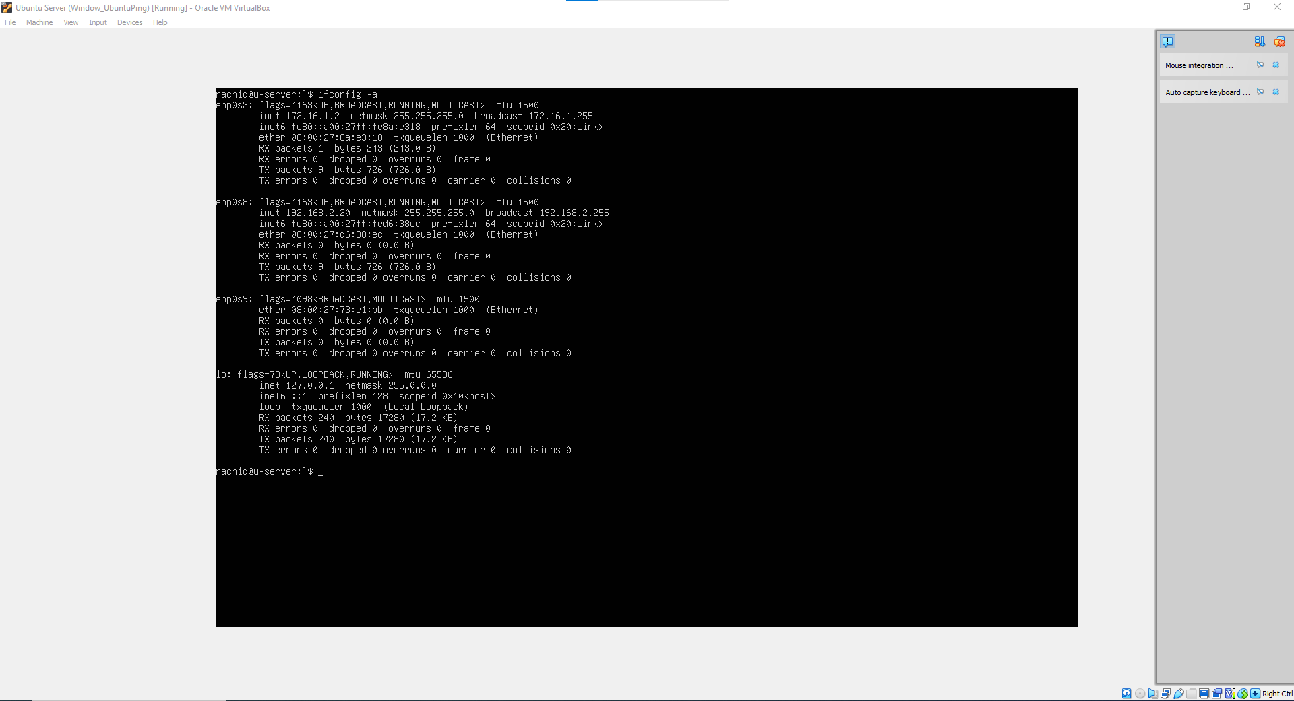

IP addressing was successfully applied to the required network adapters. To do this, it was necessary to download ‘netplan’ to be able to access the network configuration files, known as .yaml files. 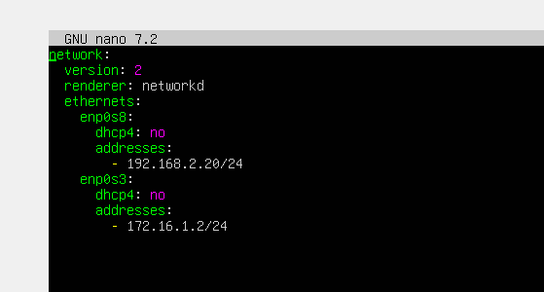

Connectivity test were then performed between the machines.
First the Windows VMs.
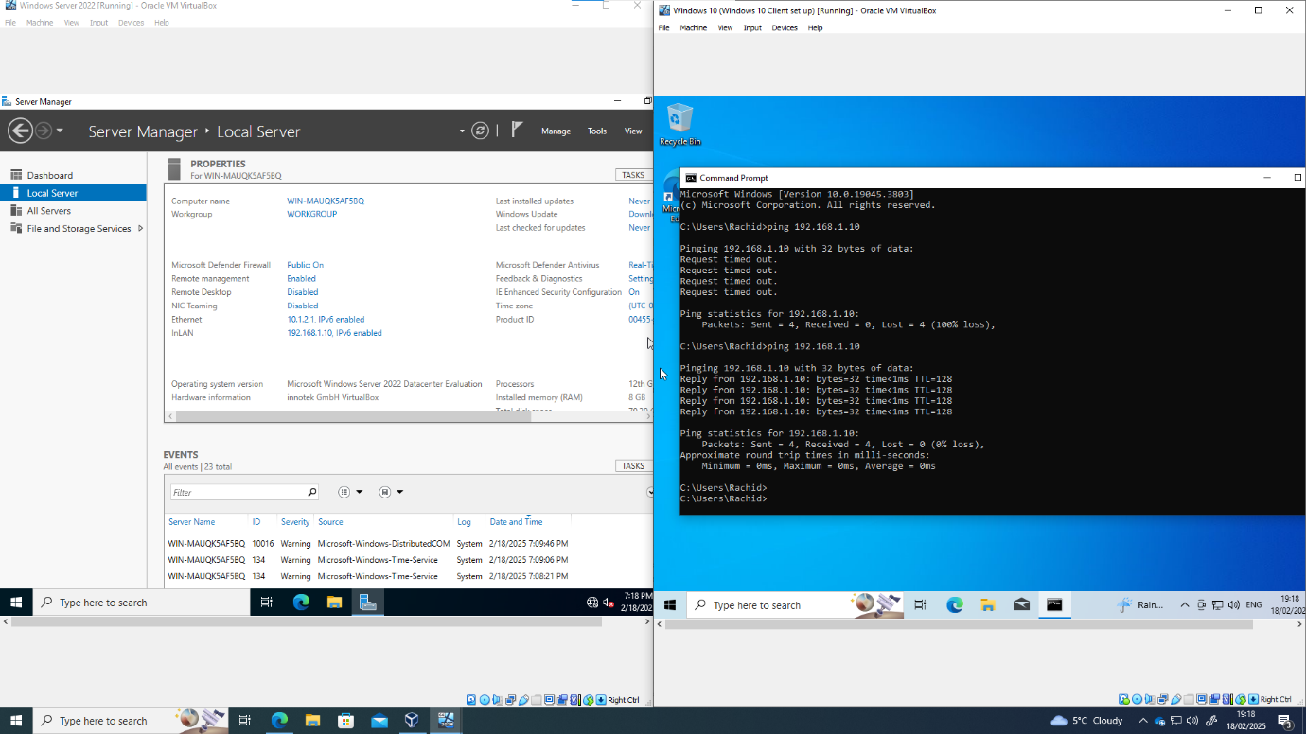
A successful connection. Initially however, this was not the case. The firewalls were preventing successful connections, so were temporarily disabled.
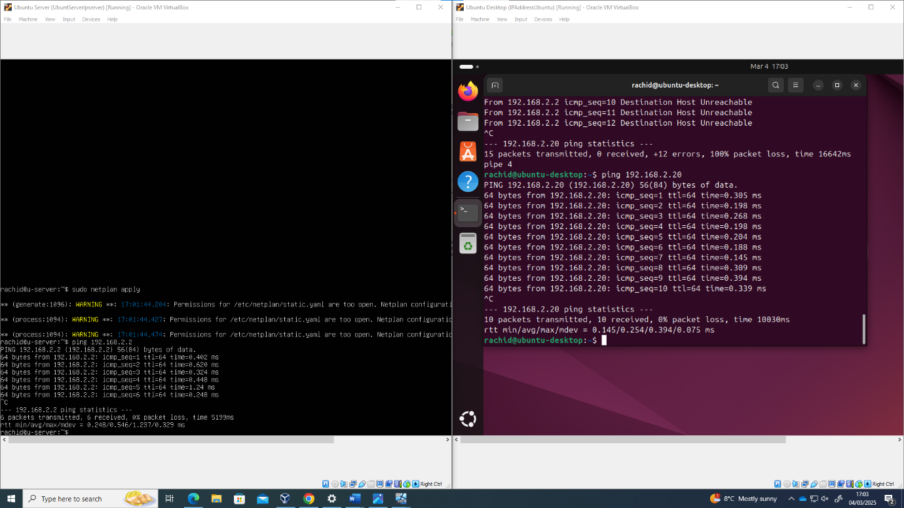
Linux machines also resulted in a successful connection. However, the same issue had occurred, so disabling the firewalls was necessary.

Finally, a ping between different operating systems.
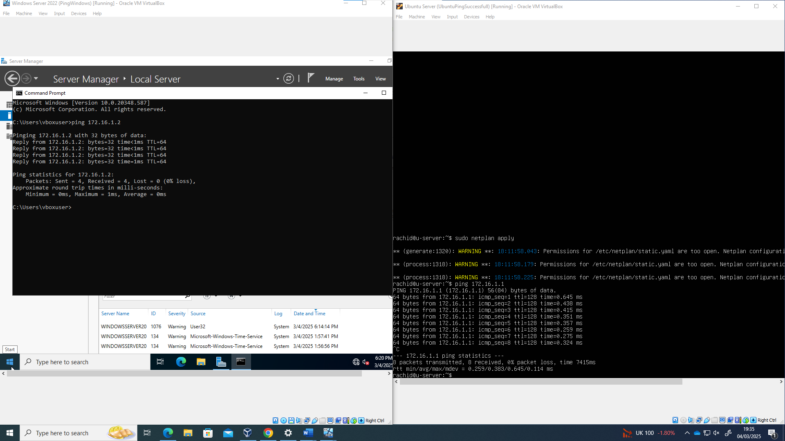
This was a success. No additional utilities were required for the successful ping.

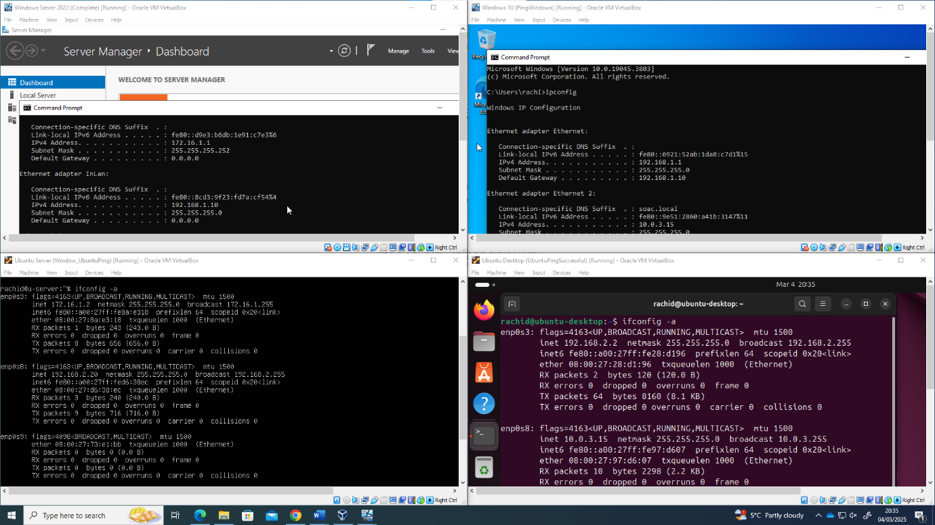

TASK 3

Reflection
During task 2, my hypervisors and ISO were stored on the computer I was using and not the OneDrive. This worried me, so midway through I deleted the VMs and moved them to OneDrive, in hindsight this was not needed as I could have moved the VMs without restarting.
The main technical issues encountered was the configuration of IP addresses in the Linux machines. This was a much more complicated processes than expected, having to learn to format the .yaml files correctly. Then the issue of firewalls blocking connections also took a bit of time to resolve.

References
[1] Fortinet. "What Is An IP Address? How Does It Work?" https://www.fortinet.com. https://www.fortinet.com/resources/cyberglossary/what-is-ip-address (accessed 25/02).
[2] GeeksforGeeks. "What is an IP Address?" https://www.geeksforgeeks.org/. https://www.geeksforgeeks.org/what-is-an-ip-address/ (accessed 25/02).
[3] R. Awati and I. Wigmore, "virtualization architecture." https://www.techtarget.com/. https://www.techtarget.com/whatis/definition/virtualization-architecture (accessed 18/02).
[4] S. Panzer. "Introduction to Virtualization." https://stl.tech/. https://stl.tech/blog/introduction-to-virtualization/ (accessed 18/02).
[5] Pranav and BDRSuite, "Type-1 and Type-2 Hypervisors Explained." bdrsuite.com. https://www.bdrsuite.com/blog/type-1-and-type-2-hypervisor/ (accessed 18/02).
[6] GeeksforGeeks. "Hypervisor." GeeksforGeeks.org. https://www.geeksforgeeks.org/hypervisor/ (accessed 18/02).
[7] C. Dulanga. "What is IPv6: The Ultimate Guide." https://brightdata.com. https://brightdata.com/blog/proxy-101/what-is-ipv6 (accessed 25/02).
[8] Cisco. "What Is Routing?" https://www.cisco.com. https://www.cisco.com/c/en/us/products/routers/what-is-routing.html (accessed 28/02).
[9] GeeksforGeeks. "What is Routing?" https://www.geeksforgeeks.org. https://www.geeksforgeeks.org/what-is-routing/ (accessed 28/02).
[10] Cisco Networking Academy. "Routing Protocols Companion Guide." https://www.ciscopress.com. https://www.ciscopress.com/articles/article.asp?p=2180210&seqNum=7 (accessed 28/02).
[11] Microsoft. "What is a VPN service?" https://azure.microsoft.com. https://azure.microsoft.com/en-us/resources/cloud-computing-dictionary/what-is-vpn#:~:text=A%20VPN%2C%20which%20stands%20for%20virtual%20private%20network%2C%20protects%20its,could%20benefit%20from%20a%20VPN. (accessed 01/03).
[12] GeeksforGeeks. "Dynamic Host Configuration Protocol (DHCP)." https://www.geeksforgeeks.org. https://www.geeksforgeeks.org/dynamic-host-configuration-protocol-dhcp/ (accessed 01/03).
[13] M. Bucklebee. "Active Directory Domain Services (AD DS): Overview and Functions." https://www.varonis.com. https://www.varonis.com/blog/active-directory-domain-services#:~:text=Directory%20Domain%20Services-,Active%20Directory%20Domain%20Services%20(AD%20DS)%20are%20the%20core%20functions,%2C%20LDAP%2C%20and%20rights%20management. (accessed 01/03).

