Name: Stefan Grasso

Student Number: 149284

Course: Illustration

Title: The new pop art: Vaporwave and the artistic rebellion against capitalism

Word Count: 1,963 words

Tutor: Louise Burston

The aim of this dissertation is to examine vaporwave. Vaporwave is an underground subculture based around the music genre of the same name and its similarities to the pop art movement. From this analysis, it will determine whether or not it is the next incarnation of pop art, in terms of its aesthetics and of its apparent artistic mission. The research will be based on the available literature and online resources. For this, it is important to note that when dealing with vaporwave, there will be a limited amount of literary resources compared to the plentiful online resources.

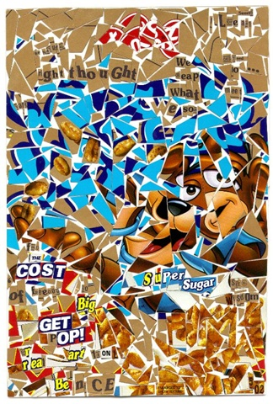
Figure 1 Golden Crisps by Michael Albert (2002)
CONSUMERISM
A key subject in both vaporwave and pop art is consumerism, or consumer culture if one so wishes to refer to it as such. Merriam-Webster (2018) defines consumerism as “a preoccupation with and an inclination towards the buying of consumer goods”. According to Professor Peter Stearns (2001: 17), consumerism in the form we know it today first emerged in the Western world during the eighteenth century, but consolidated into its modern, global form by the 1920s, from then taking the form we know today.

Part of the general consensus on the position of pop art is that it is recognised as a reflection on the post-war consumption boom that defined American society during the 1950s and 1960s (although pop art was originally conceived and termed in Britain (see Finlay, 2016)). As American studies professor Erika Lee Doss noted in Twentieth-Century American Art (2002: 154), the aim of pop artists was to engage with the culture of mass consumption not by openly attacking it, but embracing it, subverting the Descartian maxim “I consume, therefore I am” (which, funnily enough, became the title of a vaporwave track by an artist named 猫 シ Corp. on the DREAM_31 compilation album (Hermes Acosta HA, 2015)) and turning that into the mantra of the movement.

Similarly, to how pop art is seen as a commentary of post-war consumerism, many contemporary writers and music critics view vaporwave as essentially an exposition of consumerism and late capitalism. Writing for the online music publication Bandcamp Daily, Simon Chandler (2016) suggests that vaporwave’s relationship with consumerism as “little more than giving in to consumeristic detachment and alienation, and to the rampant media and materialism through which we anesthetise ourselves against the drudgery of modern life”. However in his book Babbling Corpse, one of only a handful of books on vaporwave to be published so far, writer and musician Grafton Tanner wrote:
Vaporwave spits in the face of late capitalism and mocks the very methods used to sell us the things we don’t need, all while problematizing our understanding of history. (2016: 49)

To understand these and other writers’ analysis of vaporwave, it is important to understand the defining characteristics of vaporwave. In Cambridge University’s Popular Music journal, writer and musician Laura Glitsos (2017: 100) accurately describes vaporwave as a form of music that is usually formed from a collage of forgotten mood music from the 1980s, such as muzak (the background music played in retail stores), elevator and new age ambient music, with the typical vaporwave song having a short, slow and repetitive song structure, often with vocals that have been slowed down and saturated with heavy reverb.

Consider also the imagery associated with vaporwave, which has become so characteristic of the genre that it is common knowledge. Writer Jeremy Cummings (2017) describes the aesthetic of vaporwave as being composed of repurposed older creative and aesthetic motifs. He also notes how the vaporwave aesthetic typically employs iconic consumer brands such as Pepsi and McDonalds, sometimes with Greek statues, but almost always with a vibrant colour palette consisting of mainly blues, pinks and purples.

Perhaps unknowingly, the vaporwave aesthetic echoes an awareness of the sense that we are living in frozen time, an eternal dream (or rather a nightmare if one may insist) in which we are haunted by commodities, which in this dream world would, as Jacques Derrida described in Spectres of Marx (1994: 189), take on the form of a spectre – intangible, invisible, odourless.

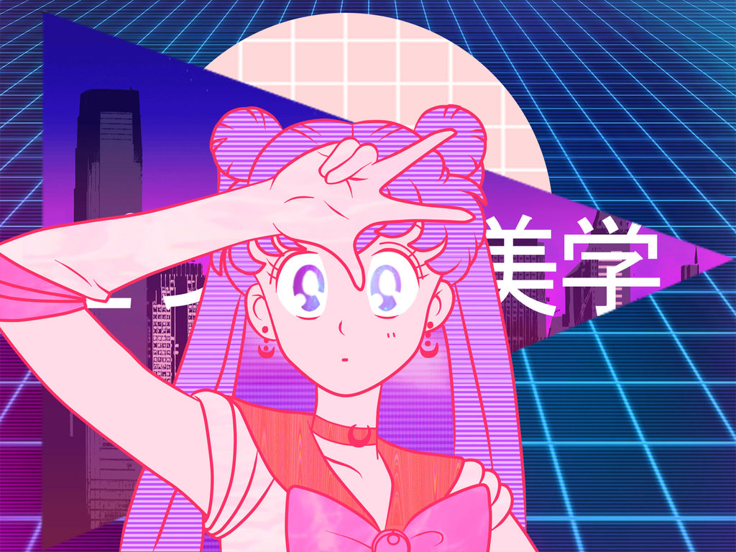
Figure 2 Sailormoon Pink Vaporwave by SirMcGrathZ (2017)
APPROPRIATION
In Ian Chilvers and John Glaves-Smith’s Dictionary of Modern and Contemporary Art (2009: 27), “appropriation” in the art world is defined as the practice of using existing images and objects with little alterations made to them, usually associated with some form of critique of the concept of originality in art. The earliest examples of the art form can be found in the Cubist collages of Pablo Picasso, who as noted by authors Daniel McClean and Karsten Schubert (2002: 199) integrated found objects such as newspapers, litter and photographs with his paintings. Perhaps the most famous and immediate example of appropriation art, however, would by Marcel Duchamp’s Fountain, an artwork so controversial that as author Robert Kilroy notes (2017: 3), writing on the centenary of its unveiling, the debate over whether it can be called art persists to this day.

Four decades later, the American pop artist Jasper Johns would become famous for his appropriation of found objects in his art. According to author John Ravenal (2016: 2-3), he appropriated easily recognisable objects such as flags, numbers and maps with the initial purpose of avoiding the preoccupation with feelings as a source of inspiration. Ironically, as observed by authors Darren Hudson Hick and Reinold Schmücker (2016: 190), he would see his work reproduced, appropriated in a way. The works of fellow artists like Andy Warhol and Robert Rauschenberg would also meet that same fate. It can be argued that the pop art movement, in appropriating found objects and corporate logos, aimed to lampoon the popular culture of their day, and indeed as author Howard Brick notes (2000: 71), this was the case made by some art critics as a defence of pop art.

If that is indeed true, the same argument can be used in defence of vaporwave, with its appropriation of imagery we nominally recognise as symbols of capitalism. Writing for the Stylus website, Christian Ward (2014) argues that the purpose of vaporwave’s appropriation is to satirise how empty capitalist society is. Further noting how the very name of the genre is a play on the word “vaporware” – a term for a software product that is announced but never released – it is not hard to see that as an apt metaphor for the promises of neoliberal capitalism. Writer Stefan Colton (2017) agrees with Ward’s assessment, arguing that this insincerity is the prime obsession of vaporwave.

Another interpretation is that appropriation is the vaporwave artist’s method of rebelling against capitalism. In a video published by Zero Books entitled Frozen Capitalism: Haunted by Vaporwave (2016), Douglas Lain rather humorously describes vaporwave as essentially a regurgitation of late 20th century pop music, with the typical vaporwave song being a pop tune that had been “tortured by teenagers using pirated copies of Ableton” (a music sequencing software package). Though the teenagers in this scenario may not have had this in mind, it is possible that they committed an act of rebellion against commercial music. This is certainly the view held by Tanner (2016: 71), who perceives vaporwave as a potentially subversive force against a music industry that effectively serves as an organ of capitalism designed to lull the masses into a state of indifference.

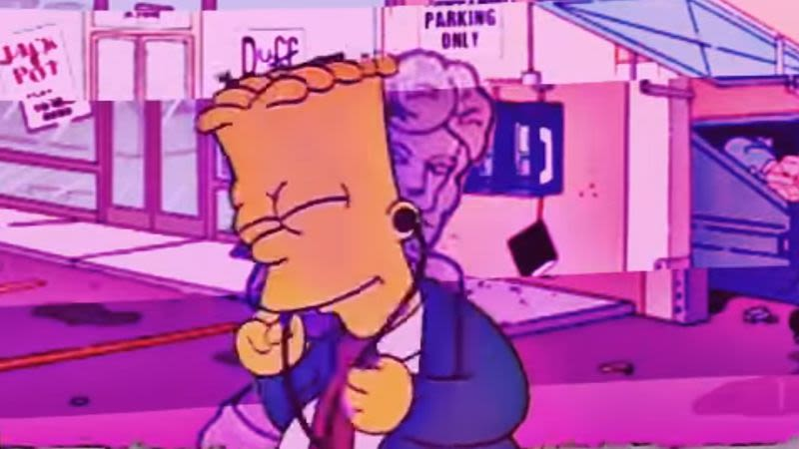
Figure 3 ＳＵＮＤＡＹ ＳＣＨＯＯＬ by Lucien Hughes (2016)
SUBVERSION
Since there is a fairly wide range of definitions for the word “subversion”, it important to first define exactly what is meant by “subversion” before proceeding further. In the context of this writing, the appropriate definition of subversion is the one provided by art historian Gavin Grindon in Michael Ryan’s The Encyclopedia of Literary and Cultural Theory (2011: 867), which states that subversion is a matter of reversing established values, or inserting other values into them. By this standard, it is possible to discuss the subversive nature of certain art forms, in the sense that they subvert established values by altering their meaning.

The way the pop art movement sought to subvert capitalist values was by pretending to embrace them, including and with particular attention to brand aesthetics. This approach has been rather aptly described by author Susan Suleiman (1990: 58) as the ironic repetition of popular imagery as a method of deconstruction. Indeed, a similar conclusion seemed to have been reached by Eliane Elmaleh in the European Journal of American Culture (2003: 181), who remarked that the pop artists of the 1960s presented themselves neutrally “as dehumanised as the objects they portrayed”. In that sense, pop art as a movement was very much a product of its time. To Professor Steven Weisenburger (1995: 111), it is perhaps precisely this perception of amorality that critics of pop art found so objectionable.

The most obvious example of this subversion in action can arguably be found in Andy Warhol’s Campbell’s Soup Cans. The entire idea of the piece is to change the meaning of a commercial object, in this case, to turn an average soup can into an artistic statement. As writer David Bourdon notes (1989: 90), his particular treatment of the object was seen by some as a Marxist critique of capitalism. Perhaps in allowing people to ascribe their own meaning, Warhol succeeded in turning the can into a work of art by virtue of being open to free interpretation.

A similar strategy appears to be in play with vaporwave, but with two key distinctions. Tanner (2016: 12) notes how in addition to most vaporwave musicians using pseudonyms, some musicians release several projects under a different alias, and to him this erases the concept of authorship and establishes the rejection of ownership. Writing for the Bandwagon website, Sean Francis Han and Daniel Peters (2016) make the observation that in addition to vaporwave being composed of stolen music, vaporwave album art is typically created as a collage of 80s iconography as discussed earlier on the section on appropriation. To them, this rampant theft is how vaporwave subverts consumer culture, twisting its stolen icons so as to give it a new meaning.

A standout example can be found in Simpsonwave, which is described by Pitchfok writer Kevin Lonzano (2016) as a genre of videos on YouTube that consists of heavily edited video collages of clips from The Simpsons set to vaporwave songs. Simpsonwave is arguably a classic example of vaporwave’s appropriative artistic subversion – taking something that another person, or a group of people, had already created, and altering it in a way that gives it new meaning. The way Simpsonwave does this is described by YouTuber Sam Sutherland, who runs a channel called This Exists, in his video “IsＳＩＭＰＳＯＮＷＡＶＥ a joke?” (2016) as Simpsonwave having added the emotional resonance of Simpsons nostalgia to a genre typified by its mocking attitude to corporate music.

The research and analysis that has been displayed contributes a sense of awareness of the omnipresence of capitalism in culture. Simultaneously, it brings an awareness that art forms such as vaporwave and arguably earlier counterparts including pop art stand in opposition to the influence of capitalism in culture. This leads to the central question of the dissertation because if capitalism is everywhere then it will have a profound effect on the art made under that system. It is only a matter of time before socially conscious artists develop the desire to resist the hegemonic force of capitalism and use art as a means to do exactly that, whether by appropriating its icons or not.

The question of the dissertation is thus: does vaporwave with its appropriation of commercial icons in disregard to intellectual property represent a brewing rebellion against capitalism?

REFERENCE LIST

BOOKS
- Brick, H. (2000). Age of contradiction: American thought and culture in the 1960s. 1st ed. Ithaca: Cornell University Press, p.71
- Bourdon, D. (1989). Warhol. 1st ed. New York: Abrams Books, p.90
- Chilvers, I. and Glaves-Smith, J. (2009). Dictionary of modern and contemporary art. 2nd ed. Oxford: Oxford University Press, p.27
- Derrida, J. (1994). Spectres of Marx: The state of the debt, the work of mourning, and the new international. 2nd ed. New York: Routledge, p.189
- Doss, E. L. (2002). Twentieth-century American art. 1st ed. Oxford: Oxford University Press, p.154
- Finlay, J. (2016). Pop! The world of pop art. 1st ed. London: Carlton Books
- Hick, D. H. and Schmücker, R. (2016). The aesthetics and ethics of copying. 2nd ed. New York: Bloomsbury, p.190
- Kilroy, R. (2017). Marcel Duchamp’s fountain: One hundred years later. 1st ed. London: Palgrave Macmillan, p.3.
- McClean, A. and Schubert, K. (2002). Dear images: Art, copyright and culture. 1st ed. London: Ridinghouse, p.199
- Ravenal, J. B. (2016). Jasper Johns and Edvard Munch: Inspiration and transformation. 1st ed. New Haven: Yale University Press, p.2-3
- Ryan, M. (2011). The encyclopedia of literary and cultural theory. 1st ed. Malden: Wiley-Blackwell, p.867
- Sooke, A. (2015). Pop art: A colourful history. 1st ed. London: Penguin
- Stearns, P. N. (2001). Consumerism in world history: The global transformation of desire. 2nd ed. New York: Routledge, p.17
- Suleiman, S. R. (1990). Subversive intent: Gender, politics and the avant-garde. 1st ed. Cambridge: Harvard University Press, p.58
- Tanner, G. (2016). Babbling corpse: Vaporwave and the commodification of ghosts. 1st ed. Croydon: Zero Books
- Weisenburger, S. (1995). Fables of subversion: Satire and the American novel, 1930-1980. 1st ed. Athens: University of Georgia Press, p.111

JOURNALS
- Elmaleh, E. (2003). American pop art and political engagement in the 1960s. European Journal of American Culture [online] 22(3), p.181-191
- Glitsos, L. (2017). Vaporwave, or music optimised for abandoned malls. Popular Music [online] 37(1), p.100-118

IMAGES
- Albert, M. (2002). Golden crisps [Collage]. Private collection.
- Hughes, L. (2016). ＳＵＮＤＡＹ ＳＣＨＯＯＬ [Online]. Available at: https://news.avclub.com/simpsonwave-is-the-most-wack-tripped-out-simpsons-me-1798247913 [Accessed 15 Mar. 2018]
- SirMacGrathZ. (2017). Sailormoon Pink Vaporwave [Online]. Available at: https://sirmacgrathz.deviantart.com/art/Sailormoon-Pink-Vaporwave-668439800 [Accessed 8 Mar. 2018]

WEBSITES
- Blechinger, J. (2016). Vaporwave and appropriation. Amplab.ca. [online] Available at: http://www.amplab.ca/2016/10/21/vaporwave-and-appropriation/ [Accessed 28 April 2018]
- Chandler, S. (2016). Music of the spectacle: Alienation, irony, and the politics of vaporwave. Bandcamp Daily. [online] Available at: https://daily.bandcamp.com/2016/08/23/politics-and-vaporwave/ [Accessed 10 April 2018]
- Colton, S. (2017). Love in the time of VHS: Making sense of vaporwave. The Politic. [online] Available at: http://thepolitic.org/love-in-the-time-of-vhs-making-sense-of-vaporwave/ [Accessed 28 April 2018]
- Cummings, J. (2017). Vaporwave is more than just music. It’s a new way way to explore ideas. Medium [online] Available at: https://medium.com/@JeremyCummings3/vaporwave-is-more-than-just-music-its-a-new-way-to-approach-new-ideas-6ede95452108 [Accessed 21 April 2018]
- Han, S. F. & Peters, D. (2016). Vaporwave: Subversive dream music for the post-internet age. Bandwagon [online] Available at: https://www.bandwagon.asia/articles/vaporwave-subversive-dream-music-for-the-post-internet-age [Accessed 3 May 2018]
- Lozano, K. (2016). What the Hell is Simpsonwave? Pitchfork. [online] Available at: https://pitchfork.com/thepitch/1188-what-the-hell-is-simpsonwave/amp/ [Accessed 3 May 2018]
- Merriam-Webster.com. 2018. "consumerism." [online]. Available at: https://www.merriam-webster.com [Accessed 15 March 2018].
- Ward, C. (2014). Vaporwave: Soundtrack to austerity. Stylus. [online] Available at: http://www.stylus.com/hzwtls [Accessed 28 April 2018]

YOUTUBE VIDEOS
- Hermes Acosta HA. (2015). 猫 シ Corp. - DREAM_31 - 08 Ｉ ｃｏｎｓｕｍｅ, ｔｈｅｒｅｆｏｒｅ Ｉ ａｍ. Available at: <https://www.youtube.com/watch?v=MmwrWOl6pqc> [Accessed 28 Mar. 2018]
- This Exists (2016). Is ＳＩＭＰＳＯＮＷＡＶＥ a joke?. Available at: <https://www.youtube.com/watch?time_continue=222&v=olXUTyk7FP4> [Accessed 3 May 2018]
- Zero Books. (2016). Frozen Capitalism: Haunted by Vaporwave. Available at: < https://www.youtube.com/watch?v=g6UAKCU5vEs> [Accessed 8 Mar. 2018]

ADDITIONAL READING

BOOKS
- Fisher, M. (2009). Capitalist realism: Is there no alternative?. 1st ed. Croydon: Zero Books.
- Marx, K. & Engels, F. (2002). The communist manifesto (Penguin classics). 1st ed. Cambridge: Penguin Books.
- Reynolds, S. (2011). Retromania: Pop culture’s addiction to its own past. 1st ed. London: Faber & Faber.

WEBSITES
- Harper, A. (2012). Comment: Vaporwave and the pop-art of the virtual plaza. Dummy. [online] Available at: http://www.amplab.ca/2016/10/21/vaporwave-and-appropriation/ [Accessed 3 May 2018]

JOURNALS
- Burgard, T. A. (1991). Picasso and appropriation. The Art Bulletin, [online] 73(3), p.479-494

