Module: preparing for research

Module code: BMHP 4027

Subject: what are the problems that children between age 5 to12 with delayed speech experience in school within UK?

Student Name: Nancy Duru

Student ID: 2414515

Template Component 1 (Second option)

Part 1: Research Question Formulation.
Who? Children age 5-12
What? Speech delay/ problems they experience.
Where? In school within UK
Result? children know the information but struggling to say it. Speaking difficulties. Struggling with reading, writing, mathematics, and understanding things. Not doing well like other classmate. Communication difficulties. Language difficulties. Social isolation and high chance of being bullied.
- Topic Area: Children with Delayed Speech
- Research Question: What are the problems that children between age 5 to 12 with delayed speech, experience in school within UK?

Part 2: Search Strategy (Keywords & Boolean Operators)
Search | Search Terms (Keywords) and  Boolean Operator (AND/OR/NOT) combinations | Database Used | Results Found
1 | "Speech delay" OR "communication difficulties" | Google Scholar | 17,900  Results after year filter 17,200.
2 | “Speech delay” OR “learning difficulties” | Google scholar | 17, 100.
3 | "Speech delay" OR "learning difficulties" AND "primary school" AND "UK" | Google scholar | 16,500.
4 | "Delay speech" OR "speaking difficulties" | Google scholar | 7,430.
5 | "Delay speech" OR "speaking difficulties" AND "primary school" AND "UK" | Google scholar | 378.
6 | "Speech delay" OR "communication difficulties" AND "primary school" AND “UK” | Google scholar | 7,920  Result after filtered 4,690.
7 | "Delayed speech" OR "speaking difficulties" AND "UK" AND "child" AND "school" | Pub Med | 8 results found.  Filter in the last 10 years
8 | "Speech delayed" or "language difficulties" AND "primary school" AND "UK" | Pub Med | 5 Results found. Filter in the last 10 years.
9 | "Speech delay" OR "language delay" AND "smart media" OR "screen time" OR "digital devices" AND children | Google scholar | 3,020 found.  Result after filtered 2,100
10 | "Relationship between speech delay" AND "smart media" AND children" | Pub Med | 1 result found. Filtered in the last 10 years.
11 | "Special needs children" AND parents employment UK | Google scholar | 15,700 found.  Results after filtered 8,010
12 | "Special needs children" OR "special educational needs" AND parents employment UK | Pub Med | 1 result found. Filtered in the last 10 years.

Part 3: Evidence of Peer-Reviewed Literature:
The search strategy was a large UK group study that investigated the educational achievement of children with teacher reported language problems on school entry (Griffiths et al, 2024).
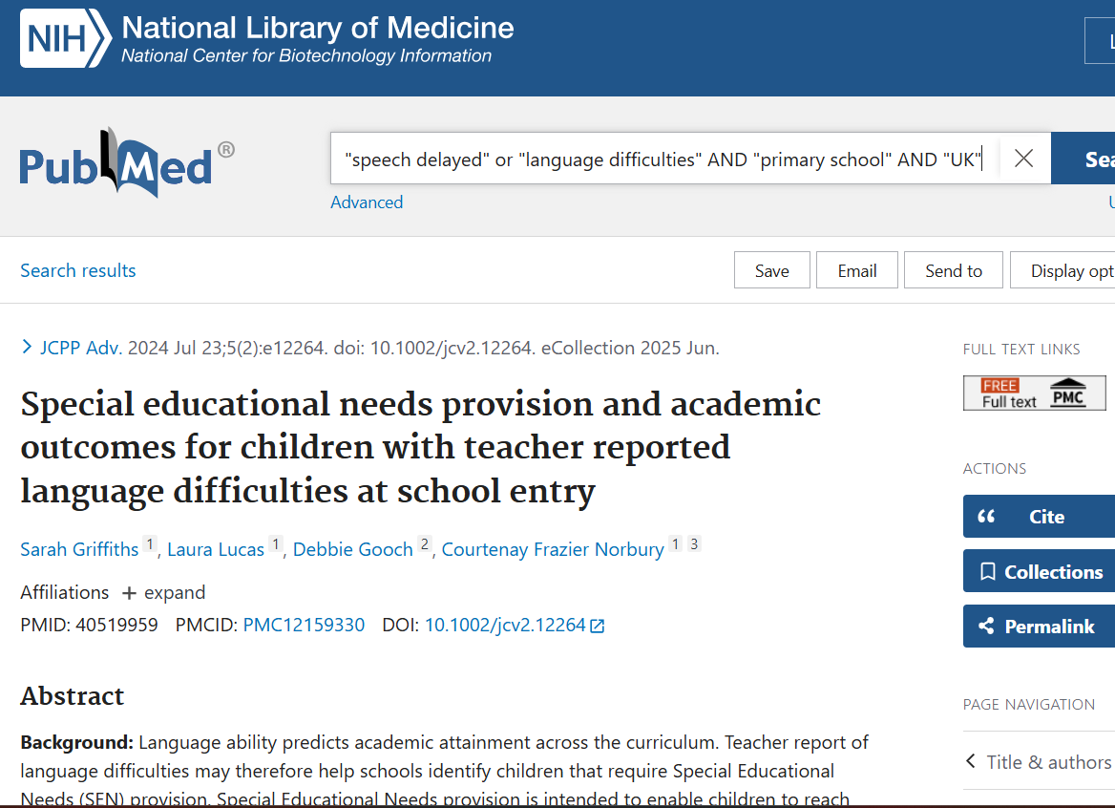

Part 4: Search Strategy Evaluation (Approx. 300 Words)
A search strategy is an organized way to look for facts that relate the subject or question. A good search strategy begins with a topic, definition of key words and ideas to help find the useful information needed (Simons, 2020).
To answer the research question, Google Scholar and PubMed were used. These databases were chosen because they provide reliable academic information in health and social care. To start the search, the keywords were used together with Boolean Operators. For example: "speech delayed" OR "language difficulties" AND "primary school" AND "UK".
Boolean operators help make searches more effective:
- AND is used to join different ideas e.g. “speech delay” AND “primary school”.
- OR is used to include similar words e.g. “speech delay” OR “communication difficulties”.
- NOT is used to remove information that is not relevant.
Filters were also used to improve the search. Only article from the last 10 years (2014-2024) were included to make sure the information is up to date. Peer-reviewed articles were chosen because they are checked by experts and are more reliable.
When started the research, the whole question was typed into Google Scholar. However, a clear answer was not found. The search changed after watching a tutorial “Combining keywords efficiently to find relevant source” published by Leeds University Library, (2023) that explained how to use special words like AND OR and NOT to find helpful information more easily. This new approach worked well, as it helped clearly see how problems with communication can lead to feeling emotional. A big concern in UK primary schools is young children who are late in developing their speech and language. This is because these difficulties can make it difficult for them to learn, communicate to others, and have a positive experience at school.
Reference list:
- Simons, J. (2020). Module 2: Developing Search Strategies. [online] NCPA Research Guide. Available at: https://pressbooks.nebraska.edu/ncparesearchguide/chapter/section-3-developing-good-search-strategies/
- Leeds University Library (2023). Combining keywords efficiently to find relevant sources. [online] YouTube. Available at: https://www.youtube.com/watch?v=jRQfhbn5Dxw [Accessed 23 Mar. 2026].
- Griffiths S, Lucas L, Gooch D, Norbury CF. Special educational needs provision and academic outcomes for children with teacher reported language difficulties at school entry. JCPP Adv. 2024 Jul 23;5(2):e12264. doi: 10.1002/jcv2.12264. PMID: 40519959; PMCID: PMC12159330.

