John Hughes
1708241
Networking & Cybersecurity

Research and Case Scenario in Data Security and Compliance

Semester 1

Assoc. Prof. Carlene Campbell

ACCA5034

- Abstract

This assignment is comprised of two sections. The first section provides details on the tools and features used in information security and is divided into specific subsections that cover technologies and measures used in industry by organisations of various sizes. It attempts to cover an array of information security requirements that protect digital, physical and reputational assets.
The second section focuses on the hypothetical application of the information provided in section one to a case scenario involving a growing organization looking to establish an information security unit. It provides several options for the application of technologies in accordance with various requirements of a modern organization and its realistic goals based on certain restrictions such as costs and feasibility.

Table of Contents

- Abstract
- List of Contents

- Implementing information security
- Security Framework ISO 27000 Standards
- Security Technologies
  - Firewalls
  - Access Controls
  - Virtual Private Networks

- Physical Security
  - Physical Intrusion
  - Environmental Threats
  - Electronic Monitoring and Surveillance

- FlowTech Case Scenario

  - Organisation Structure
  - Policies
  - Laws and Ethics
  - Governance and Strategic Security Plan
  - Risk Management
  - Contingency Planning
  - Protection Mechanisms

- Conclusion

- References

- Appendices

3. Implementing Information Security

When implementing an information security plan such as an ISMS, there is typically a need for this to be taken in a top-down approach starting with the personnel responsible for implementing the project. It would be easy to assume this person is the security project manager, but according to Alun Calder in his book, 9 Steps to Success, An ISO27001:2013 Overview, the starting point should be the person ultimately accountable for the success of the organisation, which is typically the CEO or other equal position [1].
This top-down approach is vital for success in any ISMS. Calder goes on to state that the CEO should support the project manager in a manner that is completely aligned with its business model and goals, allowing adequate level of support and resources for success. By providing support from the top of the organisation, this will help the ISMS manager to overcome any resistance from employees that are reluctant to change.
It is also possible to take a bottom-up approach, but as stated by Whitman and Mattord in The Principles of Information Security, this approach rarely works due to lack of structural support and sustainability. It could be argued however, that a bottom-up approach may be suitable for small organisations with a low number of employees as the technical expertise of IT staff can, and in many cases, will provide useful and effective information at operative levels.
With the support for the project achieved, Calder outlines the four key points to a project mandate.
Firstly, an organisation should outline its deliverables by identifying its needs and goals. Some of these goals Calder lists as a need for certification to reach a regulatory goal, costs reductions, sales and marketing. Although these issues are of significance, it may be more important to focus on the fundamental requirements of an organisations ISMS. To do this, an established method is the CIA triad of confidentiality, integrity and availability and of information. A Breakdown of the three key aspects of CIA are as follows:

- Confidentiality - This refers to information being disclosed only to authorised persons or entities
- Integrity – Information must remain complete and incorruptible
- Availability – Whilst maintaining the first two key aspects, the information must be accessible to the authorised persons/entities

The information provided in this breakdown was taken from a video produced by IT Governance Ltd and access to it can be found in Appendix A
Also, these goals need to be measurable, and to achieve this aim, the goals should be compatible with the SMART criteria, which is as follows; Specific, measurable, achievable, relevant, timebound.
The following table illustrates the SMART criteria

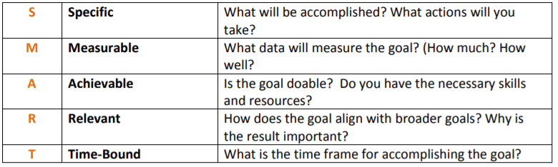
Figure 1 S.M.A.R.T Goals

According to ISACA in their 2011 journal archives, an internal audit of the organisation must also be a part of the mandate [2]. The audit will establish what Internal resources will be needed during implementation of ISMS. External resources will be needed for consultants that will save time and money. Certification fees will need to be considered and lastly continued costs of implementation. These four costs must be considered to determine a budget for the overall ISMS. [2]

4. Security Framework ISO 27000 Standards

The ISO 27000 are a series of industry standards aimed at helping online entities establish a broad range of information security.
Although this vast range of standards are currently set out by the International Organisation for Standardisation (ISO) and the International Electrotechnical Commission (IEC), they could be considered an evolution of BS7799, originally published by the British Standards Organisation (BSO)
According to Abass Asosheh in his article titled A Practical Implementation of ISMS, accessing information is fundamental to success in business [3]. It is for this reason, in 1995, BSI Group published the BS7799 standards as a means of guidance for organisations to produce an Information Security Management System (ISMS). Starting off as a code of practice for any organisation, it soon became apparent that organisations would require certification due to the increased scale and significance of information security threats, resulting in the creation of BS7799-2 in 1999, which focused on how to implement an ISMS and eventually would be used by ISO for their accreditation standards.

As stated by Eric Vanderberg in Information Security Compliance: ISO 27000, part one of BS7799 was taken by ISO and classed as ISO17799 in 2000, with BS7799-2 used as ISO 27001. The following table illustrates the framework of the ISO 27000 series.

ISO 27001 | ISMS Requirements
ISO 27002 | ISMS Controls
ISO 27003 | ISMS Implementation Guidlines
ISO 27004 | ISMS Measurements
ISO 27005 | Risk Management
ISO 27006 | Accreditation

Figure 2 ISO Series Information Security Compliance

ISO 27001 can be achieved without the remaining standards as a minimum requirement for certification. The remaining can be achieved as additional accreditation for further security on each standard and cannot be achieved without ISO 27001. In order to achieve the ISO 27001 accreditation, the following requirements, known as the nine keys, need to be achieved. taken from Luke Irwin’s 9 Step Guide to Implementing ISO 27001 [4].
Further information on the 9 step guide can be found in Appendix B.

One of the major drawbacks of the ISO 27001 is in its costs. This is evident in Irwin’s guide, the detailed information is hidden behind paywalls and is only available at significant cost. It is common for the detailed information within the nine keys/steps to be withheld by professional companies that will want to provide it as a service to customers, typically at significant cost to potential clients.

5. Security Technologies

5.1 Firewalls
As stated by Michael E. Whitman and Herbert J. Mattord in the book, Principles of Information Security, firewalls can be split into four different categories consisting of Packet filtering, application gateways, MAC layer and hybrid firewalls [5]. As modern firewalls tend to use multiple approaches, most firewalls fall into the hybrid category

5.1.1 Packet Filtering
Packet-filtering firewalls inspect the header information of data packets received at the network layer. This is to decide whether a packet is worthy of being allowed to the next connection or denied access. As explained by Whitman and Mattord, the firewall will determine whether a packet can be forwarded by the information in its header such as, destination address, source address and packet type. If the firewall identifies information that matches a set restriction, the packet will be dropped and therefore not gain further connection. Otherwise, it will be forwarded to its next stage [5]. This works amongst routers as shown in the illustration below.

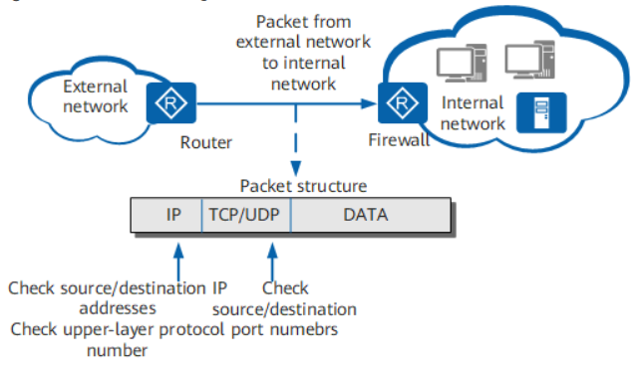
Figure 3 Packet Filtering Diagram Huawei
5.1.2 Application Gateways
Application gateways, also known as application layer firewalls or proxy servers(or reverse proxy), act as a proxy for a service request. Whitman and Mattord state that rather than exposing a web server to direct traffic, a proxy server can be used in the demilitarised zone (DMZ), to protect the web server from such risks [5].
By acting as an intermediary, the proxy server can then determine whether a request is allowed further access while protecting the networks IP address from potential hackers.
An example how proxy servers work is shown below

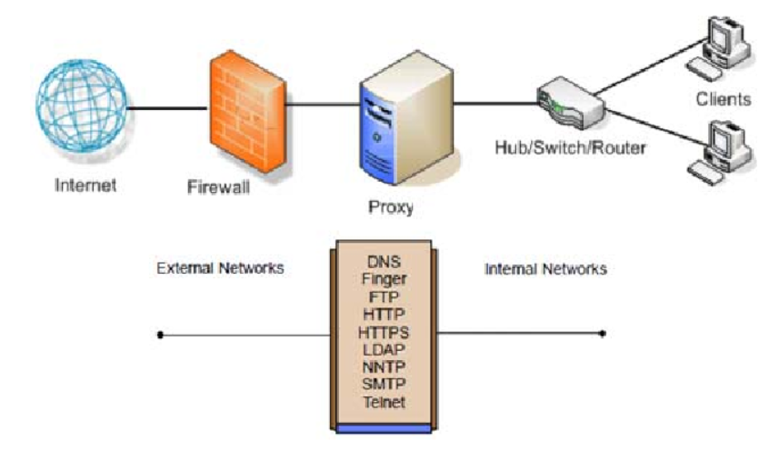
Figure 4 Application Layer

It is also worth noting that Proxy servers can be high maintenance and therefor expensive. They are typically only used for one application, such as web page or file access and will need configuring to read each packet at the application layer.

5.1.3 MAC Layer Firewalls

The purpose of a MAC layer firewall is to control device interaction by operating at the media access control layer. Whitman and Mattord state that MAC layer firewalls will filter packets based on ACL entries(access control lists). It links the MAC address of a host on the network to the ACL entries to determine whether the packet can be sent to other hosts, otherwise blocking all other traffic [5].

5.1.4 Hybrid Firewalls

Following on from the previous firewall information provided by Whitman and Mattord, hybrid firewalls combine the features of more than one type and can consist of two separate firewall devices. An example of this could be a packet-filtering firewall to check all packet requests, that then passes the allowed requests to a proxy server that protects the remaining network and their addresses. Whitman and Mattord also state the most recent generation firewall is the Unified Threat Management (UTM), capable of a multitude of defences such as network intrusion, content filter, malware protection and spam filter [5].

5.2 Access Control

There are many different types of access control, for physical access control see ….., in regard to information security, this section focuses on authorisation in the form of Access Control Lists (ACL).

According to a review by James Cox, ACL’s are network traffic filters that are the same as a stateless firewall and are regularly used in routers and firewalls, but can also be used in any device within a network by filtering traffic in accordance with a list of statements known as Access Control Entries [6].
The purpose of an ACL is to provide security restrictions between devices within a network without compromising the end performance, as would be the case with a stateless firewall. For this to work, Access Control Entries need to configured in accordance with the following information found in appendix ….

5.3 Virtual Private Networks

5.3.1 Defining a VPN

In a 2001 Article by Perry B. Gentry, he briefly defines a Virtual Private Network (VPN) as a connection through an encrypted network that transmits data privately between two parties [7].
Gentry goes on to define each of the three aspects of a VPN as follows.

“1. It is virtual because it can use a public or private network to transmit data.
2 It is private because it uses encryption that the users control to transmit data
3 It is a network because devices and systems are communicating on a common path”
5.3.2 Purpose for a VPN

In a website article by Steve Symanovich, he states that VPNs provide a degree of anonymity for users by creating a private network out of public internet resources. He states this is done by encrypting the data sent and received across the network and keeping IP addresses hidden from public [8].
Although this source was written for a service vendor, it does seem to capture the basic need for a VPN in the sense of providing anonymity to the network users whilst keeping transmitted information private.

5.3.3 Tunneling

One of the fundamental aspects of achieving privacy over public networks is known as tunnelling. Whitman and Mattord cover this in The Principles of Information Security [5]. It is explained that tunnel mode will encrypt all information in a packet including its header and attach it as the data portion of a new packet that is sent between two tunnelling servers. This packet is then decrypted by the receiving server to deliver to its final address. Tunnelling ensures both anonymity and private data because it reveals nothing to a third party attempting to intercept the packets.
This process is achieved by configuring a client’s system to connect to a VPN service. A basic diagram of this is shown below
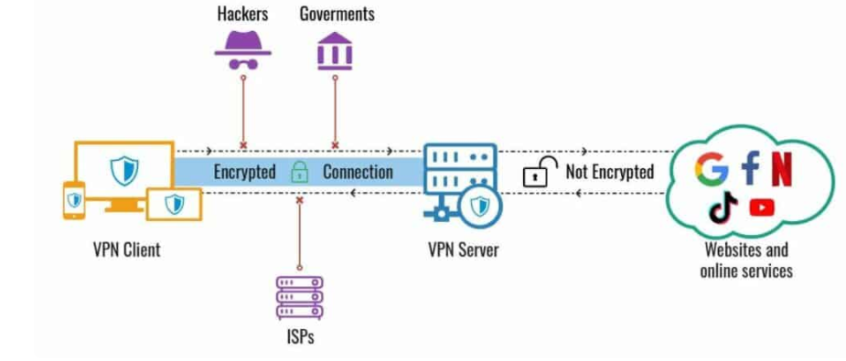
Figure 5 Tunnelling

6. Physical Security

Information security is not just applicable to digital data. It also applies to physical assets such as the devices used to send, receive and store data, the physical infrastructure used to connect a network of such devices and the personnel that use them.

6.1 Physical Intrusion

Intrusion is one of the most obvious forms of physical threats to any business. If an intruder gains access to any business premises, their unauthorized access could lead to theft, damage or corruption of both physical assets and digital data stored on their devices.
In a web article by CSO’s Dan Swinhoe, the first principle of physical security measures is access control of the building itself [9]. From simple lock and key systems to more sophisticated but expensive features such as biometrics and ID key cards, Locking the perimeter is the first step to preventing physical intrusion
Visual deterrents are also useful with varying degrees of expense. Warning signs, spiked windows and guards are a relatively cheap measure to deter less sophisticated attempts to gain building access.
Swinhoe states that more expensive access control has to be judged by its pros and cons. Radio frequency ID (RFID) for example is more sophisticated and makes forging ID cards harder, but can still be cloned, unlike magnetic strips that require physical swiping. An example of a basic card reader door lock is shown below
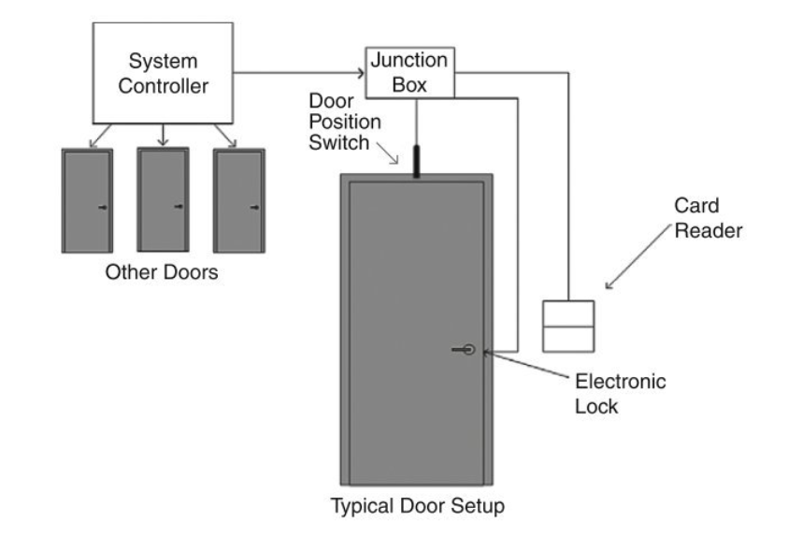
Figure 6 Key card Door

Even with adequate access control in place, another threat comes in the form of tailgating. In the book The Principles of Information Security, Whtiman and Mattord provide an example of tailgating whereby an unauthorised person enters the main door entrance by waiting for an authorised employee to open it and then follow them in. Such instances of tailgating and other techniques highlight the necessity to train staff and personnel in awareness of such issues and protocols for identifying such threats [5].

6.2 Environmental Threats

In the book The Infosec Handbook, authors Umesha Nayak and Umesh Rao state the seven major sources of physical loss are as follows [10];

- Temperature, in extreme variation from hot to cold or rapid change
- Gases. A wide-ranging threat that could be in the form of smoke, vapour, humidity or fumes and cleaning products
- Liquids such as flooding from plumbing pipes or infrastructure failure, spilled drinks, and chemicals
- Organisms. Viruses, infestations of animals or insects, bacterias, moulds or funguses
- Projectiles. Physical moving objects such as vehicles or machinery
- Environmental movements such as vibration/shaking
- Energy anomalies such as power surges or other electrical failures, presence of magnetic forces, sound, light radio, microwave or atomic/radioactivity

These listed threats can be split into the responsibility of two different parties. Firstly Nayak and Rao state that the general management should be responsible for the overall environment, including the security guards and personnel under their command, but the second party must be specifically the IT dept and their Information security staff responsible for the actual computer systems and related hardware. Any specialist requirements and/or protection methods relative to devices and network infrastructure, including its backup storage, would fall within the responsibility of the latter party [10].

6.3 Monitoring and Surveillance

The most common and perhaps important type of monitoring used by any organisation is closed circuit television cameras (CCTV). These are used to monitor some or all areas of a building, internally and externally and are typically, although not always, complimented by security personal and CCTV operatives. Nayak and Rao state that as a passive device, such systems “can only monitor but not prevent intrusions” although it could be argued that such a statement isn’t entirely true as CCTV systems can not only act as a deterrent to potential intruders, particularly when accompanied by signage, but when used in real time by operatives they can be particularly effective in preventing the level of penetration by intruders, often at a very early stage when considering external CCTV coverage [10].

7. FlowTech Case Scenario

In order to establish an information security unit, the first stage of addressing the specific requirements of FlowTech is to consider the goals and requirements of the organisation whilst implementing and combining the SMART Criteria mentioned in section 6 of the report. A SMART table of measures could be similar to the example shown below

Strategy | Measurable | Attainable | Relevant | Timebound
Establish staff structure | Assess structure once in place | Top-down approach | Allow for full support of plan | With immediate affect
Protection of data | Scheduled testing and inspection | Ensure to remain within budget and delegate to IT staff | Relating to all data including 3rd parties | Earliest Opportunity with schedule of two weeks
Physical protection of building and infrastructure | Scheduled testing and inspection | Ensure to remain within budget and acquire trusted tradesmen/installers | Relating to physical intrusion and environmental risk | Within the confines of installation times estimated 4-12 weeks
Backup plan | Scheduled testing and inspection | Consider backup storage with regular updates | Relating to data recovery | Immediate affect with daily updates
Meet the standards of security framework ISO27001 | Achieve Accreditation | Have in place an ISMS | Implement industry-recognised security standards | 6-12 months in accordance with qualified service advisors
Figure 7 S.M.A.R.T Table

Each of the targets in the table are very broadly defined and need to be broken down into greater detail beginning with staff structure

7.1 Staff Structure
FlowTech should be considered a large enough organization to implement a top-down approach to its personnel. implementing security management should begin with the FlowTech CEO. This position will initiate the process by offering full support to the information security unit, assign a champion that is tasked with overall operational management and provide an adequate budget to cover the operation. The champion should have sufficient authority over the staff structure in order to ensure full acceptance within the organization. With this support in place, it will give the greatest chance of success for the security manager, allowing him/her the authority to address any resistance to changes in company procedures that may be encountered as the project is implemented. A basic diagram of what the FlowTech structure may look like is shown as follows:

Figure 8 Staff Structure

With the FlowTech CEO taking ultimate responsibility for the success of the company, he/she should consider the security champion wisely as someone that can be trusted to undertake specific tasks and be of high enough rank to have authority over the remaining structure. With information security in place at the lower end of the hierarchy, they can always request the assistance of the CIO, acting as champion, as required.
With adequate training in place all staff should have a good understanding of requirements not just for individual roles, but also a collective understanding to threats such as tailgating, as mentioned in 5.3.

7.2 Compliance with Laws and Ethics

It is a requirement for any organization to comply with both laws and ethics in information security. Whereas ethics define socially acceptable behaviors and actions, laws are enforced by the authority of the governing body of a certain area and as such, must be adhered to. Ethics, although not strictly enforced by law, can in some cases overlap with laws. Examples of such overlapping definitions are provided by Whitman and Mattord when defining laws such as “due care” and “due diligence”. These laws are based on both legal and ethical considerations and as such, provides examples of the definition of ethics overlapping into law [5].
It is good practice to identify and familiarize with some key laws that are applicable to both industry and location. The Computer Misuse Act 1990 holds particular relevance in UK law. As does The Data Protection Act 2018. Since Brexit It is also important to stay updated to the latest regulations involving ePrivacy and data transfer laws between U.K and E.U countries. This information can be found in appendix C
The implications for breaching laws and ethics can be particularly damaging, and it is imperative that FlowTech adhere to all the laws applicable to the areas that they operate in. Organisations and the individuals that represent them can face criminal charges and/or financial penalties for failing to adhere to laws or the ethical behavior required to maintain certain laws. FlowTech should create a policy that maintains a code of ethics for all staff to adhere to in order to maintain compliance. The code should cover a range of values and principles with the aim of maintaining legal and ethical integrity. Such principles could be as follows

- Comply with all legal requirements within the jurisdiction of governing bodies
- Maintain high ethical standards including due care and diligence
- Uphold professionalism and integrity toward all colleagues, clients and entities associated with the organisation
- Uphold the reputation of the organization and the industry as a whole

With a suitable policy in place, FlowTech should be able to demonstrate that it adheres to the code, that it is easily accessible to all parties and fully understood by all employees. In the event of any legal accusations against the organization, either civil or criminal, it could be required to prove to a court that it adheres to its own code and therefore demonstratable evidence would be useful in its defence. It could be useful to become a member of a recognized organization such as the U.K Cybersecurity Council or the International Systems Security Association (ISSA). FlowTech would have to pay a membership fee but would receive accreditation as a member, see appendix D

7.3 Protecting Data and Digital Assets

FlowTech has several digital assets to secure. It has both staff and client databases, websites, and provides cloud storage and services to its clients.
The first defensive measure should be to use adequate firewall protection for its network. Referring to 4.1.4, the most modern and effective form of firewall would be a hybrid-firewall. This could be used to cover multiple areas of the network. A basic packet-filtering firewall can be used to cover the network access, although this should be combined with additional protection at more specific areas of the network. An application layer firewall can be used to protect the organisations web server as explained in 4.1.2 [5].
With the potential need for working from home, FlowTech should also consider a means for remote access to its servers. A cost-effective security approach would be the use of VPN services. As explained in section 4.2, a VPN would provide encryption over a public network to staff that require remote access to company services and sensitive/proprietary data that may be stored locally at the FlowTech premises or via cloud services. For this reason, a corporate VPN would be required.
According to web-infrastructure company Cloudflare, a corporate/business VPN would not only provide secure remote access, but also cater for Bring Your Own Device (BOYD), allowing employees to safely access organization network via personal devices such as smartphones and tablets. Although always-on VPNs would be fundamental to BYOD protection, there would also be further reliance on staff members to be adequately trained in procedures to protect both their devices, and the credentials required for network access via such devices [11].

7.4 Physical Protection

Physical protection could be delegated between different departments of the organization. Basic security for the building and its surroundings should be assigned to FlowTech’s dedicated security management team. This should cover physical intrusion mentioned in 5.1.
As mentioned by Swinhoe, it would be a mistake to focus too much security on the front door whilst leaving other areas exposed [9]. It is therefore advisable to include CCTV coverage of the building and surrounding areas where practically possible. Security management should also be tasked with physically securing entry points, manning/patrolling areas with security guards and identifying any potential weaknesses to certain areas such as windows, loading bays or emergency exits.
Another security measure would also be use of warning signage and high-vis clothing for security guards. Although these methods would only serve as a deterrent to less sophisticated threats, they still serve their purpose at low financial costs/maintenance.

As mentioned in 5.2, other aspects of physical security include environmental threats. This is where the organisations technical staff should have a greater role in addressing the threats as they will have greater expertise in identifying the vulnerabilities of FlowTech’s infrastructure. Technical staff should refer to the seven major sources of physical loss when protecting such equipment/devices. Network engineers/administrators should design a compartmentalised approach to their assets/resources that include segregated computer rooms, wiring closets and in some cases atmospheric controls to rooms that require certain temperatures, dust or other contaminant protection [10]. Technical staff should also oversee any ID card or automated locking procedures to such areas from an application perspective.
Although general fire safety should lie with Flowtech’s dedicated building security management, it would also be the responsibility of technical staff to identify areas of particular concern that may need to exclude sprinkler systems or other environmental threats.

7.5 Backup Strategy
In their book, The InfoSec Handbook, Nayak and Rao state that data loss can cause irreversible damage to an organisations reputation. With FlowTech being a threat intelligence and consultancy company, it is imperative that they take a zero-tolerance approach to data loss by adopting a sufficient backup strategy [10].
A large organization may implement such technologies as a Redundant Array of Independent Disks (RAID), server mirroring or database mirroring to replicate their web servers or remote journaling to process transactions in parallel with multiple sites. All these examples involve backing up data in multiple devices.
Like any organisation, FlowTech’s choices will depend on their budget. Using RAID technologies will be a more cost-effective method for data backup as opposed to server mirroring, which could effectively double the costs of running servers. Server mirroring however would give additional benefits as it involves a backup server duplicating the processes in real-time, which would remove any down-time since the backup server would be there for immediate recovery of services.
Some of the costs to consider when choosing backup storage are as follows:

- Backup hardware such as data storage devices or mirroring devices

- Backup software/media that may incur charges for use by vendors

- Personnel/staff costs to operate software/hardware

- Storage costs in terms of charges by third parties or costs of maintaining infrastructure at alternate locations

A minimum requirement for an organisation would be to conduct a plan that addresses all their known threats. Flowtech should store backup data in multiple locations to protect from the physical/environmental threats previously mentioned. If a disaster were to strike their main premises, backup storage would be at an alternate location. The backup locations should also have adequate security measures in place to protect from being a vulnerability.
There should also be a planned strategy in place for regularly updating the backups, as any technology would fail without the appropriate measures being conducted by staff.
It is also worth considering what the organization should do in the event of a serious cyber attack such as a ransomware attack. Ransomware involves types of viruses such as cryptowall, that target the theft of files that contain useful and valuable data. Once stolen, the data is then encrypted, while the rightful owners are then held to ransom for the decryption key. If an organization such as FlowTech are targeted by ransomware, it is fundamentally important to have accurate and up-to-date backup files. This will protect them from the demands of the attacker. It could still be an option to pay the attacker in exchange for the return of sensitive information, but it is worth noting that making payment does not guarantee the return of the stolen data and, according to Jeff Petters, only 19% of ransomware payments have resulted in successful retrieval of stolen data. It is therefore concluded that payment should always be refused if ever faced with this scenario [11].

7.6 Security Framework Accreditation

With the processes in place for developing an information security unit, FlowTech may wish to consider achieving industry recognized accreditation such ISO27001. In order to achieve this, the organization would require a comprehensive ISMS that adheres to the ISO27001 framework. It is worth considering the costs of this procedure. As stated in section 6, accreditation typically incurs four different aspects of costs. A price guide below is provided by an established consultancy firm, IT Governance. The table covers two of the four costs, consisting of auditing fees and certification fees, but does not include the remaining two costs of implementation or maintaining an ISMS once accreditation is achieved. Further information on this table can be found in appendix E

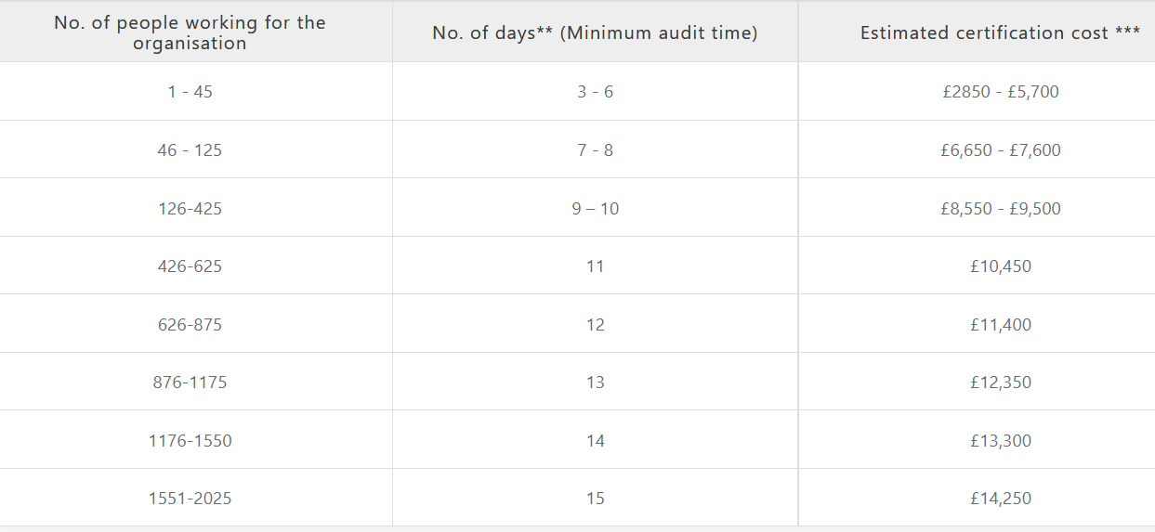
Figure 9 ISO Auditing Costs

It is worth noting that achieving accreditation can produce significant advantages for any organization, particularly when trying to establish itself during business growth. As stated by ISO, certification can be used as an effective tool for gaining credibility within the industry by proving that an organizations product will meet the needs of its customer base. As an internationally recognized accreditation, it may also be of particular use for compliance and legal procedures in multiple countries [12].

8. Conclusion

In consideration of the information provided in this assignment, the importance of information security has been growing stronger throughout the digital era and will continue to do so into the future. All organisations will require comprehensive plans to defend themselves from threats in a continuously evolving environment. Such plans will consist of a mixture of social, structural, legal and technological measures to meet the demands of modern society.
Various levels of security can be implemented from modest and affordable, to in-depth and complex measures that are at the forefront of innovation and technology. The greater the level of depth, the more secure an organization will be.
The significance of information security is so important that failure to prepare for such threats would lead to inevitable failure as an organization. However, no matter how great a threat, there is always a measure that can be taken to defend oneself. Since the threats are continuously evolving, the information security must evolve to match it.

9. References

[1] | A. Calder, 9 Steps to Success, an ISO27001:2013 Overview, 3rd ed., Cambridgeshire: IT Governance Publishing, 2016, pp. 20-33.
[2] | ISACA, “Planning for Implementing ISO 27001,” ISACA Journal Archives, 1 July 2011.
[3] | A. Abbass, “A Practical Implementation of ISMS,” April 2013.
[4] | L. Irwin, “A 9-step guide to implementing ISO 27001,” IT-Governance, 13th April 2021. [Online]. Available: https://www.itgovernance.eu/blog/en/a-9-step-guide-to-implementing-iso-27001. [Accessed 25th October 2021].
[5] | M. H. j. Whitman Michael, Principles of Information Security, fifth ed., Boston , MA: Cengage Learning, 2016.
[6] | J. Cox, “Access Control List (ACL) – What are They and How to Configure Them,” 15th January 2020. [Online]. Available: https://www.ittsystems.com/access-control-list-acl/#wbounce-modal. [Accessed 1st November 2021].
[7] | P. B. Gentry, “What Is A VPN,” Information Security Technical Report, vol. 6, no. 1, pp. p15-22, N/a N/a 2001.
[8] | S. Symanovich, “NortonLifeLock,” Norton, 21st January 2021. [Online]. Available: https://us.norton.com/internetsecurity-privacy-what-is-a-vpn.html. [Accessed 8th November 2021].
[9] | D. Swinhoe, “What is physical security? How to keep your facilities and devices safe from on-site attackers,” CSO Online, 4th August 2021. [Online]. Available: https://www.csoonline.com/article/3324614/what-is-physical-security-how-to-keep-your-facilities-and-devices-safe-from-on-site-attackers.html. [Accessed 9th November 2021].
[10] | U. R. U. Nayak, “Part V, Physical Security,” in The Infosec Handbook, Springer Nature, 2014, pp. 290-340.
[11] | Coudflare, “What is a VPN, and why do businesses use them?,” [Online]. Available: https://www.cloudflare.com/en-gb/learning/access-management/what-is-a-business-vpn/. [Accessed 30th November 2021].
[12] | J. Petters, “The State of Cryptowall,” Varonis, 17th June 2020. [Online]. Available: https://www.varonis.com/blog/cryptowall/. [Accessed 29th November 2021].
[13] | I. O. f. Standardization, “ISO Certification and Conformity,” ISO, [Online]. Available: https://www.itgovernance.co.uk/iso27001-certification-costs. [Accessed 30th November 2021].

Table of Figures

Figure 1 S.M.A.R.T Goals 6
https://www.ucop.edu/local-human-resources/_files/performance-appraisal/How%20to%20write%20SMART%20Goals%20v2.pdf
Figure 2 ISO Series Information Security Compliance 7

Figure 3 Packet Filtering Diagram Huawei 8
https://support.huawei.com/enterprise/en/doc/EDOC1000154776/88191a64/packet-filtering-firewall
Figure 4 Application Layer 9
https://www.semanticscholar.org/paper/Performance-analysis-of-application-layer-firewall-Aziz-Ibrahim/bc8a7c4d4debcf1071d1bc4b2539403193f46769/figure/1
Figure 5 Tunnelling 12
Figure 6 Key card Door 13
Smart Building Systems for Architects, Owners and Builders
James N sinopoli, publisher Butterworth-Heinemann, 11/9/2009
Figure 7 S.M.A.R.T Table 16

Figure 8 Staff Structure 17

Figure 9 ISO Auditing Costs 22
https://www.itgovernance.co.uk/iso27001-certification-costs

10.Appendices

Appendix A
CIA Video
https://www.youtube.com/watch?v=io6w3Yw4q9w

Appendix B
9-Step Guide to Implementing ISO 27001
https://www.itgovernance.eu/blog/en/a-9-step-guide-to-implementing-iso-27001

Appendix C

Computer Misuse Act 1990
https://www.legislation.gov.uk/ukpga/1990/18/contents

Data Protection Act 2018
https://www.legislation.gov.uk/ukpga/2018/12/contents/enacted

Appendix D
Code Of Ethics, UK Cybersecurity Council Membership
https://www.ukcybersecuritycouncil.org.uk/professional-ethics/code-of-ethics/

Appendix E

ISO 27000 Certification costs by IT Governance

https://www.itgovernance.co.uk/iso27001-certification-costs

marking criteria and Student FEEDBACK

This section details the assessment criteria. The extent to which these are demonstrated by you determines your mark. The marks available for each criterion are shown. Lecturers will use the space provided to comment on the achievement of the task(s), including those areas in which you have performed well and areas that would benefit from development/improvement.

Common Assessment Criteria Applied (Assignment 1) | Marks available | Marks  awarded
1. Engagement with Literature Skills
Extent of research and/or own reading, selection of credible sources, application of appropriate referencing conventions.
Your work has demonstrated that you have done your own research. While you have used relevant content. Your references are lacking more creditable peer reviewed articles. Use credible sources; academic journals are normally highly credible sources while websites require careful consideration/selection and should be used sparingly. Utilise the university online resources and journals from the library site. (Grade mark: 55.00%) | 20 | 11
2. Knowledge and Understanding Skills
Extent of knowledge and understanding of concepts and underlying principles associated with the discipline.
To showcase your knowledge and understanding try to incorporate more critical appraisal of the literature. Use more in-text citation. See comment above to improve this area. (Grade mark: 55.00%) | 10 | 5.5
3. Cognitive and Intellectual Skills
Analysis, evaluation and synthesis; logic, argument and judgement; analytical reflection; organisation of ideas and evidence
You have discussed both task criteria given. See comments in report about your abstract. You have not done an introduction. Introduction should give a background to the work along with some general research information of the subject areas, followed by what the rest of the report will include. Task 2 discussion interrelate the case study explaining how each aspect would apply to them. Your conclusion should summarize your key areas of the report, you should not introduce any new discussion within it. It was good to see you refer to additional content (appendix) (Grade mark: 60.00%) | 25 | 15
4. Practical Application Skills
Deployment of methods, materials, tools and techniques; application of concepts; formulation of innovative and creative solutions to solve problems.
Organisation chart provided and other diagrams/chart/table to discuss the case study. (Grade mark: 60.00%) | 25 | 15
5. Transferable Skills for Life and Professional Practice
Attributes in professional practice: individual and collaborative working; deployment of appropriate media; presentation and organisation.
You have not used the IEEE report format. Your report could do with some formatting. Your writing style can be improved. Reference all figures taken from sources. (Grade mark: 55.00%) | 20 | 11

Assignment Mark (Assessment marks are subject to ratification at the Exam Board. These comments and marks are to give feedback on module work and are for guidance only until they are confirmed. ) | Late Submission Penalties (tick if appropriate) |  | 58%
 | Up to four weeks late |  | 58%
 | First Attempt? |  | 58%

