Have humans lost their connection to nature as we enter our current environmental epoch of the Anthropocene? Is it possible to regain that connection using concepts of phenomenology and the sublime through art?

Alexandra Smith
1702583

“Submitted in partial fulfilment of the requirements for the degree of BA (Hons) Photography and the Arts University of Wales Trinity Saint David, Swansea”

18th December 2019

Tutor: Ryan Moule

Word Count: 6,142

Table of Contents

 | Page
Illustrations | 1
Summary | 2
Introduction | 3-4
Humans and the Anthropocene | 5-16
Phenomenological effects from Nature | 17-21
Nature and the Sublime | 22-29
Conclusion | 30-32
Personal Conclusion | 33-35
Bibliography | 36-43

List of Illustrations
Fig: 1 – George Marazakis. (2018) Fog shrouds a power plant in Ptolemaida, in northern Greece from series “A Cure for Anthropocene” .
Fig: 2 – NASA. (2010) NASA's Terra Satellites Sees Spill in May.
Fig: 3 – Sebastio Salgado. (1991) Desert Hell Kuwait.
Fig: 4 – Edward Burtynsky. (2012) Dryland Farming 31 Monegros County, Aragon, Spain.
Fig: 5 – George Steinmetz. (2014) - Inoculation new-born pigs in confined breeding cages where they will spend most of their adult lives, near Sorriso Brazil.
Fig: 6 – Jose Ferriera. (2011) Trash land.
Fig: 7 – Gulio Di Sturco. (2015) A worker with a water hose tries to tame an iceberg of foam created by the chemical waste dumped by the factories along the Yamuna river, Delhi.
Fig. 8 – Andy Goldsworthy. (1985) - Carefully broken pebbles scratched white with another stone St. Abbs, Scotland.
Fig: 9 – Edward Burtynsky. (2015) Anthropocene Basque Coast.
Fig: 10 – Andreas Gurski. (1999) RhineII.
Fig: 11 – John Martin. (1853) The Great Day of His Wrath.
Fig: 12 – John Martin. (1851) Plains of Heaven.
Fig: 13 – Ansel Adams. (1951) Manly Beacon, Death Valley National Monument, California.
Fig: 14 – Phillip James De Loutherbourg. (1803) An Avalanche in the Alps.
Fig: 15 – Sebastiao Salgado. (2010) Herd of Buffalos, Kafue National Park, Zambia.
Fig: 16 – Olaf Eliasson. (2003) The weather project, Installation, turbine Hall, Tate Modern.
Fig: 17 – Don Mccullin. (2000) The Battlefields of the Somme.
Fig: 18 – Alexandra Smith. (2018) The Anthropocene.

Summary of Topic
This independent inquiry investigates humans' impact and connection to the natural world. It states the fundamental impact humans have had on nature and how we are effectively destroying it. Looking at philosophical theories of phenomenology and the sublime will help explore the topic of humanities emotional and inner bodily connection to natural phenomena. These concepts are explored through the work of relevant artists and photographers who have touched upon these topics.

Introduction
This essay will investigate the relationship between humans and the natural world and how we have lost our affiliation, and spiritual connection to nature. This topic will be examined using three main philosophical concepts – starting with the Anthropocene, where in the subsections will be discussed how human impact that has affected our planet, leading onto phenomenology and its importance in reconnected the human soul back to nature as one, finally ending with an exploration of the sublime and its concepts of awe and terror from the natural world. These subjects will be illustrated along with the text through different art mediums to show how art can play an important role in the reconnection of humans to nature how this relates to our current geological epoch. This essay will investigate how art could help rebuild the emotional affinity we have with the natural environment that in contemporary society has been lost in this fast paced, consumer culture we live in. Finally, this will link back to my own practice and discuss how I’ve put these theories into effect.
Chapter one introduces our current environmental age of the Anthropocene, this suggests that humans for the first time in history have more control over nature than nature has over itself. The focus in this chapter is to look at this topic from a factual perspective to give statistics of how we are affectively destroying the planet, starting with global warming, leading onto the meat industry, plastic pollution, and ending with fast fashion, these topics are backed up and explored through organisations such as PETA and National Geographic.
Chapter 2 moves on to our inner body ‘s sensual experience towards the environment through the philosophical concept of phenomenology and touching upon the philosophical theme Reverence for life, studying key thinkers such as Edmund Husserl, Timothy Morton, Albert Schweitzer and Friedrich Nietzsche.
Focusing predominantly on phenomenology through philosophical theories and art to show how art can enrich our psychological state and wellbeing, evoking a spiritual connection to nature.
This then leads to Chapter 3, which explores the sublime and our embedded emotional responses we experience when encountering the vastness and scale of different natural phenomenon, while looking at key thinkers such as Edmund Burke and Martin Heidegger. These overwhelming and captivating feelings of awe combined with terror immerses us into a sense of how small and insignificant we are in comparison with our intricate and perplexing universe. From these connected topics the questions raised perhaps have a key to some solutions to these big questions that we face today.
Humans and the Anthropocene

The Anthropocene is the age of human impact on earth. The negative impact of humans to nature are causing changes to the environment at a rate never before seen in human history. According to naturalist David Attenborough:
The Holocene has ended. The Garden of Eden is no more. We have changed the world so much that scientists say we are in a new geological age: the Anthropocene, the age of humans (Attenborough, 2019)

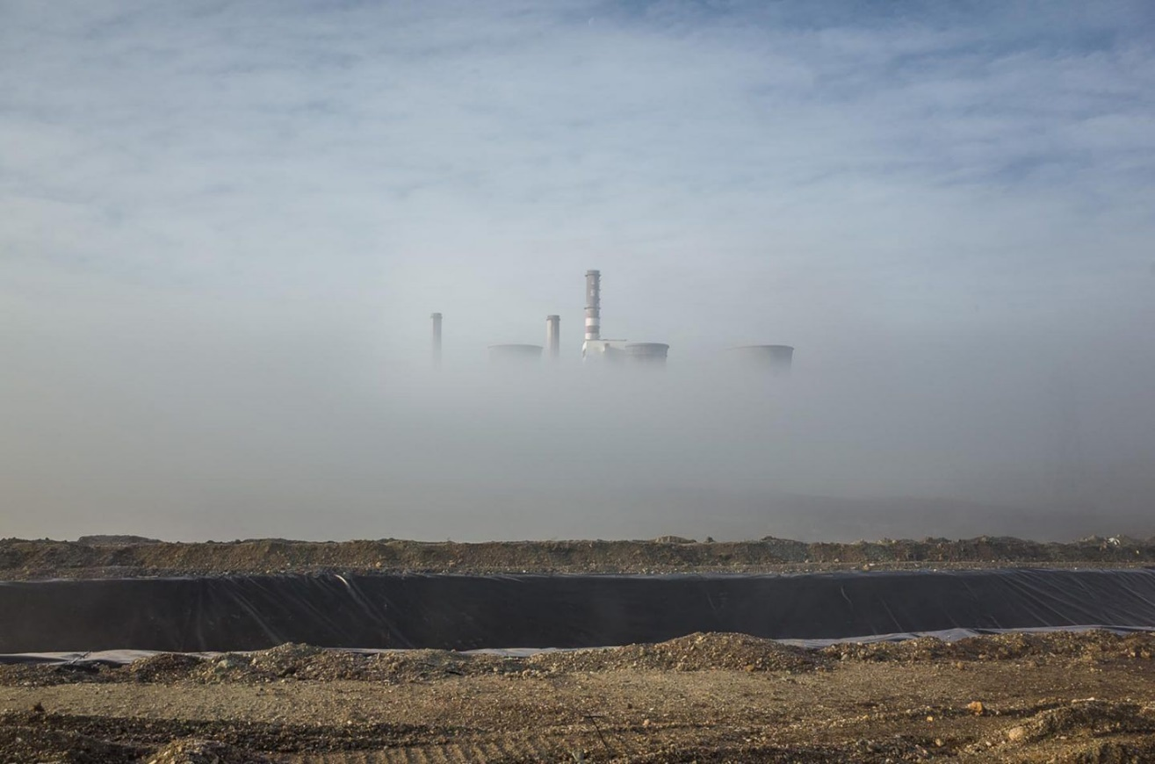
Fig 1: Fog shrouds a power plant in Ptolemaida, in northern Greece

This image by George Marazakis was chosen as it gives a clear depiction of how man and machine are influencing the world around us. The main damaging influences humans have upon the environment include our model of energy sources and resource consumption. The energy produced from coal, oil or natural gas creates large amounts of greenhouse gasses, the main culprit of global warming.
Human activities are changing the natural greenhouse. Over the last century the burning of fossil fuels like coal and oil has increased the concentration of atmospheric carbon dioxide (CO2) (Climate Change: Vital Signs of the Planet, 2019).

These actions by humans also cause impact to the water cycle, imbalances in the marine and terrine eco systems, the acidification of the oceans, increase of extreme metrological phenomena’s and the disappearance of the forests.
Earth began 3.7 billion years ago, it is home to 8.7 million forms of life and a growing population of 7 billion humans.
During the 20th century alone, the population in the world has grown from 1.65 billion to 7 billion. The current average population increase is estimated at 82 million people per year (Worldometers.info, 2019).

Our escalating population will continually demand a greater amount of natural resources than the earth can sustain. As our numbers increase so will our consumption demands continue to increase. The consequence of this will be a rapid depletion of available space for plants and animals to thrive affecting our fragile ecosystem. “as our intelligence and technology grows, we have looked beyond every corner of this planet and started to expand our territory to Mars” (Attenborough, 2003).
There are currently 100,00,000 species on planet earth and 0.01% (which equates to roughly 10,000) that go extinct every year, the current death toll of species has increased 10,000 times higher than previous extinction rates. Our greed and selfishness for unessential things is causing pain and mass suffering at uncontrollable rates but scientists cannot be sure the exact levels as which the environment is plummeting as they simply don't have enough information on each life form to give exact numbers of extinction (WWF.panda.org, 2019).
In one study of just 19 trees in Panama, 80% of the 1,200 beetle species discovered were previously unknown to science… Surprisingly, scientists have a better understanding of how many stars there are in the galaxy than how many species there are on Earth (Georgia Veterinary Associates, 2019).

More progress and changes in industry and technology have happened in the last century than in the last 250 thousand years of human history. Some disagree the planet has been under an environmental crisis since the industrial revolution began in 1760 leading us up to our current ecological epoch of the Anthropocene. The impact of machine revolution has not always been considered bad, as it is responsible for lifting more than 650 million people out of poverty since 1970.
Unfortunately, though it’s done this at a cost, to the impairment of our environment; these advances and the majority of energy sources used to improve people’s ways of living have had a devastating impact on delicate ecosystems and the environment, which has led us to the age of human impact. The Anthropocene has forced the environment to adapt to humans needs rather than allowing it to adapt to its own.
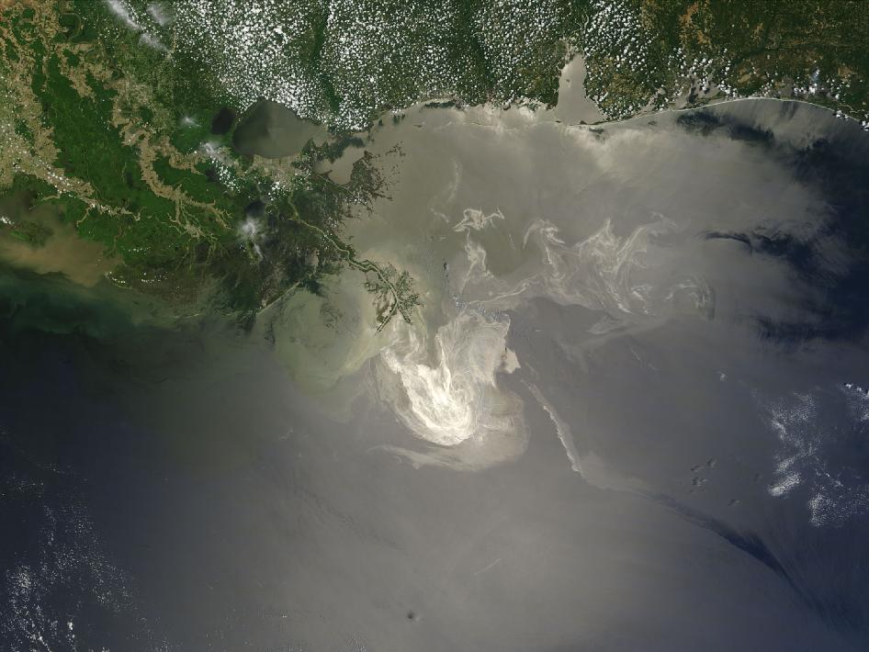

Fig. 2: NASA's Terra Satellites Sees Spill in May.

Humans have made an enormous step towards understanding the world and its many wonders. The last few years have been significant in terms of human discovery; from finding the fundamental particles that glue together the structure of the universe, to the Higgs Boson, a black hole that is 17 billion times the mass of the sun, and the invention of electric cars that can go faster than 120 miles an hour. We’ve developed mobile phones that have more power than NASA in 1969 when sending a man to walk across the surface of the moon. Are all these mass revolutions in technology and power just making the natural world worse and are they really worth it at the expense of our planet? (Anthropocene: the age of human impact on Earth | Sustainability, 2017).
From instantaneous conversations, knowledge at our fingertips and the ability to store the power of the earth and sun, has given us endless possibilities yet we are still choosing to destroy the environment for our own purposes that’ll lead to our ultimate extinction (Anthropocene: the age of human impact on Earth | Sustainability, 2017).
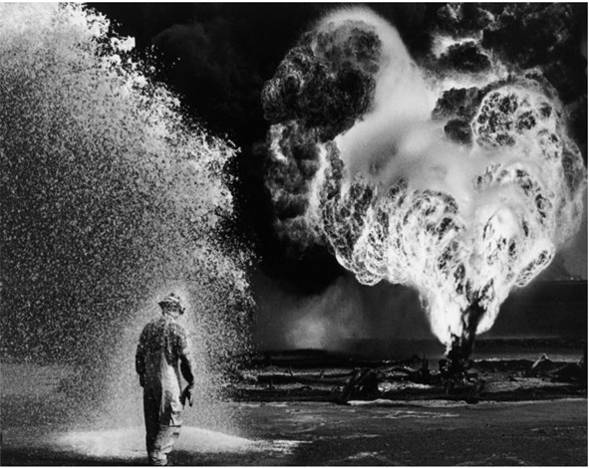
Fig. 3: Desert Hell
There are a number key factors that should be considered as major contributors to the environmental damage we are causing upon the planet such as deforestation, CO2 emissions, the meat industry and fast fashion industry.
The meat industry is a huge contributor to the worlds environmental crises. Trees, hedgerows and forests are destroyed to make waste land for crops, grazing, or factory farm sheds on a monumental scale effecting the natural land balance causing water loss, soil erosion and loss of wildlife habitats. Loss of natural land to agriculture and farming is the biggest cause of mass extinction of wildlife today.
The meat industry is directly responsible for 85% of all soil erosion in the U.S. More than 90% of all Amazon rainforest cleared since 1970 and 260 million acres of U.S forests to produce grazing and feed for animals that are being raised for food (PETA, 2019).

According to the world watch institute land used to feed and raise animals for food makes up 87% of land in the US. With 80 percent of corn and 90 percent of oats grown to feed cows alone, they inhale the same number of calories as 8.7 billion people, more than the whole human population combined. (PETA, 2019).
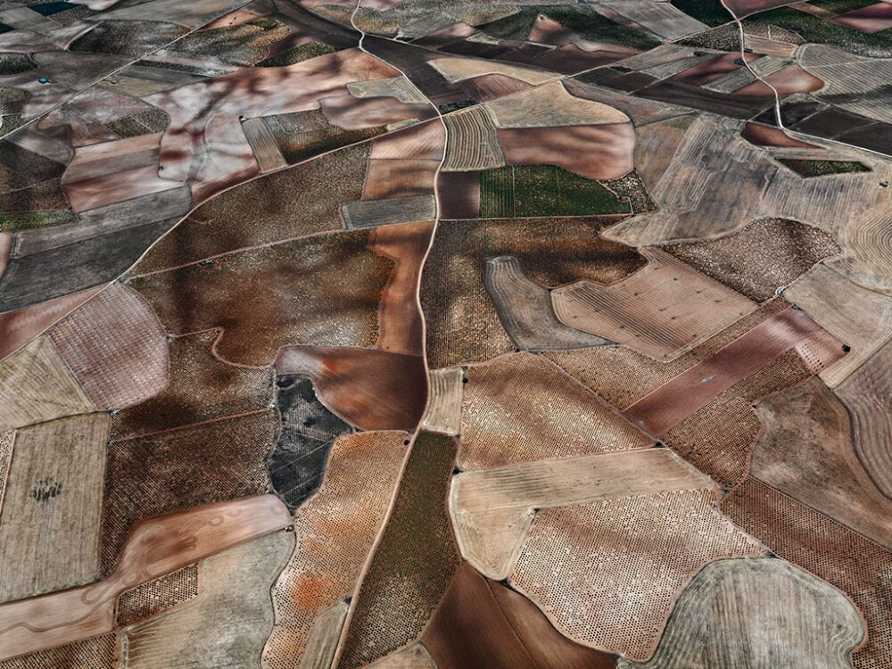
Fig. 4: Dryland Farming
A single cow will consume 16lbs of vegetables just to make 1lbs of meat; one hamburger uses the same amount of fossil fuel than it does to drive 20 miles in a small car. For every single non-renewable energy source used in America alone, more than 33% are committed to raising animals for human consumption. (PETA, 2019).
Recent findings have shown that converting to a vegan diet, could cut global farming use back by more than 75%, an area the size China, European Union, Australia and the US combined and still feed the world (Carrington, 2019)
.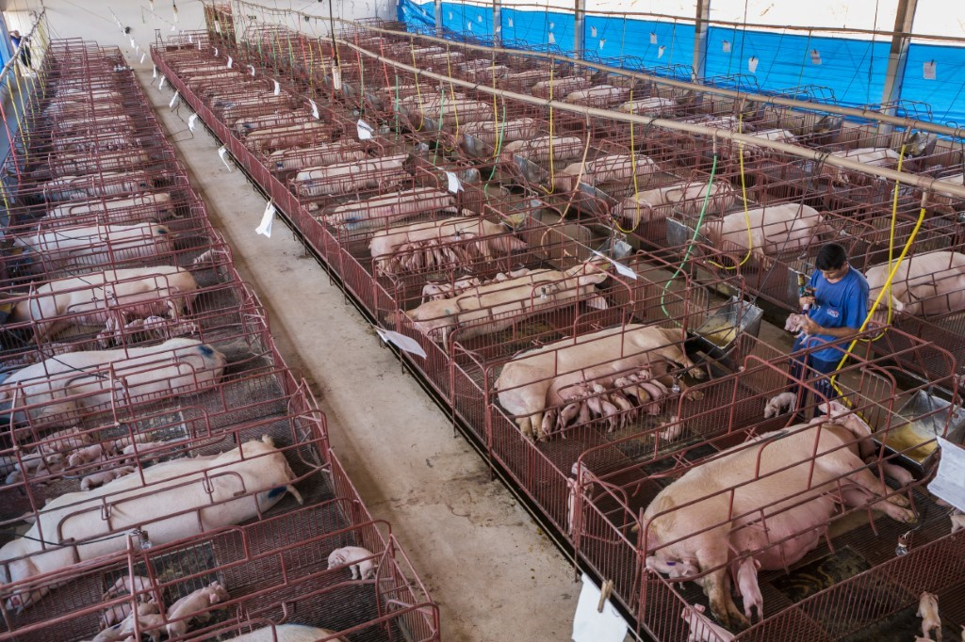
Fig.5: Inoculation new-born pigs in confined breeding cages where they will spend most of their adult lives
Raising animals for meat is the biggest source of water pollution according to the environmental protection agency. A pig farm generates the same amount of raw waste equivalent to a city of 12,000 people. Animal waste that is not properly disposed of can pollute rivers and streams, having a destructive effect on multiple aspects of our environment making meat-eating one of the biggest environmental hazards effecting the Earth in the 21 century.
Agriculture is responsible for more greenhouse emissions than all transportation globally combined. Along with pollution agriculture uses half of all the water in the US alone.
One cow can drink 50 gallons of water a day and more than 100 gallons in hot weather, just to produced 1 gallon of milk a cow has to drink 683 gallons of water, According to PETA statistics just to produce 1 pound of meat a cow must drink over 2,400 gallons (PETA,2019).
Leading onto the consumer class, according to latest statistics more than 1.7 billion people belong to the consumer class lifestyle.
The class of persons able to buy goods and services other than those that satisfy their basic needs. For example, members of the consumer class may buy cellular phones and multiple automobiles. The consumer class may broadly correspond to the middle class, but if a country is sufficiently wealthy, even its lower classes may belong to the consumer class in some way (consumer class,2019).

Western Europeans and Americans are currently the worst for over consumption, but other countries are catching up. These 1.7 billion people in the Western world currently would fall under the consumer class, lifestyle of disposable fashion, and the turnover of new cars before required, and other numerous unnecessary things that aren’t life essentials. An increasing percentage of the world's consumers live in developing countries, with 240 million individuals in China and 120 million in India, these countries are showing the biggest increase in their consumption rates (Mayell, 2004).
One of the fundamental issues is plastic waste and the abuse of single use plastics. Plastic's versatility has made plastic production double every decade. Approximately 9.2 billion tons of plastic have been made since 1950, a size compared to the pyramids of Gaza times 1600. Single use plastics, for example, straws, plastic carrier bags, and plastic packaging makes up 40% of plastic waste and can't be reused, it ends up jeopardizing natural habitats, contaminating communities, and imperilling wildlife (National Geographic, 2019).
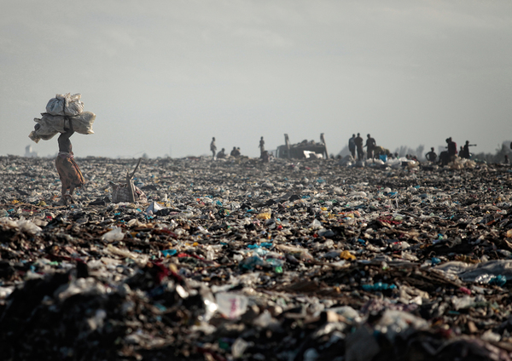
Fig. 6: Trash Land
So, where does this plastic come from? Originally plastic was made 3,500 years ago, Olmecs of Mexico used natural plastics to make latex balls used in games made from natural gumtree sap. Then in the mid-19th century Alexander Parkes invented celluloid used to create film for analogy photography, this was then followed on in the 20th century when Leo Baekeland invented Bakelite (Mayell, 2004).
The plastic problem not only lies in what happens to the plastic after its made, the problem also lies in the process of actually making the plastics. The making of plastic is highly toxic and damaging for the environment. The first part of the process is the extraction of crude oil and natural gas from the ground which is highly damaging to soil and growth. It is then sent to refineries to be converted into several products including the prime materials of plastic, ethane and propane.
These then go onto a ‘cracker plant’ that release toxic chemicals into the atmosphere to be broken down further into smaller molecules, turning the ethane and propane into ethylene and propylene, mixed into these ingredients is a catalyst to creating a resin that can then be easily moulded to create consumer plastic products. Making plastic the easiest and cheapest material to use for quick mass-produced products to live up to the greed of a lazy civilisation that’s wants everything instantaneously (Plasticseurope.org, 2019).
From looking at mass plastic production this leads onto the issues of fast disposable fashion. Fast fashion is one of the biggest contributors to environmental destruction. According to the 2019 EU report fashion companies in the year 2000 produced two collections a year but this since 2011 has grown to 5 with shops like Zara abusing the industry offering 24 per annum. The textiles industry is responsible for 1,715 million CO2 emissions. The EU states that fashion contributes more than shipping and aviation travel combined (Tucker, 2019).
Material waste is a huge problematic result of the fashion industry, as more individuals purchase garments as a statement rather than as a fundamental human need.
In today's society its cheaper to purchase new garments than to get the old ones repaired and busy lifestyles make people more time poor, with the loss of sewing and needling skills through generations means there is less motivation to repair our garments making it easier to just go out and buy another one (Tucker, 2019).
Polyester is one of the main materials used in the manufacturing of clothing, polyester is washed in industrial washing machines causing it to shed microfibres in the process, this then added to the plastic pollution in the ocean. One load wash of polyester fabric releases up to 700,000 micro plastic fibres polluting rivers, streams and oceans. This is a huge contributor to micro plastic pollution. Due to the minute size of the plastics particles, they easily make their way through sewage systems into the ocean.
This waste is released through sewage pipes, eaten by small plankton and makes it way up the food chain to then be consumed by humans. According to waste and resources programme (WRAP), UK householders send 30,000 tonnes of clothing back into the environment through landfills in 2016.
The average amount of water used for a kilo of cotton is 10,000–20,000 litres, even though India is in extreme drought due to manmade waste and the running of their government is not sustainably managing their resources.
With 18 percent of the world's population living in India and only 4 percent able to access to clean water, yet India is still the main contributor of cotton to the UK. This shows the lack of respect humanity has for one another yet alone the environmental world, we are literally killing ourselves just the live up to the needs of consumer class countries (Tucker, 2019).
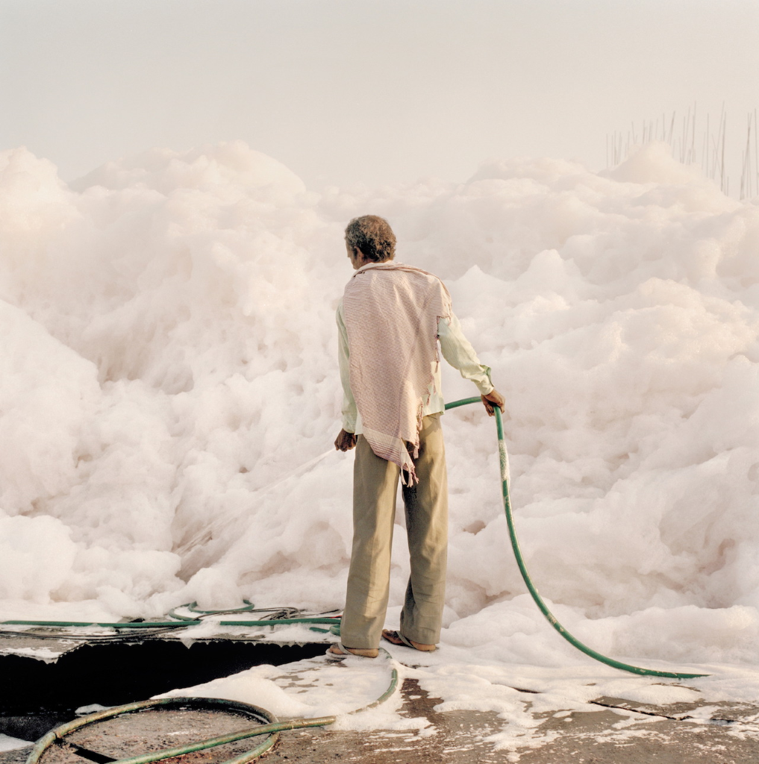
Fig. 7: A worker with a water hose tries to tame an iceberg of foam created by the chemical waste dumped by the factories along the Yamuna river.

As we regrettably enter the age of the Anthropocene, our survival as humans is arguably at breaking point, forcing us to percieve the world through a different lens in order for us to gain the much-needed respect for it. Therefore, we have no choice but to conceive of new ways of imagining the Earth. The only solution for reversing our catastrophic imprint on earth is to guide society into a creative ascent. The main resource to decarbonising the economy is relying on natural and non-carbonising energy sources such as water, wind and the sun if we make the most of these non-damaging natural resources, we will move earth into a comfortable ascent to a more simple, sustainable life (Garrard, Handwerk and Wilke, 2014).
Phenomenological effects from Nature
Our interpretation and awareness of the living natural world helps us to create meaning of the world. Every varied experience and emotion we go through while connected to nature is as unique as we are to one another, nature is constantly ever changing and is never the same.
The level of our sensibility along with our perception and awareness of our consciousness affects the way in which we feel, understand and appreciate the world around us. The more perceptive and receptive we are the more enhanced the experience we have. Albert Schweitzer (1875-1965) was a philosopher who coined the term ‘reverence for life' which encapsulates this idea.
Only by means of reverence for life can we establish a spiritual and humane relationship with both people and all living creatures within our reach. Only in this fashion can we avoid harming others, and, within the limits of our capacity, go to their aid whenever they need us (Schweitzer.1965).

Schweitzer idea proposes an ethical approach – that we should have the same respect for other forms of life as we have for our own. Only by having a good relationship with other living beings we can live harmoniously and sustainably. Rather than thinking purely about ourselves, man should think of other live forms to live an ethically correct life (Schweitzer, 1965).
If we learn to become more introspective of how we experience and interact with the natural world our view and respect for it will change. We will become more aware of the impact of nature on us as conscious beings instead of separating humanity and nature as two separate entities.

This concept is often looked at by artists and communicated through art. Andy Goldsworthy summarises this:
We often forget that we are nature. Nature is not something separate from us. So, when we say that we have lost our connection to nature, we’ve lost our connection to ourselves (Sacred Ecology, 2019).

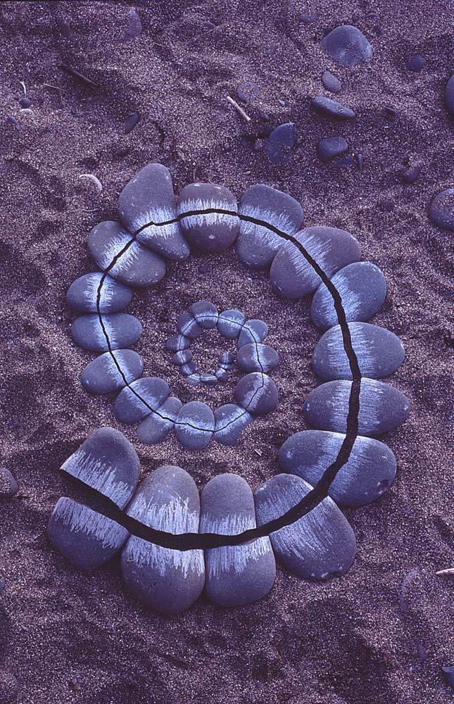
Fig. 8: Carefully broken pebbles scratched white with another stone St. Abbs, Scotland
Western society has slowly overtime dissolved their connection with the natural environment; a connection that is critical in today's deplorable state. Through a varied and complex story of the stages leading up to our current environmental crises, the widespread separation of humans from nature is a topic of interest amongst many key thinkers of past and present including author Timothy Morton, he reminds us that seeing the natural world as disconnected from humans is not only morally problematic but analytically incorrect and has no beneficial gain for humans or the environment (Sacred Ecology, 2019).
Art could help us challenge this contemporary perception and relationship to the modification of our approach to the climate crisis. Scientific discoveries are of course the key to our understanding of the fundamental facts on the effects of the Anthropocene, but they lack the emotional impact of an art piece. Art engages with all the senses merging your mind, body, and soul. For example an exhibition at the Natural History Museum on the industrial revolution, may be interesting and informative, but it lacks the climatic phenomenological shock you get whilst immersed in, for example, Olafur Eliasson’s “the weather project” at the turbine Hall at the Tate Modern (Fig 16) or an Edward Burtynsky exhibition on the “Anthropocene”, (Fig 9).
Nietzsche writes; “Only Artists have given men eyes, and ears to see and hear with some pleasure what each himself is, himself experiences, himself wants;’ (Parry2011).
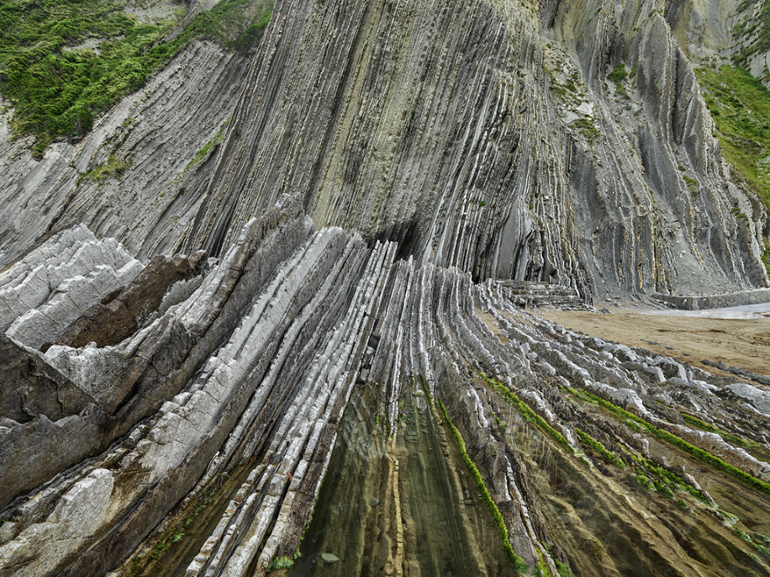
Fig 9: Basque Coast #1UNESCO Geopark, Zumaia,
A human's phenomenological response to nature is vital to attain an understanding of it. Humans must see the value of nature on their inner selves in order to ensure the future of both mankind and the natural environment is to thrive successfully and in harmony with one another. The way in which the self as a body perceives the world through the senses and the conscious understanding of this bodily relationship with its surroundings is imperative for the survival of our natural planet.
The consciousness of the self is constructed from impressions that are made upon it. For example, a person who has grown up in the countryside would have more of a connection, understanding and respect for nature than a person who has grown up in a concrete city who would be more detached and insentient towards nature. The person that has grown with natural surroundings can feel the impact and the importance it has on them in their daily life, it becomes another extension, juxtaposed to the person in the city who doesn’t feel the importance of nature because it has been absent from their day to day lives, they have not the experience to reflect upon, leaving them unable to connected to it and feel the ‘reverence for life.’
This insight may lead to the question, does this influence artists when assessing the emotions they intend to evoke from the viewer before making the work; and does that affect their process, is the outcome different than what they initially wanted because it wouldn't have created the same feelings?
Looking at the world is not like seeing a picture, but to create a depiction of the world demands that you be able to see it in the first place. Good art must come from a fire within, the world must spark something in the artists eyes that travels and pushes the mind into a creative ascent. An artist's experience of the world moves the mind and, in the process, moulds the viewpoint of what we see. The optical experience of just looking at nature is just one way in which man interacts with the natural world.
The cosmic togetherness that man and object experience from belonging to the same cosmic universe is a fundamental factor in the connection of nature and man. Finally, the attachment through intimate physical contact, we as humans have, for example the touch of sand between your toes or the flow of a fast pace waterfall splashing upon your face. These intimate moments are what connects us together, as one (Parry, 2011).
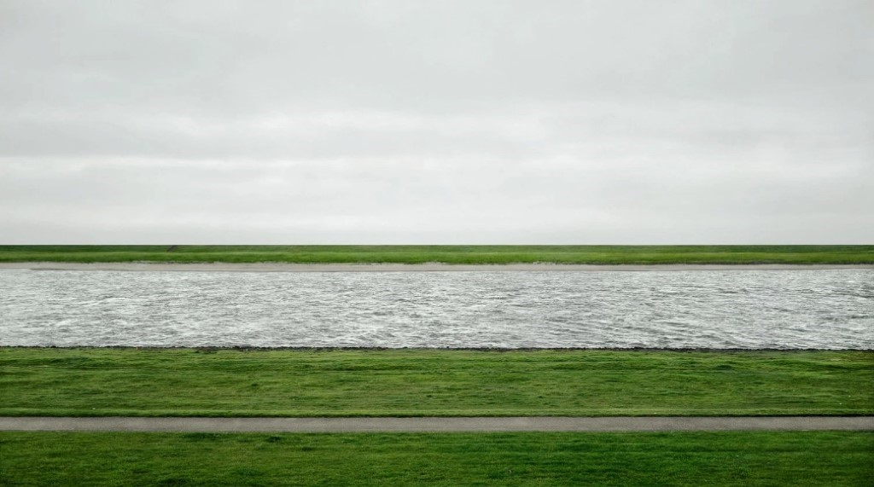
Fig 10: Rhine II 1999
Gurski's almost painting esque, romantic landscape depicts an atmospheric, hyper-real scenario that in turn teaches us to see and read the world around us while highlighting man's connection with nature.

Nature and the Sublime
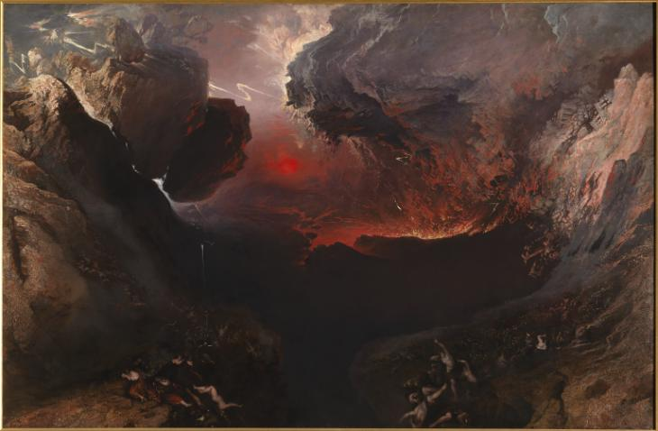
Fig 11: The Great Day of His Wrath
The concept of the sublime was developed by 18th century theorist Edmund Burke. Burke describes the sublime in a poetic fashion as “Some things that move us are beautiful and some things that move us are sublime, but the sublime moves us more profoundly than the beautiful” (Burke, 2009). This quote defines that nature is far more than pretty scenery it is something that sparks an embedded fire in our souls, gives us meaning to life, awakens the senses, and ignites feelings we didn’t know we could feel.
Edmund Burke in his essay the sublime and beautiful defines the sublime as feelings of “amazement, fear, admiration, respect and reverence” (Burke, 2009). He continues to say that,
Passions are painful or delicious, bearable or pleasurable. The feelings are triggered by exposure to something greater than oneself such as nature and the divine force. Sublime in its connection to terror touching upon themes of the void, darkness solitude, silence, vastness, unimaginable smallness of self, Majestics of the unknown, the notion of infinite and delightful horror. (Burke, 2009).

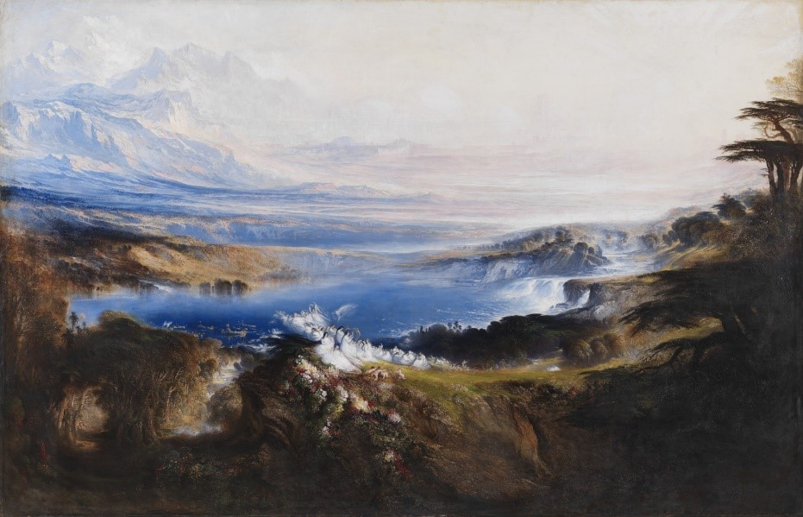
Fig 12: The Plains of Heaven
The core meaning of the sublime could perhaps be defined as an experience, rather than a strict philosophical definition. Witnessing natural phenomena such as weather of great power can cause intense emotional responses, characterised by feelings of being overwhelmed and somewhat anxious (Bethelmy and Corraliza, 2019).
To truly bring ourselves into harmony with the natural world, we must return to seeing humanity as part of it. In both the statistical and the auto-poetic fashion necessitated by modern climate science. Currently, we still have a long way to go (Garrard, 2014)

We need these emotional experiences with nature to bring humanity back down to earth, to put into perspective how infinite and powerful the universe is, and to show humanity how insignificant we are in terms of scale and power, and to evoke emotional reactions that scare and enlighten.
The sublime has a captivating aesthetic due to the way in which it expands and enriches our interactions through tense yet profound relationships with the natural world.
As said by scholar Van Elk, “sublime is experienced as boundlessness that can eventually overwhelm or even destroy the observer” (Van Elk, 2016).

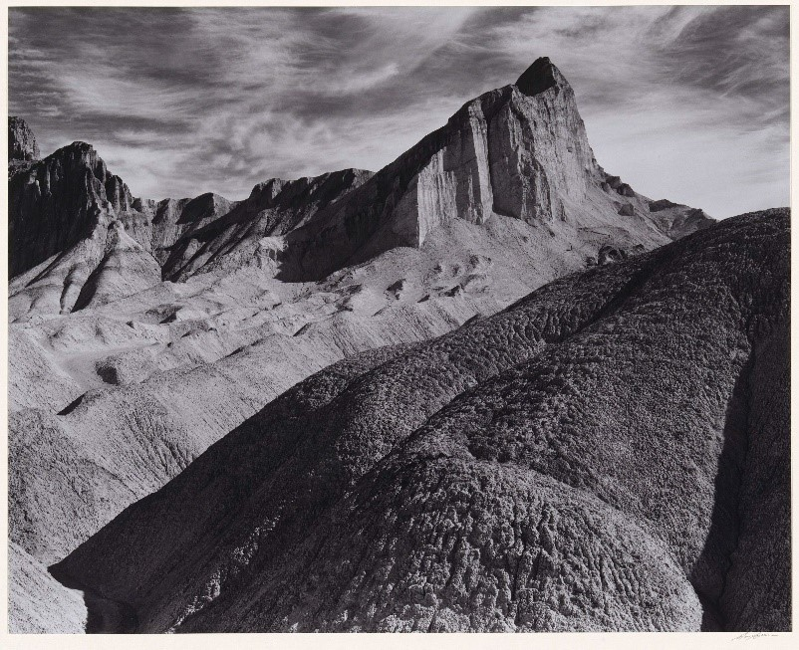
Fig 13: Manly Beacon, Death Valley National Monument, California.

There is much more to our aesthetic engagement with the environment than “beauty,” and the sublime creates new perspectives on the world. It gives a newfound respect for nature, for the scale, greatness and unpredictable size of deserts, lakes, oceans, storms, the vast night sky and huge mountains, the sublime describes a morally correct relationship with all of these, one in which is challenging and exciting.
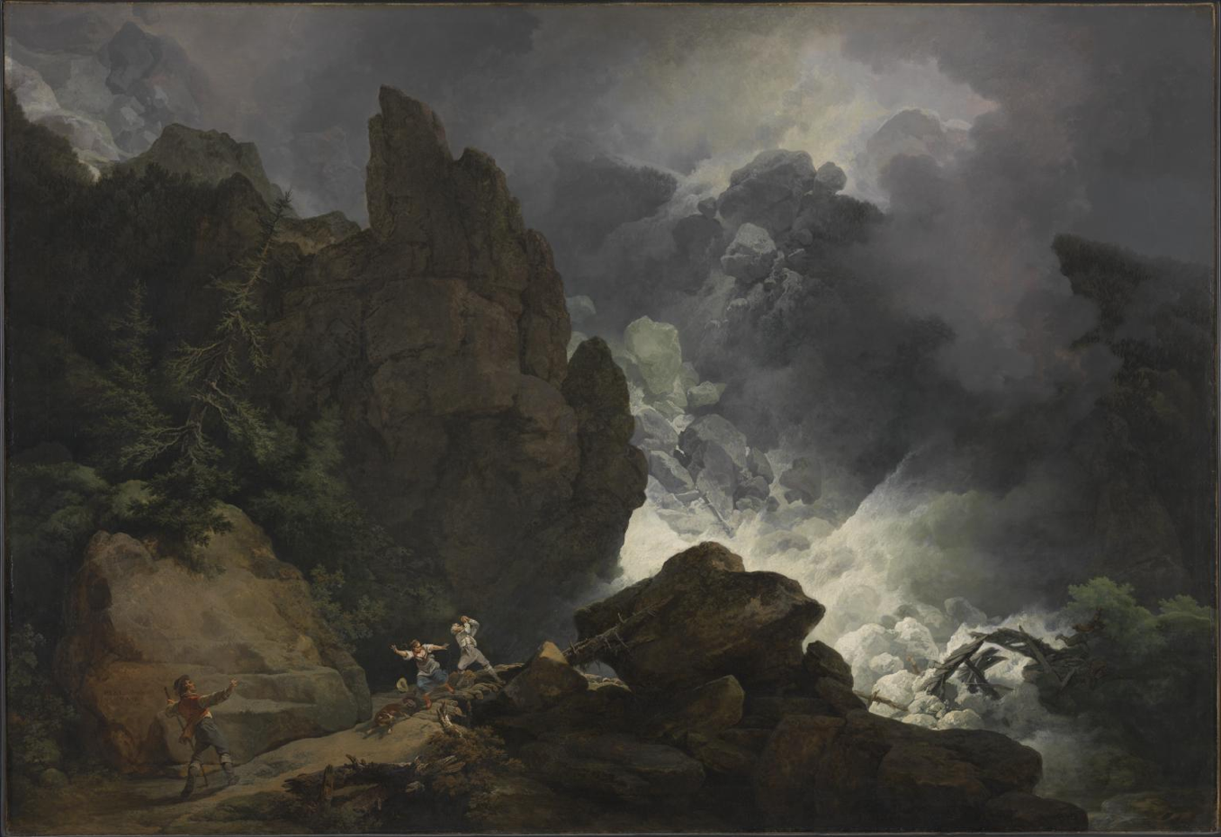
Fig 14: An Avalanche in the Alps

Nature is much more than a flower, sunset or a walk in the park it can conquer and destroy humanity and the sublime opens people's eyes to that. “the awesome power of wild nature and its indifference to human concerns” (Johnson B. 2002).
Art is suggested to be the only subject able to express the sublime other than nature itself through its use of size, scale, form, disorder, wildness and its physical vulnerability. The metaphysical effects of art enable humans to feel the importance of the wild and its effects on the psyche (Bethelmy and Corraliza, 2019). Philosopher Fredrich Nietzche states: “all art exercises the power of suggestion over the muscles and senses, all art works topically, increases strength and inflames desire” (Parry, 2011).
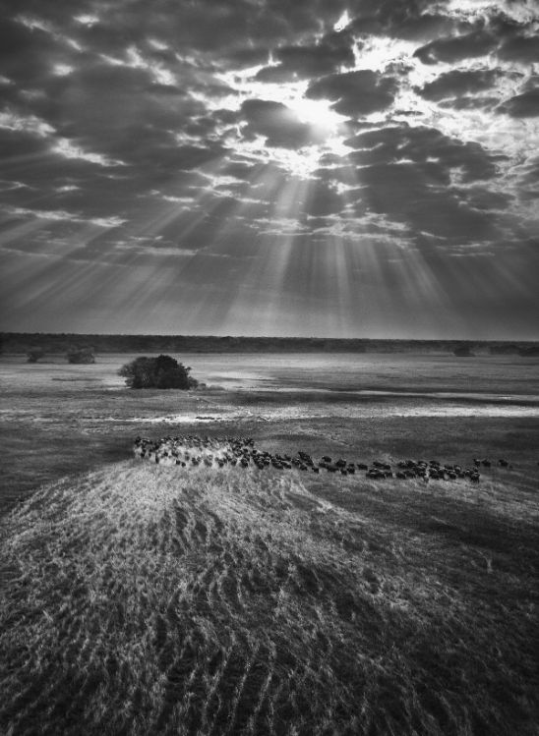
Fig 15: Herd of Buffalos, Kafue National Park, Zambia
These mystical experiences can be depicted through all art mediums for example Walt Whitman portrays his view of the sublime through his poem “Song of Myself” where the poet talks about sublime suffocation, where he is suffocated and swallowed by the overly diverse things outside the self and they are taken into his body. As the poet states “all this I swallow, it tasted good, I like it”. Whitman's poem focuses on events, situation and natural phenomenon's and how they manifest themselves in the physical world, then manifests itself inside us and sparks a celestial reaction.
Nature is one of the main emotional triggers of transcendent emotions. The wild is a primal source for humans to experience spirituality in its highest essence it is one’s individual phenomenological inner experience that gives meaning to life and allows us to travel beyond the confinements of society (Bethelmy and Corraliza, 2019).
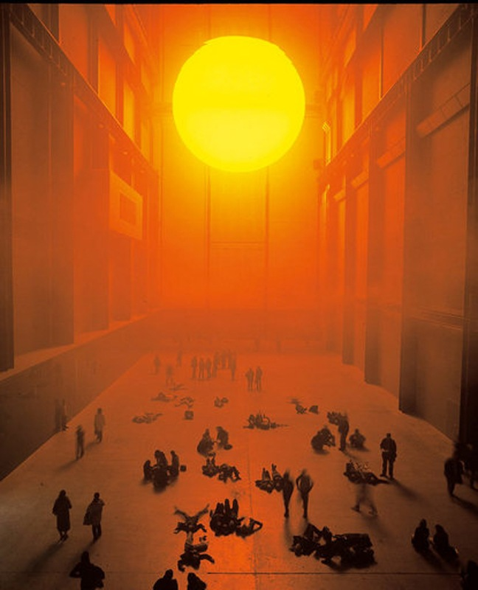
Fig 16: The weather project
The sublime is as relevant today as it was in the 18th century, artists from multiple mediums still use Burke’s concepts of awe and the unexplained in their work.
The 18th century sublime was often depicted in paintings with religious meaning and iconography. The paintings depicted Gods creation of nature as the source of wonder and awe, but in contemporary science-based society, the religious metaphysical is no longer, or certainly vastly diminished and therefore we now revere nature in a different way, not as God but in its own right.
Art is often used to represent something that is out of our control it represents the unrepresentable, The experience of transcendence, terror, the uncanny, and an altered state of consciousness.
From Heidegger’s essay The Origin of the Work of Art he wrote “Art at the highest possibility of its essence is a revealing that establishes and brings forth possibilities that of existence that could not be understood or established in any other way”.
Photography has a deep connection with the sublime. Each image taken of a natural phenomenon would have a man behind the Camera, the observer can see the scale of nature within the image in comparison to how small the man would of been behind the lens this highlights how insignificant man is in relation to the limitless non constraints of nature. All one can do is stand there and try and capture the overwhelming essence of what one is feeling. “We cannot take a photograph of our imagination, and our imaginations cannot conjure the sublime” (Mcgarrel, 2014).
The intimacy of the photographer and their subject is another reason why photography might best describe the sublime in modern culture. Photography has the power to act as a standalone tool between man's emotions and the power of nature. The Camera can capture the sublimes impact as it happens in the moment. Unlike a painting that takes time to depict, no part of this subliminal experience is lost through the creation of the artwork itself, the moment alone is its creation.
Photography is the vessel to further explore the concept of the sublime in modern society (Mcgarrel, 2014).

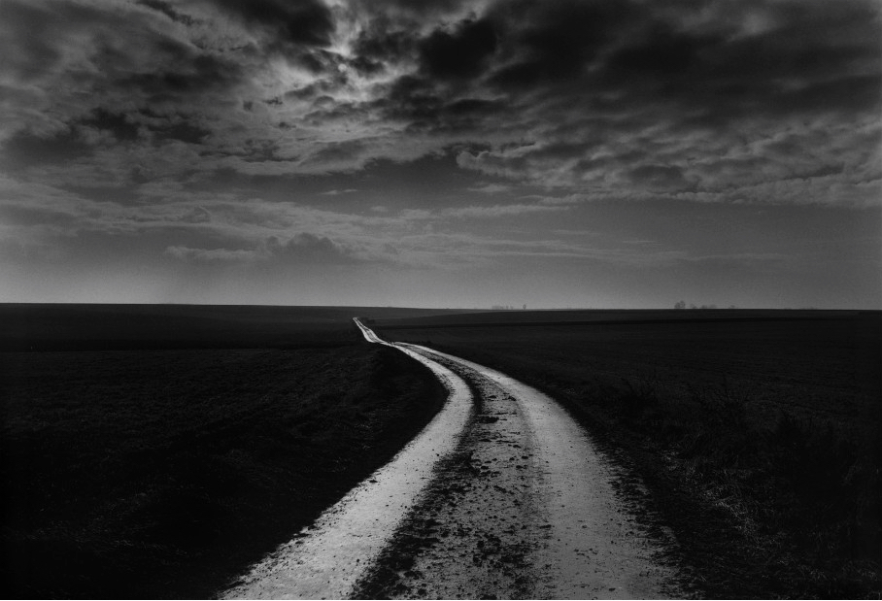
Fig 17: The Somme

Conclusion
As outlined in Chapter One the evidence is clear that man is affecting the planet at an unprecedented rate leading us into our current environmental epoch the Anthropocene. For example; the issue of overpopulation on earth and greed for non-essential items has brought earth into an environmental crisis using more resources than the earth can sustain. Some of the issues highlighted include increasing population (during the 20th Century the human population of the world has increased from 1.65 billion to 7 billion, an estimated 82 million people per year). Other major issues discussed and backed up with statistics include deforestation and the effect of the meat and fashion industries on our planet. The age of the Anthropocene has forced the environment to adapt to humans needs rather than allowing it to adapt to its own. However, the intrinsic link between man and nature cannot be ignored as we are essentially a part of nature which was further explored in Chapter 2 when the concept of Phenomenology was discussed.

Phenomenology looks at how human’s interpretation and awareness of the natural world effects the interaction we have with it. The importance of having the same respect of our natural world as we have for other human beings is potentially fundamental and critical to the survival of our planet. Schweitzer’s theory Reverence for Life was touched upon to introduce this related idea, and its importance in connecting humans emotional response to nature. Timothy Morton talks of this idea that seeing the natural world as anything but connected to humans, is morally wrong and creates no benefits for humans or the environment. In the body of text, Art works by Edward Burtynsky, Andy Goldsworthy, and Andreas Gurski were looked at as these are some artists who have attempted to capture this feeling through their work. This demonstrates that Art helps to enlighten the phenomenological feelings you get from being within nature and can fulfil the viewer by bringing it into the gallery space.

The last chapter studies Edmund Burke’s theories of the Sublime and touching upon themes of nature being something far more powerful than we can comprehend. The sublime is an emotional response embedded deep within the pit of your stomach, it gives reason to life, feeds the senses and awakens the soul. The text discusses how witnessing a subliminal force in nature, invokes strong overwhelming emotions of awe and terror. The sublime is critical in putting humans back into perspective of how unimportant we are in comparison to the infinite universe. So how dare we be so arrogant as to think the world revolves around us when in terms of size and power, we are nothing compared to the vastness of nature?

Art can play a key role in expressing and documenting this human experience and its fundamental desire on us as human beings to attempt to depict the inner body experience that we feel when we are at one with nature and its many forms. This is particularly seen with artists and photographers who try to capture the sense of awe and terror. These depictions help close the gap between us and the natural world and give us a sense of our place within it. Looking at Philip James De Loutherbourg’s painting ‘An Avalanche in The Alps 1803’ (Fig 14), where he illustrates the moment before three human figures and a dog are overwhelmed by a subliminal natural force. This is one example of how art has captured this universal feeling. More recently Olafur Elliason’s piece The Weather Project (Fig. 16), looks at ideas of the weather simulating a sun and mist creating a heated environment for the audience to engage with. He attempts to capture an experience of the sublime but in a far more physical and interactive way, in contrast to a depiction like a painting, the work allows you to be immersed and experience the sense of scale and force of nature by using colour, representation and the elements.

Engaging with these natural phenomenon's is a way that can connect us back to nature as one physical entity. Perhaps then will we gain enough respect to change our ways and avert the natural crisis we are heading towards. To truly bring ourselves into harmony with the natural world we must return to seeing humanity as part of it, only by doing this can we truly realise the importance of nature on us mentally and spiritually.

Personal Conclusion
The subjects discussed in this essay are extremely important to me and my practice. My love for nature, and the connection I feel when wandering the outdoors are essential to me and my wellbeing. I feel very strongly that people need to be made aware of this connection in order to save the world from its current environmental crisis.
As much as my belief of expressing phenomenology through art is true, it is also my concern; despite its intentions these pieces of art have a limited audience and limited effect on the feelings they invoke. Someone who hasn’t already felt that connection to nature would have a different emotional response to someone who has through other means. One response would be more personal and the other would be more informative but both responses are equally significant to the viewer.
In my opinion, the idea that we are in the age of the Anthropocene and that we are having more power over nature could be debated, as ultimately even if we destroy the planet, nature will continue.

To me, art is one of the most important forms when expressing the sublime, especially photography and installation art. Although I do argue that there is no point preaching to the already converted, the demographic of the art gallery are people that may already be familiar with these concepts, although they all may not understand the terminology but may have felt the physical emotions. Maybe we need to take the work outside of the gallery and into the streets, to make it more interactive with the everyday public. Artwork has a very positive response in heightening people's awareness on big world issues, as it pauses an overwhelming topic allowing you to focus. Everybody has their own personal understanding on art, but it is needed to bring awareness to a topic that the viewer may not have realised is suffering in the first place.

These topics are often incorporated in my own art practice, where I create miniature steppingstone worlds to act as a middle ground between the viewer and the vast environmental problem that is almost too big for humans to comprehend. I do this by highlighting the Anthropocene through scenes of awe and terror i.e. I take the problem and bring it into the gallery space to compact the issues in a more understanding way through art. My work acts as a stark reminder that we are not more powerful than nature, and in fact nature when thought about from an energetic God-like perspective is far more powerful than we can comprehend. Unless we accept this and reunite our respect and relationship with nature, instead of abusing our role on this planet nature will in the end will destroy us.

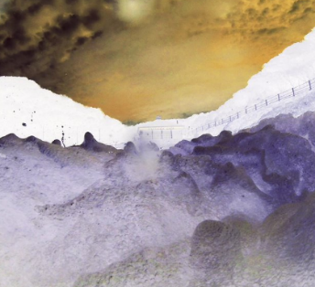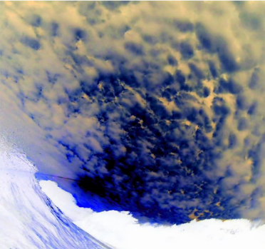
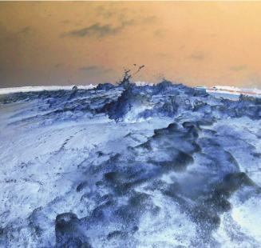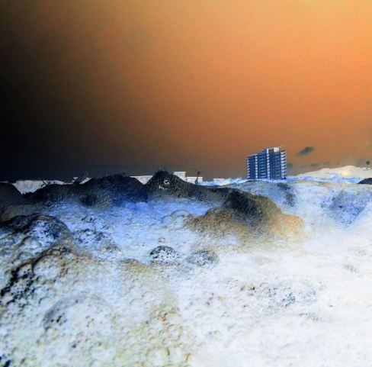
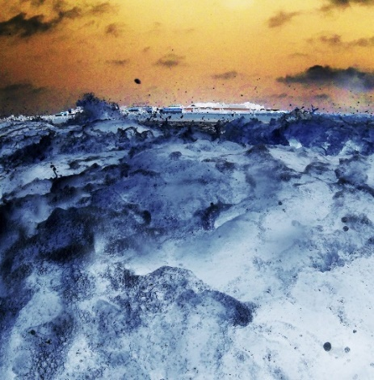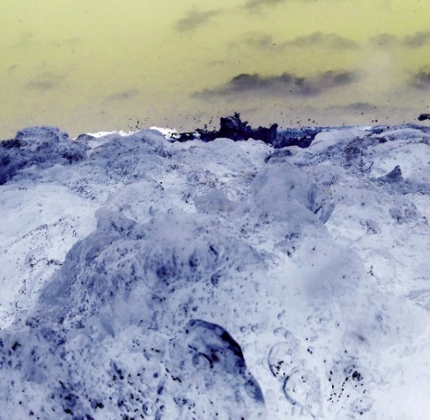
Fig. 18: The Anthropocene (2018) Artists own work

Bibliography

Books
Attenborough, D. (2003). The Life of Mammals, London; BBC Books
Burke, E. (2009). A Philosophical Enquiry into the Sublime and Beautiful. Florence: Taylor and Francis.
Parry, J.D., (2011). Art and phenomenology, London: Routledge.
Schweitzer, A (1965). Reverence for Life; The Ethics of Albert Schweitzer for the Twenty– First century, New York, Philosophical Library.

Schweitzer, A. (2017) Albert Schweitzer Reverence for Life the Adventure of Being True to Yourself. Lulu Self-Publishing

Journals
Bernstein, J. (2014). Disciplinarity and Transdisciplinarity in the Study of Knowledge. Informing Science: The International Journal of an Emerging Transdiscipline, 17, pp.241-273. (Bernstein, 2014)
Bethelmy, L. and Corraliza, J. (2019). Transcendence and Sublime Experience in Nature: Awe and Inspiring Energy. Frontiers in Psychology, 10.
Crutzen, P. (n.d.). The “Anthropocene”. Earth System Science in the Anthropocene, [online] pp.13-18. Available at: https://link.springer.com/chapter/10.1007/3-540-26590-2_3 [Accessed 27 Nov. 2019]. (Crutzen, n.d.)
Garrard, G., Handwerk, G. and Wilke, S. (2014). Introduction: “Imagining Anew: Challenges of Representing the Anthropocene”. Environmental Humanities, [online] 5(1), pp.149-153. Available at: https://read.dukeupress.edu/environmental-humanities/article/5/1/149-153/8122. [Accessed 20 Nov. 2019] (Garrard, Handwerk and Wilke, 2014)
Knebusch, J. (2008). Art and climate (change) perception: Outline of a phenomenology of climate. [online] Olats.org. Available at: http://www.olats.org/fcm/artclimat/phenomenologyclimate.pdf [Accessed 27 Nov. 2019]. (Knebusch, 2008)
Mcgarrel, C. (2014). Kant on the Sublime// Photography. [online] PHL250 Aesthetics Journal. Available at: https://phlaestheticsjournal.wordpress.com/2014/11/13/kant-on-the-sublime-photography/ [Accessed 12 Dec. 2019].
Ruddiman, W. (2013). The Anthropocene. Annual Review of Earth and Planetary Sciences, [online] 41(1), pp.45-68. Available at: https://www.annualreviews.org/doi/abs/10.1146/annurev-earth-050212-123944 [Accessed 17 Nov. 2019]. (Ruddiman, 2013)
Van Elk, M , Karinen, A, Specker, E, Stamkou, E, Baas, M (2016) Standing in Awe: The Effects of Awe on Body Perception and the Relation with Absorption Collabra 2(1),p4 (Van Elk, 2016)

Websites
Anon, (2019). [online] Available at: https://www.nationalgeographic.com/environment/2004/01/consumerism-earth-suffers/ [Accessed 27 Nov. 2019]. (Anon, 2019)
Brady, E. and Jafarzadehdarzi, V. (2014). ON THE SUBLIME IN MODERN PHILOSOPHY. [online] Society & Space. Available at: https://societyandspace.org/2014/04/09/on-7/ [Accessed 8 Nov. 2019]. (Brady and Jafarzadehdarzi, 2014)
Climate Change: Vital Signs of the Planet. (2019). The Causes of Climate Change. [online] Available at: https://climate.nasa.gov/causes/ [Accessed 11 Nov. 2019]. (Climate Change: Vital Signs of the Planet, 2019)
Flanagan, R. (2019). George Marazakis Photographs The Anthropocene - IGNANT. [online] IGNANT. Available at: https://www.ignant.com/2018/07/24/george-marazakis-photographs-the-anthropocene/ [Accessed 11 Dec. 2019].
Folsom, E. and Merrill, C. (2013). Section 45, Song of Myself | IWP WhitmanWeb. [online] Iwp.uiowa.edu. Available at: https://iwp.uiowa.edu/whitmanweb/en/writings/song-of-myself/section-45 [Accessed 27 Nov. 2019]. (Folsom and Merrill, 2013)
Georgia Veterinary Associates. (2019). Earth Day 2019: Protect Our Species. [online] Available at: https://www.mygavet.com/services/blog/earth-day-2019-protect-our-species [Accessed 5 Dec. 2019].
Ipcc.ch. (2019). Global Warming of 1.5 ºC —. [online] Available at: https://www.ipcc.ch/sr15/ [Accessed 22 Nov. 2019]. (Ipcc.ch, 2019)
Kranke, I. (2019). Ivana Franke › Retreat into Darkness. Towards a Phenomenology of the Unknown. [online] Ivana Franke. Available at: https://www.ivanafranke.net/work/retreat-into-darkness-towards-a-phenomenology-of-the-unknown [Accessed 27 Nov. 2019]. (Kranke, 2019)
MAYELL, H. (2004). As Consumerism Spreads, Earth Suffers, Study Says. [online] National Geographic. Available at: https://www.nationalgeographic.com/environment/2004/01/consumerism-earth-suffers/ [Accessed 6 Nov. 2019]. (Mayell, 2004)
National Geographic. (2019). We Made Plastic. We Depend on It. Now We’re Drowning in It [online] Available at: https://www.nationalgeographic.co.uk/2018/05/we-made-plastic-we-depend-it-now-were-drowning-it [Accessed 2 Dec. 2019].
Natural resources.wales. (2019). Natural Resources Wales / Analytical services. [online] Available at: https://naturalresources.wales/evidence-and-data/analytical-services/?lang=en [Accessed 26 Nov. 2019]. (Naturalresources.wales, 2019)
Perry, P. (2018). The environmental costs of fast fashion. [online] The Independent. Available at: https://www.independent.co.uk/life-style/fashion/environment-costs-fast-fashion-pollution-waste-sustainability-a8139386.html [Accessed 7 Nov. 2019]. (Perry, 2018)
PETA. (2019). How does eating meat harm the environment? | PETA. [online] Available at: https://www.peta.org/about-peta/faq/how-does-eating-meat-harm-the-environment/ [Accessed 25 Nov. 2019]. (PETA, 2019)
Plasticseurope.org. (2019). How plastics are made: PlasticsEurope. [online] Available at: https://www.plasticseurope.org/en/about-plastics/what-are-plastics/how-plastics-are-made [Accessed 8 Dec. 2019].
Sacred Ecology. (2019). Andy Goldsworthy | Sacred Ecology. [online] Available at: https://sacredecology.com/andygoldsworthy/ [Accessed 27 Nov. 2019]. (Sacred Ecology, 2019)
The World Counts. (2019). Hectares of forests cut down or burned - globally, this year. [online] Available at: https://www.theworldcounts.com/counters/degradation_and_destruction_of_ecosystems/facts_on_deforestation [Accessed 23 Nov. 2019]. (The World Counts, 2019)
Tucker, I. (2019). The five: ways that fashion threatens the planet. [online] the Guardian. Available at: https://www.theguardian.com/fashion/2019/jun/23/five-ways-fashion-damages-the-planet [Accessed 12 Nov. 2019]. (Tucker, 2019)
Worldometers.info. (2019). World Population Clock: 7.7 Billion People (2019) - Worldometers. [online] Available at: https://www.worldometers.info/world-population/ [Accessed 19 Nov. 2019].
WWF.panda.org. (2019). How many species are we losing?. [online] Available at: http://wwf.panda.org/our_work/biodiversity/biodiversity/ [Accessed 27 Nov. 2019]. (WWF.panda.org, 2019)

Newspapers
Carrington, D. (2019). Avoiding meat and dairy is ‘single biggest way’ to reduce your impact on Earth. The Guardian. [online] Available at: https://www.theguardian.com/environment/2018/may/31/avoiding-meat-and-dairy-is-single-biggest-way-to-reduce-your-impact-on-earth [Accessed 21 Nov. 2019]. (Carrington, 2019)
Tucker, I. (2019). The five: ways that fashion threatens the planet. The Guardian. [online] Available at: https://www.theguardian.com/fashion/2019/jun/23/five-ways-fashion-damages-the-planet [Accessed 21 Nov. 2019]. (Tucker, 2019)
Video
Acciona, (2017) Anthropocene: the age of human impact on Earth | Sustainability. (2019). [video] Available at: https://www.youtube.com/watch?v=q0VRB-PltrE [Accessed 27 Nov. 2019].

List of Illustrations
Figure 1 – Marazakis. G. (2018) Fog shrouds a power plant in Ptolemaida, in northern Greece from series “A Cure for Anthropocene” [Digital Photograph]. Available at: https://www.ignant.com/2018/07/24/george-marazakis-photographs-the-anthropocene/ [Accessed 11 Dec. 2019].
Figure 2 – NASA (2010) NASA's Terra Satellites Sees Spill in May. Available at: https://www.nasa.gov/topics/earth/features/oilspill/20100525_spill.html (Accessed 15th December 2019)
Figure 3 – Salgado.S (1991) Desert Hell Kuwait, Available at: https://huxleyparlour.com/works/desert-hell-kuwait-1991-1/ (Accessed 12th December 2019)
Figure 4 -Burtynsky, E. (2012) Dryland Farming 31 Monegros County, Aragon, Spain Available at: https://www.flowersgallery.com/artists/edward-burtynsky/works/view/14442-dryland-farming-31-monegros-county-aragon-spain (Accessed 15th December 2019)
Figure 5: Steinmetz, G.(2014) - Inoculation new-born pigs in confined breeding cages where they will spend most of their adult lives, near Sorriso Brazil. Available at: https://georgesteinmetz.com/collections/feeding-9-billion-collection/ (Accessed 4th December 2019)
Figure 6: Ferriera, J. (2011) Trash land, Available at: https://artfucksme.com/trash-land-a-documentary-project-by-jose-ferr/ (Accessed 8th December 2019)
Figure 7: Di Sturco, G. (2015) A worker with a water hose tries to tame an iceberg of foam created by the chemical waste dumped by the factories along the Yamuna river, Delhi, 2015 Available at: https://www.bjp-online.com/2019/05/the-life-of-the-ganges/ (Accessed 15th December 2019)
Fig. 8: Goldsworthy, A. (1985) - Carefully broken pebbles scratched white with another stone St. Abbs, Scotland, Available At: https://www.goldsworthy.cc.gla.ac.uk/image/?tid=1985_071 (Accessed 11th December 2019)
Figure 9: Burtynsky, E. (2015) Anthropocene Basque Coast Available at: https://www.edwardburtynsky.com/projects/photographs/anthropocene (Accessed on 1st December 2019)
Figure 10: Gurski, A. (1999) RhineII 1999, Available at: https://www.nytimes.com/2018/01/29/arts/andreas-gursky-is-taking-photos-of-things-that-do-not-exist.html (Accessed 10th December 2019)
Figure 11 - Martin, J.(1851) The Great Day of His Wrath Available at: https://www.tate.org.uk/art/art-terms/s/sublime (Accessed on 7th December 2019)
Figure 12: Martin, J.(1851) Plains of Heaven, Available at: https://www.tate.org.uk/art/artworks/martin-the-plains-of-heaven-t01928 (Accessed on 10th December 2019)
Figure 13: Adams, A.(1951) Manly Beacon, Death Valley National Monument, California, Available at: https://artsearch.nga.gov.au/detail.cfm?irn=32793 (Accessed on 10th December 2019)
Figure 14: De Loutherbourg, P. J. (1803) An Avalanche in the Alps, Available at: https://www.tate.org.uk/art/artworks/de-loutherbourg-an-avalanche-in-the-alps-t00772 (Accessed on 10th December 2019)
Figure 15: Salgado, S. (2010) Herd of Buffalos, Kafue National Park, Zambia, Available at: https://huxleyparlour.com/works/herd-of-buffalos-kafue-national-park-zambia-2010/ (Accessed on 10th December 2019)
Figure 16: Eliasson, O. (2003) The weather project, Installation, turbine Hall, Tate Modern, Available at: https://www.tate.org.uk/about-us/projects/sublime-object (Accessed on 10th December 2019)
Figure 17: Mccullin, D. (2000) The Battlefields of the Somme, Available at: https://www.tate.org.uk/art/artworks/mccullin-the-battlefields-of-the-somme-france-p80136 (Accessed on 11th December 2019)
Figure 18: Smith, A. (2018) The Anthropocene, Available at: aleandrasmithphoto.wixsite.com/artistalexandrasmith (Accessed on 14th December)

