A Project portfolio

(Redeveloping the closed central transport hub into safe, contemporary, and accessible multi-model facility for restoring the regional transport capacity)

Student name: Corason Barbu

Student number: 2325979

Lecture name: Kareem Sani

Module name: Project management

Assigment: Project Portfolio

Table of Contents
Introduction 3
Part A: Project proposal poster 3
Part B: Reflective commentary on peer and tutor feedback 4
Identification of key strengths 4
Critical analysis of gaps and areas for improvement 4
Epistemological application of feedback on final PMP 4
Part C: Project Management Plan 5
Introduction 5
Critical evaluation of Project Management Techniques 5
Project Description 6
Aim 7
SMART objectives 7
Project Scope 7
Work Breakdown Structure 8
Quad Chart 9
Stakeholder Involvement 9
Resource Allocation (RACI Matrix) 12
Risk analysis 13
Gantt chart 15
Conclusion 16
References 17

Introduction
Project management includes leveraging knowledge, skills, techniques and tools for guiding specific endeavor from beginning of the project to accomplishment of project (Gomaa, 2025). This report will emphasise on “redevelopment of the central transport hub” in major metropolitan city in UK. It will provide the project proposal poster. Later, it will critically reflect on the feedbacks received from peers. It will also provide the project management plan for demonstrating the application of project management approaches and techniques for designing the proper plan. Project Management Methodology is a standardised framework of practices, principles and guidelines that are utilised to execute, plan and control projects (Kerzner, 2025). Most common methologies include Agile, Waterfall, Scrum, Lean and Kanban. This project will ensure comprehensive and strategic redevelopment of central transport hub that will add values to environmental and social life of the UK people.

Part A: Project proposal poster
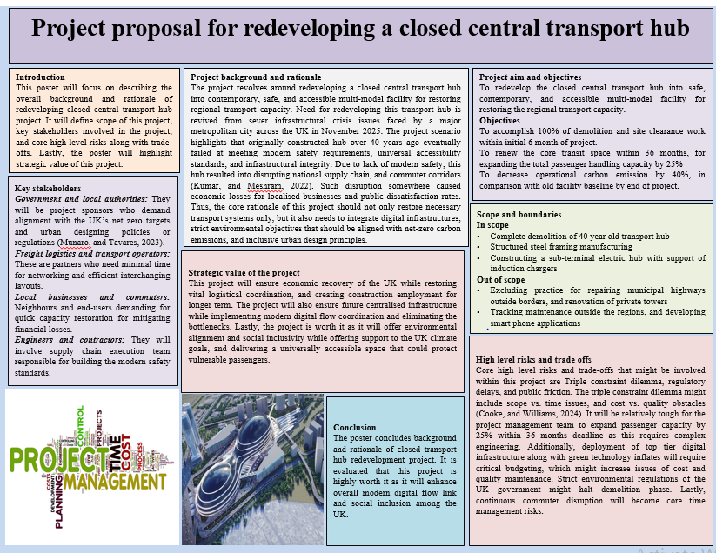

Part B: Reflective commentary on peer and tutor feedback

Identification of key strengths
Feedback gathered from peers and tutors on poster critically analysed several key strengths initially. The tutor and peers had commented about structured alignment between project’s aim and objectives for their methodological rigor. Peers and mentors noted that foundational baseline for this project is specifically in context to its operational parameters that include temporal boundary of 6 month site clearance, volume metric of 25% capacity expansion, and an environmental index, which offers a strong and cohesive framework for substantial project governance.
Additionally, the design choices have been reviewed where tutors demonstrated that visual ergonomics used in the project are highly informational. Conversely, peers commented that multi-column matrix is partitioned by typographic hierarchies that are facilitating an instinctive cognitive pathway for reviewer that could keep track of project lifecycle from rationale to an executional risks.

Critical analysis of gaps and areas for improvement
On contrary, feedback from peers and tutor identified some areas of improvements in poster section by exposing that there is needs for ensuring some refinements immediately in order to transition this proposal into potentially viable project management plan. Core theoretical critique identified is an imbalance across critical synthesis of context and synthesis resolving around vulnerability assessment. Despite, the poster accurately identified structured tensions of triple constraint dilemma, but it eventually failed at critically analysing that how these competitive forces should be managed whenever they get exposed into real life schedules. Tutors noted that there is critic related to methodological framework deployment as this is absent in the poster. Additionally, the tutors’ feedback analysed a critic revolving around 40% sustainability target and remaining critical appraisal for predictive, and adaptive models that are needed to be initiated and discussed. Lastly, the peer commentary examined that the stakeholder analysis was merely focused on taxonomy, since there is need for mentioning their power-interest dynamics.

Epistemological application of feedback on final PMP
A comprehensive and constructive appraisal serves as vital catalyst towards altering architecture of final part of this project, which is project management plan. For bridging methodological gap, section c will introduce a project management framework with proper justification of chosen method, and its suitability. The section will address overall gaps existing into section A by critically appraising limitations of waterfall project management methodology and justifying suitability of hybrid project management methodology for this section. In addition to this, the section c will fulfil stakeholder’s matrix demand by re-engineering the stakeholder section into dynamic power interest matrix along with communication protocol that could strategically manage all the stakeholders involved within this project. Lastly, the section c will ensure high level constraints analysis by offering risk optimisation and mitigation plan along with defining their impact and likelihood level, which will be presented within a formal risk log and change management strategy .This strategic implications into section C will ensure that overall unforeseen errors within section A are strategically rectified and resolved in section C.

Part C: Project Management Plan

Introduction
The project management plan is a formal and approved plan, which depicts about execution, monitoring, controlling and accomplishment of project (Alemu, 2025). This plan will emphasis on “redevelopment of the central transport hub” in major metropolitan city in UK. It will demonstrate the application of project management approaches and techniques for designing the proper plan. It will provide description of project, which will include aim and SMART objectives. Further, it will establish a definitive scope for project, which helps in eviction of future risks. Later, it will design the work breakdown structure, and will discuss each phase of project. Quad chart and Gantt chart will be useful for attaining the timeline of project. It will also evaluate about stakeholder involvement with the help of stakeholder matrix. Further, it will use RACI matrix for allocation of resources. Moreover, it will construct the risk matrix for analysing potential risks.

Critical evaluation of Project Management Techniques
Project Management Methodology is a standardised framework of practices, principles and guidelines that are utilised to execute, plan and control projects (Kerzner, 2025). Most common mythologies include Agile, Waterfall, Scrum, Lean and Kanban. Waterfall is sequential and linear framework where each stage such as Design, requirement, Verification, Construction and Maintenance should complete before the next begins. The core strength of this method is that it is highly predictable for timeline, budget and for scope standard. For this project, its sequential stages assure that structural engineering designs are confirmed before building begins. It also offers documents that are vital for safety, health and structural civil engineering. However, there are limitation of this method as it is highly rigid and is extremely expensive.
PRINCE2 is a structured and process-driven governance framework which is based on 7 principles, 7 themes and 7 procedures (Rahman and Ahmed, 2024). It provide firm governance with clear described roles and responsibilities and also mandates persistent business justification. It also manages limitation clearly between stages of project. While it is crucial for overall project Governance and Public Accountability, however there are limitation of this method as it is highly bureaucratic and can slow down daily tactical choices because of rigid authorisation rounds. Similarly, agile method is a repetitive framework which concentrates on team collaboration, flexibility and offering value via rapid increments. In contrast, this method lacks final scope, which results in long term budgeting and structural scheduling become highly unpredictable (Kerzner, 2025). For this project, it enables digital teams to rapidly test and update passenger flow apps. While hybrid, methodology balanced the strict cost and safety controls required for heavy construction along with the speed needed for digital systems. It de-risks system launch and optimise resource management as heavy equipment teams can operate on expected waterfall timelines, while IT teams operates on agile sprints. However, project manager track two distinct workflows, which ultimately enhances administrative overhead.
Justification: Most suitable framework for UK central transport hub redevelopment is Hybrid Methodology (combining Waterfall and Agile) as project demands for two wholly different deployment environments to operate at same time which include, dynamic digital systems and heavy physical infrastructure. This method enables the team of civil engineering to work with predictable and fixed milestones along with this engineers evaluate, build and integrate the digital infrastructure simultaneously via short sprints (Sargiotis, 2024). It also helps project to protect public funds with adaptive execution as local authorities are funding this project under extreme public pressure.

Project Description
The redevelopment projects will transform the 40 year old facility into highly integrated, high-capacity, and structurally resilient multi-modal transit gateway. Positioned within the existing metropolitan footprints, where the degraded structural assets will be replaced by newly engineered infrastructure. It will use sustainable materials, which are designed for 60-year operational lifecycle. The layout will combine disparate transit networks into the single, unified civic facility of transport hub. Such kind of physical and digital assimilation tends to validate about seamless transfer of passengers along with management of efficacy in logistics throughout the modernization of urban environment (Liu, 2022).
The facility design will design the operational functions into three distinct, specialised spatial layers. On level 1, the surface layer will feature extended, reinforced precast concrete heavy rail platforms for accommodating higher number of passengers. Automated cross-docking bays tends to optimise regional consignment logistics (Toth, Goga, and Boșcoianu, 2025). At ground layer on level 0, the high-ceilinged, natural illumined core concourse will help in the management of flows of passenger via assimilated digital ticketing, real-time information systems and completely accessible features like step-free elevator network along with tactile paths. Below on level -1, the subterranean zone will house a zero-emission bus terminal, which will be well-equipped with the help of induction charging infrastructure and integrated micro-mobility docking hubs for e-bikes and cargo-scooters to meet the net-zero targets.

Aim
To redevelop the closed central transport hub into safe, contemporary, and accessible multi-model facility for restoring the regional transport capacity.

SMART objectives
- To accomplish 100% of demolition and site clearance work within initial 6 month of project.
- To renew the core transit space within 36 months, for expanding the total passenger handling capacity by 25%.
- To decrease operational carbon emission by 40%, in comparison with old facility baseline by end of project.

Project Scope
To evict the last-stage scope creep, the operational boundaries of the Multimodal Transport Hub will explicitly define the project deliverables. The in-scope deliverables will comprises the demolition of 40-year-old hub, deep ground piling, construction of structural steel framing, manufacturing of sub-level electric bus terminal with induction chargers, development of automated freight sorting bays, and deployment of unified digital signaling with ticketing gates. The out-of-scope exclusion will sternly omit the repairing of municipal flyovers or highways outside the border, renovation of private towers, track management, development of smartphone applications, and procurement of bus fleets along with the fit-out of intrinsic retail stores (Stehlin, and Teron, 2026).
Project assumptions: The local authority will grant instantaneous planning approvals, ground condition support piling without remediation, and network rail will provide the access of track during the holiday periods.
Project constraints: The asset is needed to be entirely commissioned within the time-frame of 36 months. The cost is needed to be managed within the capital budget ceiling, and the construction will be limited to morning to evening hours because of noise ordinances.

Work Breakdown Structure

Figure 1: Work Breakdown structure
Phase 1- Deconstruction and clearance: It will emphasise on clearance of comprised 40-years old facility. The work will include safe asbestos abatement, asset stripping, heavy canopy removal and sectional concrete crushing for the preparation of clean brownfield footprint.
Phase 2- Substructure and Civils: It will secure the physical integrity and load-bearing capacity of site before any vertical assembly initiates (Emmitt, 2023). It will use deep concrete piling and ground stabilisation techniques for the fortification of lower spatial layers against structural shifting. Concurrently, the work stream manages the utility re-bounding and management of critical diversion of high-voltage rail traction power lines.
Phase 3- Superstructure build: It will initiate the structural framing via lifting and securing the preliminary structural steel arch frames and precast of concrete platform decks. The work-stream will follow with terminal fit-out, which will seal the facility with photo-static solar roof and will incorporate step-free elevator shafts.
Phase 4- System integration: It will include the embedding of high-density digital and logistical technologies (Pan, Yang, and Pan, 2023). It will include the installation of automated ticketing gates, real-time passenger information screens, and assimilation of cross-agency rail-to-bus active signaling systems.
Phase 5- Commissioning and handover: It will ensure about entire engineering tolerance for public utilisation. The phase will conclude after the passing of formal Railway Inspectorate safety audits and emergency stress-testing loops. Once certified the work stream will execute operational closeout, which will test the multi-modal staff trials, before formal public reopening launch (Pang, 2024).

Quad Chart
Accomplishments  The teams will finalise the asbestos abatement, demolish the concrete canopy, along with clearing the brownfield site. The network rail will approves the access of track, and the project office launches (Knorr, and Eisenkopf, 2022). | Planned Activity  Crews initiates deep concrete piling and reinforcement of sub-level walls. Engineers will divert high-voltage power lines and order main structural steel frames.
Current Open issues  Traffic diversions tends to implement public complaint. The global supply chain might delay the shipment of steel. Noise laws will restrict working at evening, and inflation rate will strain the costs. | Current Recommendations to close issues  Management can deploy the dynamic smart detour signs and will sign the fixed-price domestic steel contracts (Gucciardi, 2023). The teams can shift the low-noise whirling tasks overnight and it needs to release the contingency funds.

Stakeholder Involvement

POWER
HIGH | Keep satisfied  Freight Logistics Operators: It emphasise on routing efficacy.  Strategy: Operational committees and shared digital dashboards. | Manage Closely  Project manager: Manages task execution and baseline.  Government and local authorities: Demand policy compliance (Bailey, and Christidis, 2023).  Strategy: Written reports, briefings, and active scrum collaborations.
LOW | Monitor  Competitor transit routes: Track market shifts.  General media: Report on project outcomes.  Strategy: Passive tracking along with public press releases. | Keep Informed  Engineers and Contractors: Execution of safety standards.  Local business and Commuters: Deals with financial disruption.  Strategy: Regular scrums for site teams, and media alert for the public.
 | LOW | HIGH
 | INTEREST

Stakeholder | External or internal behaviour | Interest or power | Stakeholder effect | Communication  Strategy
Project manager | Internal | High interest, high power | Influences effective completion of the tasks, since they uphold high interest and power (Long, 2022). | Communication will involve the use of written, spoken, and non-verbal methods for sharing knowledge and exchange information.
Government and Local Authorities | External | High interest, high power | Directs fund authorisation, obligates net-zero alignment and controls formal zoning, permissions. | Formal written progress reports, signed compliance certifications and bi-weekly monthly briefing of the project (District, 2026).
Freight logistics and operators | External | Low interest, high power | Impacts critical path scheduling through transit routing requirements and interface efficacy expectations. | Spoken operational coordination committees and shared digital scheduling dashboards
Engineers and Tier 1 contractors | Internal | High interest, low power | Manages the actual construction output quality, contemporary safety compliance along with on-site deliverable execution. | Daily verbal scrum briefings, written engineering site logs, and digital technical drawings (Carril Novoa, 2024).
Local business and Commuters | External | High interest, low power | It influence public satisfaction metrics and regional economic stability during construction closures. | Written public media notifications dynamic detour signage and public community updates on regular time-intervals.

Resource Allocation (RACI Matrix)
Operational Deliverables | Project Sponsor | Lead PM/PMO | Principal Civil Contractor | Digital Systems Lead | Sustainability Consultant | Transport Operators
Site Clearance and Demolition (1-6 months) | A | C | R | I | C | I
Core Transit Civil Infrastructure (Months 7-36) | A | R | R | I | C | C
UI/UX Passenger Flow Software Sprints | I | A | I | R | I | C
Low Carbon Retrofitting and renewable grid setup | A | R | R | C | R | I
Digital Systems Simulation and Integration Testing | I | A | C | R | I | R
Operational, Readiness, Safety certification and handover | A | R | C | C | C | R

R stands for Responsible
A stands for Accountable
C stands for Consulted
I stands for informed
Interpretation:
The project sponsor owns exclusive Accountability for capital-intensive and high risk milestones such as Site Clearance, Final Handover and Civil Infrastructure. This assures that there is compliance with public funding rules. Accountability is shifted towards Lead PM/PMO for Integration testing and Software Sprints, which avoids team of software development from getting down in local council approval loops. The Digital system is kept informed, while Principal Civil Contractor is Responsible for developing the station (Mahmoodian et al. 2022). This assures that IT team is well prepared and they know when physical spaces are ready for hardware installation.

Risk analysis
Risk ID | Risk Category | Risk Description | Probability | Impact | Risk score | Mitigation strategy
R01 | Regulatory Barriers | The strict UK net-zero and environmental regulations delay the phase 1 demolition permits. | 3/25 | 5/25 | HIGH  15/25 | The company shall submit the assessment of environmental impact and salvage plans for 3 months before formal demolition begins.
R02 | Scope vs. Time | The complex engineering work fails to hit milestones and compromises passenger capacity expansion timeline. | 4/25 | 4/25 | HIGH  16/25 | It should allocate extra construction teams to run overlapping shifts.
R03 | Public Friction | Continuous commuter and freight traffic disruptions triggers public backlash and localised legal challenges. | 4/25 | 3/25 | HIGH  12/25 | It should develop temporary multi-modal drop zones and utilise agile messaging channels to offer real-time updates (Seethala, 2025).
R04 | Cost vs. Quality | High cost of low-carbon materials and IT infrastructure exhaust the budget. | 3/25 | 4/25 | HIGH  12/25 | It should partner with local UK net-zero suppliers through fixed-price contracts to lock in material cost early.

Interpretation: The 6-month site clearance phase struggles with strict net zero and environmental regulations. The prolonged business and commuter disruptions generate intense political pressure and public backlash forces council to restrict working hours, the schedules will collapse and labour cost will spike. Merging top-tier digital tech with green systems inflated the initial cost (Rezaee and Silva, 2026).

Gantt chart
Task Name | Duration | Start | Finish | Predecessors | Resource Names
Deconstructing and Clearance | 6 mons | Wed 6/17/26 | Tue 12/1/26 |  | Deconstructing and Clearance
Substructure and Civils | 5 mons | Thu 6/18/26 | Wed 11/4/26 | 1 | Substructure and Civils
Superstructure Build | 7 mons | Wed 12/2/26 | Tue 6/15/27 | 1,2 | Superstructure Build
System Integration | 5 mons | Wed 6/16/27 | Tue 11/2/27 | 1,2,3,4 | System Integration
Commissioning and Handover | 5 mons | Wed 11/3/27 | Tue 3/21/28 | 3,4,5 | Commissioning and Handover

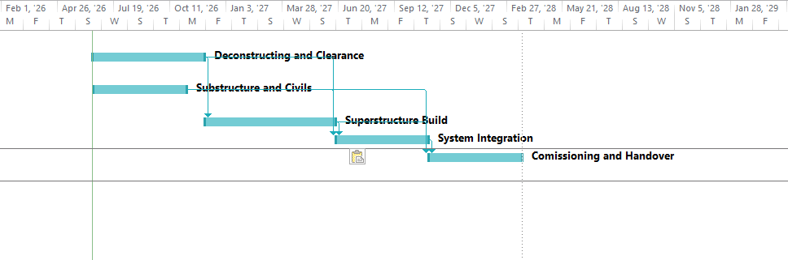

Conclusion
This report included three main sections where section A evaluated foundational values of this project through a poster. Additionally, the section B involved discussion of peer and tutors feedback received on section A, which demonstrated key drawbacks regarding lack of risk matrix, and stakeholders’ matrix. Lastly, section C presented a comprehensive and strategic plan for redevelopment project.
This project management plan has mainly focused on “redevelopment of central transport hub” in the major metropolitan city of UK. Project description has elaborated that it needs to use sustainable material along and will align disparate transit network into unified civic facility of transport hub. The work breakdown structure has multiple phases which depicted about the procedure from deconstruction and clearance to commissioning and handover. It has highlighted that the major stakeholder of this project includes project manager, government and local authorities, freight logistics and operators, engineers and tier-1 contractors as well as local businesses and commuters. It has also illustrated about application of project management approaches and techniques for designing the proper plan.

References
Books and Journals
Alemu, B., (2025). The Role of Project Management Principles in Supporting Sustainable Organizational Initiatives. In Scientia Moralitas Conference Proceedings (pp. 82-103). Scientia Moralitas Research Institute.
Bailey, S. and Christidis, A., (2023). Local government in the United Kingdom. In Local Governance in Multi-Layered Systems: A Comparative Legal Study in the Federal-Local Connection (pp. 301-330). Cham: Springer Nature Switzerland.
Carril Novoa, A., (2024). Web application that allows managing projects under the agile SCRUM methodology, promoting healthy work habits in project management.
Cooke, B. and Williams, P., (2024). Construction planning, programming and control. John Wiley & Sons.
District, A.H., (2026). Environmental and social management plan (ESMP). disclosure.
Emmitt, S., (2023). Barry's advanced construction of buildings. John Wiley & Sons.
Gomaa, A.H., (2025). Achieving Project Management Excellence through Lean Six Sigma. Middle East Res. J. Eng. Technol, 5, pp.18-32.
Gucciardi, A., (2023). Trustless contract management: a study on the benefits of blockchain-based smart contracts (Doctoral dissertation, Politecnico di Torino).
Kerzner, H., (2025). Project management: a systems approach to planning, scheduling, and controlling. John Wiley & Sons.
Kerzner, H., (2025). Project management: a systems approach to planning, scheduling, and controlling. John Wiley & Sons.
Knorr, A. and Eisenkopf, A., (2022). An alternative regulatory approach for long-distance passenger rail services: An explorative analysis with a focus on Germany. Transportation Research Interdisciplinary Perspectives, 14, p.100593.
Kumar, A. and Meshram, D.S. eds., (2022). Future of cities: Planning, infrastructure, and development. Taylor & Francis.
Liu, Y., (2022). Cognitive Smart City Logistics: a new approach for sustainable last mile in the era of digitization (Doctoral dissertation, Université Paris sciences et lettres).
Long, T., (2022). A small state's guide to influence in world politics. Oxford University Press.
Mahmoodian and et.al, (2022). Development of digital twin for intelligent maintenance of civil infrastructure. Sustainability, 14(14), p.8664.
Munaro, M.R. and Tavares, S.F., (2023). A review on barriers, drivers, and stakeholders towards the circular economy: The construction sector perspective. Cleaner and Responsible Consumption, 8, p.100107.
Pan, W., Yang, Y. and Pan, M., (2023). Implementing modular integrated construction in high-rise high-density cities: perspectives in Hong Kong. Building Research & Information, 51(3), pp.354-368.
Pang, Y., (2024). Resilience of Multi-modal Logistics Service Network: Diagnostics and Enhancement Strategies, and Impact Assessment on Global Supply Chains (Doctoral dissertation, Université Paris sciences et lettres).
Rahman, M.S. and Ahmed, E., (2024), October. Integrating PRINCE2 and agile methodologies in software development: unveiling opportunities and addressing challenges. In 2024 International Conference on Electrical, Communication and Computer Engineering (ICECCE) (pp. 1-8). IEEE. ‘
Rezaee, E. and Silva, S.R.P., (2026). Solar energy in 2025: Global deployment, cost trends, and the role of energy storage in enabling a resilient smart energy infrastructure. Energy & Environmental Materials, 9(3), p.e70199.
Sargiotis, D., (2024). Integrating digital transformation and AI in civil engineering: a multidisciplinary approach to disaster management and sustainable urban development. Available at SSRN 4789752.
Seethala, S.C., (2025). Predictive Reliability Engineering for Real-Time Event Streaming Pipelines Using Multi-Modal Deep Learning Models.’
Stehlin, J. and Teron, L., (2026). States of repair: The role (s) of state government in shaping urban highway removal in New York state. Journal of Urban Affairs, 48(4), pp.1274-1302.
Toth, Z., Goga, A.S. and Boșcoianu, M., (2025). Sustainable Strategies to Reduce Logistics Costs Based on Cross-Docking–the Case of Emerging European Markets.

