Regulations: (IMechE (2023))
Cooling system:
- Only plain water can be used
- It has to have a rigid cover
- It has to be made of a material that can withstand 120 degrees Celsius
- Cooling system catch can is 10% volume or 100ml (whichever is bigger)
- Oil catch can is 10% volume or 900ml (whichever is bigger)
- Catch cans must be mounted to the chassis, behind the firewall and below driver shoulder level
- Must vent out the bottom of the chassis and exit outside the bodywork (3mm min hose)
Shields:
- Non perforated 2mm steel (for chains) or 3mm aluminium alloy (for belts)
- Width must be 3x the width of the chain / belt
- M6 grade 8.8 mounting bolts
Gearbox:
- Must have neutral gear
Exhaust:
- Driver not exposed to fumes
- No more than 450mm behind rear axle and 600mm above ground
- Have no exposed exhaust
- No application of fibrous / absorbent material to the exhaust (e.g. header wrap)
Suspension:
- 50mm Travel
- 25mm Jounce with drive seated
- 30mm Ground clearance

Introduction:
The areas I will be covering are: Rear suspension; Transmission and final drive; Exhaust; Cooling system.
Gear ratios: Choosing the right gear ratio is important as it will determine the top speed of the vehicle as well as the torque. With a higher gear ratio increasing acceleration / torque and lower gear ratio increasing the top speed.
Wheels and Tyres: Jared has chosen suitable wheels and tires for the formula student car. The size of the tyre is important is this will affect the torque / top speed and will need to be considered in the gear ratio calculation. As for one revolution of the wheel the car would have travelled further with a bigger diameter tyre. Wheels: 13” x 7” Tyres: 180/35/13.
Differential: A differential is very important as it allows the vehicle to turn smoothly without scrubbing as the outside wheel will need to move faster than the inside wheel. Go karts have a solid live axle but due to it not having suspension and the caster / camber angles, it lifts the kart up and so lifts the inside rear wheel up so there is no scrubbing. However as the formula student car will have suspension, it won’t be able to do this and will need a differential. It will also decrease tyre wear if we used an LSD.
Exhaust: After some research on materials, the best option to go with is 409 stainless steel as it has a higher corrosion resistance and will last longer than mild steel and it isn’t too expensive. It will also be easy to bend and weld. The Triumph 675 comes with its own 3-1 manifold so it is best that we use that and fabricate the end of it to direct the fumes away. The shape and diameter of the tube in the manifold will give the right balance of exhaust gas velocity and resistance (for less back pressure). It is also designed so the negative pressure waves that are reflected create good scavenging characteristics. In order to keep within the 110db noise limit a silencer might need to be added. Having the Triumph Off Road Can with baffle and catalytic converter would produce around 102DB at 6.5k RPM (this had wadding around the baffle). (675.cc exhaust and noise levels (2013)).
Cooling system: The Radiators should be put in a position so that they are exposed to a good air flow (e.g. in the wings or at the front of the car). Due to the engine being subjected to high RPMs for prolonged period of time it would be a good idea for a second radiator. Silicone hoses will be used as they are More flexible than rubber; there is a reduced risk of splitting over time and its able to withstand higher temperatures than rubber.
Rear suspension: The suspension system helps to keep the car stable and under control during high-speed turns and sudden changes in direction. The suspension system plays a key role in maintaining traction between the tires and the road surface. By keeping the tires in contact with the road and evenly distributing the weight of the car, the suspension system maximizes grip and minimizes the risk of losing traction and sliding off the track. A good suspension system can also provide a comfortable ride for the driver. The suspension system helps to absorb shocks and bumps in the road, smoothing out the ride and reducing the strain on the driver's body.

Radiator: (thermodynamics lecture: heat transfer and heat exchangers)
There are ways of calculating the size of the radiator required if you know a few things about the engine. We can use the formula Q = m x c x (T2 – T1) to start with. Heat energy = mass flow rate x specific heat capacity x change in temperature. There is a chart which gives the specific heat capacity of the coolant (ethylene glycol solution). Once the heat lost is calculated, we can then use the same equation backwards but to work out the air temperature after its passed through the radiator. After this we should find the ‘log mean temperature difference’ (Ta-Tb) / ln(Ta/Tb). (a is the difference between the two hotter temperatures and b is the difference between the two colder temperatures). This value is used in the next equation… Q = U x A x (LMTD)… (U = overall heat transfer coefficient in W M^-2 K^-1). Then re-arrange to get the area required. For simplicity you can assume the heat exchange area is the total surface area of the tubes.

Exhaust: (thermodynamics lecture: exhaust system design)
- Exhaust runner lengths are designed so that the exhaust gasses from one cylinder cant flow back into another. The diameter is small enough for the right flow velocity but large enough for the right flow resistance.
- It is important to choose a material which can handle the repeated extreme heat and cooling.
- Ideally you want the lowest pressure at the exhaust valve when it is closing to aid extraction and increase volumetric efficiency.
- As the pulse experiences a change in diameter (expansion), it will send a negative pressure wave back down to the cylinder. This can help with scavenging. The larger the change in diameter, the stronger that pressure wave will be.
- These step ups (or collectors) can be used in different ways for example to send a pressure wave back early so that the piston has less pressure on its way up which will increase the efficiency.
- A consideration is to be able to fit the volume of exhaust gasses in the cylinder into the primary tubes.
- The exhaust gasses begin to leave the cylinder at roughly 20 degrees after the exhaust valve opens. And the return of the negative pulse is between TDC and Exhaust valve closing.
- You can use the following calculations to work out the time for the pulse to return ‘n’ amount of times:
- Time for the nth harmonic = (n x 2 x L) / speed of sound
- Work out the speed of sound for the temperature: square root of (the average exhaust temp from port to expansion plus 273 / 20 plus 273) x 330
- (Degrees the pulse travels / 360) x (60 / RPM) = (2 x n x L) / speed of sound at temperature

Exhaust Material | Life Expectancy | Cost | Corrosion and Rust Resistance | Other Notes
ALUMINISED STEEL: | 3-5 Years | Low | Aluminium coating gives the steel a good resistance | Very easy to work with (bending and welding)  Dull Finish
MILD STEEL: | 3-5 Years | Low | It will easily rust | Very easy to work with (bending and welding)  Dull Finish
INCONEL 718: | 10+ Years | Expensive | Contains Molybdenum which is corrosion and salt resistant | Nickle alloy which makes it heat resistant
Titanium Alloy: | 10+ Years | Expensive | Contains Molybdenum which is corrosion and salt resistant | Very hard to work with
316 stainless steel: | 10+ Years | Expensive | Contains Molybdenum which is corrosion and salt resistant | Similar to 304 stainless steel
304 STAINLESS STEEL: | 10+ Years | High | Really good corrosion resistance | 10% Nickle content, 20% Chromium content which makes it durable and it has a high temperature resistance  Polished Finish
439 STAINLESS STEEL: | 10+ Years | High | 0.5% Nickle resulting in less corrosion resistance than 304 but its still good | Polished Finish
409 STAINLESS STEEL: | 10 Years | Medium | Light corrosion resistance | Dull finish

Final drive:
The standard gearbox will be used. After some research into whether a belt or chain would be more suitable, I feel like a chain would be more suitable for the formula student car, especially with the engine and gearbox that we have gone for. This is because there is a sprocket already attached to the gearbox and then another one which would go onto the LSD. They are also cheaper, more common (for parts) and they are more efficient at lower power outputs.
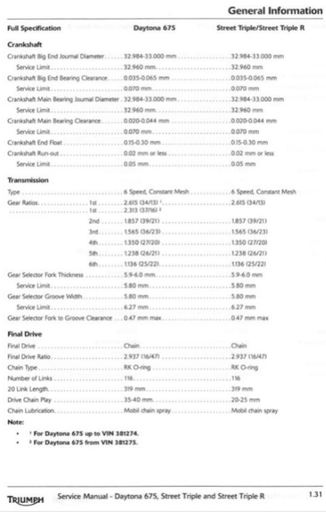
To work out the top speed (m/s): ((RPM / Gear ratio) x Tyre diameter (m) x Pi) / 60
Power = Angular Velocity x Torque
Figure 1
You can see the gear ratios of the bike in figure 1. The Final drive ratio is 2.937 (47/16). And the tyre size on the bike is 17” and the bike is about 190kg.
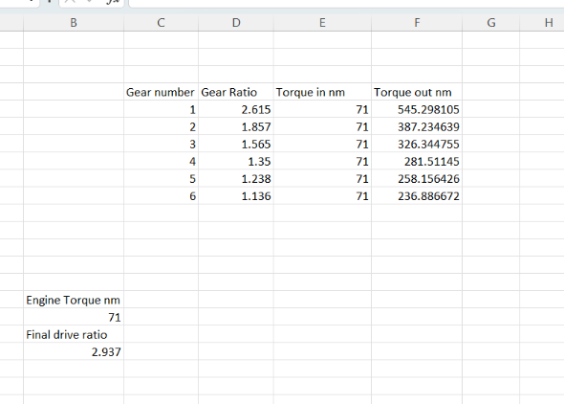
(MCN (2023))
Top speed & performance
Max power 128 bhp
Max torque 71 nm
Top speed 145 mph
Formula student: Tyre size 13”. A rough estimation for the formula student car is around 300kg.
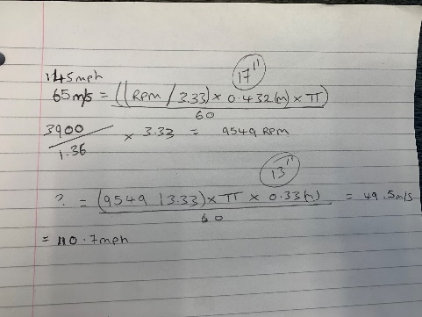
With the 13 inch wheels instead of the 17 inch wheels, that alone would reduce the top speed by about 35 mph. The formula student car is also about 110kg heavier and it will have a lot more drag and rolling resistance. However we cant reduce the gear ratio as we will still need all of this torque to be able to accelerate the car. The wheels are also smaller which would mean it can accelerate at a quicker rate. So with this into consideration its best to leave the final drive ratio at (47/16). This will give us a good baseline and then we can just put a bigger or smaller rear sprocket on after testing. This would just bolt off and on the differential and would just mean we would need to adjust the chain length.
LSD: Limited slip differentials work by delivering the torque to the wheel with the most traction instead of the one with the least. There are 3 different types: A 1-way differential will only have a positive lock to limit slip during acceleration. A 2-way differential will limit slip during both acceleration and deceleration. A 1.5-way differential is a 2-way differential with a different lockup rate between acceleration and deceleration. (DSPORT (2015)).
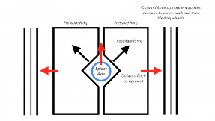
There are a few different types of LSD’s which I could choose from: (Low offset (2023) A.Mann) (Car throttle, engineering explained (2016))
- Clutch-type Limited Slip Differential is a type of LSD that uses a series of clutches to control the torque distribution between the wheels. The centrifugal force pushes the pressure rings up against the clutches. The more friction generated between them, the more torque is transferred to the drive shaft. The clutches can be engaged or disengaged based on the amount of torque being delivered to each wheel.
- Torsen / Helical differential uses gears to control the torque distribution. The gears can be locked or unlocked based on the amount of power being delivered to each wheel. Since there aren’t any clutch packs there is no way to alter the ratio. Since its all mechanical gears, they don’t need maintenance as there’s no wearing parts (e.g. clutches).
- Electronic Limited Slip Differential (eLSD): This type uses electronics to control the torque distribution. The electronics can be programmed to distribute torque based on a variety of factors, such as vehicle speed, wheel speed, and engine RPM.
- Torque vectoring differential: Its like an open differential with the pinion, ring, plant and sun gears, however, it has two separate clutch packs either side to distribute the torque using an electric motor to engage them. It is very expensive and complex.
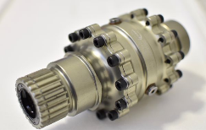
The differential that I have gone for is a Drexler adjustable preload FS differential. It is a clutch pack type differential with a sprocket attached to it so that it can be connected to the gearbox via a chain drive mechanism.
Drexler FS Differential Features: (MUR Motorsports (2017) Mr A.Giang)
- Original Version: Choice of three widths: 120mm, 140mm, or 160mm bearing distance
- Adjustable Version: Choice of two widths: 140mm and 160mm bearing distance
- Low weight: appx 2.6Kg
- Preload (changes the breakaway torque): Original= 20-25 Nm on delivery and ~10 Nm after run in; Adjustable=0-75Nm externally adjustable
- Includes 3 ramp settings for adjustability, making a total of 6 ramp setting options
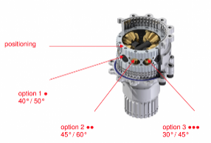
Drexler drive shafts will also be used. They slot into the differential have full articulation as well as lateral movement to allow for the hub moving closer / further away when it moves up and down.

Rear Suspension:
The rear of the car is going to use the same setup as the front, pushrod rod suspension (the spring compresses with upward movement of the wheel) with the damper and spring mount within the chassis. By using this setup, the wheel rate can be easily adjusted without changing the spring. Adjustment of wheel rate can also be altered through changing the bell crank arm length (it changes the motion ratio). Ride height can also be adjusted be changing the length of the pushrod, which is easily accessible. (VROOMO (2022)). Having a mechanism like this will significantly reduce the unsprung mass of the vehicle as the weight of the coil over is now on the chassis. This will lead to better handling characteristics. Another advantage of a push rod suspension system is that it will have improved aerodynamics as the spring and damper will be tucked away.
The Control Arms will be made out of Steel 4130 because its high strength, easily sourced and fairly cheap. It is also easy to work with in order to weld and bend.
Formula student cars tend to run 1 to 2 degrees of negative camber and ½ a degree toe in on the rear. (Formula student Germany). The reason you want toe in at the rear is to make the car more stable especially in a rear wheel drive car. The less the toe changes with wheel displacement the more predictable the car will be. The reason for having slight negative camber is when cornering the tyre deflects so you want the biggest contact patch. The amount of camber needed depends on the tyre.
At the end of the wishbones will be rose joint rod end bearings as they allow a lot of articulation for the different angles between the kingpin (hub assembly) and the wishbones. The rear hub assembly consists of the wheel bearing and the brake calliper mounts and attaches to the upper and lower control arm.
The reason for choosing double wishbone suspension is because you can change the dimensions of the joints to create different arc patterns which affect the camber. For a single arm suspension system, the camber will change with the ride height and there is no adjustability. I will investigate how different dimensions change the kinematics of the suspension using WinGeo. (see pages below)
Set up 1 and 2 has the least amount of camber change and sticks between the range of -1 and -2 degrees of negative camber. When set up 1 is at full droop (25mm), it has the most amount of negative camber. However, when set up 2 is at full droop, it has the least amount of negative camber.
Set up 3 and 4 have the most amount of camber change, this time ranging between -3.5 and 0 degrees of negative camber. When set up 3 is at full droop, its has the least amount of negative camber. However, when set up 4 is at full droop, it has the most amount of negative camber.
These results give me a clear visual understanding of how changing the geometry of the suspension system affects the camber change and is a really useful tool in order to point me in the right direction of making my first suspension designs and models.

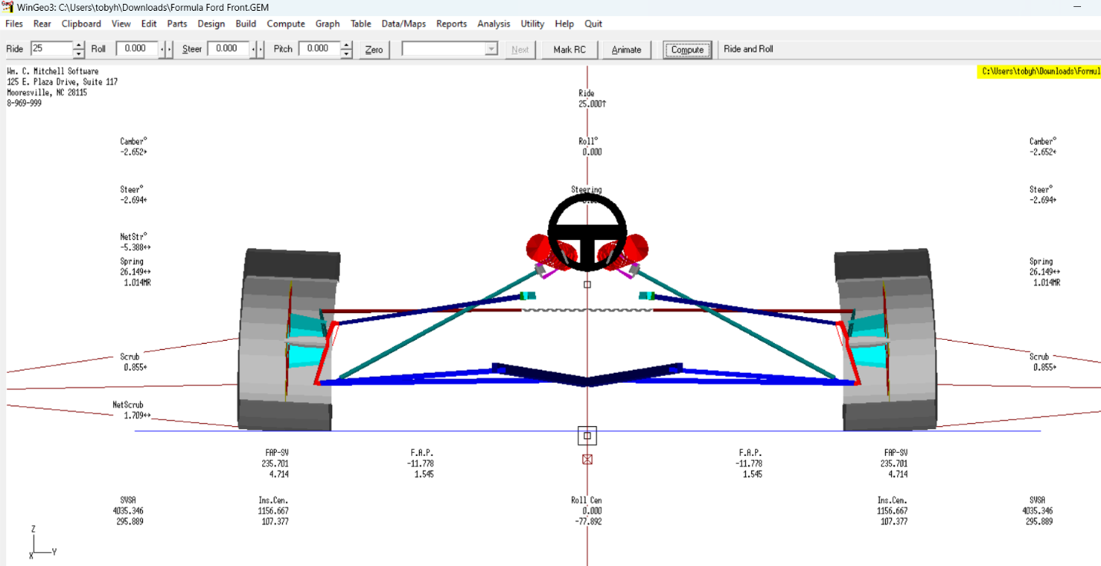
WinGeo set up 1: Upper wishbone z350, kingpin z300 (ride height: 25mm, -25mm):

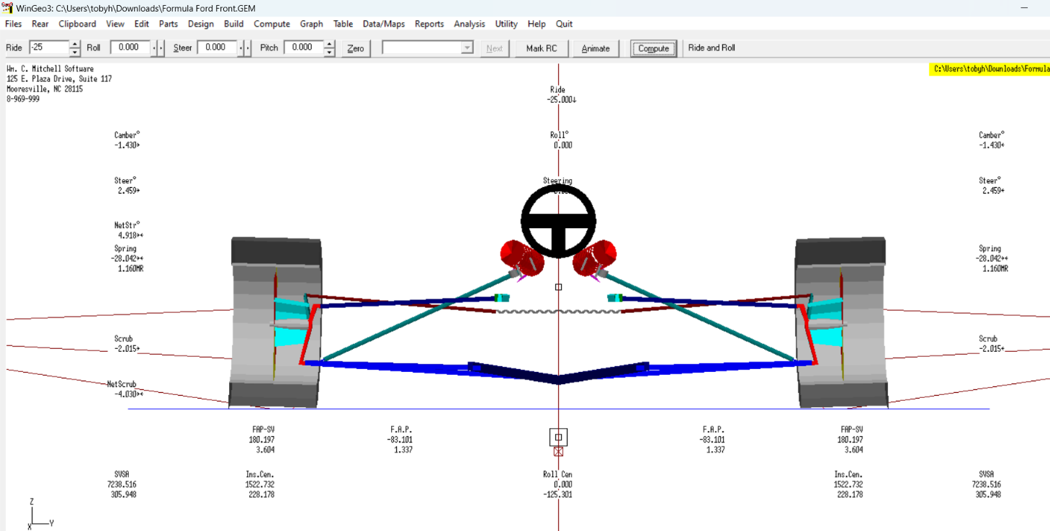
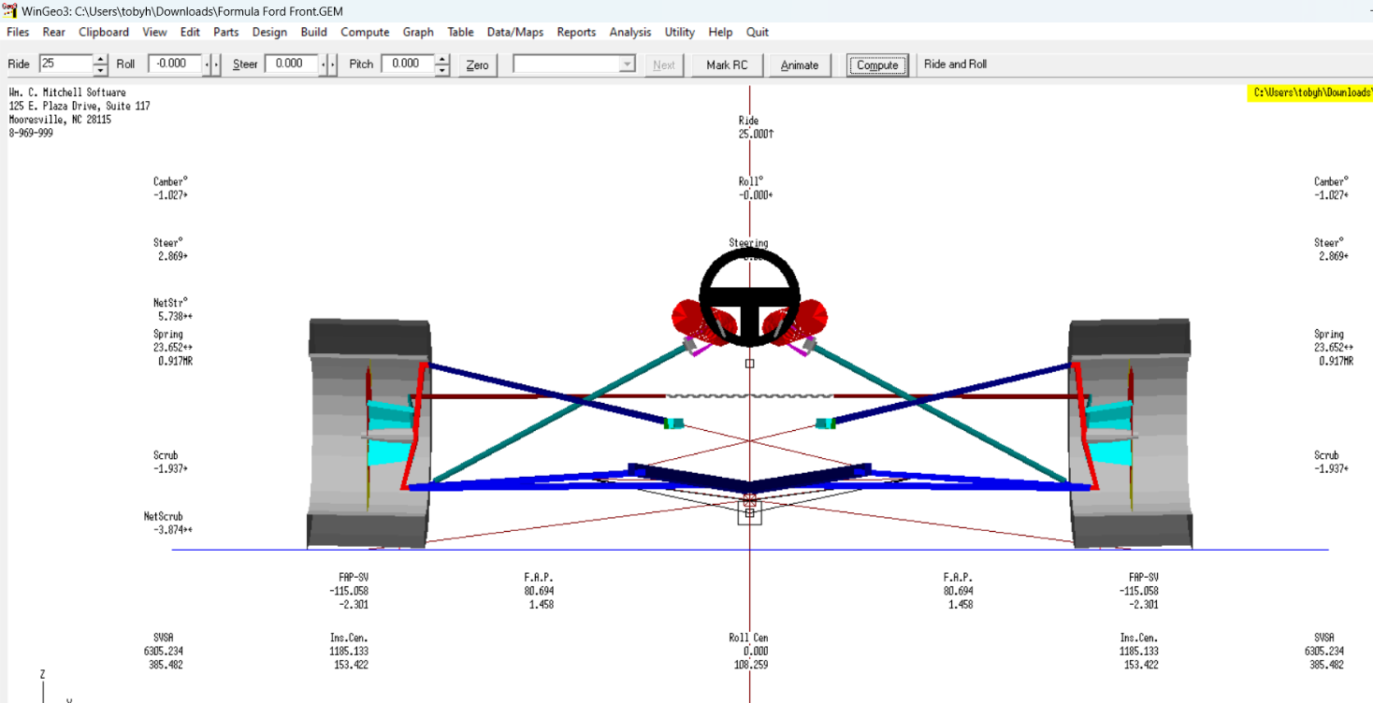
WinGeo set up 2: Upper wishbone z250, kingpin z400 (ride height: 25mm, -25mm):

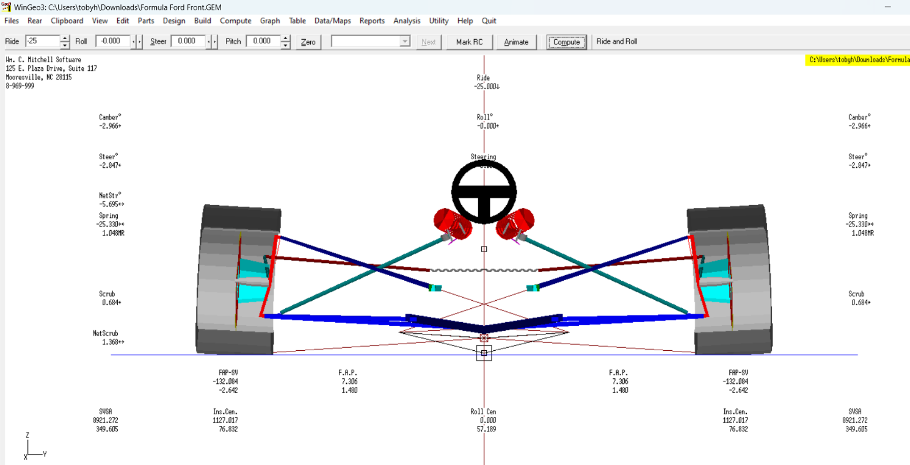

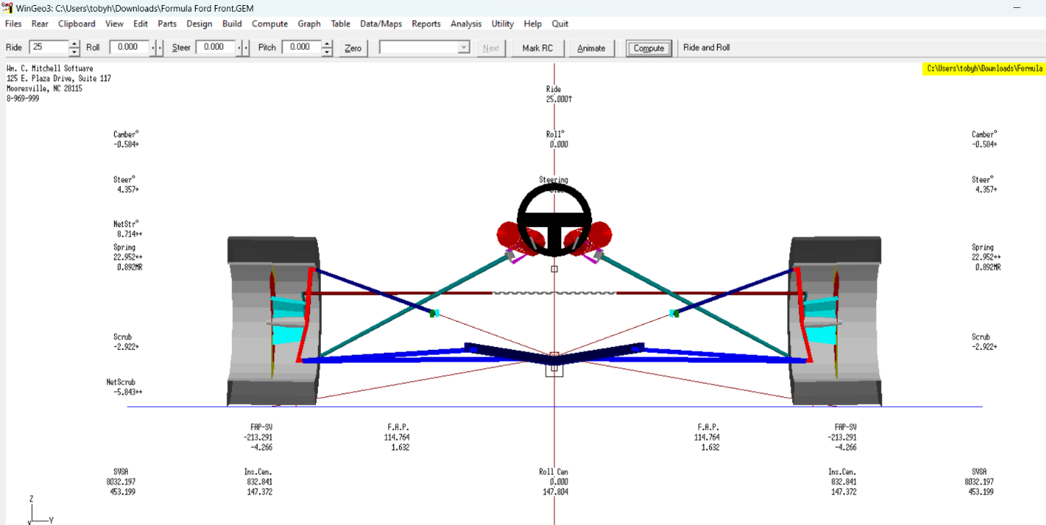
WinGeo set up 3: Upper wishbone z250 y350, kingpin z400 (ride height: 25mm, -25mm):
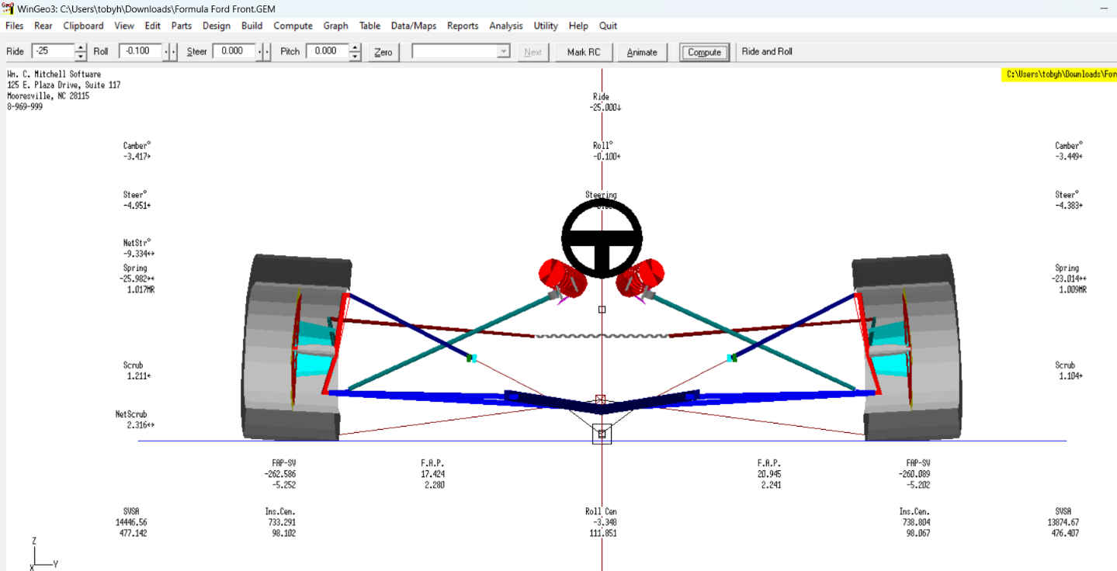
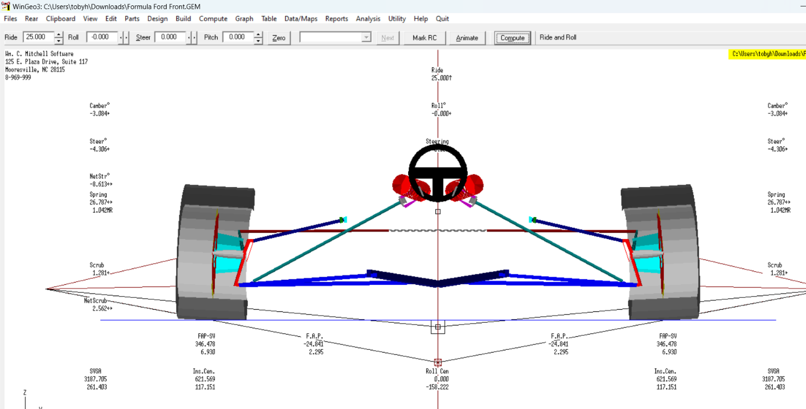
WinGeo set up 4: Upper wishbone z350 y350, kingpin z300 (ride height: 25mm, -25mm):
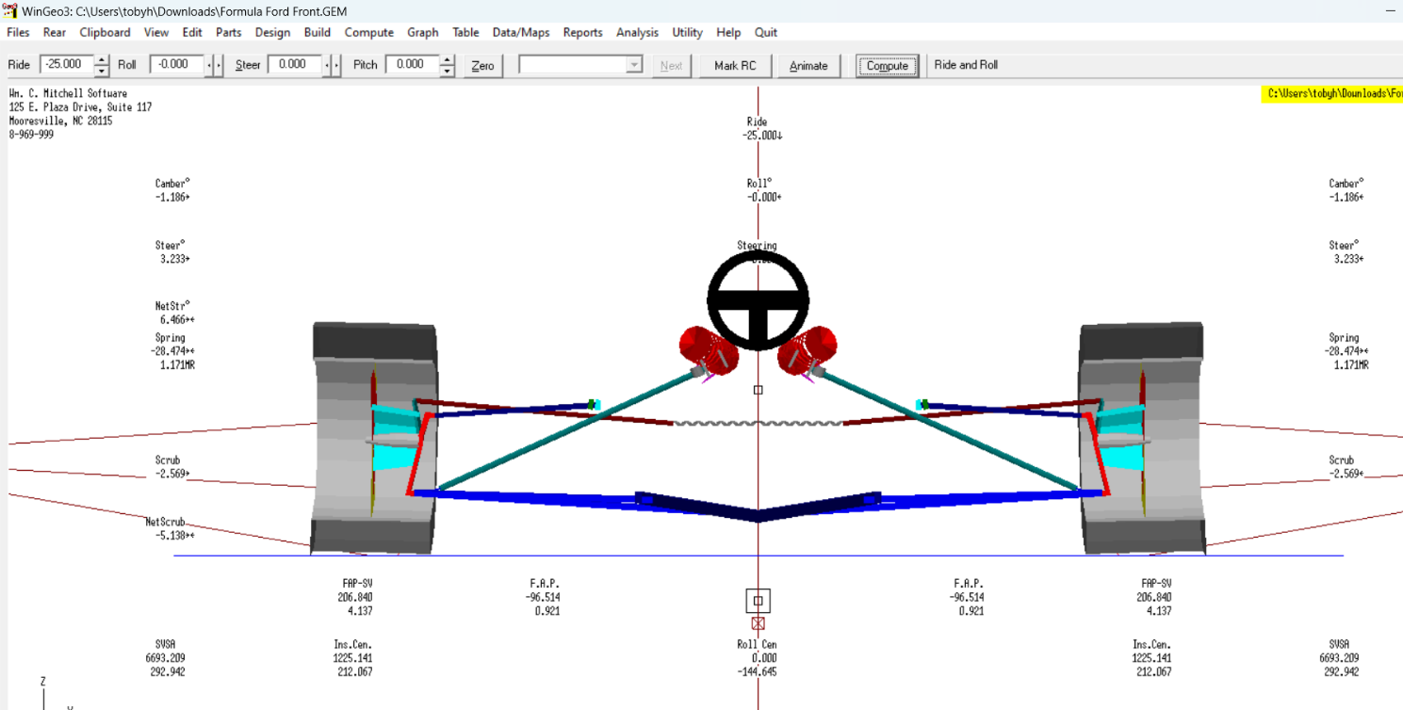

Cost of materials:
- Exhaust - £500
- Oil catch can and cooler - £50 + £50
- Radiator - £100
- Chain and sprocket - £100
- Differential - £1680 (Drexler UK Distributor | Formula Student | Limited Slip Differential Supply (cmengineering.co.uk))
- Driveshafts - £500
- Hub and bearings – £1400 (Wheel Hubs - FSAE (rcvperformance.com))
- Rose bearings and steel 4130 for the suspension - £400

References:
675.cc (2013) – Exhaust and noise levels. Accessed on 26th March 2023. Available at: Exhausts and Noise Levels | 675.cc • Triumph 675 Forum
Low offset (2023) A.Mann – Different types of Limited Slip differentials. Accessed on 26th March 2023. Available at: Different Types of Limited Slip Differentials | Low Offset (low-offset.com)
DSPORT (2015) – Differentials 101: solving differential equations. Accessed on 26th March 2023. Available at: Differentials 101: Solving the Differential Equation (dsportmag.com)
Car throttle / Engineering Explained (2016) – Best kinds of differentials and what’s most suitable for you. Accessed on 26th March 2023. Available at: Engineering Explained: The Best Kinds Of Differential And What's Most Suitable For You (carthrottle.com)
MUR Motorsports (2017) Mr A.Giang – Differentials, What’s the difference. Accessed on 26th March 2023. Available at: MUR Blog - Differentials…What’s The Difference? (Pt. 2) : MUR Motorsports (unimelb.edu.au)

MCN (2023) - TRIUMPH STREET TRIPLE 675 (2013 - 2016) Review. Accessed on 26th March 2023. Available at: 2013-2016 Triumph Street Triple 675 review and used buying guide | MCN (motorcyclenews.com)

Institution of mechanical engineers (2023) – Rules 2022. Accessed on 26th march 2023. Available at: fsuk-2022-rules---v1-3-(t11-6-5-typo-correction).pdf (imeche.org)

Vroomo (2022) - FSAE Rear Suspension (A Brief Overview). Accessed on 26th March 2023. Available at: FSAE Rear Suspension (A Brief Overview) - VROOMO

Formula student Germany (2023) – Car Set up. Accessed on 28th March 2023. Available at: https://www.bing.com/search?q=what+camber+do+formula+student+cars+run+on+the+rear&cvid=a3909ae043bb47559deac8e5b1f15a42&aqs=edge..69i57.11778j0j1&pglt=41&FORM=ANSPA1&PC=ASTS&ntref=1

