Module 6007: A Critical evaluation.

Introduction
It is the aim of this assignment to provide a critical evaluation and identification of next teaching and learning steps. Through focus based upon a case study of an individual learner or group of learners by making use of an observed critical incident. Within this assignment it is the intention to outline and discuss the use of critical incidents in relation to reflective practice in teaching. Provide school and class context of the observation, demonstrate understanding of different observation models and provide a rationale of the used method. A description of the critical incident linked to the four core purposes a literature review focusing on areas highlighted within the critical incident. Provide a reflection, evaluation and identification of next steps and finally provide a conclusion.
Before continuing the definition of a critical incident must be considered Tripp, (2011) defines critical incidents as commonplace events that occur routinely in practice, they emerge as typical occurrences at first and become critical through interpretation and analysis. And that a critical incident is formed firstly through observation and documentation and secondly by explanation the asking of why this occurred relating to a wider context. Critical Incidents do not have to be massive or negative events ‘’the point is that everything that happens is a potential critical incident: we just have to analyse it critically to make it one.’’ (Tripp, 2011, p. 28). The use of observing and analysing critical incidents professionally can prompt and ensure reflective practice. Brookfield, (1998) defines critically reflective practice as a system of research and discovery practitioners engage in relating to own work and practice. Reflective practice is beneficial as ‘’teaching in a critically reflective way keeps us alert. It’s mindful teaching practiced with the awareness that things are rarely what they seem.’’ (Brookfield, 2017, pp.90).
Observation
This section intends to set the scene and provide relevant information regarding the school and classroom setting of the observation. The observation was carried out within an English medium primary school that serves pupils of the small village in which it is based and the surrounding local catchment area. The school provides education for pupils ages three to eleven which covers from nursey up to year six. Estyn, (2018) report that there are 217 pupils attending the setting, where the percentage of pupils who receive free school meals is 27% this is higher than the national average of 19%. This is unsurprising due to the deprivation within the area which has perhaps been worsened by the effects of the pandemic. While ‘' the school identifies 38% of pupils as having additional learning needs. This is well above the national average of 21%.’’(Estyn, 2018).
Within the school ‘’there are four single-age classes in the foundation phase and three mixed-age classes in key stage 2.’’ (Estyn, 2018). However, due to the changes required as a result of Coronavirus each classroom has been split into single year groups. This included placing a barrier between the open plan year one and year two classes the observation was carried out within the year one classroom. Where there are around twenty-nine pupils of which only eight are female, with one class teacher and one teaching assistant. The observation was carried out with consideration of BERA’s ethical guidelines such as the rights to dignity, privacy and safe storage of data. As ‘’researchers should recognise the entitlement of both institutions and individual participants to privacy, and should accord them their rights to confidentiality and anonymity.’’ (BERA, 2018).
Methodology
Having examined the observational setting, it is now necessary to consider the types of observation models that are available and provide a rationale for the chosen method. ‘’Observation is one way to collect primary data. It is a purposeful, systematic and selective way of watching and listening to an interaction or phenomenon as it takes place.’’ (Kumar, 2014, p.173). While this provides a general definition and purpose of observation there are various types and methods that can be used to obtain or carry out observations. The chosen method is often decided upon depending upon the appropriateness and with regards to the type of information that is being gathered.
The first method that will be considered here is participant observation Cohen, et al, (2017) defines this as when the researcher participates within the situation or activity in which they intend to gather information, those being observed may or may not be aware of this. And the degree of involvement can alternate from each observation for example from complete observer to observer as participant. Secondly, there is event sampling for observation Cohen, et al, (2017) this is where a researcher will keep a record of the amount of times a specific event occurs this may be through the means of a tally chart. Usually the statements or events that are being looked for are predetermined by the researcher. And finally, video observations Jenkins, (2017) this is where the researcher opts to use technology such as a camera to record situations and events such as lessons, the recording can then be watched more than once and be analysed. This is not to say observation is limited to these three alone as this is just a brief outline of a few of the methods that can be used to carry out observations.
The chosen method used to obtain a critical incident was a non-participant structured case study. PressAcademia, (2018) defines case studies as a research method in which an investigation of a particular individual, group or event is observed within a real-life situation. In this instance this was a case study of critical incidents within a natural classroom setting, the case study was non-participant therefore the researcher remained uninvolved in the situations merely acting as an observer. The case study was structured using questions adapted from the work of Fletcher Wood in relation to observation checklists.
Strengths and weaknesses will be outlined here to provide a rationale of the chosen method. With regards to the strengths of case studies Cohen, et al, (2017) states that the strengths are that they are grounded in reality, accessible, relatable and that they can be rich in detail and illuminative. However, case studies do have weaknesses as situations being observed can be misinterpreted by the observer, they may also have unconscious bias that effects their judgement or understanding. While if those being observed are aware of this the Hawthorne effect can occur, Payne and Payne, (2004) this is where individuals will change the way they would usually behave because they are aware that they are being watched. This can lessen the reliability of the case study and change the outcomes of the research. While Cohen, et al, (2017) highlights weaknesses of case studies as they are not often generalizable, can be difficult to replicate and the observer lacks control.
However, in this instance due to the nature of a critical incident the use of a non-participant structured case study was the most appropriate research method. As remaining uninvolved allowed for incidents to occur naturally without any interference. The structured questions guided the case study to highlight areas of interest that could later be analysed to produce next steps. And merely observing using a case study allowed for a large amount of rich and detailed data to be recorded and collected while interpretation was key to identifying a critical incident therefore, observer misinterpretation was unlikely here. And the strengths of using a case study greatly outweighed the weaknesses in this situation.
The Four Core Purposes
The chosen critical incident will be outlined and described here with links to one of the four core purposes. The original critical incident observation sheet is available within the appendices under section A1 and A6. The lesson began on the carpet where the purpose of the session was explained to the pupils. And they practiced some word and letter formations with the teacher before being placed into their class groups and allocated different tasks to complete for the morning session. A group of four was set the task of creating their own written cards for whoever they would like such as friends or family.
During this session two pupils within the group who were sat together said that they did not want to do the work as they had already made cards before. They instead began to avoid the task scribbling and drawing on their own and each other's cards making no effort to write any words or letters. As this continued both pupils remained loud and disengaged with the work during this time the teacher kept an eye on both before coming over to ask them about their work. They said that they did not want to do the work to which the teacher asked ‘why do you come to school? It's to learn’. After this both pupils remained off task for the rest of the session and had not completed the cards.
Having provided a description of the critical incident this section will discuss and make links to the four core purposes within the successful futures curriculum review. The four-core purposes are set out within successful futures as Donaldson, (2015) suggests these should be rooted in all education and teaching decisions and experiences and should be considered a priority. The four core purposes aim is to ensure quality education for learners and support them in reaching their fullest potential. Following the themes that emerged throughout the successful futures review the purposes are categorized as follows ‘' ambitious, capable learners, ethical, informed citizens, enterprising, creative contributors and healthy, confident individuals.’’ (Donaldson, 2015). The phonics task of writing cards to friends or family members using tricky words links to a subsection of the purposes under ‘’ ambitious, capable learners who can communicate effectively in different forms and settings, using both Welsh and English’’ (Donaldson, 2015). As the purpose of the task was to promote communication skills through the medium of written work and the use of tricky words challenged the pupils to be ambitious and open to learning new skills. It is also important to consider due to the time constraints and challenges within a classroom it is not always possible to meet each of the four purposes every lesson or even each day.
Literature Review
The observation of a critical incident highlighted two key areas of interest for deeper discussion and research. The two areas are as follows differentiation and additional support strategies these will be explored within this literature review. The critical incident drew attention to the fact that two pupils perhaps required differentiation to assist in understanding work and what was expected of them. Tomlinson, (2014) defines differentiation within the classroom as alternative ways in which teachers instruct and make use of a variety of different strategies to ensure all pupils reach their full potential.
The use of differentiation is beneficial as it provides staff with a toolkit of various ways in which to best teach and support a variety of needs and abilities. Not only can it support the professional development and teaching of staff, differentiation can ensure pupils are better equipped to learn and succeed. Dixon, et al, (2014) states that differentiation is of benefit as it provides a flexible approach to teaching in which curriculum content and the way it is presented and taught is adjusted to suit pupils instead of forcing or expecting pupils to mold themselves to fit the curriculum. The use of differentiation benefits pupils as it supports staff in recognising the individual differences, strengths and weaknesses of each child and to plan accordingly. By making use of differentiation strategies teachers create a supportive learning environment which is responsive to the needs of learners and best facilitates opportunities for learning and development. As ‘' excellence should be promoted in all learning endeavors, but at different levels, based on personal mastery of material.’’ (Dixon, et al, 2014, p. 113).
However, despite the support for differentiation the strategy does have criticisms. Such as Kerry, et al, (1999) states that this adds to the already packed workload of teachers and can put strain on them by increasing the levels of resources needed for differentiated tasks, work booklets and assessment methods. This can have negative effects as teachers can become overworked and put under pressure and this can affect their ability to effectively implement differentiation among other strategies to meet the diverse needs of the classroom. This can also result in pupils missing out on learning opportunities or becoming demotivated by seeing others in the class receive work they may feel is more interesting or engaging. Misunderstanding of what is meant by differentiation can also affect how teachers feel about differentiation and willingness to implement this strategy within their classroom. Tomlinson, (2001) Suggests that differentiated instruction can become confused with individualized instruction from the 1970’s where each child is receiving different learning and tasks instead of differentiated tasks for groups of pupils. This can result in an exhaustive workload for teachers and negatively impact pupil outcomes as learning can begin to lack much needed connections and links and becomes irrelevant.
Roiha, (2014) States that research of teacher perceptions on differentiation has found that lack of time and resources, the practice of other staff and other issues that occur during the day take away time and energy from their ability to implement differentiation. This suggests that the school environment can impact the way in which teachers may choose to operate they may feel unable to use differentiation due to lack of staff and school support. Schools can also lack the funding or capacity to implement with regards to lacking understanding or purely having no access to the resources they need. As well as daily occurrences within the setting that may take precedence over the use of differentiation many staff may not view it as integral to their teaching.
Having examined both for and opposing views for the use of differentiation within the classroom this section aims to synthesize these key points. It is evident that there are some emerging themes throughout the literature with regards to the drawbacks of such a strategy such as increased workload, lack of time and resources, teacher pressure, lack of support and understanding, misinterpretation and demotivation. While the opposing literature has produced reasonable arguments about the challenges of the use of differentiation it is fair to argue that many of the issues highlighted are perhaps avoidable or fixable with the correct training, policies and support in place. And that the benefits of differentiation greatly outweigh the drawbacks as the supporting literature has indicated that making use of the classroom strategy produces benefits. Such as increased professional development, greater academic achievement, inclusion, flexibility and the ability to meet the individual needs of pupils. Having examined the literature it is evident that placing greater importance on the use of differentiation produces increased benefits for all within the school setting.
The second key area that will be explored is the use of additional support strategies within the classroom. As the observed critical incident drew attention to the fact that perhaps the two pupils who avoided engaging with the task could have found it challenging and would have benefited from additional support. The key theories that will be explored here are Vygotsky’s Zone of Proximal development (ZPD) and scaffolding. Doherty and Hughes, (2009) Lev Vygotsky’s sociocultural theory states that cognition is a social process in which children must engage with their environment, that development occurs firstly between social interaction with others and secondly internally as an individual. Vygotsky believed that for children to develop they required social interaction with others, usually those with greater skills and knowledge than them.
This idea underpinned much of his theoretical work including his theory of the ZPD Shabani, (2010) Vygotsky’s theory of the ZPD is the idea that there is a gap between children’s current development level based on individual ability and their possible development level achievable with the assistance of a more knowledgeable other (MKO). Having knowledge of theories such as the ZPD is beneficial as it provides teachers with greater knowledge regarding child development and cognition and allows them to put in place strategies for additional support. Knestrick, (2012) highlights that making use of the ZPD when teaching is beneficial as it assists teachers in their ability to best guide learning and plan more effectively ensuring targeted instruction. Having knowledge of a learners ZPD allows teachers to put in place additional support strategies such as scaffolding. Great schools' partnership, (2015) defines scaffolding as an instructional technique used to support learners in bridging gaps within their learning and assisting them with developing skills and knowledge, they would otherwise be unable to without assistance.
Making use of additional support strategies such as scaffolding techniques to assist learner's development of knowledge and skills provides benefits such as increased levels of cognitive development. Dysart, et al, (2019) states that instructional scaffolding benefits learners by developing problem solving skills, allowing them to become active participants in their own learning and become independent learners. This assists them in becoming collaborative within their learning journey and benefits them by developing understanding of the importance of personal learning goals and how to meet them. When teachers use scaffolding techniques within their classroom it enables them to become facilitators of learning. Halls, (2008) suggests that scaffolding creates a supportive learning environment where learners are engaged and experience less frustration and more motivation towards tasks and class work.
However, while the use of scaffolding techniques within the classroom are greatly supported by many there are challenges that can arise while trying to implement and make use of scaffolding. Halls, (2008) states that implementing scaffolding within the classroom can be both challenging and time consuming and often it can be difficult for teachers to know when to remove the scaffolding. This can negatively impact learners as they can become overly reliant on the additional support provided by scaffolding. This can end up negating the purpose of such a strategy as learners do not become independent and can miss out on development of greater skills and knowledge. Teachers can also feel under pressure to implement a variety of strategies within their classroom and may feel overwhelmed by the prospect of scaffolding. Leading to their implementation becoming ineffective or they may avoid making use of scaffolding completely due to time constraints. Loveless, (2020) states that a challenge of implementing scaffolding is the ability of the teacher to correctly identify the strengths of each learner and develop activities to support these. This task can be incredibly difficult for less experienced teachers and misidentifying learning styles and strengths can lead to the activities developed to support learners not being effective. Scaffolding strategies and activities are then being improperly used and implemented and learners miss out on learning opportunities.
Having examined both for and opposing views for the use of Scaffolding with links to the ZPD within the classroom this section aims to synthesize these key points. It is evident that there are some emerging themes throughout the literature with regards to the drawbacks of such a strategy such as the fact it can be both challenging and time consuming. Opportunities for misunderstanding, misidentification and misuse of scaffolding among teachers, as well as learners becoming overly reliant on the support to the point, they do not learn anything or develop independent thinking skills. The key issues highlighted within the opposing views are very much like those highlighted with regards to differentiation and arguably to avoid these challenges there is also a need for greater training, support and information available for teachers. While the supporting views of scaffolding highlight when used correctly and efficiently there is several benefits such as increased learner engagement and participation, greater independence in learning, development of numerous skills such as problem solving. And lesser likelihood of learners experiencing frustration. Having examined the literature it is evident that when implemented correctly scaffolding can produce many benefits and encourage independence in learners and develop greater levels of knowledge and skill acquisition.
Next steps
The next steps for the critical incident will be outlined and reflected upon by using Brookfield’s lenses model of reflection. The reflective model is set into the following sub sections ‘’Autobiographical lens, student’s views, colleagues' views and theoretical lens.’’ (Brown, 2017). Through my lens I viewed the incident as critical as two pupils remained off task and misbehaved regarding the set class work. The way I viewed the incident may stem from my previous experience within classrooms as a support assistant where when similar incidents have occurred. It has been because learners do not understand the task, it is too challenging or not challenging enough, behavior issues such as cannot work well with certain others in the class or they require additional support.
Whereas through the pupils lens they may have believed that by drawing and scribbling on the card they were in fact ‘making a card’ or completing the work in how they understood the task to be set. They may have felt that they were being creative and working well together by drawing on each other's cards. What I viewed to be scribbles may have in fact been letters to the pupils and they perhaps were very happy with what they had written. The pupils said they had already made cards so they may have been frustrated and felt unchallenged by having to complete the same work, they also may have found it overly challenging and therefore, acted out to avoid engaging with the task
While the class teacher who has much more knowledge of the two pupils and their work level may have viewed the incident through a completely different lens. The incident that occurred may have been some of the best engagement with work that those two pupils had shown all year. What I viewed as misbehaving may have been because the pupils had a bad experience that week or something could have been going on at home that the teacher knew about. Perhaps those two pupils rarely speak to or communicate with others in the classroom therefore the teacher did not want to interrupt them. The teacher may also have been happy with how the learners were reacting to the task because they were self-directing their learning and being creative. They could have been meeting goals and reaching developmental milestones that I had no idea about as well as developing life skills or skills within the hidden curriculum. The teacher may also have viewed the task as a chance for the two pupils to better develop their fine motor skills with regards to holding a pencil in that instance what they were writing would not have necessarily mattered.
While from a theoretical lens what was occurring could have been exactly like, similar to my interpretation or completely different. As outlined within the literature review there was perhaps a need for differentiation to support the pupils in engaging with and completing the class work. Taft, (2019) states that differentiation within the classroom allows teachers to be flexible in their delivery of content and teaching methods ensuring suitable challenges for each learner so they get the most out of their education. Therefore, if this incident were to arise during my own practice, it would be my intention to make use of different differentiation strategies to ensure support of pupil understanding while still providing challenge reasonable to each pupil's development level. With relation to this incident this may be by using letter and word cards to prompt, lists of the steps required to make a card, Sentence starters and finishers on the whiteboard and perhaps begin the lesson by modelling card writing to the class.
The literature review also highlighted making use of scaffolding strategies linked to Vygotsky’s theory of the ZPD. Vanderbilt University, (2020) scaffolding allows teachers to provide learners with the required support to boost learning, gradually taking this support away as learners acquire the needed skills and knowledge to complete work independently. Therefore, if this incident were to arise during my own practice, it would be my intention to implement scaffolding techniques to best support learners in becoming self-directed learners. With regards to this incident this could be ensuring that a member of staff sits with the pupils to support them and work collaboratively the first time they make a card. I would discuss the criteria needed to make a successful card first and work with the pupils to decide on criteria together. I would show examples of good cards and ask the pupils about what makes a good card to facilitate discussion.

Conclusion
To conclude, I undertook an observation of a critical incident and made use of this to provide a critical evaluation of the incident by providing school context, a rationale for methodology, links to the four purposes. And researching further into the key areas highlighted using the literature review to inform next steps for practice. By undertaking this opportunity, I have learnt about the importance and benefit of analyzing and exploring own teaching practice for future development. The benefit of considering that not every occurrence is as commonplace as we first may believe it to be and that looking deeper can provide many learning and development opportunities. And that by highlighting key areas of an incident for further research can bring to light theories and research that can be used to benefit and inform professional practice.
And finally, this section will provide links to the professional standards by carrying out the observations and writing this assignment. There are links to Welsh Government, (2019) the pedagogy standard of advancing learning linking to the element of promoting successful futures four core purposes. As analyzing the incident in relation to and linking it to the four purposes has developed my own learning on how to address and plan regarding the needs of learners and how to promote the four purposes while doing so. Welsh Government, (2019) as well as linking to the professional learning element regarding research and reading. As the Literature review has highlighted various areas of research and theories that have been included in university study. And have provided me with deeper knowledge and understanding of educational theories and how these are best applied in practice.

Reference list
British Educational Research Association [BERA] (2018) Ethical Guidelines for Educational Research. Available at: file:///C:/Users/Kate/Downloads/BERA-Ethical-Guidelines-for-Educational-Research_4thEdn_2018%20(1)%20(1).pdf (Accessed: 7 October 2020).
Brookfield, S. (2017) Becoming a critically reflective teacher. 2nd edn. CA: Jossey-Bass.
Brookfield, S. (1998) ‘Critically Reflective Practice’ The Journal of continuing Education in the Health Professions, 18, pp. 197-205.
Brown, N. (2017) Reflective model according to Brookfield. Available at: https://www.nicole-brown.co.uk/reflective-model-according-to-brookfield/ (Accessed: 18 October 2020).
Cohen, L, et al. (2017) Research Methods in Education. 8th edn. London and New York: Routledge.
Dixon, F, et al. (2014) ‘Differentiated instruction, professional development, and teacher efficacy’ Journal for the Education of the Gifted, 37(2), pp. 111-127.
Doherty, J and Hughes, M. (2009) Child Development Theory and Practice 0-11. England: Pearson.
Donaldson, G., 2015. Successful Futures Independent Review of Curriculum and Assessment Arrangements in Wales. [online] Welsh Government, pp.29-31. Available at: https://gov.wales/sites/default/files/publications/2018-03/successful-futures.pdf (Accessed 18 October 2020).
Dysart, D, et al. (2019) ‘The Importance of Instructional Scaffolding’, Teacher + Evidence+ Insight+ Action, 23rd April. Available at: https://www.teachermagazine.com.au/articles/the-importance-of-instructional-scaffolding (Accessed: 18 October 2020).
Estyn (2018) A report on Cwmnedd Primary School. Cardiff: Estyn Her Majesty’s Inspectorate for Education and Training in Wales. Available at: https://www.estyn.gov.wales/system/files/2020-08/Cwmnedd%2520Primary%2520School_0.pdf (Accessed: 7 October 2020).
Great Schools Partnership. (2015) Scaffolding. Available at: https://www.edglossary.org/scaffolding/ (Accessed: 18 October 2020).
Halls, C. (2008) Benefits and Challenges of Scaffolding. Available at: https://scaffoldingliteracy.weebly.com/benefits-and-challenges-of-scaffolding.html # (Accessed: 18 October 2020).
Jenkins, A. (2017) Why Video Observation Technology Leads the way. Available at: https://www.lessonbox.co.uk/lessonbox-video-observation-technology-leads-way/ (Accessed: 8 October 2020).
Kerry, T and Kerry, C. (1999) ‘The dangers of differentiation’ Gifted Education International, 13, pp. 239-242.
Knestrick, J. (2012) The Zone of Proximal Development (ZPD) and why it matters for early childhood learning. Available at: https://www.nwea.org/blog/2012/the-zone-of-proximal-development-zpd-and-why-it-matters-for-early-childhood-learning/ (Accessed: 18 October 2020).
Kumar, R. (2014) Research methodology: A Step-by-Step Guide for Beginners. 4th edn. Los Angeles: SAGE.
Loveless, B. (2020) Scaffolding in Education. Available at: https://www.educationcorner.com/scaffolding-education-guide.html (Accessed: 18 October 2020).
Payne, J and Payne, J. (2004) Key Concepts in Social Research. London: SAGE.
PressAcademia. (2018) Definition of Case Study. Available at: https://www.pressacademia.org/definition-of-case-study/ (Accessed: 18 October 2020).
Roiha, A. (2014) ‘Teachers views on differentiation in content and language integrated learning (CLIL): Perceptions, practices and challenges’ Language and education, 28 (1), pp. 1-18. doi:10.1080/09500782.2012.748061
Shabani, K. (2010) ‘Vygotsky's Zone of Proximal Development: Instructional Implications and Teachers' Professional Development’ English Language Teaching, 3(4), pp. 237-248. Available at: https://files.eric.ed.gov/fulltext/EJ1081990.pdf (Accessed: 15 October 2020).

Taft, L. (2019) ‘Strategies for Differentiation in the Classroom That Actually Work’ Twinkl Education Blog [blog]. 20 September. Available at: https://www.twinkl.co.uk/blog/strategies-for-differentiation-in-the-classroom-that-actually-work (Accessed: 18 October 2020).
Tomlinson, C. (2001) How to Differentiate Instruction in Mixed-ability Classrooms. 2nd edn. USA: ASCD.
Tomlinson, C. (2014) The Differentiated Classroom. 2nd edn. USA: ASCD.
Tripp, D. (2011) Critical incidents in teaching. Classic edn.New York: Routledge.
Vanderbilt University. (2020) What is instructional scaffolding? Available at: https://iris.peabody.vanderbilt.edu/module/sca/cresource/q1/p01/#:~:text=Instructional%20scaffolding%20is%20a%20process,they%20are%20learning%20new%20skills. (Accessed: 18 October 2020).
Welsh Government. (2019) Professional Standards of Teaching and Leaderships. Available at: https://hwb.gov.wales/api/storage/19bc948b-8a3f-41e0-944a-7bf2cadf7d18/professional-standards-for-teaching-and-leadership-interactive-pdf-for-pc.pdf (Accessed: 20 October 2020).

Appendices
A1
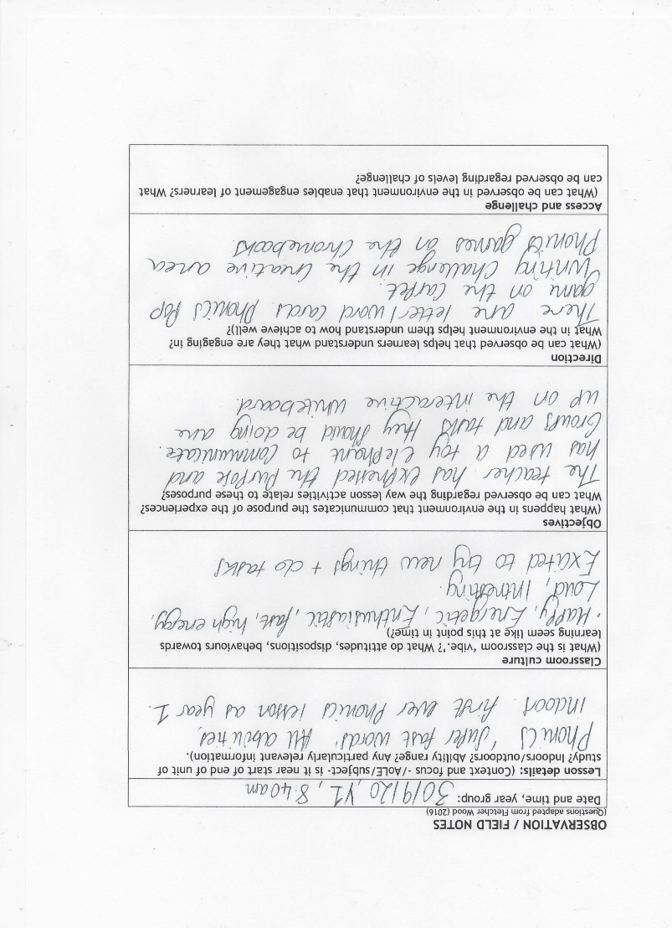
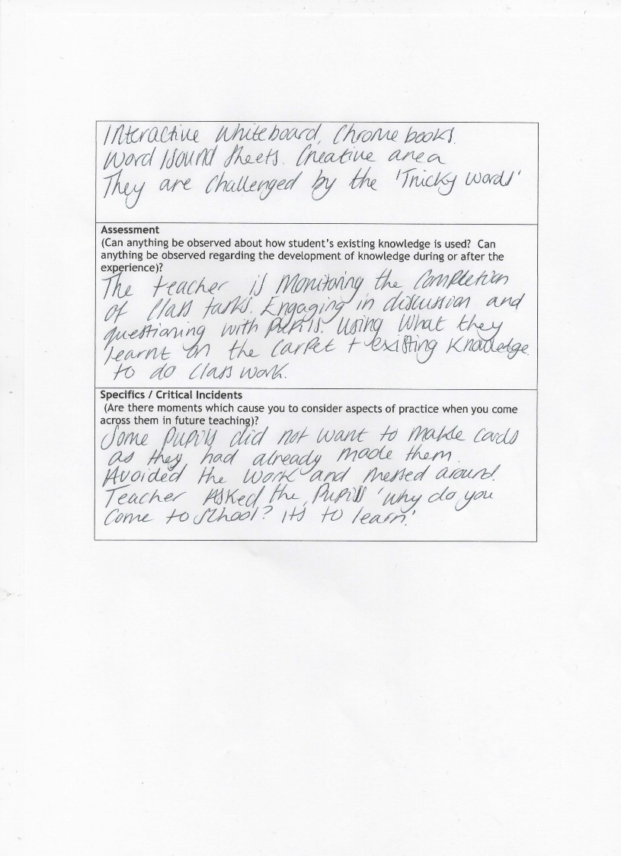
A2
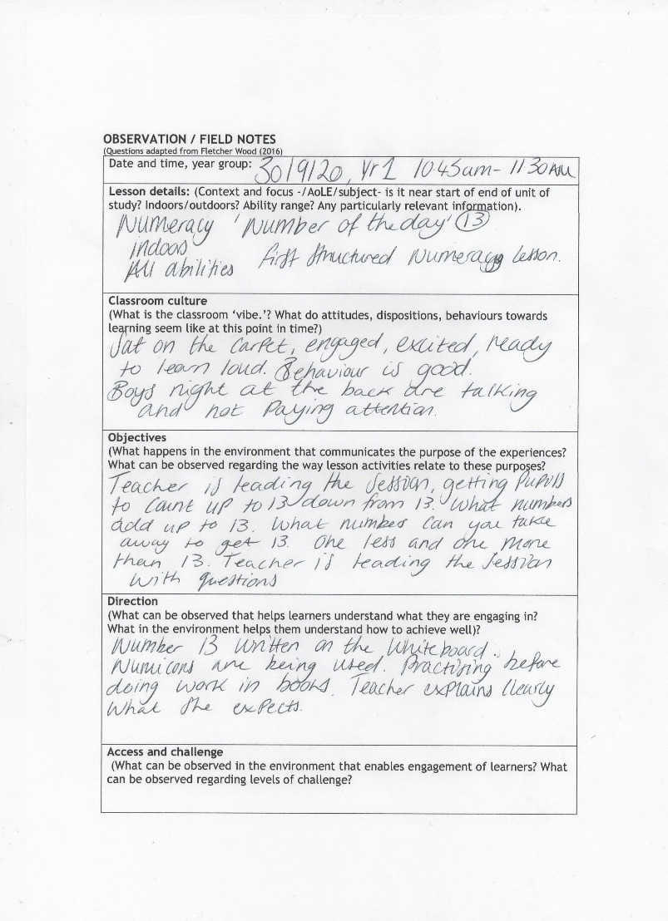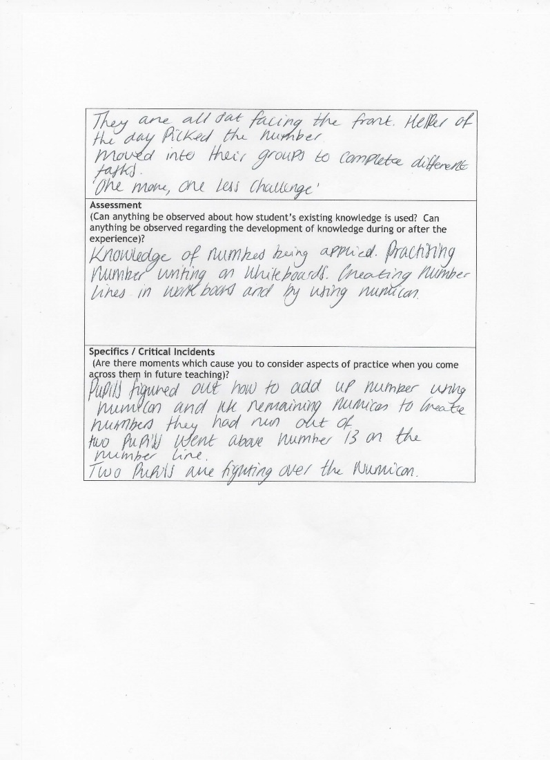
A3
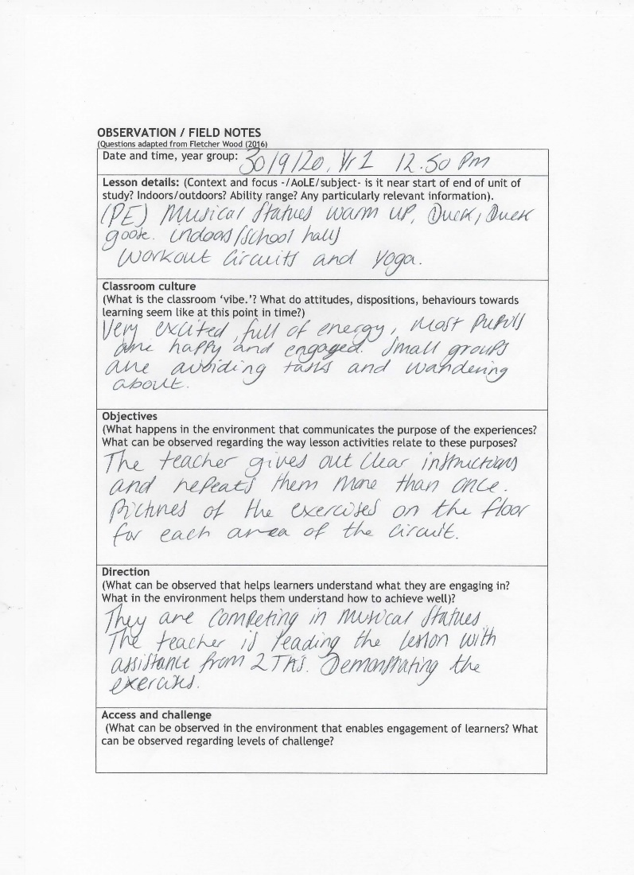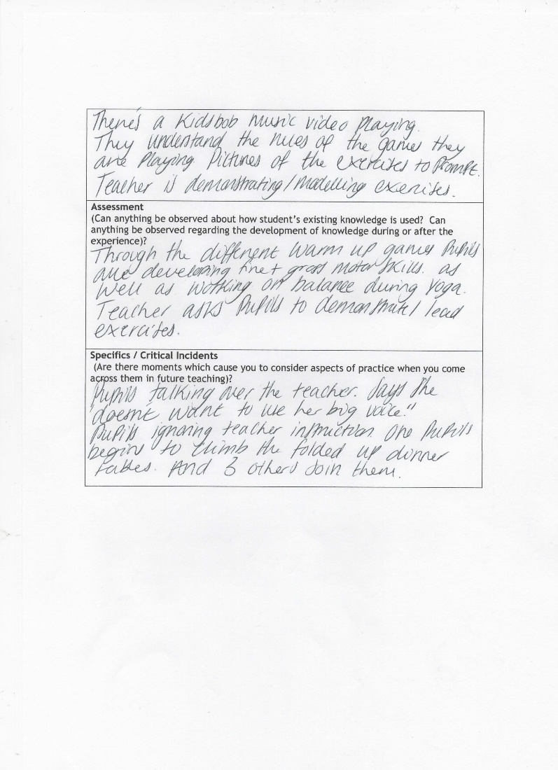
A4
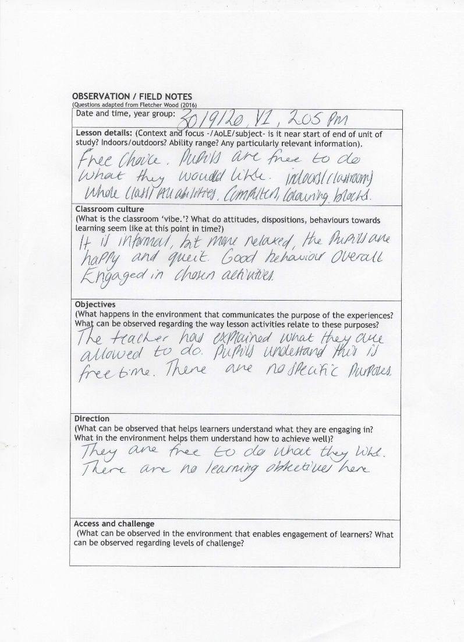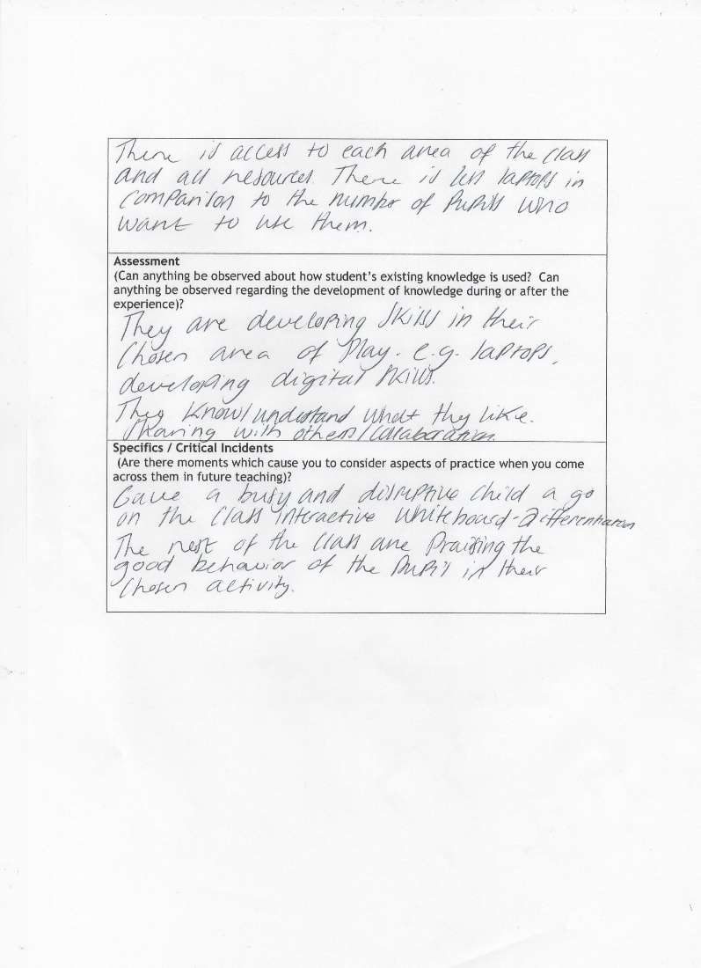

A5
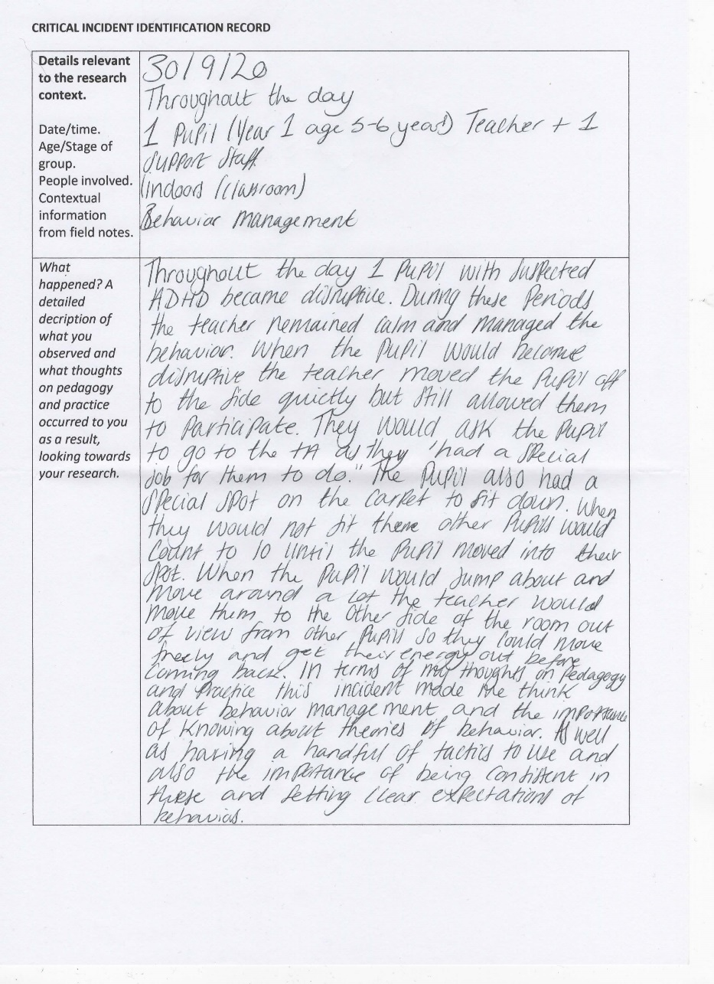
A6
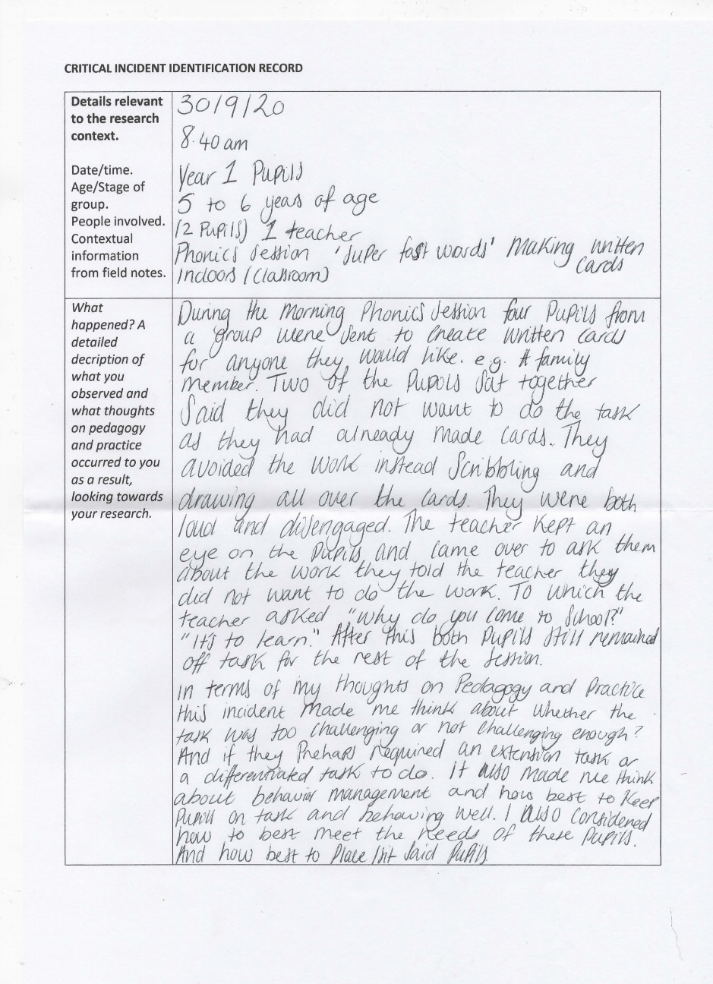
A7
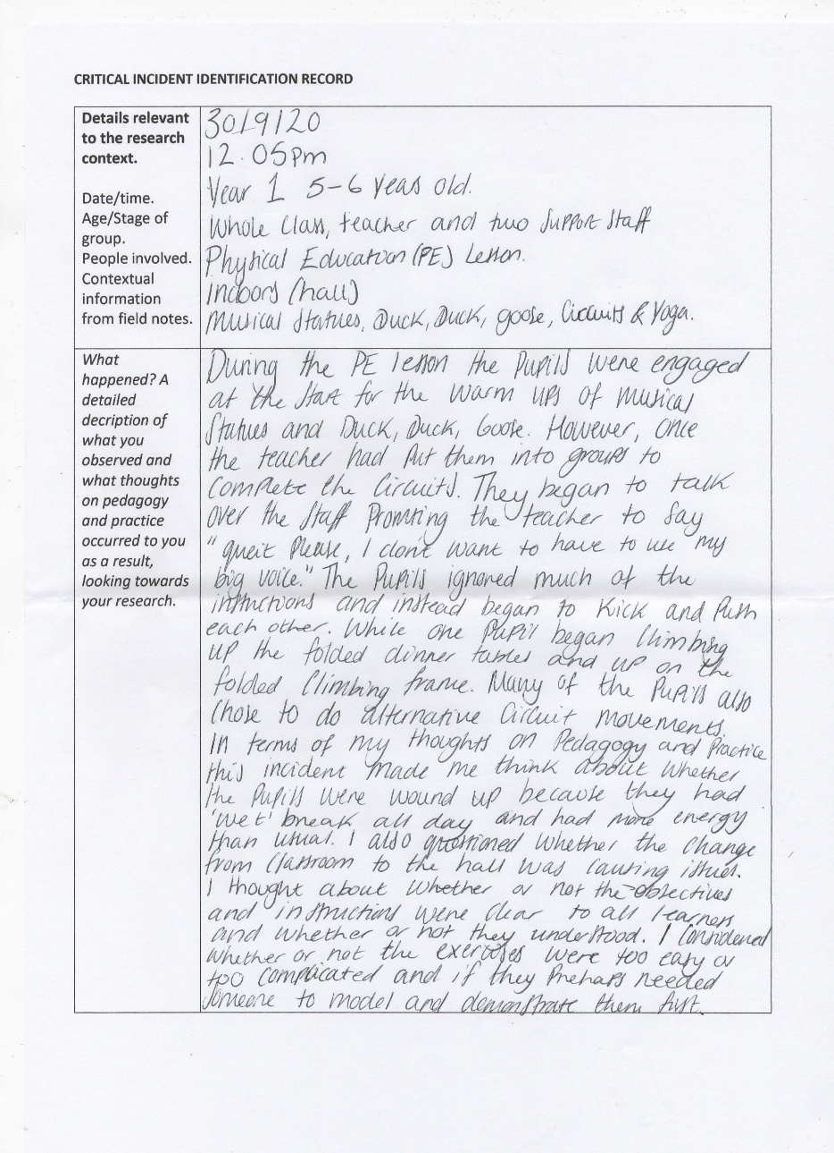
A8


