Courtney Busby
1701941
Professor: Dr. Roisin Mullins
University of Wales Trinity Saint David
Date: 4th May 2018

Contents
What is a Prosumer? 3
Uses of Microsoft Excel 3
Collated Prosumer Survey 4
Finding, Assessing & Fixing the Problem 4
Assessing the Data 4
Collated Carbon Data file 5
Finding, Assessing & Fixing the Problem 5
Assessing the Data 7
Swansea Business School – Half Hourly Data 7
Finding, Assessing & Fixing the Problem 7
Assessing the Data 7
Weather Data 2018 8
Finding, Assessing & Fixing the Problem 8
Assessing the Data 8
Conclusion 9
References 10
Appendix 11

What is a Prosumer?
According to the Oxford Dictionary, a prosumer is, “a consumer who becomes involved with designing or customizing products for their own needs”. ("prosumer | Definition of prosumer in English by Oxford Dictionaries", 2018) However, the word itself was coined by Alvin Toffler, the author of, “The Third Wave” & the term is a mixture of the words, “producer” & “consumer”. Toffler originally envisioned the world of business as consumers providing their input about products to ensure that products are wanted. This meant that consumers are now part of the development process of new products.
There are many brands in all sectors of the business world using prosumers to create or enhance products. For example, technology manufacturers update the software constantly for their products & ask for feedback if there are any bugs or glitches.
As well as this, businesses use social media & consumer awareness to get feedback off their products. An example of this is Pizza Express, a little girl wrote in to ask to stop providing plastic straws within the establishments, and Pizza Express recognized this & have switched to paper straws. This example shows that the businesses listen to their customers & want the best for them.
The influence prosumers already have it extensive as they are pushing brands to develop & create innovative products & services. (“The Rise of PROsumers (& what it means for CONsumer companies)”. 2018)

Uses of Microsoft Excel
Microsoft Excel is an extensive piece of software that is used primarily by data analysts but has many other uses. The software can create graphs, charts, tables etc. from any amount of data that is stored in the spreadsheets.
Excel is essentially a “spreadsheet program that is used to store & retrieve numerical data in a grid forgot of columns and rows”. (“What Are the Uses of Excel & MS Word in Companies?” 2018) Data analyst use excel to “enter, calculate & analyse company data” (“What Are the Uses of Excel & MS Word in Companies?” 2018) which can involve sales figures, tax, commissions etc. Unlike other programs which only has graphical & calculation capability, Excel have many tools to decipher profits, calculate trends, create numerical formats as well as visualizing data. One of the tools in Excel is to create any kind of graph from the data already inputted. It will analyse the data & provide recommended graphs & charts but there is an option to use others if the data complies with them.
Another reason as to why Excel is used by data analysts is to create company reports alongside other programs. This is because Excel can create the supporting data for the written report which could include employee statistics, profits, sales reports and more.
Lastly, Microsoft Excel has multiple functions to assess data & produce business models. The data from previous entries help to create “what-if” scenarios which can illustrate how the company is surviving. (“Advantages of Microsoft Excel”, (2018)

Collated Prosumer Survey
To create the collated version of the prosumer survey, it was important for every individual to complete the task of finding 4-5 businesses that had evidence of using prosumers. The excel file to be completed was extensive but held a lot of information regarding the amount of businesses that use prosumers, how they use prosumers, how large the business was etc. Once the 1st year Business & Management students completed this, it was collated to form one large workbook.

Finding, Assessing & Fixing the Problem
As you can see from Figure 1, the collated prosumer survey file is messy. There were blank cells, some students hadn’t completed it properly etc. Because of this, the first thing that was done to clean up the data was to use the filter icon (see figure 2) to go through each business & delete the duplicates. This was a lengthy process as many students had chosen the same business so it was important to assess each entry & decide which entry was most useful. Once this was completed, it was necessary to assess each column & row to identify any anomalies, such as a blank cell, a hyperlink not working etc.
As well as this, from column I to column V there needed to be a “Yes” or “No” answer so it was important to fill the blank cells. This was completed by using the filter icon on each column & select the blank option, which means that each cell with “Yes” in did not appear on the screen. However, once this was finished, it was noticed that the SUM column at the end of the spreadsheet was programmed to calculate the amount of entries between the columns I-V which meant that the numbers were incorrect. To solve this problem, “count-IF” was used (see figure 3) which if programmed properly, will calculate the amount of cells with “Yes”.
Additionally, the best way to analyse the data was to use the IF function (see figure 4) which was used to calculate anything above or equal to 7 in the SUM column would be classified as “good prosumer activity”, anything under 7 would be classified as “bad prosumer activity”.
These processes were continued throughout the workbook & the file itself had its font changed, its data centred & the table formatted to look presentable.

Assessing the Data
The data from the spreadsheet “Business Processes” was used to form a bar chart (see figure 5) which shows the amount of prosumer activity within each business that was selected. The graph was formed from the yes/no answers and it shows that some students chose businesses that do not show any prosumer activity, such as:
- Tesco
- Cisco
- Boots
- Allbirds.com
- Nectar
- Ikea
- H&M
- Argos
- Specsavers
- Nestle
We know that these businesses have no prosumer activity according to the graph because there were no “yes” entries in any other the columns asking questions about the businesses. It is possible to say that the businesses should improve and use prosumers to boost their sales and develop their products, but there is also the argument that the students who inputted the data may have not understood the task.
However, the other businesses have excellent prosumer activity such as:
- BMW
- Mercedes
- Google
- Audi
- Volkswagen
These businesses have the most prosumer activity and the graphs shows that compared to other businesses, they are using prosumers more which could mean that their products/services are constantly being developed to enhance user’s experience.

Collated Carbon Data file
Similar to the prosumer file. 1st year Business & Management students were tasked with completing the document. Once each individual spreadsheet was submitted, the data was then combined to form the collated carbon data file (see figure 6) which at first glance gave the reader a lot of information, but as the reader delved deeper into the data, it was clear that again, some students may not have understood the task.

Finding, Assessing & Fixing the Problem
Despite the amount of information within the spreadsheet, it was clear that the tables were not presented well and needed to be tidied. Upon this thought, it was necessary to split the 2 tables and have them in different spreadsheets within the workbook (see figure 7-8), this made it easier to tidy up the data. From examination after this, it was important to look at each part of the data and replace any mistakes as the data is meant to be binary code, 1 = yes, 0 = no. It was clear that some students did not understand this as a few students put the amount of appliances they have within the spreadsheet and some simply put the word “yes”. This meant it was simply replacing these with 1 and any blank cells were replaced with 0. Once this was completed, the format of the tables were altered slightly to enhance the presentation of the data. For example, the blue cells were surrounded in a thick black border and the font was changed into Times New Roman. The font size was also changed to 11 as well as this data font colour changed to black.
In the digital appliance table, it was necessary to continue tidying the table by merging cells. This was because the Usage column provides 2 bits of information which is only meant to be in 1 cell which meant by merging the cells for each appliance, it made it easier to understand.
Once this was completed, to assess the data, it was easier to use the SUM function and calculate how many appliances each student had within their homes to create a graph.
As well as this, another way that was necessary to assess the data was by creating 2 more tables, 2 that showed the amount of CO2 usage by each student and another 2 to show how much students are spending on these appliances per year (see figures 9-12).

To create the CO2 usage tables, it was a simple copy & paste with the tables & then delete unnecessary columns, this meant the “assumptions” & “per use” column for both of the kitchen appliance and digital appliances. Then, to calculate how much CO2 each student was using, it was important to switch each of the 1’s to the corresponding CO2 kg per year. For example, the microwave oven makes 39kg of CO2 per year, so every student who said that they have a microwave oven had 39 in their cells (see figures 9-10). To calculate the total amount of CO2 usage per year for each student, it was simply using the SUM function which added each number in the column for each student (see figure 13). Rather than use this function on each cell, it was simpler to drag the box around the total cell to the others and it would add each number up automatically.
Once this was completed, it was then time to calculate the average amount of CO2 usage each student uses per year. This means that the AVERAGE function must be used but also “absolute cell referencing” must be used as well. Absolute cell referencing is used when calculating the average between 2 numbers, but as soon as the box is dragged across, the numbers will change as the total sum will not continuously be used, this means that when creating the formula, it is necessary to place a dollar sign before and after the cell reference letter to create an absolute cell, a cell that will be used continuously (see figure 14).
To present the new data in an easy-to-read format, it was necessary to use the “conditional formatting” icon which will transform the data using images or colour. For example, the CO2 usage data is a combination of reds as the darkest red indicates that the student is creating a large amount of C02 whereas the pink represents the students who use a minimal amount of CO2.
To give clear indication as to whether the CO2 usage was good or bad, it was necessary to use the IF function which stated that anything above or equal to 5% would be classified as “Gold Award” & anything below 5% would be classified as “needs improvement”. The same principle was applied to the digital appliance CO2 usage.

Lastly, to create the costing table, it was the same method of copy & pasting & deleting the unnecessary columns, but instead of inputting the CO2 usage in the cells with 1, it was inputting the cost per year of each appliance. Again, the SUM function was use to add each price up per student to discover the total amount each student pays for digital & kitchen appliances. Similarly, the “conditional formatting” icon was also used to clearly identify which student spent the most using colour.

Assessing the Data
A graph was made for each spreadsheet in the workbook of the collated carbon data file.
The first graph (see figure 15) shows the amount of kitchen appliances each student owns & it clearly shows that student 19 owns every kitchen appliance. We can assume from this that the student will be producing more CO2 than the other students per year. The bar chart also shows that the lowest amount of appliances owned by a student is 8 which we should be able to assume that these students won’t be producing as much C02 per year.
The graph showing the amount of C02 usage per year for kitchen appliances (see figure 16) proves the assumptions made using the previous graph as student 19 is producing a large amount of C02. However, despite the assumption that the students using the less amount of products will use the least amount of C02 is slightly disproven as student 11 uses 8 appliances like 6 other students but their C02 usage is vastly different to these other students as it is so low. Because of this, we know that it will depend on the amount of C02 per appliance which is used per student not the amount of appliances a student owns.

Swansea Business School – Half Hourly Data
The electrical data provided by the Swansea Business School was extremely extensive & gruelling as it was difficult to figure out how to present the data in a better format as well as how to visually present the data using graphs etc.

Finding, Assessing & Fixing the Problem
The initial problem was that there were years of cells that did not have any data within them so the first thing to do was to delete all of the blank cells. This was done using the filter icon (see figure 2) to isolate the amount of blank cells without deleting any important data. However, there were a few months within 2015 that had blank cells so it was important that the relevant data was not removed.
Once this was completed, it was a good idea to separate the remaining years into different spreadsheets to make the data easier to understand. This was done using the filter icon to isolate the year & then using copy & paste to transfer the data into another spreadsheet (see figure 21).

Assessing the Data
To assess the data, two pivot tables were made using the electrical data. The first pivot table was made using the pivot table icon (see figure 22). Once this was completed, the pivot chart was then created using the pivot chart icon (see figure 23).
The chart it created (see figure 24-25) shows the amount of electricity used per month per year. The graph unexpectedly shows that in December 2012, there was hardly any electricity produced which is an anomaly as the rest of the months show that plenty of energy was used. The anomaly could have happened for many reasons such as the equipment recording the data could have malfunctioned or switched off, it also could’ve meant that the Business School was closed so there was no electrical data recorded etc.

Weather Data 2018
The weather data file for 2018 was given to us by a kind lady who lives on a farm in Lampeter. The lady records weather data every day to the mm of rainfall.

Finding, Assessing & Fixing the Problem
The first initial problem was that the data was just figures, it didn’t necessarily mean anything so it needed to be cleaned up. To start, it was important to differentiate the figures by using the border tool to give clear distinctive lines between the figures. Once this was completed, it was necessary to use the sorting tool to discover which figure was the highest and which was the lowest. When the sorting tool revealed the figures, it was important to input a comment so when the table goes back to normal, the highest and lowest figures will be clearly indicated by a small red triangle in the corner of the cell which shows there is a comment on the cell.
Similarly to the other spreadsheets, it was a good idea to use the “conditional formatting” tool to show which figures were the lowest/highest at a first glance by colour. The colour system shows that the dark green is the highest figure and the bright red is the lowest figure.

Assessing the Data
To assess the data, it was necessary to find the average temperature & rain fall within the month of January 2018. This was completed using the AVERAGE function (see figure 26) as well as calculating the total amount of rainfall using the SUM function (see figure 27).
Additionally, it was important to use the IF function to discover the amount of days within January that were useful to farmers, e.g. the amount of night air frosts, hot nights, grass growing days etc. (see figure 28-29). The most complex IF function used in this spreadsheet was the formula showing the amount of rainy, snowy and dry days in January 2018 (see figure 30).
Once the IF statements were completed, it was important to place the IF statements onto another spreadsheet within the workbook. For example, in January, there were 17 night air frosts which would have killed the farmer’s crops. There were 8 grass growing days in January which is different from data given 10 years ago as there were 12 grass growing days and 13 night air frosts. From the data compiled from both 2010 & 2018 (see figures 31-41), there may be evidence of global warming.

Conclusion
To conclude, using Microsoft Excel to create, store & analyse data is useful as it has many functions, look-ups, etc. that can help businesses run smoothly as well as help CEO’s and the board of directors make a good decision with enough evidence to back them up.
Word count: 2693

References
Prosumer | Definition of prosumer in English by Oxford Dictionaries. (2018). Retrieved from https://en.oxforddictionaries.com/definition/prosumer
The rise of PROsumers (And what it means for CONsumer companies). (2018). Retrieved from https://medium.com/@aditya.vikram/the-rise-of-prosumers-and-what-it-means-for-consumer-companies-26d408325934
Ziemba, E., Eisenbardt, M., Roisin, M., & Grabara, D. (2017). Investigating incentives that encouraged and can encourage Polish and UK-based prosumers to engage in knowledge sharing.
What Are the Uses of Excel & MS Word in Companies? (2018). Retrieved from http://smallbusiness.chron.com/uses-excel-ms-word-companies-37195.html
Lenotti, P. (2018). 5 Key Uses of Excel in the Work Place. Retrieved from https://learn.filtered.com/blog/5-key-uses-of-excel-in-the-work-place
Advantages of Microsoft Excel. (2018). Retrieved from https://turbofuture.com/computers/Advantages-of-Microsoft-Excel
Microsoft Excel: Advantages and Benefits | ACP E-learning | LMS | Web Development. (2018). Retrieved from https://www.acpcomputer.edu.sg/index.php/microsoft-excel-advantages-and-benefits/
O'Beirne, P. (2008). Information and data quality in spreadsheets. arXiv preprint arXiv:0809.3609.
Bewig, P. L. (2005). How do you know your spreadsheet is right? Principles, Techniques and Practice of Spreadsheet Style. In Annual EUSPRIG Conference. Retrieved December (Vol. 9, p. 2006).
MacKay, D. (2008). Sustainable Energy-without the hot air. UIT Cambridge.

Appendix
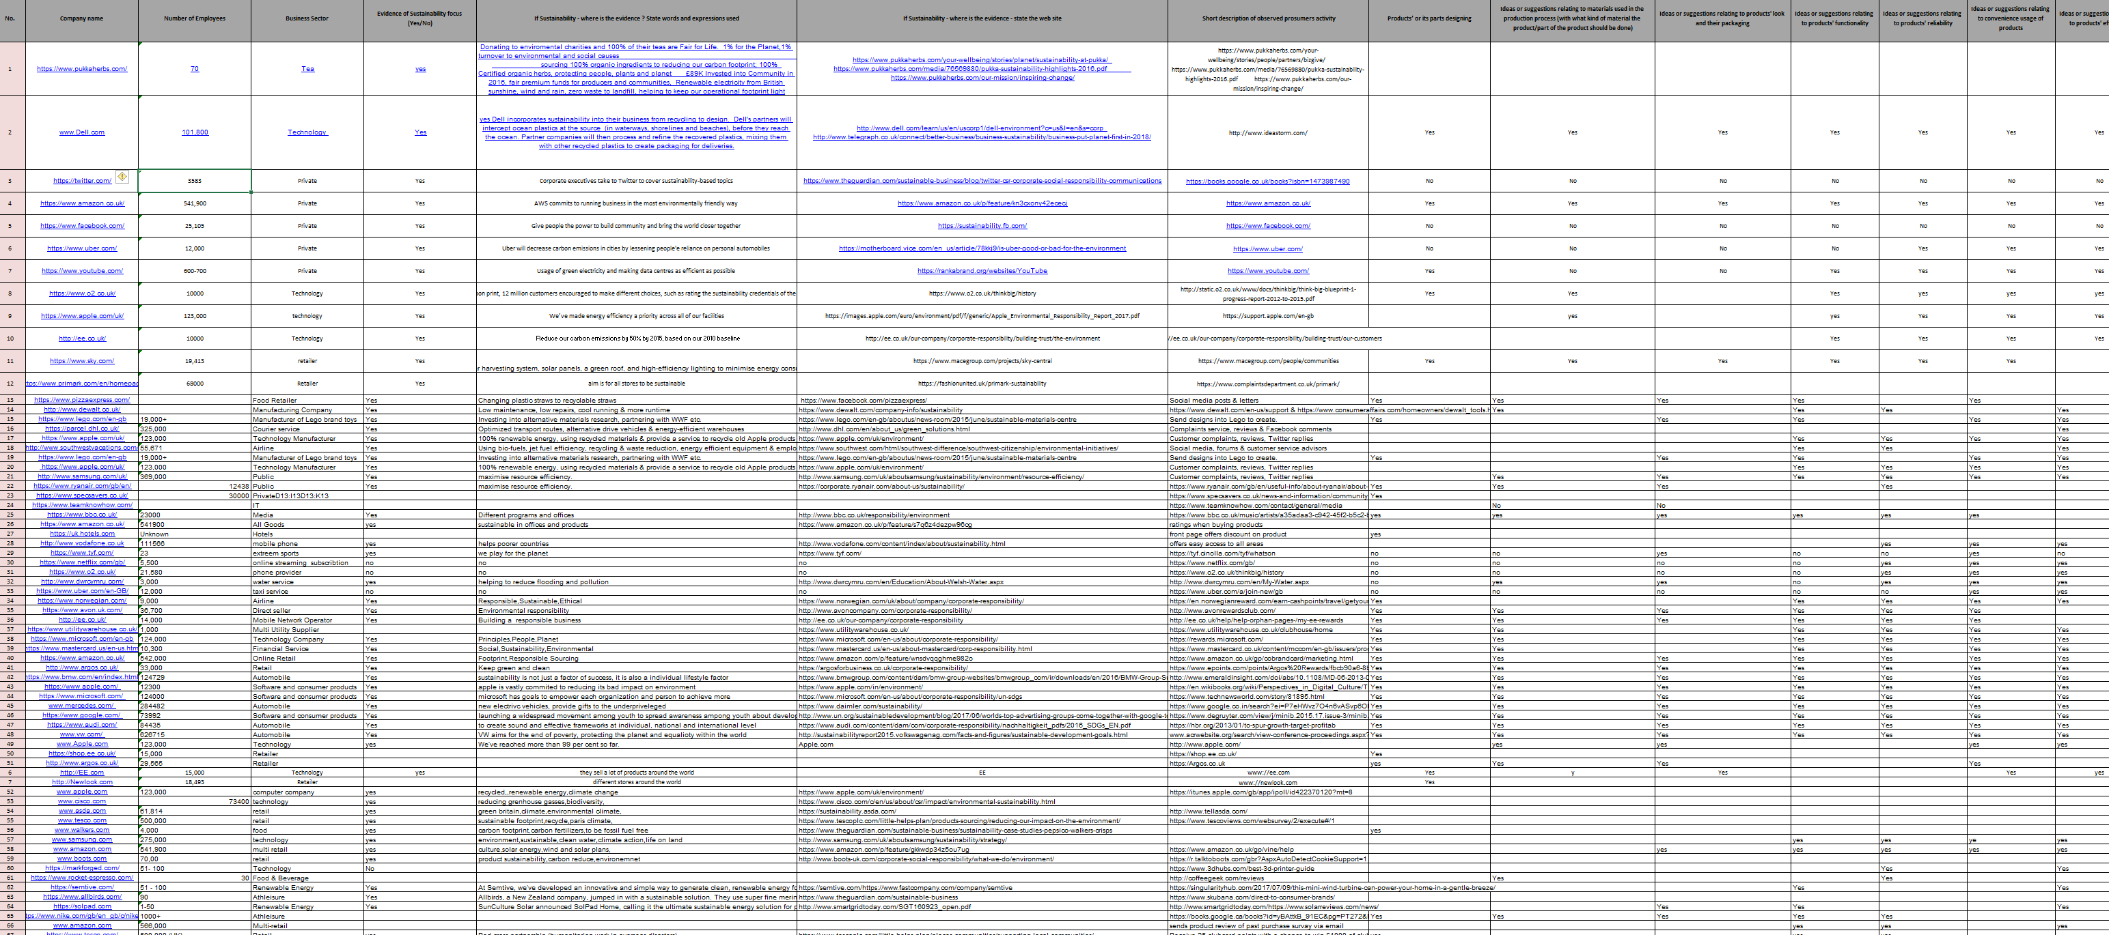
Figure 1


Figure 2

Figure 3

Figure 4

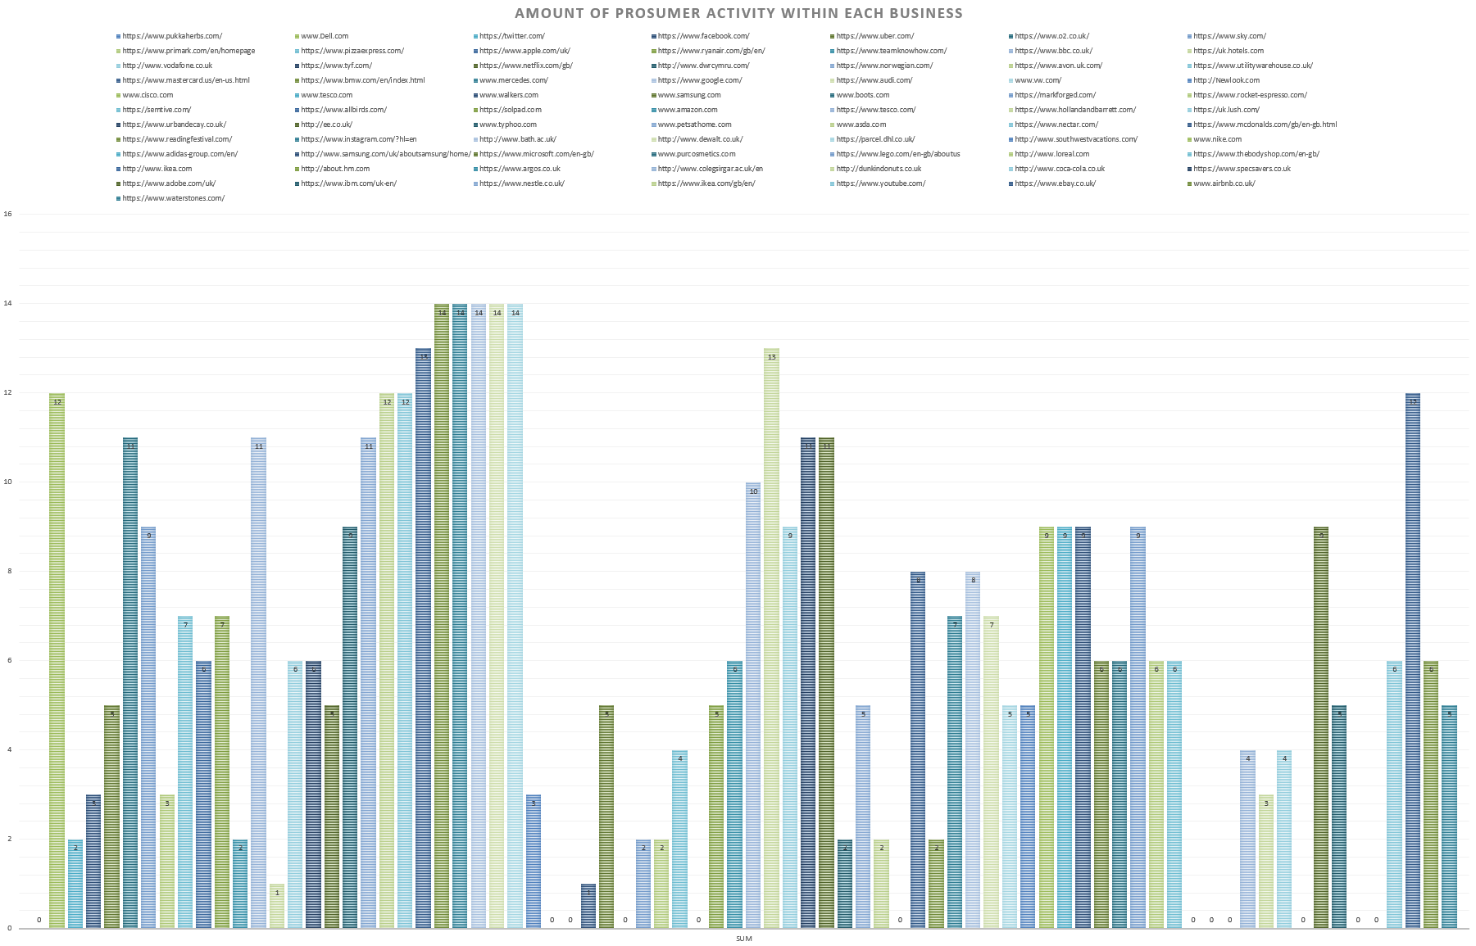
Figure 5

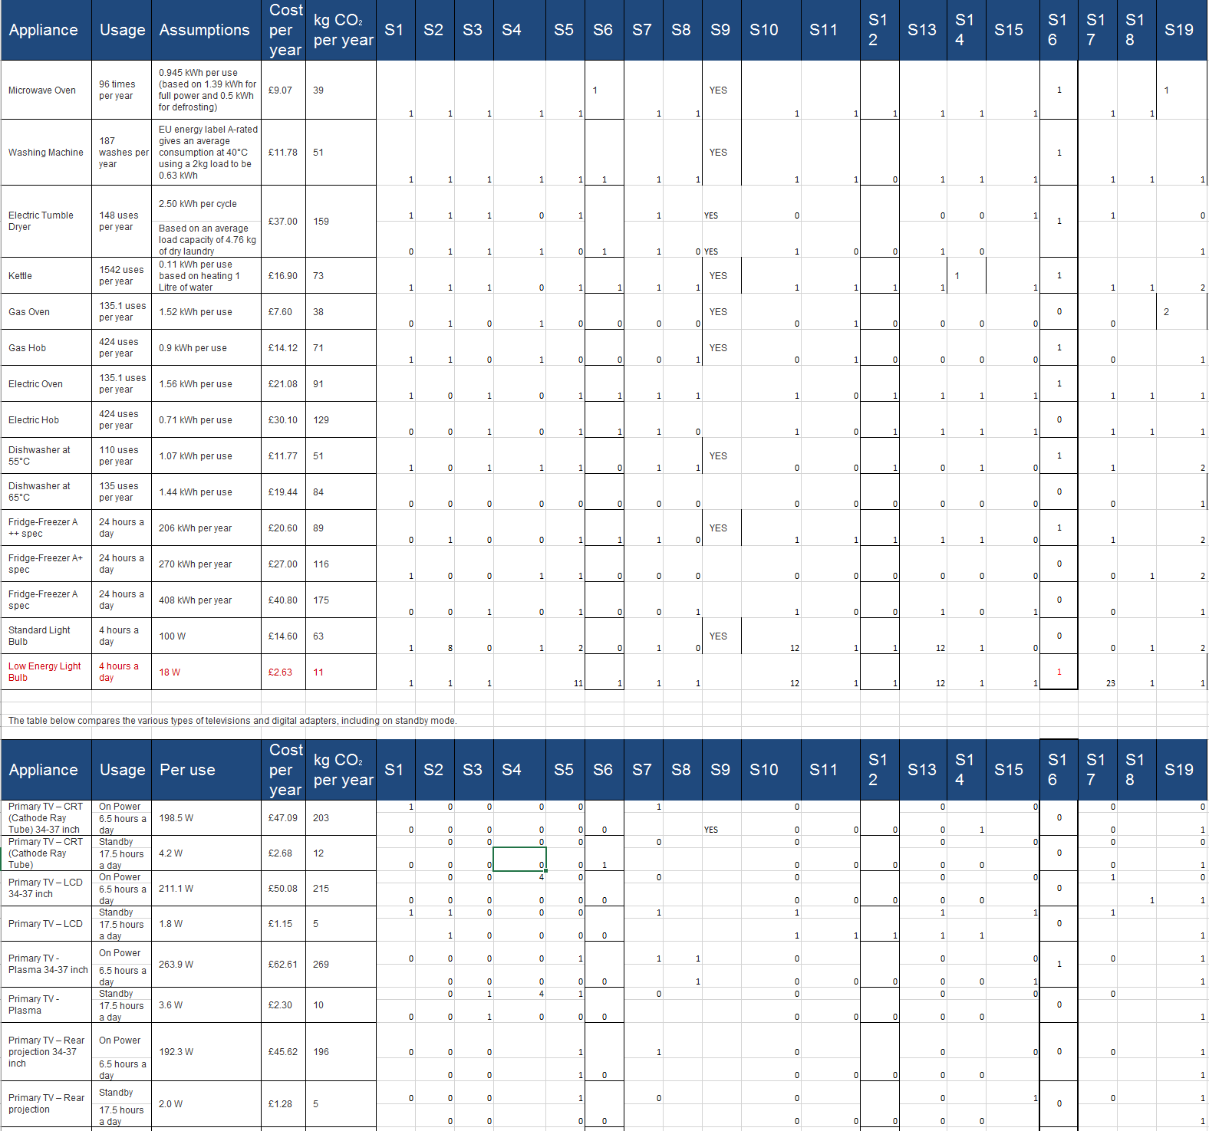
Figure 6
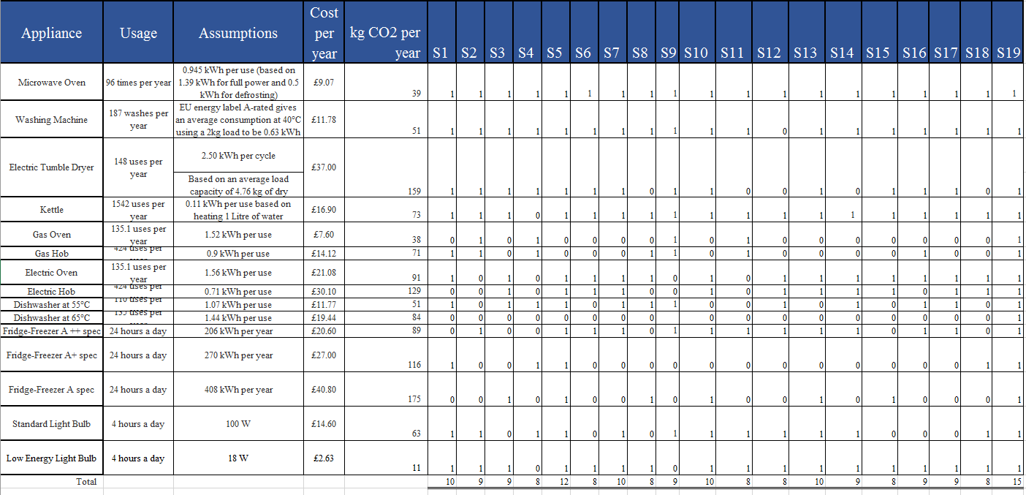
Figure 6
Figure 7
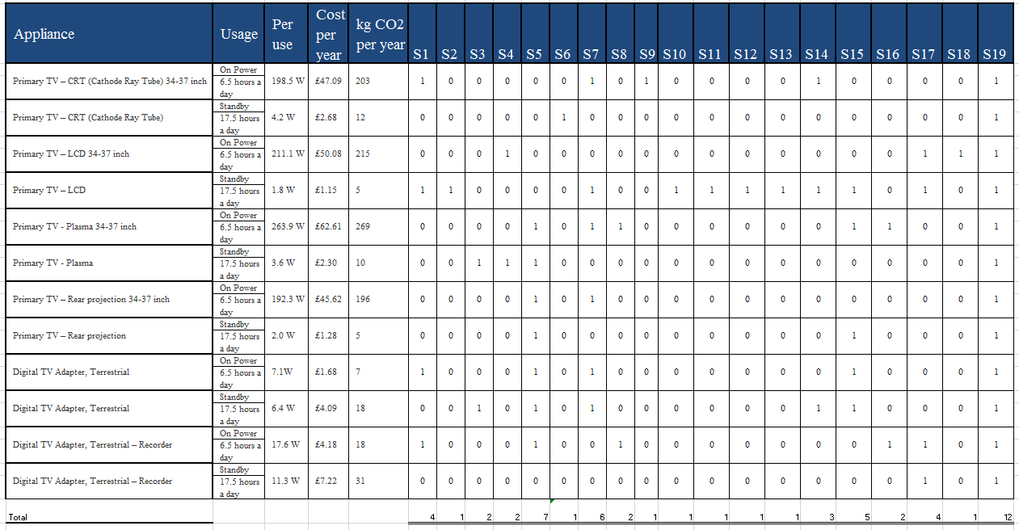
Figure 8

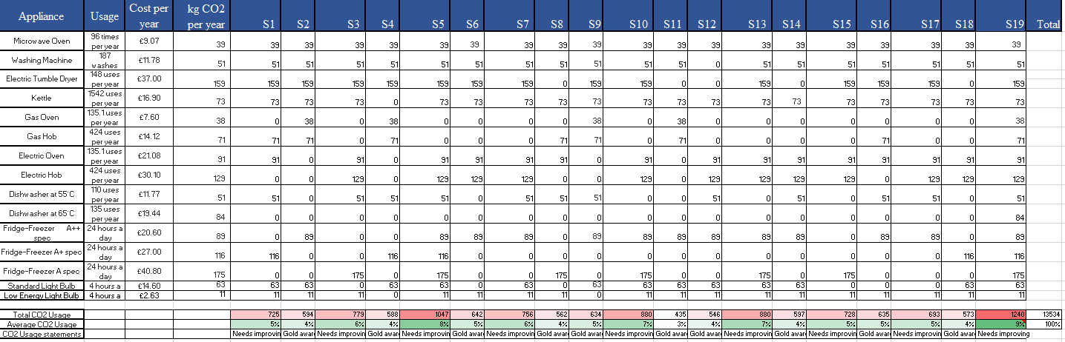
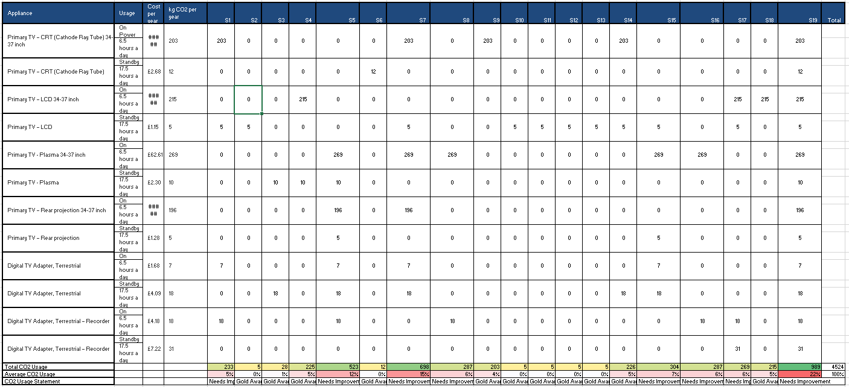
Figure 9
Figure 10
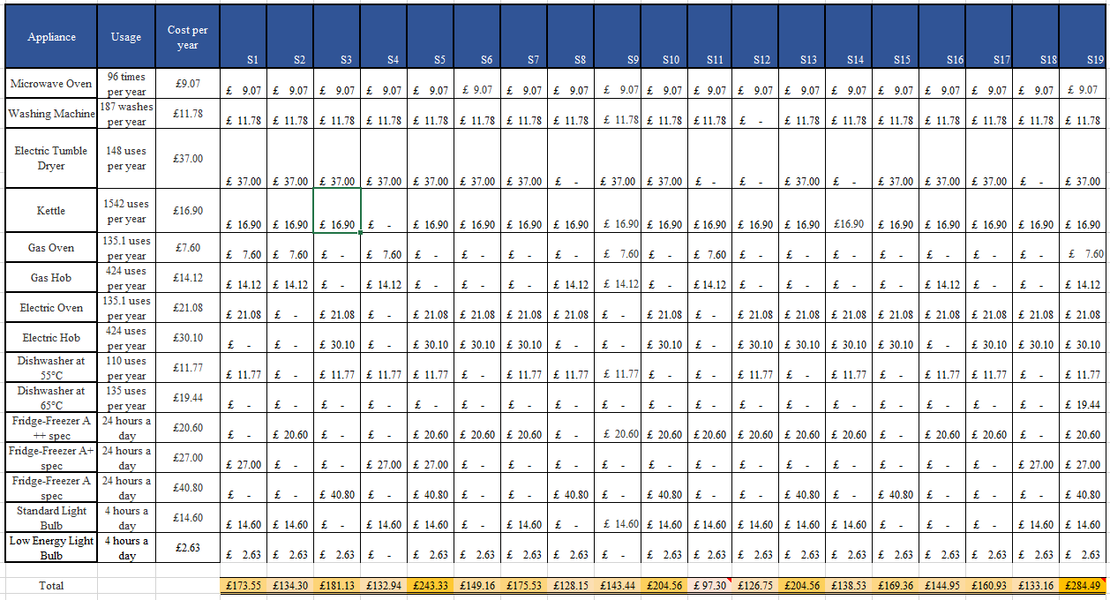
Figure 11

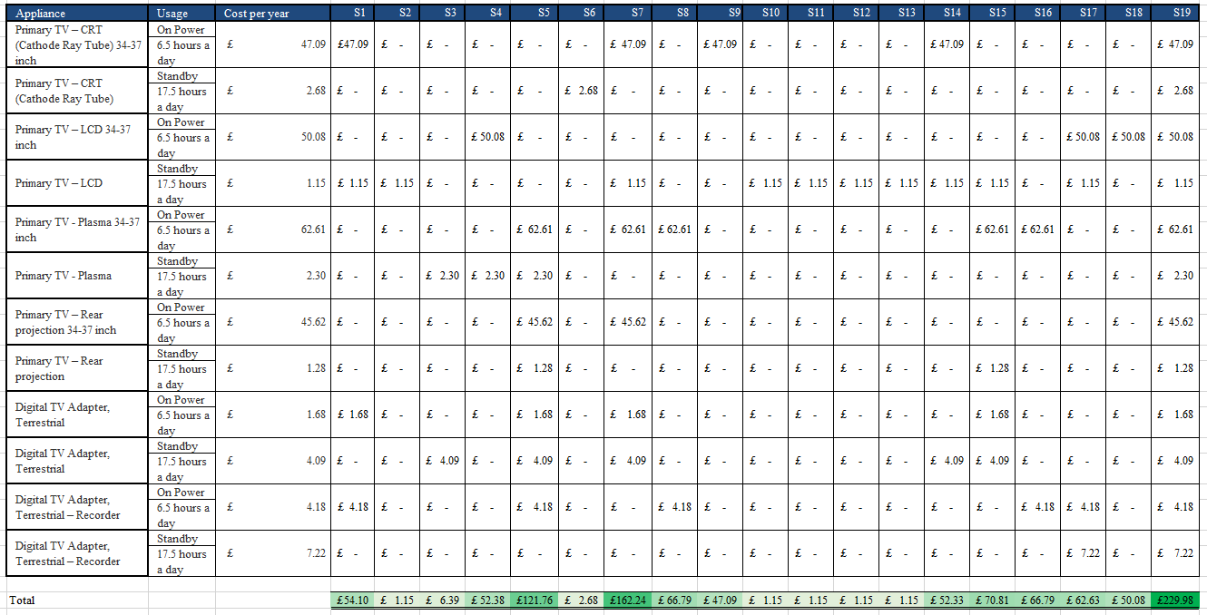
Figure 12

Figure 13

Figure 14

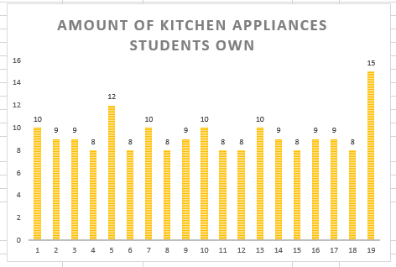
Figure 15

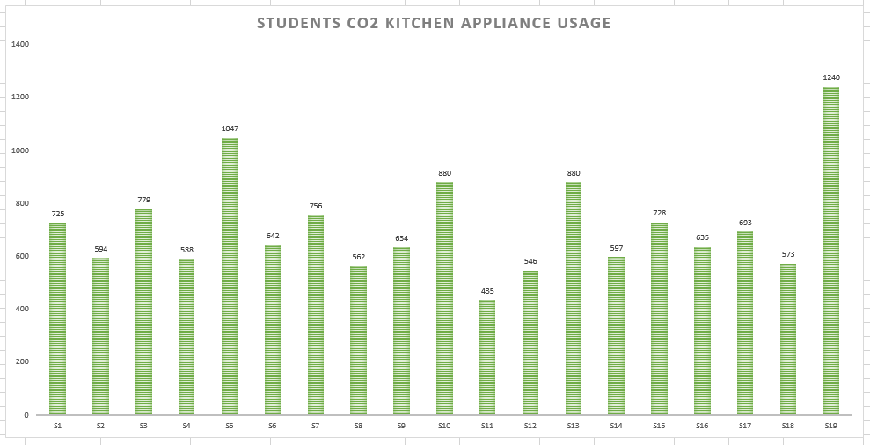
Figure 16

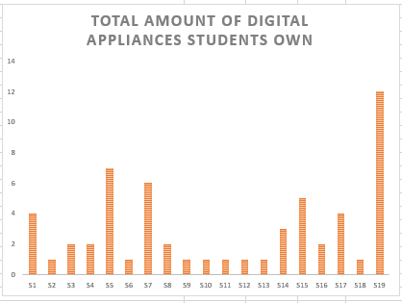
Figure 17

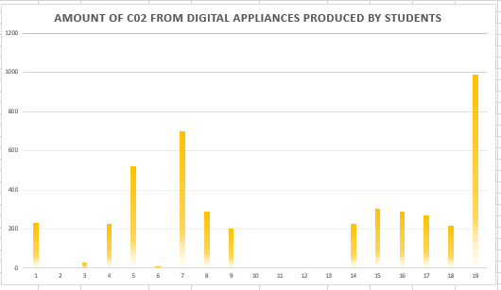
Figure 18

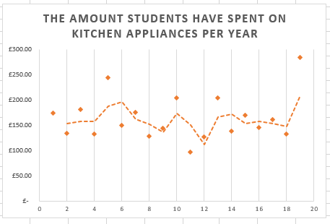
Figure 19

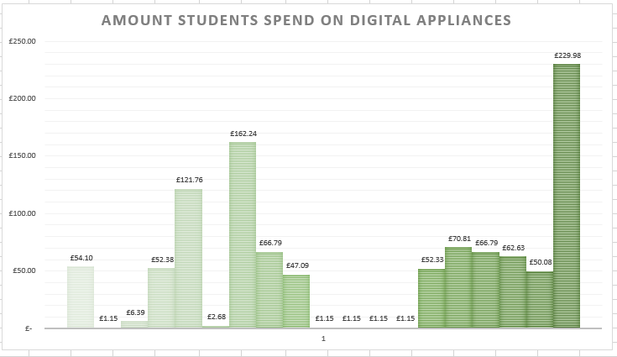
Figure 20

Figure 21


Figure 22


Figure 23

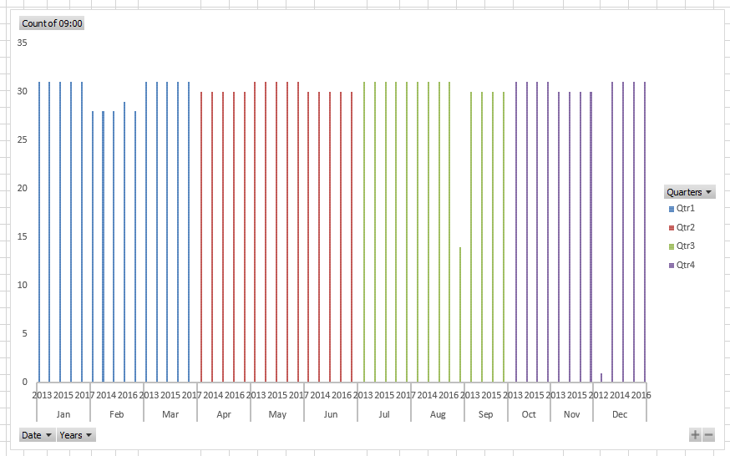
Figure 24

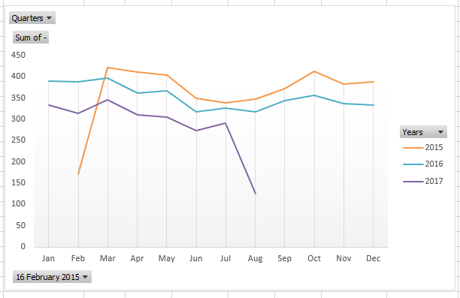
Figure 25

Figure 26

Figure 27

Figure 28

Figure 29

Figure 30
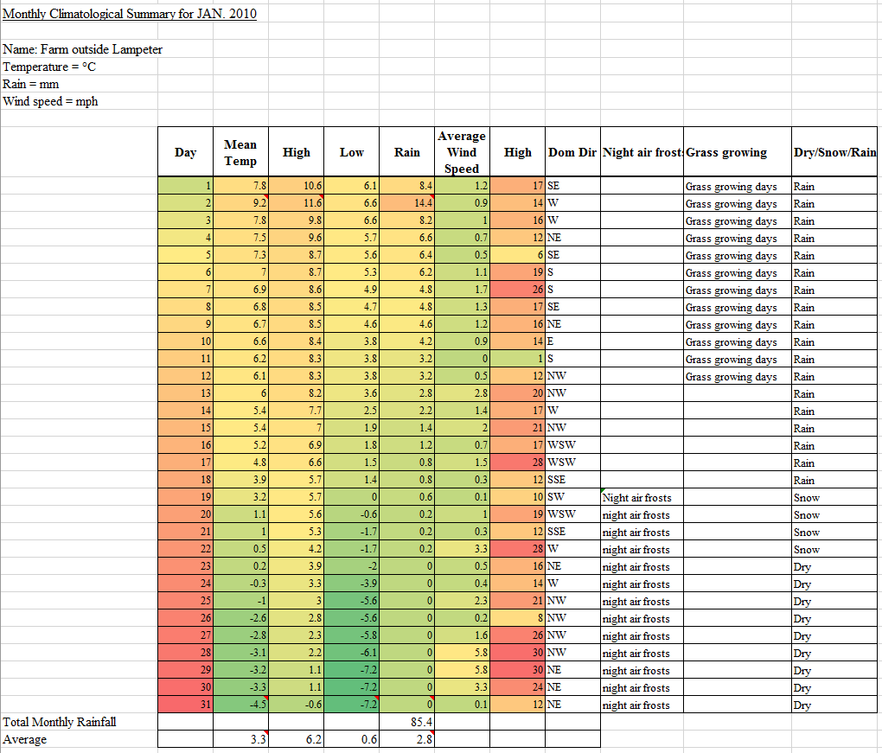
Figure 31

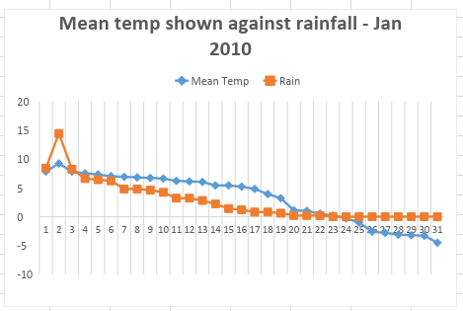
Figure 32

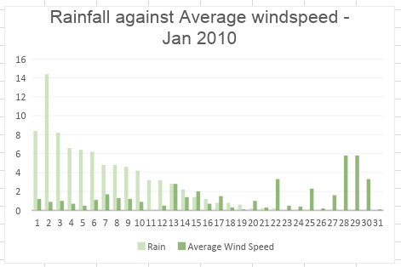
Figure 33
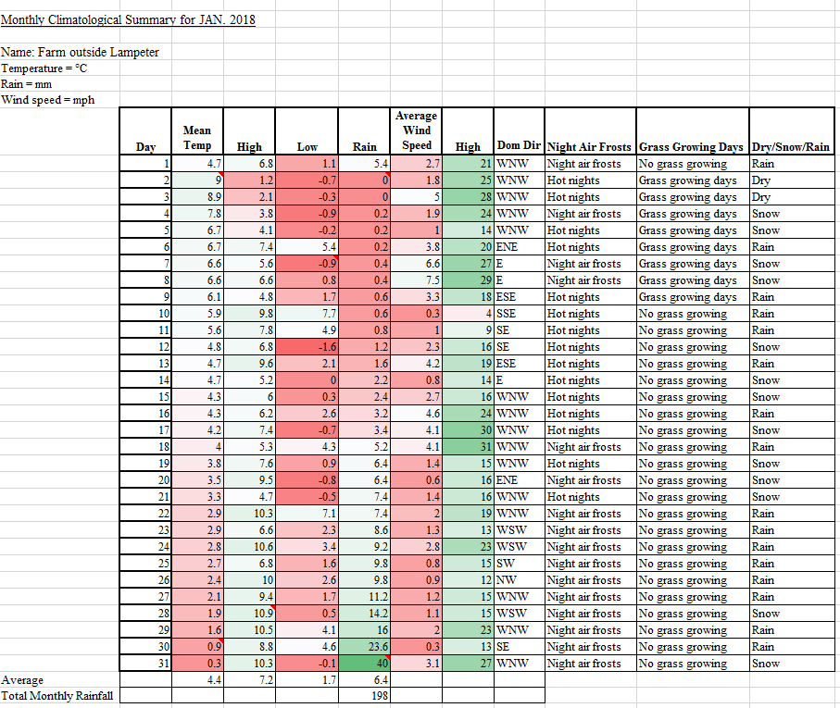
Figure 34
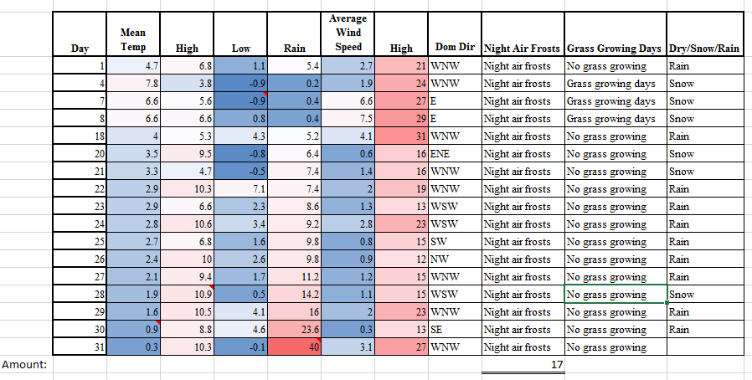
Figure 35
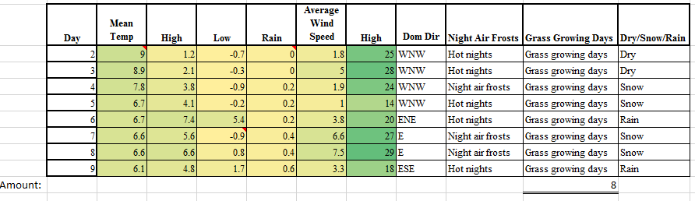
Figure 36
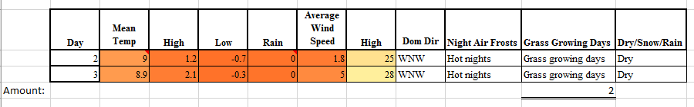
Figure 37
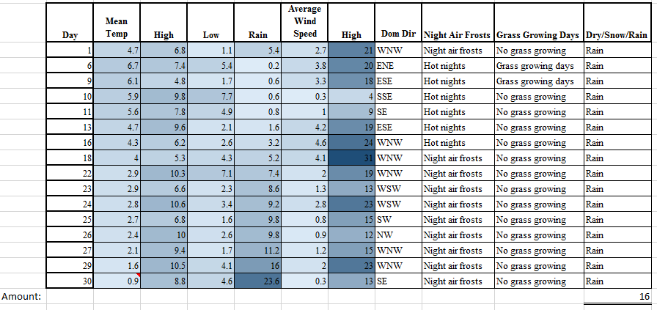
Figure 38
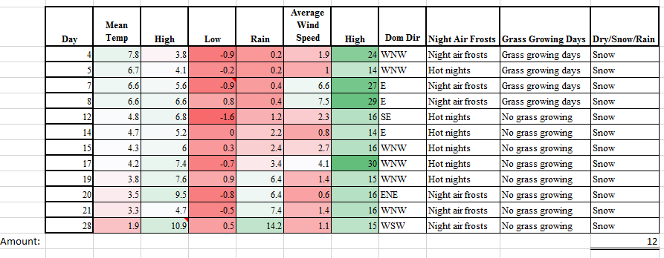
Figure 39

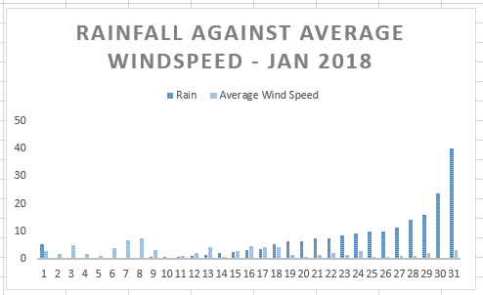
Figure 40
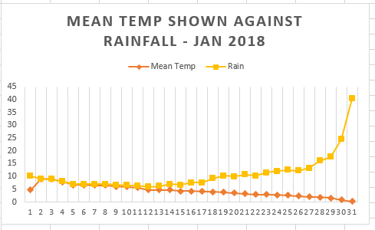
Figure 41

