CRAAP TEST Activity: Part 1:
In this activity, you will use the journal article provided to apply the CRAAP Test and evaluate the source. Your goal is to determine whether the article is appropriate and relevant for addressing the question:
To what extent are academic skills useful in the workplace?
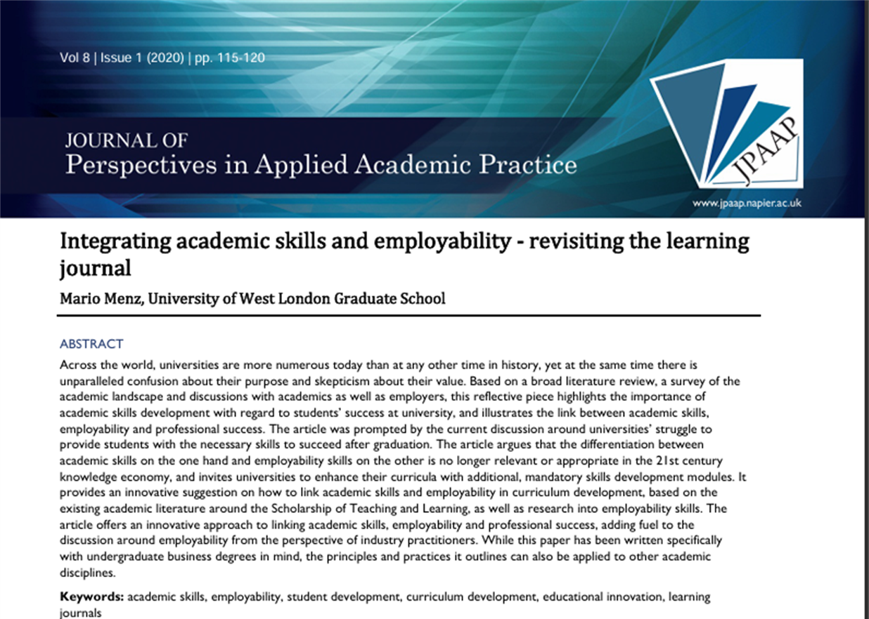

Currency
Relevance
Authority
Accuracy
Purpose

CRAAP Test Part 2:
In this activity, you will build on your understanding of the CRAAP Test by locating and evaluating one source that is both appropriate and relevant to the question: “To what extent are academic skills useful in the workplace.” Your chosen source must be found either through the UWTSD Library or via Google.
Currency
Relevance
Authority
Accuracy
Purpose

