Title Page
Lab Report Thermochemistry Calorimetry
Author Stephen Deane
Date 31st October 2024
Student number:2307720

Contents
Contents 2
1 Introduction 3
2 Results 4
3 Discussion 7
4 Conclusion 8
5 References 8
6 Appendices 8

Figure 1 Lab result sheet 1. 5
Figure 2 Lab result sheet 2 7

Equation 1 The heat change = Mass x specific heat change x Temperature change 3
Equation 2 Specific heat capacity = Heat change / Mass X Temperature change 3
Equation 3 Heat Capacity = Heat change / Temperature change 3
Equation 4 Heat Change = temperature change X Heat capacity 3
Equation 5 showings Qsystem is equal to Qsurroundings 3
Equation 6 experiment 1 workings for Qcold water. 4
Equation 7 experiment 1 workings for QHot water. 4
Equation 8 Experiment 1 workings for HC 4
Equation 9 Equation used to work out HCcalorimeter 4
Equation 10 data added to equation 9 4
Equation 11 Equation 9 rearranged to work out HCcalorimeter 4
Equation 12 experiment 1's workings for Qcalorimeter 4
Equation 13 experiment 1 workings to show the first law of thermodynamics 5
Equation 14 experiment 2 the workings to find Qwater 6
Equation 15 experiment 2 the workings to find Cp metal. 6
Equation 16 equation used to work out the Cp metal. 6
Equation 17- equation 16 find in with data. 6
Equation 18 - equation 17 rearranged to find Cp metal. 6
Equation 19 experiment 2 workings to show the first law of thermodynamics. 6

Introduction
The hypothesis for this experiment is the expected transfer of heat energy from the metal disk to the water inside the calorimeter which will then increase the temperature of the water rapidly cooling the metal till both reach thermal equilibrium. In this experiment the student will aim to measure the specific heat capacity of an undisclosed metal. Specific heat capacity can be defined as “The amount of energy needed to raise the temperature of 1 kg of substance by 1°C.” [1]. This will help the student work out the energy transfer between the hot water/metal and then cold water in the calorimeter. The student will complete two different test the first heating water and mixing it with cold water and the second being heating a metal disk in boiling water till it warms to thermal equilibrium then it will be removed and place into the calorimeter containing cold water. From this experiment it should show the first law of thermodynamics, that being energy cannot be created or destroyed it will just be converted from 1 form of energy to another.
The equations provided for this experiment are detailed below the first being used for working out the specific heat capacity.
$$Q=M ×Cp × ∆T$$
Equation 1 The heat change = Mass x specific heat change x Temperature change
$$Cp= \frac{q}{Mass × ΔT}$$
Equation 2 Specific heat capacity = Heat change / Mass X Temperature change
Equation 2 is used to work out the Cp (specific heat capacity).
$$HC= \frac{q}{ ΔT}$$
Equation 3 Heat Capacity = Heat change / Temperature change
$$q= ΔT ×HC$$
Equation 4 Heat Change = temperature change X Heat capacity
Equation 3 is used to work out the heat capacity but can be rearranged to find the heat change in equation 4.
$$QSystem=-Qsurroundings$$
Equation 5 showings Qsystem is equal to Qsurroundings
The system and surroundings can be defined as below.
System: The item involved in the reaction, such as the reactants and products.
Surroundings: anything else, such as the calorimeter and the water inside.
Some of the controlled variables are the starting temperature of the water and the temperature of the boiling water. The dependent variable in this experiment is the change of temperature and the independent variables are the surroundings and the metal used.

Results
From figure 1 it can be seen the different measurements used for this experiment. The first steps the student took was to weigh out the amount of water being used and the temperature of the water both cold and hot. Once the student had both hot and cold water they were mixed inside the calorimeter. After stirring the water together, the temperature was measured so the system and surroundings could worked out. First the system
For the cold water the equation would look like below
$QCold water=50g X 4.$186 J/OC X 18.7OC = 3913.91 J
Equation 6 experiment 1 workings for Qcold water.
The same can be done for the hot water.
$QHot water=50g X 4.$186 J/OC X -20.6OC = -4311.58J
Equation 7 experiment 1 workings for QHot water.
For the Qcalorimeter the student used the below equation but still needs to work out for the HC.
$$Qcalorimeter= HC* ΔT=HC*18.7°C$$
Equation 8 Experiment 1 workings for HC
From these results it can be added to equation to work out the Heat capacity of the calorimeter below.
$$QHotwater= -[Qcoldwater+Qcalorimeter]$$
Equation 9 Equation used to work out HCcalorimeter
When this equation is filled with the results it would look like this

$$-4311.58 J= -3913.91 J+HC . 18.7°C$$
Equation 10 data added to equation 9
Once this equation has been condensed and rearranged to find for HC it would look like the below

$$HC= \frac{-397.67}{-18.7}$$
Equation 11 Equation 9 rearranged to work out HCcalorimeter
This would then give the result of HC equaling to -21.26578. from this the last equation can be used for to find the Qcalorimeter.
$$Qcalorimeter= 21.6578 × 18.7$$
Equation 12 experiment 1's workings for Qcalorimeter
This then shows that the QCalorimeter is 397.67 J. the resulting figure can then be taken to show the relationship between the system and surroundings.
$$Q_{system}={-Q}_{surroundings}= -397.67 J=-397.67 J$$
Equation 13 experiment 1 workings to show the first law of thermodynamics
below is a scanned copy of the first experiment result page as figure 1.
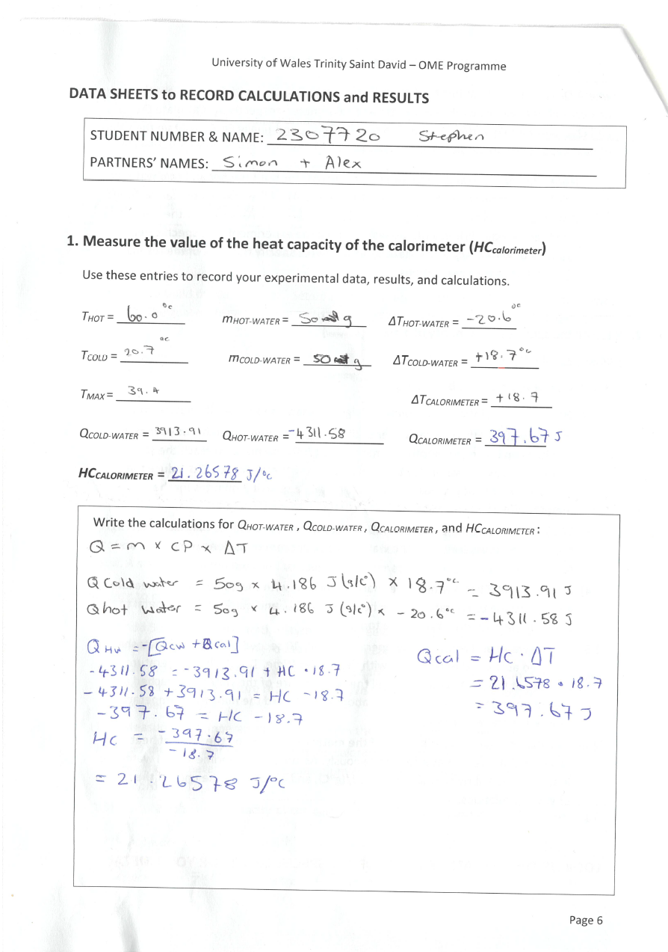
Figure 1 Lab result sheet 1.

For the second test the student placed a beaker above the Bunsen burner to start heating the water bath to a boil. This is to heat the metal disk once it is heated to equilibrium with the water the student added it to the cold water in the calorimeter. Then the student needed to stir the calorimeter to record the temperature of the water. It was expected that the water would rise when the metal disk was added. From these steps the student needed to record the temperature change the metal being -71.1 degrees and the cold water going up by +9 degrees. To work out the system and surroundings the student needed to use equation 1 and 5. First the surroundings.
$$QWater=30g ×4.186 J/(goc) ×9oc$$
Equation 14 experiment 2 the workings to find Qwater
This then gives the student the result of =-1130.22 J. then using the same equation to work out for Cp metal.
$$Cp Metal=18.5454 g×Cp × -71.1 °C$$
Equation 15 experiment 2 the workings to find Cp metal.
As the student does not know the Cp they needs to use the following equations and equation 14 results so they can work it out.

$$Q_{metal}= - Q_{water}$$
Equation 16 equation used to work out the Cp metal.
$-1318.58 J ×Cp=-1130$.22 J
Equation 17- equation 16 find in with data.
From this the student can work out the specific heat capacity
$${Cp}_{metal}= -1130.22 J-1318.58 J=0.85715J (g°C)$$
Equation 18 - equation 17 rearranged to find Cp metal.
Relationship between system and surroundings
$$Q_{system}={-Q}_{surroundings}= -1130.22 J=-1130.22 J$$
Equation 19 experiment 2 workings to show the first law of thermodynamics.

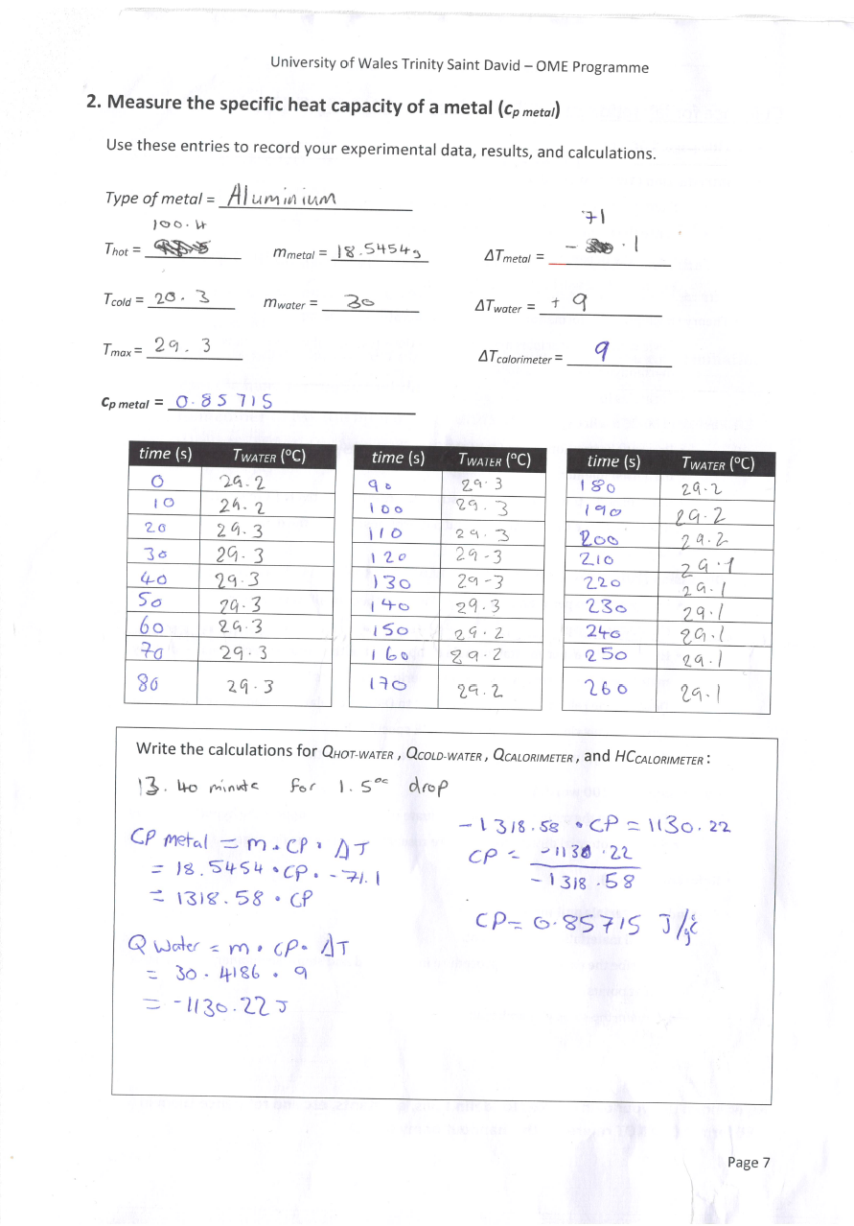
Figure 2 Lab result sheet 2

Discussion
From the results that had been worked out the specific heat of the metal was 0.85715. When comparing this and its other properties to different materials it was decided that the metal that was used in this experiment was aluminium. Reference two [2] shows mat web a website used to look up material properties. When completing the second test the student expected to see a rise in the cold water when the metal disk was added, even though this did happen it was also expected to happen when stirring the metal disk in the water. The rise the student saw was 0.1oc which only lasted for 2 minutes. A point that is worthy of noting was that in the instructions the student was informed to record the time stamps till the temperature had dropped by 2oc but it was observed that it took 13.40 minutes to only drop by 1.5oc, it has led the student to question this the experiment was completed correctly maybe the stirring wasn’t strong enough to affect the temperature or was the calorimeter too insulated for when the student was meant to be looking for. Another issue that the student had will conducting the experiment was even though it was a basic set up there were still hazards, a student injured themself on the boiling water and dropped the metal disk causing the beaker to shatter. this then added a time strain to the experiment meaning that the student had to rush so may have not noticed any wrong data.
This is a very basic version of a experiment for us to complete but there are more advanced versions being done that relate more to OME, in a calorimeter different metal powers were fired in different atmosphere to try and understand different factors like degree of afterburn to the detonation products and reactive particles [3].

Conclusion
From the resulting data it can be seen that the student was able to prove the hypothesis as in both experiments there was clear energy transfer from the Thot to the Tcold. For further research it would be good to repeat the test with deferent metals to see if you could

References
[1] B. Bitesize, “Specific heat capacity - Energy and heating - AQA - GCSE Physics (Single Science) Revision - AQA,” BBC Bitesize. Accessed: Oct. 23, 2024. [Online]. Available: https://www.bbc.co.uk/bitesize/guides/z2gjtv4/revision/5

[2] “MatWeb,” The Online Materials Information Resource. Accessed: Oct. 28, 2024. [Online]. Available: https://www.matweb.com/search/DataSheet.aspx?MatGUID=c8c56ad547ae4cfabad15977bfb537f1&ckck=1

[3] W. Kiciński and W. A. Trzciński, “Calorimetry studies of explosion heat of non-ideal explosives,” Journal of Thermal Analysis and Calorimetry, vol. 96, no. 2, pp. 623–630, Apr. 2009, doi: 10.1007/s10973-008-9100-5.

Appendices
Equipment list
- Bunsen Burner
- Beaker
- Stirring Rod
- Thermometer
- Metal Piece
- Deionised water
- Tongs
- Polystyrene cups/lid
- Weighing scales
Procedure 1
- Add 50ml of water to a cup and place the lid on top. Add the thermometer and stirring rod this makes the calorimeter.
- Take 50ml of water in the beaker and heat to 80oc. Turn off the heat and wait for the temperature to reach 60oc. Record the exact temperature of your hot water as Thot.
- Measure the temperature of the cold water and record it under Tcold.
- Add the hot water to the calorimeter then mix the waters together while watching the thermometer. Record the maximum equilibrium temperature of the mixture as Tmax.
- Calculate the heat capacity of the calorimeter use equation 1, 6 and 7.
Procedure 2
- Obtain a piece of the metal sample. Weight it and record it s mass as Mmetal.
- Set the water bath up above the Bunsen burner and heat the bath till boiling. Carefully add the metal. Keep the water boiling for 5 minuets till the metal reaches the same temperature as the water. Avoid heating the metal directly. Close of the burner after 5 minuets and leave for 2 for the water and metal to reach equilibrium.
- While you wait measure 30ml of water and add to the calorimeter. Measure the temperature and record under Tcold.
- Once the metal has reached thermal equilibrium with the boiling water measure and record the temperature as Thot. Quickly add the metal to the calorimeter using tongs.
- Stir the water and record the temperature every 10 seconds. The temperature will go up to start. Continue record the time and temperature until the water has reached its maximum and till it reaches 2oc below that. Record the maximum temperature as Tmax.
- Calculate the Cp metal using equation 3 and the value of heat capacity of the calorimeter found previously. Assume that the calorimeter and the water are in thermal equilibrium, Cp water = 4.186 J/(goc), always give units of the results of your calculations.

