 | Student No: | 2123259
 | Module Title: | Business Skills for the International Hotel Industry
 | Module Code: | BMIH4007
 | Lecturer: | Daniel Payne

Component One: Reflective Journal
I have been engaged in the study of a module pertaining to business skills for hotel management for the past six weeks. During this time frame, I actively engaged in a diverse range of educational activities, including attending lectures, contributing to group discussions, fulfilling assignments, and conducting research.
Emotions: After starting the module, I experienced a blend of anticipation and concern. I approached the opportunity to learn about the business aspects of hotel management with enthusiasm, yet I was also cognizant of the potential difficulties and heavy workload that might ensue. Over the course of the weeks, my emotional state exhibited a range of reactions, including episodes of frustration resulting from the comprehension of intricate ideas and moments of elation following the successful application of acquired knowledge to real-world situations.
In summary, this module has furnished me with an all-encompassing comprehension of the fundamental business competencies that are indispensable for proficient hotel administration. I have acquired knowledge pertaining to marketing strategies that are distinct to the hospitality sector, encompassing branding, advertising, and digital presence. Furthermore, I have acquired expertise in the areas of cost control, financial management, budgeting, and revenue forecasting. A comprehensive grasp of these financial facets is essential for hotels to sustain profitability and make well-informed decisions.
Additionally, I have gained insight into the criticality of providing exceptional customer service within the hotel sector. This includes problem-solving, effective communication, and the ability to cultivate positive relationships with guests. The operational aspects of hotel management, such as staff supervision, inventory management, and quality control, have also been investigated.
Through case studies and collaborative projects, I have been afforded the opportunity to apply what I have learned throughout the module. Participating in these endeavours has facilitated the growth of my aptitude for critical analysis, collaborative prowess, and the ability to discern intricate situations as they pertain to hotel management.
In conclusion, the six weeks that I have spent studying hotel management business skills have been extraordinarily beneficial to my professional and personal development. I have acquired a comprehensive set of knowledge and abilities that are essential for effective hotel management. With unwavering assurance, I shall implement the tenets of customer service, finance, and marketing to elevate the overall experience of the clientele. I will actively pursue opportunities to further develop my hotel management-related business acumen and incorporate this knowledge into my future endeavours.

Component Two: Action Plan
P. (2018, November 13).
Upon reflection of my experiences and the knowledge I have gained in the field of business skills for hotel management, I have identified a few areas in which I have room for further development and improvement about the following:
a) Financial Analysis: Although I have a fundamental comprehension of financial management, I would like to improve my abilities around financial analysis. Specifically, this includes the interpretation of financial statements, the execution of a comprehensive analysis of revenue and expenses, and the formulation of decisions based on data to maximise financial performance.
b) Leadership and Team Management: As I progressed through the module, I became aware of the significance of effective leadership and team management in the hospitality industry. My objective is to further develop my leadership skills, which include the ability to delegate tasks, motivate members of the team, and resolve conflicts on the team. It is possible for me to improve overall operational efficiency and create a positive work environment if I improve my ability to lead and manage a team.
2. Enhancing core strengths and focusing on those areas of strength: Although there are areas in which I could improve, I have also identified areas in which I excel and in which I have the potential to further develop my core strengths:
a) Customer Service: I have always had a natural tendency to provide excellent customer service. I have always had this natural tendency. It is possible to further improve this strength by persistently soliciting feedback from guests, putting into practise strategies for providing personalised service, and keeping abreast of the most recent developments in the field of guest satisfaction.
b) Capabilities in Communication: Throughout the entirety of the module, I have consistently demonstrated that I possess poor communication skills. It is possible for me to concentrate on developing my presentation skills and improving my capacity to communicate complicated ideas in a manner that is both clear and concise to further build upon this fundamental strength.
3. Creating opportunities for professional practise: To make the most of my education and experiences in the field of hotel management, I will make it a priority to look for opportunities for professional practise. Here are some examples:
a) Internships: I will investigate the possibility of obtaining an internship in a hotel or other hospitality organisation to acquire practical experience and put my knowledge to use in situations that are based in the real world.
b) Networking: To broaden my network and acquire expertise in the most recent hotel management practises and trends, I will actively participate in industry events, join professional associations, and make connections with professionals working in the industry.
c) Ongoing Education: To further improve my knowledge and abilities in hotel management, I will continue to keep myself engaged with the latest industry news, participate in workshops or seminars, and work towards obtaining certifications that are pertinent to the field.
Through the execution of this plan of action, I intend to continuously enhance and excel in the business skills necessary for hotel management, thereby paving the way for opportunities for professional development and achievement within the respective industry.
I would also like to take an English course in the future to improve both my speaking and writing in English.


Communication Skills | OER Commons by Unknown Author is licensed under CC BY-SA

References:
- Pat. (2018). Self-Reflection on learning!!. [Online]. Literature at Las Cumbres. Last Updated: 13 November 2018. Available at: https://pchujman.cumbresblogs.com/2018/11/13/self-reflection-on-learning/ [Accessed 2 December 2023].
2. OER Commons. (n.d.). Communication Skills. [online] Available at: https://oercommons.org/courseware/lesson/72511. [Accessed 2 December 2023].
‌

Component Three: Professional development: build a personal brand and promote a professional identity.
Canva Document
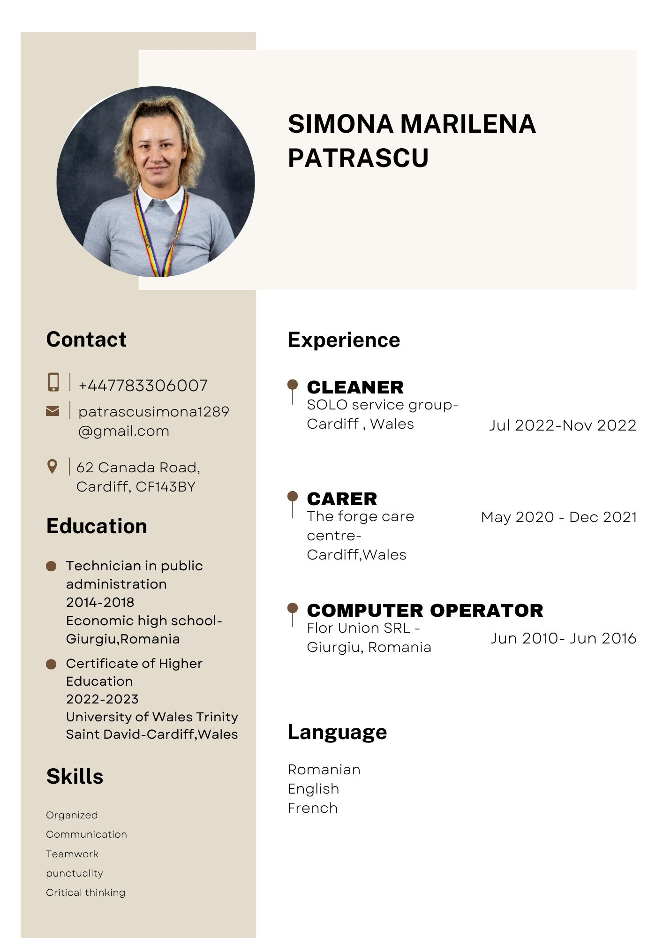

LinkedIn Screenshot
(1) Simona-Marilena Patrascu | LinkedIn
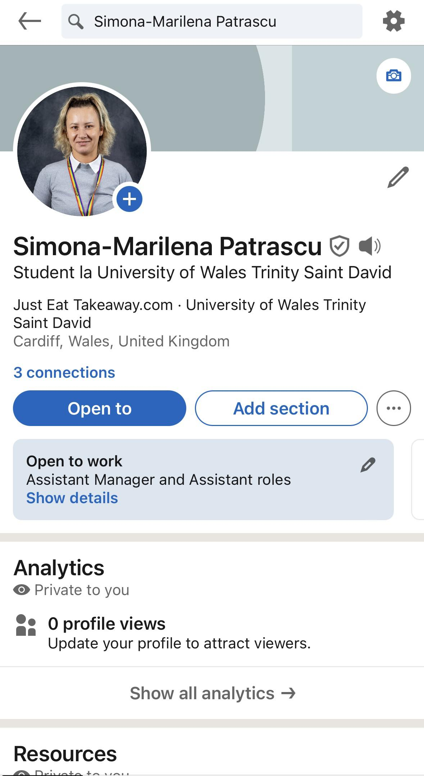
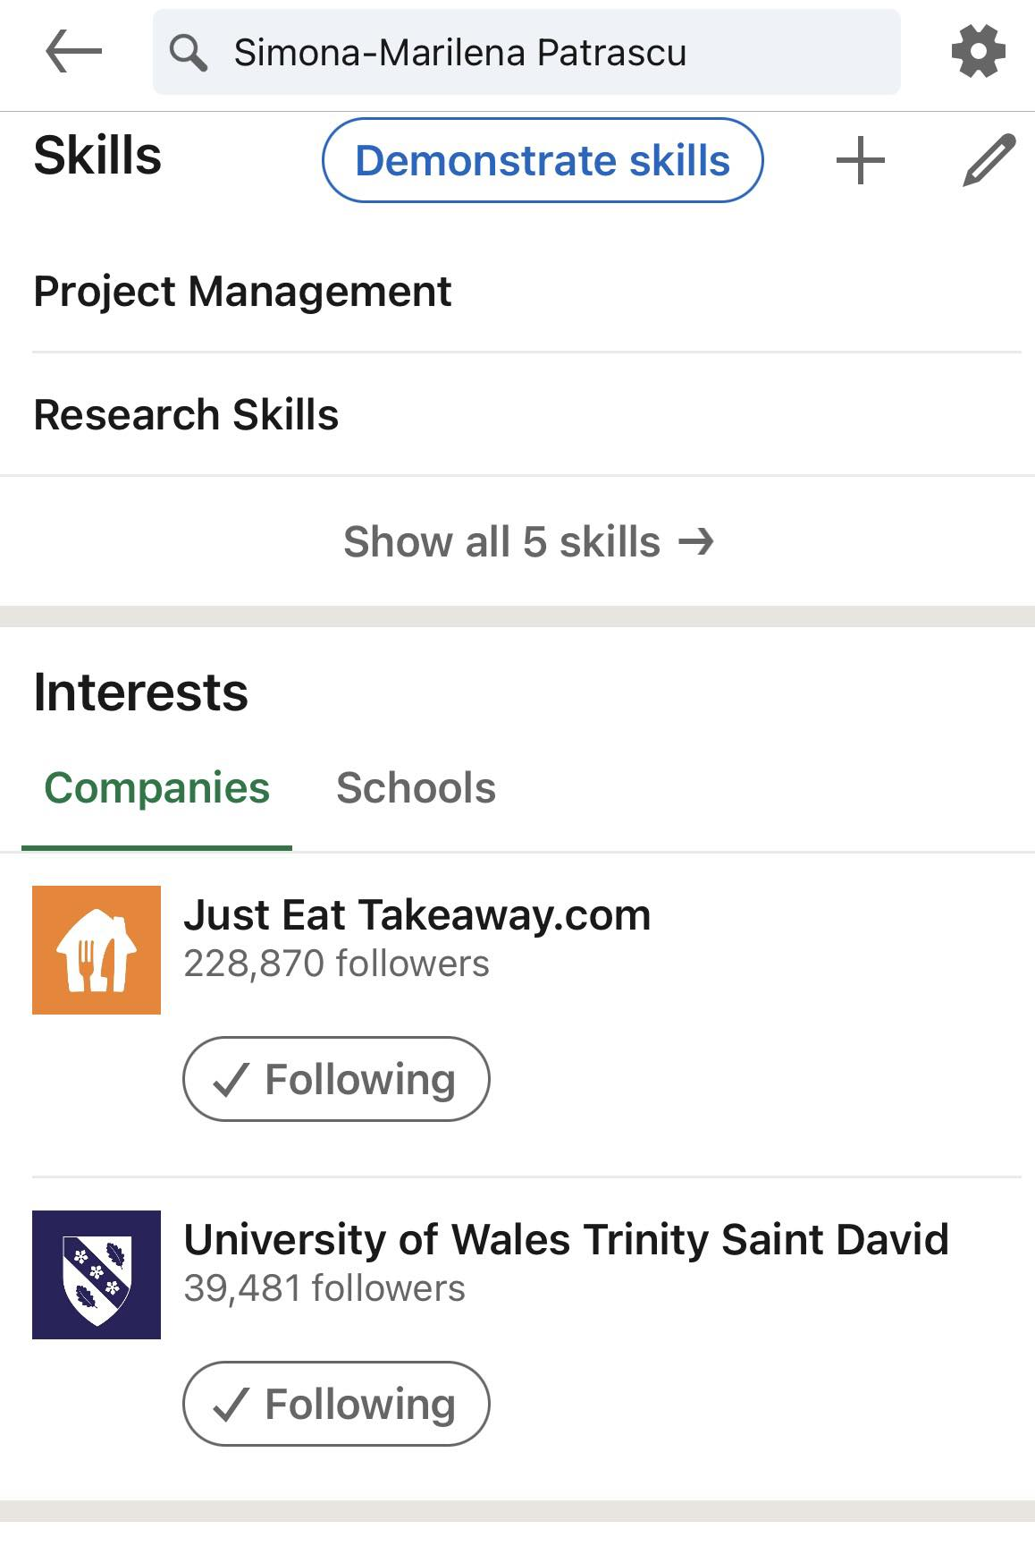
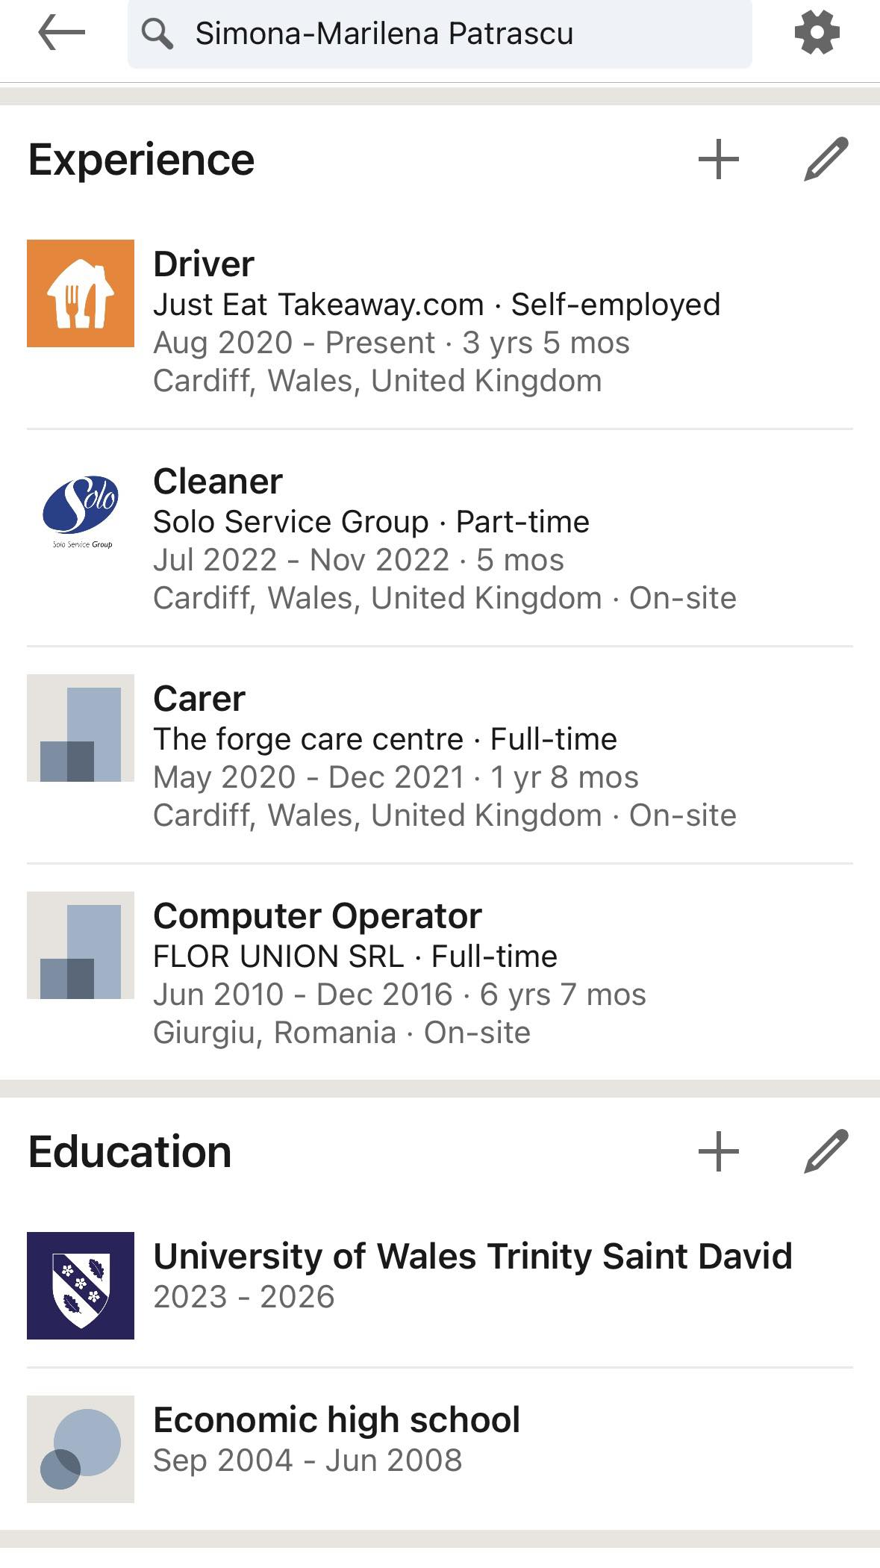
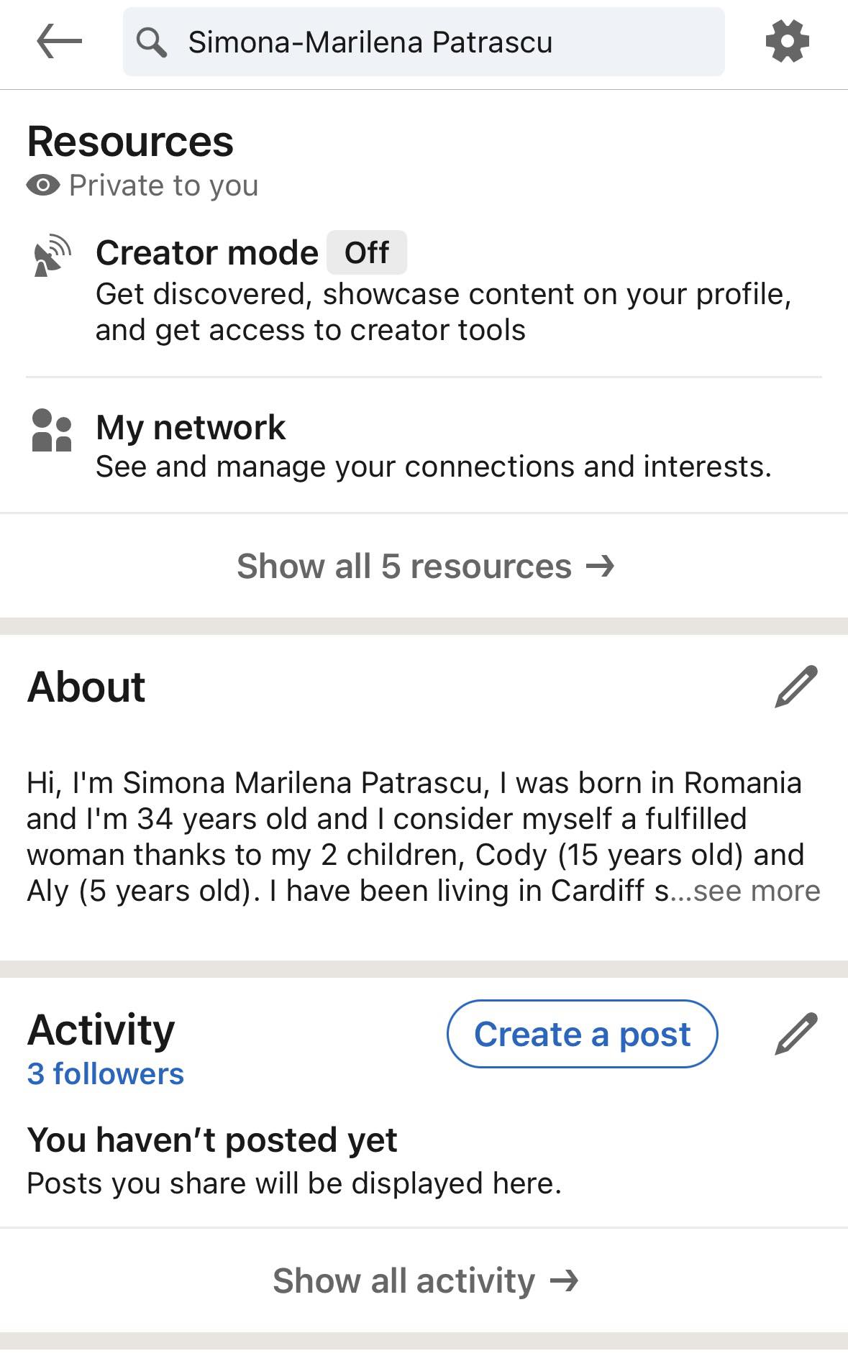

Component Four: Using the information prepared for your CV, present a 5 minute spoken CV
5/12/2023 --- 10:00am

