BA International Hotel Management
Financial Management for the Hotel Industry

Student Name: Mihaela Costache
Student ID : 2246360
Tutor Name: Tristan Hawkins

Declaration
I have used Grammarly which is an AI tool to rectify any grammatical mistakes from this study. Other than this, I confirm that I have not used any AI too in the research and creation of this assignment. I confirm that I have not presented any AI generated materials as my own work. I also confirm I have copies of my draft, notes and other resources I used, which I may be asked to provide in evidence.
Table of Contents
1. Introduction 3
2. Comparison of Total Revenue 3
3. Comparison of Market Position 4
4. Comparing Growth Potential of two organisations 6
5. Financial Commitment to CSR 8
6. Conclusion 10
References 11

1. Introduction
Financial management is pivotal to the prospect of business growth. Efficiency in financial management is crucial for catalysing business growth and it also aids in averting adverse economic crises (Seal et al., 2018). Through this study, two prominent organisations in the global hospitality industry will be compared in terms of their organisational governance along with their financial management. The Shangri-La Hotels and the Premier Inn Hotels have garnered extensive attention in the global hospitality industry. This study will explore their operational strategies and provide evidenced-based recommendations which will be aimed at mitigating potential disruptions and facilitating the organisational growth of these two organisations.

2. Comparison of Total Revenue
Business firms strive to improve individual profitability. The definition of revenue describes it as a monetary value that depicts the gains from the overall sales of a business firm (CFI, 2024). This value directly influences organisational profitability and businesses implement dedicated measures to amplify the results in terms of revenue growth. To compare the revenue of the Shangri-La Hotels and the Premier Inn Hotels, recent financial statements from both organisations were obtained and compared. The annual report of Shangri-La Hotels states that the consolidated revenue of the organisation in 2023 was $2,141.8 million (Shangri-La Asia Limited, 2023). On the other hand, the financial statement of Whitbread, the company which owns the Premier Inn Hotels indicates that the consolidated revenue of the Premier Inn Hotels in 2023 was £2,625.2 million, which roughly converts into $2882.99 million (whitbread, 2023). Comparing the consolidated revenue of both firms implies that the operations of Premier Inn Hotels have enabled it to outperform the Shangri-La Hotels in the financial year of 2023. The revenue trend of both hotels reflects positively on the financial management as both organisations have been successful in increasing their total revenue by 67.1% for the Shangri-La Hotels and 54% for the Premier Inn Hotels (Shangri-La Asia Limited, 2023; whitbread, 2023). Therefore, it can be assumed that the operations of both organisations are aligned with the developments in the external and internal environment.
The sources of revenue of the Shangri-La Hotels include its revenue from rooms, food and beverage sales, investment properties and ancillary services (Shangri-La Asia Limited, 2023). Among the sources of revenue, revenue derived from the rooms made up the majority of the revenue for the organisation, followed by food and beverage sales, investment properties and ancillary services. On the other hand, the sources of revenue for the Premier Inn Hotels include accommodation services and the sales of food and beverages across their operational markets (whitbread, 2023).
Rationalising the datasets from both financial reports, it was observed that there has been an innate increase in the sales of accommodation and food and beverages from 2022. The graph below validates the findings by displaying the increase in the market size of the tourism sector from 2022 to 2023. It can be argued that the sudden increment in tourism activities catalysed the positive changes in the total revenue of both the Shangri-La Hotels and the Premier Inn Hotels, which enabled the management to cultivate profitability by meeting the evolving consumer demand.
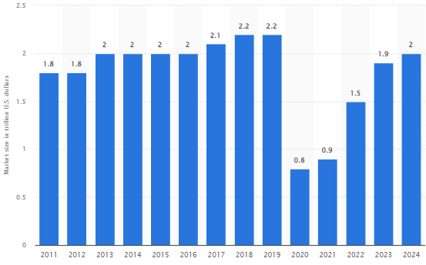
Figure 1: Market Size of the Global Tourism Sector
(Source: Statista, 2024)

3. Comparison of Market Position
Market positioning is the ability of businesses that enables them to create a unique perception regarding the brand image (CFI, 2024). Market positioning is important for brands as it influences the consumer perception associated with the brand. The market positioning of hospitality businesses is essential in the modern business environment as it influences the concurrent purchase intentions of customers.
The dataset acquired from Statista (2017) provides insights into the age group of individuals who reserve hotel suites in the UK. In the figure, it can be understood that individuals within the age bracket of 18-60 are the main customer segments of hospitality businesses in the UK. As both Shangri-La and the Premier Inn Hotels operate in the hospitality of the UK, both organisations will emphasise targeting individuals within the age bracket of 18-60, and these persons will be included in the demographic segment. Additionally, both organisations will capitalise on the desire for travelling, and the individuals who are frequent travellers will be categorised under the behavioural segment. Shangri-La Hotels operates in multiple countries but is restricted to Asian countries and a few Western countries (Shangri-La, 2024). On the other hand, the Premier Inn operates exclusively in the UK and is extending its presence in Germany (Whitbread, 2023). However, the revenue of the Premier Inn outperforms the Shangri-La Hotels, which indicates that the market share of the Premier Inn is better than that of the Shangri-La Hotels.
The website of Premier Inn Hotels states that the pricing strategy employed by the organisation aligns with the competitive pricing strategy (premierinn, 2024). Prices of rooms for accommodation within Premier Inn Hotels fluctuate on the basis of consumer demand. Conversely, the pricing strategy employed by the management of Shangri-La aligns with the principles of a premium pricing strategy (Shangri-La, 2024). The study by Ali and Anwar (2021), implies that prices are pivotal factors which influence the purchase intentions of customers. Therefore, rationalising the information from the two sets of information, it can be said that the premium pricing strategy of Shangri-La is the reason behind its lower revenue as compared to the competitive pricing strategy of the Premier Inn Hotel.
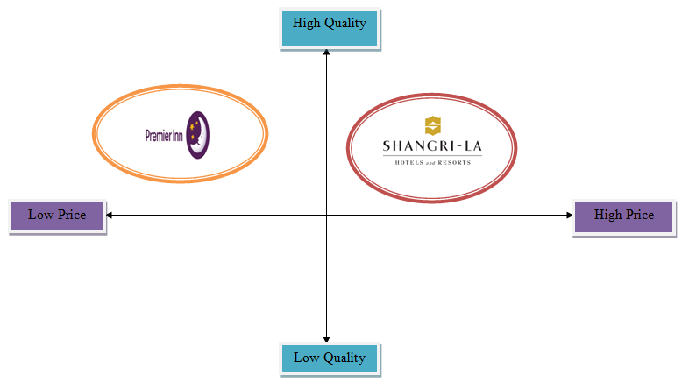
Figure 2: Positioning Map of the Shangri-La and the Premier Inn Hotels
(Source: Created by the learner)
The positioning map displayed above depicts the quality of service and pricing strategy employed by both brands. Consumers who are habituated to the operations of higher-end brands in the hospitality sector are accustomed to the operational strategies of Shangri-La and the Premier Inn. The individual practices of Shangri-La and the Premier Inn influence the purchase intentions and simultaneously affect the perception after using the services of the stated brands. However, in the current economic situation, customers will prioritise seeking the services of Premier Inn Hotels as the organisation offers similar services at a competitive rate.

4. Comparing Growth Potential of two organisations
The Ansoff Matrix can be used to assess the growth potential of Premier Inn and Shangri-La Hotels, stressing the Market Development strategy. This strategy analyses expanding into new markets to maximise revenue.
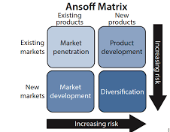
Figure 3: Ansoff Matrix
(Source: Smart Insights, 2020)
Shangri-La, a luxury hotel brand, has usually focused on high-end markets in the Pacific and Asia. The development measure relies in discovering new geographic regions, specifically in North America and Europe, where the luxury section is profitable yet extremely competitive (Hospitality Insights, 2023). The brand’s built reputation for outstanding service and quality can reach comfortable travellers in this region. Additionally, Shangri-La can discover teamwork with travel agencies and local tourism boards to better access and visibility. However, potential risks include the high price of entry into recognised markets, where brand loyalty is strong, and the confront of differentiating itself from existing luxury competitors. Geopolitical issues and financial fluctuations in target regions could also influence travel demand, posturing risks to development.
On the other hand, Premier Inn, a budget hotel chain under the Whitbread Group, mainly serves the UK market. Its development potential lies in increasing into new global markets, especially in Asia and Europe, where the insistence on inexpensive accommodations is increasing (Property Week, 2018). The brand can influence its accessible business model, contributing relaxed, basic stays at competitive prices to draw budget-aware travellers. It has a strong benefit due to its recognised brand commend in the UK and a ready structure that can be replicated in new areas. To make simple market entry, partnerships with local businesses and adapting contributions to meet local preferences can improve its appeal.
Challenges to development for Premier Inn may involve local competition from built-budget brands and conflicting policies regarding hotel operations in new market entries. Additionally, the economic situation affecting optional spending could affect occupancy rates. Both Premier Inn and Shangri-La have important growth chances through market enhancement but face different risks. Shangri-La’s comfort positioning allows it to beat into rich segments in new areas, though it must follow high competition and market entry prices. In contrast, Premier Inn’s resource-friendly approach aligns well with rising travel demand among cost susceptible customers (Property Week, 2018), though it may encounter regulatory hurdle and localised competition. In the end, the effectiveness of their development potential will depend on their capability to adapt to local market conditions and consumer needs.

5. Financial Commitment to CSR
Corporate Social Responsibility (CSR) is gradually more vital for businesses in the hospitality industry, as stakeholders, varying from investors to customers demand accountable practices. Shangri-La Hotels and Premier Inn Hotels have separate approaches and financial commitments to CSR initiatives, reflecting their brand perceptions and market positions.
Shangri-La Hotels, a luxury brand with a strong occurrence in Asia, emphasises its promise of sustainability through its "Sustainability and Social Responsibility" initiative. The company allocates important monetary resources to community development, environmental sustainability and ethical sources. Particularly, Shangri-La's "Care for People and Planet" agenda outlines determined goals, including dipping energy and water expenditure by 30% and 20%, correspondingly, by 2025 (Shangri-Laexperiences, 2023).

Figure 4: Shangri-la’s sustainability
(Source: Shangri-la, 2022)
In current years, Shangri-La has invested millions in waste reduction systems and energy-efficient technologies. The company also involved in different community projects, supporting health, education and local economies. In 2021, Shangri-La pledged $1 million to support communities affected by the COVID-19 pandemic (SHANGRI-LA GROUP, 2021), representing its financial commitment to social accountability. Additionally, its focus on sourcing sustainable resources for its operations further underscores its long-term asset in CSR.
On the other hand, Premier Inn, as a budget hotel chain, has also completed a significant stride in CSR but approaches it another way given its market sector. The brand's parent brand, Whitbread, allocates about £50 million yearly to sustainability initiatives (Whitbread, 2023). Premier Inn's focus areas involve conserving water, minimising carbon emissions and reducing waste. For example, the company aim to become carbon unbiased by 2025, committing considerable resources to energy-efficient designs and renewable energy projects in new hotel construction. The chain has also launched initiatives to support local community, including partnerships with educational programs and charities. For example, during the COVID-19 pandemic, Premier Inn offered free accommodation to NHS employees, showing its promise to social responsibility in times of disaster. Whitbread's complete sustainability strategy focuses on a circular economy approach, endorsing waste reduction and recycling across its operation.
Perception and impact
Shangri-La's general investments improve its brand picture as a head in luxury hospitality with principles, tempting wealthy consumers who prioritise sustainability (Shangri-La, 2022). Premier Inn’s highlights community-based CSR activities strengthen its brand faithfulness among budget travelers who worth ethical practice without high costs.
Both Premier Inn and Shangri-La Hotels show a strong monetary commitment to CSR, although different lenses are stated by their market position. Shangri-La’s lavishness focus allows for wider and potentially more influential investments in CSR, while Premier Inn’s sensible and community-based approach resonate with its careful clientele. Ultimately, both organisations are taking significant steps towards accountable practices, contributing to a more equitable and sustainable hospitality industry.
Investment Scale and Focus:
Shangri-La tends to spend greatly on luxury-based CSR initiatives, highlighting long-term community engagement and sustainability, aligning with its upscale market positioning. Its investments in pioneering technologies and community hold-ups reflect a complete approach to CSR. Premier Inn, while also dedicated to sustainability, focuses on lucrative measures and sensible solutions that align with its budget-conscious customer base (premiering, 2022). Its yearly investment in sustainability initiatives is considerable, though it may be lower than Shangri-La's in general spending given the scale and type of operation.

6. Conclusion
In summary, both Premier Inn and Shangri-La Hotels demonstrate significant financial commitments to CSR, tailored to their market segments. Shangri-La focuses on extensive sustainability and community commitment initiatives, reflecting its luxury positioning. In contrast, Premier Inn emphasises useful, cost-effective measures that resonate with budget-conscious travellers. In spite of their differing approaches, both brands effectively enhance their reputations and foster customer loyalty through responsible practices. Eventually, their funds in CSR contribute totally to the hospitality industry’s wider goals of sustainability and social accountability.

References
Ali, B.J. and Anwar, G., 2021. Marketing Strategy: Pricing strategies and its influence on consumer purchasing decision. Ali, BJ, & Anwar, G.(2021). Marketing Strategy: Pricing strategies and its influence on consumer purchasing decision. International journal of Rural Development, Environment and Health Research, 5(2), pp.26-39.
cdn(2022)The Economic Impact of Premier Inn Hotels[online]Available at:https://cdn.whitbread.co.uk/media/2023/08/The-Economic-Impact-of-Premier-Inn-hotels_2022-study_final.pdf[Accessed on: October 5, 2024]
CFI 2024. Market Positioning. [online] CFI. Available at: https://corporatefinanceinstitute.com/resources/management/market-positioning/ [Accessed 5 October 2024].
CFI 2024. Revenue. [online] Corporate Finance Institute. Available at: https://corporatefinanceinstitute.com/resources/accounting/revenue/ [Accessed 5 October 2024].
hospitalityinsights(2023)Top 10 Trends in the Hospitality Industry in 2024[online]Available at:https://hospitalityinsights.ehl.edu/hospitality-industry-trends[Accessed on: October 5, 2024]
premierinn 2024. Room rates | Premier Inn. [online] www.premierinn.com. Available at: https://www.premierinn.com/gb/en/faq/room-rates.html [Accessed 5 October 2024].
premierinn(2022)We're a Force for Good[online]Available at:https://www.premierinn.com/gb/en/why/force-for-good.html[Accessed on: October 5, 2024]
propertyweek(2018)Entering new markets is key to Premier Inn’s growth[online]Available at:https://www.propertyweek.com/sponsored-content/perspectives/entering-new-markets-is-key-to-premier-inns-growth[Accessed on: October 5, 2024]
Seal, W., Rohde, C., Garrison, R. and Noreen, E., 2018. Management Accounting, 6e. McGraw-Hill Education (UK).
Shangri-La 2024. Luxury Hotels and Resorts | Official Site Shangri-La Hotels and Resorts. [online] Shangri-la.com. Available at: https://www.shangri-la.com/en/find-a-hotel/?choose=Kerry [Accessed 5 October 2024].
Shangri-La Asia Limited 2023. Annual Report 2023. [online] sitecore-cd.shangri-la. Available at: https://sitecore-cd.shangri-la.com/-/media/Project/Shangri-La-Group/Investor/Files/Public-Disclosures/Latest-Top-Publications/2023_Annual_Report_E.pdf [Accessed 5 October 2024].
SHANGRI-LA GROUP(2021)Sustainability Report 2021[online]Available at:https://sitecore-cd.shangri-la.com/-/media/Project/Shangri-La-Group/OurStory/Files/Community-And-Social-Impact/Sustainability-Reports/2021_SustainabilityReport.pdf[Accessed on: October 5, 2024]
shangri-la(2022)Stay[online]Available at:https://www.shangri-la.com/group/sustainability/stay/[Accessed on: October 5, 2024]
Shangri-Laexperiences(2023)ENVIRONMENTAL AND SOCIAL GOVERNANCE[online]Available at:https://www.Shangri-Laexperiences.com/community-and-social-impact[Accessed on: October 5, 2024]
smartinsights(2020)Ansoff Matrix[online]Available at:https://www.smartinsights.com/marketing-planning/create-a-marketing-plan/ansoff-model/[Accessed on: October 5, 2024]
Statista 2017. Hotel usage by age in the UK 2017. [online] Statista. Available at: https://www.statista.com/statistics/675312/hotel-accommodation-usage-united-kingdom-uk-by-age/ [Accessed 5 October 2024].
Statista 2024. Global tourism industry market size 2021. [online] Statista. Available at: https://www.statista.com/statistics/1220218/tourism-industry-market-size-global/ [Accessed 5 October 2024].
Whitbread 2023. About Us. [online] Whitbread PLC. Available at: https://www.whitbread.co.uk/about-us/ [Accessed 5 October 2024].
whitbread 2023. FY23 Results. [online] whitbread. Available at: https://cdn.whitbread.co.uk/media/2023/04/Final-FY23-RNS-Final-Combined.pdf [Accessed 5 October 2024].
whitbread(2023)Environmental, Social and Governance Report 2022/23[online]Available at:https://cdn.whitbread.co.uk/media/2023/05/Whitbread_ESG_Report_FY22_23.pdf[Accessed on: October 5, 2024]

